Exercise 1 — Sales Revenue Summary Job

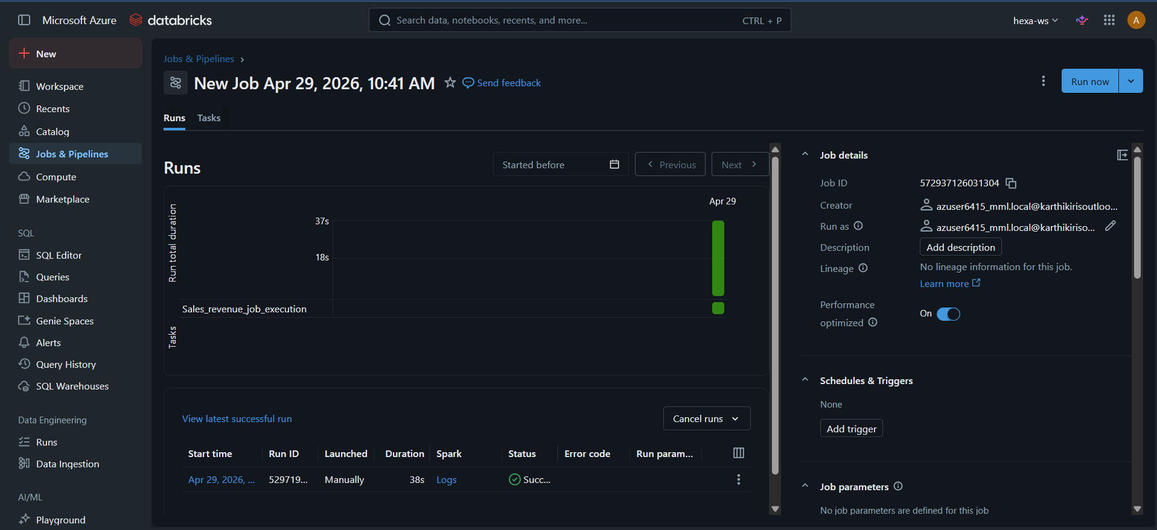

Exercise 2 — Student Performance Job

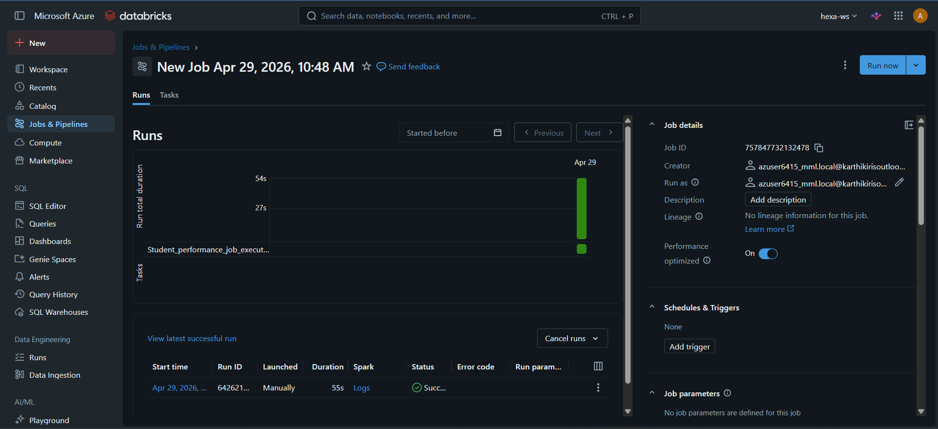

Exercise 3 — Employee Department Ranking

