What is Devops?
DevOps is a modern approach to software development that brings development and operations teams together to deliver applications faster and more reliably. It focuses on collaboration, automation, and continuous improvement across the software lifecycle.
- Encourages close collaboration between development and operations teams.
- Automates build, test, and deployment processes to reduce errors.
- Enables faster and more frequent software releases.
- Improves system reliability, monitoring, and feedback loops.
Advantages of Devops:
- Speed and Efficiency: Accelerated delivery through automated CI/CD pipelines, allowing teams to ship updates faster and more frequently.
- Improved Collaboration: Breaks down silos between development and operations teams, creating a culture of shared responsibility, trust, and improved communication.
- Enhanced Quality and Reliability: Automated testing and continuous monitoring ensure that code changes are vetted early, reducing bugs and leading to more stable, resilient applications.
- Reduced Risk and Rapid Recovery: Smaller, frequent updates combined with automated monitoring allow for faster detection, resolution, and roll-back of issues.
- Cost Efficiency and Scalability: Automation of manual tasks and infrastructure as code (IaC) reduces operational expenses and enables efficient scaling of resources.

What is Agile?
Agile is a flexible, team-based approach to project management that breaks large projects into small, manageable tasks completed in short cycles called "sprints". Instead of planning everything upfront, it focuses on continuous improvement, constant feedback, and adapting to changes quickly to deliver value faster.
What is Scrum?
Scrum is a widely used Agile framework for developing complex products, introduced by Ken Schwaber and Jeff Sutherland. It enables teams to self-organize, collaborate effectively, and deliver high-value products through an iterative and incremental approach, while adapting to changing requirements. Its key features are:
- Lightweight and simple to understand framework
- Emphasizes self-organization and teamwork
- Promotes collaboration and continuous improvement
- Supports iterative and incremental development

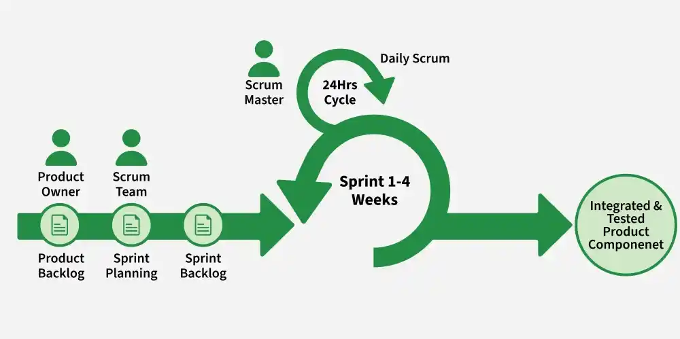
What is Product Owner?
A product owner is a role in an agile development who is responsible for the output or the final product ensures that it is up to date in terms of priorities with no backlog and has the items which are demanded in the current vision. The product owner represents the business and is accountable for collaborating with the customers to define what features will be in the product release.
What is Scrum master?
A Scrum Master is a key role in the Agile Scrum framework whose main job is to help the Scrum team work effectively by making sure Scrum practices are understood and followed.
They are often described as a servant-leader and facilitator, not a traditional manager.
What a Scrum Master does
- Facilitates Scrum events (Daily Standup, Sprint Planning, Sprint Review, Sprint Retrospective)
- Removes obstacles (impediments) that block the team’s progress
- Coaches the team on Agile/Scrum principles
- Helps ensure the team stays focused on the Sprint goal
- Works with the Product Owner to improve the product backlog and planning
- Shields the team from unnecessary distractions or outside interference
Advantages of Agile:
- Focus on Customer Value: Agile places a high priority on providing customers with value by attending to their requirements and preferences. Agile guarantees that the most important features are produced first and that iterative changes are driven by customer feedback by dividing work down into small, manageable tasks.
- Enhanced Team Morale and Motivation: Agile gives teams the freedom to own their work and decide together. Team members feel motivated, proud, and owned when they have this autonomy together with a focus on providing value and ongoing growth.
- Stakeholder Collaboration: Throughout the development process, agile promotes strong coordination between product owners, developers, and other stakeholders. Better communication, a common understanding of the objectives, and ongoing feedback are all fostered by this partnership, which produces results that are higher quality and boost stakeholder satisfaction.
- Early and Continuous Delivery: Agile encourages the tiny, incremental releases of functional software. This gives early access to observable progress and facilitates early input and validation for stakeholders. Continuous delivery reduces risks by spotting problems early on and taking action to fix them.
- Delivering high-quality software: It is a key component of agile development, and this is emphasized by techniques like continuous integration, automated testing, and frequent inspection and modification. Agile guarantees that the software satisfies the required standards and lowers the likelihood of faults by integrating quality assurance throughout the development process.

