PySpark
What is PySpark?
PySpark is the Python API for Apache Spark, an open-source, distributed computing framework designed for fast, large-scale data processing. It allows data engineers and scientists to use Python to harness Spark's power for processing petabyte-scale data, combining Python's ease of use with Scala's performance.
Key Aspects of PySpark:
- Architecture: It uses Py4J to allow Python to interface with the JVM (Java Virtual Machine) objects, enabling distributed computing across clusters.
- Functionality: Supports batch processing, real-time streaming, SQL querying (SparkSQL), and machine learning (MLlib).
- Data Structures: Primarily uses DataFrames for structured data, which are similar to tabular data in relational databases or Pandas DataFrames, but distributed across a cluster.
- Performance: While native Scala is faster because it runs directly on the JVM, PySpark offers comparable performance for most big data tasks due to in-memory processing, despite the overhead of the Python-JVM bridge.

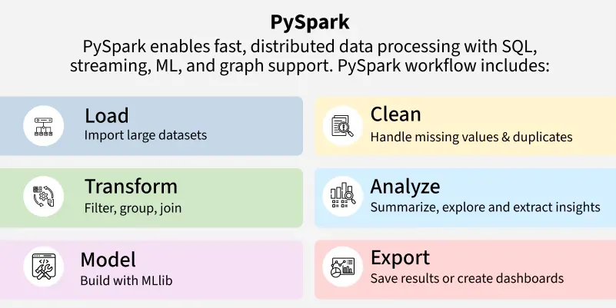
What is PySpark Used For?
PySpark lets you use Python to process and analyze huge datasets that can’t fit on one computer. It runs across many machines, making big data tasks faster and easier. You can use PySpark to:
- Perform batch and real-time processing on large datasets.
- Execute SQL queries on distributed data.
- Run scalable machine learning models.
- Stream real-time data from sources like Kafka or TCP sockets.
- Process graph data using GraphFrames.

Why Learn PySpark?
PySpark is one of the top tools for big data. It combines Python’s simplicity with Spark’s power, making it perfect for handling huge datasets.
- Enables efficient processing of petabyte-scale datasets.
- Integrates seamlessly with the Python ecosystem (pandas, NumPy, scikit-learn).
- Offers unified APIs for batch, streaming, SQL, ML and graph processing.
- Runs on Hadoop, Kubernetes, Mesos or standalone.
- Powering companies like Walmart, Trivago and many more.
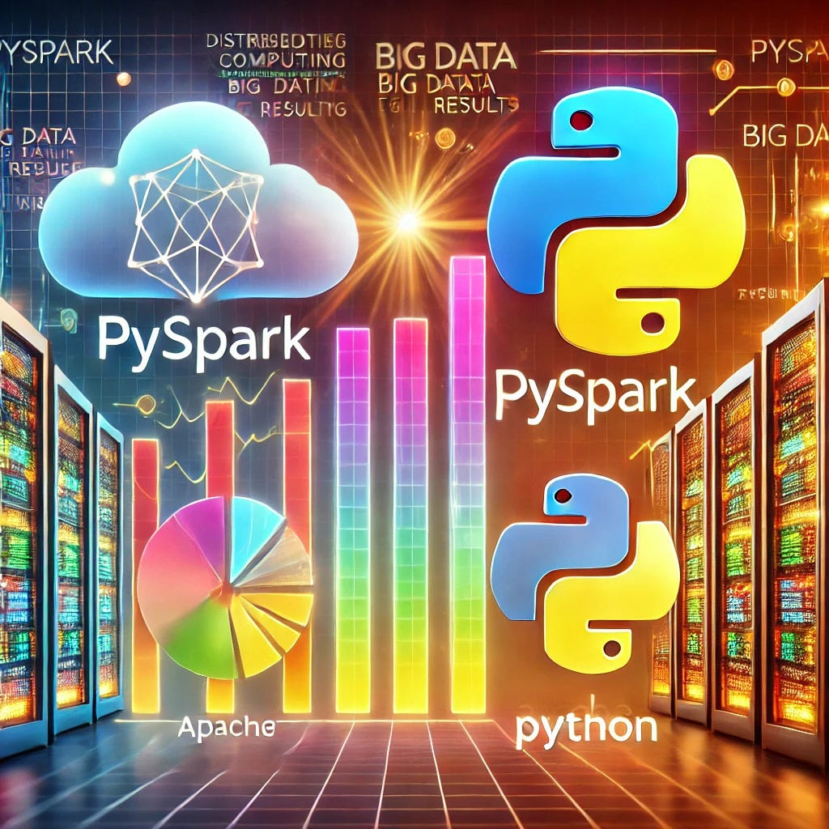

What are the advantages of PySpark?
- Scalability: PySpark allows users to scale horizontally by distributing workloads across clusters of thousands of nodes. It can process terabytes or petabytes of data that would exceed the memory of a single machine.
- High Speed and Performance: It utilizes in-memory computation, storing intermediate results in RAM rather than writing to disk after every step. This allows it to run up to 100x faster than traditional disk-based frameworks like Hadoop MapReduce.
- Lazy Evaluation: PySpark delays the execution of transformations until an "action" (like count() or show()) is called. This allows the internal Catalyst optimizer to combine operations and create the most efficient execution plan.
- Fault Tolerance: Through Resilient Distributed Datasets (RDDs), PySpark tracks the lineage of data transformations. If a worker node fails, Spark can automatically recompute the lost data partitions without restarting the entire job.
- Unified Ecosystem: A single platform handles diverse workloads, reducing the need for multiple tools.
  - Spark SQL: For structured data processing using SQL-like queries.
  - MLlib: A scalable machine learning library for building pipelines on big data.
  - Structured Streaming: For processing real-time data streams (e.g., IoT logs, social media feeds).
  - GraphFrames: For efficient graph analysis and relationship modeling.
- Integration with Python Ecosystem: It allows data scientists to leverage familiar libraries like Pandas, NumPy, and Scikit-learn directly within Spark applications, facilitating a smoother transition from local prototyping to cluster-scale production.
- Ease of Use: Compared to Scala or Java, Python has a simpler syntax and a lower learning curve, making big data engineering more accessible to a wider range of professionals.
Usecases of PySpark:
Here are five important real-world use cases of PySpark:
1. Large-Scale ETL and Data Pipeline Construction :
Organizations use PySpark to ingest raw data from disparate sources (APIs, databases, IoT sensors), clean it, transform it into structured formats (like Parquet), and load it into data lakes or warehouses.
- Real-World Example: Data engineers use PySpark to join billions of records from clickstream logs and user databases to build consolidated analytical tables.
- Why PySpark: Its distributed architecture handles heavy transformations much faster than traditional ETL tools.

2. Real-Time Fraud Detection in Finance :
Financial institutions use PySpark Structured Streaming to analyze transaction data as it occurs, rather than waiting for batch processing. This allows for immediate action on suspicious behavior.
- Real-World Example: Banks compare incoming credit card transactions against a database of previous fraud patterns in real-time. If a transaction matches a fraudulent footprint, a trigger is sent to halt the transaction or alert the user instantly.
- Why PySpark: Low-latency streaming capabilities allow for immediate decision-making.
3. Personalized Recommendation Engines (E-commerce & Streaming) :
PySpark's Machine Learning Library (MLlib), specifically the Alternating Least Squares (ALS) algorithm, is used to build recommendation engines at scale, analyzing user interactions in real-time to offer personalized product or content recommendations.
- Real-World Example: Netflix uses Spark for real-time stream processing to provide personalized show recommendations based on billions of user activity events per day.
- Why PySpark: It can process and train models on massive datasets that are too large for single-node libraries like Scikit-learn.
4. Real-Time User Behavior Analytics in Retail :
Retailers and digital platforms use PySpark to analyze user clicks, browse history, and purchase activity to optimize inventory and marketing in real-time.
- Real-World Example: Yelp uses PySpark to analyze huge volumes of data for ad targeting, predicting the likelihood of a person interacting with an ad to enhance click-through rates.
- Why PySpark: It enables fast exploratory data analysis (EDA) on vast, rapidly growing datasets.

5. Log Processing and System Monitoring :
Companies with extensive digital infrastructure use PySpark to analyze logs from multiple sources to monitor system performance, identify errors, and automate troubleshooting.
- Real-World Example: Uber and other tech companies process TBs of log data to detect system bottlenecks and generate automated alerts to ensure high service availability.
- Why PySpark: Its ability to filter and aggregate unstructured log files quickly across many nodes.

