ITIE Academy

EEG Research Project

Brain Dynamics during Visual Search and Object Identification

Sanjan Das

Undergraduate

Engineering at University of Cambridge

# **OVERVIEW**

The study of this experiment is to analyse the brain dynamics as obtained by an EEG headset during a visual search and object identification task. The subjects were presented with the image of a single object, which they had to find in another image containing various objects. The EEG data recorded was analysed in MATLAB using the Psychophysics-3 Toolbox.

The goal of this project was to learn more about neuroscience experiments from a signal processing perspective, as well as try out some deep neural networks to classify the processed data. It gave me a chance to develop a stimuli presentation and interact with subjects as well as work through suggested neuro experiment literature online. Finally, I got to try my hand at writing a research project report.

Table of Contents

**OVERVIEW** 1

**INTRODUCTION** 3

**METHODOLOGY** 3

Setup 3

Hardware 3

Software 4

Subjects and Room Preparation 4

Pre-processing 5

**RESULTS AND DISCUSSION** 6

Channel ERSPs (Event Related Spectral Perturbations) 6

Channel ERPs (Event Related Potentials) 7

Classifying the Epochs 8

1. LSTM on the sequential epoch data 8

2. CNN on the spectrograms of the epoch data 10

**CONCLUSIONS AND FUTURE WORK** 10

**REFERENCES** 10

# **INTRODUCTION**

Visual search and object Identification take place so very frequently in our daily lives. When we can’t remember where we kept something, we have an image of that item in mind and look in various places to try and spot it.

# **METHODOLOGY**

## Setup

### Hardware

The EEG headset used was an 8-electrode Enobio from Neuroelectrics. Out of the 8 possible electrode links, only 6 were used in the experiment as only 6 dry electrodes were used. No wet or gel electrodes were used in the experiment. The electrodes were placed according to the 10/20 system.

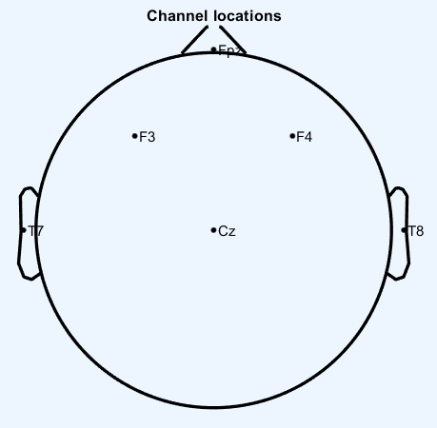Channel 1 – T7

Channel 2 – F3

Channel 3 – (none)

Channel 4 – CZ

Channel 5 – FPZ

Channel 6 – (none)

Channel 7 – F4

Channel 8 – T8

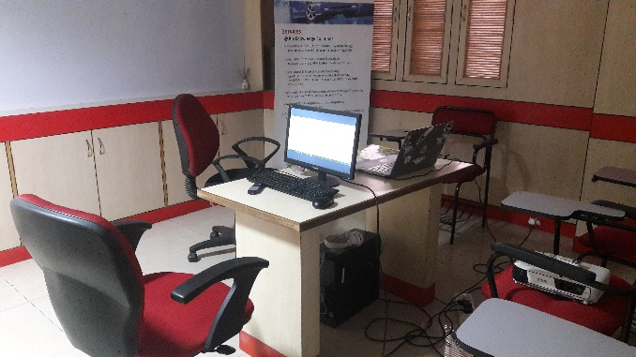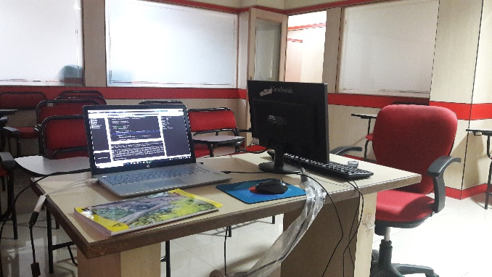This placing of the electrodes was chosen after referring to articles that suggested what regions of the brain played a role in object recognition and visual search (REFERENCE HERE). To obtain a more localised analysis, no parietal or occipital region was used in the analysis.

A single laptop connected to an external monitor via HDMI cable. The external monitor was used to present the task and images to the subjects.

### Software

The stimulus presentation was written in MATLAB with the help of the Psychophysics Toolbox (PTB-3). The tool used to record the EEG data was Neuroelectrics NIC v1.4.

For the analysis of the obtained data, MATLAB and the EEGLAB toolbox (available from SCCN) were used. LSL (Lab Streaming Layer) was downloaded to make TCP/IP connections to the Enobio.

### Subjects and Room Preparation

The subject was asked to wear the Enobio headset and make sure that all the dry electrodes were felt on the scalp. Adjustments were made to stabilise the EEG readings.

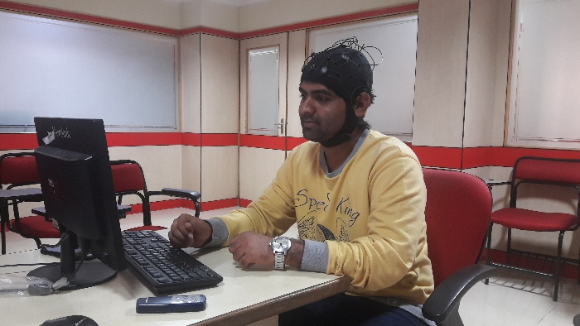The subject was given a keyboard, mouse and the external monitor.

The subject was asked to fill in a questionnaire which asked for name, age, and basic health details. The question regarding consent towards participating in this experiment was present in this questionnaire.

Experiment was carried out in a well-lit room at approximately room temperature. No AC or fan were switched on. There was the unavoidable presence of low traffic and construction noise from the environment outside the building. All windows and doors were closed.

## Pre-processing

The pre-processing of the obtained data was done on EEGLAB. No MATLAB scripts were written, rather the GUI of EEGLAB was used for the various steps.

1. Removing the 2 unnecessary channel data
   * Channel 3 and Channel 6 did not have the right electrodes, and so their recording was excluded from the data.
2. Filtering
   * The dataset was filtered for 1-40 Hz through a Butterworth filter. This was done to remove the effect of line noise and related high frequencies.
3. Average Referencing
   * The remaining 6 channels were average referenced.
4. Epoching
   * The dataset was epoched to create 3 new datasets, epoched -
     1. around the marker ‘5’ (Item found). The range of -2s:1s was used to create the epoch, since it was assumed that related brain dynamics would take place before the marker.
     2. around marker ‘4’ (Image to search in shown). Range of -1:2s used.
     3. one around marker ‘3’ (Item to find shown). Range of -1:2s used.
   * All the epochs were 1500 data samples long, since they were all 3 seconds long with a sampling rate of 500.
5. Rejection of Epochs
   * Since only 11/12 epochs were created per subject, epoch rejection was done manually. Key things looked out for were –
     1. Evident presence of electrode noise
     2. More than 2 eyeblinks in the epoch
6. ICA of epoched data
   * ICA was run with the runica algorithm.
7. ICA Component rejection
   * 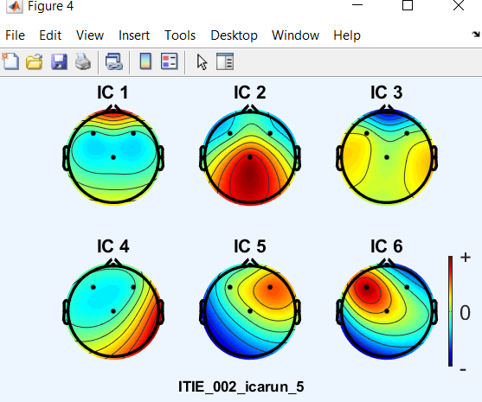Only one ICA component was rejected – the eyeblink. It was identified by the large weightage towards the FPZ electrode while observing the 2D map of ICA components.
8. STUDY creation
   * A STUDY (EEGLAB data structure) was created using the sequences with ICA components rejected. The STUDY had a total of 15 datasets, for each subject (5) and each marker/condition (3).

# **RESULTS AND DISCUSSION**

For better analysis of the results across all subjects and channels, the concept of EEGLAB STUDY was used.

## Channel ERSPs (Event Related Spectral Perturbations)

For the channel ERSPs, it can be noticed that the power spectral density increases for certain bands of frequencies. A look at the original plots show this increase in the alpha (8-12 Hz) and gamma (25-40 Hz) bands

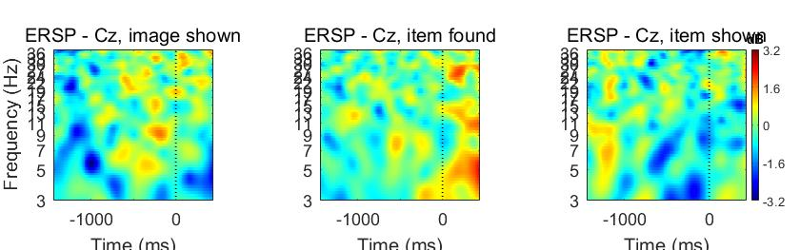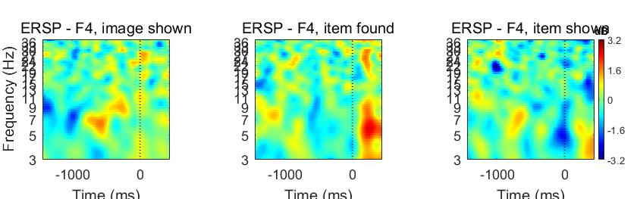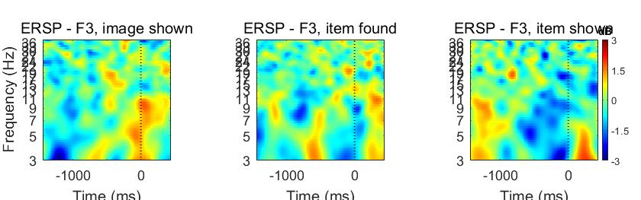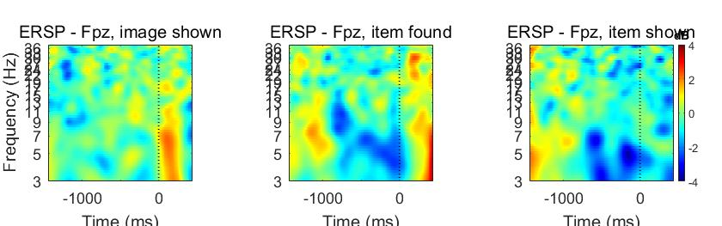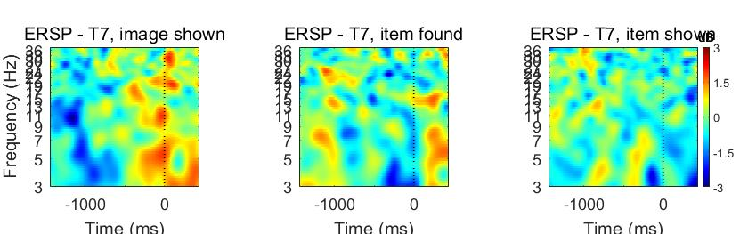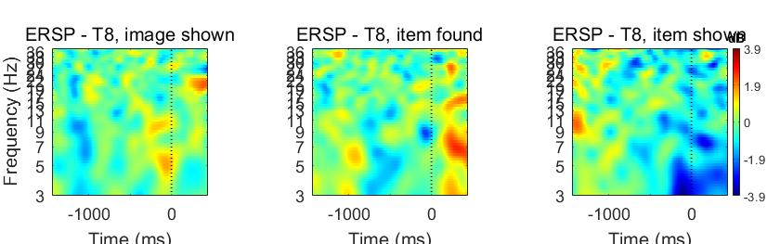

## Channel ERPs (Event Related Potentials)

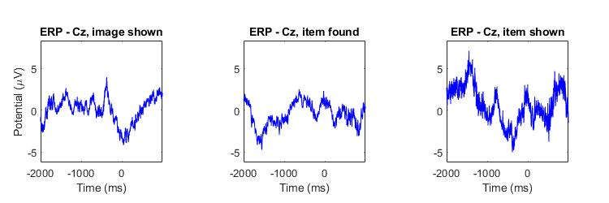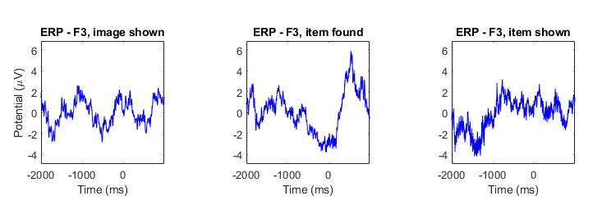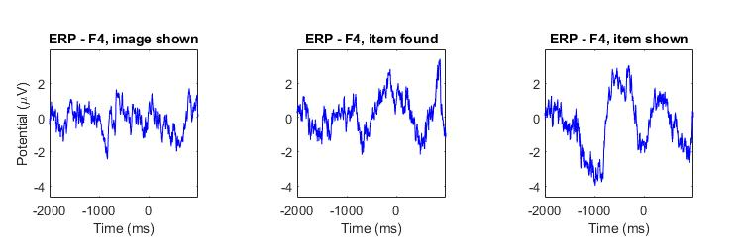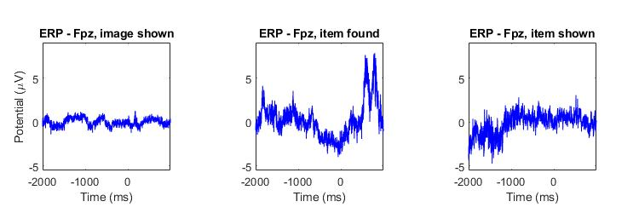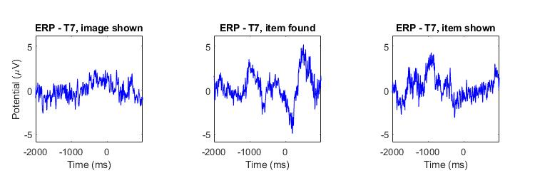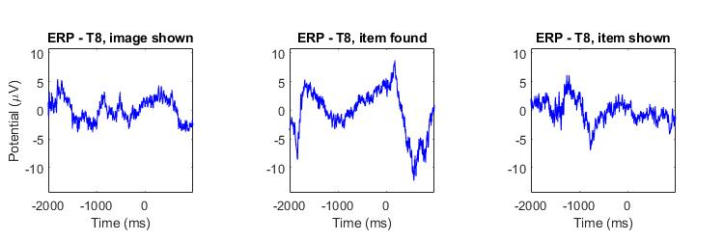

## Classifying the Epochs

Attempts were made to classify the epochs as accurately as possible using deep learning techniques. Due to the time-bound and subject-limited nature of the experiment, great results weren’t expected mainly due to insufficient data. Two approaches were used –

### LSTM on the sequential epoch data

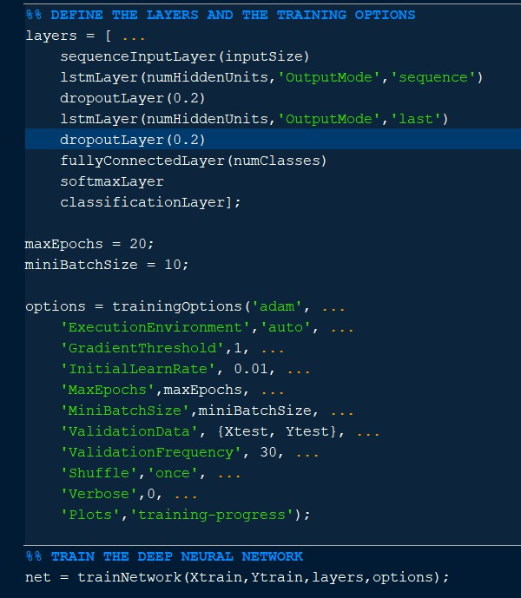There were two types of LSTM considered. One that classified the epochs as ‘3’, ‘4’, ‘5’, and one that classified them as ‘5’ (item found) and ‘1’ (item not found). The latter was chosen for the final results as it was decided that not enough data was available for 3 class classification.

The figure beside shows the parameters used that provided the best accuracy and results.

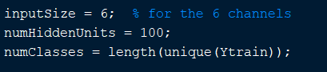

The corresponding training progress image is shown below. The validation (done with the test data) is also plotted.

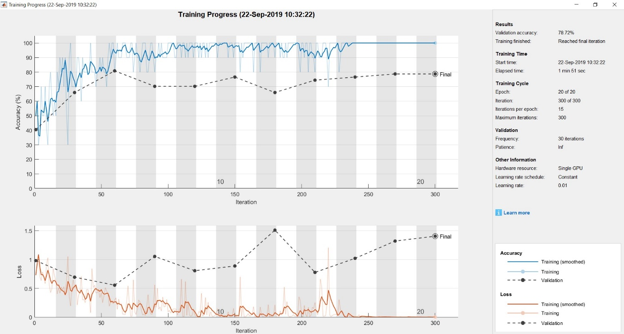

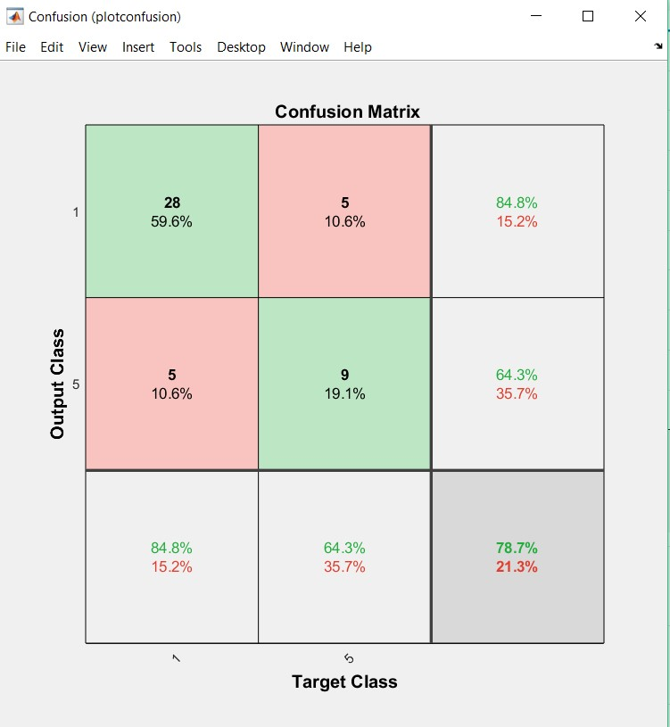

Training the LSTM required a significant amount of trial and error.

Better accuracy for the classification of an epoch as ‘5’ would have been better overall, since that is the main goal of this part of the analysis.

### CNN on the spectrograms of the epoch data

The CNN was trained on the spectrogram data for each subject, channel and epoch. This produced a lot of training images; however, the training data wasn’t very suitable for the CNN since all the spectrograms had been labelled.

A better option would have been to run a CNN separately to classify each channel, and then use those accuracy results to give an overall accuracy in classification.

# **CONCLUSIONS AND FUTURE WORK**

Since this was a summer project with a time bound of 2 months, all features and methods of EEG data analysis obviously could not be explored.

One of the main concepts left out was component clustering and subsequent plotting. It is possible that more interpretation can be got from these results.

The LSTM and CNN have been implemented as a sort of experimental analysis, rather than looking for it to contribute directly to the study. More focus could have been kept on the cleaning of the initial data. The main problem felt with these approaches were the data involved. Also, it is possible that the amount of training data was less and so the less accuracy involved.

# **REFERENCES**

<https://www.sciencedirect.com/science/article/pii/S0960982218305645> : the results from this report helped me decide which electrode positions were best for my scenario

<https://sccn.ucsd.edu/eeglab/index.php> : All the tutorials on EEGLAB helped me process the data obtained