- Project Summary

1.Industry and Organization Background information:
The Corporate Social Responsibility and event management sector has one significant challenge: the ethical and effective redistribution of excess food and materials from events. Thousands of corporate events, conferences, weddings, and public events annually create excess resources much of which is wasted in the face of persistent need in the surrounding communities.
The task of rapidly matching surplus to local food banks and charities is also being made challenging due to the needs of real-time tracking, compliance, and scalability. At an era where companies are being expected to achieve more Corporate Social Responsibility standards, technology driven solutions are needed in order to maximize social benefit as well as ease operational effectiveness.
Our project addresses an Event Leftover Redistribution System a system intended for event planners, food banks, and nonprofits. The system constructs an online bridge connecting surplus holders (event managers, venues, caterers) with deficit holders (food banks, nonprofits), through automated monitoring, smart matching, and real-time alerts to ease redistribution.
The program directly promotes corporate social responsibility and sustainability goals by preventing waste, increasing transparency, and enabling timely, efficient redistribution of resources. By utilizing sophisticated cloud computing, predictive analytics powered by AI, and multichannel communication, ELRS transforms what is otherwise a time-consuming, inefficient process into a seamless, automated one.

2.Planning Phase

Project Overview Statement:

Organizational information:
The target users of Event Leftover Redistribution System are event management companies, conference centres, catering companies, University Events, Marriages, Food banks, and non-profit organizations responsible for redistributing donated items.
Goals:
- To provide a centralized, automated platform for listing and matching surplus food.
- To utilize AI and cloud technology to ensure efficient, data-based redistribution.
- To enable real-time, multi-channel alerts for utmost speed and coordination.
- To facilitate scalability, security, and open tracking for all the stakeholders.
Alignment and Value Addition
The ELRS project directly addresses industry inefficiencies, brings actual value in terms of reduced waste, and positions organizations in the lead on social contribution and sustainability.
As Is System:
Current Processes:
- Surplus food redistribution is handled manually by calls or spreadsheets.
- Organizers have no way to broadcast available leftovers to multiple charities at once.
- Charities often miss opportunities due to delayed or lost communication.
- No system exists to track donations or ensure timely pickups.
- As a result, a significant amount of food goes to waste after events.
Current Problems:
- Lack of a centralized system to post and manage surplus donations.
- Manual coordination leads to slow responses and missed pickups.
- No real-time alerts for charities, resulting in food wastage.
- Donor and recipient communication is inefficient and untracked.
- Limited visibility into inventory and donation history
Three Options for New System:
Alternative 1: Smart Matching System
Matches surplus with recipient needs instantly and reduces delays and ensures optimal resource allocation.
Alternative 2: Real-time Notifications
Enables fast responses via email, SMS, and push alerts and Minimizes spoilage through timely pickups.
Alternative 3: Inventory Tracking and Reporting
Keeps accurate records of donations and current stock and enhances transparency and helps plan future redistribution

Feasibility Study (Summary):

Technical Feasibility
Assess cloud-based options like AWS for scalability and uptime.
Ensure compatibility with mobile platforms and third-party APIs like Google Maps.
Prioritize data security, notification reliability, and ease of integration.

Economic Feasibility
Estimate cost of development, deployment, and maintenance.
Project potential cost savings from reduced food waste and improved coordination.
Evaluate return on investment through community impact and long-term efficiency.

Organizational feasibility
Analyze how easily event teams and NGOs can adopt the system.
Ensure minimal disruption to current donation workflows.
Foster a culture of tech-enabled sustainability and social good.

3.Project Selection and Management

Baseline Project Report:
The Baseline Project Report of the Event Leftover Redistribution System is an evolving document that captures day-by-day progress, increasing challenges, and up-to-date solutions throughout the development life cycle. It establishes an open ledger of the way the project is progressing, tracks any divergence from the original plan, and records the team's adaptive steps.
Status Reports: At each key milestone, the team captures progress on deliverables, status versus the project schedule, spending versus budget, and resource allocation. Status reports at regular intervals make sure that the project is still on course relative to its goals and schedules, and variances are identified and addressed early.
Progress Diagrams: Visual management aids such as Gantt charts and Network Diagrams are used to illustrate the timeline of the project, critical path, dependencies, and progress of completion. These diagrams provide stakeholders and the project team with an open and up-to-date view of where the project stands and what remains to be accomplished.
Risk and Issue Tracking: A risk and issues log is maintained solely for documenting active and prospective risks, such as technical problems, third-party integrations delays, or lack of resources. The document contains the status, impact, owner, and mitigation strategy or corrective action for every risk or issue. It enables the team to have minimal disruptions and make constant progress.

Project Plan:

Milestones:

Phase | Milestone | Description | Dates
Planning | Project Planning | Planning of objectives, team forming, role creation, and overall project schedule and roadmap development. | January, 2025
Analysis Stage | Requirements Gathering | Event planner, food bank, and charity workshops and interviews for gathering all non-functional and functional requirements. | January, 2025
Design Phase | System Design | DFD’s and ERDs, system architecture design; workflow and integration points planning. | February, 2025
Implementation Phase | System Integration & Security | Core modules of ELRS construction and integrating into a safe environment. | February, 2025
Testing & Pilot Phase | Pilot Run | Pilot running with selected event organisers and charity groups to validate system functionality, usability, and integration. | March, 2025
Full Deployment | System Rollout | Rolling out the ELRS platform at organisational level, involving all users, and carrying out training to facilitate easy adoption. | March, 2025
Research Stage | Feasibility Study & Technology Review | Completion of initial market research into current practice, examination of technological limitation and room for innovation. | March, 2025
Design Solutions | Developing Solutions | Continuous development of system capabilities like smart surplus matching, real-time notifications, and cloud-based integration scalability. | March, 2025
Development Phase | Building & Testing Components | System component development and initial prototype, feature testing like inventory management, role-based authentication, and notifications. | April,  2025
Testing & Integration Phase | System Testing | Testing the system under real-world conditions, ensuring robust integration with partner organizations and scalability. | April, 2025
Rollout Phase | Full System Implementation | Rollout to all intended users, refining user experience and finishing all functionalities for live use. | April, 2025
Final Review & Presentation | Project Wrap-Up & Summary | Reporting the final system to stakeholders, demonstrating impact, system performance, and alignment with organizational goals. | April, 2025

Individual role:

Name | Roles | Responsibilities
Mohammed Sajid Ahmed | Backend Developer | Setting up and managing the database, as well as implementing the logic for matching items and sending notifications.
Sai Chakravarthy Morla | Frontend Developer | Designing the user interface for listing items and sending notifications to users.
Sai Venkata Krishna Swamy Nagireddy | Tester | Testing the system thoroughly to ensure it works smoothly and reliably.
Sanjana Neralwar | Developer And Documentation Specialist | Creating project reports, user guides, and other documentation to support the system.
Pradeep Ponnam | Research Analyst | Researching existing systems, gathering insights on charities event organizers.

Task status
Phase 1: Research & Planning (Completed)
Task
We began by conducting extensive research on the current inefficiencies in excess redistribution at events. This involved studying current manual processes used by event organizers, charities, and food banks in dealing with excess materials and food. We analyzed leading pain points such as delays, incoherent real-time coordination, and wastage risk that is too high. The team also investigated technology alternatives like AI-based demand forecasting, notification systems, and cloud databases to address these problems.

Outcome
Our research confirmed that existing methods are normally isolated and inefficient, leading to massive wastage and missed opportunities for early donation. These findings are the foundation of our envisioned automated system with focus on real-time monitoring, intelligent matching, and multi-channel notifications to increase social impact.
Phase 2: Design Solutions (Ongoing)
At this phase, we conceptualized the system architecture and technical design to address the issues we outlined. Some of the major features implemented are:
- Automated Surplus Posting: A streamlined interface for event organizers to quickly post excess items available.
- AI-Powered Matching: Smart algorithms to match excess with the most suitable food banks or charities by location, need, and history.
- Cloud-Based Inventory Management: Centralized management of excess and donated products, viewable real-time.
Outcome
Moving ahead in this phase, we are closing out on the work for developing the technical details of each of these proposed enhancements. Those changes will help make a system saleably large and will blend in with the Amazon systems currently in place. He also mentioned these design changes will help to improve the customer experience since they provide faster and more personalized service.
Phase 3: Prototype Build & Testing
Task:
- We created a functional prototype that included all main system components. Some of the key tasks were:
- Development of backend database and match logic.
- Enabling the notification engine.
- Development of the UI to post, claim, and handle excess items.
- Executing end-to-end test integration for workflow and system check.

Outcome:
Pilot testing with test users (representative event planners and charities) validated the system's ability to automate matching, facilitate real-time communication, and maintain inventory records. Testing feedback further tuned the user experience and fixed minor technical glitches.
Phase 4: Refinement & Optimization
Task:
- Once the pilot feedback was received, the system was optimized for improved usability, security, and performance. The improvements included:
- Improved role-based authentication and data encryption.
- UI improvements to go through easily and post excess quicker.
- Improvement in AI matching to improve accuracy.

Outcome:
The ELRS platform proved to be strong, scalable, and deployable in live environment, with improved features to provide both operational efficiency and data security.

Final Review & Presentation
The project was closed with a comprehensive presentation and demonstration of the completed ELRS system to stakeholders. The presentation covered system architecture, process workflows, and key advantages, highlighting how ELRS transforms leftover redistribution into an automated, efficient, and sustainable process.

4. Requirements Determination
Scope Changes
As the project progressed and following input from stakeholders, the ELRS project team made some substantial additions to the project scope to better align with operational realities, user needs, and technological advancement:
Database Architecture Updates: The system's initial centralized database strategy was replaced with a distributed, cloud-based system (on AWS DynamoDB or RDS platforms, for example). This allows ELRS to handle larger numbers of transactions effectively, have dynamic inventories for multiple event sites, and provide real-time updates to users and partners alike.
AI-Powered Matching and Predictive Analytics: Donation matching was originally rules-based. Following feedback from users, the system was enhanced with AI-driven algorithms that learn from historical donation data, predict which charities or food banks are most likely to benefit from what types of surplus, and rank matches by real-time demand and proximity. Predictive analytics were also introduced to allow organizers to anticipate surplus volumes and plan future events more efficiently.

Advanced Notification System: The early email-only notification system was upgraded to support SMS and push notifications to give charities and food banks timely, actionable notice of available donations wherever they are, on any device. This multi-channel functionality radically improves response rates and reduces wastage.

Mobile and Web Platform Integration: Apart from the initial web-based interface, the system was subsequently enhanced to include a mobile-friendly interface so that event organizers and charity representatives can post, claim, and track surplus items directly from their mobile phones. This tremendously increases usability and speeds up the redistribution process.

Enhanced Security and Role-Based Access: Role-based authentication and more granular user permissions were added to protect sensitive data, attain compliance, and ease operations. This allows organizers, charities, and system administrators to securely access only the functionality that is relevant to their role.

Cloud Compute Integration for Scalability: To handle real-time processing and achieve scalability, the system now uses cloud compute services. This enables it to scale seamlessly on demand during peak periods and ensures that the platform is both stable and quick.

Requirements Analysis Techniques to Be Employed: In order to ensure that the Event Leftover Redistribution System (ELRS) indeed meets all the requirements of stakeholders and users, certain requirements analysis techniques were employed by our team. The application of a multi-method enabled us to elicit, clarify, and interpret stakeholders' needs into potential system requirements.

Who Will Be Interviewed

Event Organizers & Planners:

Familiarize them with their business processes, excess management problems, and their expectations from the new system.

Charity and Food Bank Members:

Understand their needs of timely notifications, surplus type desires, and pickup scheduling needs.

End Users (Volunteers & Staff):

Give feedback regarding usability, accessibility, and pain areas in current process.

Technical Team Members

Assess feasibility, integration needs, and technical constraints for system deployment.

What We Learned
- Recognized frictionless, real-time communication to be crucial for effective surplus transfer.
- Recognized system usability to be critical for fast adoption by a diverse user population.
- Mapped technical design decisions into end user and operational partner real-world requirements.

Requirements Gathering Techniques

1. Brainstorming
- Purpose: To extract a large range of ideas and possible solutions from stakeholders.
- Usage: Facilitated group sessions with event organizers, charity staff, and technical team to explore issues and Wishlist items.
- Prioritized list of system features and weaknesses (integration, scalability).
- Critical challenges: Multiple request handling and system’s scalability.

2. Use Case & Scenario Analysis
- Definition: Define and describe how the users will interact with the system in real-world situations.
- Implementation: Developed comprehensive use cases for posting, matching, claiming, and tracking excess.
- Output: Detailed user stories, functional specifications, and finding edge cases that could occur.

3. Workflow Analysis
- Goal: Map out current and ideal processes to identify inefficiencies and areas for automation.
- Activity: Followed the journey of surplus items from listing to pick up, logging manual blockages and waiting times.
- Output: Recommendations for efficient, automated processes.

4. Observation
- Objective: Observe actual behavior and witness actual problems in the field.
- Activities: Lived with live events and followed employees in surplus redistribution; observed pilot use of the system prototype.
- Output: Revealed typical issues, user errors, and opportunities for the interface to be enhanced.

5. Surveys and Questionnaires
- Purpose: Collect input and feedback from a wide range of users and partners.
- Operations: Sent out online surveys via email to volunteers, charity representatives, and event organizers; used Likert scales to score feature importance.
- Output: Numerical measures of user priorities and satisfaction.

6. Focus Groups
- Purpose: Deep discussion to uncover latent expectations and needs.
- Operations: Had focus group interviews with regular and new users to discuss features such as notification timing and mobile access informally.
- Prioritized requirements agreement and feedback on system prototypes.

7. Prototyping
- Purpose: Evaluate ideas and uncover usability issues early for full development.
- Delivery: Developed good implementations of surplus posting and claiming process; performed user walkthroughs.

8. Document Analysis
- Purpose: Use history data and past reports to inform system design.
- Delivery: Explored history of past events, donations history, and compliance history; analyzed trends in surplus type and allocation.

Advantages of using multiple techniques
- Widely Comprehensive: Ensures no user group or requirement is omitted.
- Validation: Comparison of multiple method results strengthens reliability and confidence in findings.
- Innovation: Techniques like brainstorming and prototyping promote creative, user-based solutions.

Requirements Documentation
Stakeholder Dialogue Notes
Objective:
To determine principal concerns event organizers, charity organizations, and technical staff are facing during the surplus redistribution process and identify technical requirements for successful system implementation.

Discussion Points:
- Event organizers report that surplus tracking is done manually, time-consuming, and prone to errors.
- Charities receive late notifications, and possible claims on surplus prior to spoilage are not brought up to date.
- Technical staff cite secure, scalable, and integratable systems.
- All the stakeholders want an easy-to-use platform with timely alerts and open communication lines.
Sample Questionnaire For Stakeholders
For Event Organizers:
- How do you currently handle excess food and materials after events?
- What are the challenges you face while alerting charities or food banks to available excess?
- On a scale of 1-10, how would you rate the effectiveness of your current excess redistribution process?
- What would simplify the process for you?
For Charity/Food Bank Representatives
- How often do you receive too late excess notifications to answer?
- What information do you need when you are alerted to excess available?
- How would real-time notification or a mobile application impact your business?
- What would you like in a surplus redistribution system?
For Volunteers/Staff:
- What are the most difficult aspects of surplus collection or distribution?
- Do you find the process easy to learn and implement today?
- How can technology simplify your work or increase it?

Sample Interview Transcript:
Interviewer: Can you explain the greatest challenge in coordinating surplus redistribution after an event?
Event Organizer: The greatest challenge is the delay in communication. By the time we can alert charities, some items become unusable.
Interviewer: Would it be helpful to have real-time alerts and a collaborative dashboard?
Charity Representative: Absolutely. Getting instant alerts would enable us to arrange pickups much faster and reduce waste.
Interviewer: How important is mobile access to you?
Volunteer: Very important. We’re often on the move and need to claim or update statuses quickly.
Brainstorming Output
Participants: Project Manager, Developers, Event Organizers, Charity Representatives, Volunteers.

Key Ideas:
- Cloud-based, real-time inventory and surplus posting
- Multi-channel notifications (email, SMS, push)
- Mobile app/web portal for posting and claiming surplus
- AI-driven matching to connect the right charities with the right surplus at the right moment
- Simple, intuitive interface for all users
- Automated acceptance and monitoring of collections and deliveries
- Impact and effectiveness monitor analysis dashboard.

5. Diagrams

Use Case Diagram

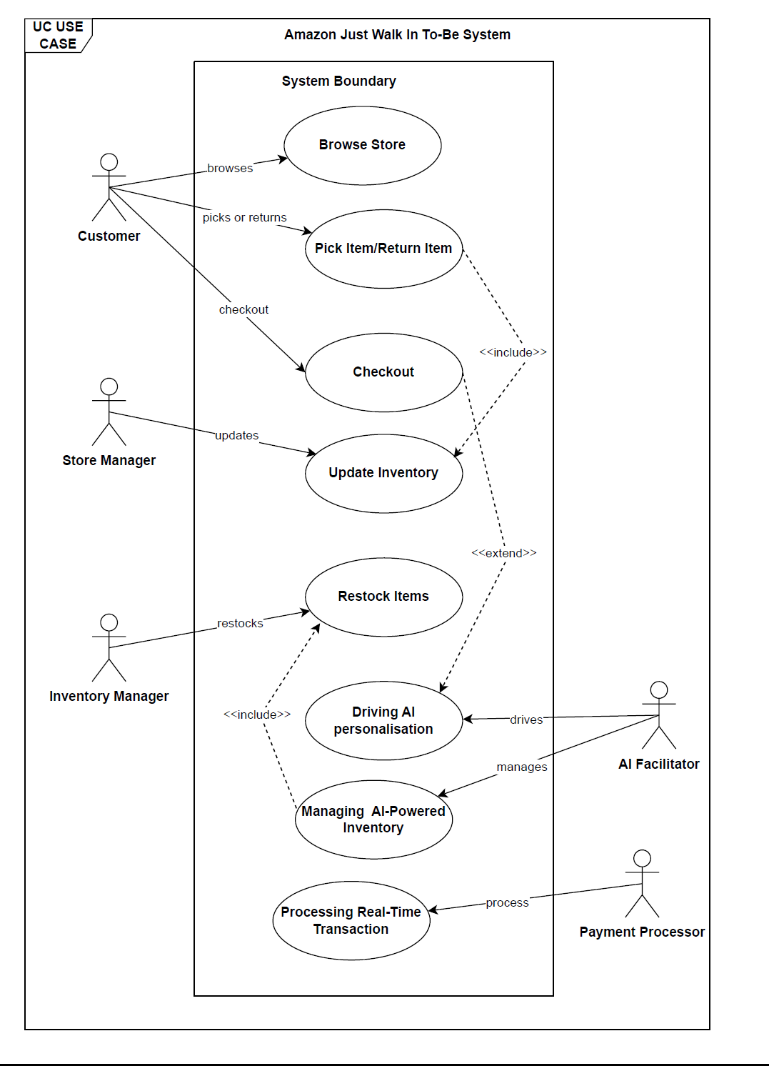

6. Data Flow Diagram

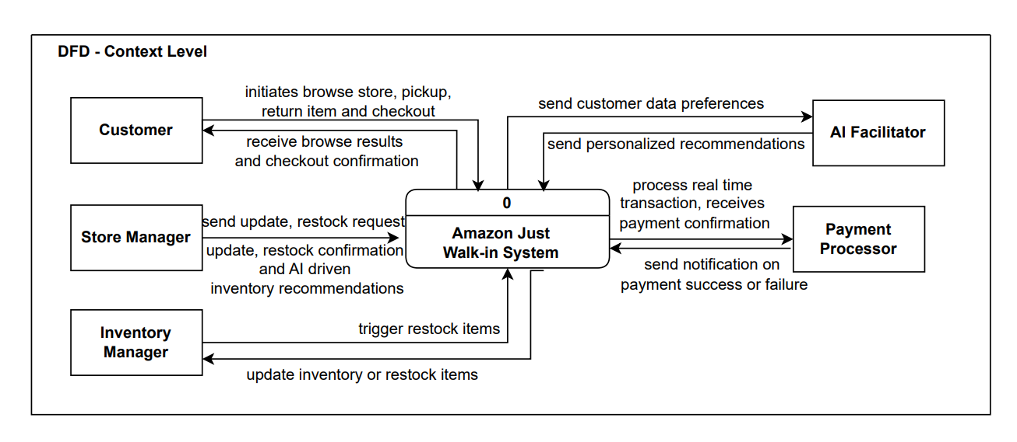

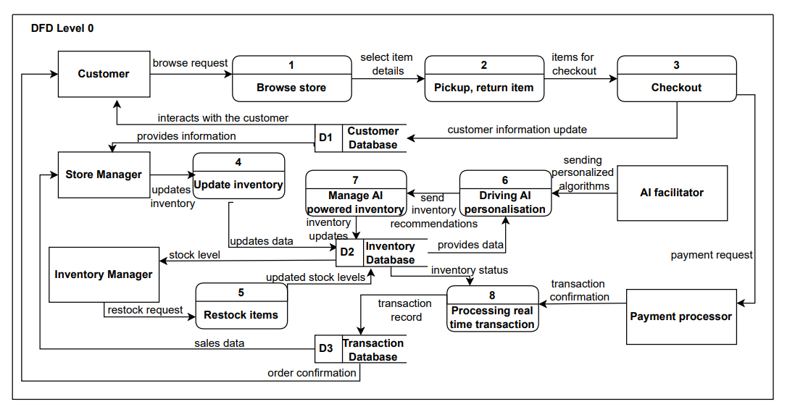

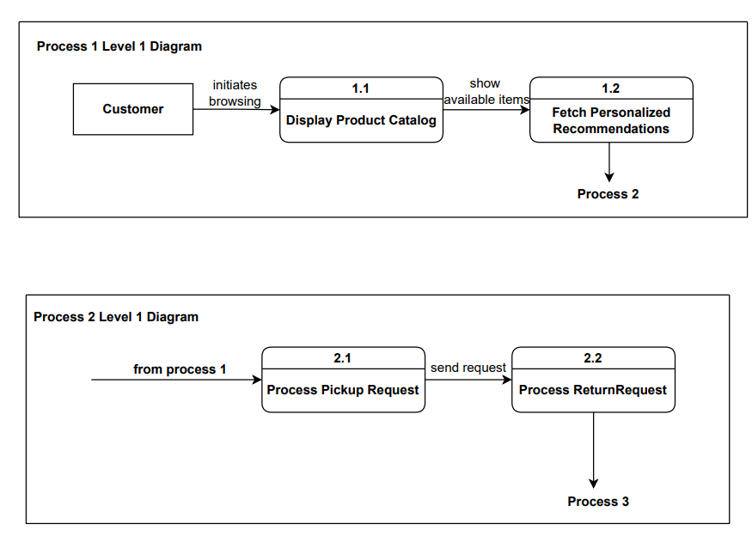

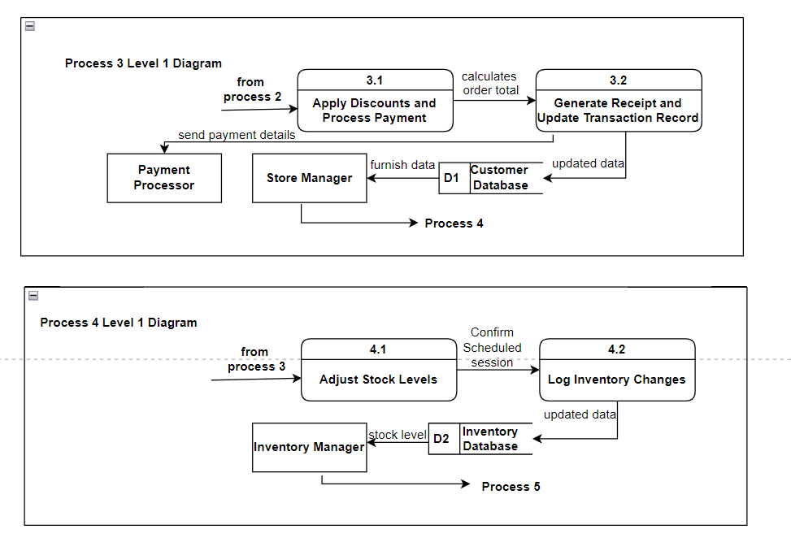

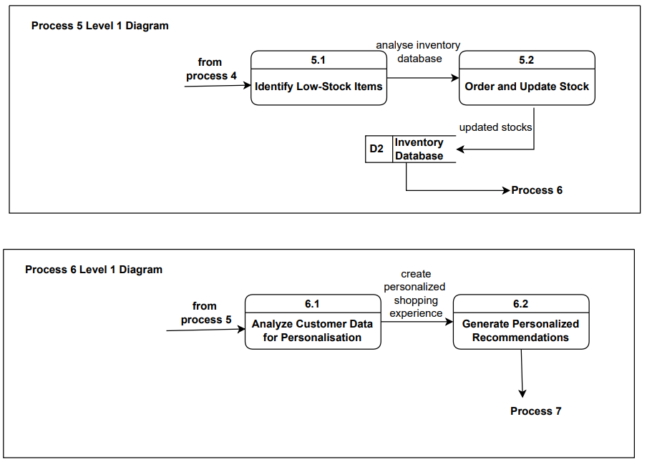

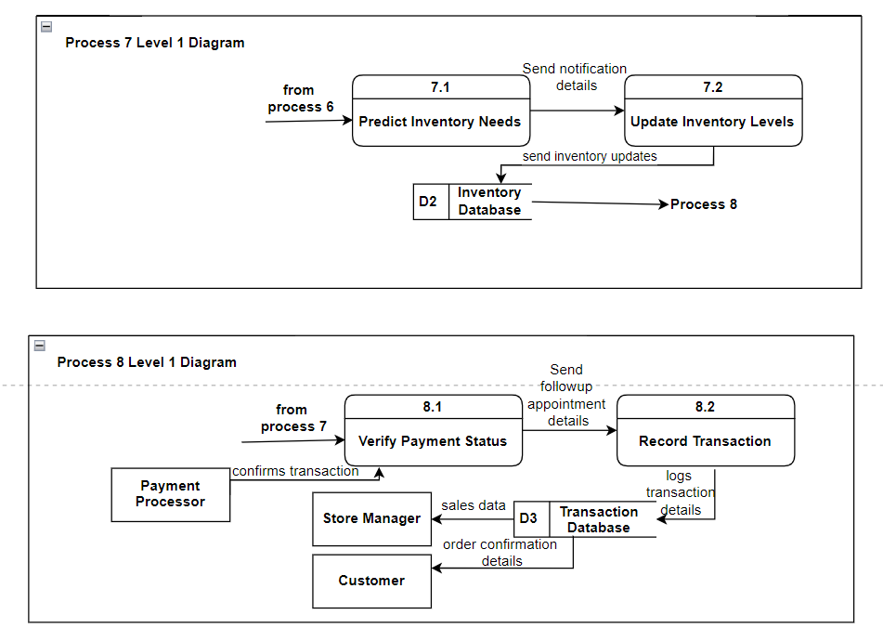

7. Entity Relationship Diagram

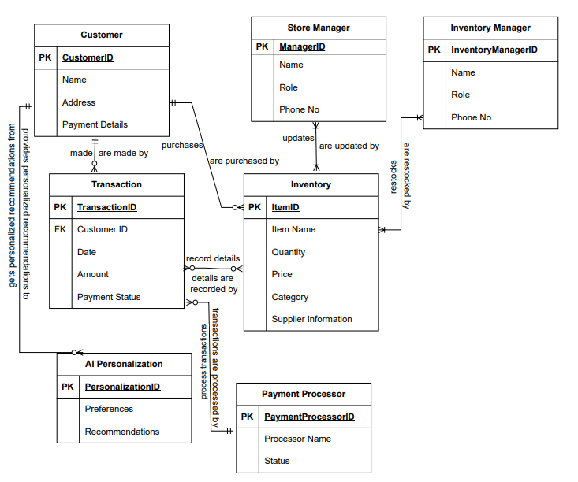

8. Design Acquisition Strategy

Acquisition Strategy Design

Description of Acquisition Strategy: Using acquisition as a basis, Amazon focuses on "Just Walk Out," aiming for cutting-edge technology with the interests of the customer and sustainability to the organization. Amazon will consider new or alternative ways of how to enhance the "Just Walk Out" system in terms of scalability, cost-effectiveness, and personalization. With respect to its feasibility, cost, and synergy to the strategy of long-term business objectives, all options will be evaluated.

Alternative Matrix
Criteria | Cloud-Based System Expansion | Mobile-Driven Checkout System | Next Generation AI and Sensor Integration
Solution Description | Expand AWS-based system for real-time inventory management, AI, and scaling without physical hardware. | Implement mobile-driven checkout system to reduce in-store hardware and improve flexibility. | Leverage advanced AI and sensors for customer behavior tracking, preference monitoring, and stock management.
Cost | Lower long-term costs (AWS scalability reduces need for hardware). | Lower hardware costs but depends on mobile adoption by customers. | High initial costs for advanced AI and sensor technology.
Scalability | Highly scalable through cloud architecture. | Scalable but limited by customer mobile device compatibility. | Scalability limited by the cost and complexity of AI/sensor integration.
Technical Feasibility | Leverages existing AWS infrastructure, easy to implement for Amazon. | Feasible with Amazon's current mobile app infrastructure. | Complex due to advanced AI and sensor integration, requiring custom development.
Operational Impact | Minimal disruption, existing staff can adapt to cloud integration. | May require training for customers, no major operational changes. | Significant change in store operations, new hardware required.
Customer Experience | Seamless, cloud-based improvements, real-time data for better customer insights. | Customer convenience, enables checkout flexibility with mobile devices. | Enhances personalized shopping experiences but may need more customer adaptation.
Timeline | Moderate, AWS systems can be expanded within months. | Quick to implement as it integrates with current mobile infrastructure. | Longer due to complexity of AI and sensor integration.
Risk Factors | Low risk; AWS infrastructure is stable and proven. | Moderate risk; mobile app adoption rates may vary. | High risk; AI models may require fine-tuning, sensor tech may be costly.
Organizational Fit | Strong fit with Amazon's cloud-first strategy and data-driven operations. | Aligns well with Amazon's mobile-driven innovation. | Aligns with Amazon’s vision of AI/automation but requires significant investment.

9. Architecture Design
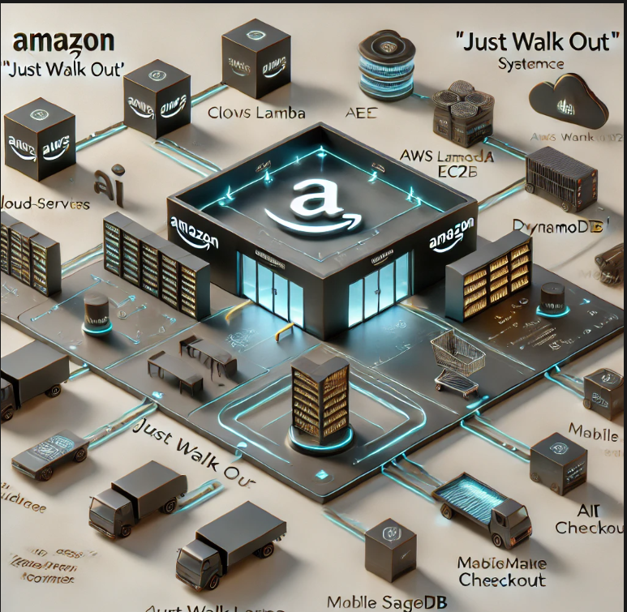
Here is the architectural flow diagram for the advanced "Just Walk Out" system, integrating services that are cloud-based, AI and machine learning, a mobile checkout, and IoT sensors enabling the tracking of customer behavior, focusing on scalability and security.
Architecture Specification for "Just Walk Out" System Enhancement
The improved architecture makes priorities out of scalability, inventory management, and customer experience with the "Just Walk Out" system of Amazon using cloud technology, AI, and mobile-driven solutions.

Architecture Specification Documents
Main components:
- Cloud Services: AWS has a solution that uses Lambda, EC2, and DynamoDB in handling real-time inventory and customer data to handle scalability and efficient stock management.
- AI & Machine Learning: Integrated AI (SageMaker) will help analyze real-time customer behavior and provide them with customized shopping experiences as well as optimize stock predictions.
- Mobile-Driven Checkout: Immediate checkout through Amazon app entirely eliminates the need for in-store equipment.
- IoT Sensors: Controls the movement of product and interactions of customer through better inventory management and customer insights.
System Flow:
- The behavior of the customers is tracked by the IoT sensors.
- AI engine directs this to analyze through proper behavior, the recommendations are given as per requirement.
- Checkout can be carried out through the mobile app directly without the dependency on in-store hardware.
- Real-time updates of the cloud-based update inventory through automation of the stock management.
- Predictive analytics in enhancing the efficacy of the supply chain and demand forecasting.
Scalability & Security
- Cloud Architecture: Scalable across multiple stores with minimal hardware costs.
- Security: Data encryption, privacy compliance, and multi-level access control protect customer data.
Overall, this design helps to increase efficiency of operation, higher customer satisfaction, and better scalability for the future.

10. User Interface Design

Login Screen

In the login screen, users - be it store managers, employees, or customers can access their accounts to use all the features of the system. Upon submission, the user clicks on the login button that allows him to enter the system. Sign up enables new users to create an account.
Main Dashboard


This main dashboard provides views on all the key metrics and activities that are involved with the store, as well as functionality of the system. Using the navigation buttons will allow access to specific modules, such as those listed below - Store Performance, Customer Data, Inventory, and Predictive Analytics.

Inventory Management Screen
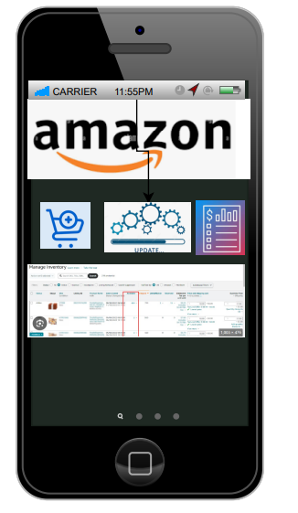

From the above, the inventory management screen, which allows the user to track the real-time stock levels, update the information of the stock, and even add new products, thus automatically syncing with the cloud-based infrastructure of Amazon to ensure that the data is up-to-date.

AI Profiling Screen



The AI profiling screen shows insight into how customers behave, which is inferred from sensors and AI algorithms. It gives further insight into how customers are using the products so far that have led to the customization of marketing strategies and improved customer experience.

Mobile Checkout Screen

The mobile checkout screen allows shoppers to scan the products they want to buy using their mobile phones. This frees up a smooth payment process from the traditional tills, thus allowing shoppers to make purchases easily.

Real-Time Analytics Screen

The real-time analytics screen lets visibility into consumer preferences and sales trends as well as inventory requirements. It utilizes predictive analytics to ensure that stores will have just the right amount of stock and can also make predictions regarding future requirements much better.

Store Settings Screen



The store settings screen is where administrators may configure all sensor settings, AI profiling, and other store-specific settings. This enables a tailor-made setup for every store with the system working optimally in a given retail environment.

11. Data Storage Design with appropriate data types
Entity | Attributes | Data Type | Description
Customer | CustomerID (PK) | INT | Unique identifier for each customer.
 | Name | VARCHAR(100) | Stores customer name.
 | Address | VARCHAR(255) | Stores customer address.
 | Payment Details | VARCHAR(50) | Stores masked payment details like credit card last digits or payment method.
Transaction | TransactionID (PK) | INT | Unique identifier for each transaction.
 | CustomerID (FK) | INT | Foreign key linking to the CustomerID.
 | Date | DATETIME | Stores the date and time of the transaction.
 | Amount | DECIMAL(10, 2) | Stores the total transaction amount with two decimal places for precision.
 | Payment Status | VARCHAR(20) | Stores the status of the payment (e.g., 'Completed', 'Pending', 'Failed').
Inventory | ItemID (PK) | INT | Unique identifier for each inventory item.
 | Item Name | VARCHAR(150) | Stores the name of the item.
 | Quantity | INT | Stores the available quantity of the item in stock.
 | Price | DECIMAL(10, 2) | Stores the price of the item with two decimal places.
 | Category | VARCHAR(100) | Stores the category of the item (e.g., 'Electronics', 'Groceries').
 | Supplier Information | VARCHAR(255) | Stores information about the supplier.
Store Manager | ManagerID (PK) | INT | Unique identifier for each store manager.
 | Name | VARCHAR(100) | Stores the name of the store manager.
 | Role | VARCHAR(50) | Stores the role of the store manager (e.g., 'Inventory Manager').
 | Phone Number | VARCHAR(15) | Stores the contact phone number of the manager.
Inventory Manager | InventoryManagerID (PK) | INT | Unique identifier for each inventory manager.
 | Name | VARCHAR(100) | Stores the name of the inventory manager.
 | Role | VARCHAR(50) | Stores the role of the inventory manager.
 | Phone Number | VARCHAR(15) | Stores the contact phone number of the inventory manager.
AI Personalization | PersonalizationID (PK) | INT | Unique identifier for personalization records.
 | Preferences | VARCHAR(255) | Stores customer preferences (e.g., product types or categories).
 | Recommendations | VARCHAR(255) | Stores personalized product recommendations for customers.
Payment Processor | PaymentProcessorID (PK) | INT | Unique identifier for each payment processor.
 | Processor Name | VARCHAR(100) | Stores the name of the payment processor (e.g., 'PayPal', 'Stripe').
 | Status | VARCHAR(20) | Stores the status of the payment processor (e.g., 'Active', 'Inactive').

Description of how our ERDs support our plan
The ERD is a central aspect of the data design plan because it indicates how various entities involved in the system are related and how data is structured. This will effectively allow for storing, retrieving, and managing the data.
- It links the Customer table to the Transaction table using an identifier named CustomerID so that all the purchases made can be traced appropriately. Thus, the AI gets motivated to provide the customer with personalized recommendations. It also reduces redundancy further by maintaining such data separate from the transaction details of the customer as the principles of normalization demand it.
- The Transaction table captures such important information as Amount, Payment Status, and links both Customer and Payment Processor entities to ensure accurate and secured payment processing.
- The Inventory table regulates product information and thus is associated with Store Managers and Inventory Managers to ensure timely updates on stock.
- This structure will, thus support inventory control and effective management.
- AI Personalization relies on transaction history when shopping to give personal experiences. This consequently depends on the good data relationships established in the ERD.
By being relational, the ERD supports data normalization, referential integrity, and scalability so as to ensure the system's efficiency and security as well as its capability to expand into the future.

12. Implementation & Transition Plan

Implementation Plan
Phase 1: Pilot Launch
- Sites: Identified three pilot stores in different locations.
- Configuration: Established newer sensors, cameras, and cloud-based inventory management systems.
- Testing: Conducted intense stress tests for checking scalability and reliability of the system.
- Result: All the pilot stores reported successful integration with minimal disturbance.
Phase 2: System Integration
- Cloud Solution: Integrated AWS services, including Lambda, EC2, and DynamoDB, to enable real-time data analytics and inventory tracking.
- API Deployment: Set up secure data pipelines to enable smooth communication between in-store systems and cloud infrastructure.
Phase 3: Feedback and Optimization.
- Feedback Collection: They began collecting insights from store managers and customers.
- Optimization: They mitigated minor bottlenecks like camera coverage adjustments and accuracy of AI profiling.
Phase 4: Gradual Expansion.
- Progress: It expanded to 25% of the Amazon Go stores within three months; at six months it had a 100% rollout.
- Monitoring: Served as a watchdog on the system uptime, transaction success rate, and data throughput.
Phase 5: Full Deployment
- Improvements: Included mobile checkout integration for customer convenience.
- Advanced Analytics: Rolled out predictive tools for real-time inventory forecasting and supply chain management.

Risk analysis and mitigation plans

Risk Analysis and Mitigation Plan for "Just Walk Out" Technology Expansion Project
Risk Categories and Analysis
Risk | Description | Impact | Likelihood | Priority
Technical Failures | System glitches, sensor inaccuracies, or downtime impacting the user experience. | High | Moderate | High
Data Privacy and Security Risks | Breach of sensitive customer data or inventory analytics. | High | Moderate | High
Operational Challenges | Delays in integrating new systems with existing store operations. | Moderate | Moderate | Medium
Cost Overruns | Unexpected expenses due to hardware or software issues. | Moderate | Low | Medium
Employee Resistance to Change | Staff reluctance to adopt new processes or perceived fear of redundancy. | Moderate | High | High
Customer Resistance or Misuse | Customers unfamiliar with or mistrusting the new technology may misuse the system. | Moderate | Low | Medium
Regulatory and Compliance Issues | Violations of local data laws or operational requirements in certain regions. | High | Low | Medium
Scalability Issues | Difficulty in replicating the technology efficiently across multiple stores. | High | Moderate | High

Risk Mitigation Plans
Technical Failures
- Pilot extensively to test the system in order to identify and correct vulnerabilities.
- Software updates and hardware maintenance should be scheduled regularly.
- Data Privacy and Security Risks
- Sensitive data must be encrypted with strong encryption.
- Institute regular security audits and compliance measures such as GDPR or CCPA.
Operational Challenges
- Create a detailed project timeline with milestones.
- Stakeholders must be trained so that they understand how to live with the new system.
Cost Overruns
- There needs to be a contingency budget in case of unexpected expenses.
- Monitor expenses closely throughout every phase and keep them as low as possible.
Resistance from Employees
- Provide change management workshops to attain understanding and acceptance.
- Engage the employees openly and continuously to dispel fears.
Acceptance by Customers

- Maintain user-friendly interfaces for easy use.
- Provide in-store facilitation and support within the transition time.
Compliance Risks with Regulations
- Consult a lawyer and ensure state laws and regulations are abided by.
- Keep records updated to facilitate the regulatory inspections
Scale Risks
- Offer phased rollouts to test how scalable are a smaller part.
- Utilize cloud infrastructure to handle traffic spikes.
Unforeseen Challenges
- Institutionalize a feedback loop for continuous improvement.
- Flexibility in timelines and resource allocation to be open to adjusting them based on circumstances.

Transition Plan

1. Migration Plan
- Data Migration: Existing inventory and transaction data were migrated into the new cloud systems.
- System Downtime: Ensure operational continuity during any downtime events which will occur within a 2 hour window per store.

2. Training Employees
- Provide holistic training for the employees that focuses on troubleshooting and system care at the shop level.
- Enable digital learning modules to ensure similar understanding in all locations.

3. Motivating Employees
- Motivate employees through incentive programs for top performers during the transition.
- Organized town hall meetings to discuss issues and spotlight the advantages of the new approach.

Forecast and maintenance:
Growth and flexibility
- The cloud-based architecture (AWS services like EC2 and DynamoDB) is ready for scaling as new stores accrue customers, increasing the volume of customer data and transactions.
- Future international markets can be scaled with little to no modifications to the architecture.
Modular Approach:
- The sensor and AI system is modular and can be upgraded incrementally without the necessity of shutting down the stores.
- This will make it easier to accommodate new technological breakthroughs, be it improvements to AI algorithms or new hardware.
Dynamic Inventory Systems:
- Real-time analytics are used to easily adapt and change inventories to customer demand. This improves supply chain management in the event of changing seasons or unexpected increases in demand.

Budget

Category | Estimated Budget | Actual Budget | Variance | % Under Estimate
Development Costs
AI Integration | $600,000 | $550,000 | -$50,000 | -8%
Sensor Hardware Upgrades | $450,000 | $430,000 | -$20,000 | -4%
Mobile Checkout Features | $250,000 | $230,000 | -$20,000 | -8%
Operational Costs
Cloud Infrastructure | $350,000 | $320,000 | -$30,000 | -9%
Staff Training & Support | $100,000 | $90,000 | -$10,000 | -10%
Marketing Campaign | $200,000 | $180,000 | -$20,000 | -10%
Maintenance Costs
Regular Software Updates | $120,000 | $110,000 | -$10,000 | -8%
Bug Fixes & Patches | $80,000 | $75,000 | -$5,000 | -6%
Total | $2,150,000 | $1,985,000 | -$165,000 | -8%

- The total cost savings were also achieved 8 %below the budget prepared for this project.
- Areas of Efficiency: This actually saved on development and operation due to the optimized process.
- Future Allocation: Money saved can be reinvested back into expanding or refining related technologies.

Future Issues/Problems
System Vulnerabilities:
Data breaches or hacking remain a concern due to the sensitive customer and operational information being processed.
Hardware Aging:
Sensors and other physical parts could be replaced or calibrated periodically, which could cause downtime or higher costs.
AI Bias and Errors:
Misidentifications or biases in AI profiling tools can lead to customer dissatisfaction or inaccuracies in financial transactions.
Customer Resistance to Technology:
Some customers may have a preference for the older checkout options, which would limit adoption in those specific regions.
Regulatory Challenges:
- The increasingly strict regulations may apply to more advanced AI and autonomous systems, which could lead to higher compliance costs. Mitigation Approaches
- Establish Strong cybersecurity measures, including regular audits and swift incident response plans.
- Make investments in predictive maintenance tools to address hardware issues early on
- Continuously update AI models with new datasets to reduce biases and errors
- Provide hybrid checkout options that meet diverse customer choices.
- Stay updated on regulatory changes, trends to maintain a dedicated compliance team.

