REPORT
(Home Automation using Zigbee technology.)
Aim : To make a home automation prototype using NodeMCU ESP8266.
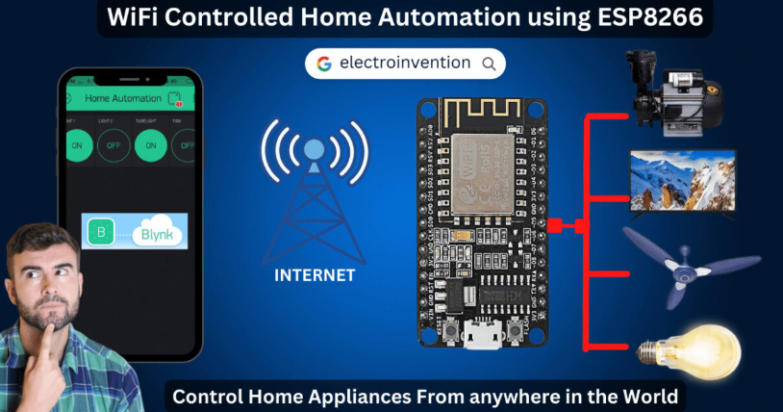
Apparatus :
. NodeMCU ESP8266 – 1
. 5V 4 Channel Relay Module – 1
. Female to Female jumper wire – 6
. Bulb holder , Bulbs– 4
. 2 pin – 1
. wires [as per requirement]
. Blynk Applications
. Screwdriver
Procedure :
- Gather Required Materials:
  - NodeMCU ESP8266: A low-cost Wi-Fi microcontroller used for IoT applications.
  - 5V 4-Channel Relay Module: Allows the microcontroller to control high-voltage devices
  - Female-to-Female Jumper Wires: For connecting components.
- Configure the Blynk App:
  - Download and install the Blynk app from the App Store or Google Play Store.
  - Create a new account or log in if you already have one.Start a new project by selecting the "+" icon.
  - Choose "NodeMCU" as the hardware model and set the connection type to Wi-Fi.
  - An authentication token will be sent to your registered email; note this for later use.
  - Design your project's user interface by adding widgets (e.g., buttons, sliders) corresponding to the devices you intend to control.
- Set Up the Hardware:
  - Connect the NodeMCU to the 4-channel relay module using jumper wires:
    - IN1 to D1
    - IN2 to D2
    - IN3 to D3
    - IN4 to D4
    - VCC to 3V3
    - GND to GND
  - Ensure that the relay module's JD-VCC jumper is set correctly if it has one.
- Program the NodeMCU:
  - Install the Arduino IDE on your computer and add the ESP8266 board support.
  - Install the Blynk library within the Arduino IDE.
  - Open a new sketch and include the necessary libraries:
  - Enter your Wi-Fi credentials and the Blynk authentication token
  - Define the relay pins
  - In the setup() function, initialize the serial communication, Blynk, and set the relay pins as outputs
  - Create Blynk virtual pin functions to control the relays
  - Repeat for other relays with V2, V3, V4
  - Upload the code to the NodeMCU.
- Operate the System:
  - Open the Blynk app and start the project.
  - Use the app's interface to control the relays, thereby managing connected appliances.
Code :
// wifi controlled home automation using Blynk App & ESP8266
#define BLYNK_TEMPLATE_ID "YourTemplateId" //blynk template ID
#define BLYNK_TEMPLATE_NAME "YourTemplateName " //blynk template name
#define BLYNK_AUTH_TOKEN "4ANo-vG6TpPOvyXdbZgxBBLCVz976NmB" // enter your blynk auth token

#define BLYNK_PRINT Serial
#include <gpio.h>
#include <ESP8266WiFi.h>
#include <BlynkSimpleEsp8266.h>

char auth[] = BLYNK_AUTH_TOKEN;

char ssid[] = "YouWifiName"; // Your Wifi Name
char pass[] = "YourWifiPasword"; // Your Wifi Password

//in the below code, we have set all values reverse
//For value==1, digitalWrite is "LOW" as the realy module is active "LOW" to turn device ON.
//For value==0, digitalWrite is "HIGH" as Optocoupler based relay is turned OFF when HIGH Input is given
BLYNK_WRITE(V1)
{
int value = param.asInt();
Serial.println(value);
if(value == 1)
{
digitalWrite(D0, LOW);
Serial.println("LED ON"); //Setting Digital PIN as LOW to turn ON Device if relay module is "active low"
}
if(value == 0)
{
digitalWrite(D0, HIGH);
Serial.println("LED OFF");//Setting Digital PIN as HIGH to turn OFF Device if relay module is "active low"
}
}

BLYNK_WRITE(V2)
{
int value = param.asInt();
Serial.println(value);
if(value == 1)
{
digitalWrite(D1, LOW);
Serial.println("LED ON");
}
if(value == 0)
{
digitalWrite(D1, HIGH);
Serial.println("LED OFF");
}
}

BLYNK_WRITE(V3)
{
int value = param.asInt();
Serial.println(value);
if(value == 1)
{
digitalWrite(D2, LOW);
Serial.println("LED ON");
}
if(value == 0)
{
digitalWrite(D2, HIGH);
Serial.println("LED OFF");
}
}

BLYNK_WRITE(V4)
{
int value = param.asInt();
Serial.println(value);
if(value == 1)
{
digitalWrite(D3, LOW);
Serial.println("LED ON");
}
if(value == 0)
{
digitalWrite(D3, HIGH);
Serial.println("LED OFF");
}
}

void setup()
{
Serial.begin(115200);
Blynk.begin(auth, ssid, pass);
pinMode(D0,OUTPUT); //GPIO 16 (equivalent to PIN 16 of Arduino)
pinMode(D1,OUTPUT); //GPIO 05 (equivalent to PIN 05 of Arduino)
pinMode(D2,OUTPUT);//GPIO 04 (equivalent to PIN 16 of Arduino)
pinMode(D3,OUTPUT);//GPIO 00 (equivalent to PIN 00 of Arduino)
}

void loop() {
Blynk.run();
}
Circuit connection :
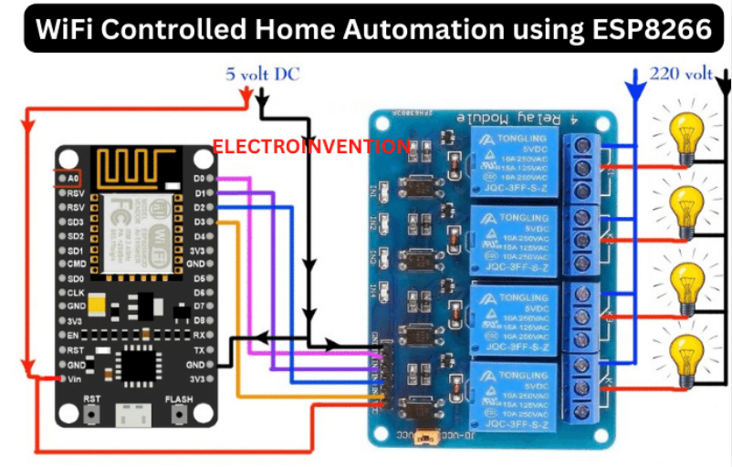

Results :
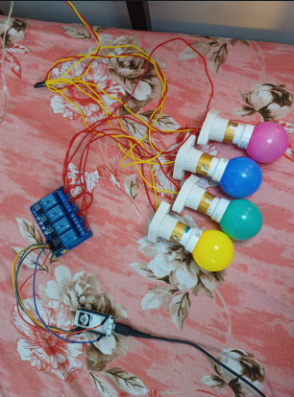
Before connecting to Blynk

After connection with Blynk application
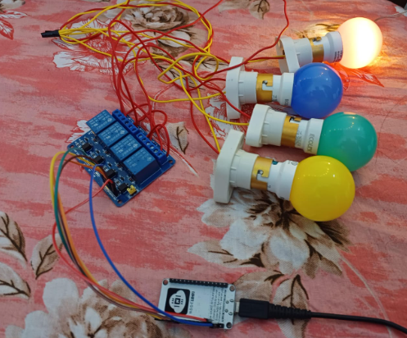

- Remote Control of Appliances :
  - Users can operate home appliances such as lights, fans, and televisions remotely via the Blynk app on their smartphones, enhancing convenience and energy efficiency.
- Manual and App-Based Operation:
  - The system supports both manual control through physical switches and remote control via the Blynk app, ensuring flexibility in managing appliances.
- Real-Time Feedback:
  - The Blynk app provides real-time status updates of connected appliances, displaying whether a device is currently on or off, which enhances user awareness and control.
- Operation Without Internet:
  - In the absence of an internet connection, appliances can still be controlled manually using physical switches, ensuring continuous functionality.
Challenges :
- Wi-Fi Connectivity Issues:
  - The system's reliance on Wi-Fi means that any instability or loss of connection can hinder remote control capabilities.
- Blynk Server Dependence:
  - Server downtime or maintenance can temporarily disrupt the system's functionality.
- Hardware Compatibility:
  - Mismatched voltage levels or incorrect wiring can lead to hardware malfunctions.
- Security Concerns:
  - Implementing secure authentication methods and regularly updating firmware can help protect against unauthorized access.
Conclusion :
The home automation project utilizing NodeMCU ESP8266 and the Blynk app enables users to remotely control household appliances via smartphones, enhancing convenience and energy efficiency. Additionally, it supports manual operation through physical switches, ensuring continuous functionality even without internet access.

