SWIFT TAGS

In this project we are scrapping YouTube server to find relevant tags for user input and for Instagram and Twitter we are using dataset to find relevant tags. This dataset contains more than 350000 tags and application will filter those dataset tags to get relevant top 10 tag suggestions. To run this project your system must be connected to INTERNET. Dataset also depends on internet to get tag details

SCREEN SHOTS

To run project double click on ‘run.bat’ file and to get below screen

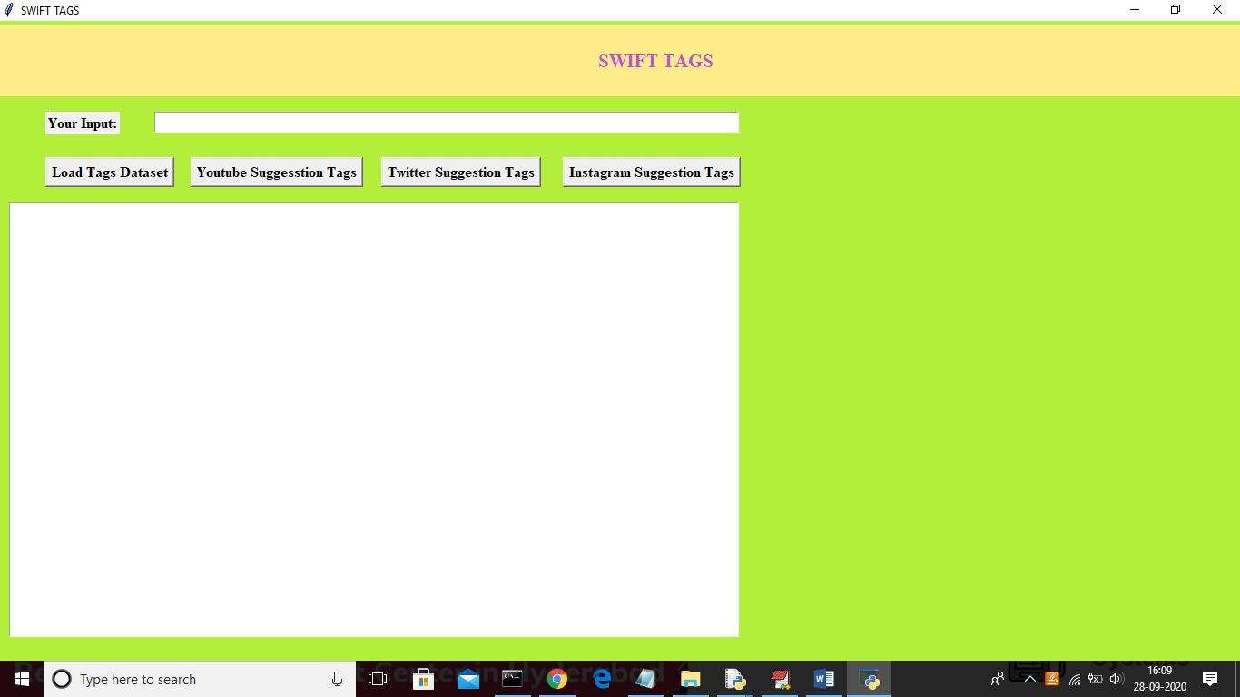

In above screen click on ‘Load Tags Dataset’ button to load dataset and this has click only one time while running, if you click this button multiple times in singe run then your system goes out of memory.

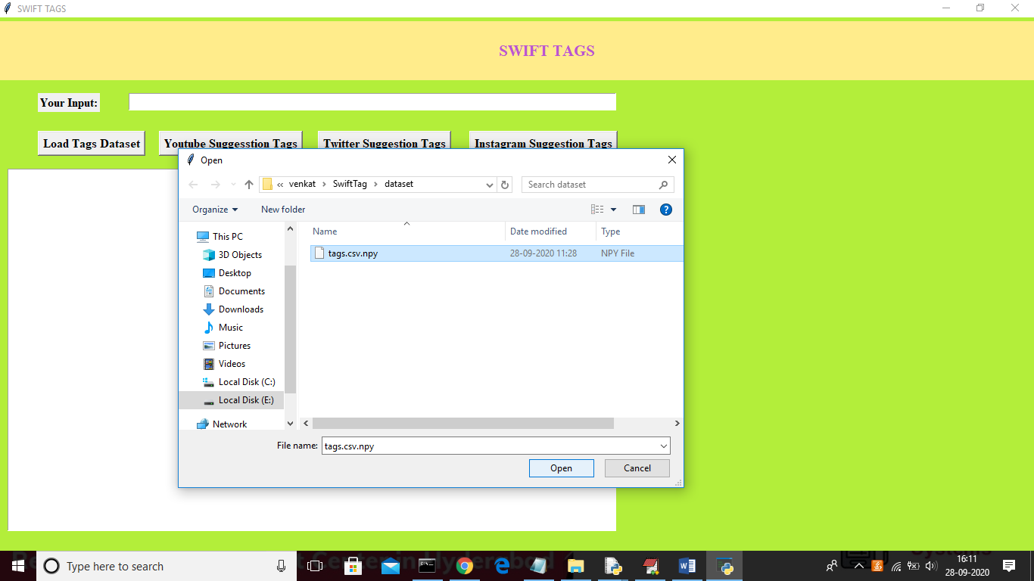

In above screen uploading tags.csv file and then click on ‘Open’ button to load dataset and to get below screen

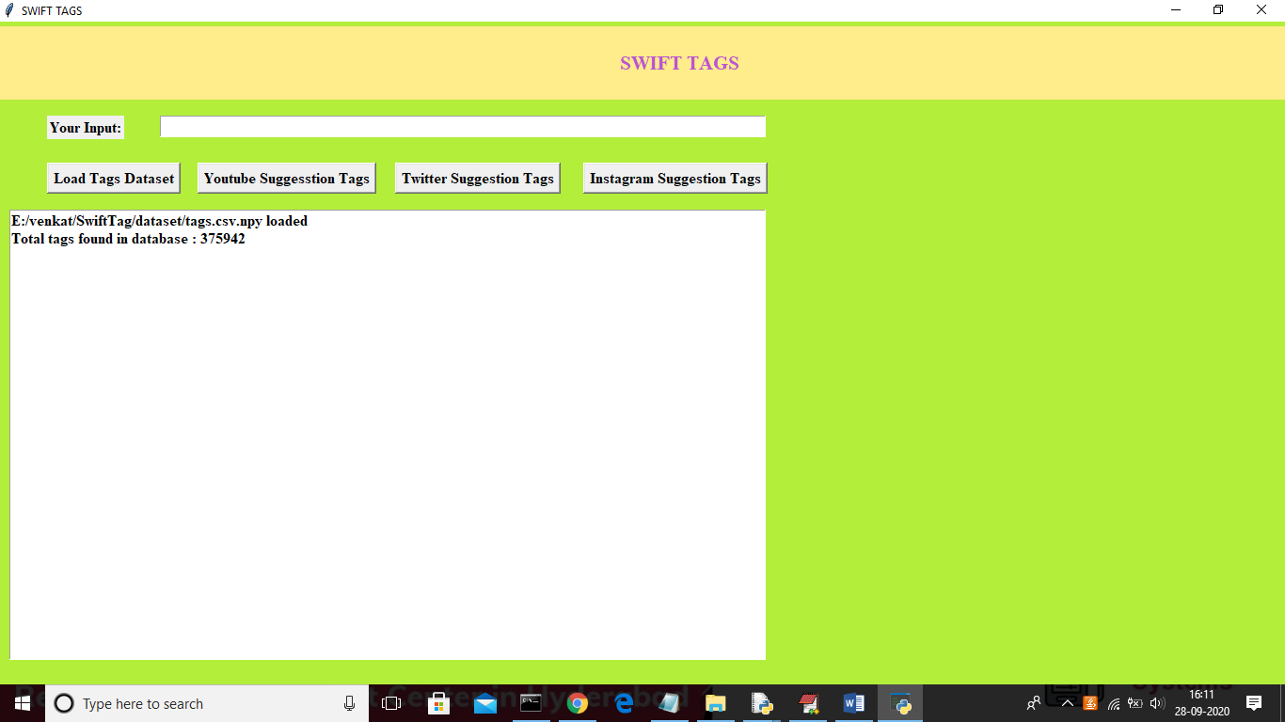

In above screen we can see total 3,75,942 tags found in dataset and now enter any keywords in text field and then click on ‘YouTube Suggestion Tags’ button to get top 10 relevant tags for given input

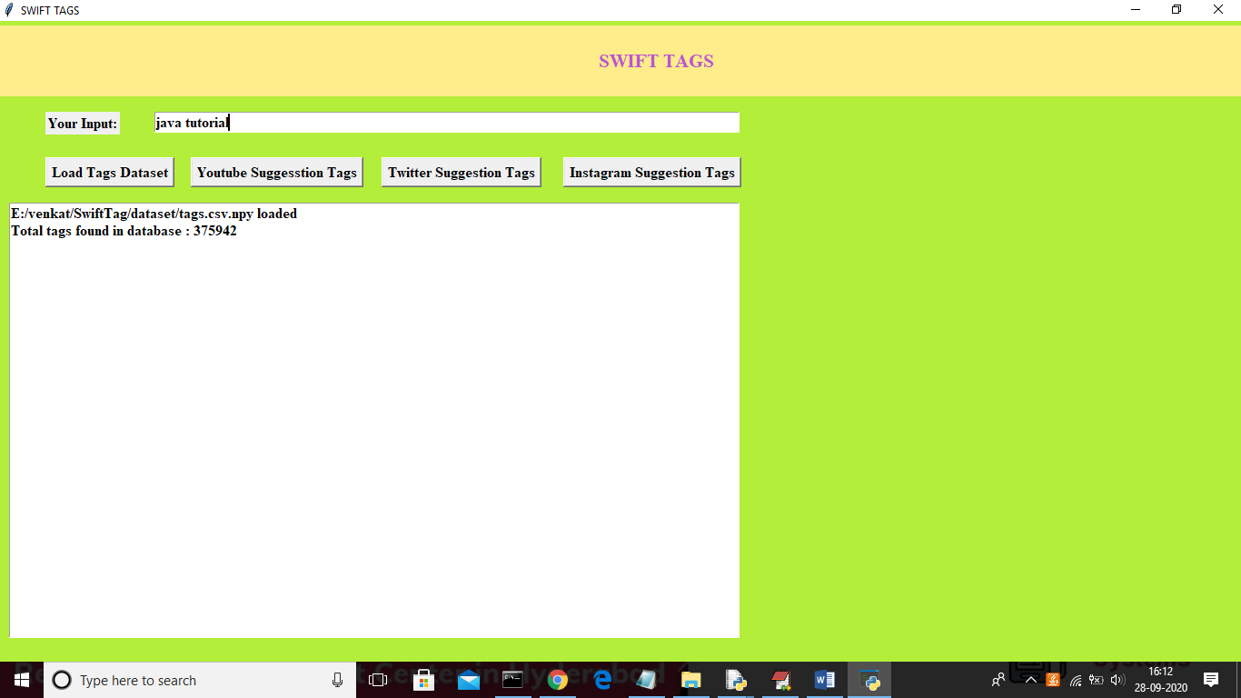

In above screen I gave input as ‘java tutorial’ and then click on ‘YouTube Suggestion Tags’ button to get below suggestions

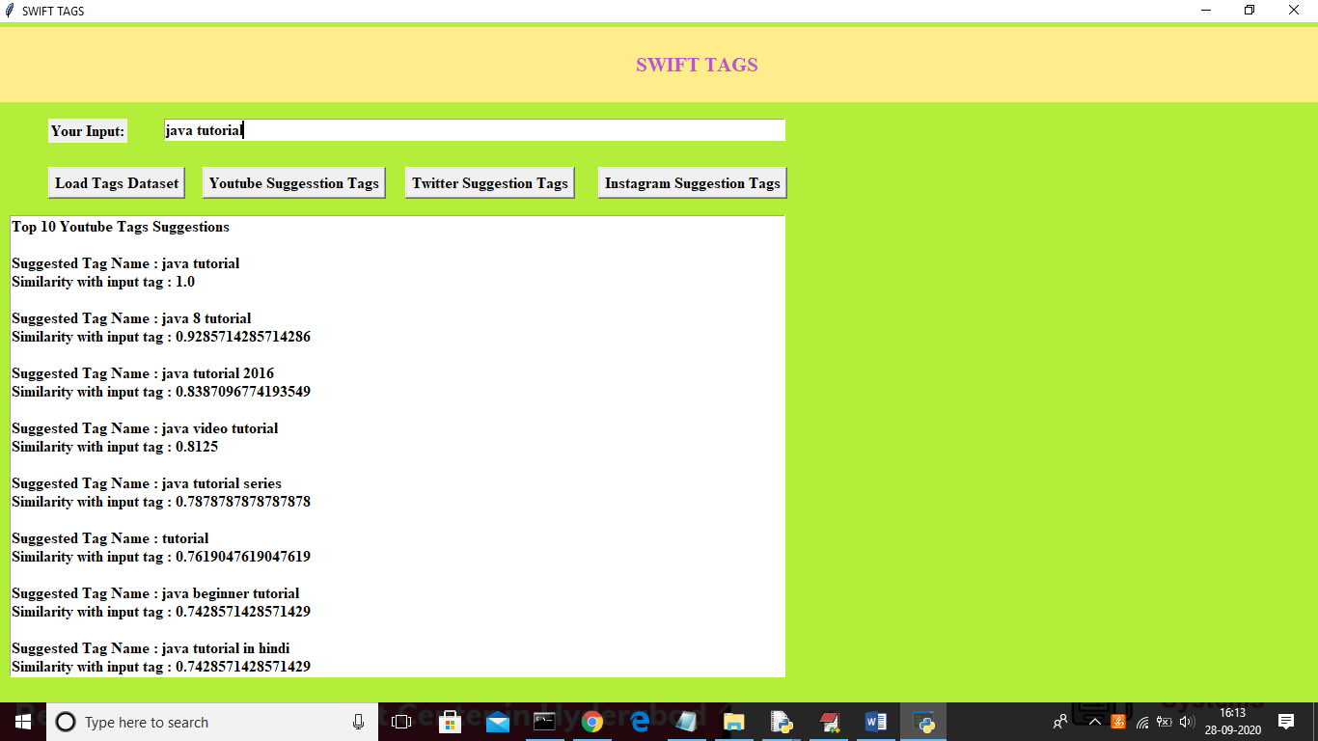

In above screen displaying 10 tag suggestion with tag name and similarity score between suggested tags and input query in descending order. Scroll down above text area to view all tags

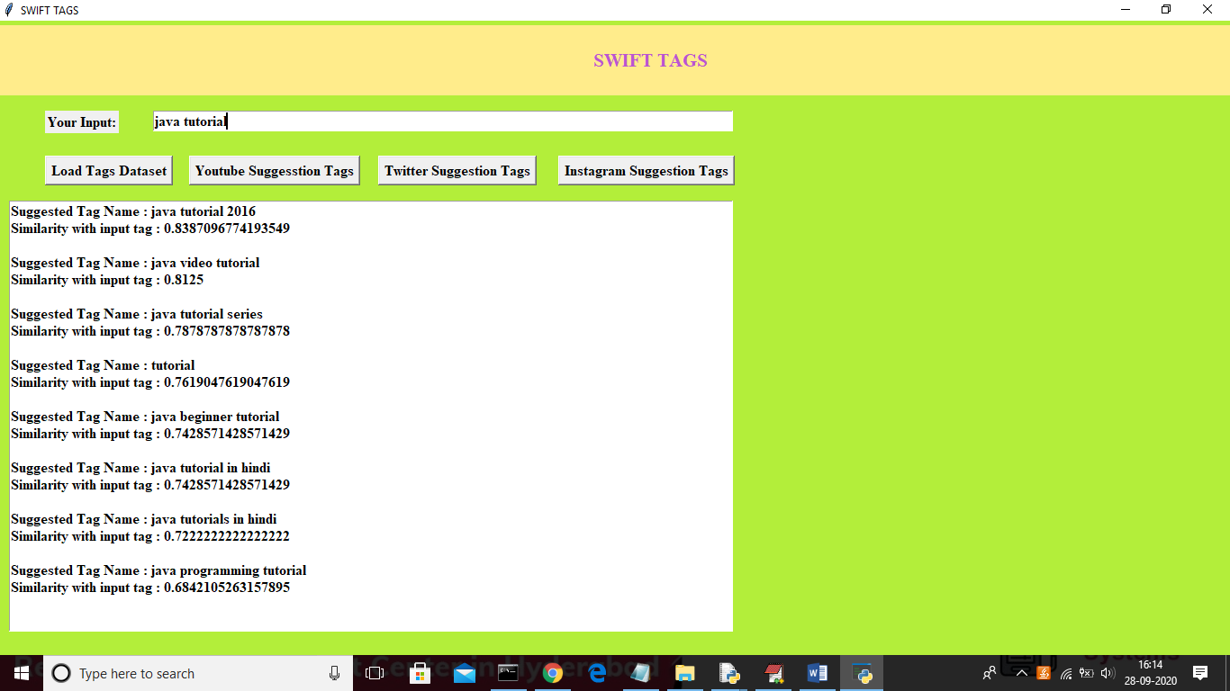

Now click on ‘Twitter Suggestion Tags’ button to get below tags screen

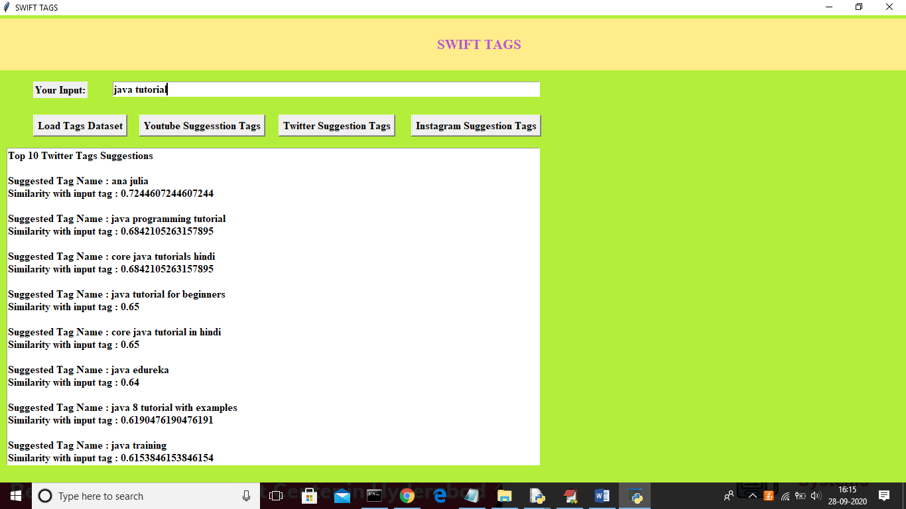

Now click on ‘Instagram Suggestion Tags’ button to get below details

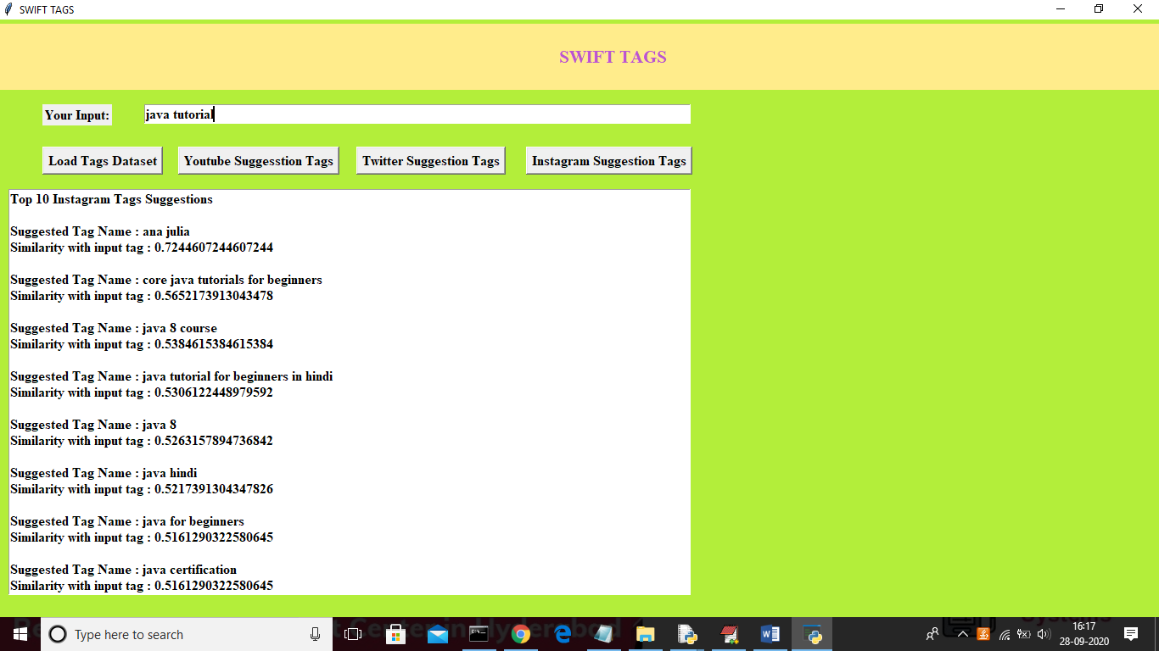

In above screens we can see tags generated for given input from various social media sites. Similarly you can give any input to get tags. See below screen with different input

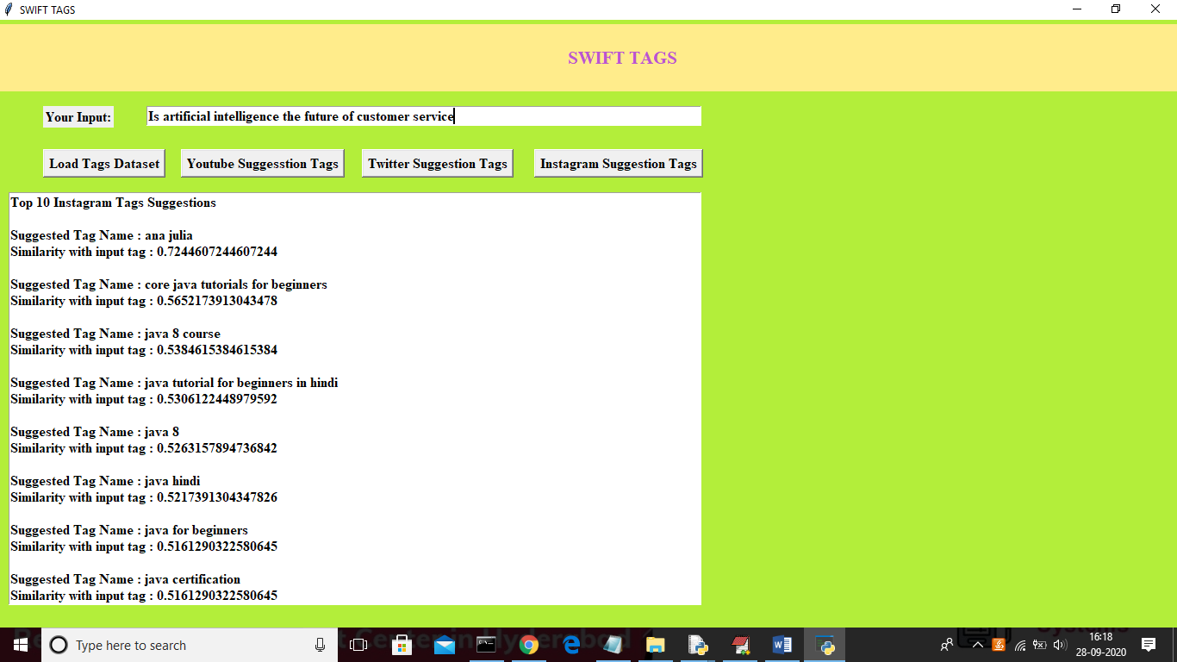

In above screen as input I gave sentence as ‘Is artificial intelligence the future of customer service’ and then click on ‘YouTube Suggestion Tags’ button to get below output. Below are the suggestion tags for given input

