Junit Basic Testing Exercises

# Exercise 1: SETTING UP JUNIT:

**Scenario:**

**You need to set up JUnit in your Java project to start writing unit tests.**

Steps:

1. Create a new Java project in your IDE (e.g., IntelliJ IDEA, Eclipse).

2. Add JUnit dependency to your project. If you are using Maven, add the following to your pom.xml:

<dependency>

<groupId>junit </groupId>

<artifactId>jupiter</artifactId>

<version>4.13.2</version>

<scope>test</scope>

</dependency>

3. Create a new test class in your project

## SOLUTION:

Step 1. Create or Open a **Maven Project**:

You can use an IDE like **IntelliJ IDEA**, **Eclipse**, or set it up manually.

Step 2. Click File-> New-> Maven Project (Click on create a simple project) Then write the name of group id and artifact id and then click on finish button.

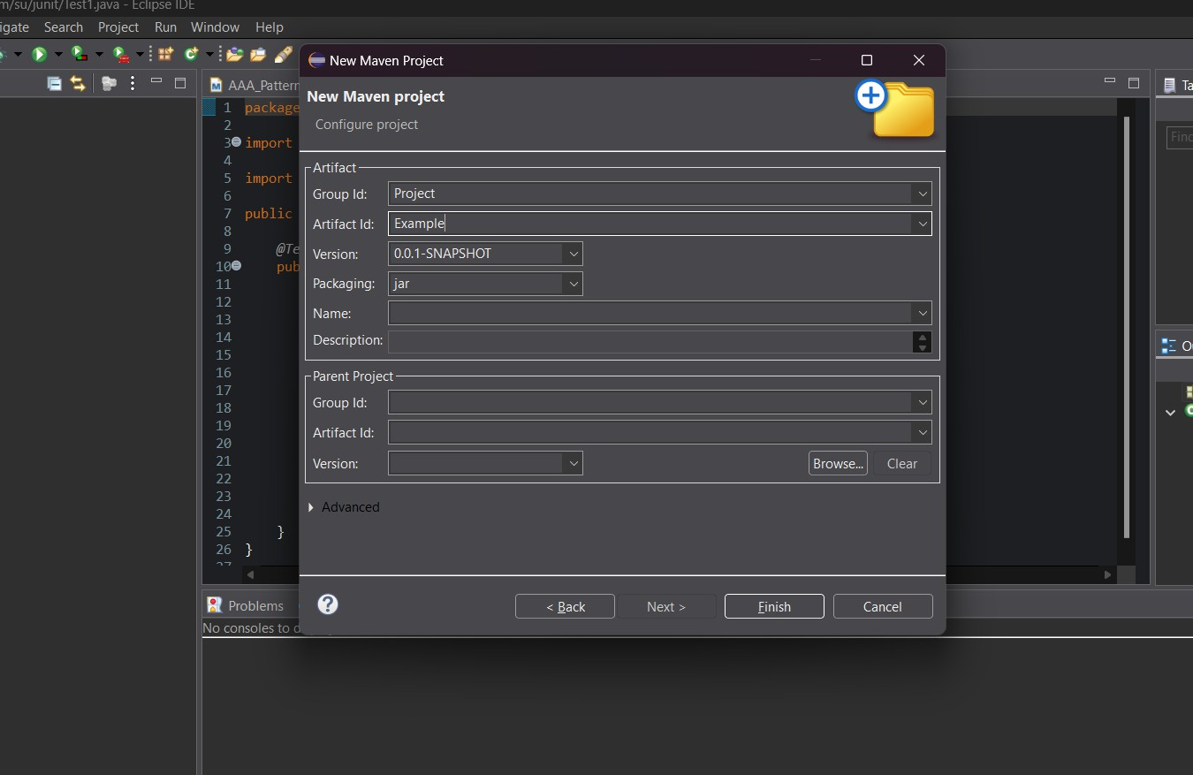

Step 3. Add **Junit Dependency** to your project. Add following to your **pom.xml** file:

**Pom.xml:**<project xmlns[="http://maven.apache.org/POM/4.0.0"](http://maven.apache.org/POM/4.0.0) xmlns:x[si="http://www.w3.org/2001/XMLSchema-instance"](http://www.w3.org/2001/XMLSchema-instance)

xsi:schemaLocati[on="http://maven.apache.org/POM/4.0.0](http://maven.apache.org/POM/4.0.0) https://maven.apache.org/xsd/maven- 4.0.0.xsd">

<modelVersion>4.0.0</modelVersion>

<groupId>Project</groupId>

<artifactId>Example</artifactId>

<version>0.0.1-SNAPSHOT</version>

<dependencies>

<!-- JUnit Jupiter (API + Engine) -->

<dependency>

<groupId>org.junit.jupiter</groupId>

<artifactId>junit-jupiter</artifactId>

<version>5.9.3</version>

<scope>test</scope>

</dependency>

</dependencies>

<build>

<plugins>

<!-- Correct Surefire Plugin version to support JUnit 5 -->

<plugin>

<groupId>org.apache.maven.plugins</groupId>

<artifactId>maven-surefire-plugin</artifactId>

<version>3.0.0-M9</version>

</plugin>

</plugins>

</build>

</project>

Then run this by maven test.

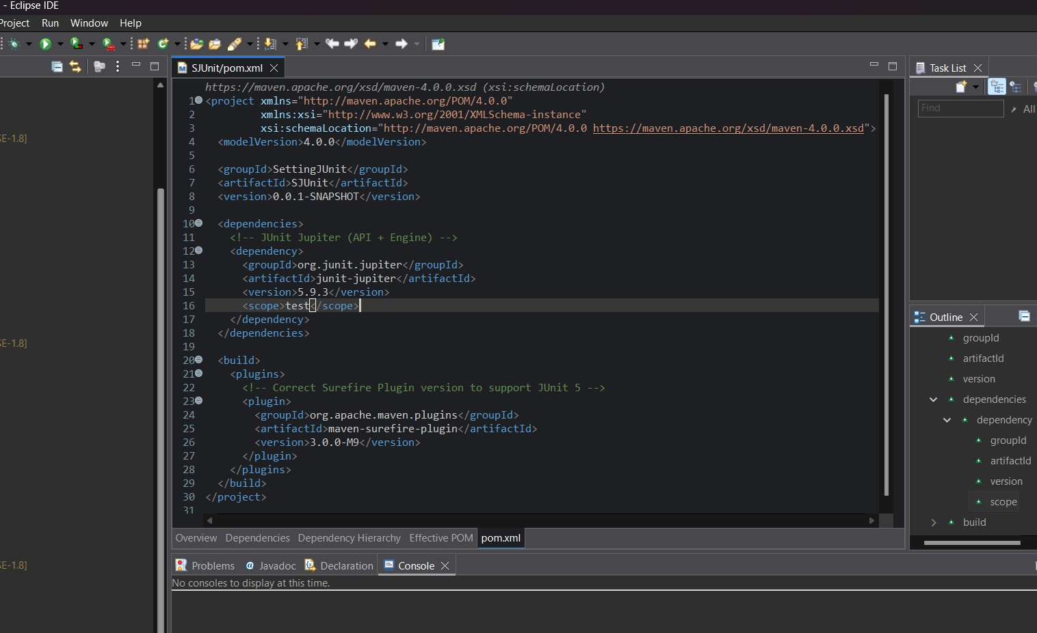

Step 4. Create your test classes in **src/test/java**. Write a sample test case:

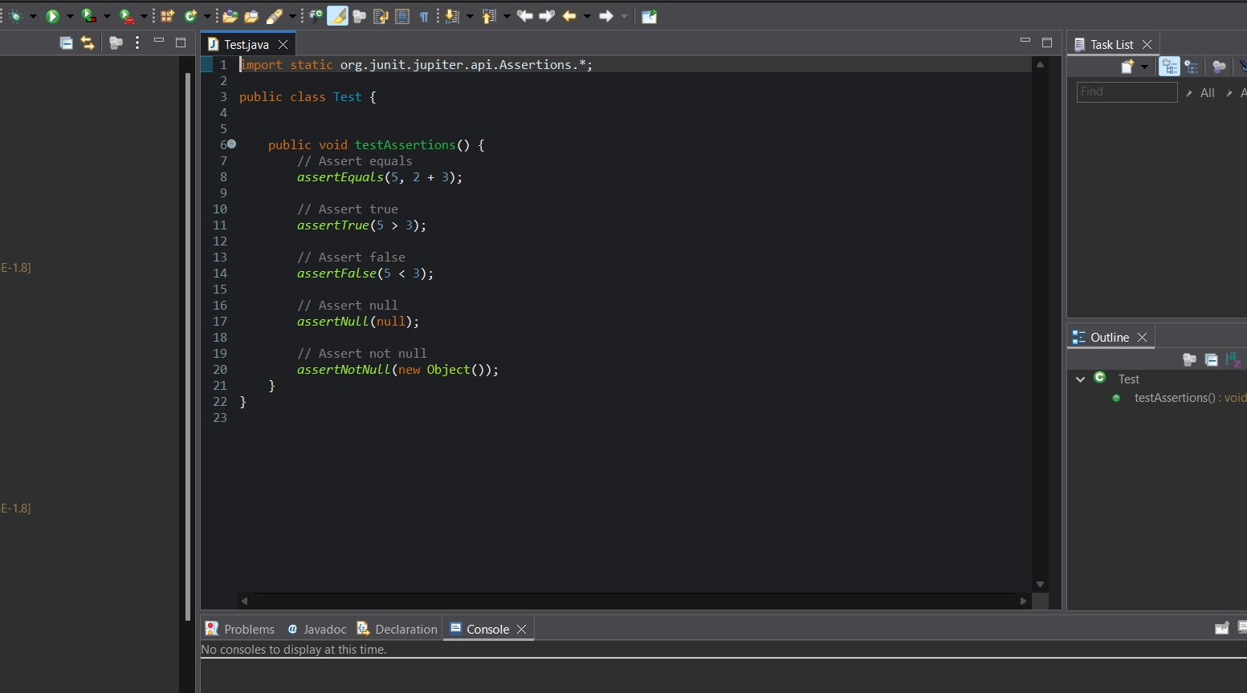

## CODE:

import static org.junit.jupiter.api.Assertions.*; public class Test {

public void testAssertions() {

assertEquals(5, 2 + 3);

assertTrue(5 > 3);

assertFalse(5 < 3);

assertNull(null);

assertNotNull(new Object());

}

}

Step 5. Then run the test class in **maven test** and then **Junit test** .

## OUTPUT:

**Maven Test:**

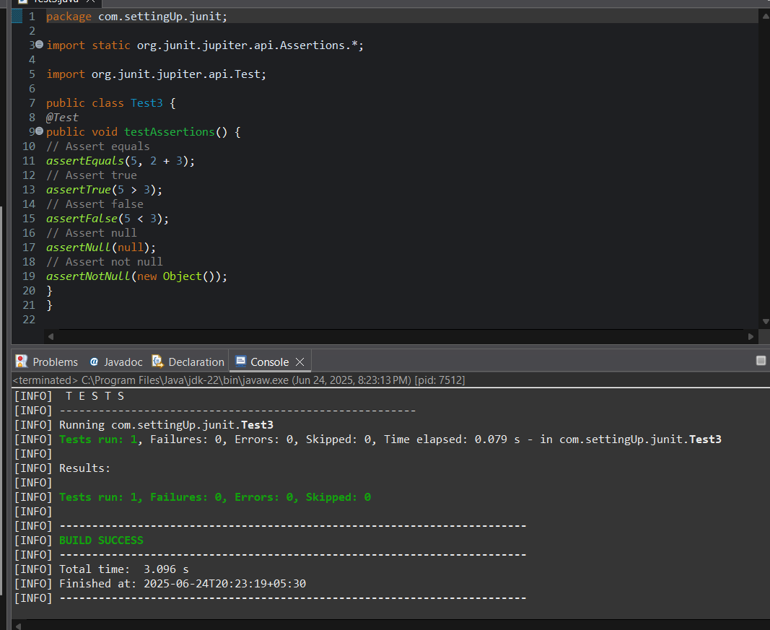

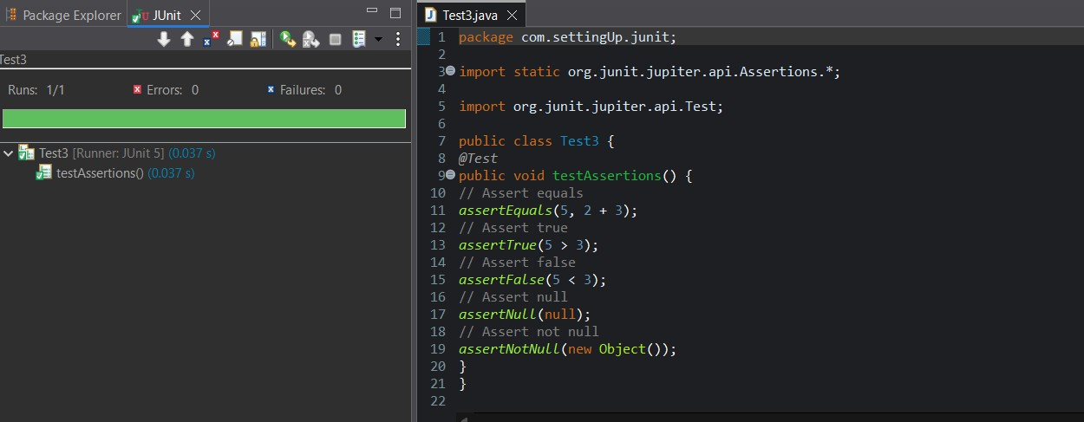**Junit Test:**

# Exercise 3: Assertions in Junit

**Scenario:**

**You need to use different assertions in JUnit to validate your test results**

Steps:

1. Write tests using various JUnit assertions. Solution Code:

public class Assertion {

@Test

public void testAssertions() {

// Assert equals

assertEquals(5, 2 + 3);

// Assert true

assertTrue(5 > 3);

// Assert false

assertFalse(5 < 3);

// Assert null

assertNull(null);

// Assert not null

assertNotNull(new Object());

}

}

## SOLUTION:

Step 1:Add the Junit Dependency in pom.xml

### pom.xml :

<project xmln[s="http://maven.apache.org/POM/4.0.0"](http://maven.apache.org/POM/4.0.0) xmlns:x[si="http://www.w3.org/2001/XMLSchema-instance"](http://www.w3.org/2001/XMLSchema-instance)

xsi:schemaLocati[on="http://maven.apache.org/POM/4.0.0](http://maven.apache.org/POM/4.0.0) https://maven.apache.org/xsd/maven- 4.0.0.xsd">

<modelVersion>4.0.0</modelVersion>

<groupId>sudeep</groupId>

<artifactId>AssertionInJUnit</artifactId>

<version>0.0.1-SNAPSHOT</version>

<dependencies>

<!-- JUnit Jupiter (API + Engine) -->

<dependency>

<groupId>org.junit.jupiter</groupId>

<artifactId>junit-jupiter</artifactId>

<version>5.9.3</version>

<scope>test</scope>

</dependency>

</dependencies>

<build>

<plugins>

<!-- Correct Surefire Plugin version to support JUnit 5 -->

<plugin>

<groupId>org.apache.maven.plugins</groupId>

<artifactId>maven-surefire-plugin</artifactId>

<version>3.0.0-M9</version>

</plugin>

</plugins>

</build>

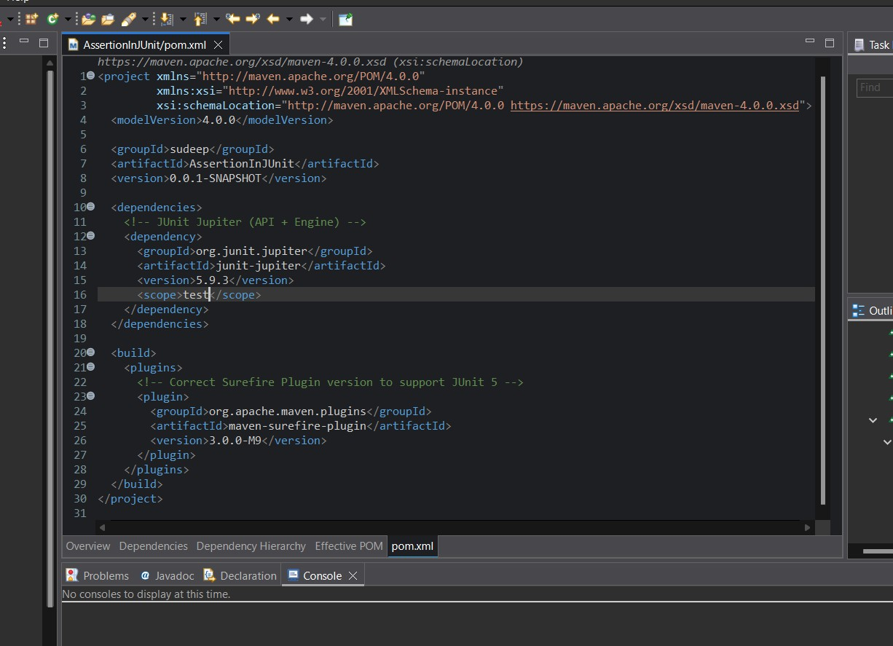</project>

Step 2: Create your test classes in **src/test/java**.

Write the required test case and run as maven test and Junit test:

**CODE:**

package com.AssertionInJUnit.junit; import org.junit.jupiter.api.Test;

import static org.junit.jupiter.api.Assertions.*; public class Assertion {

@Test

public void testAssertions() {

// Assert equals

assertEquals(5, 2 + 3);

// Assert true

assertTrue(5 > 3);

// Assert false

assertFalse(5 < 3);

// Assert null

assertNull(null);

// Assert not null

assertNotNull(new Object());

}

}

## OUTPUT:

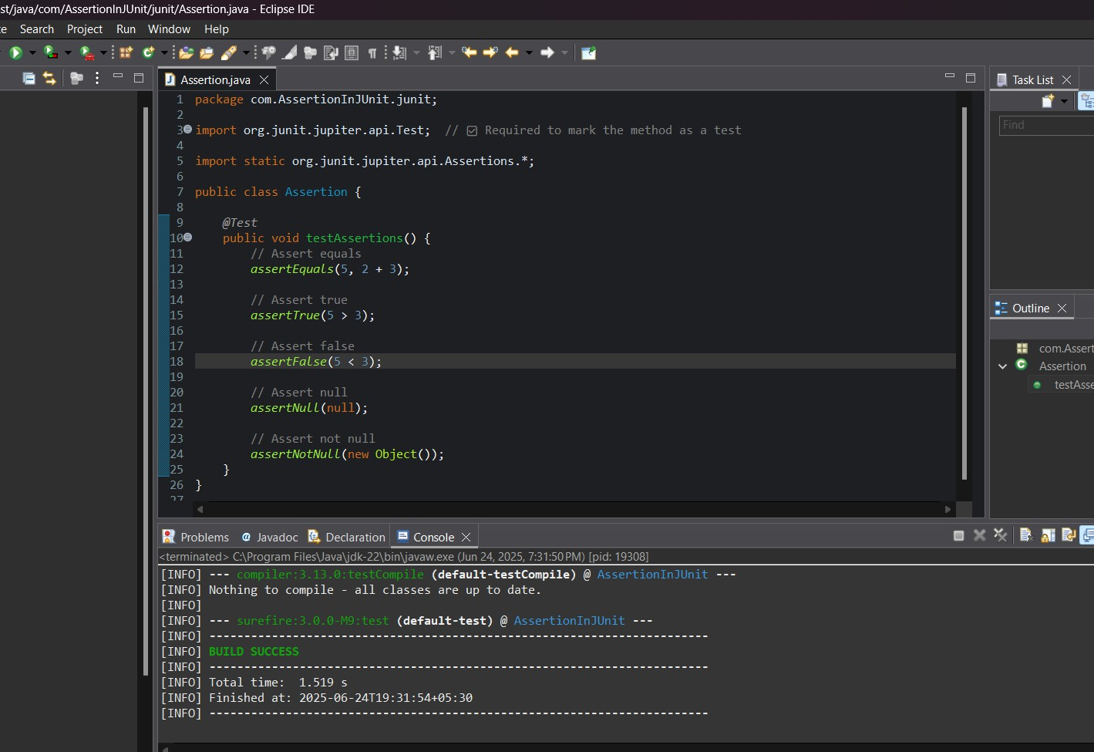**Maven test:**

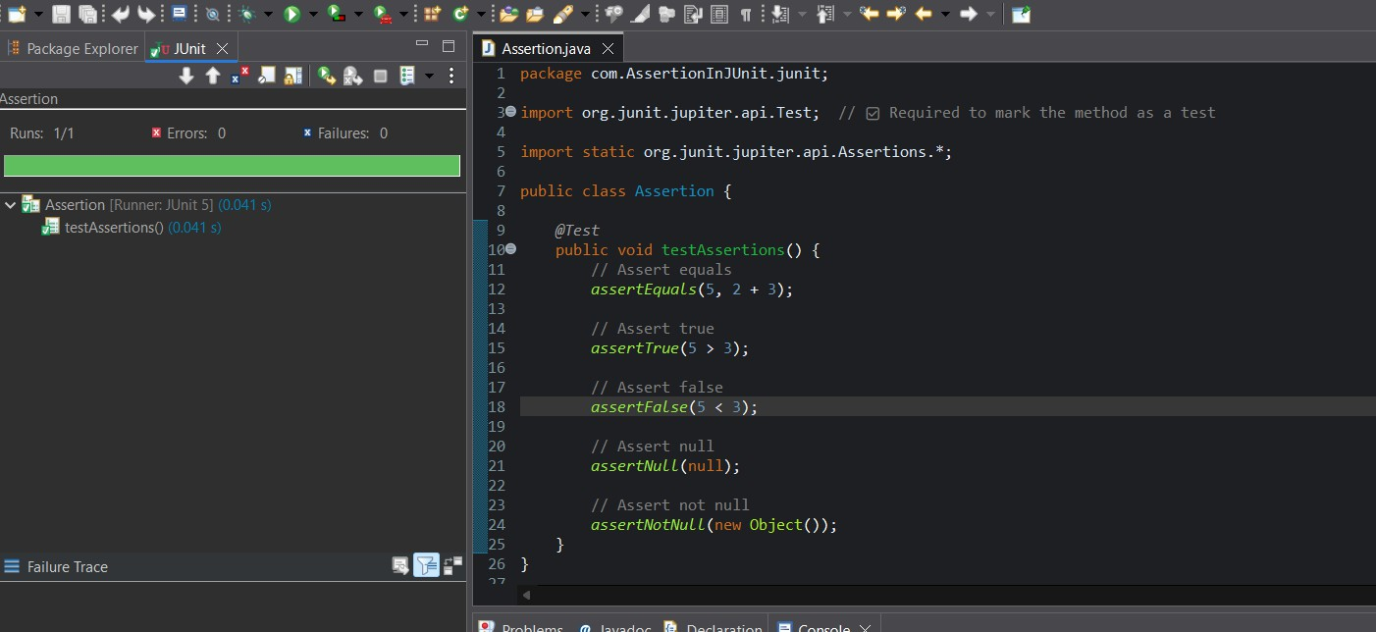**Junit test:**

# Exercise 4: Arrange-Act-Assert (AAA) Pattern, Test Fixtures, Setup and Teardown Methods in Junit

## Scenario: You need to organize your tests using the Arrange-Act-Assert (AAA) pattern and use setup and teardown methods.

## Steps:

## 1. Write tests using the AAA pattern.

## 2. Use @Before and @After annotations for setup and teardown methods.

## SOLUTION:

Step 1:Add the Junit Dependency in pom.xml

### pom.xml :

<project xmln[s="http://maven.apache.org/POM/4.0.0"](http://maven.apache.org/POM/4.0.0) xmlns:x[si="http://www.w3.org/2001/XMLSchema-instance"](http://www.w3.org/2001/XMLSchema-instance)

xsi:schemaLocati[on="http://maven.apache.org/POM/4.0.0](http://maven.apache.org/POM/4.0.0) https://maven.apache.org/xsd/maven- 4.0.0.xsd">

<modelVersion>4.0.0</modelVersion>

<groupId>AAA</groupId>

<artifactId>AAA_Pattern</artifactId>

<version>0.0.1-SNAPSHOT</version>

<dependencies>

<!-- JUnit Jupiter (API + Engine) -->

<dependency>

<groupId>org.junit.jupiter</groupId>

<artifactId>junit-jupiter</artifactId>

<version>5.9.3</version>

<scope>test</scope>

</dependency>

</dependencies>

<build>

<plugins>

<!-- Correct Surefire Plugin version to support JUnit 5 -->

<plugin>

<groupId>org.apache.maven.plugins</groupId>

<artifactId>maven-surefire-plugin</artifactId>

<version>3.0.0-M9</version>

</plugin>

</plugins>

</build>

</project>

### OUTPUT:

Step 2: Create your test classes in **src/test/java**.

Write the required test case and run as maven test and Junit test:

**CODE for Calculator.java:** package com.AAA.patterns; public class Calculator {

public int add(int a, int b) { return a + b;

}

public int subtract(int a, int b) { return a - b;

}

}

**OUTPUT: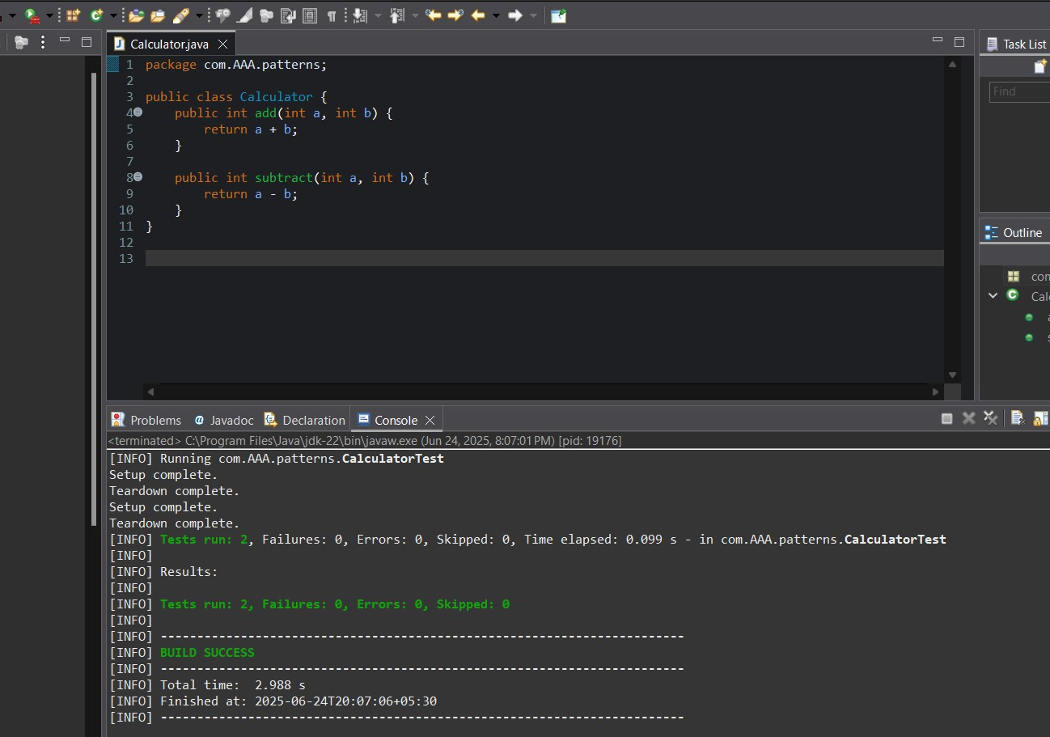Maven Test for Calculator.java:**

**CODE for CalculatorTest.java:**

package com.AAA.patterns; import org.junit.jupiter.api.*;

import static org.junit.jupiter.api.Assertions.*; public class CalculatorTest {

private Calculator calculator;

@BeforeEach

void setUp() {

calculator = new Calculator(); System.out.println("Setup complete.");

}

@AfterEach

void tearDown() { calculator = null;

System.out.println("Teardown complete.");

}

@Test

void testAddition() {

// Arrange int a = 10; int b = 5;

// Act

int result = calculator.add(a, b);

// Assert

assertEquals(15, result);

}

@Test

void testSubtraction() {

// Arrange int a = 10; int b = 3;

// Act

int result = calculator.subtract(a, b);

// Assert

assertEquals(7, result);

}

}

## OUTPUT:Maven Test for CalculatorTest.java:

**Junit Test for CalculatorTest.java:**

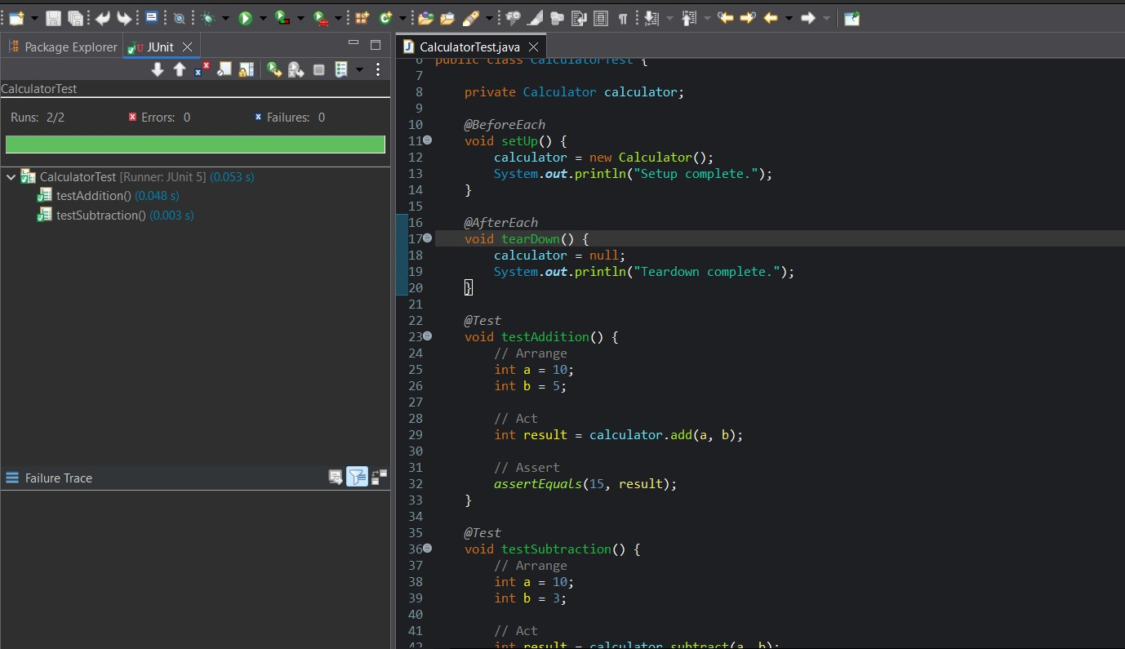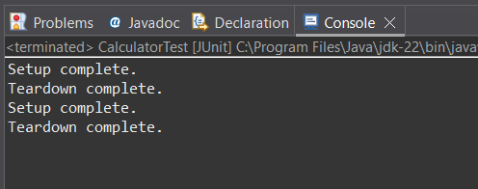

Jambu Sanjana

[Sanjana1373277@gmail.com](mailto:Sanjana1373277@gmail.com)

Superser Id: 6208959