MOCKITO EXERCISES

**Exercise 1: Mocking and Stubbing**

**Scenario:**

You need to test a service that depends on an external API. Use Mockito to mock the external API and stub its methods.

# SOLUTION:

Step 1:Add the Dependency in pom.xml.

# CODE:

<project xmlns="[http://maven.apache.org/POM/4.0.0"](http://maven.apache.org/POM/4.0.0) xmlns:xsi="<http://www.w3.org/2001/XMLSchema-instance>" xsi:schemaLocation="<http://maven.apache.org/POM/4.0.0> https://maven.apache.org/xsd/maven-

4.0.0.xsd">

<modelVersion>4.0.0</modelVersion>

<groupId>TDDMockito</groupId>

<artifactId>mockito</artifactId>

<version>0.0.1-SNAPSHOT</version>

<properties>

<maven.compiler.source>11</maven.compiler.source>

<maven.compiler.target>11</maven.compiler.target>

<project.build.sourceEncoding>UTF-8</project.build.sourceEncoding>

<junit.jupiter.version>5.10.0</junit.jupiter.version>

<mockito.version>5.11.0</mockito.version>

<surefire.version>3.2.3</surefire.version> <!-- Updated surefire version -->

</properties>

<dependencies>

<!-- JUnit 5 -->

<dependency>

<groupId>org.junit.jupiter</groupId>

<artifactId>junit-jupiter</artifactId>

<version>${junit.jupiter.version}</version>

<scope>test</scope>

</dependency>

<!-- Mockito Core -->

<dependency>

<groupId>org.mockito</groupId>

<artifactId>mockito-core</artifactId>

<version>${mockito.version}</version>

<scope>test</scope>

</dependency>

<!-- Mockito JUnit 5 integration -->

<dependency>

<groupId>org.mockito</groupId>

<artifactId>mockito-junit-jupiter</artifactId>

<version>${mockito.version}</version>

<scope>test</scope>

</dependency>

<!-- Add ByteBuddy dependency for Mockito's modern mocking -->

<dependency>

<groupId>net.bytebuddy</groupId>

<artifactId>byte-buddy</artifactId>

<version>1.14.9</version>

<scope>test</scope>

</dependency>

</dependencies>

<build>

<plugins>

<!-- Updated Maven Surefire Plugin configuration -->

<plugin>

<groupId>org.apache.maven.plugins</groupId>

<artifactId>maven-surefire-plugin</artifactId>

<version>${surefire.version}</version>

<configuration>

<argLine>

--add-opens java.base/java.lang=ALL-UNNAMED

--add-opens java.base/java.util=ALL-UNNAMED

</argLine>

</configuration>

</plugin>

<!-- Add Maven Compiler Plugin for explicit configuration -->

<plugin>

<groupId>org.apache.maven.plugins</groupId>

<artifactId>maven-compiler-plugin</artifactId>

<version>3.11.0</version>

<configuration>

<release>11</release>

</configuration>

</plugin>

</plugins>

</build>

</project>

**OUTPUT:**

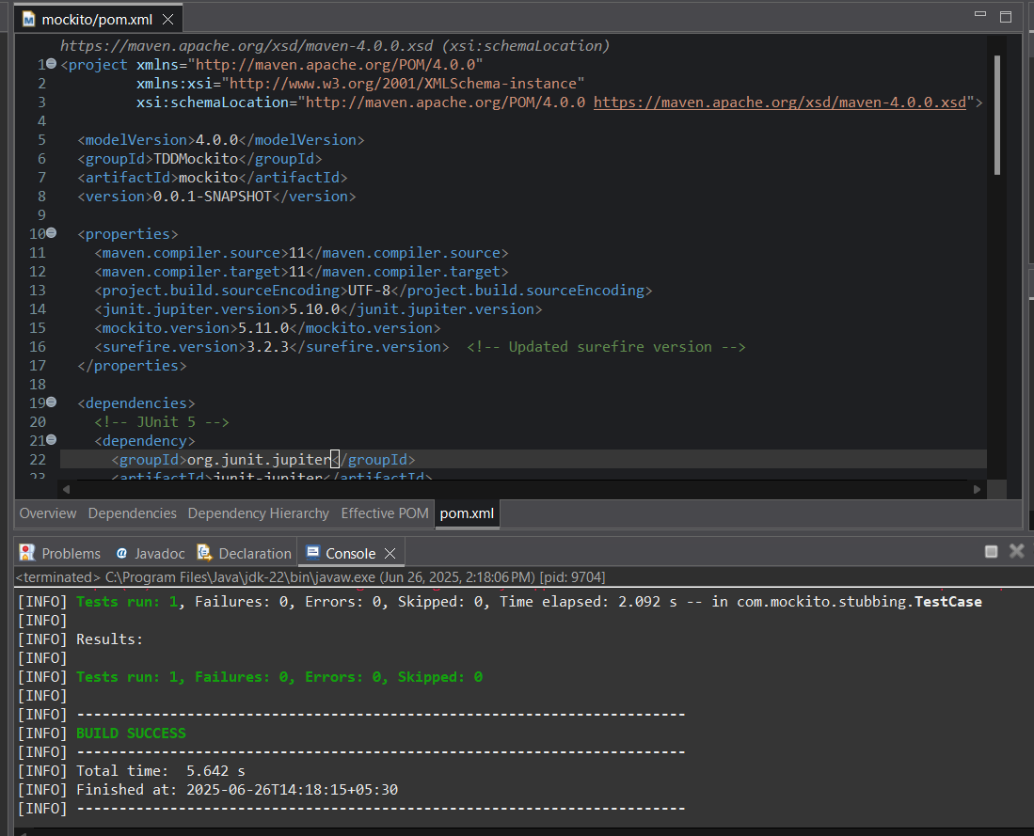

Step 2:Create a mock object for the external API.

**CODE (for ExternalApi.java):** package com.mockito.stubbing; public interface ExternalApi {

String getData(); String getData1();

}

**OUTPUT(for ExternalApi.java):**

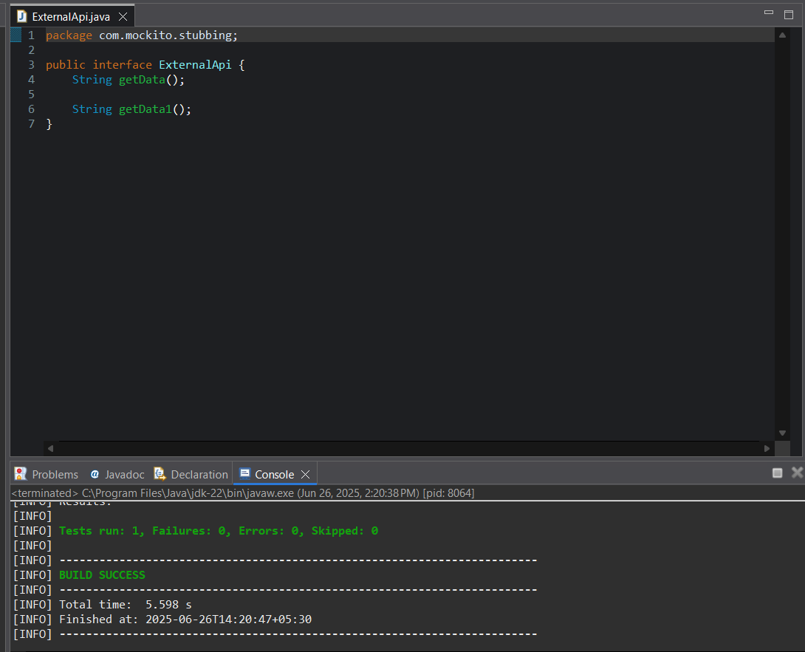

**CODE(for MyService.java):**

package com.mockito.stubbing;

public class MyService {

private ExternalApi api;

public MyService(ExternalApi api) {

this.api = api;

}

public String fetchData() {

return api.getData();

}

}

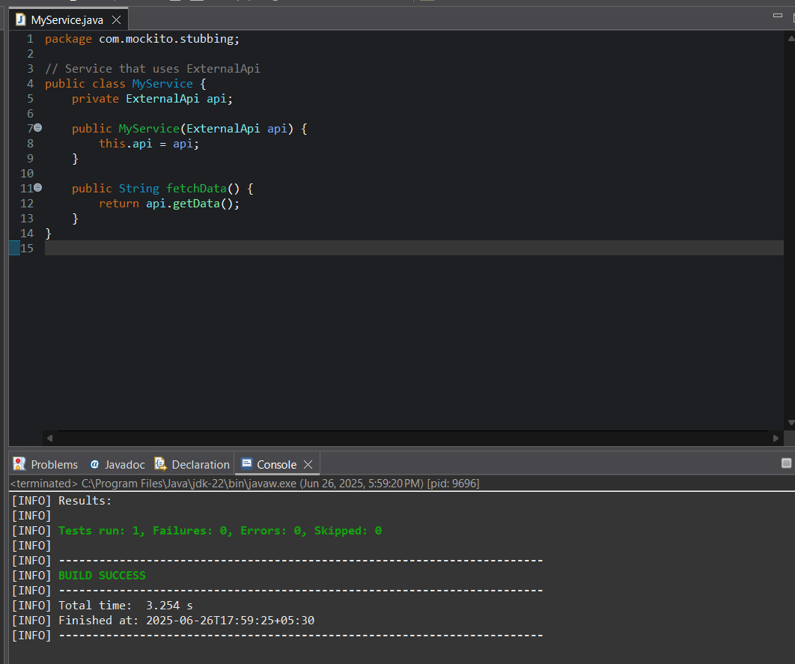**OUTPUT(for MyService.java):**

Step 3&4: Stub the methods to return predefined values. Write a test case that uses the mock object.

**CODE(for TestCase.java):**

package com.mockito.stubbing;

// Needed for assertEquals

import static org.junit.jupiter.api.Assertions.*; import static org.mockito.Mockito.*;

import org.junit.jupiter.api.Test; import org.mockito.Mockito;

// Test class

public class TestCase {

@Test

public void testExternalApi() {

// Create a mock for the ExternalApi

ExternalApi mockApi = Mockito.mock(ExternalApi.class);

// Stub the getData() method

when(mockApi.getData()).thenReturn("Mock Data");

// Inject mock into MyService

MyService service = new MyService(mockApi);

// Call the method under test String result = service.fetchData();

// Assert the result

assertEquals("Mock Data", result);

}

}

**OUTPUT(for TestCase.java): Maven test:**

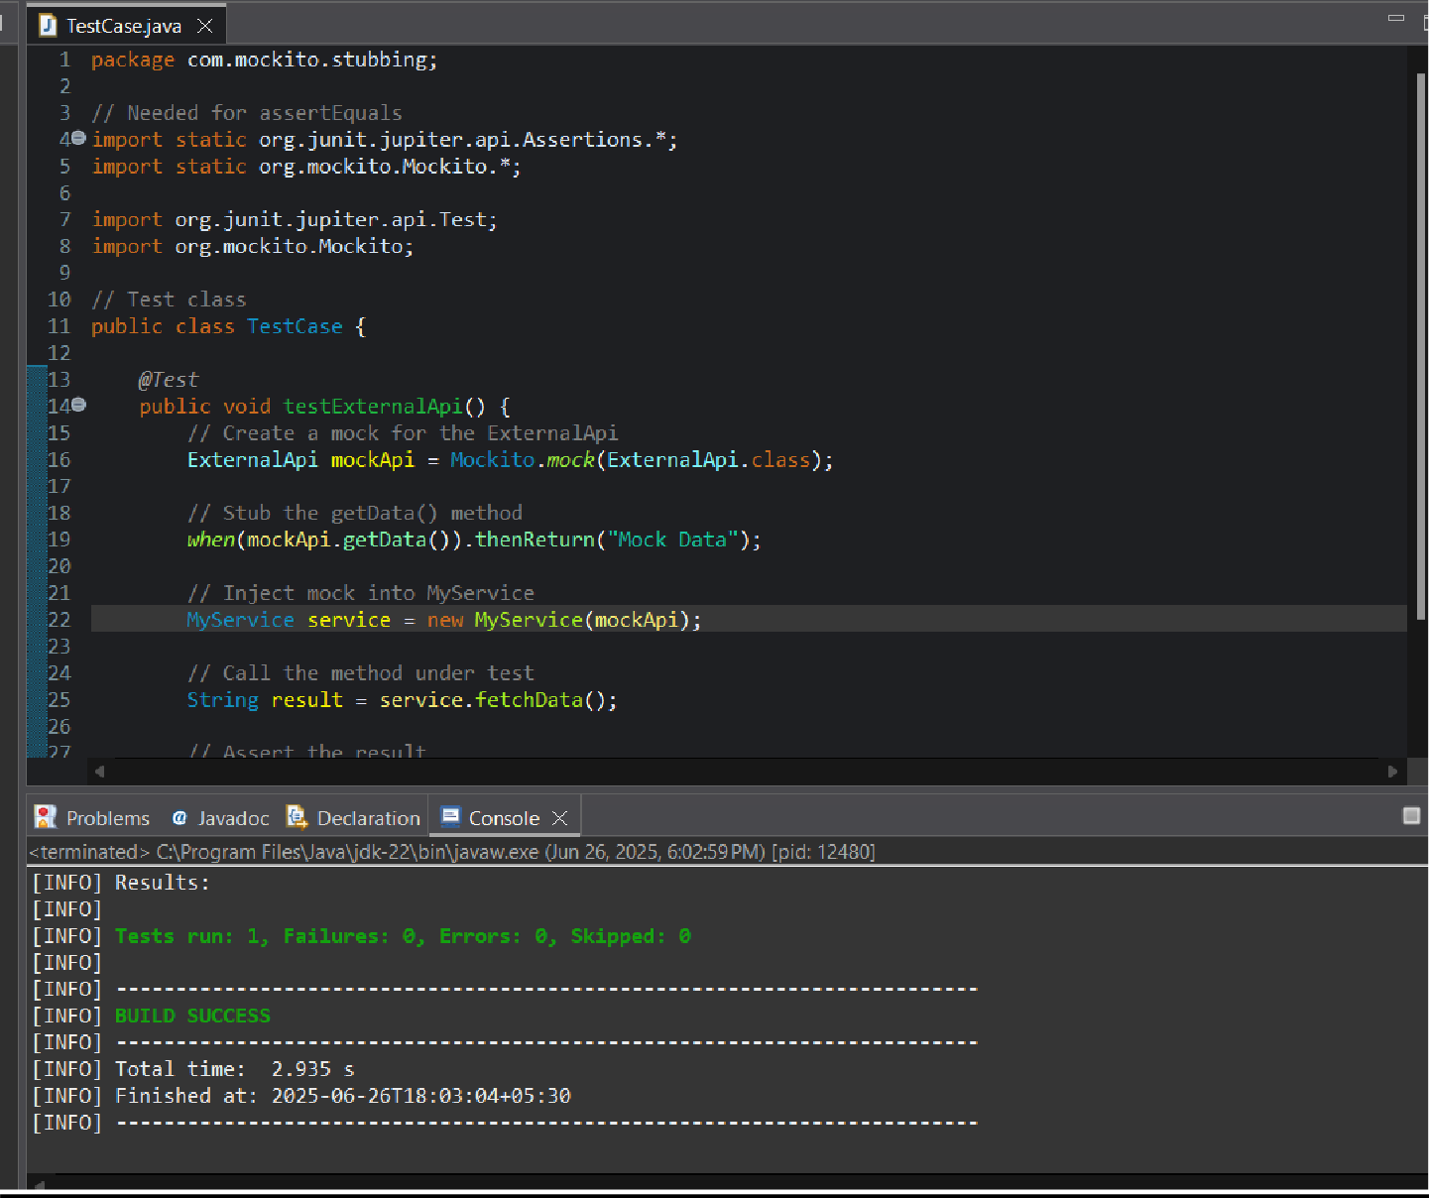

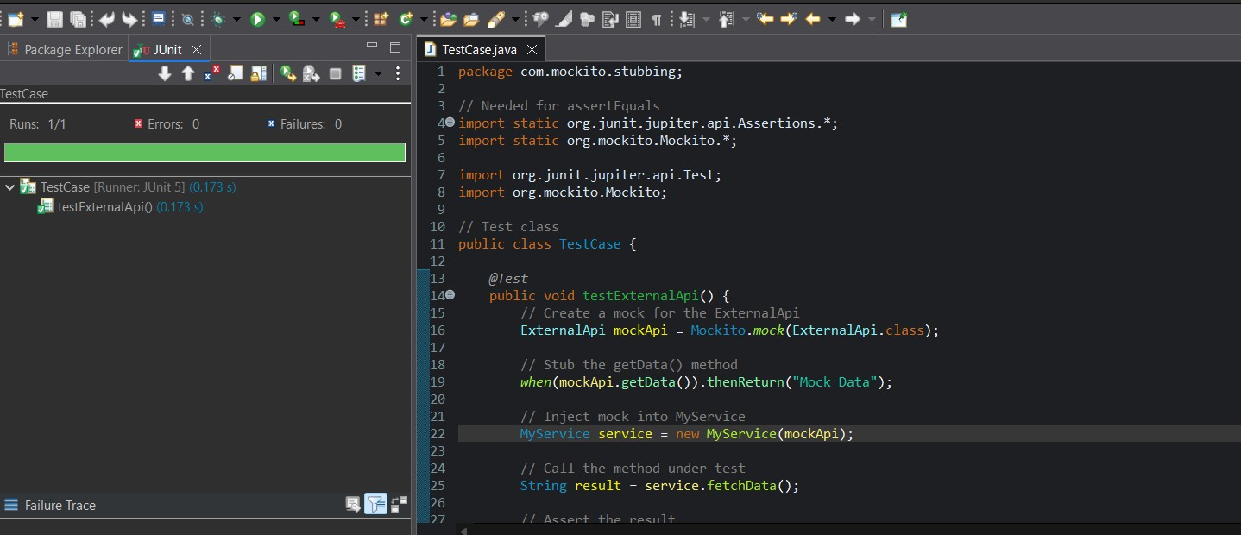 **Junit test:**

**Exercise 6: Verifying Interaction Order**

**Scenario: You need to ensure that methods are called in a specific order.**

**SOLUTION:**

Step 1:Add the Dependency in pom.xml.

# CODE:

<project xmlns="[http://maven.apache.org/POM/4.0.0"](http://maven.apache.org/POM/4.0.0) xmlns:xsi="<http://www.w3.org/2001/XMLSchema-instance>" xsi:schemaLocation="<http://maven.apache.org/POM/4.0.0> https://maven.apache.org/xsd/maven-

4.0.0.xsd">

<modelVersion>4.0.0</modelVersion>

<groupId>Verify</groupId>

<artifactId>VerifyingInteractions</artifactId>

<version>0.0.1-SNAPSHOT</version>

<dependencies>

<!-- JUnit 5 (Jupiter) for testing -->

<dependency>

<groupId>org.junit.jupiter</groupId>

<artifactId>junit-jupiter</artifactId>

<version>5.10.0</version>

<scope>test</scope>

</dependency>

<!-- Mockito core library -->

<dependency>

<groupId>org.mockito</groupId>

<artifactId>mockito-core</artifactId>

<version>5.11.0</version>

<scope>test</scope>

</dependency>

</dependencies>

<build>

<plugins>

<!-- Maven Surefire Plugin to run JUnit 5 tests -->

<plugin>

<groupId>org.apache.maven.plugins</groupId>

<artifactId>maven-surefire-plugin</artifactId>

<version>3.2.5</version>

<configuration>

<useModulePath>false</useModulePath>

</configuration>

</plugin>

</plugins>

</build>

</project>

# OUTPUT:

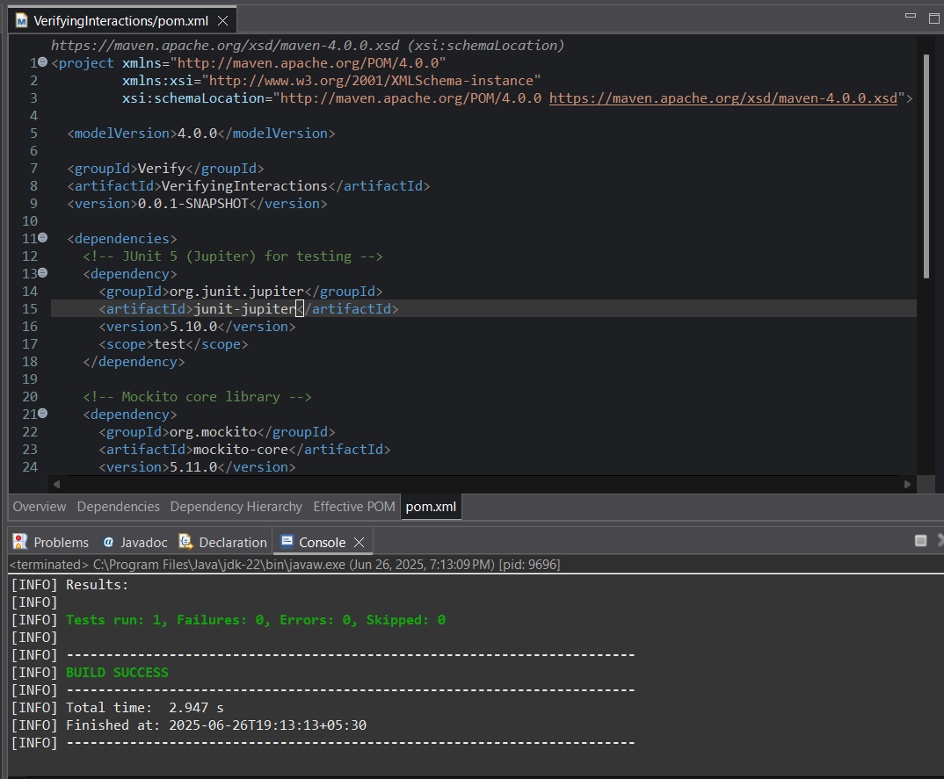

Step 2:Create a mock object.

**CODE(for NetworkClient.java):**

package com.mockito;

public interface NetworkClient { void upload(String payload);

}

**OUTPUT(for NetworkClient.java):**

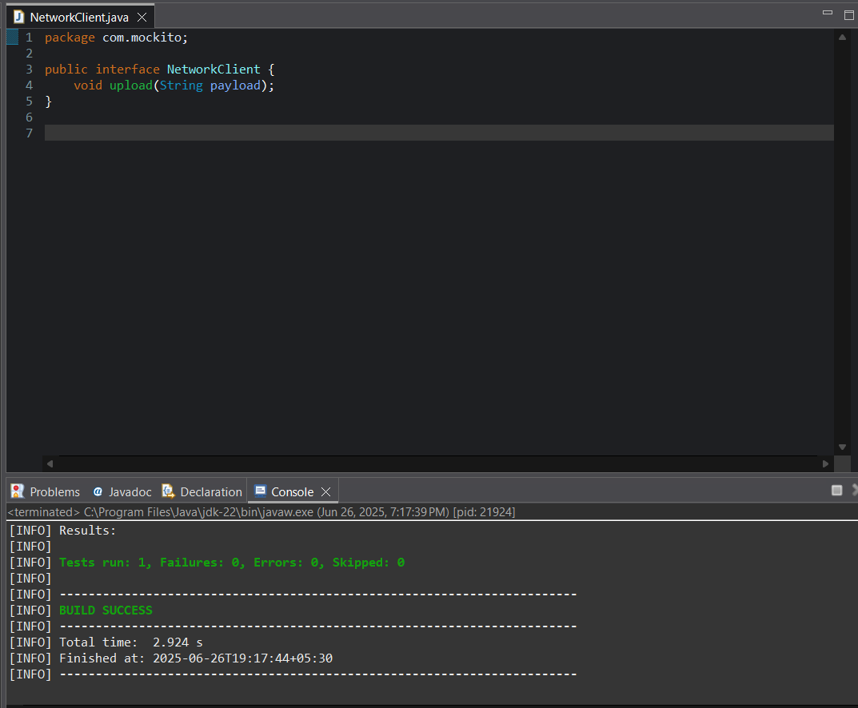

**CODE(for DataUploader.java):**

package com.mockito; public class DataUploader {

private final NetworkClient client;

public DataUploader(NetworkClient client) { this.client = client;

}

public void performUpload() { client.upload("TestPayload");

}

}

**OUTPUT(for DataUploader.java):**

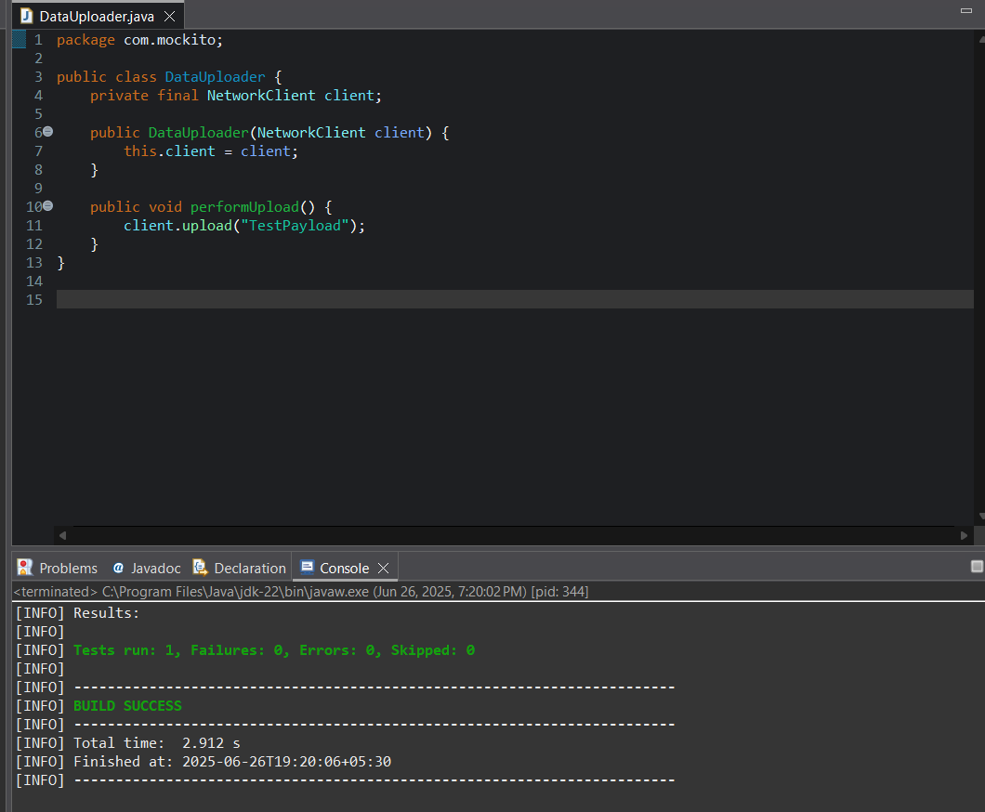

Step 3&4: Call the methods in a specific order.Verify the interaction order.

**CODE(for TestDataUploader.java):**

package com.mockito;

import static org.mockito.Mockito.*; import org.junit.jupiter.api.Test; import org.mockito.Mockito;

public class TestDataUploader {

@Test

public void testUploadCalledWithCorrectArgument() {

// Step 1: Create mock

NetworkClient mockClient = Mockito.mock(NetworkClient.class);

// Step 2: Call method with specific argument DataUploader uploader = new DataUploader(mockClient); uploader.performUpload();

// Step 3: Verify interaction

verify(mockClient).upload("TestPayload");

}

}

# OUTPUT:Maven Test:

**Junit Test:**

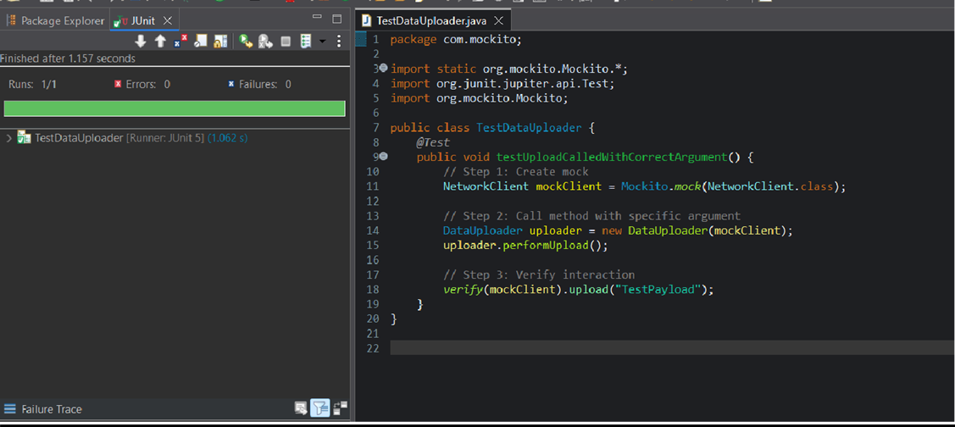

Jambu Sanjana

[Sanjana1373277@gmail.com](mailto:Sanjana1373277@gmail.com)

Superser Id: 6208959