## **WEEK-7:REACT**

## **HANDS-ON - 01:**

## **Objectives**

* List the features of ES6
* Explain JavaScript let
* Identify the differences between var and let
* Explain JavaScript const
* Explain ES6 class fundamentals
* Explain ES6 class inheritance
* Define ES6 arrow functions
* Identify set(), map()

In this hands-on lab, you will learn how to:

* Use map() method of ES6
* Apply arrow functions of ES6
* Implement Destructuring features of ES6

## **Prerequisites**

The following is required to complete this hands-on lab:

* Node.js
* NPM
* Visual Studio Code

## **Notes**

Estimated time to complete this lab: **60 minutes.**

Create a React Application named “cricketapp” with the following components:

1. ListofPlayers

* Declare an array with 11 players and store details of their names and scores using the map feature of ES6

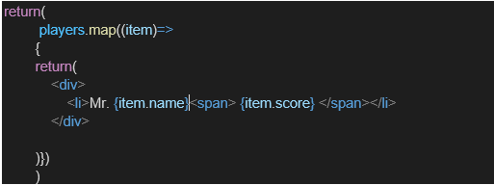

* Filter the players with scores below 70 using arrow functions of ES6.

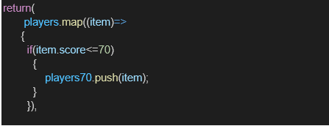

1. IndianPlayers
   1. Display the Odd Team Player and Even Team players using the Destructuring features of ES6

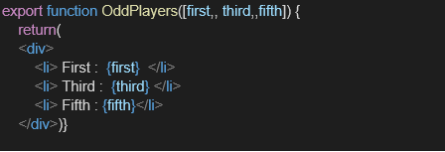

* 1. Declare two arrays T20players and RanjiTrophy players and merge the two arrays and display them using the Merge feature of ES6

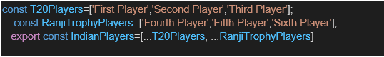

Display these two components in the same home page using a simple if else in the flag variable.

**Output:**

When Flag=true

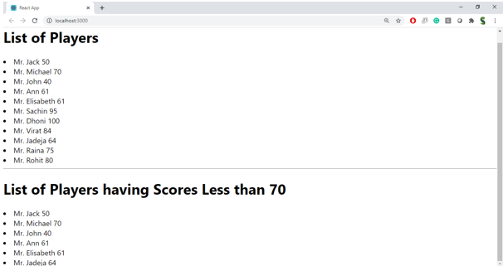

When Flag=false

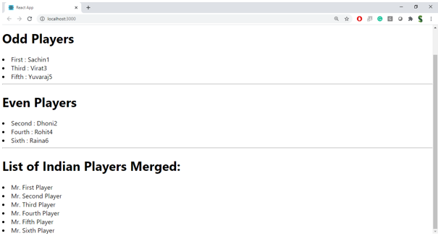 **Hint:**

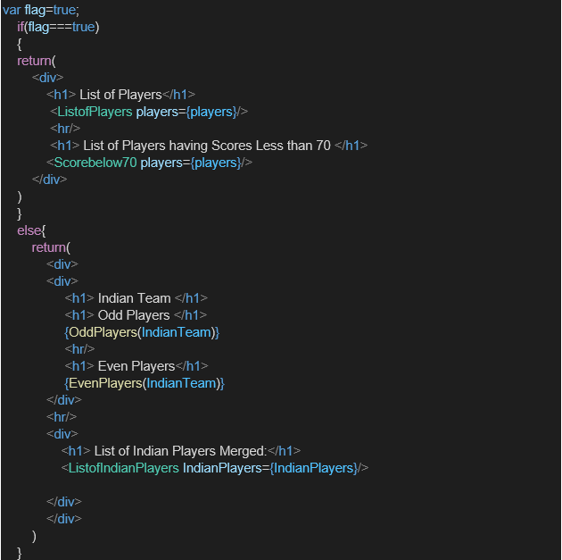

**CODES:**

APP.js

// src/App.js

import React from 'react';

import './App.css';

import ListofPlayers from './ListofPlayers';

import IndianPlayers from './IndianPlayers';

function App() {

  const flag = true; // set to false to display IndianPlayers layout

  return (

    <div className="App">

      {flag ? <ListofPlayers /> : <IndianPlayers />}

    </div>

  );

}

export default App;

IndianPlayer.js

// src/IndianPlayers.js

import React from 'react';

function IndianPlayers() {

  const oddTeam = ['Sachin1', 'Virat3', 'Yuvaraj5'];

  const evenTeam = ['Dhoni2', 'Rohit4', 'Raina6'];

  const mergedPlayers = [

    'Mr. First Player',

    'Mr. Second Player',

    'Mr. Third Player',

    'Mr. Fourth Player',

    'Mr. Fifth Player',

    'Mr. Sixth Player',

  ];

  const oddLabels = ['First', 'Third', 'Fifth'];

  const evenLabels = ['Second', 'Fourth', 'Sixth'];

  return (

    <div style={{ width: '80%', margin: 'auto', textAlign: 'left' }}>

      <h2>Odd Players</h2>

      <ul>

        {oddTeam.map((name, idx) => (

          <li key={idx}>

            {oddLabels[idx]} : {name}

          </li>

        ))}

      </ul>

      <hr />

      <h2>Even Players</h2>

      <ul>

        {evenTeam.map((name, idx) => (

          <li key={idx}>

            {evenLabels[idx]} : {name}

          </li>

        ))}

      </ul>

      <hr />

      <h2>List of Indian Players Merged:</h2>

      <ul>

        {mergedPlayers.map((name, idx) => (

          <li key={idx}>{name}</li>

        ))}

      </ul>

    </div>

  );

}

export default IndianPlayers;

ListOfPlayers.js

// src/ListofPlayers.js

import React from 'react';

function ListofPlayers() {

  const players = [

    { name: 'Jack', score: 50 },

    { name: 'Michael', score: 70 },

    { name: 'John', score: 40 },

    { name: 'Ann', score: 61 },

    { name: 'Elisabeth', score: 61 },

    { name: 'Sachin', score: 95 },

    { name: 'Dhoni', score: 100 },

    { name: 'Virat', score: 84 },

    { name: 'Jadeja', score: 64 },

    { name: 'Raina', score: 75 },

    { name: 'Rohit', score: 80 },

  ];

  const below70 = players.filter(p => p.score < 70);

  return (

    <div style={{ width: '80%', margin: 'auto', textAlign: 'left' }}>

      <h2>List of Players</h2>

      <ul>

        {players.map((p, idx) => (

          <li key={idx}>Mr. {p.name} {p.score}</li>

        ))}

      </ul>

      <hr />

      <h2>List of Players having Scores Less than 70</h2>

      <ul>

        {below70.map((p, idx) => (

          <li key={idx}>Mr. {p.name} {p.score}</li>

        ))}

      </ul>

    </div>

  );

}

export default ListofPlayers;

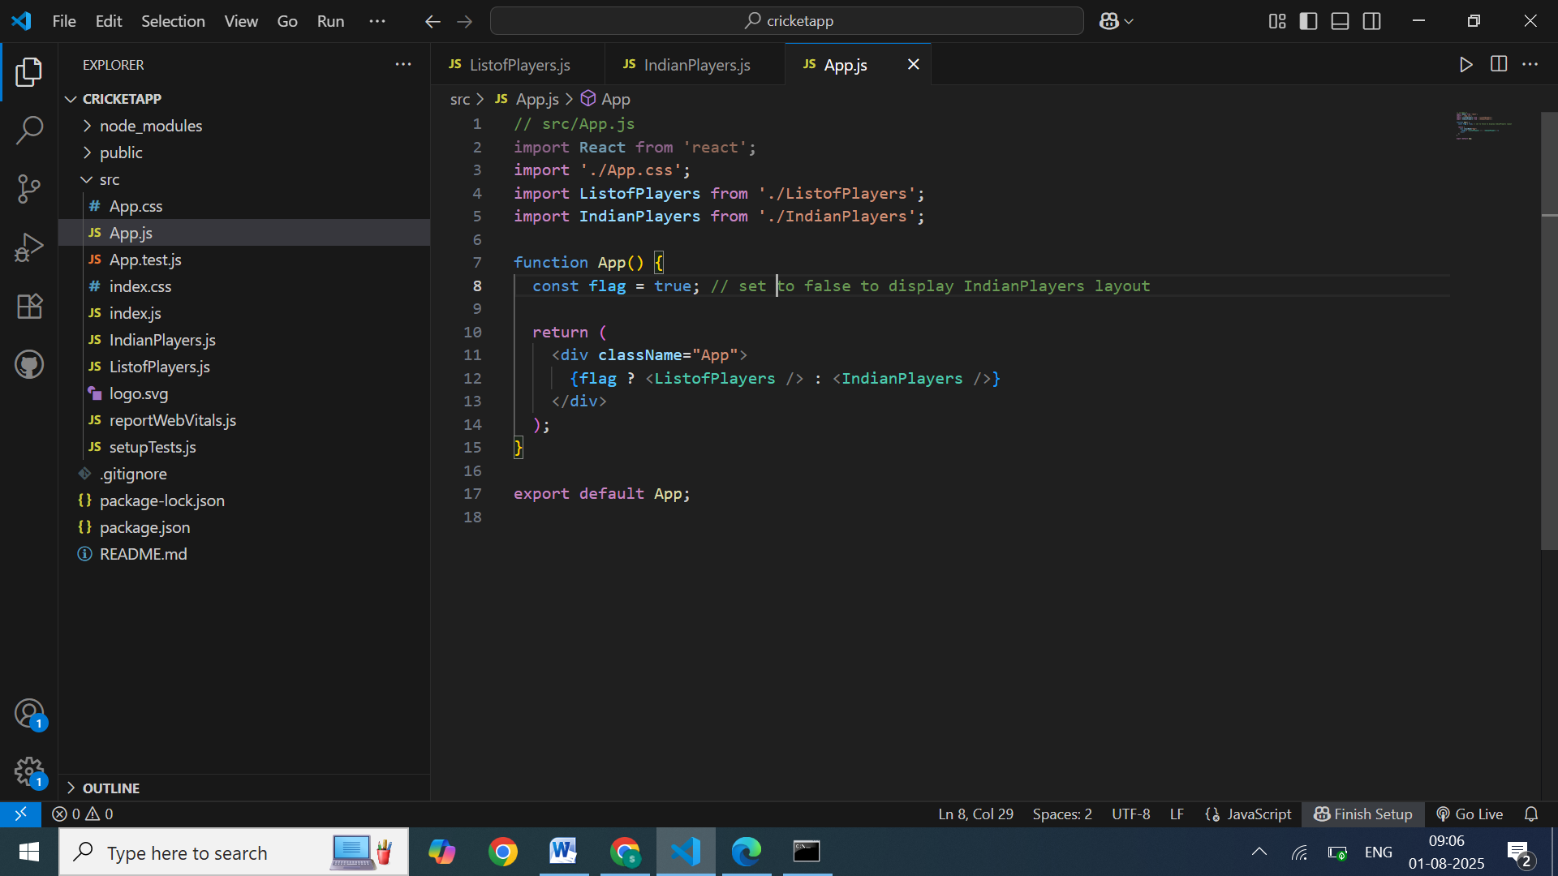

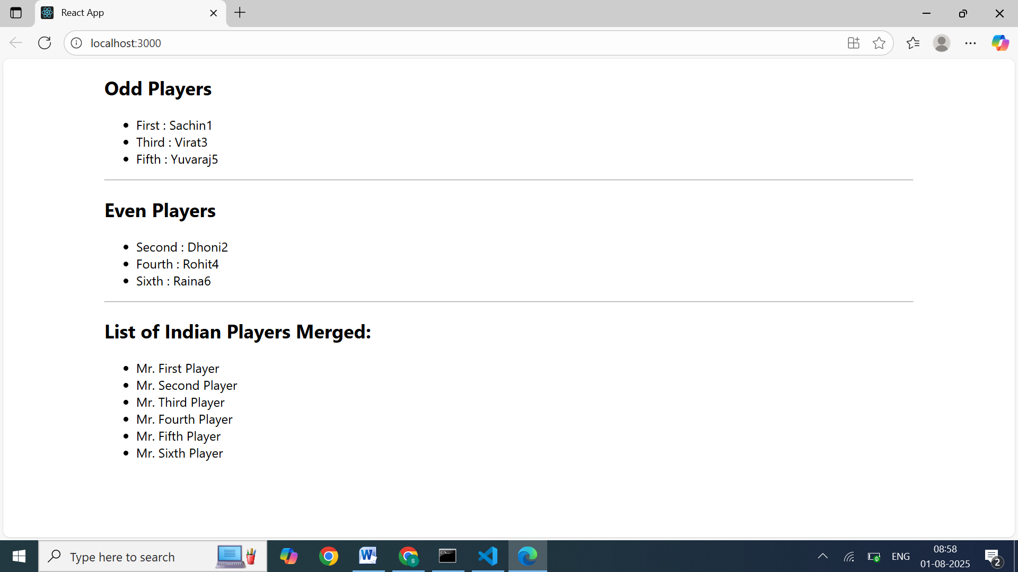

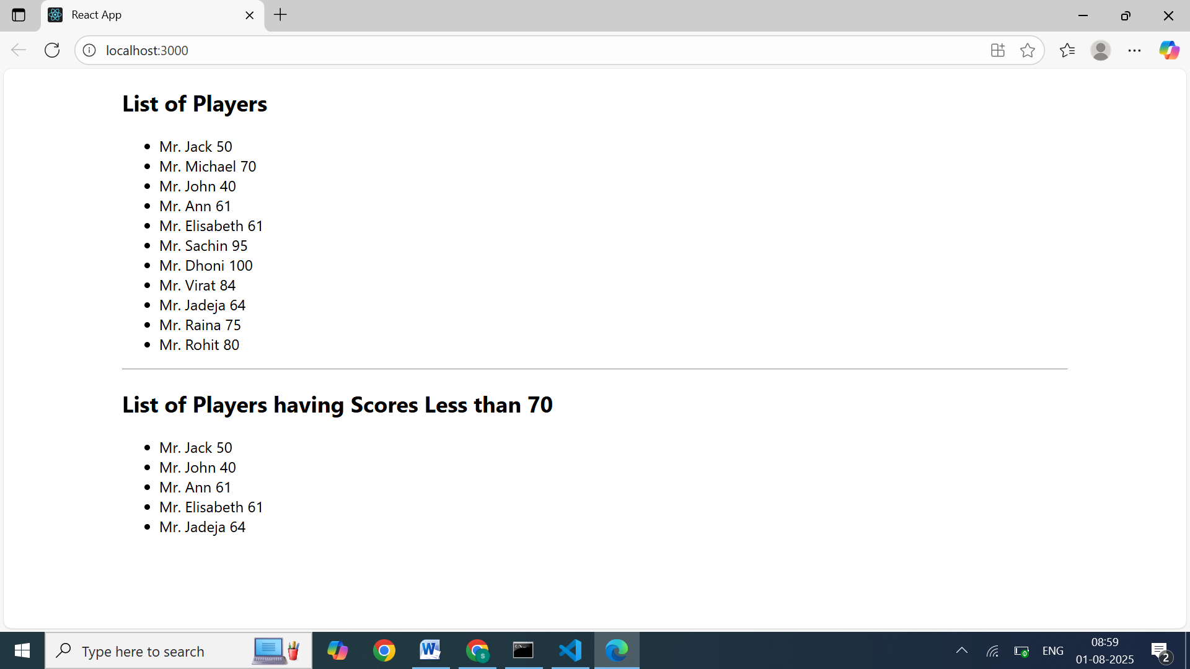

## **HANDS-ON - 02:**

## **Objectives**

* Define JSX
* Explain about ECMA Script
* Explain React.createElement()
* Explain how to create React nodes with JSX
* Define how to render JSX to DOM
* Explain how to use JavaScript expressions in JSX
* Explain how to use inline CSS in JSX

In this hands-on lab, you will learn how to:

* Use JSX syntax in React applications
* Use inline CSS in JSX

## **Prerequisites**

The following is required to complete this hands-on lab:

* Node.js
* NPM
* Visual Studio Code

## **Notes**

Estimated time to complete this lab: **60 minutes.**Create a React Application named “officespacerentalapp” which uses React JSX to create elements, attributes and renders DOM to display the page.

Create an element to display the heading of the page.

Attribute to display the image of the office space

Create an object of office to display the details like Name, Rent and Address.

Create a list of Object and loop through the office space item to display more data.

To apply Css, Display the color of the Rent in Red if it’s below 60000 and in Green if it’s above 60000.

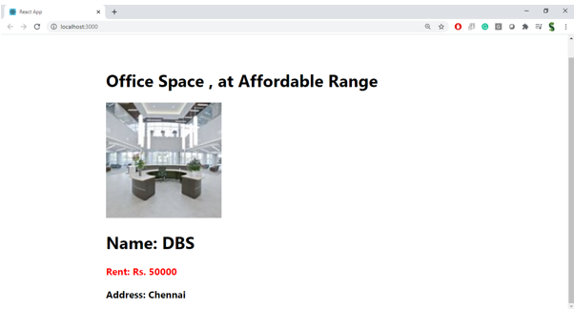

**Hint:**

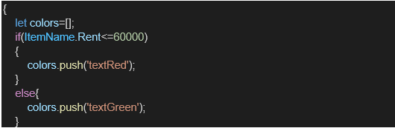

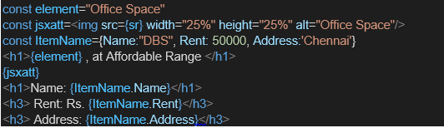

**CODES:**

APP.js

import React from 'react';

import officeImg from './assets/office.jpg'; // Import your image

function App() {

  const heading = "Office Space";

  const offices = [

    { id: 1, Name: "DBS", Rent: 50000, Address: "Chennai" },

    // Add more objects as needed

  ];

  return (

    <div style={{

      display: 'flex',

      justifyContent: 'center',

      alignItems: 'center',

      height: '100vh',

      fontFamily: 'Arial, sans-serif',

      padding: '20px',

      boxSizing: 'border-box'

    }}>

      <div>

        <h1>{heading}, at Affordable Range</h1>

        {offices.map((office) => (

          <div key={office.id} style={{ marginBottom: '30px' }}>

            <img

              src={officeImg}

              alt="Office Space"

              width="25%"

              height="25%"

            />

            <h2>Name: {office.Name}</h2>

            <h3 style={{ color: office.Rent <= 60000 ? 'red' : 'green' }}>

              Rent: Rs. {office.Rent}

            </h3>

            <h3>Address: {office.Address}</h3>

          </div>

        ))}

      </div>

    </div>

  );

}

export default App;

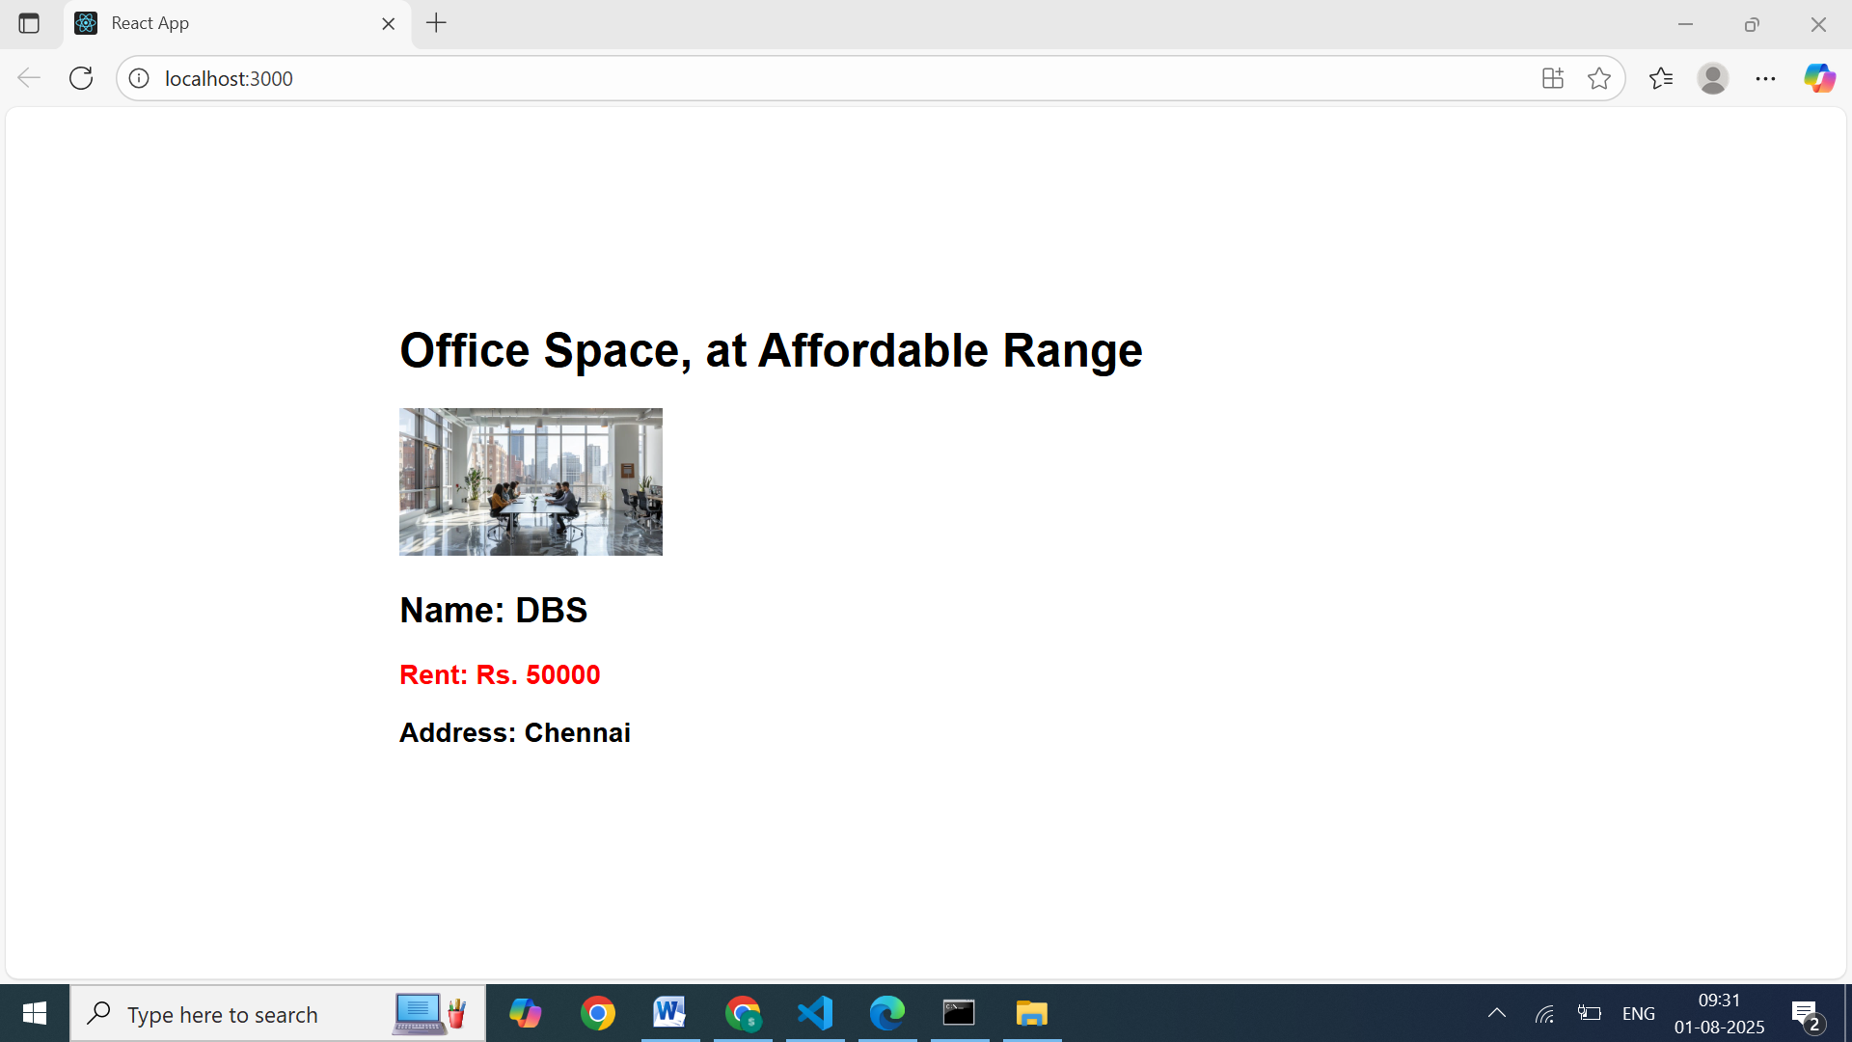

## **HANDS-ON - 03:**

## **Objectives**

* Explain React events
* Explain about event handlers
* Define Synthetic event
* Identify React event naming convention

In this hands-on lab, you will learn how to:

* Implement Event handling concept in React applications
* Use this keyword
* Use synthetic event

## **Prerequisites**

The following is required to complete this hands-on lab:

* Node.js
* NPM
* Visual Studio Code

## **Notes**

Estimated time to complete this lab: **90 minutes.**

Create a React Application “eventexamplesapp” to handle various events of the form elements in HTML.

1. Create “Increment” button to increase the value of the counter and “Decrement” button to decrease the value of the counter. The “Increase” button should invoke multiple methods.
   1. To increment the value
   2. Say Hello followed by a static message.

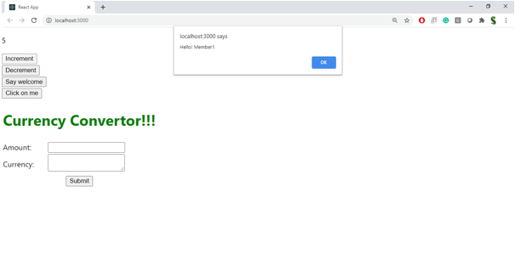

1. Create a button “Say Welcome” which invokes the function which takes “welcome” as an argument.

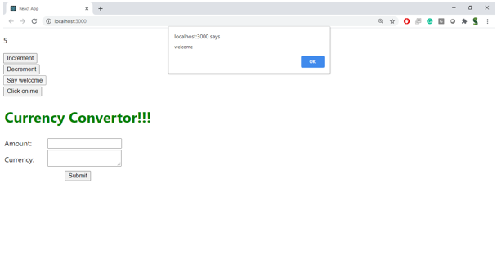

1. Create a button which invokes synthetic event “OnPress” which display “I was clicked”

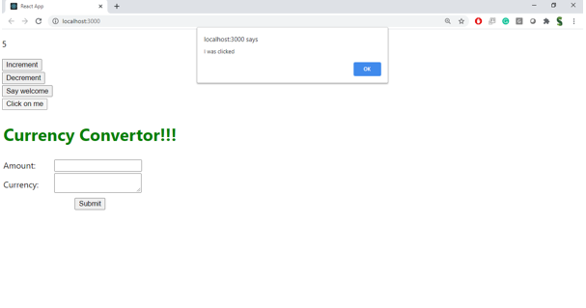

Create a “CurrencyConvertor” component which will convert the Indian Rupees to Euro when the Convert button is clicked.

Handle the Click event of the button to invoke the handleSubmit event and handle the conversion of the euro to rupees.

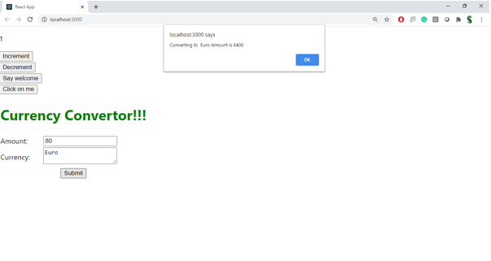

**CODES:**

App.js:

// src/App.js

import React from 'react';

import Counter from './Counter';

import CurrencyConverter from './CurrencyConverter';

function App() {

  return (

    <div>

      <Counter />

      <CurrencyConverter />

    </div>

  );

}

export default App;

CurrencyConverter.js:

import React, { useState } from 'react';

function CurrencyConverter() {

  const [rupees, setRupees] = useState('');

  const [euros, setEuros] = useState('');

  const handleSubmit = (event) => {

    event.preventDefault();

    const euroAmount = (parseFloat(rupees) / 90).toFixed(2); // Example conversion rate: 1 EUR = 90 INR

    alert(`Converting ₹${rupees} to €${euroAmount}`);

  };

return (

    <div>

      <h2 style={{ color: 'green', fontWeight: 'bold' }}>

  Currency Converter!!!

</h2>

      <form onSubmit={handleSubmit}>

  <label>Amount:   </label>

  <input

    type="number"

    value={rupees}

    onChange={(e) => setRupees(e.target.value)}

    placeholder="Enter amount in INR"

  />

  <div style={{ display: 'flex', alignItems: 'center', marginTop: '10px', gap: '10px' }}>

    <label>Currency:</label>

    <button type="submit">Convert to Euro</button>

      {euros && <p>{rupees} INR = {euros} EUR</p>}

  </div>

</form>

    </div>

  );

}

export default CurrencyConverter;

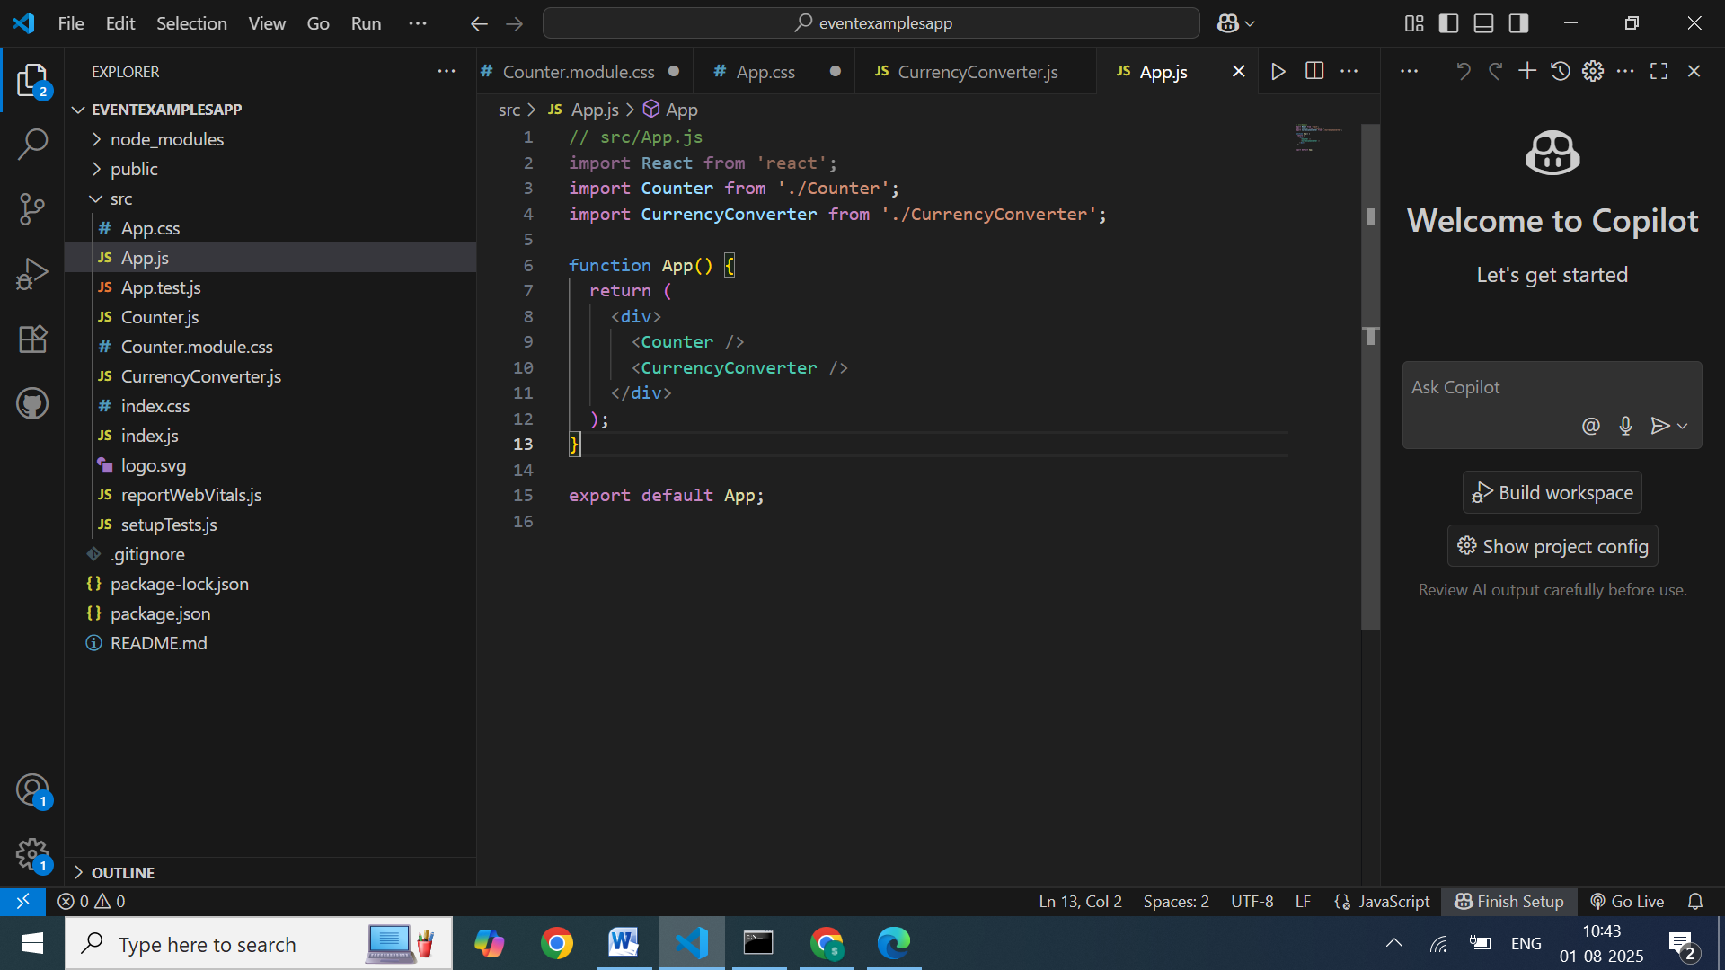

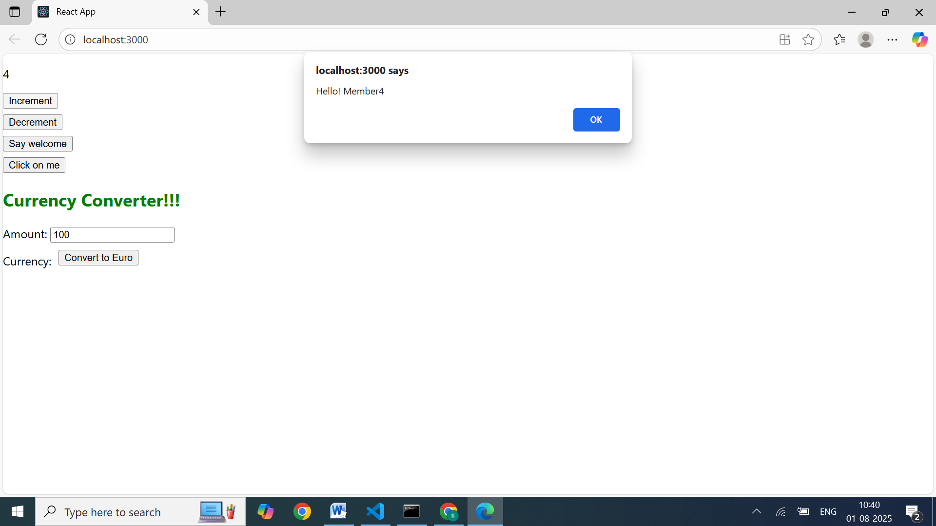

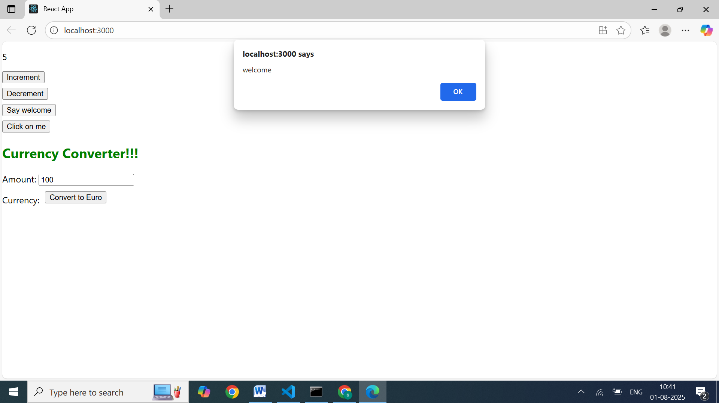

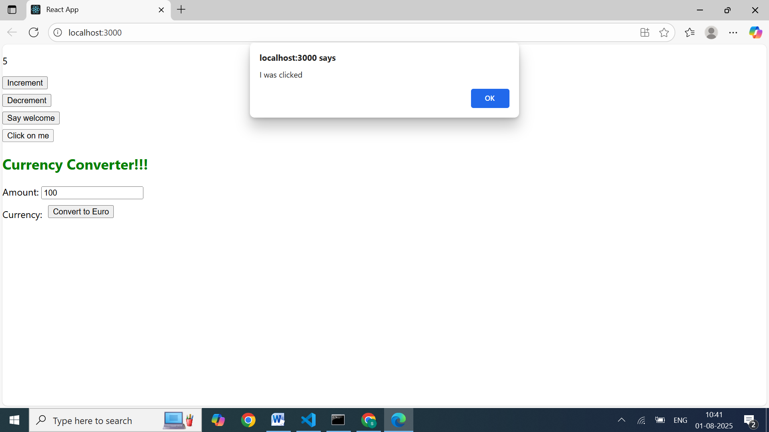

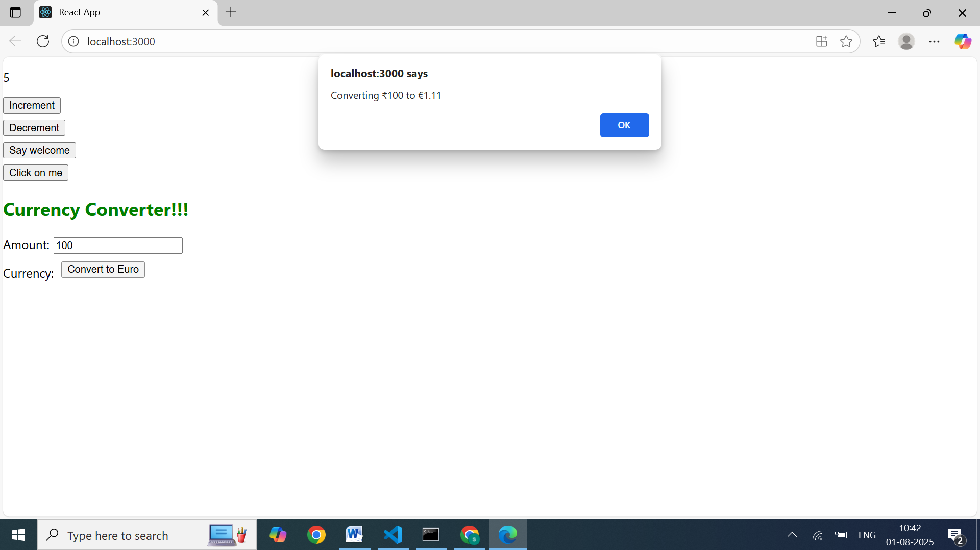

## **HANDS-ON - 04:**

## **Objectives**

* Explain about conditional rendering in React
* Define element variables
* Explain how to prevent components from rendering

In this hands-on lab, you will learn how to:

* Implement conditional rendering in React applications

## **Prerequisites**

The following is required to complete this hands-on lab:

* Node.js
* NPM
* Visual Studio Code

## **Notes**

Estimated time to complete this lab: **60 minutes.**

Create a React Application named “ticketbookingapp” where the guest user can browse the page where the flight details are displayed whereas the logged in user only can book tickets.

The Login and Logout buttons should accordingly display different pages. Once the user is logged in the User page should be displayed. When the user clicks on Logout, the Guest page should be displayed.

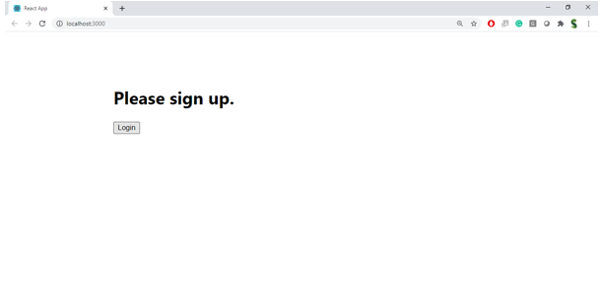

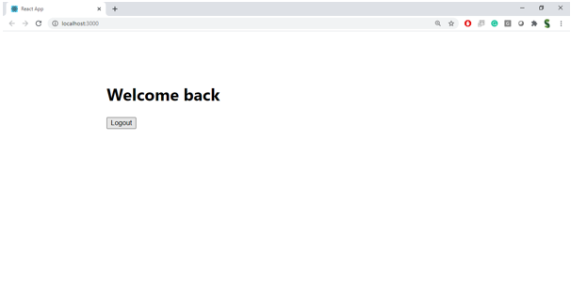

**Hint:**

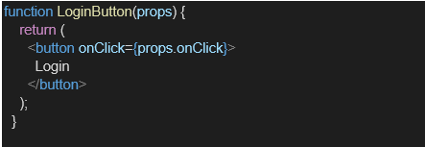

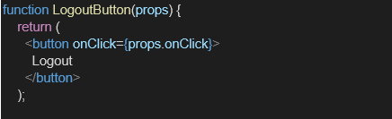

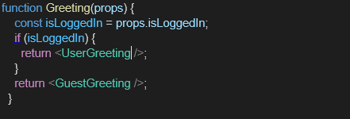

## Component files

### 1. UserGreeting.js

export function UserGreeting() {

return <h1>Welcome back</h1>;

}

### 2.GuestGreeting.js

export function GuestGreeting() {

return <h1>Please sign up.</h1>;

}

### 3. LoginButton.js

export function LoginButton({ onClick }) {

return <button onClick={onClick}>Login</button>;

}

### 4. LogoutButton.js

export function LogoutButton({ onClick }) {

return <button onClick={onClick}>Logout</button>;

}

### 5. Greeting.js

import { UserGreeting } from "./UserGreeting";

import { GuestGreeting } from "./GuestGreeting";

export function Greeting({ isLoggedIn }) {

if (isLoggedIn) {

return <UserGreeting />;

}

return <GuestGreeting />;

}

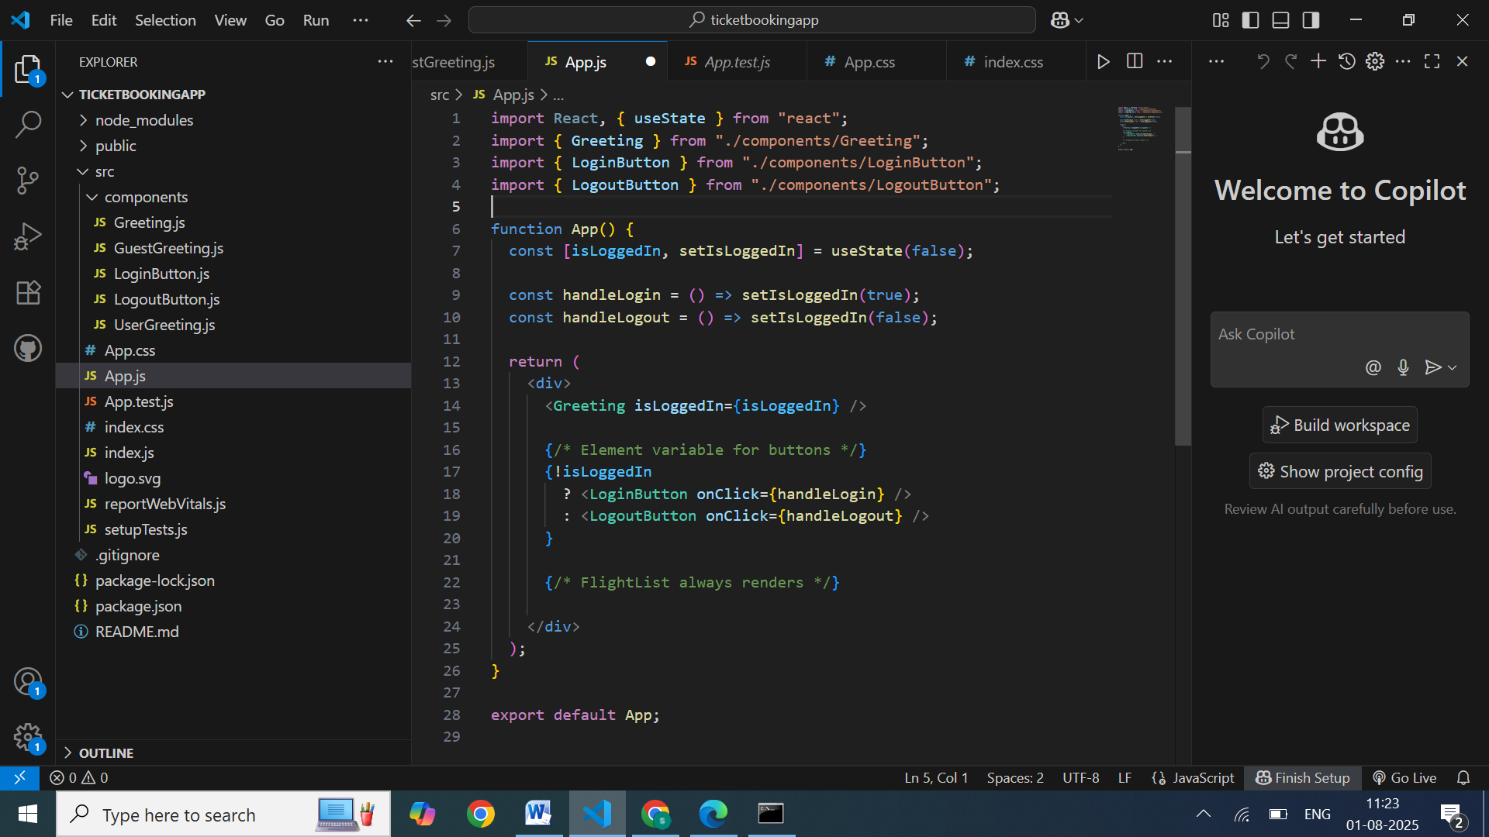

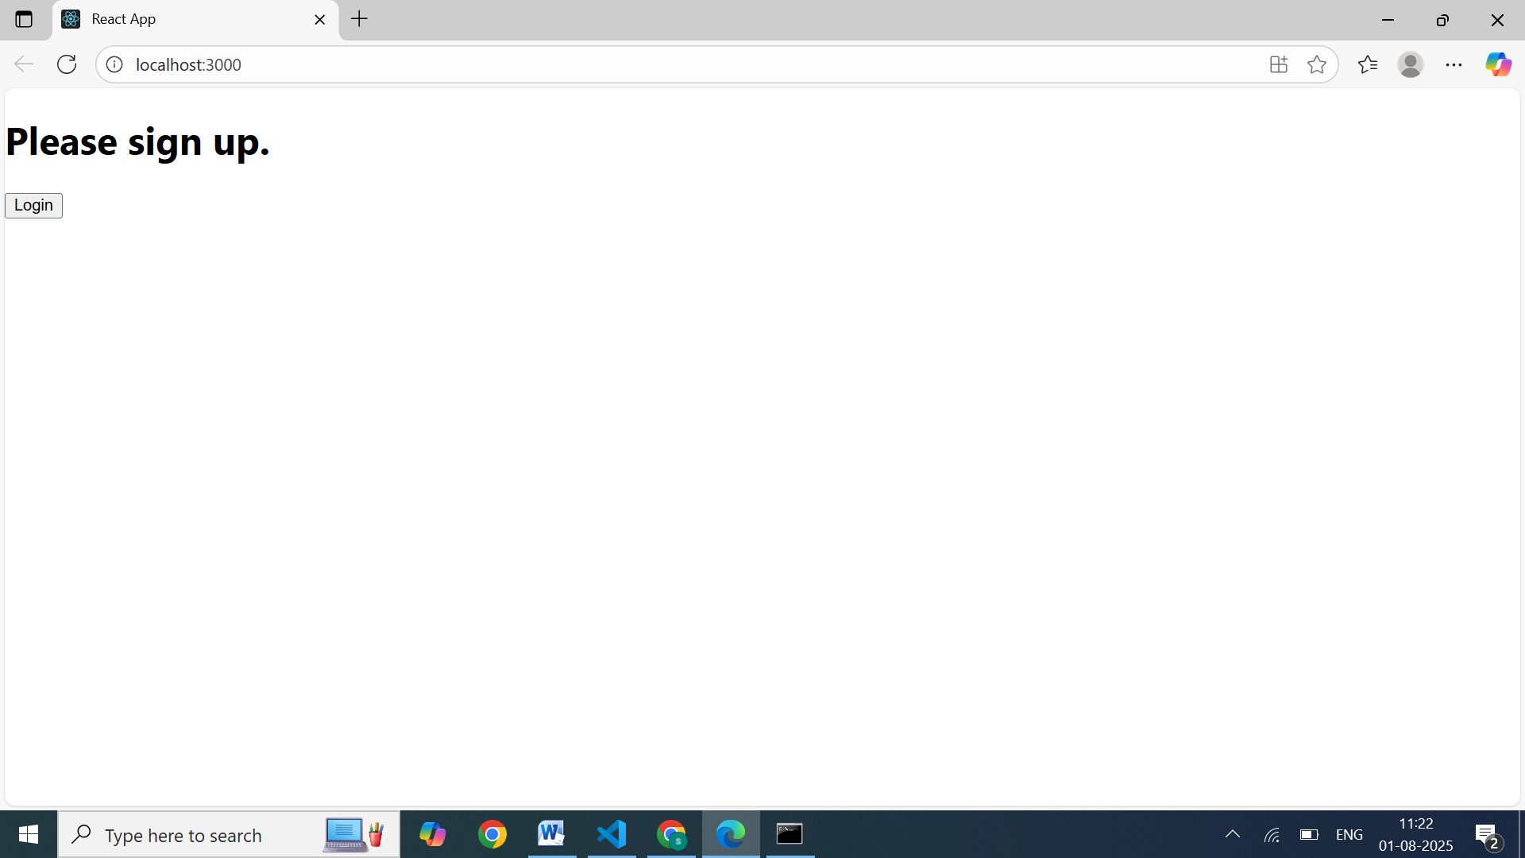

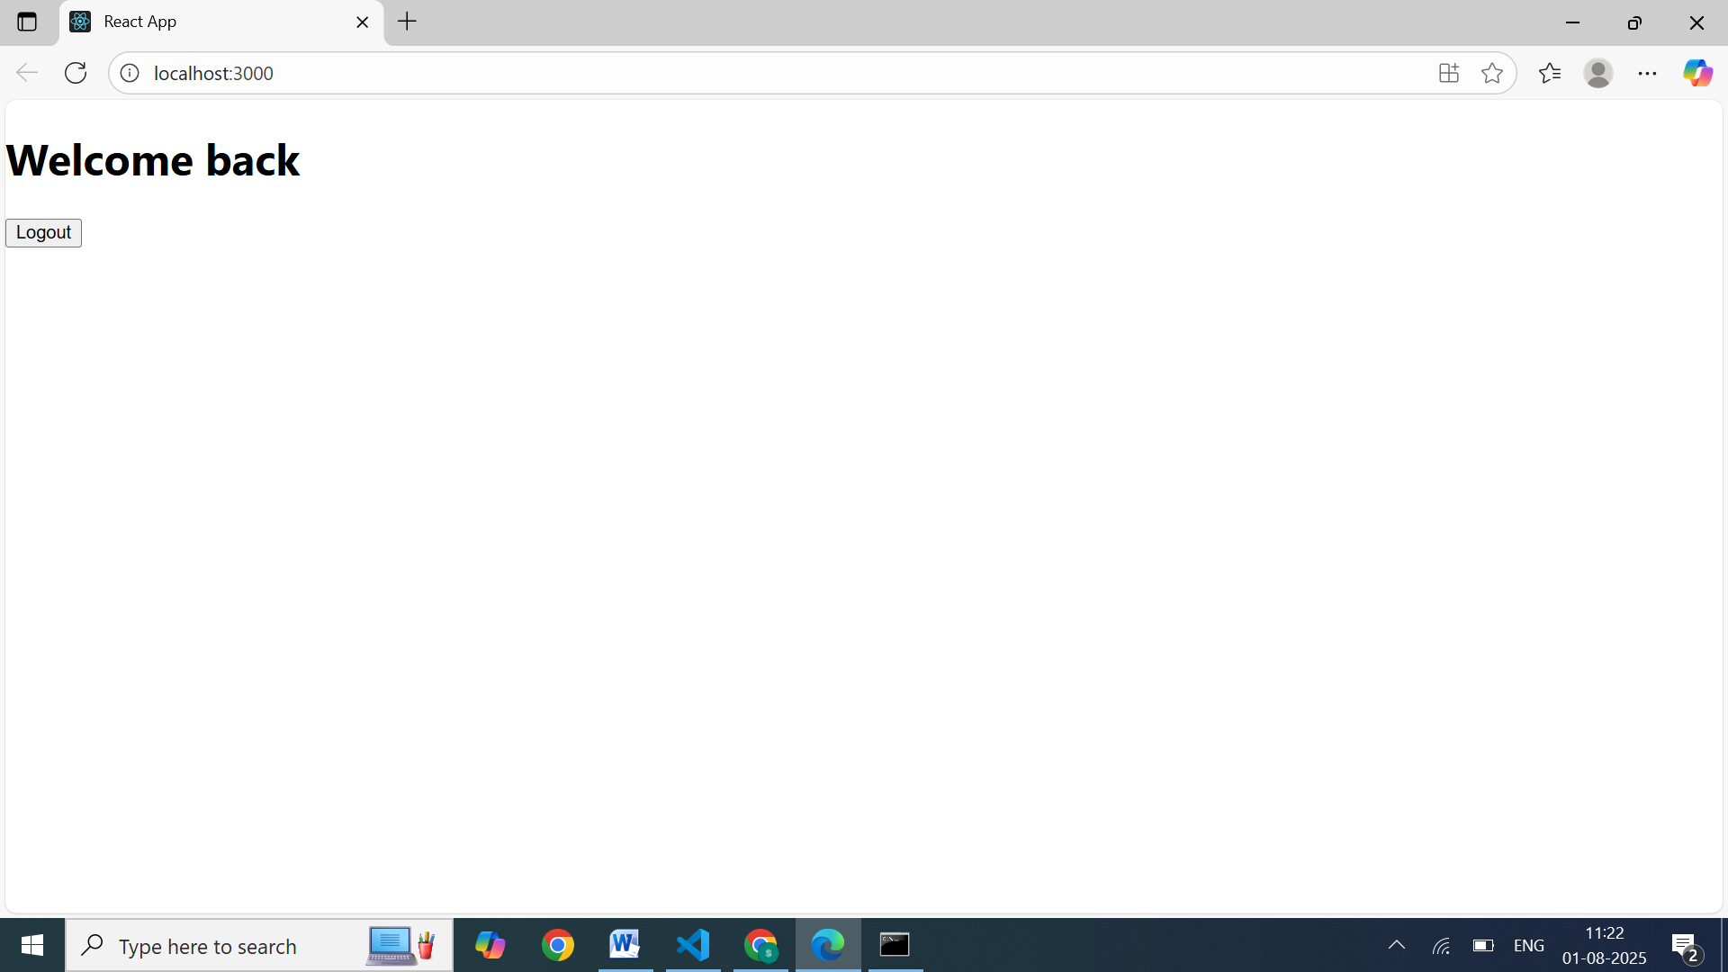

## **HANDS-ON - 05:**

## **Objectives**

* Explain various ways of conditional rendering
* Explain how to render multiple components
* Define list component
* Explain about keys in React applications
* Explain how to extract components with keys
* Explain React Map, map() function

In this hands-on lab, you will learn how to:

* Implement conditional rendering in React applications

## **Prerequisites**

The following is required to complete this hands-on lab:

* Node.js
* NPM
* Visual Studio Code

## **Notes**

Estimated time to complete this lab: **60 minutes.**

Create a React App named “bloggerapp” in with 3 components.

1. Book Details
2. Blog Details
3. Course Details

Implement this with as many ways possible of Conditional Rendering.

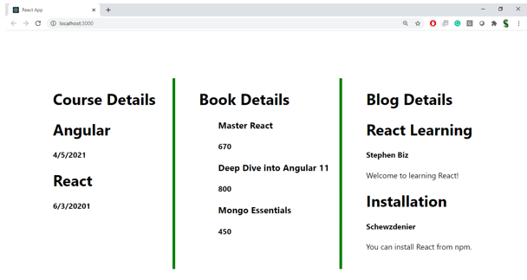

**Hint:**

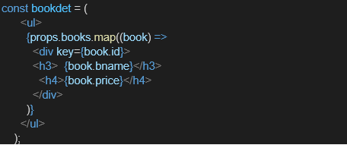

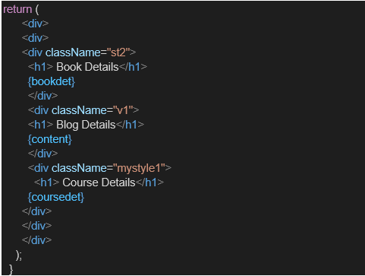

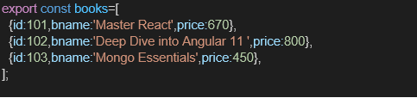

**CODES:**

BlogDetails.js

import React from 'react';

export default function BlogDetails() {

  return (

    <div className="column">

      <h2>Blog Details</h2>

      <div><strong>React Learning</strong><br /><em>Stephen Biz</em><br />Welcome to learning React!</div>

      <div style={{ marginTop: '1rem' }}><strong>Installation</strong><br /><em>Schewzdiener</em><br />You can install React from npm.</div>

    </div>

  );

}

BookDetails.js

import React from 'react';

export default function BookDetails() {

  return (

    <div className="column">

      <h2>Book Details</h2>

      <div><strong>Master React</strong><br />670</div>

      <div style={{ marginTop: '1rem' }}><strong>Deep Dive into Angular 11</strong><br />800</div>

      <div style={{ marginTop: '1rem' }}><strong>Mongo Essentials</strong><br />450</div>

    </div>

  );

}

CouseDetails.js

import React from 'react';

export default function CourseDetails() {

  return (

    <div className="column">

      <h2>Course Details</h2>

      <div><strong>Angular</strong><br />4/5/2021</div>

      <div style={{ marginTop: '1rem' }}><strong>React</strong><br />6/3/2021</div>

    </div>

  );

}

