**Topics: Descriptive Statistics and Probability**

1. Look at the data given below. Plot the data, find the outliers and find out $μ, σ, σ^{2}$

|  |  |
| --- | --- |
| **Name of company** | **Measure X** |
| Allied Signal | 24.23% |
| Bankers Trust | 25.53% |
| General Mills | 25.41% |
| ITT Industries | 24.14% |
| J.P.Morgan & Co. | 29.62% |
| Lehman Brothers | 28.25% |
| Marriott | 25.81% |
| MCI | 24.39% |
| Merrill Lynch | 40.26% |
| Microsoft | 32.95% |
| Morgan Stanley | 91.36% |
| Sun Microsystems | 25.99% |
| Travelers | 39.42% |
| US Airways | 26.71% |
| Warner-Lambert | 35.00% |

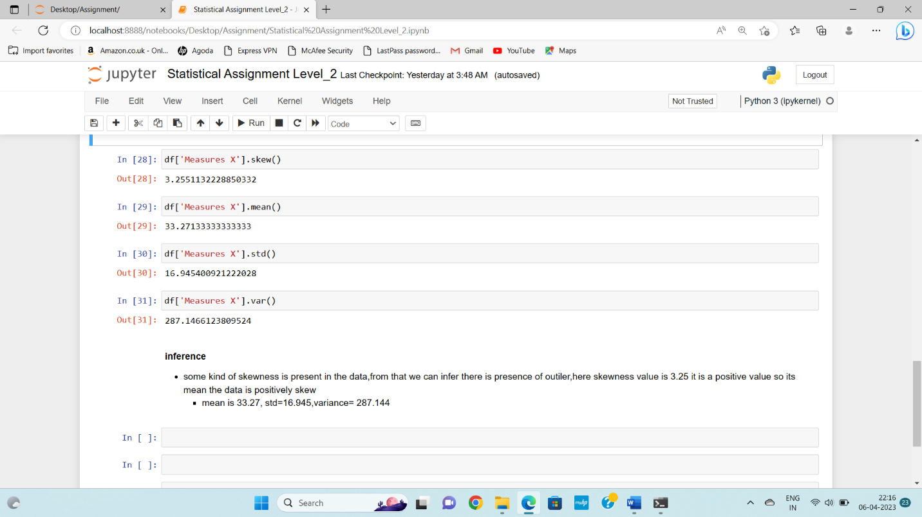



Answer the following three questions based on the box-plot above.

1. What is inter-quartile range of this dataset? (please approximate the numbers) In one line, explain what this value implies.

Ans:- IQR=Q3-Q1

15-5=10

1. What can we say about the skewness of this dataset?

Ans:- it is a right skew,hence we can say that mean>median

1. If it was found that the data point with the value 25 is actually 2.5, how would the new box-plot be affected?

Ans : In this case there would be a no outlier.



Answer the following three questions based on the histogram above.

1. Where would the mode of this dataset lie?

Ans: In between 4-7,mode is lie because this two bins are equally same .

1. Comment on the skewness of the dataset.

Ans: From given histogram we can infer that it is right skew, because at the right side data is sightly increase to 25 so we can say that outlier is present in upper extreme.

1. Suppose that the above histogram and the box-plot in question 2 are plotted for the same dataset. Explain how these graphs complement each other in providing information about any dataset.

Ans : Histogram and Boxplot, both are use to identify outlier in the data set, but boxplot show that clear image of the outlier, mean, skewness.

1. AT&T was running commercials in 1990 aimed at luring back customers who had switched to one of the other long-distance phone service providers. One such commercial shows a businessman trying to reach Phoenix and mistakenly getting Fiji, where a half-naked native on a beach responds incomprehensibly in Polynesian. When asked about this advertisement, AT&T admitted that the portrayed incident did not actually take place but added that this was an enactment of something that “could happen.” Suppose that one in 200 long-distance telephone calls is misdirected. What is the probability that at least one in five attempted telephone calls reaches the wrong number? (Assume independence of attempts.)

Ans: Given – One in 200 long-distance telephone call is misdirected.

To find - What is the probability that at least one in five attempted telephone calls reaches the wrong number

Solution – probability of one in 200 long-distance telephone call is misdirected.

P = 1/200

Probability of getting not of call misdirected q = 1-1/200 = 199/200

No. of call = 5, n= 5

P(x) = ⁿCₓpˣqⁿ⁻ˣ

Probability of getting at least one in five attempted telephone calls reaches the wrong number

1 – probability or getting call not reaches wrong number

1 – p(0)

1 - ⁵C₀(1/200)⁰(199/200)⁵⁻⁰

1 – (199/200)^5

1 – 0.9752

0.025

The probability that at least one in five attempted telephone calls reaches the wrong number is 0.025

1. Returns on a certain business venture, to the nearest $1,000, are known to follow the following probability distribution

|  |  |  |  |
| --- | --- | --- | --- |
| x | P(x) | E(x) = ∑ x *p(x) | E(x)^2=∑ x^2*p(x) |
| -2,000 | 0.1 | -200 | 400000 |
| -1,000 | 0.1 | -100 | 100000 |
| 0 | 0.2 | 0 | 0 |
| 1000 | 0.2 | 200 | 200000 |
| 2000 | 0.3 | 600 | 1200000 |
| 3000 | 0.1 | 300 | 900000 |
|  |  | 800 | 2800000 |

1. What is the most likely monetary outcome of the business venture?

Ans: most likely monetary outcome of the business venture is 2000 because it has maximum probability 0.3

1. Is the venture likely to be successful? Explain

= 0.

Ans: Venture is successful if X is positive(+ve)

Hence, X is 1000,2000,& 3000 and probability is 0.2 + 0.3 +0.1=0. 6

Hence the venture is successful.

1. What is the long-term average earning of business ventures of this kind? Explain

Ans : E(x) = ∑ x.p(x) = 800

So $800 is the long term average earning of business ventures.

1. What is the good measure of the risk involved in a venture of this kind? Compute this measure

Variance (x) = E(x)^2- (E(x))^2

2800000 – 640000 = 2160000

SD = √var =√2160000 = 147

Variability is high so risk is quite high.