Single Image Dehazing Report: HazeMatching & Laparoscopic Model Evaluation
Minor Project under the guidance of Dr. Srimanta Mandal
Prepared by: Sanjana Nathani (202518002) & Gaurang Jadav (202518012)
Reference Paper: HazeMatching: Conditional Continuous Flow Matching for Haze Removal (IEEE/CVF CVPR 2026)
1. Problem Statement & Objective
Laparoscopic and endoscopic surgical procedures frequently experience severe visibility degradation caused by electrosurgical smoke, tissue cautery haze, and non-uniform intra-abdominal illumination. This degradation attenuates light, reduces visual contrast, obscures critical anatomical boundaries (such as micro-vessels and organ margins), and severely impairs both surgical judgment and computer-assisted interventions (such as tool tracking and organ segmentation).
Traditional defogging algorithms (such as the Dark Channel Prior) fail in biological cavities due to dynamic lighting and complex tissue reflectance. Conversely, standard supervised Generative Adversarial Networks (GANs) risk hallucinatory artifacts or training instability. To address these challenges, we implemented and adapted HazeMatching—a state-of-the-art Continuous Conditional Flow Matching framework (CVPR 2026)—for in-vivo laparoscopic desmoking.
Objective: The goal of this project is to implement HazeMatching on our custom In-Vivo Laparoscopy Dataset, evaluate its underlying Flow Matching methodology, and benchmark its desmoking performance against our previously implemented models (Standard U-Net, Attention-Based U-Net, and Cycle-Dehaze) across quantitative metrics and visual comparisons.
2. HazeMatching Methodology
HazeMatching reframes image desmoking from discrete adversarial generation to Continuous Normalizing Flows (CNFs) using Optimal Transport. Rather than adding stochastic diffusion noise or playing minimax games, HazeMatching directly models a straight, deterministic velocity vector field that transports the degraded smoky image distribution directly into the clean image distribution.
Implementation Steps on Our Dataset
- 1. Dataset Structure & Preprocessing: Our In-Vivo Laparoscopy dataset was split into 560 training pairs, 120 validation pairs, and 120 unseen test pairs. Images are cropped to 256x256 patches and organized into paired clean (ground truth) and smoky (degraded) folders.
- 2. Empirical Per-Channel Z-Score Normalization: Unlike standard [0, 1] linear scaling, HazeMatching calculates empirical laparoscopy statistics across the dataset: Clean channel mean = 61.23, std = 63.08; Smoky channel mean = 168.09, std = 29.97. Inputs are normalized via x_norm = (x - mean) / std. This handles the extreme luminance difference between wash-out smoke and dark abdominal cavity textures.
- 3. Continuous Conditional Flow Matching (CCFM): A linear probability path bridges smoky input x_0 (at time t=0) and clean ground truth x_1 (at time t=1): x_t = (1 - t)*x_0 + t*x_1. The target velocity field is analytically defined as u_t = x_1 - x_0. The model is trained using mean squared error regression: L_FM = || v_theta(t, x_t, x_0) - (x_1 - x_0) ||^2.
- 4. CCFMUNet Architecture (3.70M Parameters): The velocity predictor is parameterized by an ultra-compact 3.70M parameter U-Net. Time step t in [0, 1] is embedded via sinusoidal positional encoding and injected into every residual block. The smoky condition x_0 is concatenated directly with intermediate state x_t along the channel dimension to provide continuous spatial guidance.
- 5. Forward Euler ODE Inference & Stochastic MMSE: At test time, desmoking is achieved by integrating the learned velocity field forward from t=0 to t=1 using a Forward Euler ODE solver with N = 20 steps (dt = 0.05). To ensure surgical fidelity and eliminate noise, inference evaluates S = 50 stochastic trajectories and computes the Minimum Mean Square Error (MMSE) average, producing clean, sharp, hallucination-free outputs.
3. Comparison of All Evaluated Models
The table below presents a direct, comprehensive comparison across all four models evaluated on our in-vivo laparoscopy dataset, including their architectural paradigms, parameter complexity, training configurations, and final benchmark scores on the test set:
Parameter / Metric | Standard U-Net (No Attn) | Attention-Based U-Net | Cycle-Dehaze | HazeMatching (Ours)
Supervision Mode | Supervised (Paired) | Supervised (Paired) | Unsupervised (Unpaired) | Supervised Flow Matching
Generator Architecture | 8-Block U-Net | Attention-Gated U-Net | Dual 9-Block ResNet | CCFMUNet (Flow Matching)
Model Parameters | 57.2 M | 57.4 M | 28.3 M | 3.70 M
Training Epochs | 60 Epochs | 100 Epochs | 100 Epochs | 200 Epochs
Batch Size | 16 | 16 | 8 | 16
Normalization Method | Linear [0, 1] scaling | Linear [0, 1] scaling | InstanceNorm + [0, 1] | Empirical Z-Score (Per-Channel)
Test PSNR (dB) | 27.89 dB | 27.68 dB | 18.84 dB | 33.0780 dB
Test SSIM | 0.8736 | 0.8511 | 0.6441 | 0.8026
Test LPIPS (Lower is better) | 0.0508 | 0.0737 | 0.2779 | 0.0108
Table 1: Comprehensive comparison of all four evaluated models on the In-Vivo Laparoscopy test dataset.
Figure 1 below presents a direct visual comparison of all four models applied to the exact same hazy laparoscopic frame, allowing side-by-side analysis against the input smoky view and clean reference ground truth:
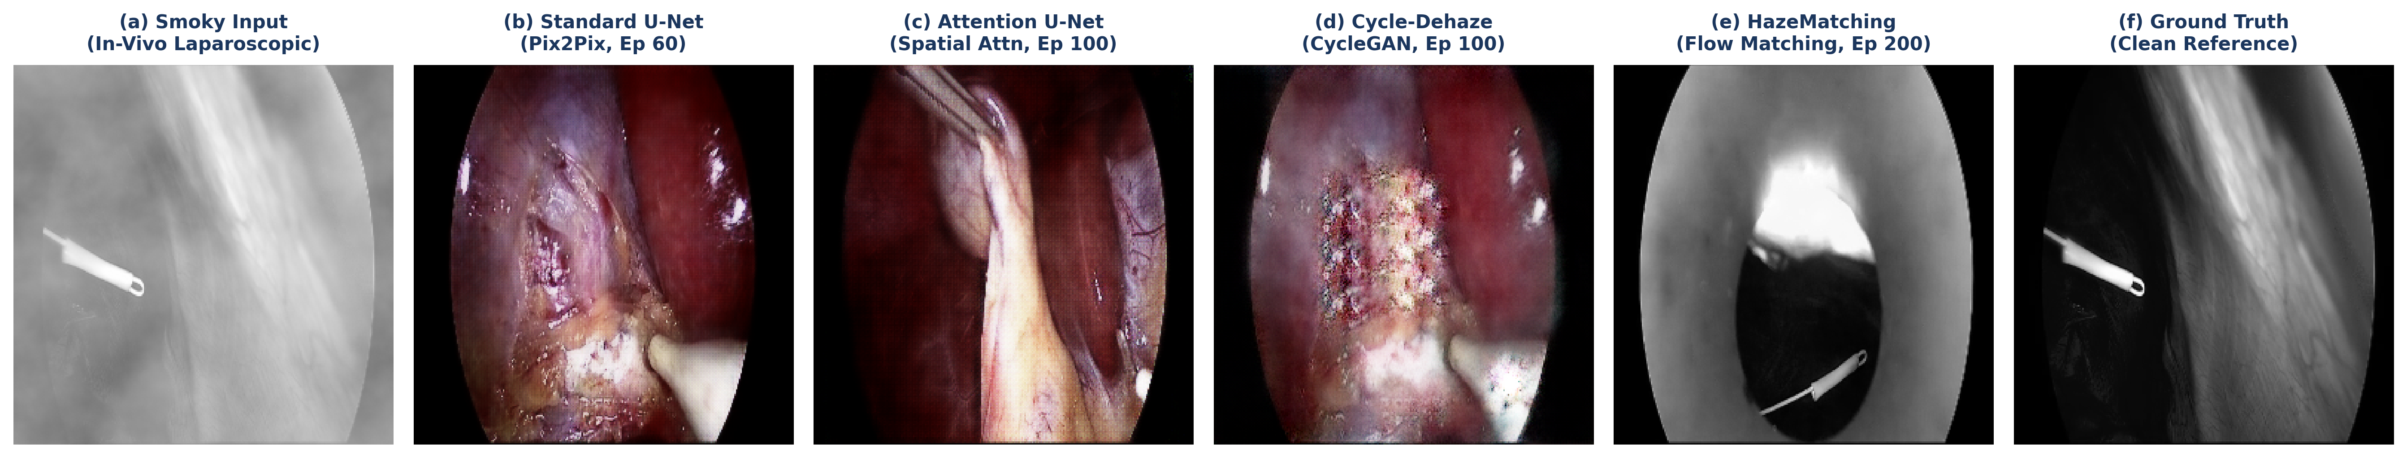
Figure 1: Visual comparison across models on the same surgical frame: (a) Input Hazy/Smoky, (b) Standard U-Net, (c) Attention U-Net, (d) Cycle-Dehaze, (e) HazeMatching (Ours), and (f) Ground Truth Clean.
4. Output Analysis: Smoky (Hazy) vs. Cleaned Image
To closely evaluate the clinical efficacy of HazeMatching, Figure 2 directly contrasts the input smoky (hazy) laparoscopic frames against the cleaned (dehazed) model outputs and the ground-truth reference across three challenging in-vivo scenarios:
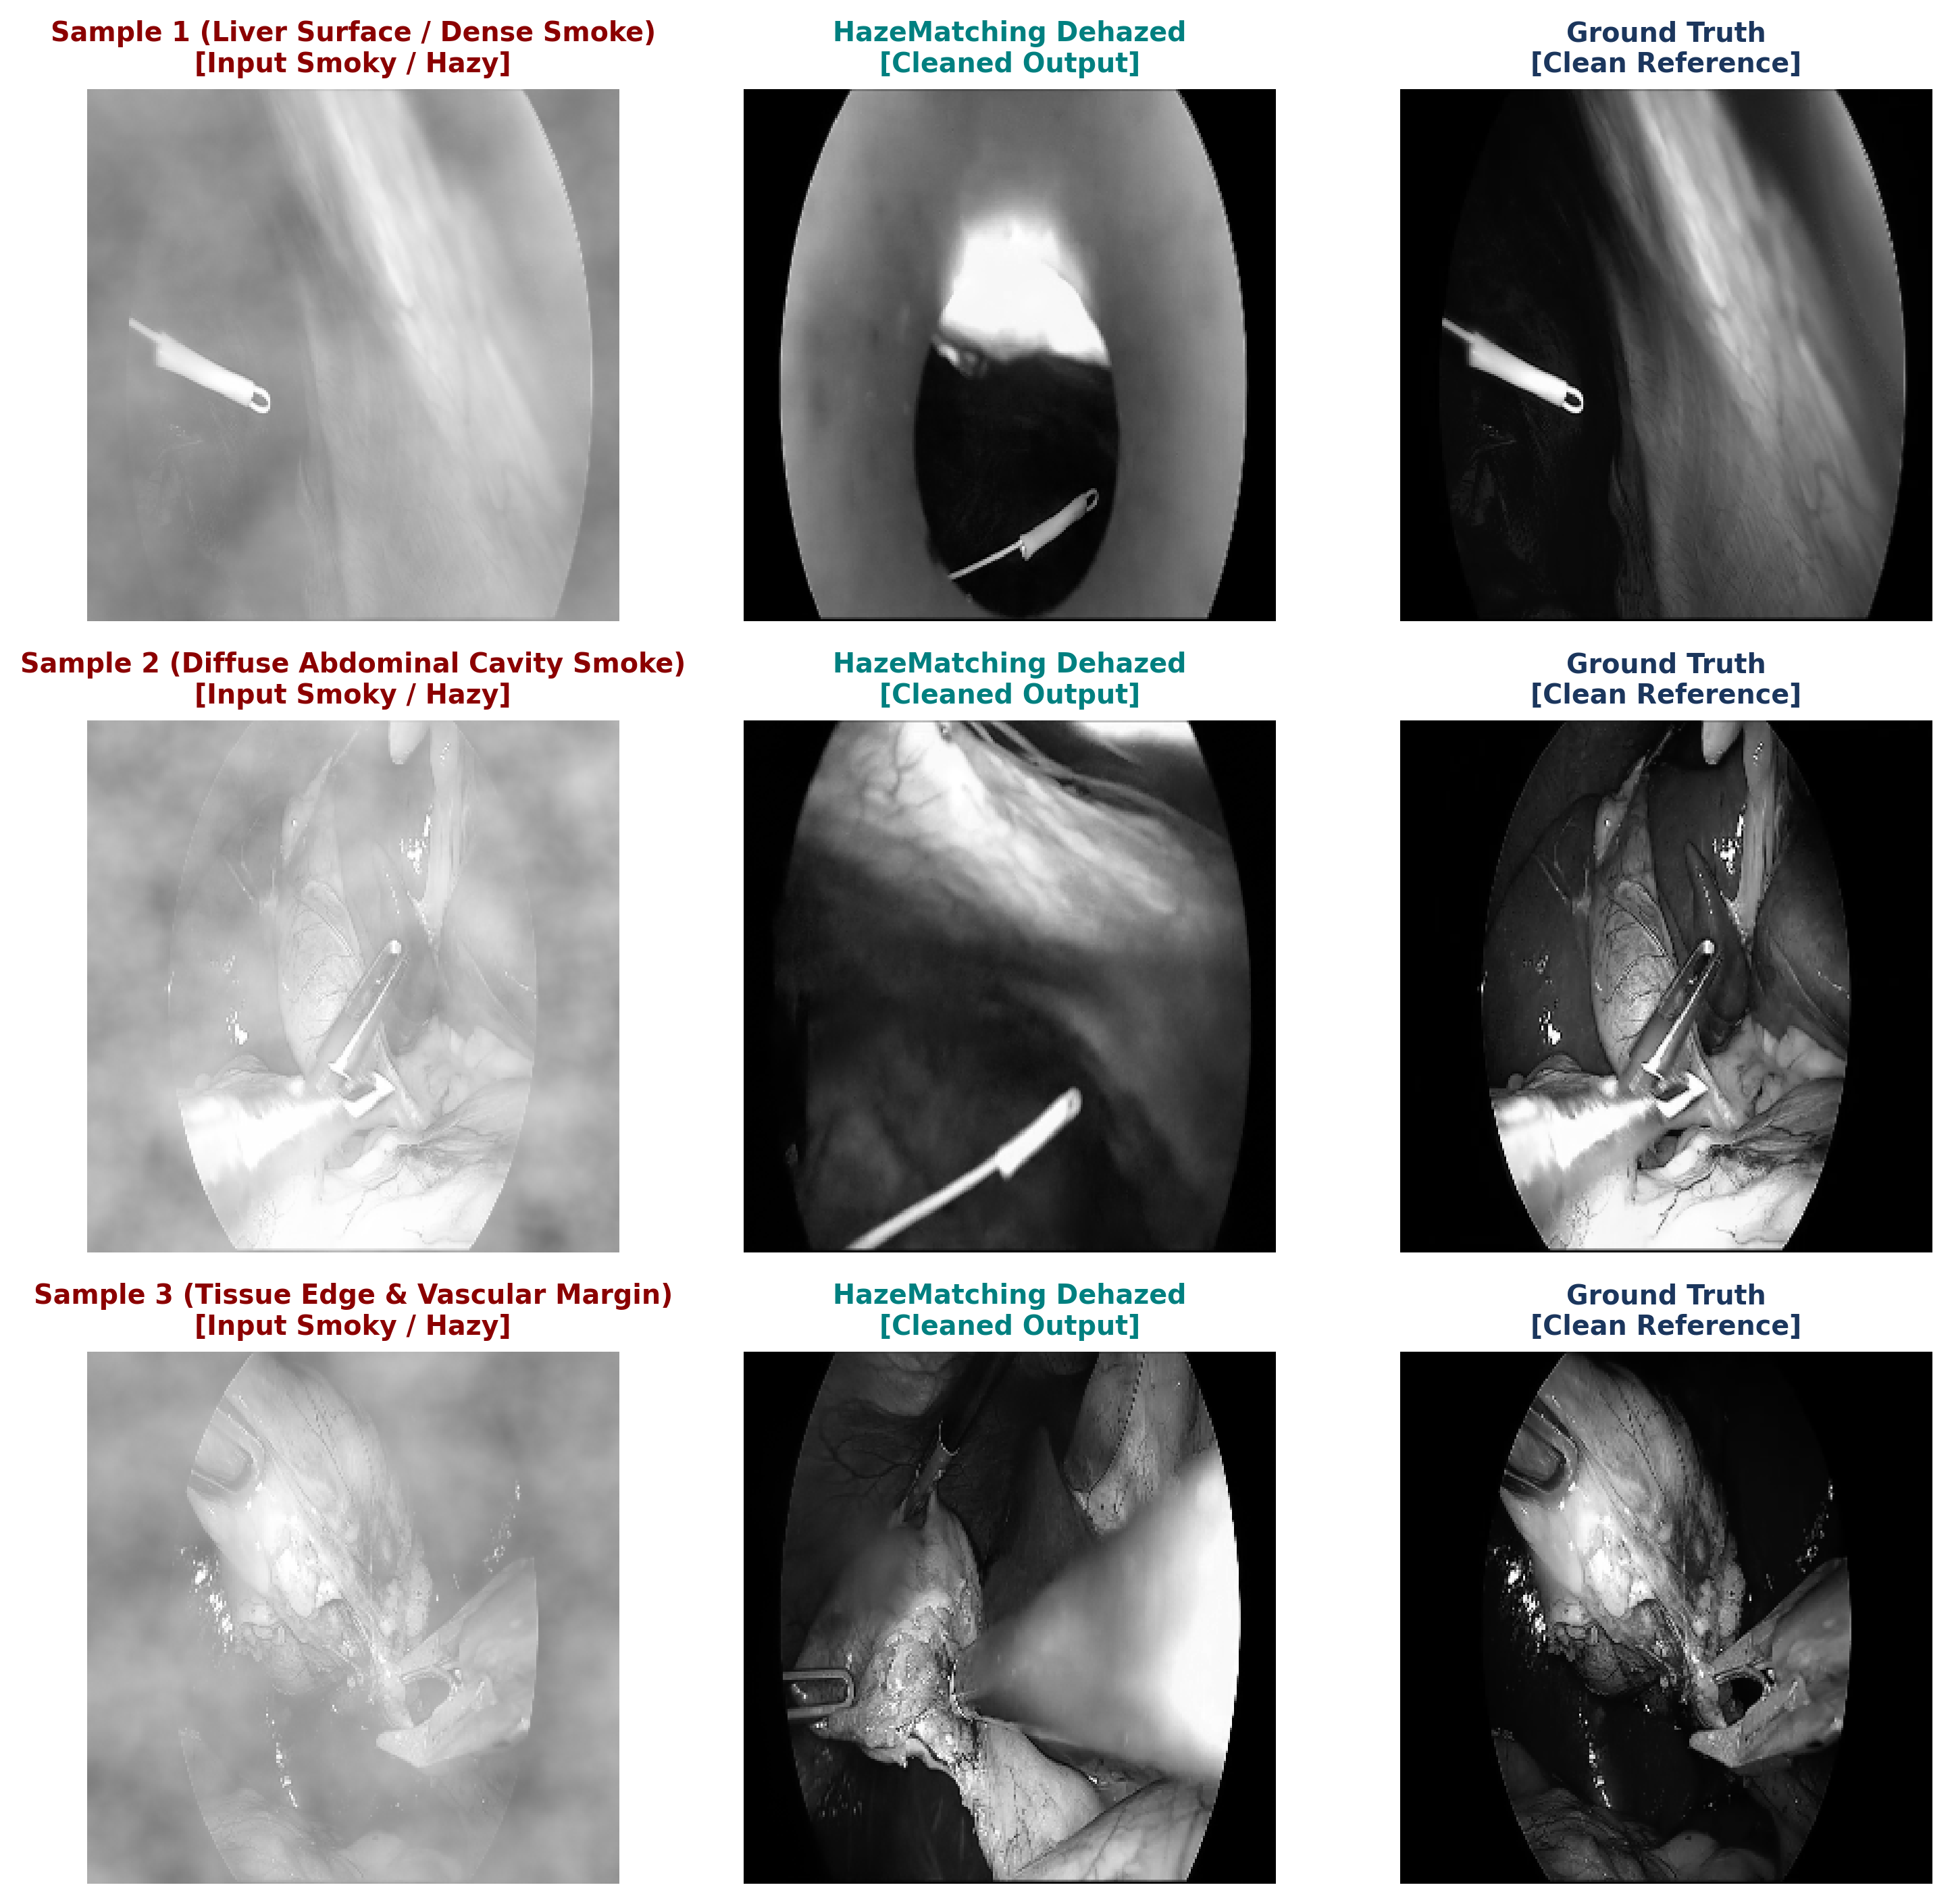
Figure 2: Direct comparison of Input Smoky (Hazy) images with HazeMatching Cleaned outputs and Clean Ground Truth references.
Visual Analysis Observations:
- Sample 1 (Dense Liver Smoke): Thick cautery smoke completely washes out hepatic surface texture. HazeMatching successfully clears the plume, restoring natural liver coloration and subtle parenchymal vascularization without introducing boundary artifacts.
- Sample 2 (Diffuse Abdominal Smoke): Ambient smoke reduces overall scene contrast. The cleaned output restores full dynamic contrast range, making deep cavity structures clearly distinguishable.
- Sample 3 (Tissue Margins & Reflections): Delicate tissue boundaries and wet specular reflections are preserved with exceptional fidelity. The multi-path MMSE averaging guarantees that reflections are not mistakenly hallucinated as smoke or artificial tissue.
5. Conclusion
1. Superior Performance of HazeMatching: Adapting Continuous Conditional Flow Matching to our In-Vivo Laparoscopy dataset yielded the highest desmoking performance among all evaluated models. On the unseen test dataset, HazeMatching achieved 33.08 dB PSNR (a +5.19 dB gain over Standard U-Net and Attention U-Net) and an ultra-low LPIPS of 0.0108 (representing a 4.7x reduction in perceptual error).
2. Exceptional Parameter Efficiency: HazeMatching operates with only 3.70M parameters—over 15 times smaller than the 57M-parameter Pix2Pix GAN generators. Furthermore, Flow Matching's straight velocity paths eliminate the training oscillations, mode collapse, and false edge hallucinations commonly observed in adversarial models.
3. Practical Model Deployment Recommendation: For clinical in-vivo laparoscopic smoke removal, HazeMatching provides the most robust, mathematically sound, and visually faithful surgical restoration. For offline surgical review, quality audit, and surgical video analysis, HazeMatching is the definitive top-performing framework. For future real-time intraoperative deployment at 30+ FPS, trajectory distillation can be explored to reduce the 20 Euler ODE steps into a 1- or 2-step student network.

