**ShoeBrand WEBSITE**

Skills required: HTML, CSS

This is a basic ShoeBrand website that displays variety of shoes as the content and has a menu button which displays few options on the site. This a responsive website in which the formatting style changes based on the Window width.

We’ll attach a picture of our website about how it is supposed to look after your corrections. Below we have given the details on what needs to be corrected. Go through carefully and do the appropriate changes in the style.css file that we have provided.

*Things to be changed in the website(corrections):*

1. Change the font style to ‘Roboto’
2. In the logo ‘ShoeBrand’, change the ‘Brand’ part to red colour.
3. In the logo ‘ShoeBrand’, change the font weight to Bold.
4. Keep the hero image width to 100% when in 680-920px window width
5. Display a pointer when the cursor hovers on the menu button.
6. Inside the menu button, for the lists shown, change the list style type to none.
7. Inside the menu button, for the lists shown, change the bg colour to grey when hovered.
8. Make the close button to float on the right.
9. Change the font size of h1 to 2rem.
10. If the window width is more than 920px:
11. Change the hero img width to 50%
12. Make the close button to disappear on the screen.
13. When hovered on the menu functions, change the text decoration to underline.

Expected Website:

680-920px window:

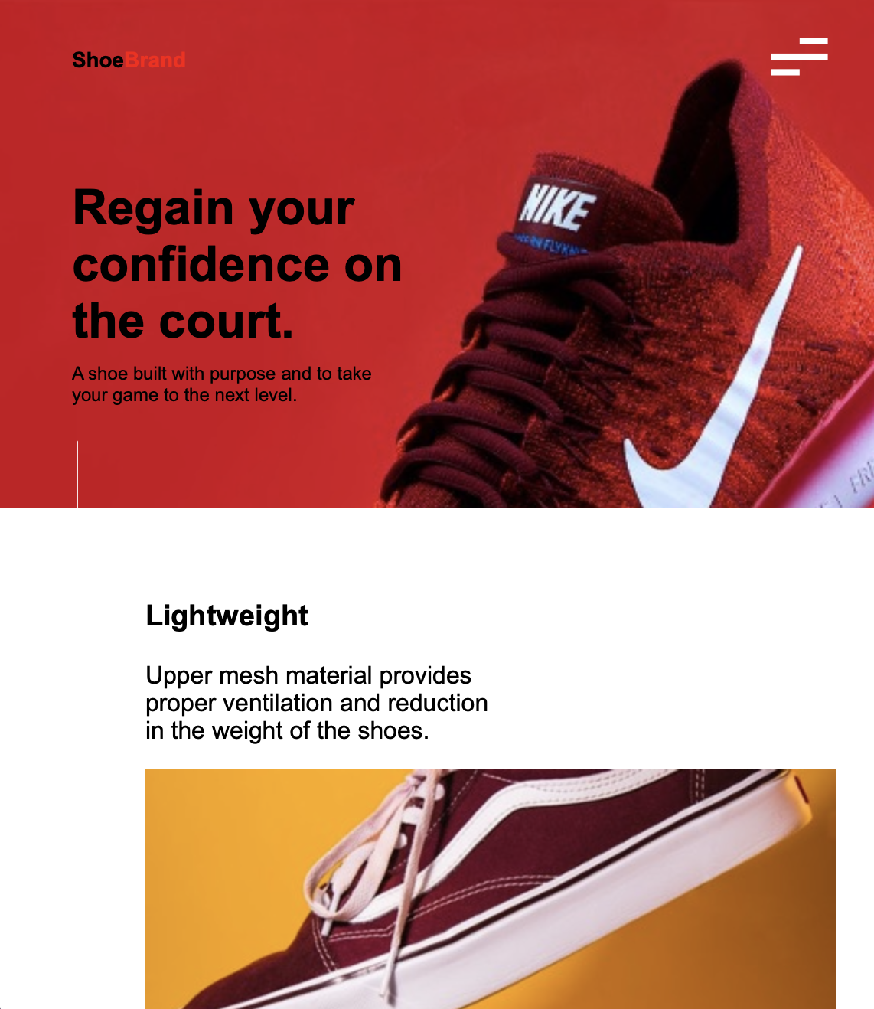

When menu button is clicked:



Min window width: 920px

