Product Enhancement Specification (PES)
© Dassault Systèmes | Confidential Information | ref.: 3DS_Document_2020
Function Title: Extended Collaborations Control Center: Modify (content) of a Collaboration

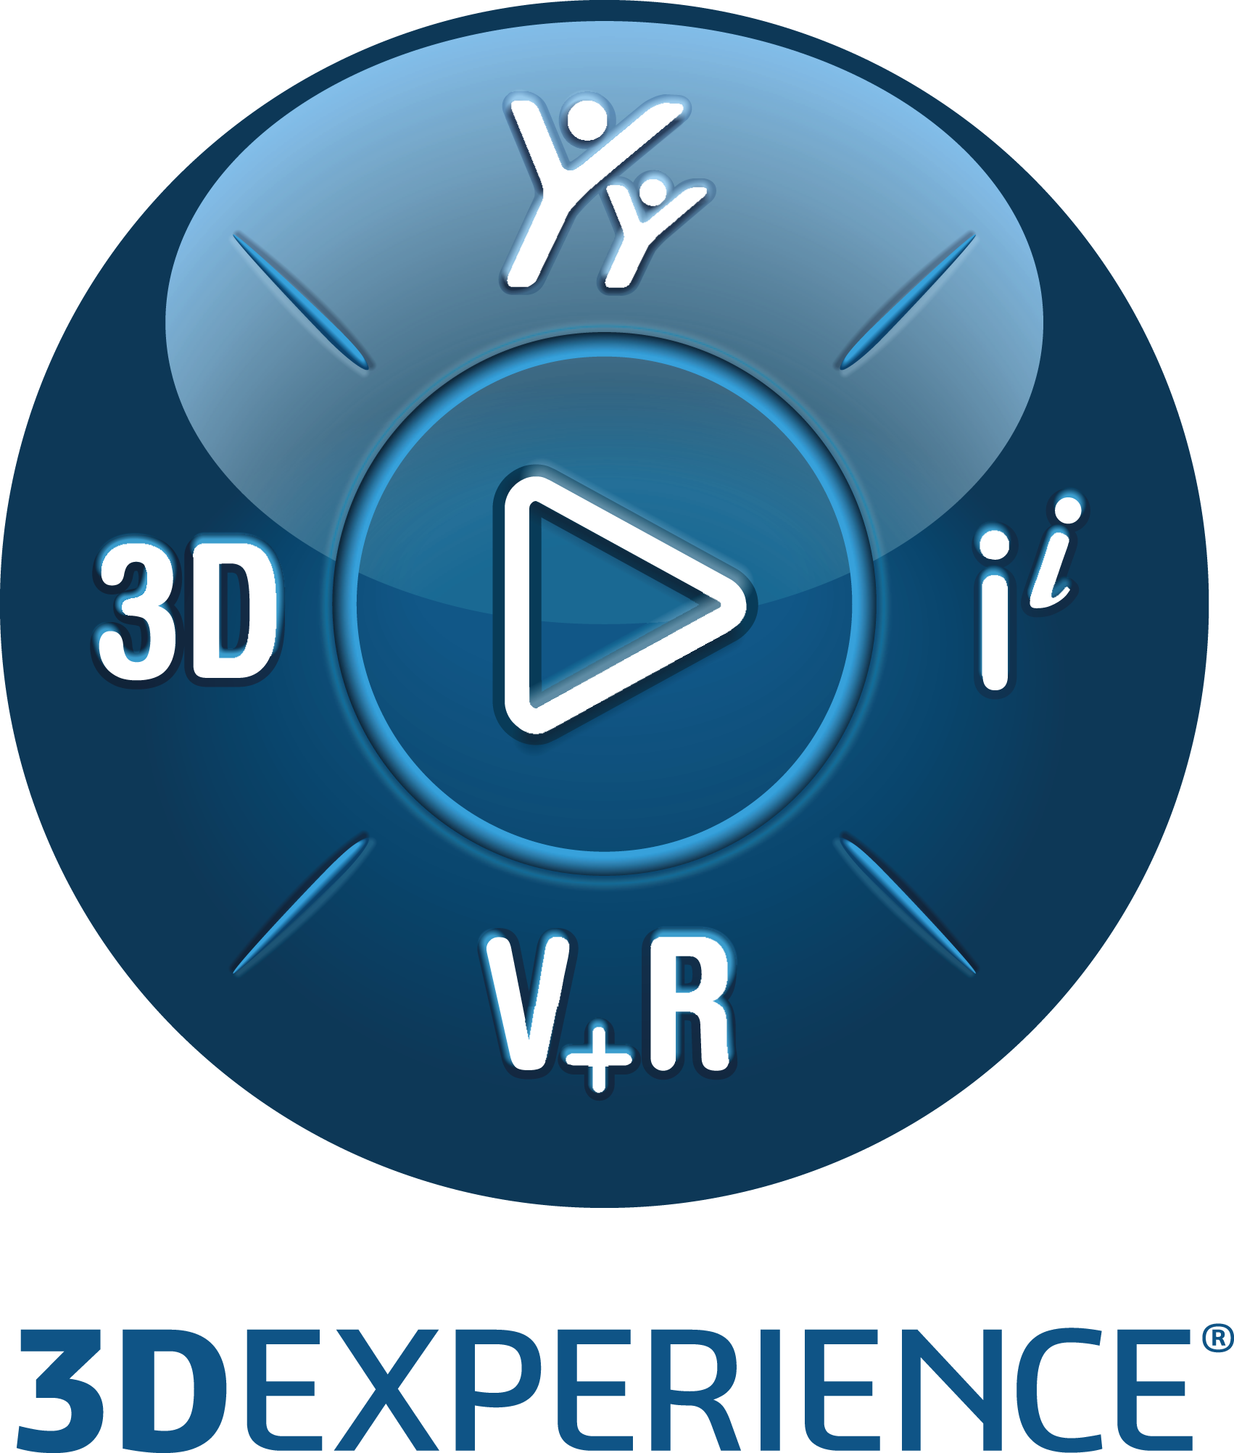

Function and PES Owner ID
Function ID | PES Owner Name | PES Owner Role
FUN137740 | Y. WALLIER | Service/App/Component Manager


Section 1: High-level specifications 3
1. Related requirement(s) 3
2. What will the customer use this for? 3
3. What the function will do 3
4. What the function will not do 11
5. Commercial packaging 11
Section 2: Detailed Specifications 12
1. Packaging 12
2. User experience and interactions 12
3. Data management 17
4. Customization by end user or administrator 18
5. Programming interface 18
Section 3: Quality of services 20
1. Performance, capacity and salability (PCS) 20
2. Security controls 20
3. Data privacy 21
Section 4: Acceptance Test Protocols 22
1. Functional Acceptance Tests 22
2. Limit & Negative Acceptance Tests 24
3. Performance/Capacity/Scalability Acceptance Tests 25
4. Page Objects usage by acceptance tests 26
Section 5 (optional): 3DSpace Baseline Behavior Support 27
Section 6 (optional): PES related material 28
1. Reference Materials 28
2. PES Authoring Rules Checklists (if relevant) 28
Template Life trace 29

For more information on completing the PES, refer to the PES Authoring Best Practices. This document provides detailed instructions to fill some specific parts of the PES
Important: To HIDE/unhide all instructions (which appear like this):
Toggle the ¶ symbol in Word paragraph options, or
In Word, go to File Options Display Hidden text

Section 1: High-level specifications

Provide a global understanding of the function scope: why must it be developed? What will it do and not do? How does this new functionality relate to what the product/component already does?
Note: The “High-level specifications” and “Acceptance test protocol” sections must be clear and complete enough to enable reviewers to assess that this function will satisfy its associated requirement(s).
This section can then be shared with DS customers through a Customer Answer.
If this PES is to be shared via an extracted Customer Answer (CA) document: ensure it does not contain anything relating to another customer, including within the proposed solution, the document name, and the table below. To learn more about producing an externally viewable PES, see Customer Answer Best Practices.
- Related requirement(s)
Identify the requirements driving this function.
Requirement & Target | Details
Customer or DS Team | DS Team
Related Elementary Requirement ID | None
If this PES answers similar requirements from different customers, repeat the “Customer” row in the table above for each customer. If the requirement is internal to DS, list “DS Team” as the customer.
- What will the customer use this for?
Summarize the need for the function. Explain here how the function fits into the customer’s use case and how it enables or improves the ability of the customer to perform their activities. Define the end user profiles to which this function applies.

The modification of a collaboration content (Community, Collaborative Space, Bookmark, Project) is now possible

- What the function will do
Provide a clear and concise overview of what the function will do to satisfy the requirement, in terms of external behavior.
  - Concepts
Explain the concepts that the customers of this function have to understand in order to use it. Define the vocabulary used in later sections. Include a description of the User Data Model illustrated by data structure diagrams featuring entity types and their relationships if this information would be relevant and meaningful for an end user.
The proposed functionality is to extend the Extended Collaboration functionality while providing capability to modify full content of a collaboration after creation, and clarify behavior of title/description modification:
Note: Modification of the title and the description of a collaboration is already possible but propagation of the modification on contents (Dashboard, Community, Bookmark, Project) is not clearly defined. One of the objective of this highlight is to clearly define all behaviors.
As a brief reminder:
- The 'Extended Collaborations Control Center‘ is an App provided by ‘Integrated Engineering Collaboration Service’, available through the 3DCompass.

- The 'Extended Collaborations Control Center‘ App allows a platform administrator to create an Extended Collaboration and invite members to the Collaboration. Members can access to the collaboration through a Dashboard with several predefined tabs.

  - Function capabilities overview

The 'Properties tab in Edit mode', allows to modify, remove or add some of the information of the collaboration.
It displays below the header of the Open Collaboration widget view, the same content than the Create a Collaboration panel.
 Only Collaboration which state is Activated can be modified.
Collaboration in Deactivated state can only be browsed.
In case of the administrator running the modification is not a member of the leading team, some of the modification may fail due to lower privilege, missing access right.
To prevent such a case, the administrator is informed when opening the edit mode, with an info bubble that he may have some trouble, and he is invited to become member of the Leading Team before any modification.
You are not a member of this collaboration.
It is recommended to add you first as a member of the Leading team before doing any modification.
Please, refer to Create a Collaboration section to get all resources behavior and limitations.
All the fields are valuated with previous state of the collaboration (creation, or the last modification).
The fields, which are not allowed to be modified, are disabled.
Below table lists all resources, and for each of them, possible action in the 'Properties tab in Edit mode':
Resource | Modifiable | Possible action
Collaboration Identification
Collaboration Title |  | Can rename the collaboration.  Impact on content titles: Title of content (Dashboard, CollaborativeSpace, Community, Project, Bookmark) cannot be directly modified through the Extended Collaborations Control Center app, but it can be impacted by the Collaboration title modification:  • For 'collaboration' content (content created by the collaboration, or by another collaboration and reused by this collaboration), which title is same than the current collaboration title (taking into account title length specificities), title of the content is automatically changed to the new collaboration title value.  • For 'non collaboration' content (content created outside any collaboration and reused by this collaboration), or for 'collaboration' content which title differs (taking into account title length specificities) from the collaboration title, title of the content is not modified.  Content created Content title same as collaboration title Content title modified  Outside a Collaboration By a Collaboration  Y N Y/N N  N Y N N  N Y Y Y    Changing the collaboration title will systematically change titles of internal User Groups and Organizations created to manage Members within the collaboration and (Dashboard, CollaborativeSpace, Community, Project) contents
Collaboration Description |  | Can change or empty the description.  Impact on content descriptions: Description of content (Dashboard, Community, Project, Bookmark) cannot be directly modified through the Extended Collaborations Control Center app, but it can be impacted by the Collaboration description modification:  Description modification follows the same rules than the Title modification:  - For 'collaboration' content (content created by the collaboration, or by another collaboration and reused by this collaboration), which title is same than the current collaboration title (taking into account title length specificities), description of the content is automatically changed to the new collaboration description value.  - For 'non collaboration' content (content created outside any collaboration and reused by this collaboration), or for 'collaboration' content which title differs (taking into account title length specificities) from the collaboration title, description of the content is not modified.  Content created Content title same as collaboration title Content title modified  Outside a Collaboration By a Collaboration  Y N Y/N N  N Y N N  N Y Y Y
Collaboration 'Team'
'Leading Team' |  |   Can rename the 'Leading Team'.  Changing the LeadingTeam title will systematically change titles of corresponding internal 'LeadingTeam' User Group and Organization created to manage LeadingTeam Members within the collaboration and (Dashboard, CollaborativeSpace, Community, Project) contents.
'Partner Team' |  |   Can rename a 'Partner Team'.  Changing the PartnerTeam title will systematically change titles of corresponding internal 'PartnerTeam' User Group and Organization created to manage PartnerTeam Members within the collaboration and (Dashboard, CollaborativeSpace, Community, Project) contents.    Can remove a 'Partner Team'.  Removing a PartnerTeam title will systematically remove corresponding internal 'PartnerTeam' User Group and Organization (missing service) created to manage PartnerTeam Members within the collaboration and (Dashboard, CollaborativeSpace, Community, Project) contents.  Can change the capacity of a 'Partner Team'.   Cannot change the capacity to a lower value than the number of members already defined for the 'Partner Team'. Capacity is automatically reseted to the actual number of members.  Can add ⁽¹⁾ a new 'Partner Team'.
Collaboration Content
Dashboard |  | None:Title cannot be edited and is disabled.  Title changes when collaboration title is changed.
Collaborative Space |  | Can change the Collaborative Space from status (new/reuse) to target status (new/reuse)  New/reuse a Collaborative Space may lead to previous Collaborative Space deletion ⁽²⁾.  For Collaborative Space which Title is the same title than the Collaboration, changing the collaboration title will automatically change the Collaborative Space Title to the new collaboration title value.
Community |  | Can enable / disable Community usage.  Can change the Community from any initial status (none/new/reuse) to any target status (none/new/reuse)  None/New/reuse a Community may lead to previous Community deletion ⁽²⁾.  For Community which Title is the same title than the Collaboration, changing the collaboration title will automatically change the Community Title to the new collaboration title value.
Project |  | Can enable / disable Project usage.  Can change the Project from any initial status (none/new/reuse) to any target status (none/new/reuse)  None/New/reuse a Project may lead to previous Project deletion ⁽²⁾.  For Project which Title is the same title than the Collaboration, changing the collaboration title will automatically change the Project Title to the new collaboration title value.
Bookmark |  | Can enable ⁽¹⁾ / disable Bookmark usage.  Can change the Bookmark from any initial status (none/new/reuse) to any target status (none/new ⁽¹⁾/reuse ⁽¹⁾)  None/New/reuse a Bookmark may lead to previous Bookmark deletion ⁽²⁾.  For Bookmark which Title is the same title than the Collaboration, changing the collaboration title will automatically change the Bookmark Title to the new collaboration title value.
Note:
  - ⁽¹⁾ Admin must be owner of the collaborative Space to be allowed to modify (new/reuse) some content or add a 'Team'.
  - ⁽²⁾ Deactivating or changing a (CollaborativeSpace, Community, Project, Bookmark) content:
In some case, deactivating or changing a (CollaborativeSpace, Community, Project, Bookmark) content may lead to previous content deletion:
Content created |  | Content still used  in another collaboration  (whatever the Activated/Deactivated status) | Content  deletion
Outside a Collaboration | By a Collaboration
Y | N | Y/N | N
N | Y | Y | N
N | Y | N | Y(*)
(*) Collaborative Space must be empty to be deleted. See Limitation#6.
More about (Dashboard, CollaborativeSpace, Community, Project, Bookmark) Title:
  - Title is always displayed whatever the corresponding toggle (optional content) is active or if no corresponding toggle (mandatory content).
  - Title is disabled (fig2) when the corresponding toggle (optional content) is inactive or when the content cannot be reused (Dashboard).
  - Cross appears when the content title is not the same than collaboration title, else it is not displayed.
☛ No cross means that the content can be renamed while renaming the Collaboration.
  - Cross can be used to modify the content to a new content with same title than the Collaboration
By default when entering in the 'Properties Tab in Edit mode':
- 'Edit' button is replaced by  and buttons.
Only 'Cancel' is enabled.
- Pushing the button close the 'Properties tab in Edit mode' and returns to the 'Properties' Tab.
- As soon as almost one resource has been modified, the  button becomes enable:

- As soon as almost one resource has been modified, the 'Close' button is replaced by:
  -  button: When pushing the 'Save' button, all modification done in the panel are committed.

  - In case of the modification leads to a (CollaborativeSpace, Community, Project, Bookmark) content deletion, an additional confirmation pop-up is displayed, requesting end-user to confirm his choice.
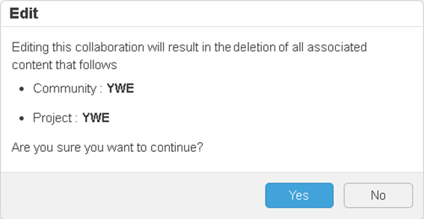
The message is adapted depending on the content(s) which will be deleted.
  - If end-user confirm the deletion, a ‘progress-bar' is displayed.
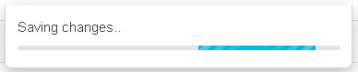
Once all modifications are processed (successfully committed or failed),
    - 'Properties tab in Edit mode' is closed and returns to the 'Properties' tab.
    - A bubble is displayed resuming, for each content, actions done on the Collaboration:
      - Content which has been renamed
      - Content which has been reused
      - Content which has been deleted
    -  As a Collaboration modification may create or modify data in several services in asynchronous mode, a modification can be partial.
In case of one of the modification cannot be done, an additional red bubble is displayed with the list of not done operation:
    - End-user has to change the resource leading to the error and try again to validate the modification.
History: All events done in the context of the modification are captured in the History tab as sub-events of a main 'modification' event. ﻿ ﻿ ﻿
 Collaboration was modified.
 Collaboration modification was partial.
 Collaboration failed to be modified.

With sub-events logging operations such as:
      - Modification of the title of the collaboration
      - Modification, new or empty of the description of the collaboration
      - Rename a team
      - Change capacity of a team
      - Add a new team
      - Remove a team
      - Add a new content, deactivate a content
  - : When pushing the No button, a confirmation request is sent to the user to confirm cancelation:
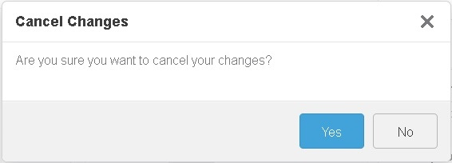
    - : If end user confirm the cancelation: all modifications since the initial state of the collaboration when entering in the 'Properties tab in Edit mode', or since the last 'Accept' (if any) are discarded.
Confirmation request panel is closed.
Close the 'Properties tab in edit mode' and returns to the 'Properties' tab.
    - : If end user doesn't confirm the cancelation:
Confirmation request panel is closed.
Returns to the 'Properties tab in edit mode' to allow end user to save or update the properties modification.

    - Modified capabilities: impact for end users
If the new capabilities replace existing features, detail here how the new usage compares to the previous usage. This is required to help the end users transition seamlessly to the new usage.
  - Limitations
Document the limits (or boundaries) of this function within the intended scope. Consider the expected behavior of the functionality under all circumstances, including possible usage errors or malicious use. Wherever possible, the usage of the function beyond its limits must be made impossible by construction or design.
If this function is not available on all supported platforms, specify the non-supported platforms here.
For each identified limitation, ensure that acceptance test coverage is provided.
    - Limitation #1: Cloud Only
Modification (and Extended Collaborations Control Center app) is not available for ‘On Premise’ platform
    - Limitation #2: Platform admin only
Modification (and Extended Collaborations Control Center app) is only accessible for Administrators. So in case of members decide modify a collaboration, Members have to contact Platform Administrator to perform the operation.
    - Limitation #3: No retry
In case of the modify collaboration fails to modify one of the content, the operation is partially done without automatic retry. Administrator has to remodify the collaboration to reapply missing operations.
    - Limitation #4: No rollback
Once modified, a collaboration cannot be roll backed any more.
    - Limitation #5: Not available for Collaboration with ‘Creation’ status
It is not possible to modify a collaboration in Creation, Failed or Deactivated status.
    - Limitation #6: Non empty collaborative space
It is not possible to delete a content’ Collaborative space’ in case of the collaborative space is not empty. Trying to modify and extended collaboration which leads to the deletion of a non-empty collaborative space will result in a partial modification. Extended collaboration will be modified but previous Collaborative space will be kept.
    - Limitation #7: No modification for non Leading team member
It is not possible for a non leading team member, even if platform administrator, to modify the Extended Collaboration. The Edit button is disabled.
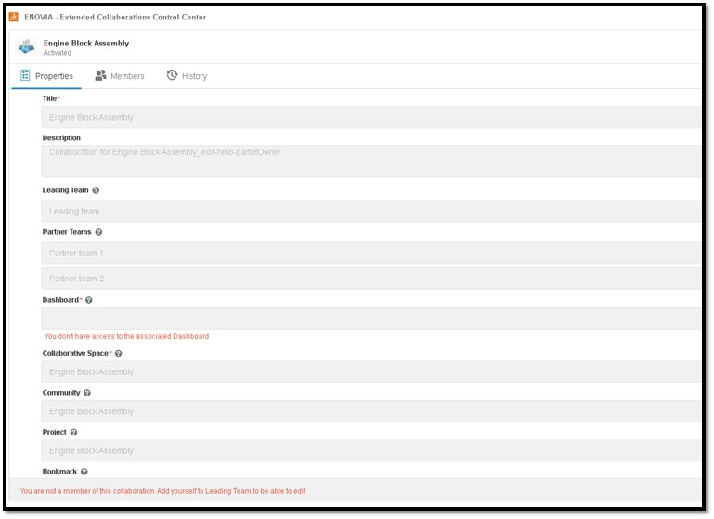
The administrator has first to read himself as a leading member using the ‘Members’ tab to be allowed to perform Properties modification.

- What the function will not do
If the function is not going to address some of the requested items of the associated Requirement PER(s), list these exceptions here:
NaN
- Commercial packaging
List here the Products/Role and App required to access the function.
Product (Role /App) in which the function will be available: The Edit button is only accessible for Administrators with 3D Product Architect (PAU) on Cloud in the Extended Collaborations Control Center App + Open the Collaboration + Enter Properties tab.

Section 2: Detailed Specifications
Expand on the Capability Summary provided above by detailing all aspects of the functionality.
- Packaging
If this function impacts the packaging, a Software Architect must be named in the role of Design Reviewer in the Function Planning. This assignment will create a “Design Task” task allowing the Software Architect to review the packaging changes via a dedicated Design Enhancement Specification “DES” and eventually to make the required packaging enhancements. For more information about “DES”, click here. If a Service or Component is involved, the associated “referential” may require an update.
If this function modifies the existing packaging, specify the necessary changes below. Include whether commercial pre-requisite products are required and, if so, whether these must be created. If packaging changes will affect pricing, explain this here.

For more information of this topic, refer to the “Packaging” section of PES Authoring Best Practices.
Required Information | Response
Does this function impact the packaging? | No Impact

Packaging items to be modified:
None

- User experience and interactions
For information on completing this PES section, refer to the PES Authoring Best Practices section “What about User Experience and Interaction”.
  - User interface
    - New UI components
If the function adds new UI “components”, (commands/dialog boxes/panels/widgets) list them in the table below.
Main purpose of the screenshot provided below is to highlight functionalities and UX resources positioning. Screenshot are sample and may slightly differ with final version.

Extended Collaborations Control Center modification:
Extended Collaborations Control Center app needs to provide a way to fully modify a collaboration taking into account collaboration contents (Organization, User groups, Dashboard, Community, Collaborative Space, Bookmark, Project) lifecycle.

Component List | New component behavior
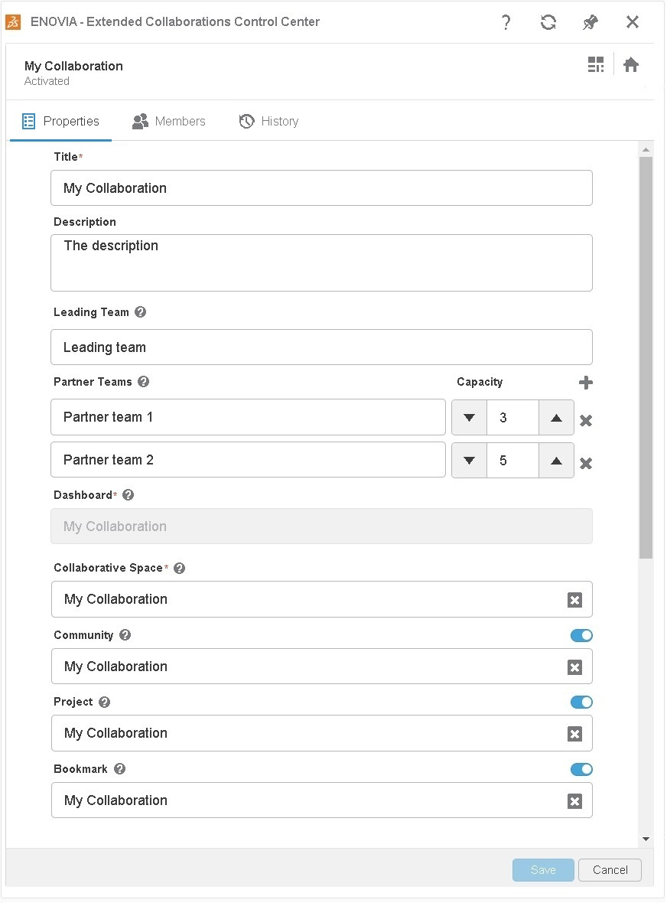 | It is now possible in edit mode to  - Change Content toggle definition (from use content, no use content)  - Change content value (from reuse to new, from new to reuse)  By default when entering in the 'Properties Tab in Edit mode':  Edit button is replaced by Save and Cancel buttons.  Only is enabled.  - Pushing the button close the 'Properties tab in Edit mode' and returns to the 'Properties' Tab.  - As soon as almost one resource has been modified, the button becomes enabled.  - If all modification are removed, the Save button becomes disabled again.  - When pushing the 'Save' button, all modification done in the panel are committed.  In case of the modification leads to a (CollaborativeSpace, Community, Project, Bookmark) content deletion, an additional confirmation pop-up is displayed, requesting end-user to confirm his choice.    The message is adapted depending on the content(s) which will be deleted.  -  If end-user confirm the deletion, a ‘progress-bar' is displayed.    Once all modifications are processed (successfully committed or failed),  - 'Properties tab in Edit mode' is closed and returns to the 'Properties' tab.  - A bubble is displayed resuming, for each content, actions done on the Collaboration:  - Content which has been renamed  - Content which has been reused  - Content which has been deleted   Your collaboration was saved with following changes - Dashboard title - Collaborative space title - Community new has been created - Community previous has been deleted - Bookmark reused is used - Team(s) capacity - Team(s) added  -  As a Collaboration modification may create or modify data in several services in asynchronous mode, a modification can be partial.  In case of one of the modification cannot be done, an additional red bubble is displayed with the list of not done operation:   Your collaboration failed to save following changes - Community title - 'Team' title  - End-user has to change the resource leading to the error and try again to validate the modification.  History: All events done in the context of the modification are captured in the History tab as sub-events of a main 'modification' event. ﻿ ﻿ ﻿  - Collaboration was modified.   Collaboration modification was partial.   Collaboration failed to be modified.  For instance (case of a modification while changing the collaborative space with a new one, whereas the previous was not empty and can’t be deleted):  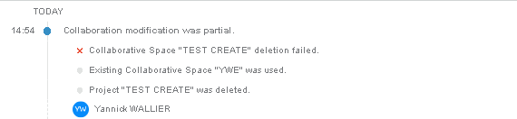  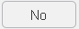 button: When pushing the 'Cancel' button, a confirmation request is sent to the user to confirm cancelation:    - : If end user confirm the cancelation: all modifications since the initial state of the collaboration when entering in the 'Properties tab in Edit mode', or since the last 'Accept' (if any) are discarded.  Confirmation request panel is closed.  Close the 'Properties tab in edit mode' and returns to the 'Properties' tab.  - : If end user doesn't confirm the cancelation:  Confirmation request panel is closed.  Returns to the 'Properties tab in edit mode' to allow end user to save or update the properties modification.

    - Modified UI components

If the function changes existing dialogs, specify below which dialogs are impacted and how. Explain also any change to information access (for instance if some properties will now be accessible through a different dialog.
Required Information | Response
Is the Current User Experience Impacted? | No
If the function impacts the current User Experience (an action can no longer be performed, default behavior is modified, etc.), a User Experience Expert must be named in the Function Plan. This will create a “UEE PES Review” task allowing the User Experience Expert to evaluate whether the impact is acceptable and, if so, how to minimize impact on the end user. If no User Experience Expert is available, assign the task to the App Manager.
Modified Component List | Modified behavior | New behavior

  - User assistance

    - Embedded user assistance (tooltips, UA panel, etc.)
List below the new or existing UI components (e.g: action bar command, dialog box, button, field) that require a change to embedded User Assistance
User-visible Title | Component type | New or updated | Brief description of change
Properties tab | Dialog box | Updated | Modify Panel allows more modifications

    - User documentation (optional)
If user documentation is required, describe the changes below.
Guide | Component type | New or updated | Brief description of change
Extended Collaboration Control Center | Doc | New | Modify Collaboration for administrator

Admin Collaboration guides is updated with the extended Modify behavior
Doc Admin | : Installation and Setup | Social and Collaborative | Structured Collaboration & Collaborative Content | Extended Collaboration Control Center

  - Page Objects
The Page Object Model is a design pattern that is becoming a standard for end-to-end automation of Web applications, its methods expose possible end-user interactions with the UI of the page/component. For more information of this topic, join the CHEETAH Automation Framework Swym community.
If the function has features with external visibility to be covered by a Quality Scenario, you have to deliver the necessary Page Objects on the Function’s “Test Task” in DSxRD.
Required Information | Response
Does your function require PageObject delivery? | Yes

If yes, provide the list of the page objects that will allow to programmatically interact with it.
    - Page Object PO-1 Name: ModifyCollaboration.po.js
Page objects will be updated with 3DEXPERIENCER2024xFD02
<Repeat as necessary>
Specify the acceptance tests that use the Page Object(s) here.
- Data management
Specify the user data that will be created while using the function.
  - Supported object types (run-time data and persistent data)
List the object types applicable to this function and their properties.
Not applicable

  - Expected behavior for each object type (run-time data and persistent data)
Create a matrix that describes the behavior of the function (rows) for each object type (columns). For more information, refer to the “ENOVIA Document tab” of this example.
Not applicable

  - Data persistency and/or upgrade (if applicable)
Specify which data created or modified by the function is persistent (i.e., data with a lifecycle that spans beyond the user’s session). Specify how/where/in what database, etc., each type will be managed.
Not applicable


Concerning existing data model structures, specify if there is a modification:
Required Information | Response
Does this function require a change to the data model schema? | No


If the migration batch has to be enhanced (for instance, if the previous data structure will no longer be handled by the application), indicate below that an upgrade procedure is needed:
Required Information | Response
Does this function require an upgrade procedure? | No

If you answer “yes” to either of the above two questions, ensure the corresponding information is set for the function in DSxRD Authoring.
Notes: Customer data loss is NOT permitted. “Data loss” means: the data is not upgraded and definitely lost or the data is migrated but no longer accessible to the end user without user actions. If a data upgrade is needed, dedicated Acceptance Tests must be created. These tests must specify the data sample used to perform the test and the method and criteria to verify the results of the data migration after upgrade. The developer and the QA leader must ensure the chosen samples contain sufficient data to test all data schema impacts.
    - Schema or other changes impacting multi-level compatibility
Specify whether this functionality is able to operate consistently with older releases or with products designed for interoperability. Identify the key compatibility aspects of this function in terms of both function behavior and data compatibility. For help on this topic, refer to the PES Authoring Best Practices section “What about Compatibility”.
  - Data repository
Specify the data repository used.

Required Information | Response
Is this function related to 3DEXPERIENCE 3DSpace Baseline Behavior? | No
If the answer is “YES”, you must complete the dedicated sub-section.
- Customization by end user or administrator
Describe any custom functionality that will accommodate a specific customer or User Role Profile. How does the user or administrator change the way the functionality behaves? Explain who can make changes and how they will do so. If this function makes customization available through a user interface check, a profile check, or a similar mechanism, describes this here or in the External View section.
Not applicable

- Programming interface

Required Information | Response
Does this function provide APIs to clients? | No
If you answer “yes” to the above question, ensure the corresponding information “CAA Exposition” is also set for the function in DSxRD Authoring.
  - Detailed API description (if relevant)
For help on this topic, refer to the PES Authoring Best Practices section “What about API”.
Not applicable

  - Automation for command journaling (if relevant)
Specify here whether new commands created by this function (if any) will be exposed for automation and for availability in journaling.

Not applicable

Section 3: Quality of services

Specify the “nonfunctional” qualities of service (performance, capacity, scalability, ) and security controls (Confidentiality, Integrity, Availability...) related to the requested functionality.
- Performance, capacity and salability (PCS)
Evaluate and specify the PCS objectives for industrial usage of this function. For more information of this topic, refer to the “What About Performance, Capacity and Scalability (PCS)” section of PES Authoring Best Practices.
Definitions:
Performance - Time and system resources required to complete a set of scenarios
Capacity - Number of concurrent users supported by a given hardware configuration
Scalability - Ability to add proportional amounts of workload and resources while maintaining performance
  - Performance objectives:

The Extended Collaboration Control Center App opens a Collaboration in Edit mode in less than 2 seconds
The Extended Collaboration Control Center App modifies a collaboration (with no impact on any content) in less than 3 seconds (for instance while adding the reuse of an existing bookmark).
See FUN129899: Integrated Engineering Collaboration Service PCS
  - Capacity objectives:
See FUN129899: Integrated Engineering Collaboration Service PCS
  - Scalability objectives:
See FUN129899: Integrated Engineering Collaboration Service PCS
  Required Information | Response
Are PCS tests provided with the function? | No
If yes, specify the tests in the dedicated section.
If you answered “no” or “Non Applicable” explain why briefly:

- Security controls

For more information on this topic, refer to the “What about: Security Control” section of PES Authoring Best Practices.
Required Information | Response
Does this function comply with security control rules for maintaining safe function usage? | Yes
If you answered “No” or “Non-Applicable” to the above question, explain why briefly:
Click or tap here to enter text.
Specify the detailed security controls available to the end user of this functionality. For help on this topic, refer to the “Security Control” section of PES Authoring Best Practices. The list below is not exhaustive; add topics as needed.
  - Confidentiality
Not applicable
  - Integrity
Not applicable
  - Availability
Not applicable
  - Authentication
Not applicable
  - Authorization
Not applicable
- Data privacy
According to Data Privacy laws (more information in Ethics & Compliance at 3DS community), including GDPR, a personal data is any information that can identify directly or indirectly an individual (e.g. name, userid, cookies, IP Address).
All 3DS products must comply with the following rules (more information in R&D Data Privacy – 3DS as a software vendor community, ask for access rights if needed).
- Transparency: list of processed personal data (including cookies) and list of third parties to which personal data are transferred (e.g. Outscale, AWS and Huawei) are not modified by your function – else, contact your R&D Data Privacy Director.
- Minimization: collect and use only needed personal data for a defined retention period.

- Respect of data subject rights: possibility to access, modify and delete personal data.

For more information of this topic, refer to the “What about: Data Privacy” section of PES Authoring Best Practices.
Required Information | Response
Does this function comply with 3DS obligations related to the use and protection of personal data? | Yes

If you answered “No” or “Non applicable” to the above question, explain why briefly:
Click or tap here to enter text.

Section 4: Acceptance Test Protocols
Specify the testing that will be done to demonstrate that this function works as specified. Acceptance tests are expected to work in the integrated code base at or before the FCF gate, before QA takes over the function for a more thorough suite of tests.
Acceptance Tests must cover each capability and limitation described in the previous sections. Each test definition must include objective criteria to assess whether the test produced the expected results. Automated tests should be delivered whenever possible.
- Functional Acceptance Tests
Functional acceptance tests demonstrate that the expected results are obtained or that the expected behavior occurs for each aspect of the new or modified functionality when used as intended. This includes testing of specific topics as applicable: embedded user assistance, data upgrade, etc.
  - Functional AT-1 Name: Nominal case of collaboration modification

    - What’s being tested?
Test modification of extended collaborations with reused and new contents
    - Test data
With Bookmark editor App, create a bookmark named MyBookmark
    - Test protocol
Create a collaboration COLLAB01 with
- Description = DESCRIPTION_COLLAB01
- No Project
- New Community
- Reuse Bookmark MyBookmark
Create a collaboration COLLAB02 with
- New Project
- Reuse community COLLAB01
- Reuse MyBookmark
Edit COLLAB01
- Rename COLLAB01 in COLLAB01_NEW
- Change description to DESCRIPTION_COLLAB01_NEW
Edit COLLAB02
- Deactivate Project
- Deactivate Community
- Deactivate Bookmark
Confirm modification
    - Related automatic tests
None
- Test verification
When modifying COLLAB01:
- After modification
  - Check below list of objects has been renamed and description updated:
    - Project, Dashboard, Collaborative Space, community named COLLAB01_NEW
  - Check that below list of objects are not modified accessible
    - Bookmark MyBookmark
When modifying COLLAB02:
- Check you receive a confirmation panel informing that Project will be deleted
- After modification
  - Check below list of objects are no more accessible:
    - Project named COLLAB02
  - Check that below list of objects are still accessible
    - Community COLLAB01
    - Bookmark MyBookmark

    - Test responsibility
R&D/QA

  - Functional AT-2 Name: Cancel collaboration modification
<Repeat as necessary>
    - What’s being tested?
Test that canceling the modification has no effect on objects.
    - Test data
None
    - Test protocol
Create a collaboration COLLAB00 with
- Description= DESCRIPTION
- No Project
- New Community
- New Bookmark
Modify COLLAB00
- Description changed to NEW DESCRIPTION
- Title Changed to COLLAB_NEW
- Deactivate Project
- Deactivate Community
- Deactivate Bookmark

Cancel modification
    - Related automatic tests
None
- Test verification
- Check COLLAB00 has not changed after modification cancel operation
- Check that COLLAB00 is still displayed in the list of collaborations
    - Test responsibility
R&D/QA

- Limit & Negative Acceptance Tests
Limit and negative acceptance tests demonstrate that the software handles boundary cases correctly and that appropriate warning and error messages are produced.
  - Limit & Negative Test LN-1 Name: Partial deletion of content

    - What’s being tested?
Test that collaboration is modified even if modification is partial due to a not possible deletion of Project content
    - Test data
Platform admin ADM1 with PAU & XPP roles
Platform admin ADM2 with PAU role
    - Test protocol
ADM1 create a collaboration COLLAB03 with
- New Project
- New Community
- New Bookmark
ADM2 modify the collaboration COLLAB03
- Deactivate Project
- Change Bookmark to already existing MyBookmark bookmark
    - Related automatic tests
None
    - Test verification
When modifying COLLAB03:
- Check you receive a confirmation panel informing that Project will be deleted
- After deletion
  - Check Community COLLAB03 still exists
  - Check Bookmark COLLAB03 has been deleted
  - Check you receive a bubble error
 | Your collaboration failed to run following deletion  - Project COLLAB03

    - Test responsibility
  - Limit & Negative Test LN-2 Name: No modification for a non Leading team member

    - What’s being tested?
Test that collaboration can’t be modified if administrator is not a member of the leading team
    - Test data
Platform admin ADM1 with PAU & XPP roles
Platform admin ADM2 with PAU & XPP roles
    - Test protocol
ADM1 create a collaboration COLLAB04 with
- New Project
- New Community
- New Bookmark
ADM1 enters in the Members tab (1)
- Add ADM2 as Leading Team member
- Removes himself from the Leading Team
ADM1 enters in the Properties tab
ADM1 enters in the Members tab
- Add himself as Leading Team member
ADM1 enters in the Properties tab (2)
- Edit the Collaboration
- Change the description of the Collaboration
    - Related automatic tests
None
    - Test verification

- (1) Check the Edit button is disabled and an error message is displayed

- (2) check the Edit button is available
- Description is successfully changed

    - Test responsibility
(optional) The developer has primary responsibility for executing this test. If applicable, specify who is additionally responsible for executing this test. For instance, User Experience Expert or User Assistance to check error messages.

(optional) The developer has primary responsibility for executing this test. If applicable, specify who is additionally responsible for executing this test. For instance, User Experience Expert or User Assistance to check error messages.

- Performance/Capacity/Scalability Acceptance Tests
Performance/Capacity/Scalability tests demonstrate that the software satisfies the PCS objectives defined in Section 3, Quality of Services
  - Performance/Capacity/Scalability AT-1 Name: None
Provide the detailed test description. Specify whether the functionality is new or whether it is an improvement to existing functionality. Explain the expected results.
Select the PCS test type.
    - What’s being tested?

    - Test protocol
Describe the step by step scenario.

    - Test data
Describe the usage and content of standard or specific/customer data.
Specify the size/amount of data.

    - Environment
Specify the necessary test execution environment.

    - Related automatic tests
Specify the names of the related Automatic Tests (ODT names), if any.

    - PCS Objectives
Specify the objectives and their level (UI level for end-user time perception and/or Algorithm level for instance)

    - Test execution timeframe and measurements
Specify for which master schedule gate these tests are planned to be run and which measurements will be taken. (Note: All Acceptance Tests are expected to work at FCF. If your target gate is later than FCF, please explain why.)

    - Limitations

- Page Objects usage by acceptance tests
List the Page Objects specified in the PES and the acceptance test(s), which test and validate them.
Page Object | Acceptance Test(s)

Section 5 (optional): 3DSpace Baseline Behavior Support

Required Information | Response
Does the function support the 3DSpace Baseline Behavior? | Yes

Summarize the main characteristics of this app by completing the topics below. The User Assistance Developer will then use a documentation template to create a dedicated entry in this app’s documentation.
    - Content categories
Depending on your access role, you can create and manage the following types of content with <this App>
Content type | Category
NA | NA
    - Access roles
<This App> uses the 3DEXPERIENCE platform 3DSpace baseline access roles that your business administrator assigns to you. The table below describes the level of access for each role.
Access Role | Description
Reader  ( Views <app external naming types> ) | NO
Author  (Creates , Modifies, and deletes  <App External naming types> | YES
Click here to enter text. | Click here to enter text.
    - Content lifecycle
If you do not use Baseline Behavior lifecycle maturity states, specify the mapping you have provided (e.g. <MyMaturityState> is mapped with “in Work”, etc.

    - Limitations
Specify any limitations in comparison to Baseline Behavior fundamentals

Section 6 (optional): PES related material
- Reference Materials
List documents or other reference materials (e.g. Samples, User Experience videos, Prototypes, etc.) relating to this PES.
See:
Extended Collaboration doc Admin | : Installation and Setup | Social and Collaborative | Structured Collaboration & Collaborative Content | Extended Collaboration Control Center
Extended Collaboration doc User | : Social and Collaborative | Structured Collaboration & Collaborative Content | Extended Collaboration Dashboard

- PES Authoring Rules Checklists (if relevant)

Authoring Rules are specific lists of rules that has to be addressed by this PES. Each Rules Checklist has a name and applicability criterion; both PES authors and reviewers are expected to use Authoring Rules Checklists to ensure completeness of the PES.
Required Information | Response
Do specific rules apply to this PES ? | No

Name of Checklists used in this PES | Reason why that checklist applies to this PES
Ex: Checklist_UXRules-v3-1.docx | Facilitates verification that generic usability criteria have been properly considered during the conception of the user interface.
Click here to enter the item to check. | Click here to enter text.

Template Life trace

Note that the last version of published PES template is available here.
If you are using a local copy template, download the last version to ensure you have the right version. If not, look at the template lifetrace to know what has changed.
Author | Activity | Change Id  Major.minor |  | Date (yy/mm/dd) | Change comments  ( Specify list of Reviewers for major changes) | Maturity
JDT | Creation | V4R43 |  |  |  | Validated
ccc | Update | V5R1 (major) | 2021/04/29 |  | • some information have been re-organized  - specific information (3DSpace Baseline Behavior for instance) have been kept but in a dedicated section  - functional content has been better dispatched between the first two sections  - explanations have been rewritten with Susan Trager to make them easier to understand in particular for anglophones  - information relative to PCS, security, personal data have been moved and regrouped in a dedicated section “Quality of Services”  - the User Experience and interactions section has been reviewed and the part relative to documentation has been modified on technical writers requests  - the “packaging” has been separated in two parts :  -- the “commercial packaging” which specifies the licences the end user has to use to access the function capabilities – in high level specifications  -- the “implement packaging” which specifies what has to be modified in terms of packaging implementation (roles, apps, technical products, components, medias – in detailed specifications  - “required” information have been updated to provide information more useful to analyze PES Content.  • Content has been added  - process reminder in PES context  - new type of acceptance tests for “limit & negative” cases (to test and ensure what happen/is displaued in case of bad usage by end user)  - the list of Page objects which are provided and the acceptance tests which use them  • Few obsolete information or information which were never set have been removed  • New corporate word document template has been used. | Validated
ccc | Update | V5R2 | 21/03/16 |  | adding Page Object information | Validated
ccc | Update | V5R3 | 21/10/13 |  | Fix format issues  Add template lifetrace | Validated
ccc | Update | V5R4 | 22/04/11 |  | Section 2: Detailed Specifications / Programming interface : explicit the parameter to set in DSxRD  Section 3: Quality of services/Data privacy : provide more information to help PES writer answering the question | Validated

