Product Enhancement Specification (PES)
Extended Collaborations Control Center: Create a Dashboard from template

© Dassault Systèmes | Confidential Information | 2024

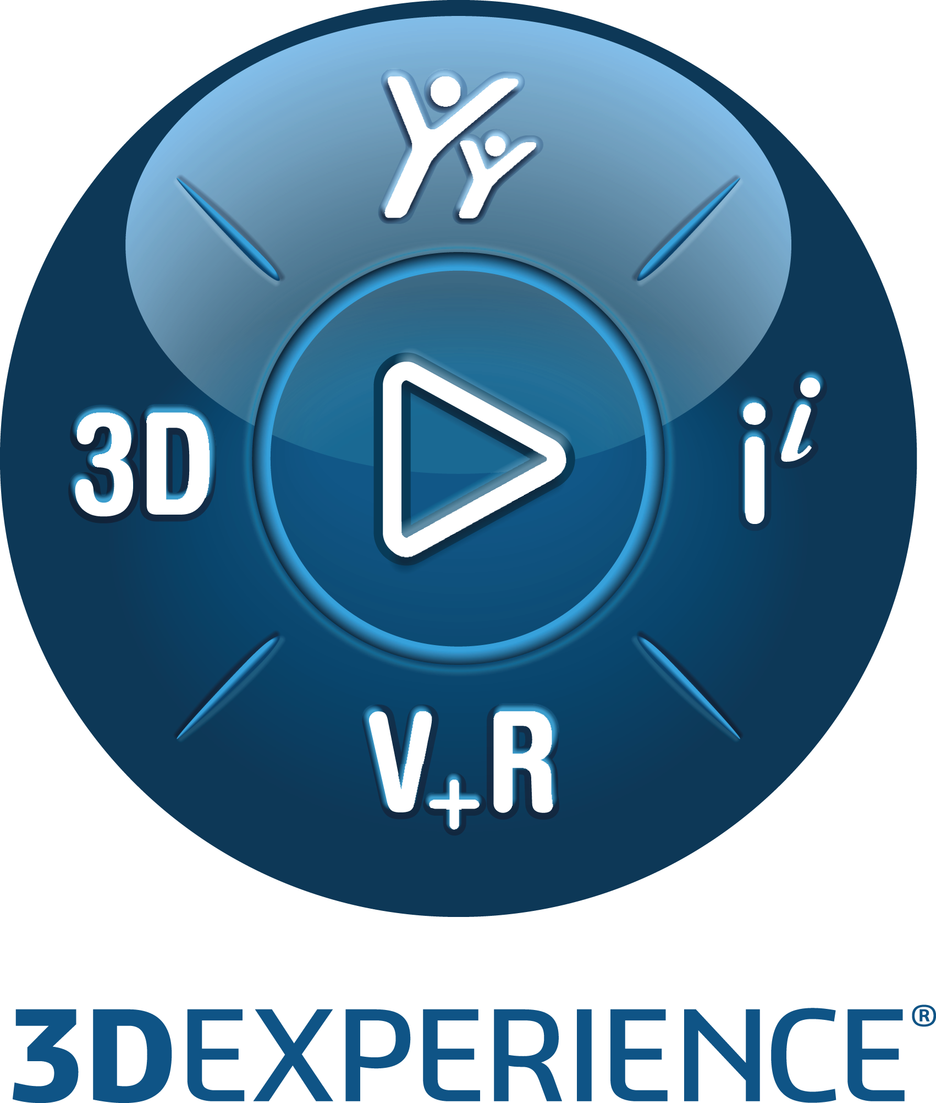

Function ID | PES Owner Name | PES Owner Role
FUN166608 rev. 0.0 | Akshay More | Software Engineer

Table of Contents
Section 1: High-level specifications 3
1.1. Related requirement(s) 3
1.2. What will the customer use this for 3
1.3. What the function will do 3
1.4. What the function will not do 6
1.5. Commercial packaging 6
Section 2: Detailed Specifications 7
2.1. Packaging 7
2.2. User experience and interactions 7
2.3. Data management 12
2.4. Customization by end user or administrator 13
2.5. Programming interface 13
Section 3: Quality of services 14
3.1. Performance, capacity and scalability (PCS) 14
3.2. Security controls 14
3.3. Data privacy 15
Section 4: Acceptance Test Protocols 16
4.1. Functional Acceptance Tests 16
4.2. Limit & Negative Acceptance Tests 23
4.3. Performance/Capacity/Scalability Acceptance Tests 26
4.4. Page Objects usage by acceptance tests 27
Section 5: (optional) 3DSpace Baseline Behavior Support 28
Section 6: (optional) PES related material 29
6.1. Reference Materials 29
6.2. PES Authoring Rules Checklists (if relevant) 29

For more information on completing the PES, refer to the PES Authoring Best Practices.
This document provides detailed instructions to fill some specific parts of the PES
Important: To HIDE/unhide all instructions (which appear like this):
Toggle the ¶ symbol in Word paragraph options, or
In Word, go to File Options Display Hidden text
- High-level specifications
Provide a global understanding of the function scope: why must it be developed? What will it do and not do? How does this new functionality relate to what the product/component already does?
 Note: The “High-level specifications” and “Acceptance test protocol” sections must be clear and complete enough to enable reviewers to assess that this function will satisfy its associated requirement(s).
This section can then be shared with DS customers through a Customer Answer.
If this PES is to be shared via an extracted Customer Answer (CA) document: ensure it does not contain anything related to another customer, including within the proposed solution, the document name, and the table below. To learn more about producing an externally viewable PES, see Customer Answer Best Practices.
  - Related requirement(s)
Identify the requirements driving this function.
Requirement & Target | Details
Customer or DS Team | DS Team
Related Elementary Requirement ID | None
If this PES answers similar requirements from different customers, repeat the “Customer” row in the table above for each customer. If the requirement is internal to DS, list “DS Team” as the customer.
  - What will the customer use this for
The customer will use this functionality to create an extended collaboration dashboard more efficiently by leveraging pre-defined template.

  - What the function will doProvide a clear and concise overview of what the function will do to satisfy the requirement, in terms of external behavior.
    - Concepts
With this function, we are introducing a new "Dashboard from template" capability, during collaboration creation. This will allow user to create dashboard based on pre-defined template which can be either platform templates (linked to specific roles) or user templates (created by the user themselves). Explain the concepts that the customers of this function have to understand in order to use it. Define the vocabulary used in later sections. Include a description of the User Data Model illustrated by data structure diagrams featuring entity types and their relationships if this information would be relevant and meaningful for an end user.
Platform Template: A dashboard linked to a role granted to the user. For example, a platform administrator can link a dashboard to a specific role to meet business needs. Users with this role will find the dashboard within the list of proposed templates when creating a new dashboard.
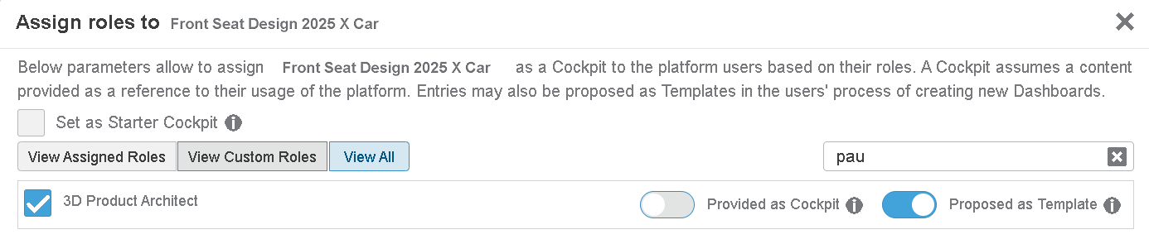

User Template: A dashboard that you (user) have previously set as a template. Any dashboard can be set as a user template from “Manage Dashboards & Cockpits” app for future use. User can share this template with other users
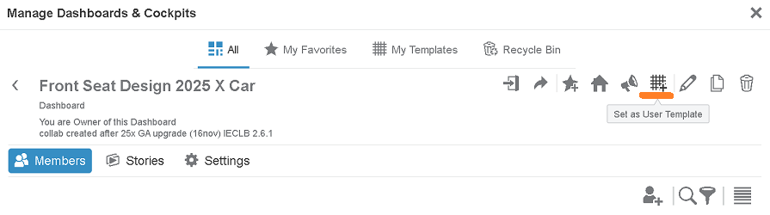
As a brief reminder:
- The 'Extended Collaborations Control Center’ is an application provided by ‘Integrated Collaboration Service’, available through the 3DCompass.
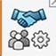
- The 'Extended Collaborations Control Center’ application allows a platform administrator to create an Extended Collaboration and invite members to the Collaboration.
- Currently extended collaboration setup creates a specific dashboard with apps to support downstream functions. The apps are grouped into the following tabs: ‘Collaborate’, ‘Share’, ‘Review’, ‘Prepare’, ‘Members’ and ‘History’. This dashboard is shared with user groups of teams.
- Members of teams (user groups) can access to the collaboration through a Dashboard with several predefined tabs.
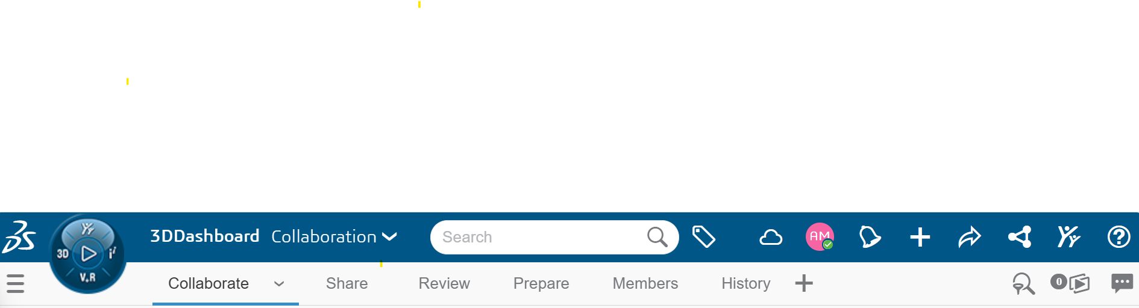
    - Function capabilities overview
Specify the user interface concepts and rules of conformity, which user interaction model is used (e.g. direct manipulation, command language ...). Provide navigation activity diagrams or UML diagrams to describe the additional capabilities, if applicable. UI mockups can be used for a function providing a User Interface.
For each capability, provide a “Use Case” narrative-- that is explain what the user can do and what the response will be.
- New capabilities
- Currently, when creating an extended collaboration, the collaboration title is automatically populated in the dashboard textbox, and it is non-editable. This results in the creation of a specific dashboard with predefined apps to support downstream functions.
- With the new functionality, while creating a collaboration, the dashboard textbox will be editable, and will follow behavior as explained below.
  - A computed dashboard title will be displayed in this text box. If user proceeds with creation of collaboration without editing this text box, a dashboard with predefined apps will be generated. This dashboard generation is existing behavior. In this PES, we call this dashboard as ‘default dashboard’.
  - If user edits this text box,
    - A search will fetch matching dashboards that are templates.
      - User will be able to search dashboards which are accessible to him.
      - The search result will display title of each of matching dashboards.
      - These can be either platform or user templates.
      - When a user selects a template from the search results, the title of that dashboard will be displayed in the dashboard text box. Based on selected template, we will create a new dashboard by using the Import Dashboard capability. There is no link between these two dashboards; and, hence change in template will not have impact on the created dashboard.
    - If the user does not select a template and proceeds with collaboration creation, a default dashboard with predefined apps will be generated. This is same behavior as if user never edited it.
    - User can abandon search by deleting text he added. He can delete text by using ‘x’ button at the end of the text box. The text box will show auto populated title (coming from collaboration). If the user manually clears the search, the textbox will temporarily remain blank. However, once the user clicks outside the textbox, the default title will reappear.
    - When user moves focus out of the text box without selecting search result, then the default title (auto-populated from the collaboration) will reappear.
- Dashboard creation mechanism: Dashboard created using template will be a copy of that template:
  - We will export the template dashboard.
  - Prepare definition of dashboard to be created using the exported definition (see next point)
  - Import dashboard with this definition.
- Dashboard content:
  - Title: Title of collaboration will be assigned as title of the newly created dashboard.
  - New dashboard has same tabs & widgets as that of template dashboard. It maintains the same location & size for tabs & widget too.
  - The template dashboard definition retrieved using export capability, does not provide duplication information (enable duplication for all members, enable duplicated dashboard to be resynchronized on-demand), background & thumbnail information. Hence, the new dashboard will not inherit those from template.
  - If the template dashboard does not have the “History” & “Members” widgets, the new dashboard will be created with these two widgets.
  - If the template dashboard has “History” & “Members” widgets, they will be linked to the current collaboration.
- Dashboard members: Dashboard created from template will have same members as in case of default dashboard - Leading team user group is ‘Owner’ and partner team user groups are ‘Contributor’.
- History: An event of dashboard creation from the template will be captured in the History tab as sub-event of a main 'creation' event.
History Messages for Dashboard Creation from Template:
  - For success case: “Dashboard <title> is created from <template dashboard title>”.
  - For failure case: “Dashboard <title> creation from <template dashboard title> failed.”
- Analytics: We had defined the analytics event in FUN137070 rev. 0.0. We will generate a dashboard using a template while creating a collaboration, and this creation event will include the field operation.content.dashboard. In this scenario, we will assign the value "createdFrom" to this field.
- Restore dashboard behavior when dashboard is created from template:
  - In case user deletes the history or members tab from the dashboard, we will re-create the deleted widgets, thanks to restore dashboard capability. For more information, please refer FUN137512 rev. 0.0
  - In case dashboard has been deleted but still in the Dashboard recycle bin, restore dashboard operation will continue to restore it from the recycle bin.
  - In case dashboard has been completely deleted and is no more available in the recycle bin, restore dashboard will lead to default dashboard creation.
- Edit Collaboration: There is no change in the edit collaboration capability.

- Modified capabilities: impact for end users
If the new capabilities replace existing features, detail here how the new usage compares to the previous usage. This is required to help the end users transition seamlessly to the new usage.
    - Limitations
Document the limits (or boundaries) of this function within the intended scope. Consider the expected behavior of the functionality under all circumstances, including possible usage errors or malicious use. Wherever possible, the usage of the function beyond its limits must be made impossible by construction or design.
If this function is not available on all supported platforms, specify the non-supported platforms here.
For each identified limitation, ensure that acceptance test coverage is provided.
- Limitation #1: Dashboard is created from template, and then it is permanently deleted. The following restore dashboard functionality will create default dashboard.
- Limitation #2: The template dashboard definition retrieved using export capability, does not provide duplication information (enable duplication for all members, enable duplicated dashboard to be resynchronized on-demand), background & thumbnail information. Hence, the new dashboard will not inherit those from template.

<Repeat as necessary>

  - What the function will not do
NaNIf the function is not going to address some of the requested items of the associated Requirement PER(s), list these exceptions here:
  - Commercial packaging
List here the Products/Role and App required to access the function.
Product (Role /App) in which the function will be available: The new Dashboard from template functionality is only accessible for Administrators with 3D Product Architect (PAU) on Cloud in the Extended Collaborations Control Center App + New Extended Collaboration + Select dashboard textbox

- Detailed Specifications
Expand on the Capability Summary provided above by detailing all aspects of the functionality.
  - Packaging
 If this function impacts the packaging, a Software Architect must be named in the role of Design Reviewer in the Function Planning. This assignment will create a “Design Task” task allowing the Software Architect to review the packaging changes via a dedicated Design Enhancement Specification “DES” and eventually to make the required packaging enhancements. For more information about “DES”, click here. If a Service or Component is involved, the associated “referential” may require an update.
If this function modifies the existing packaging, specify the necessary changes below. Include whether commercial pre-requisite products are required and, if so, whether these must be created. If packaging changes will affect pricing, explain this here.
For more information of this topic, refer to the “Packaging” section of PES Authoring Best Practices.
! | Required Information | Response
 | Does this function impact the packaging? | No Impact
Packaging items to be modified:
None

  - User experience and interactions
For information on completing this PES section, refer to the PES Authoring Best Practices section “What about User Experience and Interaction”.
    - User interface
- New UI components
If the function adds new UI “components”, (commands/dialog boxes/panels/widgets) list them in the table below.
Component List | New component behavior

- Modified UI components
If the function changes existing dialogs, specify below which dialogs are impacted and how. Explain also any change to information access (for instance if some properties will now be accessible through a different dialog.
! | Required Information | Response
 | Is the Current User Experience Impacted? | Yes

 If the function impacts the current User Experience (an action can no longer be performed, default behavior is modified, etc.), a User Experience Expert must be named in the Function Plan. This will create a “UEE PES Review” task allowing the User Experience Expert to evaluate whether the impact is acceptable and, if so, how to minimize impact on the end user. If no User Experience Expert is available, assign the task to the App Manager.

Modified Component List | Modified behavior | New behavior
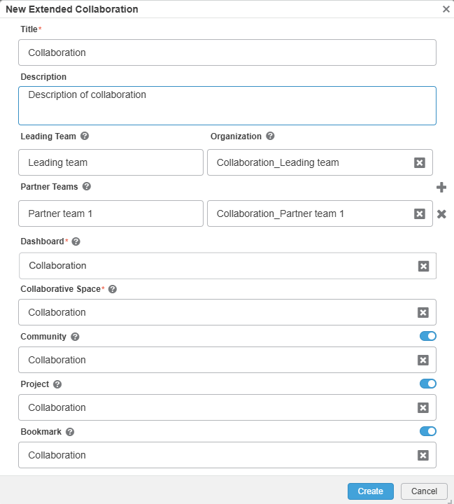 | While creating an extended collaboration, the collaboration title is automatically populated in the dashboard textbox, and it is editable. | While creating a collaboration, the dashboard textbox will be editable. By default, a computed dashboard title will be displayed in this text box.  - When a user edits this text box, a search will fetch matching dashboards that are templates. These can be either platform or user templates.  - When a user selects a template from the search results, the title of that dashboard will be displayed in the text box.  History: An event of dashboard creation from the template will be captured in the History tab sub-events of a main 'creation' event.  (Case 1: Creating dashboard from the template)  - Collaboration was created.  “Dashboard <title> is created from <template dashboard title>”.

UI Representation | Description
 | - During the creation of a collaboration, the dashboard textbox is now editable. By default, the collaboration title is propagated into this textbox.  - When the user clicks the ‘x’ button, the default title remains unchanged.
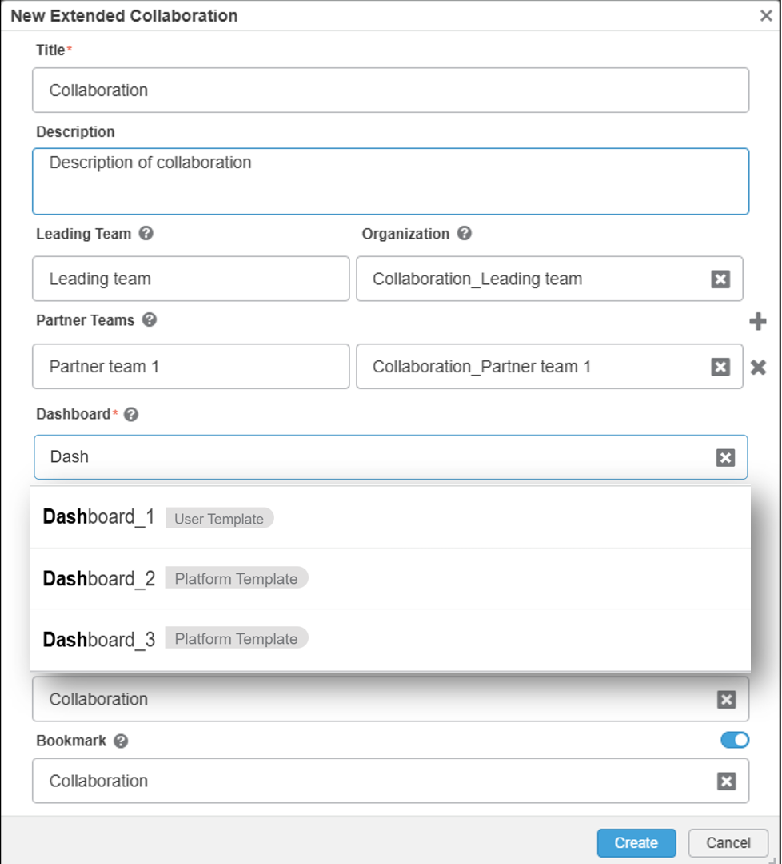 | - When the user edits the dashboard textbox, a search will retrieve matching dashboard templates.  - The search results will display the titles of each matching dashboard.  - The user can search for dashboards that are accessible to them.  - These can be either platform or user templates.
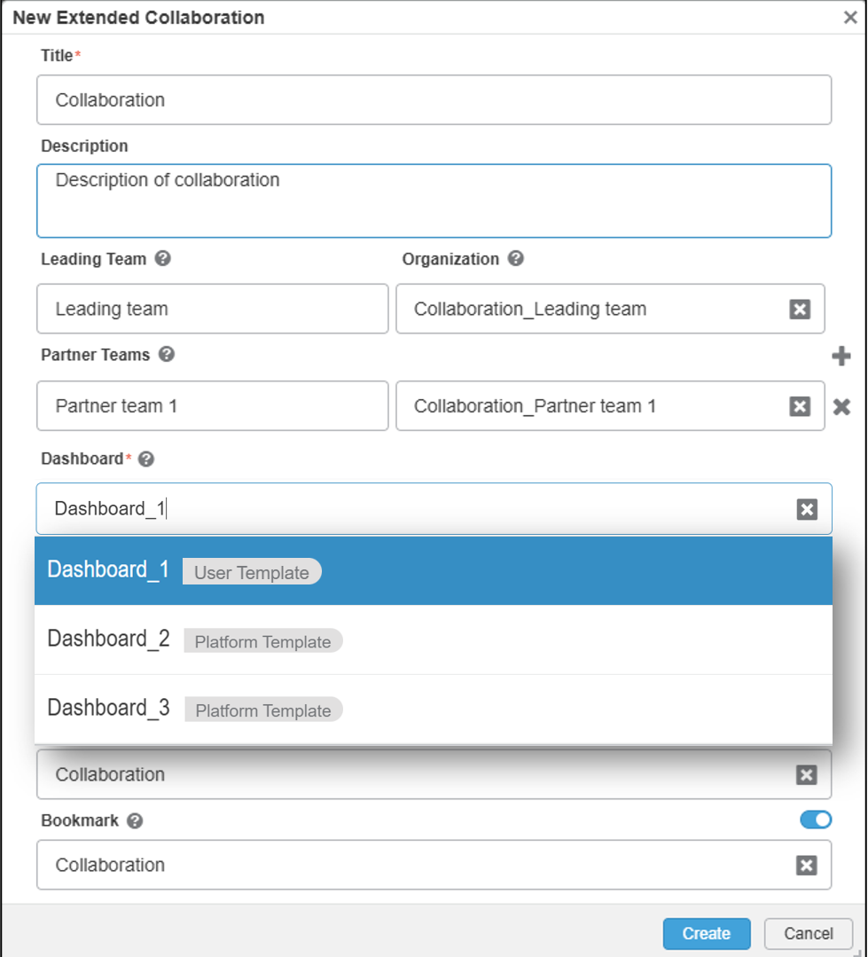 | - When a user selects a template from the search results, the title of that dashboard will be displayed in the dashboard textbox.  - There are two types of templates: User Template and Platform template. In the search result list, user can see template type along with the dashboard template title.  - Based on the selected template, a new dashboard will be created using the Import Dashboard capability.
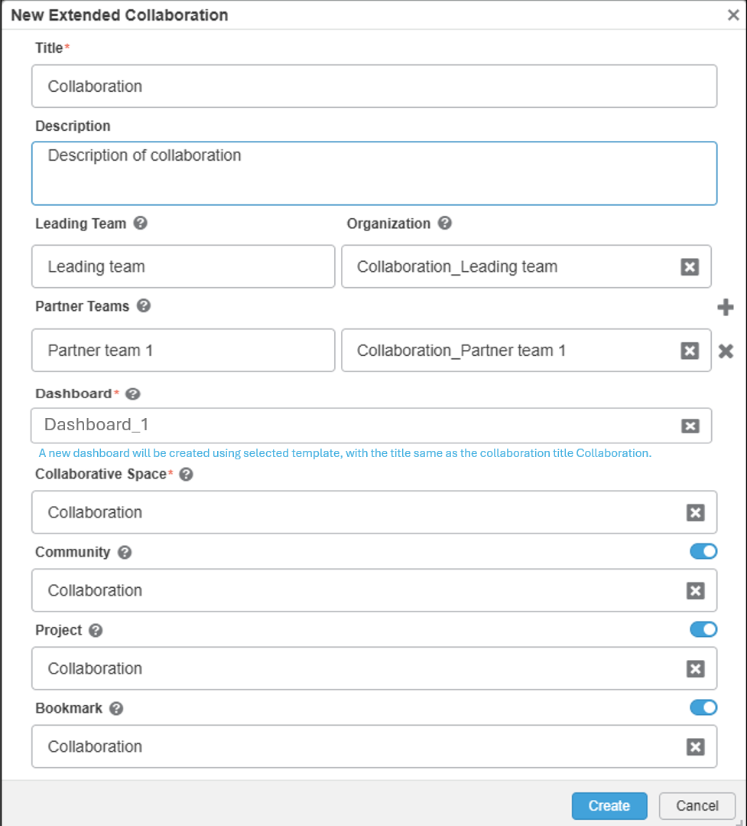 | - Once the user selects the dashboard template, one information message with the collaboration title will be shown just below the dashboard textbox.  - Information message: A new dashboard will be created using selected template, with the title same as the collaboration title Collaboration.  - If the user updates the collaboration title, the same will be updated in the information message.
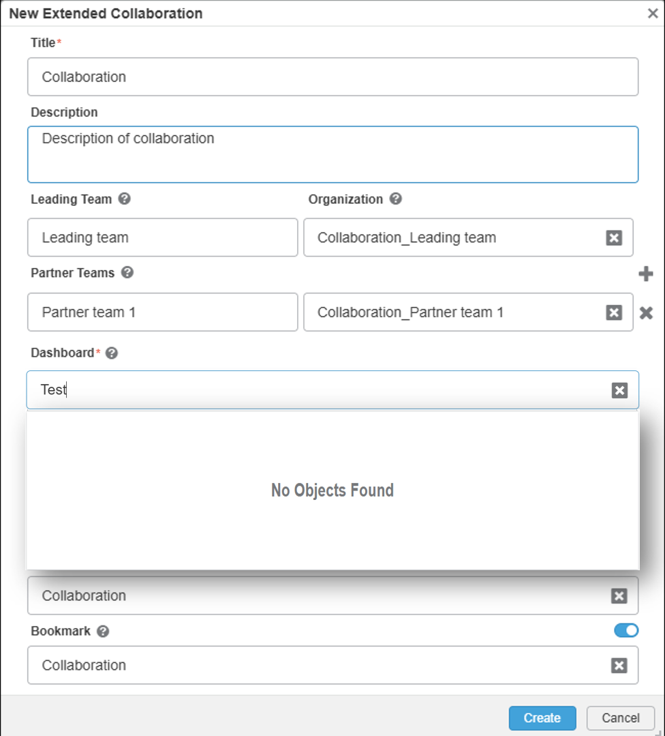 | - When a user searches for a template that does not exist, a "No Objects Found" message is displayed.  - The user can clear the search by either manually deleting the entered text or by clicking the ‘x’ button at the end of the textbox.  - If the user clears the search manually, the textbox will remain blank temporarily. However, once the user clicks outside the textbox, then the default title (auto-populated from the collaboration) will reappear.  - If the user clears the search by clicking the ‘x’ button, then the default title (auto-populated from the collaboration) will reappear.

    - User assistance
- Embedded user assistance (tooltips, UA panel, etc.)
List below the new or existing UI components (e.g: action bar command, dialog box, button, field) that require a change to embedded User Assistance. Duplicate the row when needed.
User-visible Title | Component type | New or updated | Brief description of change
Title | action bar command, dialog box, etc. | Select an item. | Click or tap here to enter text.

- What’s New

! | Required Information | Response
 | Display this function as a highlight in What’s New? | Yes

- User documentation (optional)
If user documentation is required, describe the changes below. Duplicate the row when needed.
Guide | Component type | New or updated | Brief description of change
Title | Click or tap here to enter text. | Select an item. | Click or tap here to enter text.

    - Page Objects
The Page Object Model is a design pattern that is becoming a standard for end-to-end automation of Web applications, its methods expose possible end-user interactions with the UI of the page/component. For more information of this topic, join the CHEETAH Automation Framework Swym community.
If the function has features with external visibility to be covered by a Quality Scenario, you have to deliver the necessary Page Objects on the Function’s “Test Task” in DSxRD.
! | Required Information | Response
 | Does your function require PageObject delivery? | Yes
If yes, provide the list of the page objects that will allow to programmatically interact with it.
- PO-1: CollaborationCreateMode.po.js
Specify the end user interaction(s) that is (are) exposed through the page object method(s).
Page object will be delivered with 3DEXPERIENCER2026xFD02
Specify the acceptance tests that use the Page Object(s) here.

  - Data management
Specify the user data that will be created while using the function.
    - Supported object types (run-time data and persistent data)
Not applicableList the object types applicable to this function and their properties.
    - Expected behavior for each object type (run-time data and persistent data)
Not applicableCreate a matrix that describes the behavior of the function (rows) for each object type (columns). For more information, refer to the “” of this example.
    - Data persistency and/or upgrade (if applicable)
Not applicableSpecify which data created or modified by the function is persistent (i.e., data with a lifecycle that spans beyond the user’s session). Specify how/where/in what database, etc., each type will be managed.
Concerning existing data model structures, specify if there is a modification:
! | Required Information | Response
 | Does this function require a change to the data model schema? | No

If the migration batch has to be enhanced (for instance, if the previous data structure will no longer be handled by the application), indicate below that an upgrade procedure is needed:
! | Required Information | Response
 | Does this function require an upgrade procedure? | No

 If you answer “Yes” to either of the above two questions, ensure the corresponding information is set for the function in DSxRD Authoring.
Notes: Customer data loss is NOT permitted. “Data loss” means: the data is not upgraded and definitely lost or the data is migrated but no longer accessible to the end user without user actions. If a data upgrade is needed, dedicated Acceptance Tests must be created. These tests must specify the data sample used to perform the test and the method and criteria to verify the results of the data migration after upgrade. The developer and the QA leader must ensure the chosen samples contain sufficient data to test all data schema impacts.
- Schema or other changes impacting multi-level compatibility
Specify whether this functionality is able to operate consistently with older releases or with products designed for interoperability. Identify the key compatibility aspects of this function in terms of both function behavior and data compatibility. For help on this topic, refer to the PES Authoring Best Practices section “What about Compatibility”.
    - Data repository
Specify the data repository used.
! | Required Information | Response
 | Is this function related to 3DEXPERIENCE 3DSpace Baseline Behavior? | No
 If yes, you must complete the dedicated sub-section.

  - Customization by end user or administrator
Not applicableDescribe any custom functionality that will accommodate a specific customer or User Role Profile. How does the user or administrator change the way the functionality behaves? Explain who can make changes and how they will do so. If this function makes customization available through a user interface check, a profile check, or a similar mechanism, describes this here or in the External View section.
  - Programming interface

! | Required Information | Response
 | Does this function provide APIs to clients? | No
 If yes, ensure the corresponding information “CAA Exposition” is also set for the function in DSxRD Authoring.

    - Detailed API description (if relevant)
Not applicableFor help on this topic, refer to the section “What about API”.
    - Automation for command journaling (if relevant)
Not applicableSpecify here whether new commands created by this function (if any) will be exposed for automation and for availability in journaling.
- Quality of services
Specify the “nonfunctional” qualities of service (performance, capacity, scalability, ) and security controls (Confidentiality, Integrity, Availability...) related to the requested functionality.
  - Performance, capacity and scalability (PCS)
Evaluate and specify the PCS objectives for industrial usage of this function. For more information on this topic, refer to the “What About Performance, Capacity and Scalability (PCS)” section of PES Authoring Best Practices.
Definitions:
Performance - Time and system resources required to complete a set of scenarios
Capacity - Number of concurrent users supported by a given hardware configuration
Scalability - Ability to add proportional amounts of workload and resources while maintaining performance
    - Performance objectives
Evaluate the time and system resources required to create a dashboard from a large template. With a large template, we expect impact during the export of the template dashboard & import (creation) of the new dashboard. However, the total collaboration creation should finish in two minutes.
    - Capacity objectives
NA
    - Scalability objectives
NA
! | Required Information | Response
 | Are PCS tests provided with the function? | Yes
If yes, specify the tests in the dedicated section.
 In this case, at least one task containing “PCS” has to be created in the function plan to ensure the tests defined to measure the objectives will be run and assessed.
If you answered “No”, explain why briefly:

  - Security controls
 For more information on this topic, refer to the “What about: Security Control” section of PES Authoring Best Practices.
! | Required Information | Response
 | Does this function comply with security control rules for maintaining safe function usage? | Yes
If you answered “No” to the above question, explain why briefly:
Click or tap here to enter text.
Specify the detailed security controls available to the end user of this functionality. For help on this topic, refer to the “Security Control” section of PES Authoring Best Practices. The list below is not exhaustive; add topics as needed.
    - Confidentiality
Not applicable
    - Integrity
Not applicable
    - Availability
Not applicable
    - Authentication
Not applicable
    - Authorization
Not applicable
  - Data privacy
 According to Data Privacy laws (more information in Ethics & Compliance at 3DS community), including GDPR, a personal data is any information that can identify directly or indirectly an individual (e.g. name, userid, cookies, IP Address).
All 3DS products must comply with the following rules (more information in R&D Data Privacy – 3DS as a software vendor community, ask for access rights if needed).
- Transparency: list of processed personal data (including cookies) and list of third parties to which personal data are transferred (e.g. Outscale, AWS and Huawei) are not modified by your function – else, contact your R&D Data Privacy Director.
- Minimization: collect and use only needed personal data for a defined retention period.
- Respect of data subject rights: possibility to access, modify and delete personal data.
 For more information on this topic, refer to the “What about: Data Privacy” section of PES Authoring Best Practices.
! | Required Information | Response
 | Does this function comply with 3DS obligations related to the use and protection of personal data? | Yes
If you answered “No” to the above question, explain why briefly:
Click or tap here to enter text.

- Acceptance Test Protocols
Specify the testing that will be done to demonstrate that this function works as specified. Acceptance tests are expected to work in the integrated code base at or before the FCF gate, before QA takes over the function for a more thorough suite of tests.
Acceptance Tests must cover each capability and limitation described in the previous sections. Each test definition must include objective criteria to assess whether the test produced the expected results. Automated tests should be delivered whenever possible.
  - Functional Acceptance Tests

Functional acceptance tests demonstrate that the expected results are obtained or that the expected behavior occurs for each aspect of the new or modified functionality when used as intended. This includes testing of specific topics as applicable: embedded user assistance, data upgrade, etc.
    - AT-1: Verify pre-defined Dashboard Creation
- What’s being tested?
Ensure that users can create a pre-defined dashboard if they do not select a template. Explain the objectives of this test.
- Test data
Extended collaboration setup without template selection. Define the input data and the data of reference used to check that the test execution produces the expected results.
- Test protocol
- Connect to the 3DEXPERIENCE cloud platform with 3D Product Architect (PAU) role + platform admin responsibility.
  - Select the ‘Extended Collaborations Control Center’ app available in the 3DCompass.
  - Select New Extended Collaboration.
  - Enter a collaboration title.
  - Observe that the collaboration title is reflected in the dashboard textbox.
- Proceed with the collaboration creation process.
- Related automatic tests
<> Specify the names of the related Automatic Tests (ODTs), if any.
- Test verification
Specify the names of the related Automatic Tests (ODTs), if any.
Examples of verification criteria:
- Expected results and acceptable tolerance
- Allowable exceptions
- Expected performance
- Engineering judgment
Example sources of verification criteria:
- Physical test data
- Published journal results
- NAFEMS test
- Closed-form solution
- Verify that dashboard is created with tabs: ‘Collaborate’, ‘Share’, ‘Review’, ‘Prepare’, ‘Members’ and ‘History’.
- Test responsibility
Developer and QA Team
(optional) The developer has primary responsibility for executing this test. If applicable, specify who is additionally responsible for executing this test in terms of Role.

    - AT-2: Verify Template Search Functionality
- What’s being tested?
The search functionality for matching dashboards (platform or user templates) when editing the dashboard textbox. Explain the objectives of this test.
- Test data
Platform and user template dashboards, extended collaboration setup.Define the input data and the data of reference used to check that the test execution produces the expected results.
- Test protocol
- Connect to the 3DEXPERIENCE cloud platform with 3D Product Architect (PAU) role + platform admin responsibility
  - Create platform, user template dashboards.
  - Select the ‘Extended Collaborations Control Center’ app available in the 3DCompass
  - Select New Extended Collaboration.
- Edit the dashboard textbox to trigger the search.
- Observe the search results.
- Related automatic tests
<>Specify the names of the related Automatic Tests (ODTs), if any.
- Test verification
- Specify the names of the related Automatic Tests (ODTs), if any.
Examples of verification criteria:
- Expected results and acceptable tolerance
- Allowable exceptions
- Expected performance
- Engineering judgment
Example sources of verification criteria:
- Physical test data
- Published journal results
- NAFEMS test
- Closed-form solution
Template dashboard titles are listed in search result matching the text input.
- Test responsibility
Developer and QA Team

    - AT-3: Verify Dashboard from Template Functionality (Platform template)
- What’s being tested?
Ensure that users can create a dashboard from a platform template during the creation of an extended collaboration.Explain the objectives of this test.
- Test data
Platform template dashboard, extended collaboration setup.Define the input data and the data of reference used to check that the test execution produces the expected results.
- Test protocol
- Connect to the 3DEXPERIENCE cloud platform with 3D Product Architect (PAU) role + platform admin responsibility.
  - Create a dashboard & mark it as platform template (possibly link to PAU role).
  - Select the ‘Extended Collaborations Control Center’ app available in the 3DCompass.
  - Select New Extended Collaboration.
- Verify that the dashboard textbox is editable.
- Edit the dashboard textbox to search for matching platform template(s).
- Select a template from the search results.
- Verify that the title of the selected template is displayed in the textbox.
- Complete the collaboration creation process.
- Related automatic tests
<>Specify the names of the related Automatic Tests (ODTs), if any.
- Test verification
- Specify the names of the related Automatic Tests (ODTs), if any.
- Examples of verification criteria:
- Expected results and acceptable tolerance
- Allowable exceptions
- Expected performance
- Engineering judgment
- Example sources of verification criteria:
- Physical test data
- Published journal results
- NAFEMS test
- Closed-form solution
- The created dashboard name/title is same as that of collaboration title.
- It has same tabs & widgets as that of template dashboard.
- Verify that the "History" and "Members" widgets are added.
- Verify the dashboard members: Leading team user group is ‘Owner’ & partner team user groups are ‘Contributor’.
- An analytics event should be captured indicating the dashboard was created from a template.
- An event of dashboard creation from the template should be captured in the History tab as sub-event of a main 'creation' event.
- Test responsibility
Developer and QA Team

    - AT-4: Verify Dashboard from Template Functionality (User template)
- What’s being tested?
Ensure that users can create a dashboard from a user template during the creation of an extended collaboration.Explain the objectives of this test.
- Test data
User template dashboards, extended collaboration setup.Define the input data and the data of reference used to check that the test execution produces the expected results.
- Test protocol
- Connect to the 3DEXPERIENCE cloud platform with 3D Product Architect (PAU) role + platform admin responsibility.
  - Create a dashboard & mark it as user template.
  - Select the ‘Extended Collaborations Control Center’ app available in the 3DCompass.
  - Select New Extended Collaboration.
- Verify that the dashboard textbox is editable.
- Edit the dashboard textbox to search for matching user template(s).
- Select a template from the search results.
- Verify that the title of the selected template is displayed in the textbox.
- Complete the collaboration creation process.
- Related automatic tests
<>Specify the names of the related Automatic Tests (ODTs), if any.
- Test verification
- Specify the names of the related Automatic Tests (ODTs), if any.
- Examples of verification criteria:
- Expected results and acceptable tolerance
- Allowable exceptions
- Expected performance
- Engineering judgment
- Example sources of verification criteria:
- Physical test data
- Published journal results
- NAFEMS test
- Closed-form solution
- The created dashboard name/title is same as that of collaboration title.
- It has same tabs & widgets as that of template dashboard.
- Verify that the "History" and "Members" widgets are added.
- Verify the dashboard members: Leading team user group is ‘Owner’ & partner team user groups are ‘Contributor’.
- An analytics event should be captured indicating the dashboard was created from a template.
- An event of dashboard creation from the template should be captured in the History tab as sub-event of a main 'creation' event.
- Test responsibility
Developer and QA Team

    - AT-5: Verify "History" and "Members" Widgets are checked and added if missing.
- What’s being tested?
The functionality to check and add the "History" and "Members" widgets if they are missing in the selected template.
- Test data
Pre-defined platform and user templates that do not have "History" and "Members" widgets,
- Test protocol
- Connect to the 3DEXPERIENCE cloud platform with 3D Product Architect (PAU) role + platform admin responsibility.
  - Select the ‘Extended Collaborations Control Center’ app available in the 3DCompass.
  - Select New Extended Collaboration.
- Edit the dashboard textbox to trigger the search.
- Select a template from the search results that does not have "History" and "Members" widgets.
- Complete the collaboration creation process.
- Verify the created dashboard.
- Related automatic tests
<>Specify the names of the related Automatic Tests (ODTs), if any.
- Test verification
The new dashboard includes the "History" and "Members" widgets.
Specify the names of the related Automatic Tests (ODTs), if any.
Examples of verification criteria:
- Expected results and acceptable tolerance
- Allowable exceptions
- Expected performance
- Engineering judgment
Example sources of verification criteria:
- Physical test data
- Published journal results
- NAFEMS test
- Closed-form solution
- Test responsibility
Developer and QA Team

    - AT-6: Verify that the "History" and "Members" widgets are linked to the current collaboration.
- What’s being tested?Explain the objectives of this test.
Ensure that the "History" and "Members" widgets are correctly linked to the current collaboration if present in the template.
- Test data
Pre-defined templates with "History" and "Members" widgets, extended collaboration setup.
- Test protocolSpecify what environment, if any, must be prepared in order to run the test. Specify the sequence of operations/steps).
- Connect to the 3DEXPERIENCE cloud platform with 3D Product Architect (PAU) role + platform admin responsibility.
  - Select the ‘Extended Collaborations Control Center’ app available in the 3DCompass.
  - Select New Extended Collaboration.
- Edit the dashboard textbox to trigger the search.
- Select a template from the search results that has "History" and "Members" widgets.
- Complete the collaboration creation process.
- Verify the created dashboard.
- Related automatic tests
NoneSpecify the names of the related Automatic Tests (ODTs), if any.
- Test verification
The "History" and "Members" widgets are linked to the current collaboration- they show history & members of this collaboration.
- Test responsibility
Developer and QA Team

    - AT-7: Verify that the dashboard can be restored from the recycle bin.
- What’s being tested?
The ability to restore a dashboard from the recycle bin which is created from the template.
- Test data
Pre-defined platform and user templates, extended collaboration setup.
- Test protocol
- Connect to the 3DEXPERIENCE cloud platform with 3D Product Architect (PAU) role + platform admin responsibility.
  - Select the ‘Extended Collaborations Control Center’ app available in the 3DCompass.
  - Select New Extended Collaboration.
- Edit the dashboard textbox to trigger the search.
- Select a template from the search results.
- Complete the collaboration creation process.
- Delete the created dashboard.
- Restore the dashboard from the recycle bin.
- Verify that the dashboard is restored.
- Related automatic tests
NoneSpecify the names of the related Automatic Tests (ODTs), if any.
- Test verificationSpecify the names of the related Automatic Tests (ODTs), if any.
The dashboard is restored from the recycle bin, and it remains a same as before deletion.
- Expected results and acceptable tolerance
- Allowable exceptions
- Expected performance
- Engineering judgment
Example sources of verification criteria:
- Physical test data
- Published journal results
- NAFEMS test
- Closed-form solution

- Test responsibility
Developer and QA Team

    - AT-8: Verify that a default dashboard is created during restore, if collaboration was created with dashboard from template.
- What’s being tested?
The creation of a default dashboard during restore, if collaboration was created with dashboard from template.
- Test dataDefine the input data and the data of reference used to check that the test execution produces the expected results.
Pre-defined platform and user templates, extended collaboration setup.
- Test protocol
- Connect to the 3DEXPERIENCE cloud platform with 3D Product Architect (PAU) role + platform admin responsibility.
  - Select the ‘Extended Collaborations Control Center’ app available in the 3DCompass.
  - Select New Extended Collaboration.
- Edit the dashboard textbox to trigger the search.
- Select a template from the search results.
- Complete the collaboration creation process.
- Delete the created dashboard permanently.
- Attempt to restore the dashboard.
- Verify that a default dashboard is created.
- Related automatic tests
<>Specify the names of the related Automatic Tests (ODTs), if any.
- Test verification
A default dashboard is created.
- Test responsibility
Developer and QA Team
    - AT-9: Dashboard creation from large template.
- What’s being tested?
Dashboard is created from a large template.
- Test protocolSpecify the output data and verification criteria for each item to be verified. For instance, check that necessary and sufficient error messages are displayed to the end user, and that the situation can be recovered.
- Connect to the 3DEXPERIENCE cloud platform with 3D Product Architect (PAU) role + platform admin responsibility.
  - Select the ‘Extended Collaborations Control Center’ app available in the 3DCompass.
  - Select New Extended Collaboration.
- Edit the dashboard textbox to trigger the search.
- Select the large template from the search results.
- Complete collaboration creation process.
- Verify the behavior.

- Test data
Pre-defined user template with twenty tabs, each with one widget. Describe the usage and content of standard or specific/customer data.
Specify the size/amount of data.
- Environment
On CloudSpecify the necessary test execution environment
- Dedicated / shared hardware and software
- Isolated / non-isolated network
- Usage of any device that may impact operations performed during the test (writing, reading…) such as latency, tool
- Related automatic tests
NoSpecify the names of the related Automatic Tests (ODT names), if any.
- PCS Objectives
Capacity: With the large template as described, collaboration creation should succeed. The new dashboard does not omit any of the tabs, widgets.Specify the objectives and their level (UI level for end-user time perception and/or Algorithm level for instance).
- Test execution timeframe and measurements
Verify that Step 4 (Collaboration creation) is successful.Specify for which master schedule gate these tests are planned to be run and which measurements will be taken. (Note: All Acceptance Tests are expected to work at FCF. If your target gate is later than FCF, please explain why.)
- Limitations

  - Limit & Negative Acceptance Tests
Limit and negative acceptance tests demonstrate that the software handles boundary cases correctly and that appropriate warning and error messages are produced.
    - LN-1: Verify Behavior When No Matching Templates Are Found
- What’s being tested?
The behavior when no matching templates are found during the search.Explain the objectives of this test: specify whether this is a test of the boundaries / limits of the functionality, or an error test.
- Test data
Pre-defined platform and user templates, extended collaboration setup.
- Test protocol
- Connect to the 3DEXPERIENCE cloud platform with 3D Product Architect (PAU) role + platform admin responsibility.
  - Select the ‘Extended Collaborations Control Center’ app available in the 3DCompass.
  - Select New Extended Collaboration.
- Edit the dashboard textbox to trigger the search.
- Enter a non-existent template name.
- Verify the search results.
- Related automatic tests
<>
- Test verificationSpecify the output data and verification criteria for each item to be verified. For instance, check that necessary and sufficient error messages are displayed to the end user, and that the situation can be recovered.
No matching templates are found.
- Test responsibility
Developer and QA Team (optional) The developer has primary responsibility for executing this test. If applicable, specify who is additionally responsible for executing this test. For instance, User Experience Expert or User Assistance to check error messages.

    - LN-2: Verify Behavior When Template Is Deleted Before Dashboard Creation
- What’s being tested?
The behavior when a template is deleted before the dashboard is created.Explain the objectives of this test: specify whether this is a test of the boundaries / limits of the functionality, or an error test.
- Test data
Pre-defined platform and user templates, extended collaboration setup.
- Test protocol
- Connect to the 3DEXPERIENCE cloud platform with 3D Product Architect (PAU) role + platform admin responsibility.
  - Select the ‘Extended Collaborations Control Center’ app available in the 3DCompass.
  - Select New Extended Collaboration.
- Edit the dashboard textbox to trigger the search.
- Select a template from the search results.
- Delete the selected template before completing the collaboration creation process.
- Verify the behavior.
- Related automatic tests
<>
- Test verificationSpecify the output data and verification criteria for each item to be verified. For instance, check that necessary and sufficient error messages are displayed to the end user, and that the situation can be recovered.
Collaboration creation fails with appropriate error message indicating issue with template provided.
- Test responsibility
Developer and QA Team

    - LN-2: Verify Behavior When Template visibility to user is suppressed Before Dashboard Creation
- What’s being tested?
The behavior when a template visibility to user is suppress before the dashboard is created.Explain the objectives of this test: specify whether this is a test of the boundaries / limits of the functionality, or an error test.
- Test data
Pre-defined platform and user templates, extended collaboration setup.
- Test protocol
- Connect to the 3DEXPERIENCE cloud platform with 3D Product Architect (PAU) role + platform admin responsibility.
  - Select the ‘Extended Collaborations Control Center’ app available in the 3DCompass.
  - Select New Extended Collaboration.
- Edit the dashboard textbox to trigger the search.
- Select a template from the search results.
- Suppress template’s visibility to user.
- Complete collaboration creation process.
- Verify the behavior.
- Related automatic tests
<>
- Test verificationSpecify the output data and verification criteria for each item to be verified. For instance, check that necessary and sufficient error messages are displayed to the end user, and that the situation can be recovered.
Collaboration creation fails with appropriate error message indicating issue with template provided.
- Test responsibility
Developer and QA Team

    - LN-3: Verify Behavior of search for non-template dashboard
- What’s being tested?
Incremental behavior of system when user attempts to search dashboard which is not a template.Explain the objectives of this test: specify whether this is a test of the boundaries / limits of the functionality, or an error test.
- Test data
Platform and user template dashboards, non- template dashboards, extended collaboration setup.
- Test protocol
- Connect to the 3DEXPERIENCE cloud platform with 3D Product Architect (PAU) role + platform admin responsibility.
  - Select the ‘Extended Collaborations Control Center’ app available in the 3DCompass.
  - Select New Extended Collaboration.
- Edit the dashboard textbox to trigger the search for non-template dashboard.
- Verify the behavior.
- Related automatic tests
<>
- Test verificationSpecify the output data and verification criteria for each item to be verified. For instance, check that necessary and sufficient error messages are displayed to the end user, and that the situation can be recovered.
Search result should not return non-template dashboard. If it returns, see that UX doesn’t allow to select it. In worst case, collaboration creation should return error.
- Test responsibility
Developer and QA Team

  - Performance/Capacity/Scalability Acceptance Tests
Performance/Capacity/Scalability tests demonstrate that the software satisfies the PCS objectives defined in Section 3, Quality of Services
    - PCS-1: Dashboard creation from large template
Provide the detailed test description. Specify whether the functionality is new or whether it is an improvement to existing functionality. Explain the expected results.
Performance
- What’s being tested?
Dashboard is created from a large template.
Collaboration creation finishes within two minutes.
- Test protocolSpecify the output data and verification criteria for each item to be verified. For instance, check that necessary and sufficient error messages are displayed to the end user, and that the situation can be recovered.
- Connect to the 3DEXPERIENCE cloud platform with 3D Product Architect (PAU) role + platform admin responsibility.
  - Select the ‘Extended Collaborations Control Center’ app available in the 3DCompass.
  - Select New Extended Collaboration.
- Edit the dashboard textbox to trigger the search.
- Select the large template from the search results.
- Complete collaboration creation process.
- Verify the behavior.

- Test data
Pre-defined user template with twenty plus tabs, each with one widget.Describe the usage and content of standard or specific/customer data.
Specify the size/amount of data. Describe the usage and content of standard or specific/customer data.
Specify the size/amount of data.
- Environment
On CloudSpecify the necessary test execution environment
- Dedicated / shared hardware and software
- Isolated / non-isolated network
- Usage of any device that may impact operations performed during the test (writing, reading…) such as latency, tool
- Related automatic tests
NoSpecify the names of the related Automatic Tests (ODT names), if any.
- PCS Objectives
Performance: With such large template, we expect impact during export of the template dashboard & import(creation) of new dashboard. However, the total collaboration creation should finish in two minutes.
- Test execution timeframe and measurements
Verify that Step 4 (Collaboration creation) is completed in less than two minutes.Specify for which master schedule gate these tests are planned to be run and which measurements will be taken. (Note: All Acceptance Tests are expected to work at FCF. If your target gate is later than FCF, please explain why.)
- Limitations

  - Page Objects usage by acceptance tests
List the Page Objects specified in the PES and the acceptance test(s), which test and validate them.
Page Object | Acceptance Test(s)

- (optional) 3DSpace Baseline Behavior Support

 | Response
Does the function support the 3DSpace Baseline Behavior? | Yes

Summarize the main characteristics of this app by completing the topics below. The User Assistance Developer will then use a documentation template to create a dedicated entry in this app’s documentation.
- Content categories
Depending on your access role, you can create and manage the following types of content with <this App>.
Type | Category
NA | NA

- Access roles
<This App> uses the 3DEXPERIENCE platform 3DSpace baseline access roles that your business administrator assigns to you. The table below describes the level of access for each role.
Access Role | Description
Reader  (Views <app external naming types>) | NO
Author  (Creates, Modifies, and deletes  <App External naming types> | YES
Click here to enter text. | Click here to enter text.
- Content lifecycle
If you do not use Baseline Behavior lifecycle maturity states, specify the mapping you have provided (e.g. <MyMaturityState> is mapped with “in Work”, etc.
- Limitations
Specify any limitations in comparison to Baseline Behavior fundamentals.
- (optional) PES related material
  - Reference Materials
List documents or other reference materials (e.g. Samples, User Experience videos, Prototypes, etc.) relating to this PES.

Official Extended Collaboration documentation:
- Doc Admin: Installation and Setup | Social and Collaborative | Structured Collaboration & Collaborative Content | Extended Collaboration Control Center
- Doc User: Social and Collaborative | Structured Collaboration & Collaborative Content | Extended Collaboration Dashboard

  - PES Authoring Rules Checklists (if relevant)
Authoring Rules are specific lists of rules that has to be addressed by this PES. Each Rules Checklist has a name and applicability criterion; both PES authors and reviewers are expected to use Authoring Rules Checklists to ensure completeness of the PES.
 | Response
Do specific rules apply to this PES? | No

Name of Checklists used in this PES | Reason why that checklist applies to this PES
Ex: Checklist_UXRules-v3-1.docx | Facilitates verification that generic usability criteria have been properly considered during the conception of the user interface.
Click here to enter the item to check. | Click here to enter text.

Template Life trace (deploy chapter to read content)

Note that the last version of published PES template is available here.
If you are using a local copy template, download the last version to ensure you have the right version. If not, look at the template lifetrace to know what has changed.
Author | Activity | Change Id  major.minor | Date (yy/mm/dd) | Change comments  (Specify list of Reviewers for major changes) | Maturity
jdt | Creation | 4.43 |  |  | Validated
ccc | Update | 5.1 (major) | 21/04/29 | • some information have been re-organized  - specific information (3DSpace Baseline Behavior for instance) have been kept but in a dedicated section  - functional content has been better dispatched between the first two sections  - explanations have been rewritten with Susan Trager to make them easier to understand in particular for Anglophones  - information relative to PCS, security, personal data have been moved and regrouped in a dedicated section “Quality of Services”  - the User Experience and interactions section has been reviewed and the part relative to documentation has been modified on technical writers requests  - the “packaging” has been separated in two parts:  -- the “commercial packaging” which specifies the licenses the end user has to use to access the function capabilities – in high level specifications  -- the “implement packaging” which specifies what has to be modified in terms of packaging implementation (roles, apps, technical products, components, medias – in detailed specifications  - “required” information have been updated to provide information more useful to analyze PES Content.  • Content has been added  - process reminder in PES context  - new type of acceptance tests for “limit & negative” cases (to test and ensure what happen/is displayed in case of bad usage by end user)  - the list of Page objects which are provided and the acceptance tests which use them  • Few obsolete information or information which were never set have been removed  • New corporate word document template has been used. | Validated
ccc | Update | 5.2 | 21/03/16 | Adding Page Object information | Validated
ccc | Update | 5.3 | 21/10/13 | Fix format issues  Add template life trace | Validated
ccc | Update | 5.4 | 22/04/11 | Section 2: Detailed Specifications / Programming interface: explicit the parameter to set in DSxRD  Section 3: Quality of services/Data privacy: provide more information to help PES writer answering the question | Validated
man22  rdh1  ccc | Update | 5.5 | 24/08/27 | All template (man22):  - Fix format issues,  - Restriction of mandatory fields,  - Required Information” deleted on optional chapters  - Alignment with Dassault Systèmes Brand Equity  Section 2.2.2: add question about What’s new (rdh1)  Section 3.1 Performance, capacity and scalability (PCS):  - add reminder about the process rule to create a PCS task to ensure the tests will be run and assessed  - new authorized answers are “yes” or “no” to the question “Are PCS tests provided with the function?”  Section 3.2 Security Controls: new authorized answers are “yes” or “no”  Section 3.3 Data Privacy: new authorized answers are “yes” or “no” | Validated
man22 | Update | 5.5.1 | 24/10/04 | Fix format issues on mandatory fields | Validated

