

`

Product Enhancement Specification (PES)
3dxml exchanges - Split export mode - Classification support

© Dassault Systèmes | Confidential Information | 2024

Function ID | PES Owner Name | PES Owner Role
FUN157294 | Saurabh N KUMAR | Software Engineer

Table of Contents
Section 1: High-level specifications 3
1.1. Related requirement(s) 3
1.2. What will the customer use this for 3
1.3. What the function will do 3
1.4. What the function will not do 3
1.5. Commercial packaging 4
Section 2: Detailed Specifications 5
2.1. Packaging 5
2.2. User experience and interactions 5
2.3. Data management 6
2.4. Customization by end user or administrator 7
2.5. Programming interface 7
Section 3: Quality of services 9
3.1. Performance, capacity and scalability (PCS) 9
3.2. Security controls 9
3.3. Data privacy 10
Section 4: Acceptance Test Protocols 11
4.1. Functional Acceptance Tests 11
4.2. Limit & Negative Acceptance Tests 11
4.3. Performance/Capacity/Scalability Acceptance Tests 12
4.4. Page Objects usage by acceptance tests 13
Section 5: (optional) 3DSpace Baseline Behavior Support 14
Section 6: (optional) PES related material 15
6.1. Reference Materials 15
6.2. PES Authoring Rules Checklists (if relevant) 15

For more information on completing the PES, refer to the PES Authoring Best Practices.
This document provides detailed instructions to fill some specific parts of the PES
Important: To HIDE/unhide all instructions (which appear like this):
Toggle the ¶ symbol in Word paragraph options, or
In Word, go to File Options Display Hidden text
- High-level specifications
Provide a global understanding of the function scope: why must it be developed? What will it do and not do? How does this new functionality relate to what the product/component already does?
 Note: The “High-level specifications” and “Acceptance test protocol” sections must be clear and complete enough to enable reviewers to assess that this function will satisfy its associated requirement(s).
This section can then be shared with DS customers through a Customer Answer.
If this PES is to be shared via an extracted Customer Answer (CA) document: ensure it does not contain anything related to another customer, including within the proposed solution, the document name, and the table below. To learn more about producing an externally viewable PES, see Customer Answer Best Practices.
  - Related requirement(s)
Identify the requirements driving this function.
! | Customer or DS Team | Related Elementary Requirement ID
 | SCANIA | ER146905
If this PES answers similar requirements from different customers, repeat the “Customer” row in the table above for each customer. If the requirement is internal to DS, list “DS Team” as the customer.
  - What will the customer use this for
Customers handling large-scale data exchanges, such as exporting or importing extensive assemblies, may encounter failures due to server overload. This occurs when high-volume operations or queries (for example: import, navigation, open etc.) are executed simultaneously, causing performance bottlenecks.
Even if an export succeeds and generates a large 3DXML file, the subsequent import may still fail due to the sheer number of objects involved in the transaction. For cloud-based operations, this limitation is particularly critical: since R2021x FD04, imports of 3DXML files containing over 47,000 objects fail in cloud environments.
Currently, split export has limitation where classification data (along with classified objects) cannot be split into multiple 3DXML files during split export. With this new functionality, customers will be able to split classification data and classified objects during 3DXML exports, reducing risks of failure. It will break large datasets into smaller, manageable 3DXML files, which will finally improve reliability.
However, it is important to note that during the export of a specific package, additional objects could still be included, meaning there is a risk of having a large number of objects for export, which could affect the 3DXML size.Summarize the need for the function. Explain here how the function fits into the customer’s use case and how it enables or improves the ability of the customer to perform their activities. Define the end user profiles to which this function applies.
  - What the function will do
For better understanding of Classification Data, its use-cases and methodologies, refer PES_0000072521. Similarly, to understand the split functionality in detail, refer PES_0000098779 and PES_0000095917.
With this enhancement, when user exports classification data alongside classified objects while the split export option is enabled, the system will generate multiple 3DXML files based on the specified packet size. Among these files, one dedicated 3DXML will contain only classification data (‘General Library’, ‘General Class’, and ‘Subclass’). The ‘Classified Item’ relationships will be exported alongside the classified objects in the remaining 3DXML files.
Import Workflow:
To ensure complete classification data import (including classified objects), users must follow this sequence:
- First, import the 3DXML file containing only classification data.
- Subsequently, import the other 3DXML files (containing classified objects).
Note: This sequence will be documented in the export report for clarity.

Import Behavior:
- If a user imports the 3DXML containing classified objects (skipping the classification data file), the import will still succeed. But it will function as a "Classified Object Only" use case, ignoring the ‘Classified Item’ relations and classification extensions on classified objects.
- If the classification data 3DXML is imported after the classified objects, users must re-import the classified object 3DXMLs to fully reconstruct the complete classification structure.
    - Concepts
- 3DXML with Authoring: A 3D XML file encapsulating a PLM Briefcase is called 3DXML with Authoring. This file enables to exchange data between two PLM repositories (R1.X+n) without having lost of information. This file is generated thanks to export command from VPM Navigator, Search result window or from Export batch utility.
- Export 3D XML: An operation consisting in extracting some content from a site to put it into a 3D XML file.
- Split Export: When exporting content to 3DXML with the Export command or the Export 3DXML batch file, user can split this content into several packages to export it into several 3DXML files.
When user selects the Split option, the objects selected are exported into several 3DXML files instead of one, based on the package size user specified in native apps preferences.
For more details, refer Split Export dsdoc.
- Completion: A V6/3DEXPERIENCE mechanism to build a consistent scope of objects for a specific operation. In context of Export 3DXML with Authoring (PLMBriefcase),
several usages can be distinguished
  - Channel: Scope of objects to be exchanged through PLMChannel
(Automated Repository Replication)
  - Design: Scope of objects to be exchanged through 3DXML with Authoring
  - TSO: Scope of objects on which edition rights have to be transferred or to be delegated
  - Remove: Scope of Distant objects to be removed.Explain the concepts that the customers of this function have to understand in order to use it. Define the vocabulary used in later sections. Include a description of the User Data Model illustrated by data structure diagrams featuring entity types and their relationships if this information would be relevant and meaningful for an end user.

    - Function capabilities overview
Specify the user interface concepts and rules of conformity, which user interaction model is used (e.g. direct manipulation, command language ...). Provide navigation activity diagrams or UML diagrams to describe the additional capabilities, if applicable. UI mockups can be used for a function providing a User Interface.
For each capability, provide a “Use Case” narrative-- that is explain what the user can do and what the response will be.
- New capabilities
This function addresses the limitation in the current system where classification data (along with classified objects) cannot be split into multiple 3DXML files during export. In the current setup, when exporting classification data with classified objects (with large assemblies), the complete data is exported in a single 3DXML. It happens because classified objects come in scope after classification completion. And then, ‘Expand’ is called on these classified object and so new objects from the classified assembly comes in scope. Then, we create small packages from the expanded list and then we call the completion on these packages. Currently, we do not handle the classification completion before creating the packages for split export that is why complete structure is exported in a single 3DXML.
Below diagram shows the current flow of split export:
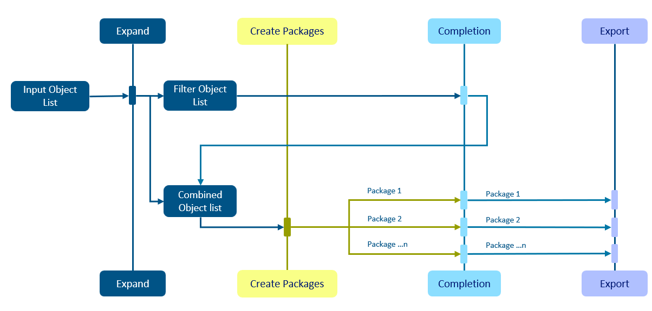
Current Flow of split export (supports ‘Filter’ split export)
After this development, we will first call classification completion on selected object (‘General Library’ or ‘General Class’), if split option is activated during 3DXML export. And after getting the classified objects, ‘Expand’ will be called on classified objects and then packages will be created from this expanded list. A separate 3DXML will be created only for classification data (‘General Library’, ‘General Class’ and ‘Subclass’).

After this development, classification data types will be supported for split export after ‘Filter’ data type. Below diagram shows the flow of split export after this development:
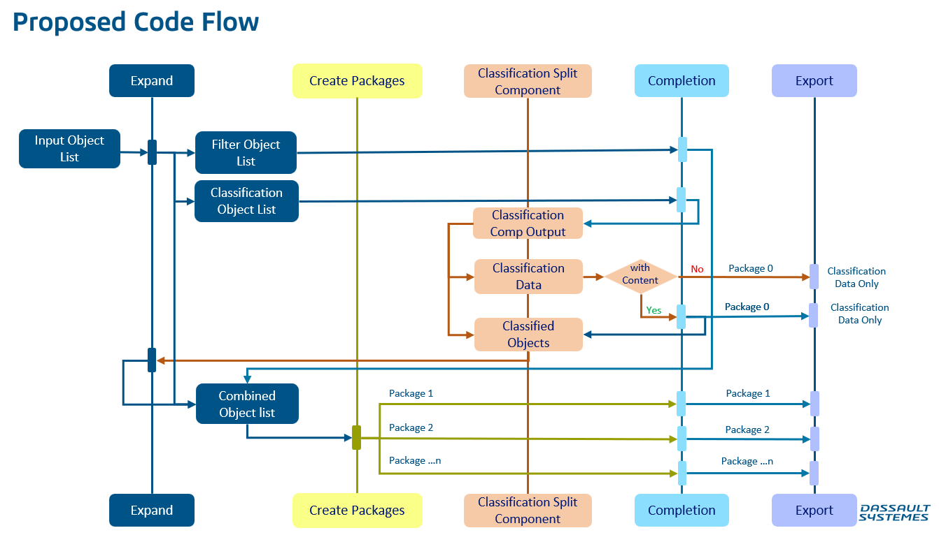
Flow of split export
Here’s a detailed breakdown of the process:
- Current Limitation:
The current export system can't split classification data into smaller parts when exporting 3DXML files. So, even if a user wants to export classification data (“General Library” with option ‘Library with content’ activated or “General Class”), the system treats everything as one large single export. Large size 3DXML containing higher number of objects can cause problems when the data is too large, leading to errors or failures during the export. Even if export is successful, import of large size 3DXML can fail too. Also, we have a limit of 47000 objects for import on cloud.

- Split Export Functionality:
In the current split export functionality, the system splits packages (a collection of objects) into smaller parts, but it does so before the package export is fully completed. This helps manage large datasets during export, but it doesn’t handle classification data (Library, Class and Classified Objects) in the same way.

- New Approach with Classification Data:
With the new functionality, we will first apply classification completion process to the classification objects (‘General Library’ and ‘General Class’). After that we will filter out the classification data (‘General Library’ and ‘General Class’) to create a separate 3DXML and then normal split export functionality will be applied to the classified objects.

- Classification Completion:
The classification completion output will provide ‘General Library’, ‘General Class’ and classified objects. From this, we will separate the classification data (‘General Library’, and ‘General Class’) to create a separate 3DXML. This will ensure that all the necessary adjustments are applied before attempting to split classified objects/assemblies.
Below are the main use-cases for classification data:

- Export of root Library with option ‘Library with Content’ deactivated:
In this use case, the user selects the root Library to export the library structure. The library structure is composed of many subclasses and Classified Items/objects as illustrated in below image.
Once “LibA” is selected and exported with option ‘Library with Content’ deactivated, the library structure including the library and the classes will be retrieved to be exported in the 3DXML file. The 3DXML file will contain also the “Attribute Groups” retrieved by the web service for all Classes of this structure. Note that the classified Items will not be retrieved in this use case.
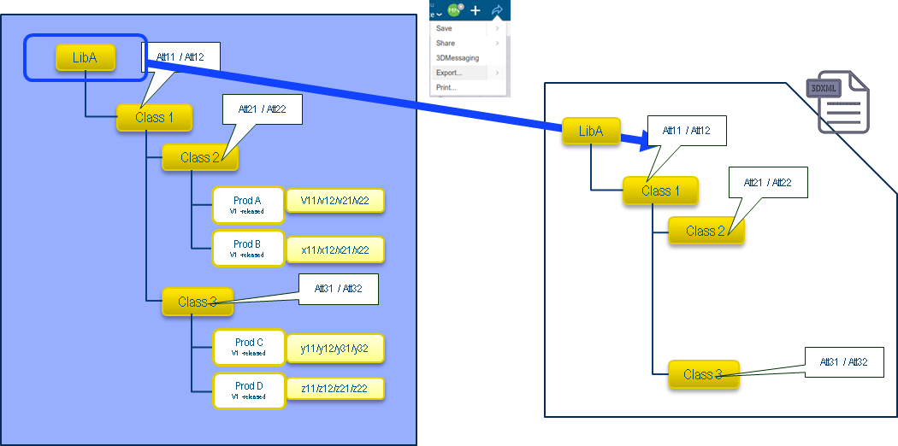
Selection of root Library to export

- Export of root Library with option ‘Library with Content’ activated:
In this use case, the user selects the root Library to export the complete library structure.
Once “LibA” is selected and exported with option ‘Library with Content’ activated, the library structure including the library and the classes will be retrieved to be exported in the 3DXML file. In this use-case, all classified Items will be exported.
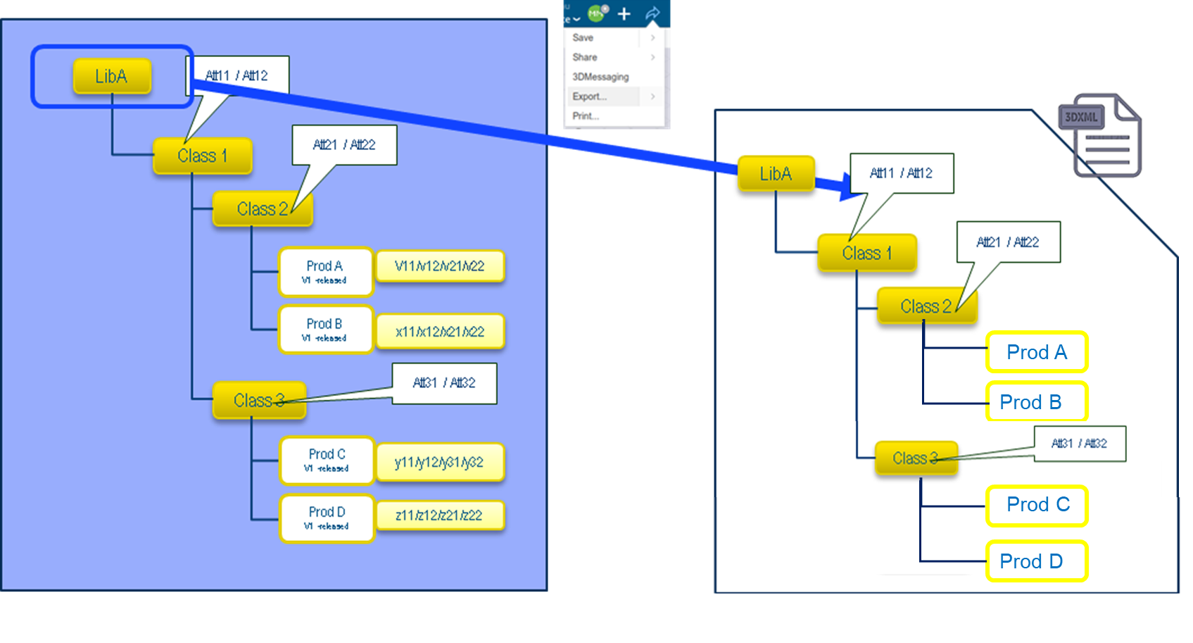
Selection of root Library to export

- Partial export of Library structure by selecting a Class:
In this use case, we have the same structure as in the previous use case, but the user selects the “Class 3” to be export the data. In this case, the completion procedure will retrieve the entity parents, “Class 1” and “LibA”, and its children (the Classified Items “Prod C” and “Prod D”) with the classification extensions.
Option ‘Library with content’ is valid only when ‘General Library’ is present in the selected object list.
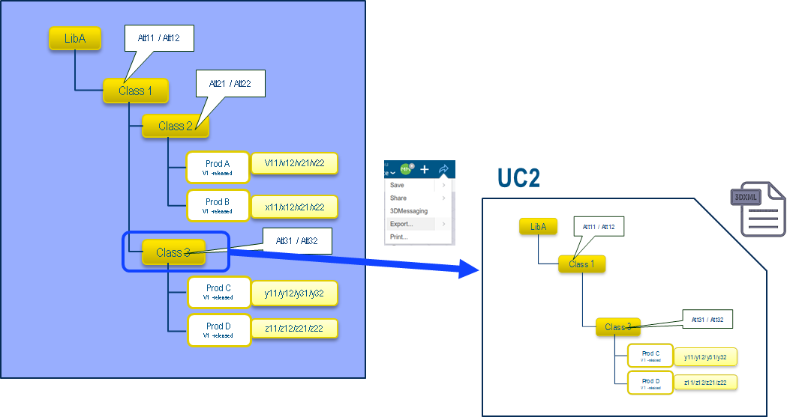
Selection of a Class inside a structure to export
- Split Export Engine:
After the classification completion is performed on classification objects (‘General Library’ and ‘General Class’), the output (classified objects) is first sent to ‘Expand’ and then to the split export engine. This engine will then handle the process of dividing the data into multiple smaller 3DXML files.
The idea here is that by splitting the data into smaller files, the export process becomes more manageable, and the chances of errors or failures due to large data sizes are minimized.

- Final Outcome:
The result is that the system will now be able to export classification data as multiple 3DXML files. One 3DXML will contain only classification objects (‘General Library’ and ‘General Class’). Other 3DXMLs will contain the classified objects/assemblies. This will help in managing large assemblies or datasets that previously might have failed during export due to the sheer size or number of objects involved.
This function adds the capability to split classification data into multiple 3DXML files by applying classification completion process before using the split export engine. This solution enhances the system’s ability to handle large datasets, improving both performance and reliability during export operations.For each capability, provide a “Use Case” narrative, by explaining what the user can do and what the response will be. Include a description of the main error cases (i.e. situations where the function will not be able to do what is requested and how it will gracefully respond).
- Modified capabilities: impact for end users
N/AIf the new capabilities replace existing features, detail here how the new usage compares to the previous usage. This is required to help the end users transition seamlessly to the new usage.
    - Limitations
Document the limits (or boundaries) of this function within the intended scope. Consider the expected behavior of the functionality under all circumstances, including possible usage errors or malicious use. Wherever possible, the usage of the function beyond its limits must be made impossible by construction or design.
If this function is not available on all supported platforms, specify the non-supported platforms here.
For each identified limitation, ensure that acceptance test coverage is provided.
- Limitation #1
If during export of a particular package, as completion could bring additional objects there is still a risk of having large number of objects for export in a single 3dxml.
- Limitation #2
If the completion of any other object brings classification data into scope of export after the split packaging is done, this may still end up in single big 3dxml.
  - What the function will not do
N/AIf the function is not going to address some of the requested items of the associated Requirement PER(s), list these exceptions here:
  - Commercial packaging
List here the Products/Role and App required to access the function.
Product (Role /App) in which the function will be available: EXH

- Detailed Specifications
Expand on the Capability Summary provided above by detailing all aspects of the functionality.
  - Functional Capabilities
This function will address the limitation in the current system where classification data (along with classified objects) cannot be split into multiple 3DXML files during export. After this development, now user can split export the classification data using batch and by interactive export.
    - Report Improvement
The export reported generated after export will contain a message for user regarding the classification data only 3DXML. Currently the name of the created 3DXMLs are like Name-(1).3dxml, Name-(2).3dxml, Name-(3).3dxml and so on according to the number of 3DXMLs generated.
After this development, if classification data is exported with option ‘Split’ activated, the first 3DXML that is Name-(1).3dxml will be the classification data only 3DXML. In report, the message will be:
“Name-(1).3dxml contains only classification data. You should first import Name-(1).3dxml first and then wait for 5 minutes to import other 3DXMLs.”
    - Use-Cases
Below are the use-cases for classification split export. In the below use-cases, flow of the split export is also explained.
- Object selected is ‘General Library’ with option ‘Library with content’ activated:
Below image shows the split export of complete library structure with classified objects/assemblies by selecting ‘General Library’. The split export of the classification data be performed using batch and interactive both.
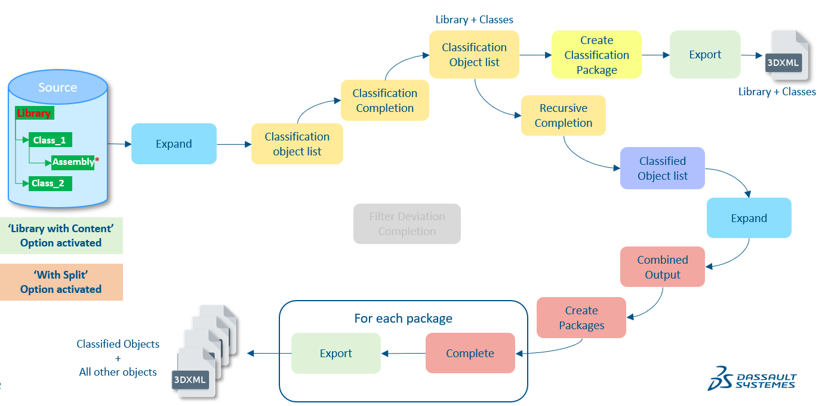
Split export of Library Structure by selecting ‘General Library’ with option ‘Library with content’ activated

Out of the multiple exported 3DXML, one 3DXML will contain only classification data (Library, Class and Subclass).

- Object selected is ‘General Library’ with option ‘Library with content’ deactivated:
Below image shows the split export of the library structure without classified objects/assemblies by selecting ‘General Library’. In this use-case, only ‘General Library’, ‘General Class’, ‘Subclass’ will be exported and a single 3DXML will be generated.
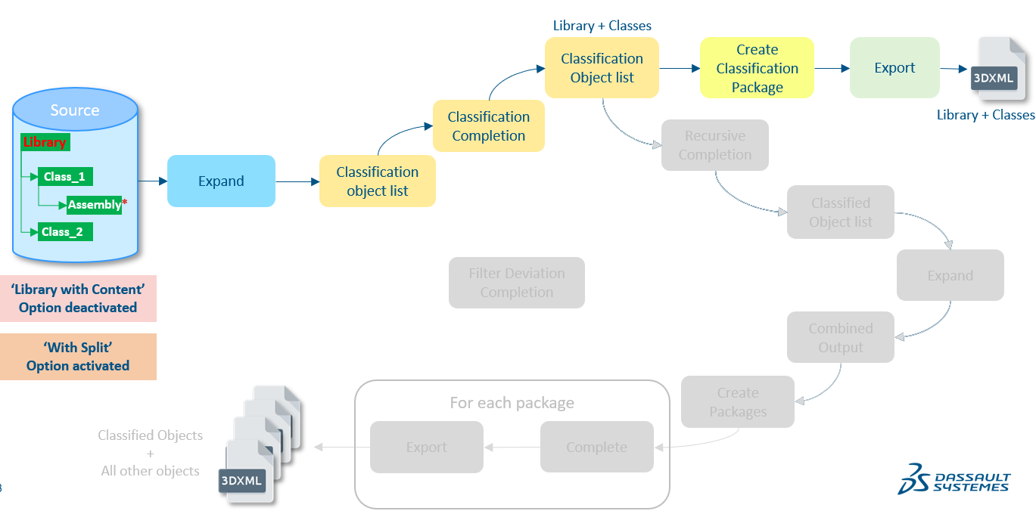
Split export of Library Structure by selecting ‘General Library’ with option ‘Library with content’ deactivated

- Object selected is ‘General Class’:
Below image shows the split export of library structure by selecting ‘General Class’. In this use-case, option ‘Library with content’ is not valid. In this case, only parent classes and library will be exported along with the classified objects/assemblies.
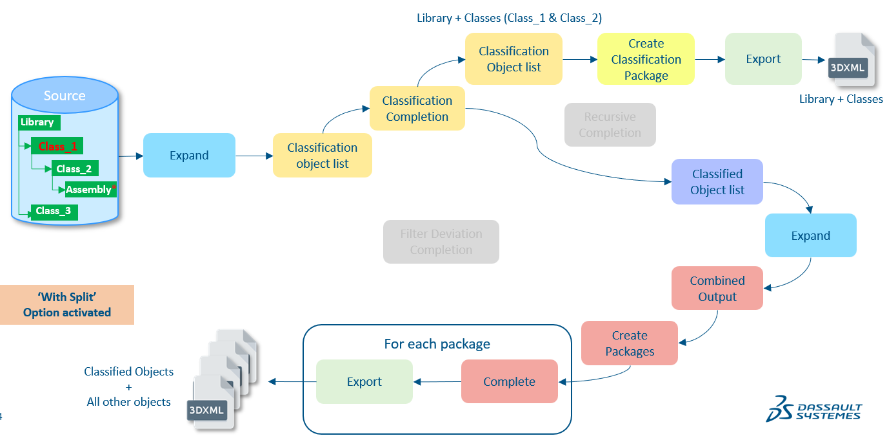
Split export of Library Structure be selecting ‘General Class’ (Class_1)
As we can see from above picture, only Class_1 and Class_2 will be exported along with Library and Assembly (classified object). Class_3 will not be present in any 3DXML.
- Object selected is ‘General Class’ and ‘General Library’ with option ‘Library with content’ activated:
In this case, complete structure will be exported as ‘Library with content’ is activated.
Below picture shows the split export of the library structure by selecting ‘Library’ and ‘Class_1’.
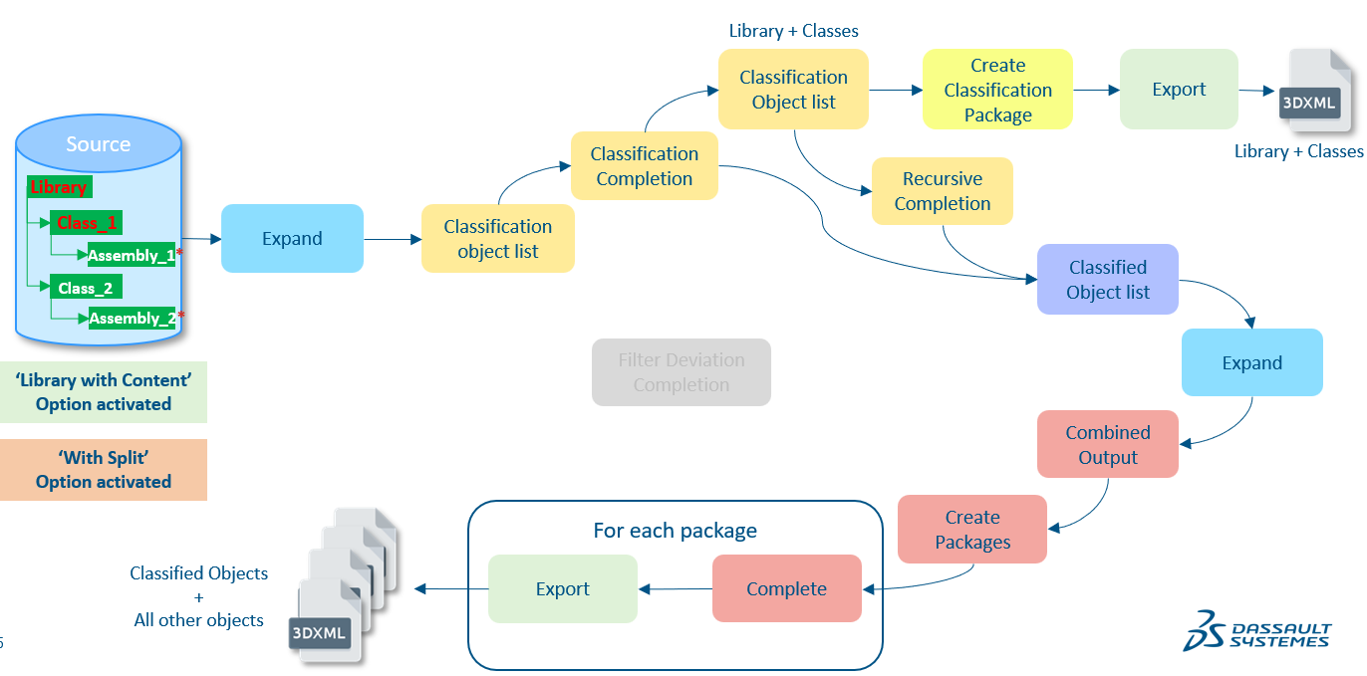
Split export of Library Structure by selecting ‘General Class’ (Class_1) and ‘General Library’ with option ‘Library with content’ activated
- Object selected is ‘General Class’ and ‘General Library’ with option ‘Library with content’ deactivated:
In this case, complete classification objects (Library and Classes) will be exported. But there will be classified objects too in other 3DXML.
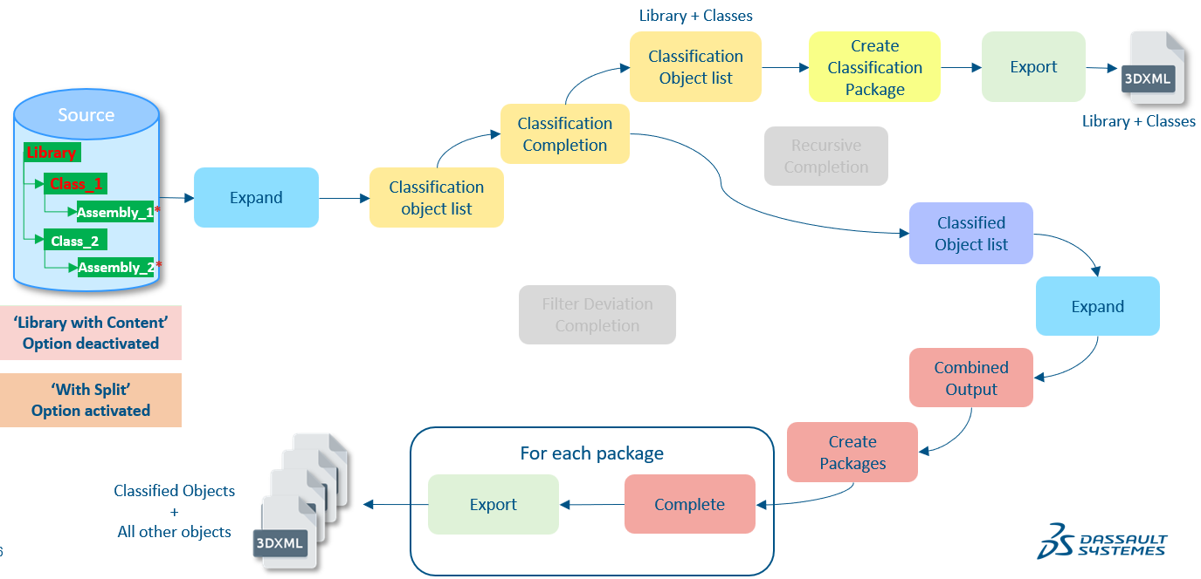
Split export of Library Structure by selecting ‘General Class’ (Class_1) and ‘General Library’ with option ‘Library with content’ deactivated
As we can see from the above image, ‘Class_1’ and ‘Library’ are selected with option ‘Library with content’ activated, all classification objects that is ‘Library’, ‘Class_1’ and ‘Class_2’ will be exported in a 3DXML (classification data only 3DXML). And, Assembly_1 will be exported in other 3DXMLs as it is classified under ‘Class_1’ (selected object) but Assembly_2 will not be there in any 3DXML.

- Object selected is ‘VPMreference’ (root of another assembly) and ‘General Library’ with option ‘Library with content’ activated:
As we see from the below image, selected object is Library and root of ‘Assembly_2’ (VPMReference). The selected ‘VPMreference’ is not classified under any class and this is a separate assembly.
The exported 3DXMLs will contain the complete library structure along with all the classified objects/assemblies. Also, complete ‘Assembly_2’ structure will be present too in the exported 3DXMLs.
In the below image, flow of split export is shown.
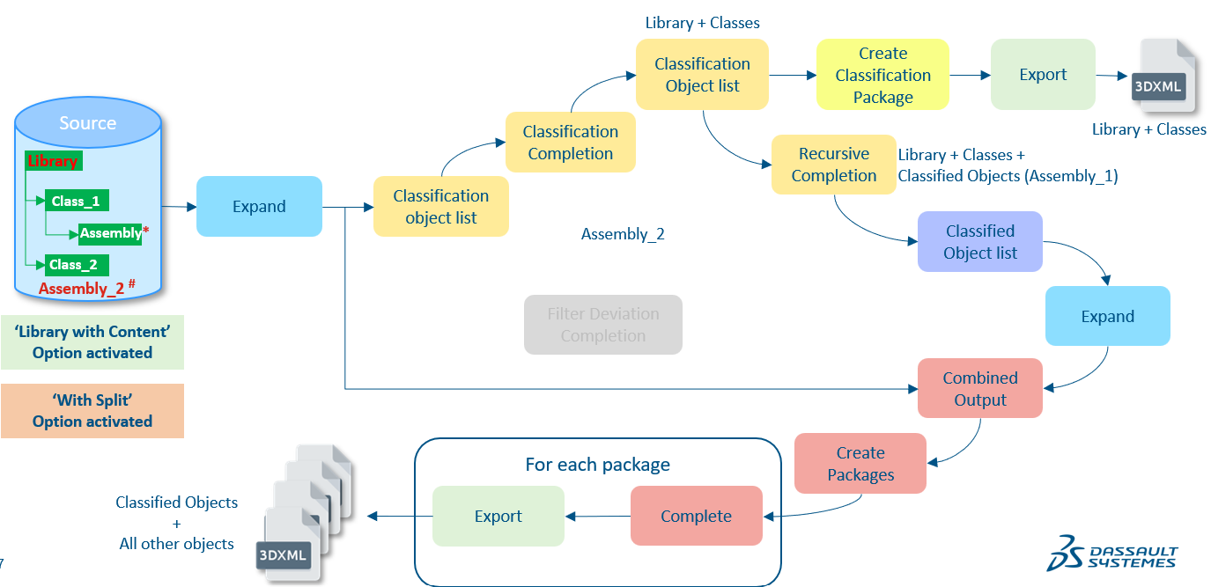
Split export of Library Structure by selecting ‘VPMreference’ and ‘General Library’ with option ‘Library with content’ activated
- Object selected is ‘Filter’ and ‘General Library’ with option ‘Library with content’ activated:
‘Filter’ is a deviation object type which supports split export too. We have covered the use-case in which user selects ‘Filter’ and ‘General Library’ both.
Below image shows the flow of split export when user selects root of Assembly_2, having object type ‘Filter’ and ‘Library’.
In this case, complete library structure will be exported (classified object too).
In one 3DXML, only classification data (‘Library’, ‘Class-1’ and ‘Class_2’) will present. ‘Assembly’, which is classified under ‘Class_1’ and ‘Assembly_2’, whose root object type is ‘Filter’, will be exported in other 3DXMLs.
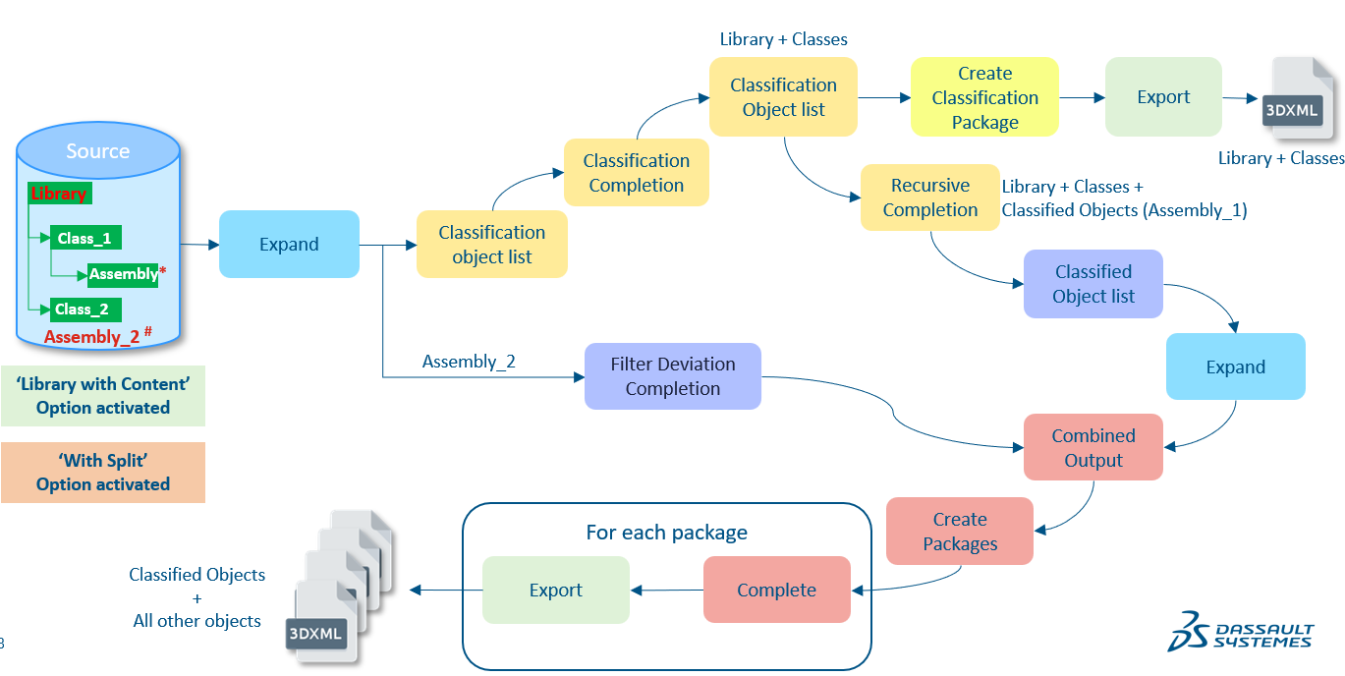
Split export of Library Structure by selecting ‘Filter’ and ‘General Library’ with option ‘Library with content’ activated
- Object selected is ‘Filter’, ‘VPMReference’ (root of classified assembly) and ‘General Library’ with option ‘Library with content’ deactivated:
In this case, total selected objects are 3. One is ‘Library’, second is root of classified assembly (Assembly_1) having object type ‘VPMReference’ and third is root of a separate assembly (Assembly_3) having object type ‘Filter’, as shown below. Below image shows the flow of split export of three different types of object selected.
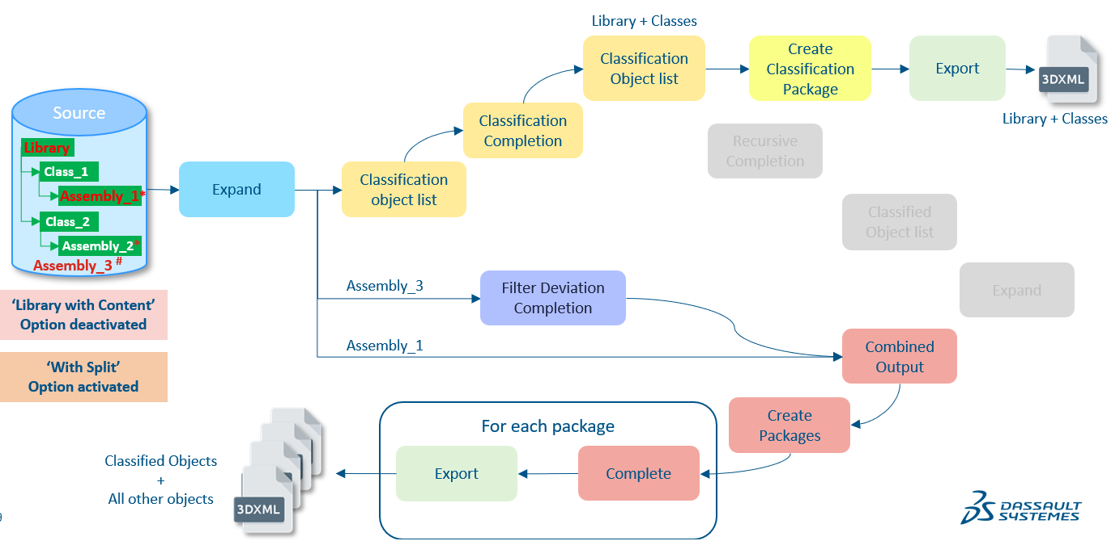
Split export of Library Structure by selecting ‘Filter’, ‘VPMreference’ and ‘General Library’ with option ‘Library with content’ deactivated
In this case, ‘Library’, ‘Class_1’ and ‘Class_2’ will be exported in classification data only 3DXML. And, ‘Assembly_1’ and ‘Assembly_3’ will be exported in other 3DXMLs.

  - Packaging
 If this function impacts the packaging, a Software Architect must be named in the role of Design Reviewer in the Function Planning. This assignment will create a “Design Task” task allowing the Software Architect to review the packaging changes via a dedicated Design Enhancement Specification “DES” and eventually to make the required packaging enhancements. For more information about “DES”, click here. If a Service or Component is involved, the associated “referential” may require an update.
If this function modifies the existing packaging, specify the necessary changes below. Include whether commercial pre-requisite products are required and, if so, whether these must be created. If packaging changes will affect pricing, explain this here.
For more information of this topic, refer to the “Packaging” section of PES Authoring Best Practices.
! | Required Information | Response
 | Does this function impact the packaging? | No Impact
Packaging items to be modified:
List the packaging items to modify, separated by a semicolon.
  - User experience and interactions
For information on completing this PES section, refer to the PES Authoring Best Practices section “What about User Experience and Interaction”.
    - User interface
- New UI components
If the function adds new UI “components”, (commands/dialog boxes/panels/widgets) list them in the table below.
Component List | New component behavior
N/A | N/A

- Modified UI components
If the function changes existing dialogs, specify below which dialogs are impacted and how. Explain also any change to information access (for instance if some properties will now be accessible through a different dialog.
! | Required Information | Response
 | Is the Current User Experience Impacted? | No
 If the function impacts the current User Experience (an action can no longer be performed, default behavior is modified, etc.), a User Experience Expert must be named in the Function Plan. This will create a “UEE PES Review” task allowing the User Experience Expert to evaluate whether the impact is acceptable and, if so, how to minimize impact on the end user. If no User Experience Expert is available, assign the task to the App Manager.
Modified Component List | Modified behavior | New behavior
N/A | N/A | N/A
    - User assistance
- Embedded user assistance (tooltips, UA panel, etc.)
List below the new or existing UI components (e.g: action bar command, dialog box, button, field) that require a change to embedded User Assistance. Duplicate the row when needed.
User-visible Title | Component type | New or updated | Brief description of change
Title | action bar command, dialog box, etc. | Select an item. | Click or tap here to enter text.

- What’s New

! | Required Information | Response
 | Display this function as a highlight in What’s New? | Yes

- User documentation (optional)
If user documentation is required, describe the changes below. Duplicate the row when needed.
Guide | Component type | New or updated | Brief description of change
Title | Click or tap here to enter text. | Select an item. | Click or tap here to enter text.

    - Page Objects
The Page Object Model is a design pattern that is becoming a standard for end-to-end automation of Web applications, its methods expose possible end-user interactions with the UI of the page/component. For more information of this topic, join the CHEETAH Automation Framework Swym community.
If the function has features with external visibility to be covered by a Quality Scenario, you have to deliver the necessary Page Objects on the Function’s “Test Task” in DSxRD.
! | Required Information | Response
 | Does your function require PageObject delivery? | No
If yes, provide the list of the page objects that will allow to programmatically interact with it.
- PO-1: N/A
Specify the end user interaction(s) that is (are) exposed through the page object method(s).
- PO-2: N/A
<Repeat as necessary>
Specify the acceptance tests that use the Page Object(s) here.

  - Data management
Specify the user data that will be created while using the function.
    - Supported object types (run-time data and persistent data)
All Classification data.List the object types applicable to this function and their properties.
    - Expected behavior for each object type (run-time data and persistent data)
N/ACreate a matrix that describes the behavior of the function (rows) for each object type (columns). For more information, refer to the “” of this example.
    - Data persistency and/or upgrade (if applicable)
N/ASpecify which data created or modified by the function is persistent (i.e., data with a lifecycle that spans beyond the user’s session). Specify how/where/in what database, etc., each type will be managed.
Concerning existing data model structures, specify if there is a modification:
! | Required Information | Response
 | Does this function require a change to the data model schema? | No

If the migration batch has to be enhanced (for instance, if the previous data structure will no longer be handled by the application), indicate below that an upgrade procedure is needed:
! | Required Information | Response
 | Does this function require an upgrade procedure? | No

 If you answer “Yes” to either of the above two questions, ensure the corresponding information is set for the function in DSxRD Authoring.
Notes: Customer data loss is NOT permitted. “Data loss” means: the data is not upgraded and definitely lost or the data is migrated but no longer accessible to the end user without user actions. If a data upgrade is needed, dedicated Acceptance Tests must be created. These tests must specify the data sample used to perform the test and the method and criteria to verify the results of the data migration after upgrade. The developer and the QA leader must ensure the chosen samples contain sufficient data to test all data schema impacts.
- Schema or other changes impacting multi-level compatibility
N/ASpecify whether this functionality is able to operate consistently with older releases or with products designed for interoperability. Identify the key compatibility aspects of this function in terms of both function behavior and data compatibility. For help on this topic, refer to the PES Authoring Best Practices section “What about Compatibility”.
    - Data repository
Specify the data repository used.
! | Required Information | Response
 | Is this function related to 3DEXPERIENCE 3DSpace Baseline Behavior? | No
 If yes, you must complete the dedicated sub-section.

  - Customization by end user or administrator
N/ADescribe any custom functionality that will accommodate a specific customer or User Role Profile. How does the user or administrator change the way the functionality behaves? Explain who can make changes and how they will do so. If this function makes customization available through a user interface check, a profile check, or a similar mechanism, describes this here or in the External View section.
  - Programming interface
N/A
! | Required Information | Response
 | Does this function provide APIs to clients? | No
 If yes, ensure the corresponding information “CAA Exposition” is also set for the function in DSxRD Authoring.
    - Detailed API description (if relevant)
N/AFor help on this topic, refer to the section “What about API”.
    - Automation for command journaling (if relevant)
N/ASpecify here whether new commands created by this function (if any) will be exposed for automation and for availability in journaling.
- Quality of services
Specify the “nonfunctional” qualities of service (performance, capacity, scalability, ) and security controls (Confidentiality, Integrity, Availability...) related to the requested functionality.
  - Performance, capacity and scalability (PCS)
Evaluate and specify the PCS objectives for industrial usage of this function. For more information on this topic, refer to the “What About Performance, Capacity and Scalability (PCS)” section of PES Authoring Best Practices.
Definitions:
Performance - Time and system resources required to complete a set of scenarios
Capacity - Number of concurrent users supported by a given hardware configuration
Scalability - Ability to add proportional amounts of workload and resources while maintaining performance
    - Performance objectives
To measure the performance difference in time taken to export and split export classification data with classified objects/assemblies.
    - Capacity objectives
N/A
    - Scalability objectives
N/A
! | Required Information | Response
 | Are PCS tests provided with the function? | Yes
If yes, specify the tests in the dedicated section.
 In this case, at least one task containing “PCS” has to be created in the function plan to ensure the tests defined to measure the objectives will be run and assessed.
If you answered “No”, explain why briefly:
  - Security controls
 For more information on this topic, refer to the “What about: Security Control” section of PES Authoring Best Practices.
! | Required Information | Response
 | Does this function comply with security control rules for maintaining safe function usage? | Yes
If you answered “No” to the above question, explain why briefly:
Click or tap here to enter text.
Specify the detailed security controls available to the end user of this functionality. For help on this topic, refer to the “Security Control” section of PES Authoring Best Practices. The list below is not exhaustive; add topics as needed.
    - Confidentiality
N/A
    - Integrity
N/A
    - Availability
N/A
    - Authentication
N/A
    - Authorization
N/A
  - Data privacy
 According to Data Privacy laws (more information in Ethics & Compliance at 3DS community), including GDPR, a personal data is any information that can identify directly or indirectly an individual (e.g. name, userid, cookies, IP Address).
All 3DS products must comply with the following rules (more information in R&D Data Privacy – 3DS as a software vendor community, ask for access rights if needed).
- Transparency: list of processed personal data (including cookies) and list of third parties to which personal data are transferred (e.g. Outscale, AWS and Huawei) are not modified by your function – else, contact your R&D Data Privacy Director.
- Minimization: collect and use only needed personal data for a defined retention period.
- Respect of data subject rights: possibility to access, modify and delete personal data.
 For more information on this topic, refer to the “What about: Data Privacy” section of PES Authoring Best Practices.
! | Required Information | Response
 | Does this function comply with 3DS obligations related to the use and protection of personal data? | Yes
If you answered “No” to the above question, explain why briefly:
Click or tap here to enter text.

- Acceptance Test Protocols
Specify the testing that will be done to demonstrate that this function works as specified. Acceptance tests are expected to work in the integrated code base at or before the FCF gate, before QA takes over the function for a more thorough suite of tests.
Acceptance Tests must cover each capability and limitation described in the previous sections. Each test definition must include objective criteria to assess whether the test produced the expected results. Automated tests should be delivered whenever possible.
  - Functional Acceptance Tests

Functional acceptance tests demonstrate that the expected results are obtained or that the expected behavior occurs for each aspect of the new or modified functionality when used as intended. This includes testing of specific topics as applicable: embedded user assistance, data upgrade, etc.
    - AT-1: Split Export of Classification Data by selecting ‘General Library’ with option ‘Library with content’ activated
- What’s being tested?
Generation of multiple 3DXMLs and out of these one 3DXML contains only classification data. Explain the objectives of this test.
- Test data
Classification Data with Classified ObjectsDefine the input data and the data of reference used to check that the test execution produces the expected results.
- Test protocol
- Specify what environment, if any, must be prepared in order to run the test. Specify the sequence of operations/steps).Create a library structure with multiple classes. Some of the classes should have child class.
- AttaAClassify some assemblies to the classes.
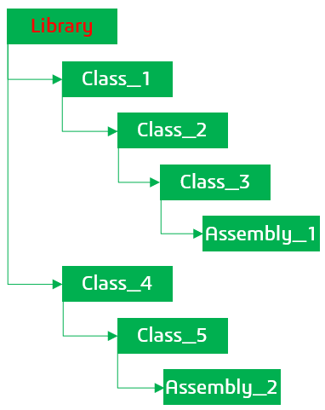
- Classify some objects having different types to multiple classes, for example Drawing, Document, VPMReference, 3DPart etc.
- Export the above assembly by selecting ‘General Library’ with option ‘Library with content’ activated.
- Related automatic tests
RE_ClassificationData_SplitExport.sh will be created.Specify the names of the related Automatic Tests (ODTs), if any.
- Test verification
- Specify the names of the related Automatic Tests (ODTs), if any.
Examples of verification criteria:
- Expected results and acceptable tolerance
- Allowable exceptions
- Expected performance
- Engineering judgment
Example sources of verification criteria:
- Physical test data
- Published journal results
- NAFEMS test
- Closed-form solution
- Export must be successful.
- At least 2 3DXML must be generated.
- One 3DXML should contain classification data only that is only ‘General Library’ and ‘General Class’.
- Check the classification data only 3DXML name in report and verify with the exported 3DXML file.
- Test responsibility
R&D/QA(optional) The developer has primary responsibility for executing this test. If applicable, specify who is additionally responsible for executing this test in terms of Role.

    - AT-2: Split Export of Classification Data by selecting ‘General Library’ with option ‘Library with content’ deactivated
- What’s being tested?
Generation of multiple 3DXMLs and out of these one 3DXML contains only classification data. Explain the objectives of this test.
- Test data
Classification Data with Classified ObjectsDefine the input data and the data of reference used to check that the test execution produces the expected results.
- Test protocol
- Specify what environment, if any, must be prepared in order to run the test. Specify the sequence of operations/steps).Create a library structure with multiple classes. Some of the classes should have child class.
- AttaAClassify some assemblies to the classes.

- Classify some objects having different types to multiple classes, for example Drawing, Document, VPMReference, 3DPart etc.
- Export the above assembly by selecting ‘General Library’ with option ‘Library with content’ deactivated.
- Related automatic tests
N/ASpecify the names of the related Automatic Tests (ODTs), if any.
- Test verification
- Specify the names of the related Automatic Tests (ODTs), if any.
Examples of verification criteria:
- Expected results and acceptable tolerance
- Allowable exceptions
- Expected performance
- Engineering judgment
Example sources of verification criteria:
- Physical test data
- Published journal results
- NAFEMS test
- Closed-form solution
- Export must be successful.
- Only one 3DXML should be generated.
- The 3DXML should contain classification data only that is only ‘General Library’ and ‘General Class’ and no classified objects.
- Test responsibility
R&D/QA

    - AT-3: Split Export of Classification Data by selecting ‘General Class’
- What’s being tested?
Generation of multiple 3DXMLs and out of these one 3DXML contains only classification data. Explain the objectives of this test.
- Test data
Classification Data with Classified ObjectsDefine the input data and the data of reference used to check that the test execution produces the expected results.
- Test protocol
- Specify what environment, if any, must be prepared in order to run the test. Specify the sequence of operations/steps).Create a library structure with multiple classes. Some of the classes should have child class.
- AttaAClassify some assemblies to the classes.
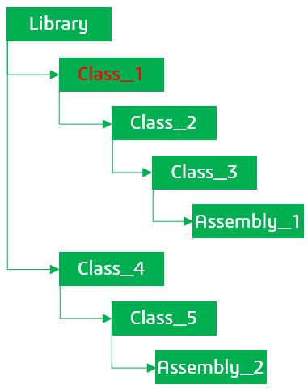
- Classify some objects having different types to multiple classes, for example Drawing, Document, VPMReference, 3DPart etc.
- Export the above assembly by selecting the ‘General Class’ (Class_1).
- Related automatic tests
RE_ClassificationData_SplitExport.sh will be created.Specify the names of the related Automatic Tests (ODTs), if any.
- Test verification
- Specify the names of the related Automatic Tests (ODTs), if any.
Examples of verification criteria:
- Expected results and acceptable tolerance
- Allowable exceptions
- Expected performance
- Engineering judgment
Example sources of verification criteria:
- Physical test data
- Published journal results
- NAFEMS test
- Closed-form solution
- Export must be successful.
- At least 2 3DXML must be generated.
- One 3DXML should contain classification data only that is only ‘General Library’ and ‘General Class’. In this, only the children of Class_1 should be present (Class_2 and Class_3) and not Class_4 or it’s children.
- Check the classification data only 3DXML name in report and verify with the exported 3DXML file.
- Test responsibility
R&D/QA

    - AT-4: Split Export of Classification Data by selecting ‘General Library’ and ‘General Class’
- What’s being tested?
Generation of multiple 3DXMLs and out of these one 3DXML contains only classification data. Explain the objectives of this test.
- Test data
Classification Data with Classified ObjectsDefine the input data and the data of reference used to check that the test execution produces the expected results.
- Test protocol
- Specify what environment, if any, must be prepared in order to run the test. Specify the sequence of operations/steps).Create a library structure with multiple classes. Some of the classes should have child class, as shown below.
- Classify some assemblies to the classes.
- Classify some objects having different types to multiple classes, for example Drawing, Document, VPMReference, 3DPart etc.
- Export the above assembly by selecting the ‘General Library’ and ‘General Class’ (Class_1) with option ‘Library with content’ deactivated.
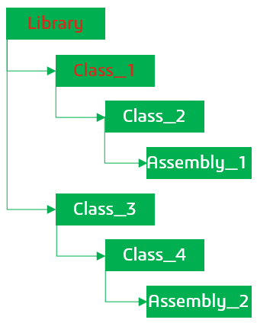AttaA
- Related automatic tests
RE_ClassificationData_SplitExport.sh will be created.Specify the names of the related Automatic Tests (ODTs), if any.
- Test verification
- Specify the names of the related Automatic Tests (ODTs), if any.
Examples of verification criteria:
- Expected results and acceptable tolerance
- Allowable exceptions
- Expected performance
- Engineering judgment
Example sources of verification criteria:
- Physical test data
- Published journal results
- NAFEMS test
- Closed-form solution
- Export must be successful.
- At least 2 3DXML must be generated.
- One 3DXML should contain classification data only that is only ‘General Library’ and ‘General Class’.
- Check the classification data only 3DXML name in report and verify with the exported 3DXML file.
- Assembly_1 should be exported in separate 3DXML and Assembly_2 should not be present in any 3DXML.
- Test responsibility
R&D/QA

    - AT-5: Split Export of Classification Data by selecting ‘General Library’ and ‘VPMReference’ (classified object/assembly)
- What’s being tested?
Generation of multiple 3DXMLs and out of these one 3DXML contains only classification data. Explain the objectives of this test.
- Test data
Classification Data with Classified ObjectsDefine the input data and the data of reference used to check that the test execution produces the expected results.

- Test protocol
- Specify what environment, if any, must be prepared in order to run the test. Specify the sequence of operations/steps).Create a library structure with multiple classes. Some of the classes should have child class.
- AttaAClassify some assemblies to the classes.
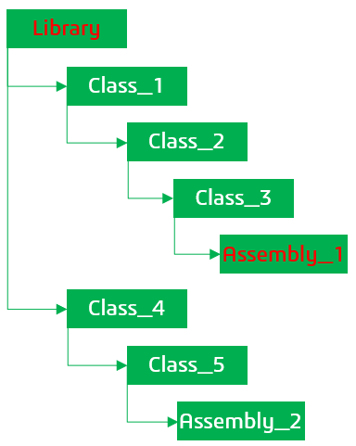
- Classify some objects having different types to multiple classes, for example Drawing, Document, VPMReference, 3DPart etc.
- Export the above assembly by selecting the ‘General Library’ and ‘VPMReference’ (root of Assembly_1) with option ‘Library with content’ deactivated.
- Related automatic tests
RE_ClassificationData_SplitExport.sh will be created.Specify the names of the related Automatic Tests (ODTs), if any.
- Test verification
- Specify the names of the related Automatic Tests (ODTs), if any.
Examples of verification criteria:
- Expected results and acceptable tolerance
- Allowable exceptions
- Expected performance
- Engineering judgment
Example sources of verification criteria:
- Physical test data
- Published journal results
- NAFEMS test
- Closed-form solution
- Export must be successful.
- At least 2 3DXML must be generated.
- One 3DXML should contain classification data only that is only ‘General Library’ and ‘General Class’.
- Check the classification data only 3DXML name in report and verify with the exported 3DXML file.
- Assembly_1 should be exported in separate 3DXML and Assembly_2 should not be present in any 3DXML.
- Test responsibility
R&D/QA

    - AT-6: Split Export of Classification Data by selecting ‘General Library’, ‘VPMReference’ and ‘Filter’(separate object/assembly)
- What’s being tested?
Generation of multiple 3DXMLs and out of these one 3DXML contains only classification data. Explain the objectives of this test.
- Test data
Classification Data with Classified ObjectsDefine the input data and the data of reference used to check that the test execution produces the expected results.
- Test protocol
- Specify what environment, if any, must be prepared in order to run the test. Specify the sequence of operations/steps).Create a library structure with multiple classes. Some of the classes should have child class.
- AttaAClassify some assemblies to the classes.
- Create one separate assembly of ‘Filter’ root object type (Assembly_3).
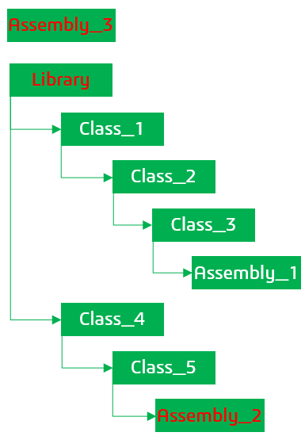
- Classify some objects having different types to multiple classes, for example Drawing, Document, VPMReference, 3DPart etc.
- Export the above assembly by selecting the ‘General Library’ and ‘VPMReference’ (root of Assembly_2) with option ‘Library with content’ deactivated.
- Related automatic tests
RE_ClassificationData_SplitExport.sh will be created.Specify the names of the related Automatic Tests (ODTs), if any.
- Test verification
- Specify the names of the related Automatic Tests (ODTs), if any.
Examples of verification criteria:
- Expected results and acceptable tolerance
- Allowable exceptions
- Expected performance
- Engineering judgment
Example sources of verification criteria:
- Physical test data
- Published journal results
- NAFEMS test
- Closed-form solution
- Export must be successful.
- At least 2 3DXML must be generated.
- One 3DXML should contain classification data only that is only ‘General Library’ and ‘General Class’.
- Check the classification data only 3DXML name in report and verify with the exported 3DXML file.
- Assembly_2 and Assembly_3 should be exported in separate 3DXMLs and Assembly_1 should not be present in any 3DXML.
- Test responsibility
R&D/QA
    - AT-7: Split Export of Classification Data by selecting ‘General Library’ and ‘Filter’ (separate object/assembly)
- What’s being tested?
Generation of multiple 3DXMLs and out of these one 3DXML contains only classification data. Explain the objectives of this test.
- Test data
Classification Data with Classified ObjectsDefine the input data and the data of reference used to check that the test execution produces the expected results.
- Test protocol
- Specify what environment, if any, must be prepared in order to run the test. Specify the sequence of operations/steps).Create a library structure with multiple classes. Some of the classes should have child class.
- AttaAClassify some assemblies to the classes.
- Create one separate assembly of ‘Filter’ root object type (Assembly_3).

- Classify some objects having different types to multiple classes, for example Drawing, Document, VPMReference, 3DPart etc.
- Export the above assembly by selecting the ‘General Library’ and ‘Filter’ (root of Assembly_3) with option ‘Library with content’ deactivated.
- Related automatic tests
RE_ClassificationData_SplitExport.sh will be created.Specify the names of the related Automatic Tests (ODTs), if any.
- Test verification
- Specify the names of the related Automatic Tests (ODTs), if any.
Examples of verification criteria:
- Expected results and acceptable tolerance
- Allowable exceptions
- Expected performance
- Engineering judgment
Example sources of verification criteria:
- Physical test data
- Published journal results
- NAFEMS test
- Closed-form solution
- Export must be successful.
- At least 2 3DXML must be generated.
- One 3DXML should contain classification data only that is only ‘General Library’ and ‘General Class’.
- Check the classification data only 3DXML name in report and verify with the exported 3DXML file.
- Assembly_3 should be exported in separate 3DXMLs and Assembly_1 should not be present in any 3DXML.
- Test responsibility
R&D/QA

  - Limit & Negative Acceptance Tests
Limit and negative acceptance tests demonstrate that the software handles boundary cases correctly and that appropriate warning and error messages are produced.
    - LN-1: Enter the name of the test

  - Performance/Capacity/Scalability Acceptance Tests
Performance/Capacity/Scalability tests demonstrate that the software satisfies the PCS objectives defined in Section 3, Quality of Services
    - PCS-1: Export Performance Benchmark [valid in 2026x FD03]
Provide the detailed test description. Specify whether the functionality is new or whether it is an improvement to existing functionality. Explain the expected results.
Performance
- What’s being tested?
Test the time required to split export the classification data.
- Test protocol
- Create a library structure with multiple classes at site 1. Some of the classes should have child class.
- AttaACreate few assemblies with around 8000-10000 objects at site 1 with variety of types like port, connection, references, representations, documents, Filter etc.
- Classify the above assemblies to the multiple classes.
- Classify some objects having different types to multiple classes, for example Drawing, Document, VPMReference, 3DPart, Filter etc.
- Launch export panel to export the selected data.
- Activate option ‘Split’ on the export panel.
- Now, export the data.Specify the output data and verification criteria for each item to be verified. For instance, check that necessary and sufficient error messages are displayed to the end user, and that the situation can be recovered.
- Test data
Create a library structure with classified objects/assemblies and multiple types like IRPC or ER or NLV.Describe the usage and content of standard or specific/customer data.
Specify the size/amount of data.
- Environment
The PCS test has to be run on both environments 2026x FD03 OnPremise and OnCloud.Specify the necessary test execution environment
- Dedicated / shared hardware and software
- Isolated / non-isolated network
- Usage of any device that may impact operations performed during the test (writing, reading…) such as latency, tool
- Related automatic tests
N/ASpecify the names of the related Automatic Tests (ODT names), if any.
- PCS Objectives
Measure time taken to split export the data after clicking on run to benchmark the performance.Specify the objectives and their level (UI level for end-user time perception and/or Algorithm level for instance).
- Test execution timeframe and measurements
Measure time taken to split export the data at step 5.Specify for which master schedule gate these tests are planned to be run and which measurements will be taken. (Note: All Acceptance Tests are expected to work at FCF. If your target gate is later than FCF, please explain why.)
- Limitations
N/A
  - Page Objects usage by acceptance tests
List the Page Objects specified in the PES and the acceptance test(s), which test and validate them.
Page Object | Acceptance Test(s)

- (optional) 3DSpace Baseline Behavior Support

 | Response
Does the function support the 3DSpace Baseline Behavior? | Select an item.

Summarize the main characteristics of this app by completing the topics below. The User Assistance Developer will then use a documentation template to create a dedicated entry in this app’s documentation.
- Content categories
Depending on your access role, you can create and manage the following types of content with <this App>.
Type | Category
Click here to enter the content type | Click here to enter the category.

- Access roles
<This App> uses the 3DEXPERIENCE platform 3DSpace baseline access roles that your business administrator assigns to you. The table below describes the level of access for each role.
Access Role | Description
Reader  (Views <app external naming types>) | Click here to enter text.
Author  (Creates, Modifies, and deletes  <App External naming types> | Click here to enter text.
Click here to enter text. | Click here to enter text.
- Content lifecycle
If you do not use Baseline Behavior lifecycle maturity states, specify the mapping you have provided (e.g. <MyMaturityState> is mapped with “in Work”, etc.
- Limitations
Specify any limitations in comparison to Baseline Behavior fundamentals.
- (optional) PES related material
  - Reference Materials
List documents or other reference materials (e.g. Samples, User Experience videos, Prototypes, etc.) relating to this PES.
 Click here to enter text.
  - PES Authoring Rules Checklists (if relevant)
Authoring Rules are specific lists of rules that has to be addressed by this PES. Each Rules Checklist has a name and applicability criterion; both PES authors and reviewers are expected to use Authoring Rules Checklists to ensure completeness of the PES.
 | Response
Do specific rules apply to this PES? | Select an item.

Name of Checklists used in this PES | Reason why that checklist applies to this PES
Ex: Checklist_UXRules-v3-1.docx | Facilitates verification that generic usability criteria have been properly considered during the conception of the user interface.
Click here to enter the item to check. | Click here to enter text.

Template Life trace (deploy chapter to read content)

Note that the last version of published PES template is available here.
If you are using a local copy template, download the last version to ensure you have the right version. If not, look at the template lifetrace to know what has changed.
Author | Activity | Change Id  major.minor | Date (yy/mm/dd) | Change comments  (Specify list of Reviewers for major changes) | Maturity
jdt | Creation | 4.43 |  |  | Validated
ccc | Update | 5.1 (major) | 21/04/29 | • some information have been re-organized  - specific information (3DSpace Baseline Behavior for instance) have been kept but in a dedicated section  - functional content has been better dispatched between the first two sections  - explanations have been rewritten with Susan Trager to make them easier to understand in particular for Anglophones  - information relative to PCS, security, personal data have been moved and regrouped in a dedicated section “Quality of Services”  - the User Experience and interactions section has been reviewed and the part relative to documentation has been modified on technical writers requests  - the “packaging” has been separated in two parts:  -- the “commercial packaging” which specifies the licenses the end user has to use to access the function capabilities – in high level specifications  -- the “implement packaging” which specifies what has to be modified in terms of packaging implementation (roles, apps, technical products, components, medias – in detailed specifications  - “required” information have been updated to provide information more useful to analyze PES Content.  • Content has been added  - process reminder in PES context  - new type of acceptance tests for “limit & negative” cases (to test and ensure what happen/is displayed in case of bad usage by end user)  - the list of Page objects which are provided and the acceptance tests which use them  • Few obsolete information or information which were never set have been removed  • New corporate word document template has been used. | Validated
ccc | Update | 5.2 | 21/03/16 | Adding Page Object information | Validated
ccc | Update | 5.3 | 21/10/13 | Fix format issues  Add template life trace | Validated
ccc | Update | 5.4 | 22/04/11 | Section 2: Detailed Specifications / Programming interface: explicit the parameter to set in DSxRD  Section 3: Quality of services/Data privacy: provide more information to help PES writer answering the question | Validated
man22  rdh1  ccc | Update | 5.5 | 24/08/27 | All template (man22):  - Fix format issues,  - Restriction of mandatory fields,  - Required Information” deleted on optional chapters  - Alignment with Dassault Systèmes Brand Equity  Section 2.2.2: add question about What’s new (rdh1)  Section 3.1 Performance, capacity and scalability (PCS):  - add reminder about the process rule to create a PCS task to ensure the tests will be run and assessed  - new authorized answers are “yes” or “no” to the question “Are PCS tests provided with the function?”  Section 3.2 Security Controls: new authorized answers are “yes” or “no”  Section 3.3 Data Privacy: new authorized answers are “yes” or “no” | Validated
man22 | Update | 5.5.1 | 24/10/04 | Fix format issues on mandatory fields | Validated

