**Assignment 3**

Make 3 repositories which are private having branch named master,2025Q1,2025Q2 consisting same file named index.html.Launch an instance having hhtpd services.If any changes are done in any repository in file index.html it should be deployed in EC2.

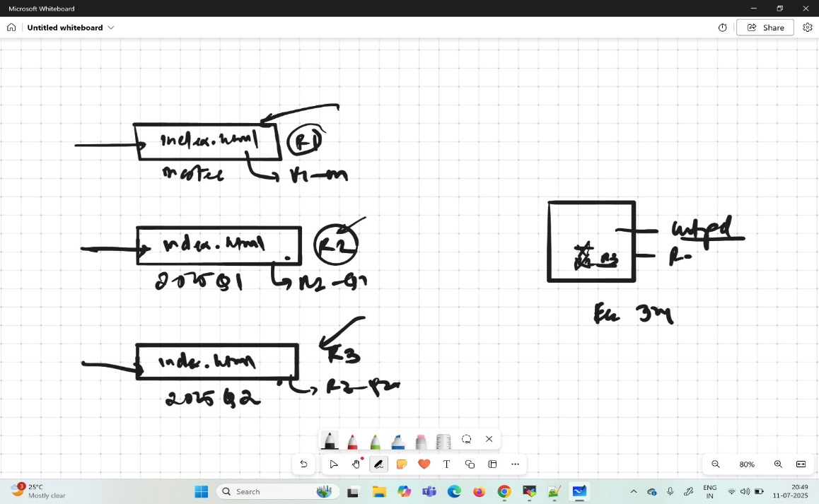

**Three Repository-**

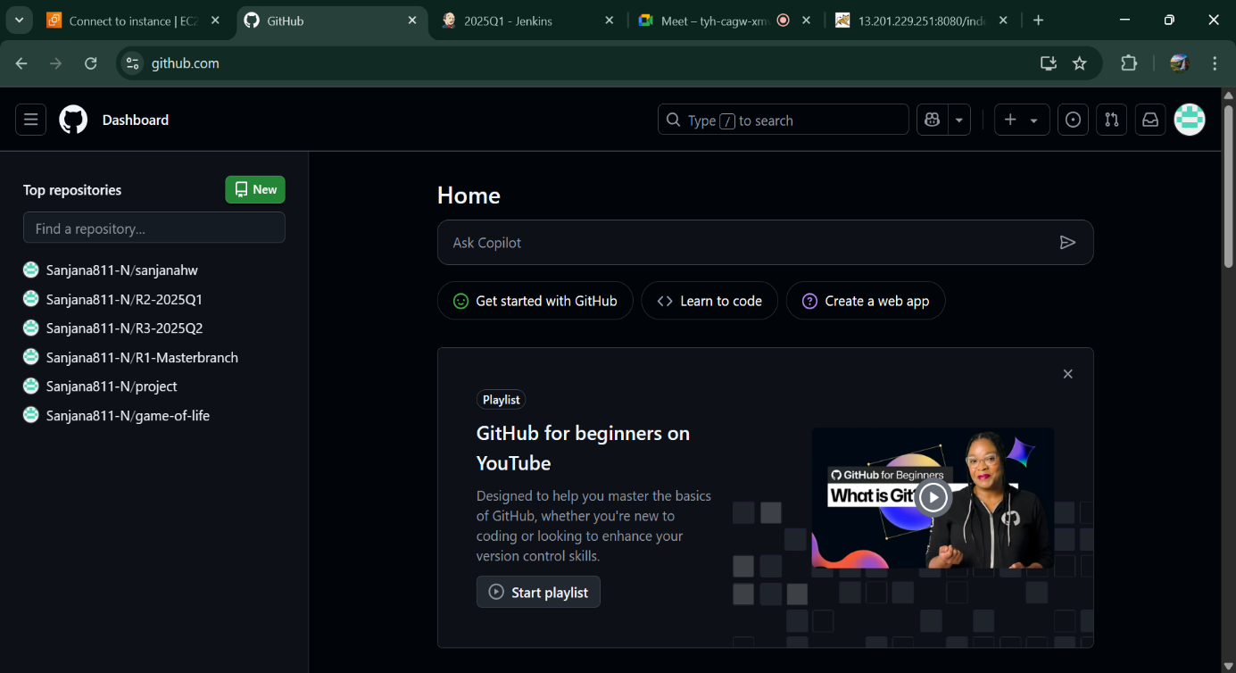

**Three jobs having webhook featured-**

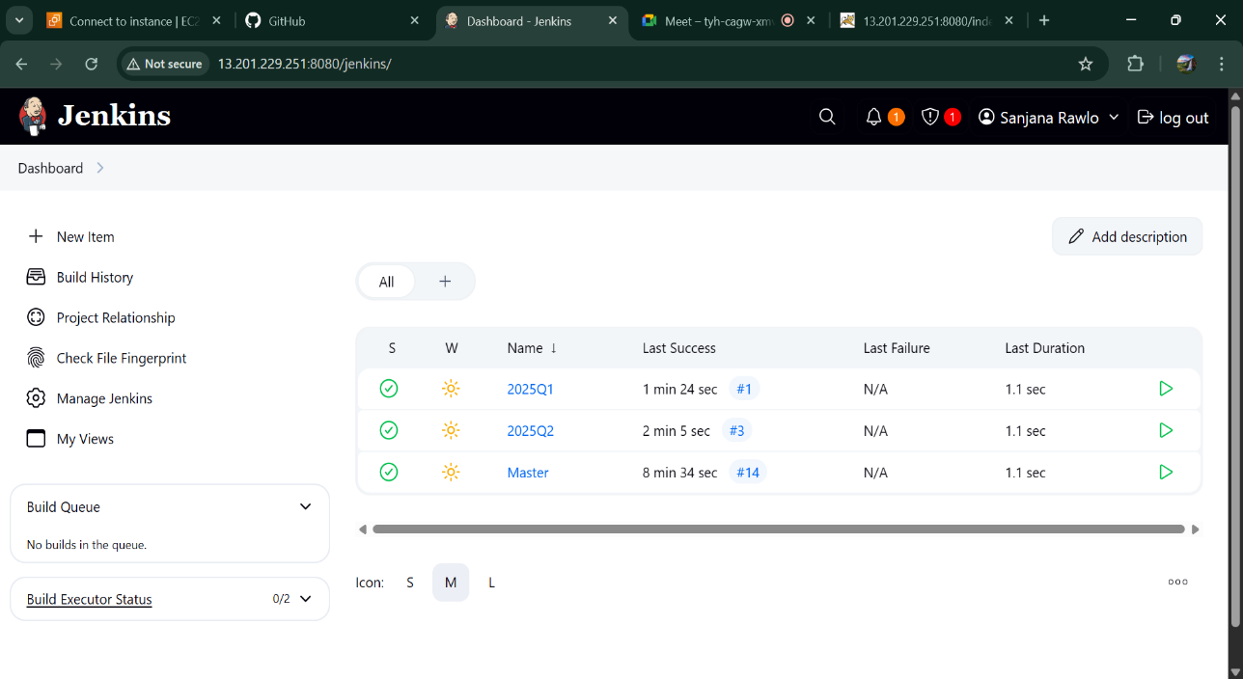

**Push in master-**

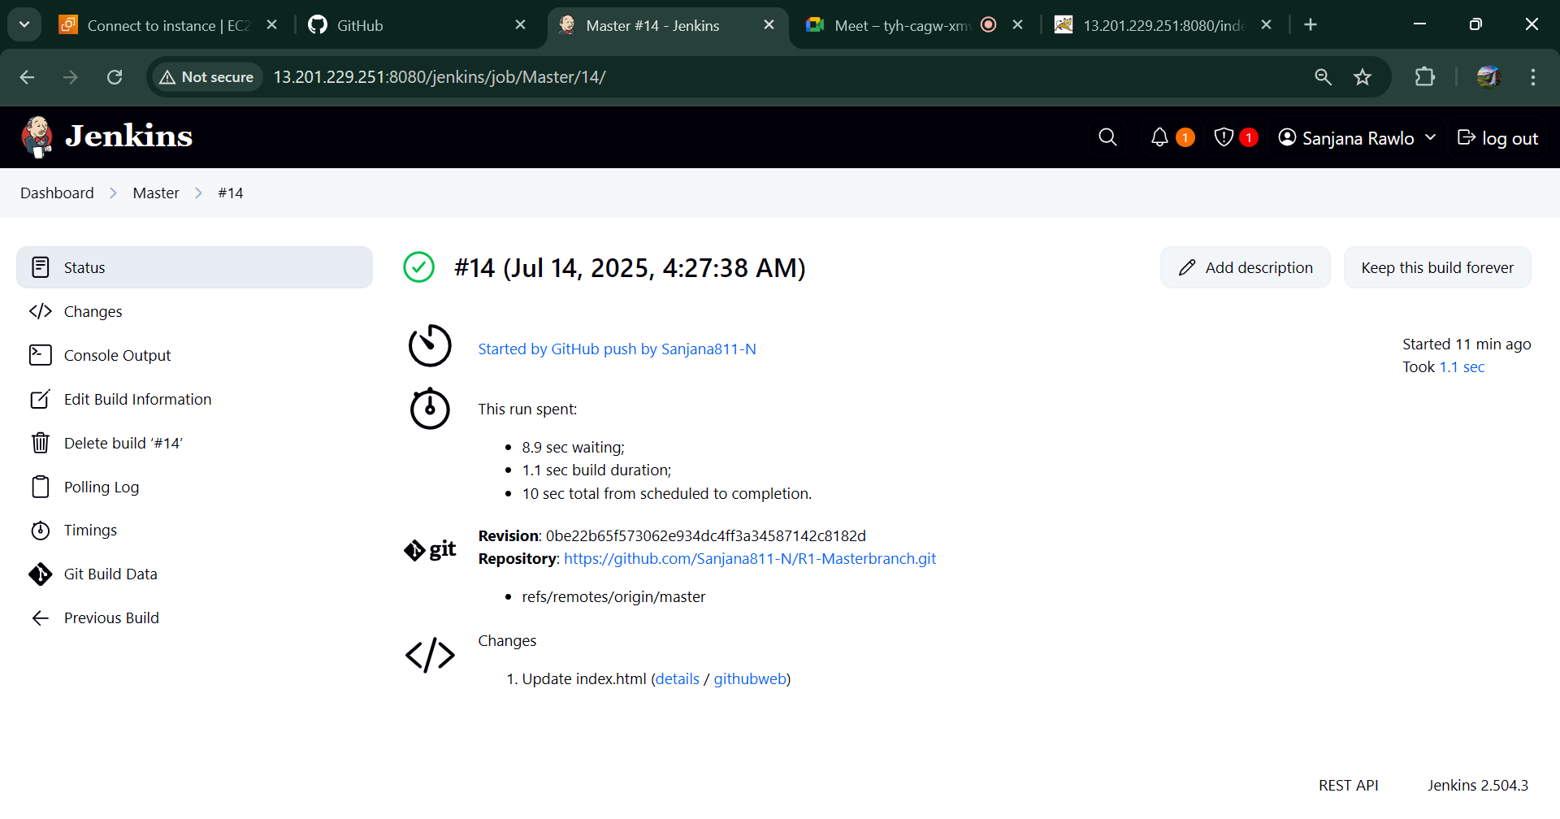

**Master job automatically triggered –**

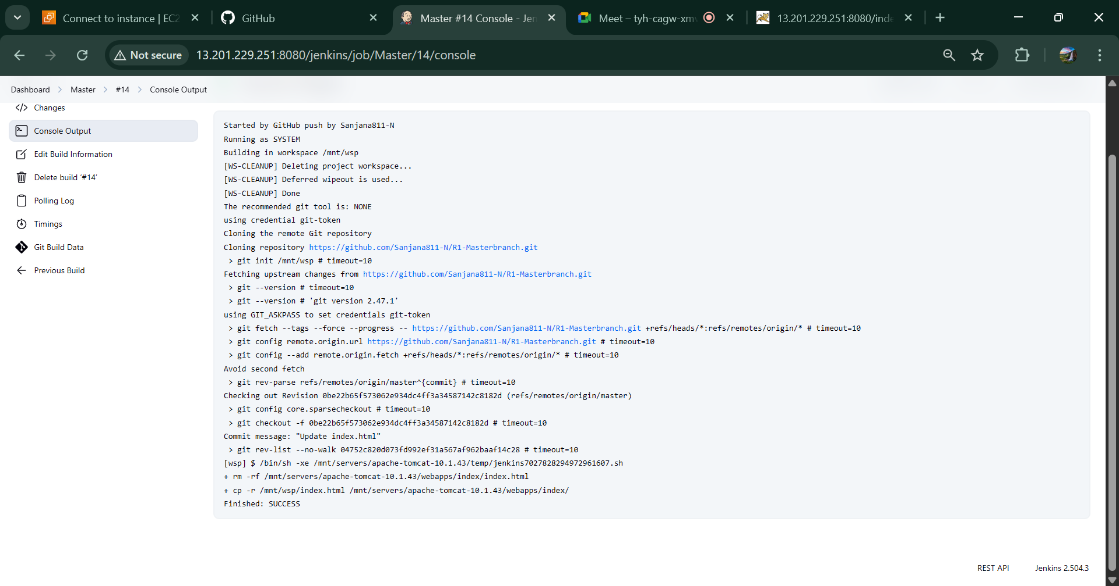

**Push in 2025Q1-**

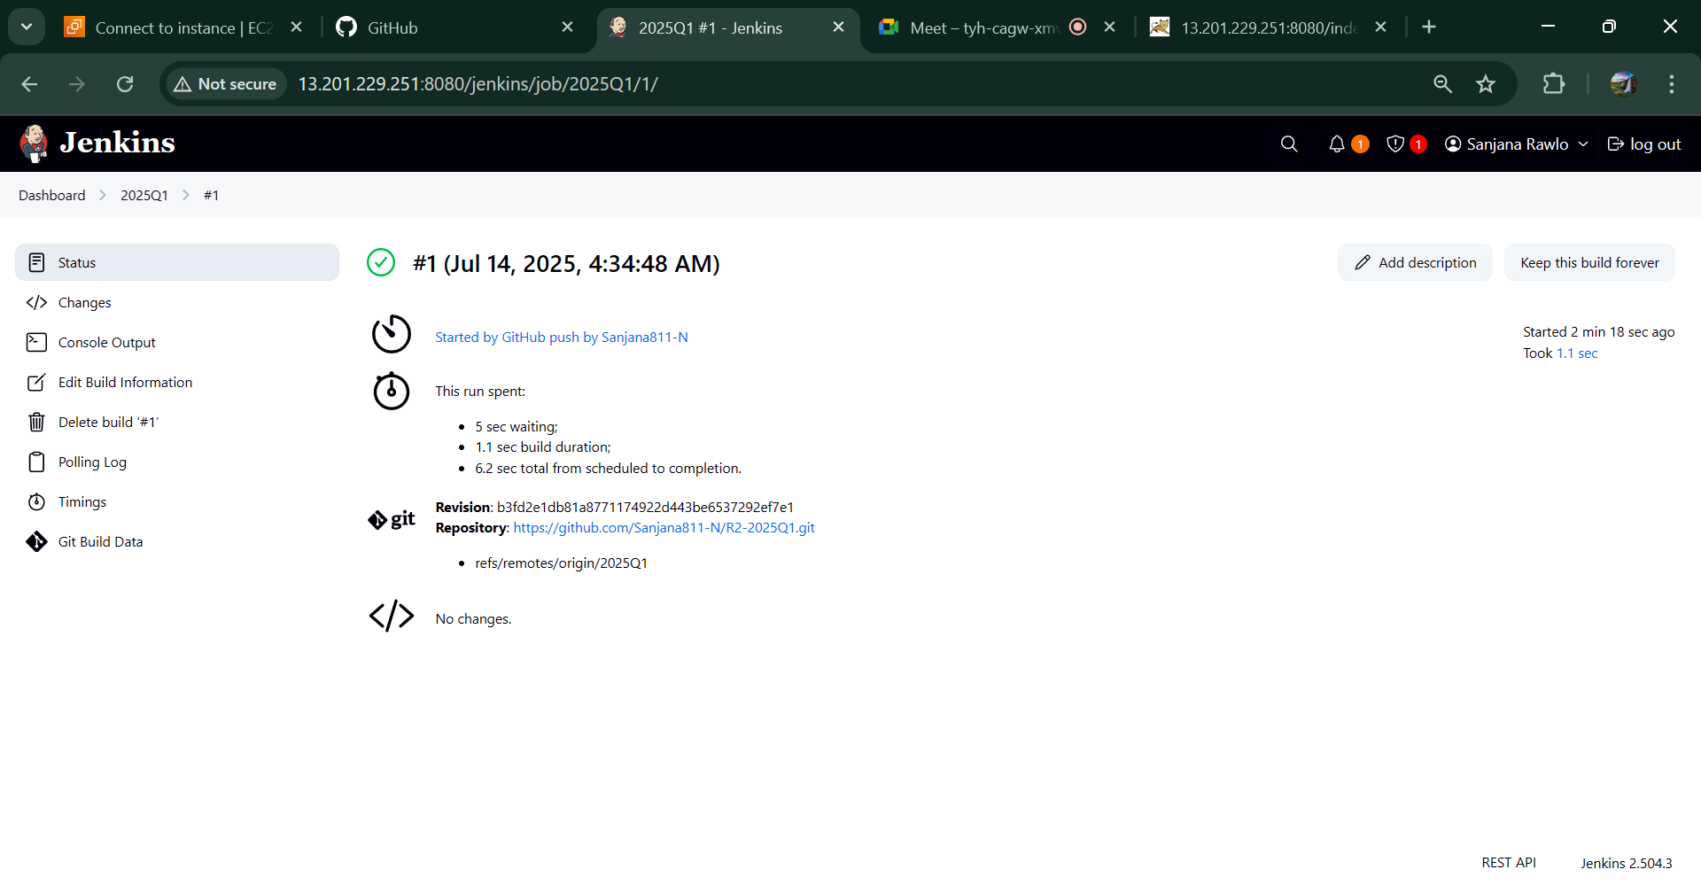

**2025Q1 job automatically triggered –**

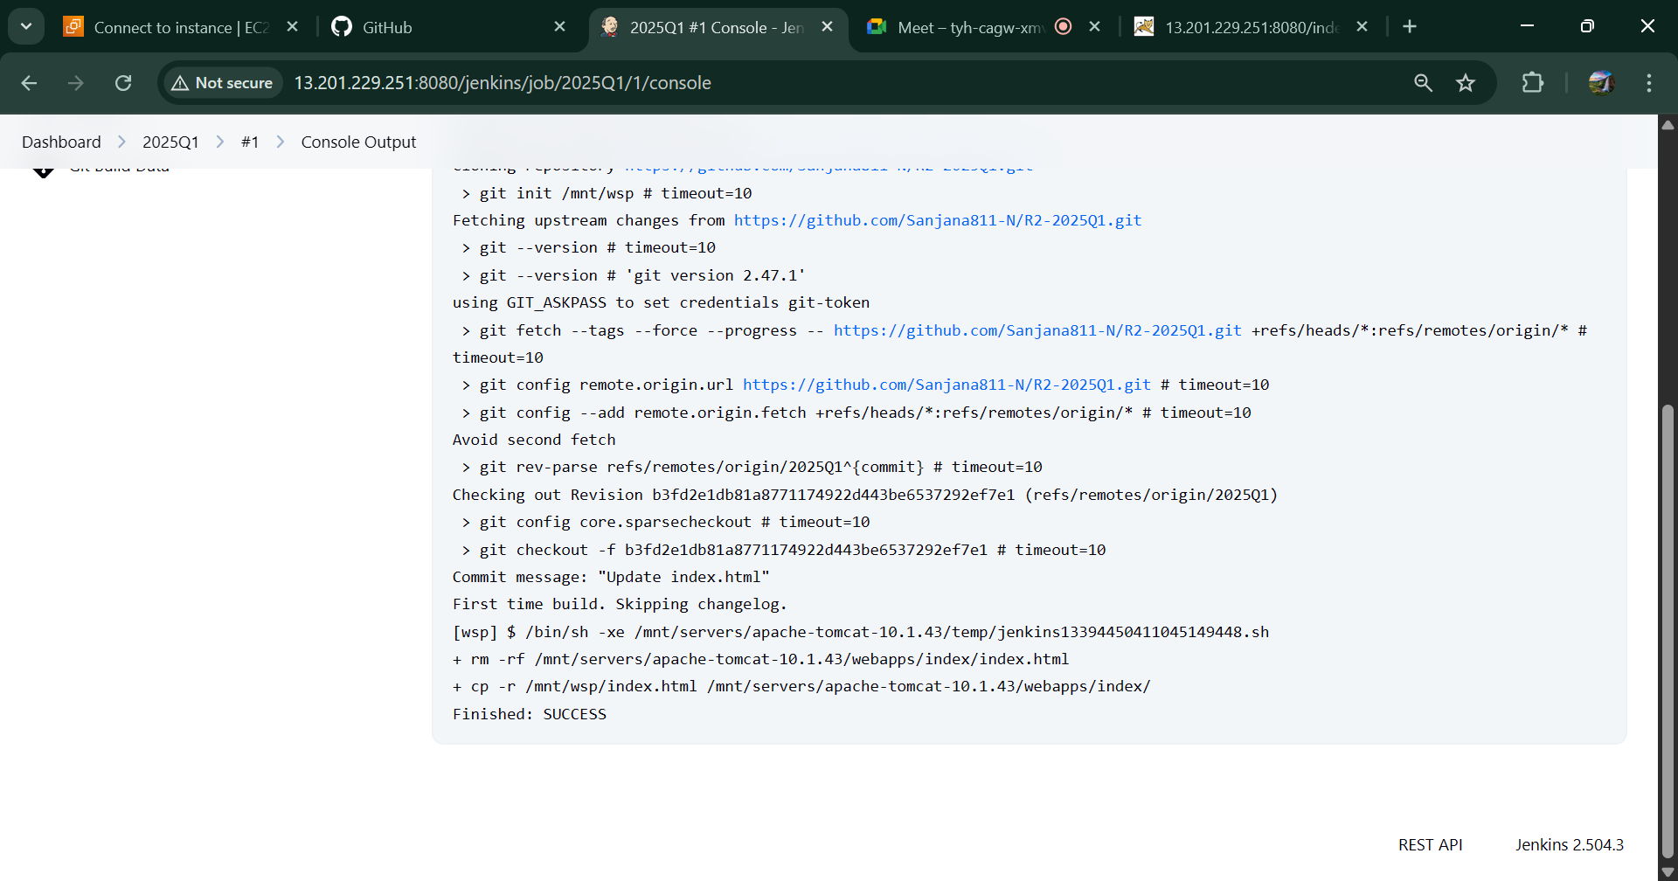

**Push in 2025Q2-**

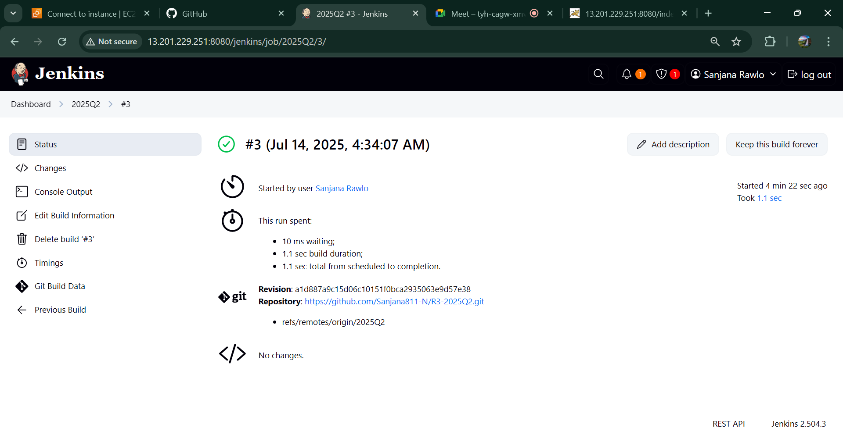

**2025Q2 job automatically triggered –**

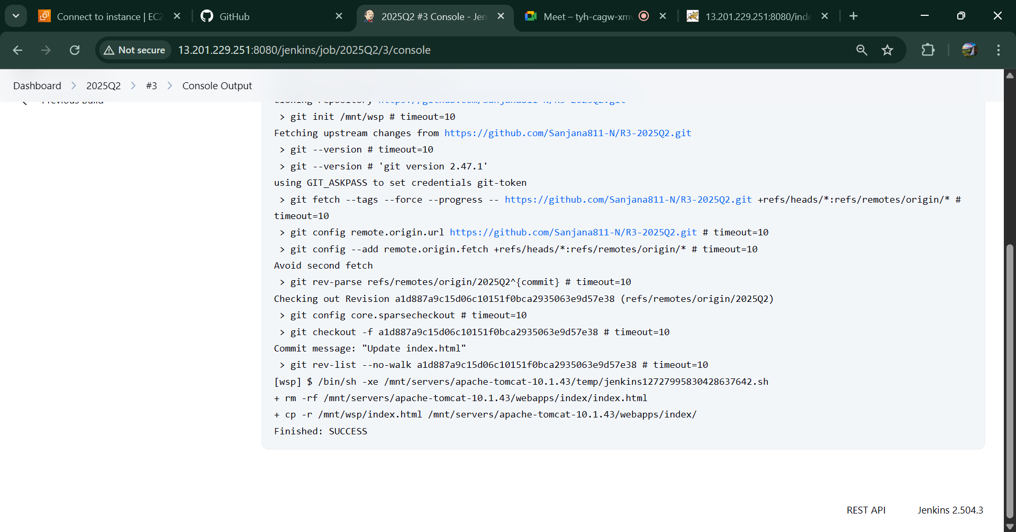

**Website –**

