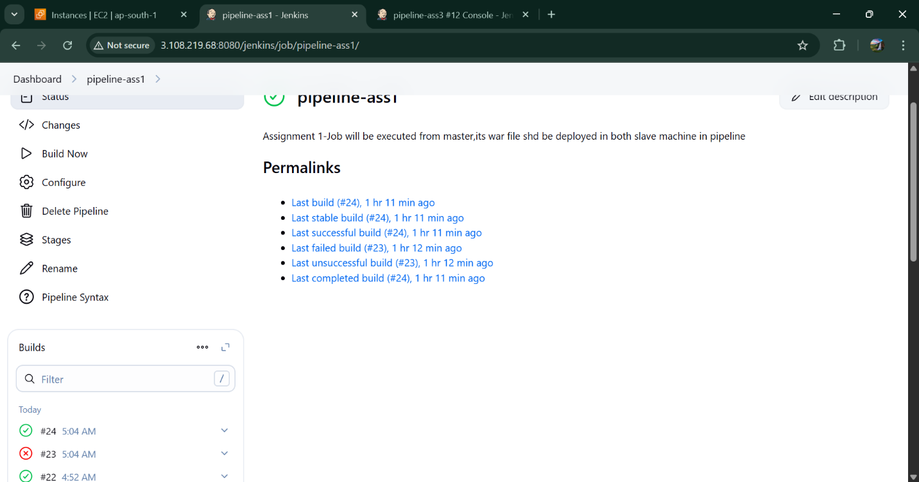

Pipeline Script : -

pipeline {

agent none

environment {

MAVEN_HOME = '/mnt/Build-tools/apache-maven-3.9.11'

WAR_FILE = 'target/LoginWebApp.war'

REMOTE_PATH = '/mnt/servers/apache-tomcat-10.1.43/webapps'

PEM_FILE = '/key/key.pem'

SLAVE1_IP = '3.109.201.172'

SLAVE2_IP = '3.111.33.254'

}

tools {

maven 'maven'

}

stages {

stage('Checkout Source') {

agent { label 'built-in' }

steps {

dir('/mnt/wsp/') {

deleteDir()

git credentialsId: 'git-id', url: 'https://github.com/Sanjana811-N/project.git'

}

}

}

stage('Build WAR') {

agent { label 'built-in' }

steps {

dir('/mnt/wsp/') {

sh " mvn clean install "

// stash name: 'war-build', includes: 'target/LoginWebApp.war'

}

dir('/mnt/wsp/target') {

stash name: 'war-build', includes: 'LoginWebApp.war'

}

}

}

stage('Deploy in Slave1') {

agent { label 'slave1' }

steps {

dir('/mnt/servers/apache-tomcat-10.1.43/webapps') {

sh " rm -rf LoginWebApp* "

unstash 'war-build'

}

dir('/mnt/servers/apache-tomcat-10.1.43/bin') {

sh "sudo ./shutdown.sh || true"

sh "sudo ./startup.sh"

}

}

}

stage('Deploy in Slave2') {

agent { label 'slave2' }

steps {

dir('/mnt/servers/apache-tomcat-10.1.43/webapps') {

sh " rm -rf LoginWebApp* "

unstash 'war-build'

}

dir('/mnt/servers/apache-tomcat-10.1.43/bin') {

sh "sudo ./shutdown.sh || true"

sh "sudo ./startup.sh"

}

}

}

}

post {

success {

echo 'Deployment Successful!'

}

failure {

echo 'Deployment Failed!'

       }

    }

}