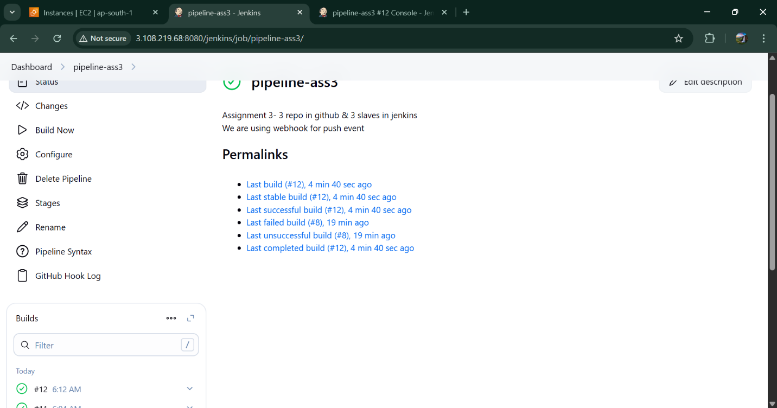

Pipeline script : -

pipeline {

agent none

triggers {

githubPush()

}

stages {

stage('Checkout Source') {

agent { label 'slave1' }

steps {

dir('/mnt/wsp/') {

deleteDir()

git credentialsId: 'git-id', url: 'https://github.com/Sanjana811-N/R1-Masterbranch.git'

}

}

}

stage('Downloading httpd') {

agent { label 'slave1' }

steps {

sh 'sudo yum remove httpd -y'

sh 'sudo yum install httpd -y'

sh 'sudo systemctl start httpd'

sh 'sudo systemctl enable httpd'

}

}

stage('Deploy in Slave1') {

agent { label 'slave1' }

steps {

sh '''

sudo rm -rf /var/www/html/index\*

sudo cp /mnt/wsp/index.html /var/www/html/

'''

}

}

}

post {

success {

echo 'Deployment Successful!'

}

failure {

echo 'Deployment Failed!'

       }

    }

}