LAB ASSIGNMENT-4
Sanjana Bayya
2303A52019
Batch-38

Task Description-1
• Zero-shot: Prompt AI with only the instruction. Write a Python function to determine
whether a given number is prime
Expected Output-1
• A basic Python function to check if a number is prime, demonstrating correct logical
conditions without relying on examples or additional context

Prompt: Write a Python function to determine whether a given number is prime, taking the number from user input.

Code:
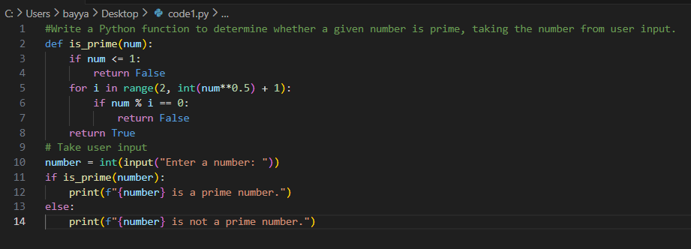

Output:
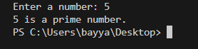

Explanation:
This program checks if a number is prime.
The user enters a number n. The function tests divisibility from 2 up to √n.
If no divisor is found, it prints that the number is prime; otherwise, it prints not prime.

Task Description-2
• One-shot: Provide one example: Input: [1, 2, 3, 4], Output: 10 to help AI generate a
function that calculates the sum of elements in a list.
Expected Output-2
• A correct conversion function guided by the single example.

Prompt: Write a Python function that calculates the sum of elements in a list ,for example: Input: [1, 2, 3, 4]

Code:
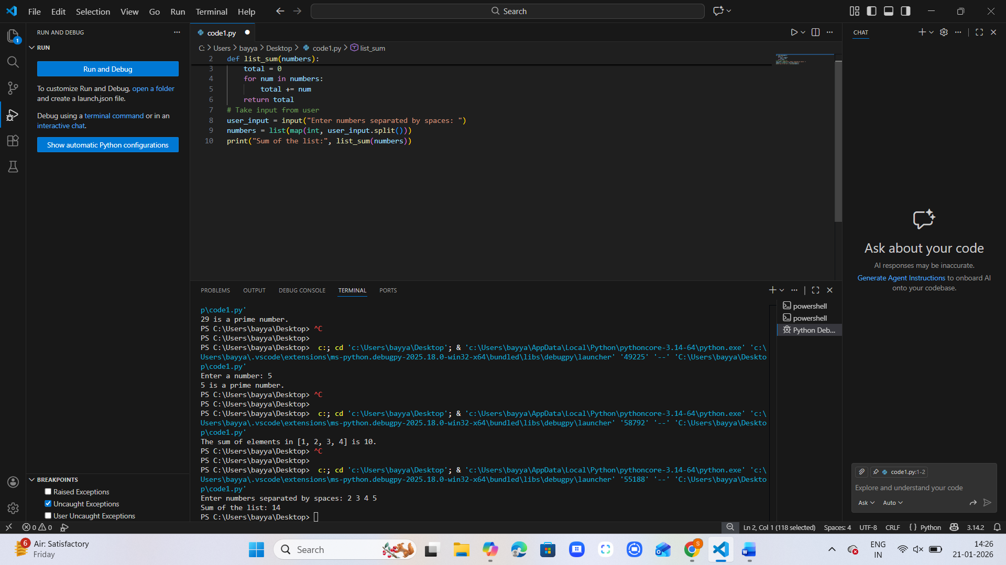

Output:
Explanation:
This program calculates the sum of numbers in a list.
The user enters numbers separated by spaces, which are converted into integers.
The function adds them together and prints the total sum.

Task Description-3
• Few-shot: Give 2–3 examples to create a function that extracts digits from an
alphanumeric string.
Expected Output-3
• Accurate function that returns only the digits from alphanumeric string.

Prompt:
Write a Python function that extracts digits from an alphanumeric string.
Examples:
Input: 'abc123' → Output: '123'
Input: 'a1b2c3' → Output: '123'
The program should take input from the user as a string, loop through each character, check if it is a digit, collect all digits, and print them.

Code:
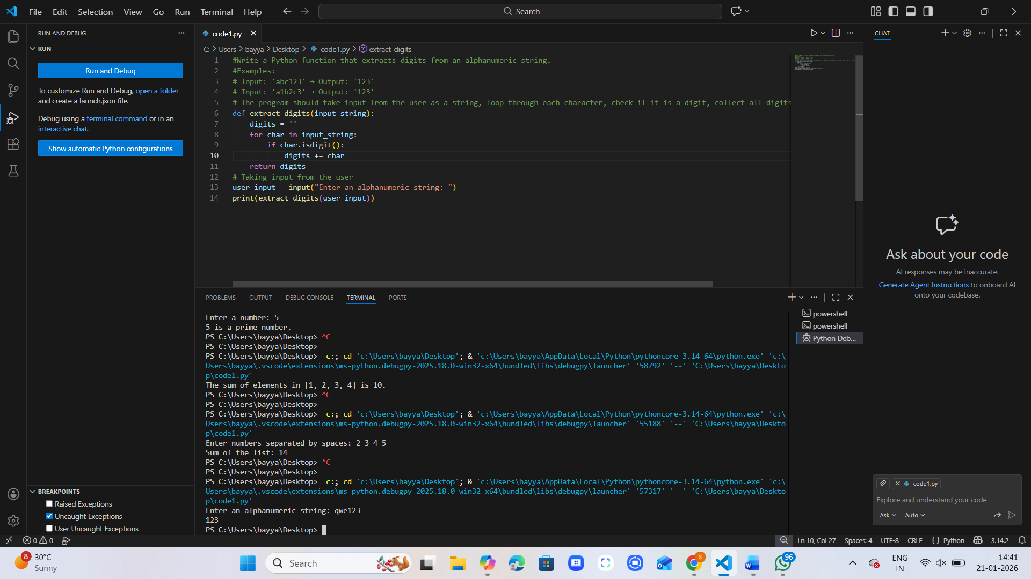

Output:

Explanation:
This program extracts digits from an alphanumeric string.
The function checks each character, collects only digits, and returns them as a string.
The user enters a string, and the program prints the digits found.

Task Description-4
• Compare zero-shot vs few-shot prompting for generating a function that counts the
number of vowels in a string.
Expected Output-4
• Output comparison + student explanation on how examples helped the model.

Prompt:
Write a Python function to count the number of vowels in a string.

Code:
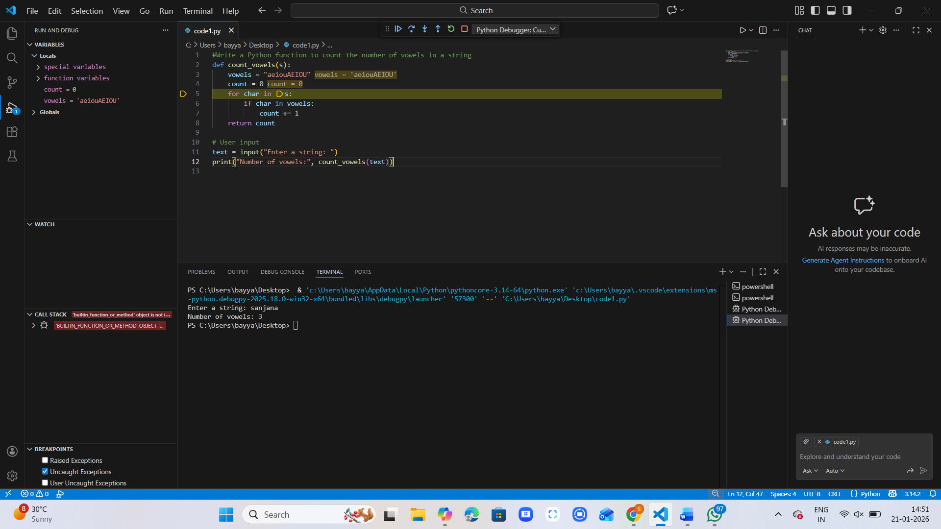

Output: Zero Shot

Prompt:
Write a Python function to count the number of vowels in a string.
Examples:
Input: 'hello' → Output: 2
Input: 'world' → Output: 1
Input: 'AEIOU' → Output: 5

Code:
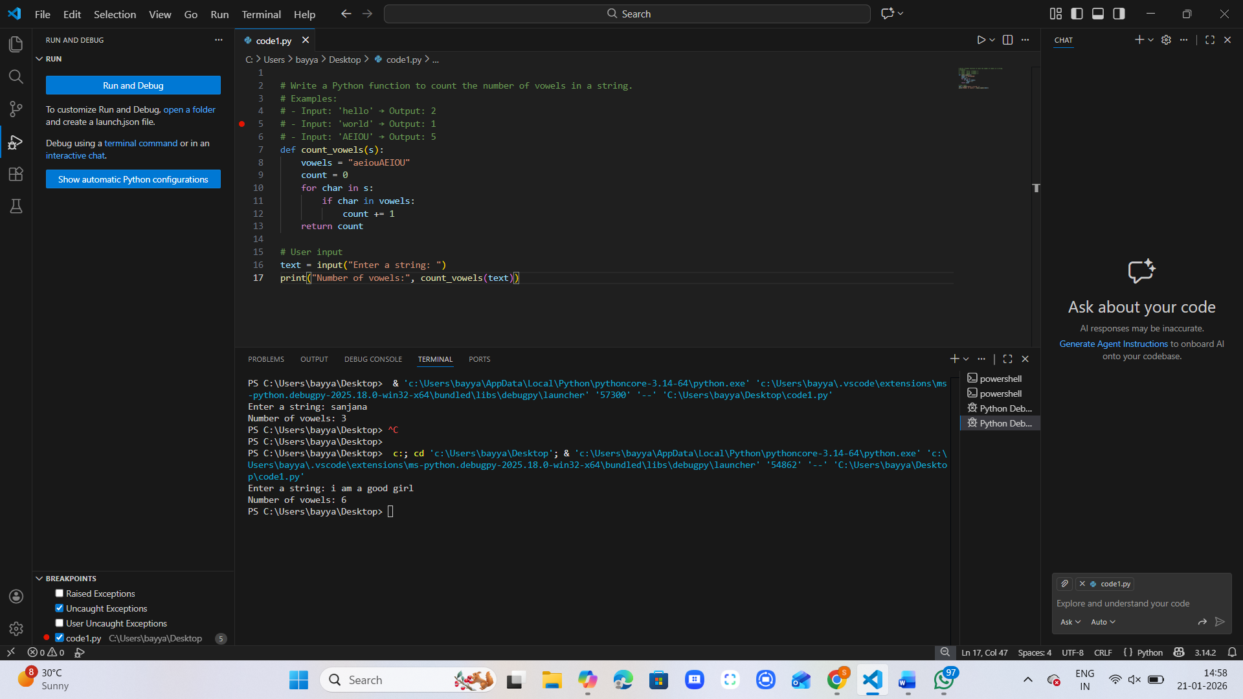

Output: Few- Shot

Explanation:
In zero-shot, the model wrote the function only from the instruction.
In few-shot, the examples guided it to handle different cases more accurately.
Examples make the model more reliable by showing the expected pattern.

Task Description-5
• Use few-shot prompting with 3 sample inputs to generate a function that determines
the minimum of three numbers without using the built-in min() function.
Expected Output-5
• A function that handles all cases with correct logic based on example patterns.

Prompt:
Write a Python function that determines the minimum of three numbers without using the built-in min() function.
Examples:
Input: (3, 7, 5) → Output: 3
Input: (10, 2, 8) → Output: 2
Input: (6, 6, 9) → Output: 6

Code:
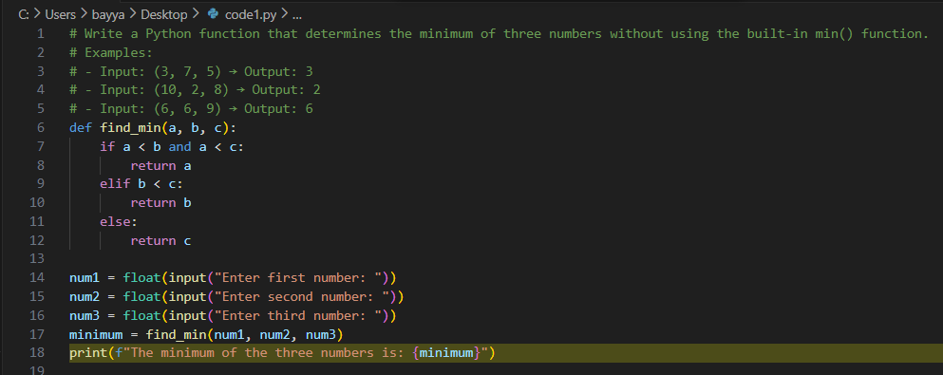

Output:
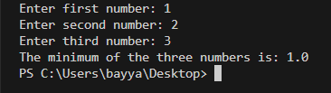

Explanation:
This program finds the smallest of three numbers without using min().
It compares each number step by step to figure out which one is the smallest.
The examples helped the model learn the pattern and apply correct logic for all cases.

