Q   
Write a program that accept string as command line argument and generate  
the output in specific way  
Example if two  
command line argument are wipro and bangolre then the ouput generated should be  
wipro technology banglore  
If the argument  
are ABC and Mumbai then output should be ABC technology Mumbai

**package** cmdline_Assign;

**public** **class** que1 {

**public** **static** **void** main(String[] args) {

String name=args[0];

String loc=args[1];

System.***out***.println(name+" technology "+loc);

}

}

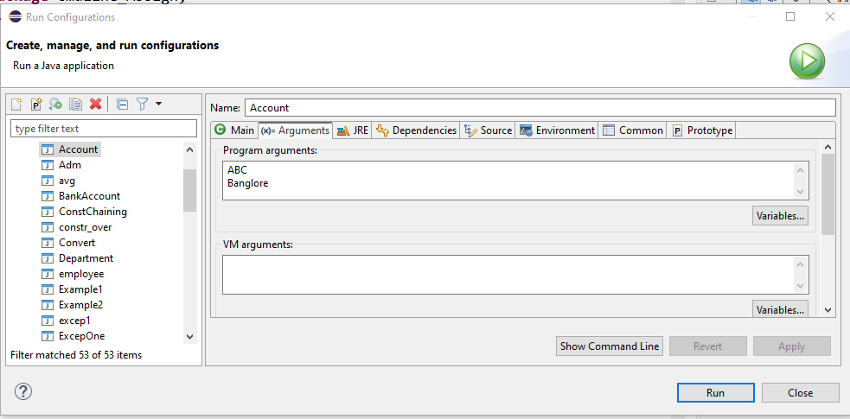  
  
**Output**

ABC technology Banglore  
 

LAB ON STRING  
  
  
   
  
  
   
  
  
1.      Write a java program to ask a  
String from user  
  
  
  a)      Using command line argument  
  
  
  b)      Another string is asked from user  
using Scanner object  
  
  
  c)      Pass both the Strings to a  
function check which return true if both strings are having same value and false  
otherwise .  
  
**package** String_Assign;

**import** java.util.Scanner;

**public** **class** que1 {

**public** **void** cmpstring1(String st1, String st2) {

**if**(st1.compareTo(st2) == 0) {

System.***out***.println("true");

}**else** {

System.***out***.println("false");

}

}

**public** **static** **void** main(String[] args) {

// **TODO** Auto-generated method stub

String s1= args[0];

Scanner sc= **new** Scanner(System.***in***);

System.***out***.println("Enter string: ");

String s2 = sc.nextLine();

que1 q1 = **new** que1();

q1.cmpstring1(s1,s2);

sc.close();

}

}

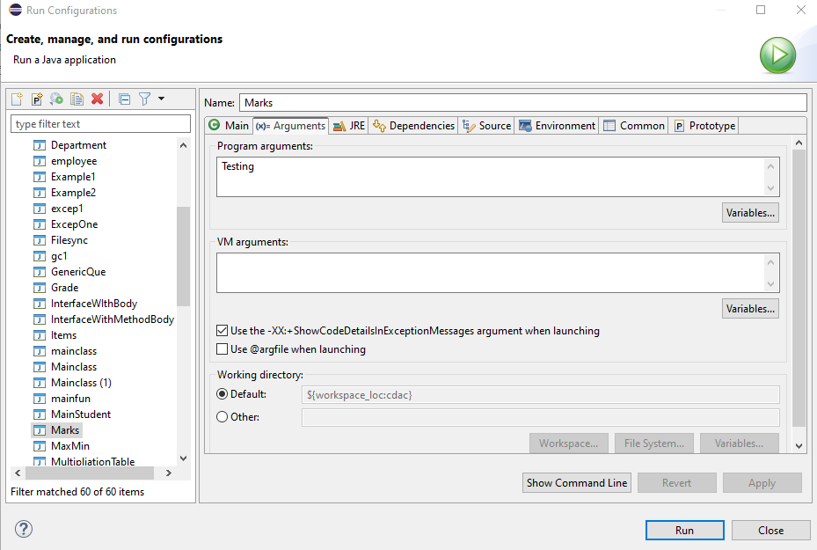

Output

Enter string:

Testing

true

Enter string:

cdac

false

   
  
  
2.      Write a function that counts and  
returns the number of vowels in the string. (For the purposes of this exercise,  
we are talking about the standard 5 vowels -- A, E, I, O, U).  
  
  
Hint Use charAt function to get single character  
**package** String_Assign;

**public** **class** que2 {

**public** **void** vowelfind(**int** count, String s) {

**int** c=0;

**char** arr[]= **new** **char**[count];

**for**(**int** i=0;i<count;i++) {

**if**((s.charAt(i)=='a') || (s.charAt(i)=='e') || (s.charAt(i)=='i') ||s.charAt(i)=='o') {

arr[c]=s.charAt(i);

c++;

}

}

System.***out***.println("number of vowels are "+c);

**for**(**int** k=0; k<c;k++) {

System.***out***.println(arr[k] +" ");

}

}

**public** **static** **void** main(String[] args) {

String s ="soniaa";

String snew = s.toLowerCase();

**int** count = s.length();

que2 q= **new** que2();

q.vowelfind(count, snew);

}

}

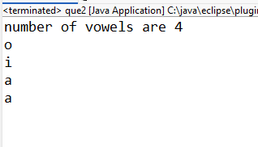  
  
3.      Create a menu driven application  
in java for displaying String based functions  
  
  
a)      Convert string to upper case  
  
  
b)      Convert string to lower case  
  
  
c)      Display string character by character  
on screen  
  
  
d)     Count occurrence of particular  
character in string  
  
  
e)      Concatenate two strings  
  
  
f)       Print length of string  
  
  
g)      Check if string is palindrom or  
not  
  
  
h)      Extract and print first three  
character from string (use substring method)  
  
  
i)         
Replace a  
character with another character from string ( use replace ())  
  
**package** String_Assign;

**public** **class** que3 {

**public** **void** uppercase(String s) {

String uc= s.toUpperCase();

System.***out***.println("Upper case -> "+uc);

}

**public** String lowercase(String s) {

String lc= s.toLowerCase();

**return** lc;

}

**public** **void** charbychar(String s) {

**int** len = s.length();

**for**(**int** i=0;i<len;i++) {

System.***out***.println(s.charAt(i));

}

}

**public** **void** Count_occurrence(String s, **char** c) {

**int** len = s.length();

**int** count =0;

String st = lowercase(s);

**for**(**int** i=0;i<len;i++) {

**if**(c==st.charAt(i)){

count++;

}

}

System.***out***.println("Count of -> "+c+" is "+count);

}

**public** **void** str_concat(String s1, String s2) {

String snew= s1.concat(s2);

System.***out***.println(s1+" + "+s2+" = "+snew);

}

**public** **void** str_len (String s) {

**int** len = s.length();

System.***out***.println("length of string "+s+" is "+len);

}

**public** **void** palindrome(String s) {

**int** len = s.length();

String st = lowercase(s);

**int** count=0;

**int** t=len/2;

**for**(**int** i=0;i<t;i++) {

**if**(st.charAt(i)==st.charAt(len-(i+1))) {

count++;

}

}

**if**(count==t) {

System.***out***.println("palindrome exist for "+s);

}**else** {

System.***out***.println("palindrome not exist for "+s);

}

}

**public** **void** printchar(String s, **int** n) {

String s1 = s.substring(0, n);

System.***out***.println(s1);

}

**public** **void** replacechar(**char** a1, **char** a2,String s) {

String snew= s.replace(a1, a2);

System.***out***.println(snew);

}

**public** **static** **void** main(String[] args) {

// **TODO** Auto-generated method stub

String s ="saNjaNa";

que3 q= **new** que3();

q.uppercase(s);

String p=q.lowercase(s);

System.***out***.println("lower case -> "+p);

q.charbychar(s);

q.Count_occurrence(s, 'n');

q.str_concat("sanjana","kumbhar");

q.str_len(s);

q.palindrome(s);

q.palindrome("sanas");

q.palindrome("sannas");

q.printchar(s,3);

q.replacechar('a','b',s);

}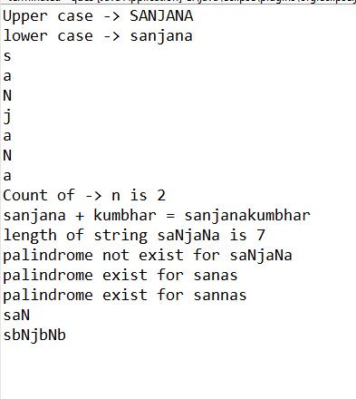

}

Enter a loop, allowing the user to type in a menu choice each time. Loop  
should continue until the user enters the command to exit. Upper and lowercase  
letters should be allowed for the menu choices.  
  
**package** String_Assign;

**import** java.util.Scanner;

**public** **class** Que4 {

**public** **static** **void** main(String[] args) {

Scanner scanner = **new** Scanner(System.***in***);

String choice;

**do** {

System.***out***.println("Menu:");

System.***out***.println("A. Option A");

System.***out***.println("B. Option B");

System.***out***.println("C. Option C");

System.***out***.println("X. Exit");

System.***out***.print("Enter your choice: ");

choice = scanner.nextLine().trim().toUpperCase();

**switch** (choice) {

**case** "A":

System.***out***.println("You chose Option A.");

**break**;

**case** "B":

System.***out***.println("You chose Option B.");

**break**;

**case** "C":

System.***out***.println("You chose Option C.");

**break**;

**case** "X":

System.***out***.println("Exiting the menu. Goodbye!");

**break**;

**default**:

System.***out***.println("Invalid choice. Please try again.");

}

} **while** (!choice.equals("X")); // Loop until the user enters "X" for exit

scanner.close();

}

}

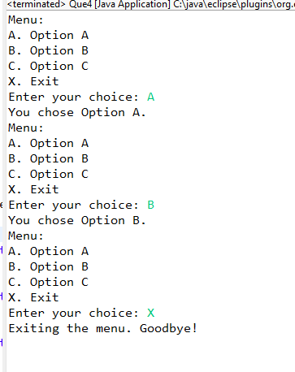  
  
3. Write a function to append a string “noida” after a String  
  
**package** String_Assign;

**public** **class** Que5 {

//Write a function to append a string “noida” after a String

**public** **void** appendstring(String oldstr, String newstr) {

String s1= oldstr+newstr;

String s2=oldstr.concat(newstr);

System.***out***.println(s1);

System.***out***.println(s2);

}

**public** **static** **void** main(String[] args) {

Que5 q5=**new** Que5();

q5.appendstring("welcome in ", "noida");

}

}

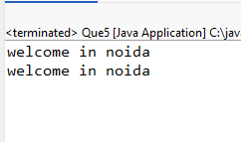  
4. Write a function to delete first character from a string (use String Buffer  
class)  
**package** String_Assign;

**public** **class** Que6 {

**public** **static** String deleteFirstChar(String i) {

StringBuffer b=**new** StringBuffer(i);

b.deleteCharAt(0);

**return** b.toString();

}

**public** **static** **void** main(String[] args) {

// **TODO** Auto-generated method stub

String input = "Hello World";

String result = *deleteFirstChar*(input);

System.***out***.println("Before deleting first character: " + input);

System.***out***.println("After deleting first character: " + result);

}

}

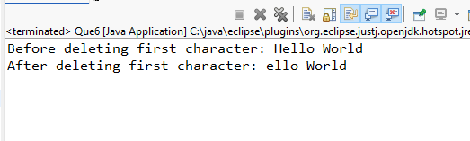  
5 .Write a function to insert a character in a string

**package** String_Assign;

**public** **class** Que7 {

**public** **static** String insertChar(String input, **char** ch, **int** position) {

**if** (position < 0 || position > input.length()) {

**throw** **new** IndexOutOfBoundsException("Position out of range");

}

StringBuffer buffer = **new** StringBuffer(input);

buffer.insert(position, ch);

**return** buffer.toString();

}

**public** **static** **void** main(String[] args) {

String input = "Hello World";

**char** ch = 'X';

**int** position = 5;

String result = *insertChar*(input, ch, position);

System.***out***.println("After inserting character: " + result);

}

}

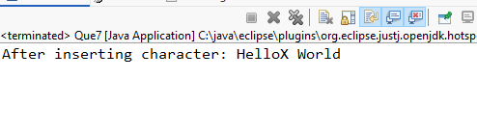  
  
  
6 write a program to ask 5 names from user in string array and display first character of each name

**package** String_Assign;

**import** java.util.Scanner;

**public** **class** Que {

**public** **static** **void** main(String[] args) {

Scanner scanner = **new** Scanner(System.***in***);

String[] names = **new** String[5];

**for** (**int** i = 0; i < names.length; i++) {

System.***out***.print("Enter name " + (i + 1) + ": ");

names[i] = scanner.nextLine();

}

System.***out***.println("\n First character of each name:");

**for** (String name : names) {

**if** (!name.isEmpty()) {

System.***out***.println(name.charAt(0));

} **else** {

System.***out***.println("Name is empty!");

}

}

scanner.close();

}

}

