1. Given an integer array nums, return true if any value appears at least twice in the array, and return false if every element is distinct.  
   Example 1:  
   Input: nums = [1,2,3,1]  
   Output: true  
   Explanation:  
   The element 1 occurs at the indices 0 and 3.

Sanjana Kumbhar

PGDAC Aug-2024

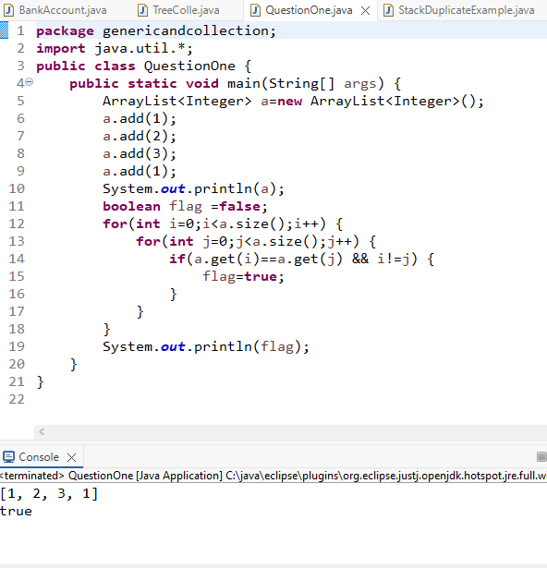

1. Reverese String using collection (Stack)

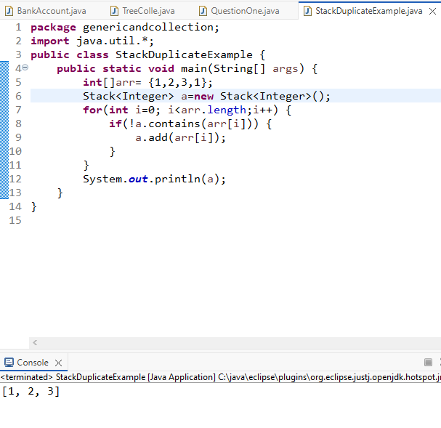

1. without collection  
    \* Given an integer array nums, return an integer array counts  
    \* where counts[i] is the number of smaller elements to the right of nums[i].  
   Example 1:  
   Input: nums = [5,2,6,1]  
   Output: [2,1,1,0]  
   Explanation:  
   To the right of 5 there are 2 smaller elements (2 and 1).  
   To the right of 2 there is only 1 smaller element (1).  
   To the right of 6 there is 1 smaller element (1).  
   To the right of 1 there is 0 smaller element.

