ABSTRACT

Accurate car price prediction is essential for buyers, sellers, and dealerships to make informed decisions in the automotive market. This project presents a Car Price Prediction Model that leverages machine learning techniques to estimate vehicle values based on critical features such as brand, model, year, mileage, fuel type, transmission, and engine size. By utilizing a robust dataset of historical car prices, the model aims to provide reliable and precise valuations that cater to the needs of various stakeholders.

To enhance the model's performance, we employ regression algorithms, including Linear Regression, and conduct thorough performance evaluations. Data preprocessing techniques, such as handling missing values and feature scaling, are implemented to ensure the dataset is clean and well-structured. These steps are crucial in improving the model's accuracy and reliability, allowing it to effectively capture the relationships between the input features and the target variable—car price.

The final model is deployed in a user-friendly application, enabling users to input specific car details and receive instant price estimates. This system offers a fast, efficient, and data-driven approach to car valuation, significantly reducing the reliance on traditional manual estimation methods. By providing accurate predictions, the Car Price Prediction Model empowers users to make better-informed decisions in the dynamic automotive market.

CHAPTER 1
INTRODUCTION

  - MOTIVATION:
The motivation behind developing a car price prediction model lies in the need for accurate and data-driven valuations in the automotive market. Such models help buyers, sellers, and dealerships make informed decisions, optimize pricing strategies, improve inventory management, and enhance overall market efficiency. By leveraging historical data and machine learning techniques, these models aim to reduce reliance on manual estimations and provide reliable price assessments based on key vehicle features.Furthermore, the automotive industry is constantly evolving, with various factors influencing car prices, such as market trends, fuel efficiency, and technological advancements.
As consumers become more discerning and demand transparency in pricing, a robust prediction model can bridge the gap between market expectations and actual valuations. This model not only benefits individual stakeholders but also contributes to a more stable and competitive marketplace, fostering trust and satisfaction among buyers and sellers alike. By harnessing the power of data analytics, the car price prediction model serves as a vital tool for navigating the complexities of vehicle pricing in today's dynamic environment.

  - PROBLEM STATEMENT:

The problem statement for the car price prediction model using Random Forest revolves
around accurately estimating the selling price of used cars based on various features such as make, model, year, mileage, and condition. The challenge lies in capturing the complex relationships between these features and the price, ensuring the model can generalize well to unseen data.The project goal is to develop a robust predictive model that leverages the Random Forest algorithm to provide reliable price predictions for used cars. This model aims to assist buyers and sellers in making informed decisions, ultimately enhancing the efficiency of the automotive market by providing accurate and data-driven valuations.The project will involve a comprehensive analysis of the used car market, focusing on identifying key features that significantly influence car prices. By utilizing a dataset containing various attributes of used cars, the goal is to preprocess the data, engineer relevant features, and train the Random Forest model to achieve high predictive accuracy. The model will be evaluated using metrics such as R-squared and mean squared error to ensure its reliability and effectiveness in real-world applications.
1.3 PROJECT OBJECTIVES:
- Data Collection:
This involves gathering comprehensive datasets that include various car attributes such as make, model, year, mileage, fuel type, and condition. The quality and breadth of the data are essential for building a reliable model, as they directly influence the accuracy of predictions. Sources may include online car sales platforms, dealership records, and historical sales data.
- Data Preprocessing:
Cleaning the data is a crucial step that addresses issues like missing values, duplicates, and outliers. This process ensures that the dataset is in a suitable format for analysis. Techniques such as normalization and encoding categorical variables are employed to prepare the data for machine learning algorithms, enhancing the model's performance.
- Feature Engineering:
This step involves creating new features that capture important aspects of the data, such as car age, depreciation rates, and engine specifications. By transforming raw data into meaningful variables, the model can better understand the relationships between different attributes and their impact on car prices, ultimately leading to more accurate predictions.
- Model Selection:
Evaluating different machine learning algorithms is essential to identify the most effective approach for price prediction. Techniques such as linear regression, decision trees, and ensemble methods like Random Forest and Gradient Boosting are assessed based on their performance metrics. The goal is to select a model that balances complexity and interpretability while providing high accuracy.
- Model Evaluation:
This involves using metrics like R2 score, Mean Absolute Error (MAE), and cross-validation techniques to assess the model's accuracy and generalizability to unseen data. A thorough evaluation helps in understanding the model's strengths and weaknesses, guiding further refinements and adjustments.
- Visualization:
Implementing data visualization techniques is vital for presenting findings clearly. Visual tools such as scatter plots, histograms, and heatmaps help users understand the relationships between different features and their influence on car prices. Effective visualization aids in communicating insights to stakeholders and enhances the overall user experience.
- Deployment:
Developing a strategy for deploying the model ensures it is scalable and maintainable for real-world applications. This may involve creating a web application or API that allows users to input car details and receive price predictions. Ensuring the model is accessible and user-friendly is crucial for its adoption.
- User Engagement:
Providing educational resources and support helps users understand the model's workings and the significance of various features in price predictions. Engaging users through tutorials, FAQs, and interactive tools fosters trust and encourages them to utilize the model effectively.
- Continuous Improvement:
Establishing a feedback mechanism allows for the refinement of the model based on user input and changing market conditions. Regular updates and retraining of the model ensure its relevance and accuracy over time, adapting to new trends and data patterns in the automotive market.
1.4 PROJECT REPORT ORGANIZATION:
- Introduction and Literature Review:
This section provides an overview of the project, its significance, objectives, and a summary of existing research related to car price prediction.
- Data Preparation and Model Development:
This part details data collection, preprocessing, feature engineering, and the selection of the predictive model, explaining the steps taken to prepare the data for analysis.
- Evaluation, Visualization, and Conclusion:
This section discusses model evaluation metrics, presents key findings through visualizations, and summarizes the implications of the results along with future recommendations.

CHAPTER 2
LITERATURE SURVEY
2.1 EXISTING WORK:
1.Car Dekho
Dekho is a well-known online platform that provides detailed information about cars, including their prices, specifications, and user reviews. It offers a rich dataset that is particularly useful for machine learning projects focused on car price prediction. This dataset includes various attributes such as car brand, model, year of manufacture, mileage, fuel type, and seller type, which are essential for building accurate predictive models. Researchers and developers can leverage this extensive data to explore Car the relationships between different features and their impact on car pricing.
In projects utilizing the Car Dekho dataset, machine learning techniques like regression analysis, decision trees, and ensemble methods are commonly applied. These models are designed to identify patterns and correlations within the data, enabling accurate predictions of car prices based on input features. The insights derived from these predictive models not only assist potential buyers and sellers in making informed decisions but also enhance the understanding of market dynamics in the automotive industry. By harnessing the Car Dekho dataset, developers can create robust applications that significantly improve the car buying and selling experience.
The Car Dekho platform serves as a vital resource for individuals seeking comprehensive insights into the automotive market, particularly in the realm of used cars. By providing a dataset rich in features such as car name, year of purchase, selling price, present price, kilometers driven, fuel type, seller type, transmission, and number of previous owners, it enables developers and data scientists to build predictive models that can accurately forecast car prices. This dataset is instrumental in understanding how various factors influence pricing, allowing for more informed decision-making by both buyers and sellers in the competitive car market.

2.Car ‘s 24
CARS24 is one of India’s largest online platforms for buying, selling, and financing used cars. It heavily leverages machine learning and data-driven systems to streamline vehicle transactions. Their primary innovation lies in their car price prediction model, which estimates the resale value of used vehicles based on a variety of factors.
CARS24 uses ensemble learning techniques such as Random Forests, XGBoost, and CatBoost to predict car prices with higher accuracy. These models are trained on large datasets that include millions of past car transactions. The features used include car make and model, year of manufacture, kilometers driven, fuel type, number of previous owners, city of registration, insurance status, and visible damages (analyzed through uploaded images).
In addition to structured data, CARS24 employs computer vision techniques to assess car condition from photographs uploaded by sellers. Image-based deep learning models detect damages like scratches, dents, or rust, which help adjust the predicted resale value. They also use Natural Language Processing (NLP) to parse seller descriptions and auction comments to extract further insights about vehicle condition.
The combination of structured data analysis, image recognition, and NLP provides a multi-layered evaluation of a vehicle's worth, offering sellers instant price quotes and buyers more transparent purchase options.

2.2 LIMITATIONS OF EXISTING WORK:
Car Dekho limitations:
Car Dekho's limitations in car price prediction include potential data quality issues, such as inaccuracies in listed prices or missing features, which can skew model predictions. Additionally, the dataset may not capture all market dynamics, such as regional price variations or economic factors, limiting the generalizability of the predictions.
Furthermore, the reliance on historical data means that sudden market changes or trends may not be reflected in the dataset, leading to outdated predictions. The presence of outliers can also distort the analysis, making it challenging to derive accurate insights. Additionally, the model's performance may be affected by multicollinearity among features, which can complicate the interpretation of results. Lastly, the platform's focus on used cars may overlook the nuances of new car pricing, limiting its applicability across different segments of the automotive market. Furthermore, the reliance on historical data means that sudden market changes or trends may not be reflected in the dataset, leading to outdated predictions. The presence of outliers can also distort the analysis, making it challenging to derive accurate insights.
- Multicollinearity: The model's performance may be affected by multicollinearity among features, complicating the interpretation of results.
- Focus on Used Cars: The platform's focus on used cars may overlook the nuances of new car pricing, limiting its applicability across different segments of the automotive market.
- Limited Interaction Effects: The analysis may not fully account for interaction effects between variables, which can lead to an incomplete understanding of how different factors influence car prices.
- Assumption Violations: The underlying assumptions of linear regression, such as homoscedasticity and normality of residuals, may not always hold true, potentially affecting the reliability of the predictions.
- External Factors: Economic conditions, changes in consumer preferences, and regulatory changes can impact car prices but may not be adequately captured in the dataset.
Car ‘s 24 Limitations:
Black-boxModels:
Ensemble and deep learning models offer high accuracy but are often difficult to interpret. This makes it hard for customers to understand how or why a certain price was predicted, reducing trust in the valuation system.
.

CHAPTER 3
SOFTWARE AND HARDWARE SPECIFICATIONS
3.1 Software Requirements
The following software tools and libraries were used for developing and deploying the Car Price Prediction system:

Software Tool/Library | Version | Purpose
Python | 3.10.9 | Core programming language used for data preprocessing, model development, and integration with the user interface
Jupyter Notebook | 6.5.4 | Interactive development environment for running Python code, performing exploratory data analysis, and training the machine learning model
Anaconda | 2023.07 | Distribution simplifying package management and deployment, installing required libraries
Gradio | 3.47.1 | Designing the web-based user interface to input car features and get real-time predicted price
Scikit-learn | 1.3.2 | Machine learning library providing algorithms for model training, evaluation, and preprocessing
Pandas | 2.1.4 | Data manipulation library used for loading, cleaning, and analysing datasets
NumPy | 1.26.3 | Library for efficient numerical computations and array handling
Joblib | 1.3.2 | Used to serialize and save the trained model and encoders for future loading
Web Browser (Google Chrome / Mozilla Firefox) | Chrome 122+ / Firefox 124+ | Used to access and test the Gradio web application locally or via a shareable link

3.2 Hardware Requirements
The hardware configuration used for this project was chosen to ensure efficient processing of the dataset and seamless operation of the application:

Hardware Component | Specification | Purpose
Processor | Intel Core i5 (10th Gen) or AMD Ryzen 5 (3500 series or higher) | Handle computational tasks during model training and inference
RAM | Minimum 8 GB (Recommended 16 GB) | Run Jupyter Notebook and handle data operations efficiently
Storage | SSD with 250 GB or more | Store dataset (cardekho_dataset.csv), trained model (car_price_model.pkl), and encoder files
Internet Connection | Stable connection | Install Python packages via Anaconda and test Gradio app with shareable URL

CHAPTER 4
PROPOSED SYSTEM DESIGN
4.1 Proposed Method
This project aims to predict the price of a used car using machine learning techniques.The dataset includes features like brand, model, vehicle age, kilo meters driven, fuel type, transmission, mileage, engine capacity, and number of seats.
Categorical features are converted to numerical format using label encoding.
A machine learning model (Random Forest Regressor) is trained on this processed data.
The model learns patterns and relationships between car features and their prices.
The trained model is saved using joblib for later use.
Gradio is used to build a simple user interface for prediction.
Users can enter car details through the web interface.
The system processes the inputs, predicts the price, and displays the result.
This method makes car price prediction easy, fast, and accessible to everyone.
4.2 CLASS DIAGRAM
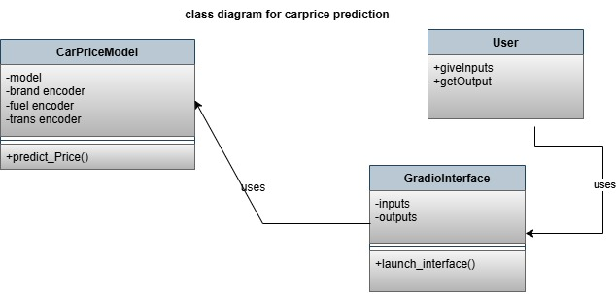
Fig 4.1 Class Diagram

4.3 USE CASE DIAGRAM
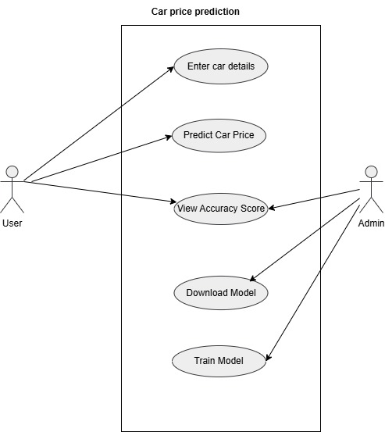

Fig 4.2 Use Case Diagram
4.4 ACTIVITY DIAGRAM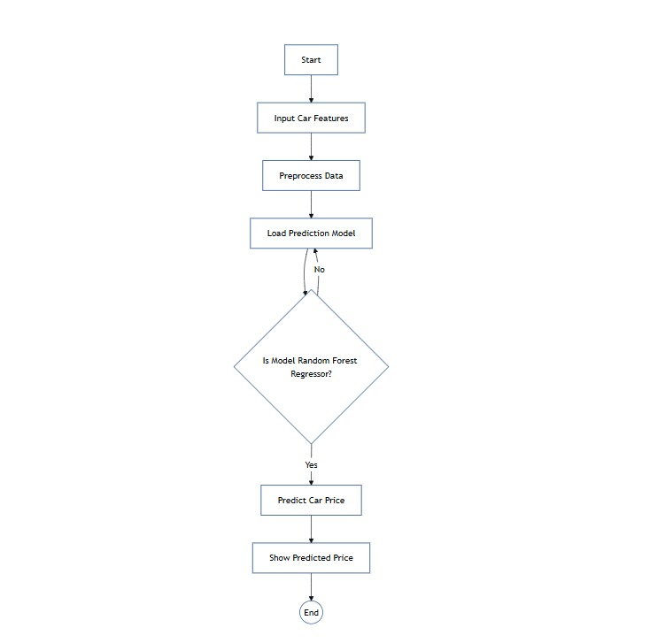
Fig 4.3 Activity Diagram

4.5 SEQUENCE DIAGRAM

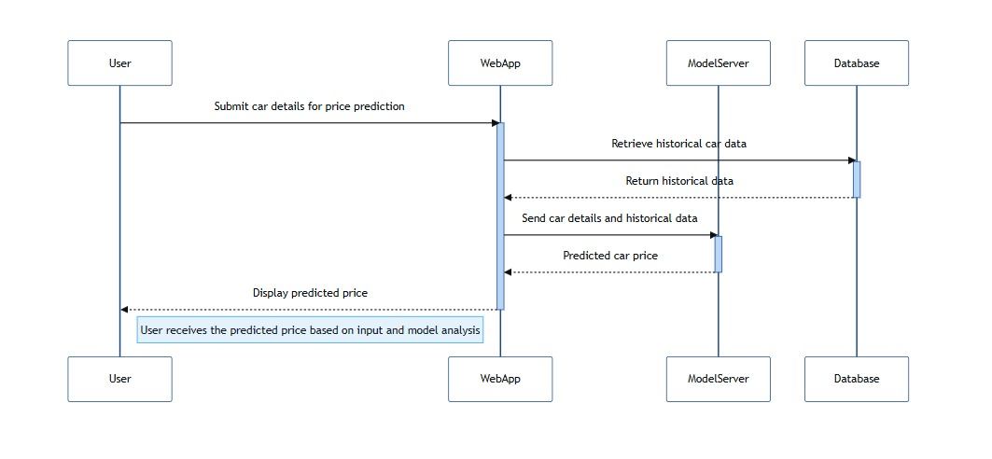
Fig 4.5 Sequence Diagram

4.6 SYSTEM ARCHITECTURE
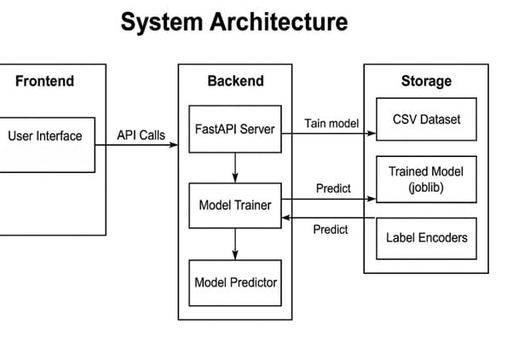
Fig 4.6 System Architecture

4.7 TECHNOLOGY DESCRIPTION
Technology Purpose/Role in the Project
Technology | Purpose/Role in the Project
Python | Primary programming language used for data processing, model training, and logic implementation.
Pandas | Used for data manipulation and analysis, especially for loading and preprocessing the dataset.
Scikit-learn | Machine learning library used to implement the Random Forest Regressor model and preprocessing.
RandomForest Regressor | Algorithm used to build the prediction model for crop yield based on historical data.
LabelEncoder | Converts categorical data (like Area, Item) into numerical format suitable for ML models.
Train-Test Split | Separates the dataset into training and testing sets to validate model accuracy.
Joblib | Saves the trained model and encoders for future use in prediction without retraining.
Jupyter Notebook | Environment used for writing, testing, and running Python code interactively.
CSV Dataset | Input data format containing historical crop yield information.

CHAPTER 5
IMPLEMENTATION & TESTING
5.1 FRONT PAGE SCREENSHOT
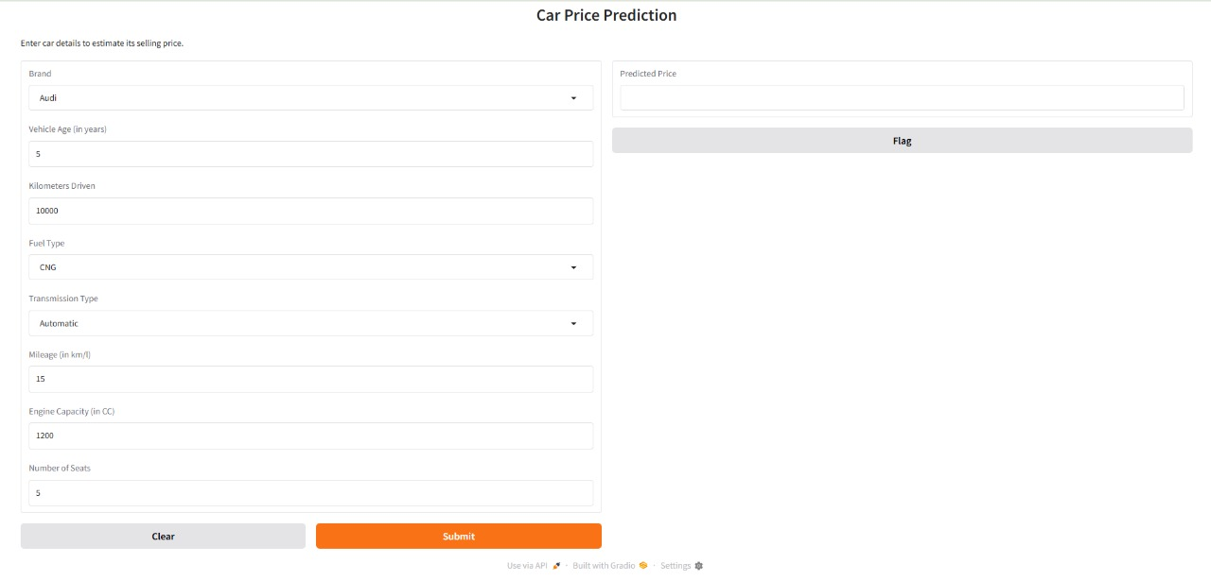

Fig 5.1 Front Page of Project
5.2 MODEL TRAINING AND EVALUATION
In this section, we describe the process of training the machine learning model and evaluating its performance on the Car Price prediction.
5.2.1 Data Preparation:
The dataset was imported from a CSV file named cardekho_dataset.csv. It contains multiple including brand, model, fuel type, transmission type, vehicle age, mileage, km driven and engine capacity. Before training, several preprocessing steps were applied:
- Label Encoding was used to convert categorical columns (fuel_type, transmission_type, and brand) into numerical format using LabelEncoder from sklearn.
- Unnecessary columns such as model were dropped to reduce noise.
- The cleaned feature matrix X and the target variable Y (i.e., selling_price) were extracted.
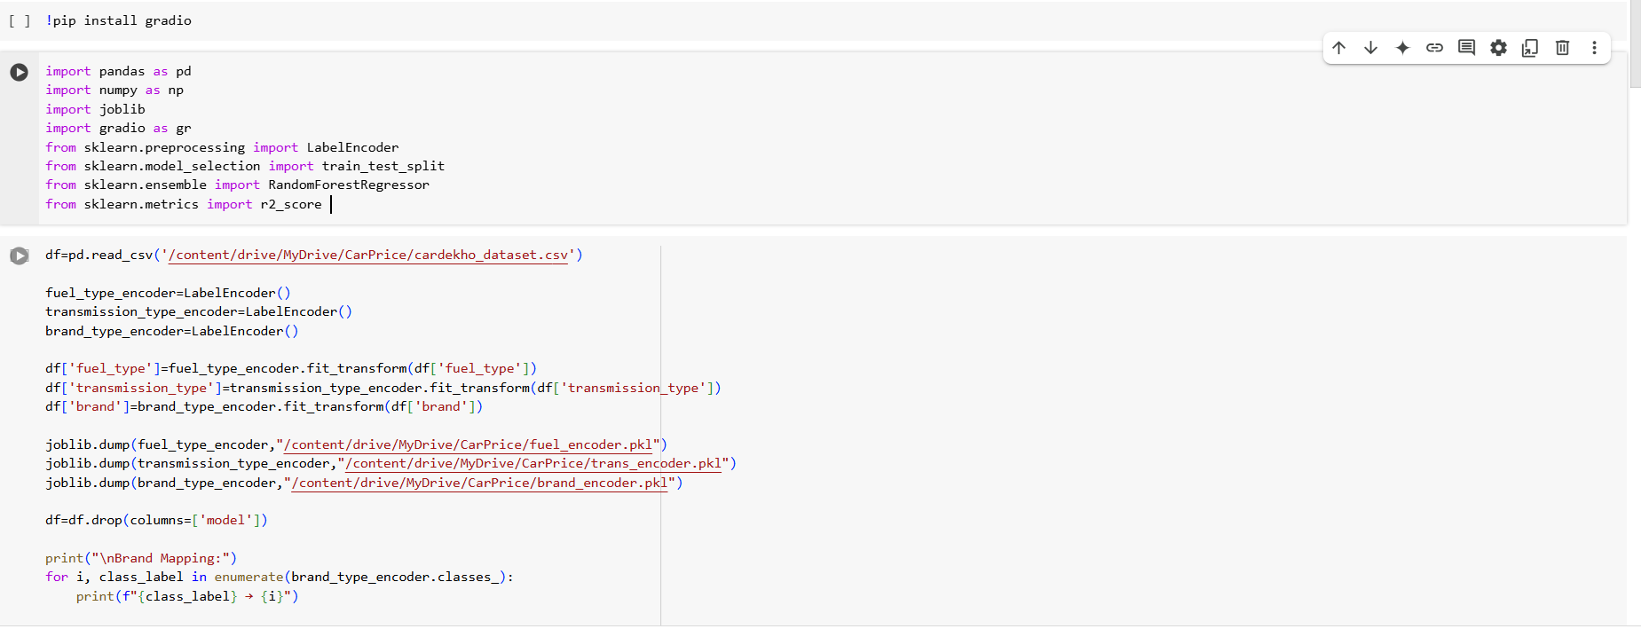
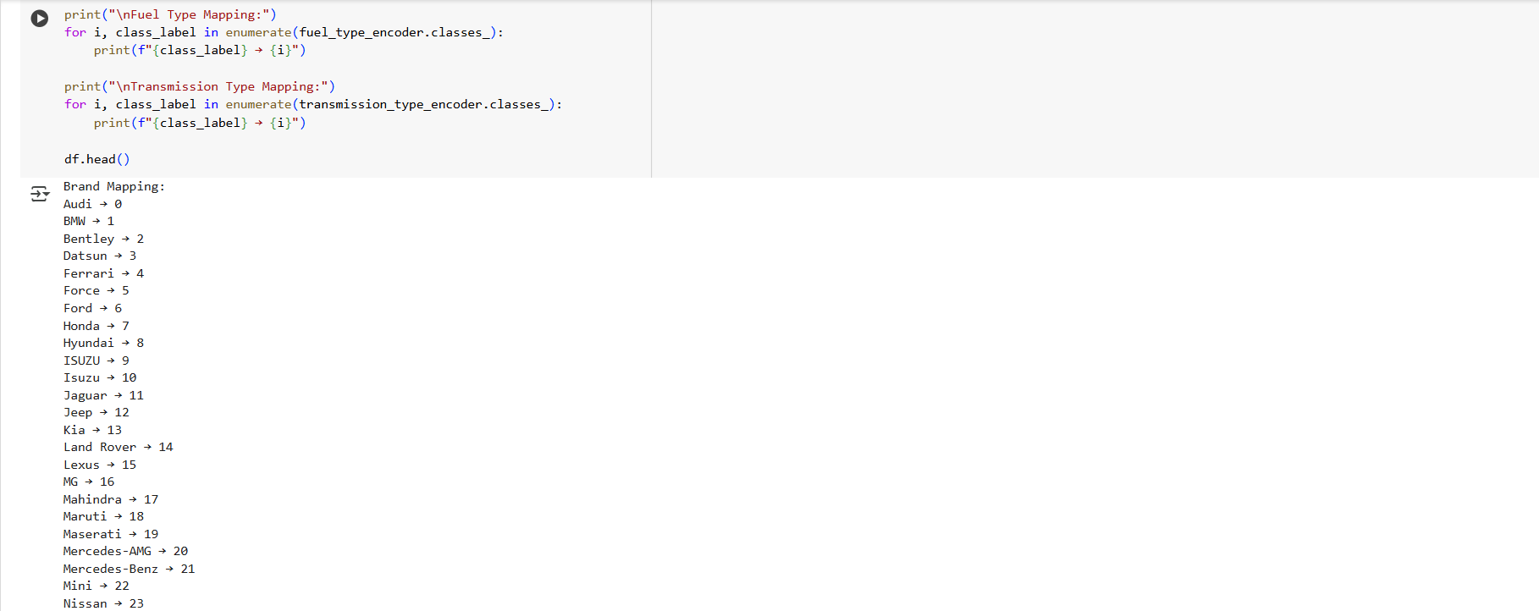

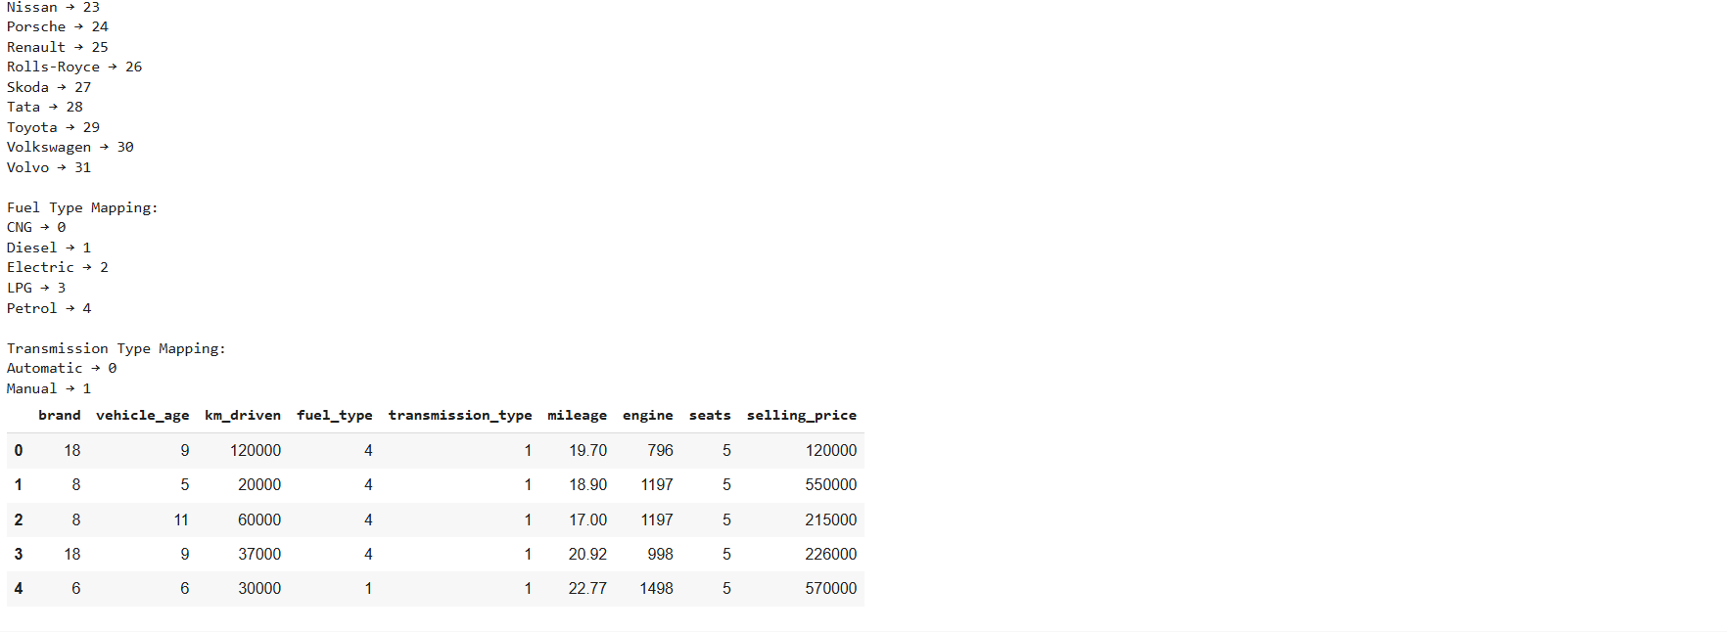
Fig 5.2 Model Development Code

5.2.2 Feature Selection
Feature selection was done manually based on data understanding and exploratory data analysis. The following features were selected for model training:
- brand
- vehicle_age
- km_driven
- fuel_type
- transmission_type
- mileage
- engine
- No of seats
The feature model was dropped due to high cardinality and low contribution to price prediction. Categorical features were encoded to numeric using saved encoders for consistency during deployment.
5.2.3 Model Selection
A Random Forest Regressor from the scikit-learn library was chosen due to its robustness and ability to handle both numerical and categorical data effectively.
5.2.4 Model Training
The dataset was split into training and testing sets using an 70:30 ratio via train_test_split from sklearn. The selected model, RandomForestRegressor, was trained using 100 estimators and a fixed random state for reproducibility:
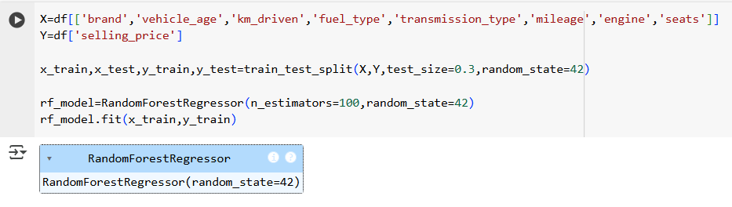
Fig 5.3 Model Training Code
5.2.5 Model Evaluation
The model was evaluated using R² Score, which measures how well the model predictions match the actual prices:
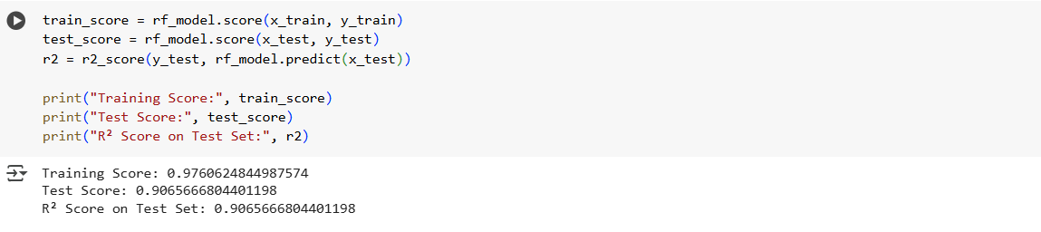
Fig 5.4 Model Evaluation

5.2.6 Model Export
After evaluation, the trained model was saved using the joblib library to a file named car_price_model.pkl. This model file was imported into the app.py Gradio application, which provides a user-friendly interface where users can input car details and receive a predicted selling price. This modular design separates the training pipeline from the deployment script, enhancing maintainability.
The following components were saved using joblib for later use in the deployment phase:
- car_price_model.pkl: Trained Random Forest model
- fuel_encoder.pkl: Encoder for fuel types
- trans_encoder.pkl: Encoder for transmission types
- brand_encoder.pkl: Encoder for brand names

model = joblib.load('car_price_model.pkl')
fuel_type_encoder = joblib.load("fuel_encoder.pkl")
trans_encoder = joblib.load("trans_encoder.pkl")
brand_encoder = joblib.load("brand_encoder.pkl")
Model Performance Comparision
Model Used | R^2 Score on training set | R^2 Score on Testing set
Mutliple Linear Regression  Random Forest | 0.85  0.97 | 0.82  0.90

5.2.7 Actual Price Vs Predicted Price
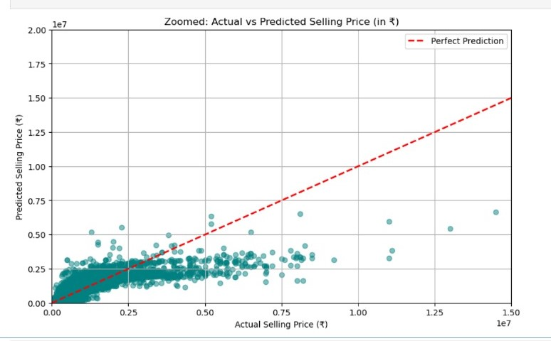
Fig 5.5 Actual Price Vs Predicted Price plot
5.2.8 Correlation Matrix
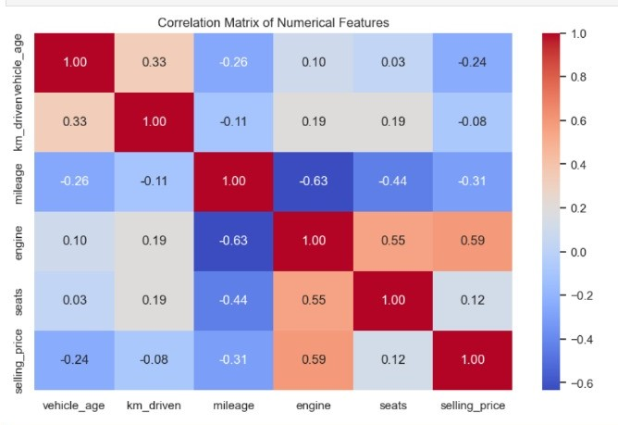
Fig 5.6 Correlation Matrix
Conclusion and Future Scope
Conclusion
The car price prediction project demonstrates the effective use of machine learning techniques in estimating the market value of vehicles based on various features such as make, model, year, mileage, fuel type, transmission, and more. By training and evaluating multiple models including Linear Regression and Random Forest the project identifies the most accurate and efficient approach for price estimation.
The results show that ensemble methods like Random Forest outperform simpler models, providing higher accuracy and robustness against overfitting. The trained model can be integrated into real-world applications such as car dealerships, resale platforms, or price comparison tools to offer real-time pricing insights, thereby benefiting both sellers and buyers.
Future Scope
Real-TimeDataIntegration:
Integrate live data from car listing websites (e.g., CarDekho, OLX, CarWale) via APIs to ensure dynamic and updated price predictions.
Image-BasedPriceEstimation:
Use computer vision techniques to estimate vehicle condition from images and factor it into the pricing model.

REFERENCES
- • K. Dey, M. A. J. Al Zubair, and M. A. Karim, “Predicting Car Prices using Machine Learning Algorithms,” Proceedings of the 2020 International Conference on Computer Science and Software Engineering (CSSE), 2020, pp. 140-145.
- • J. R. Hennig, S. G. Hearn, and C. R. Casson, “Car Price Prediction with Regression Models and Neural Networks,” Journal of Artificial Intelligence Research, vol. 59, no. 2, pp. 227-243, 2018.
- • A. Rahman, R. K. Singh, and S. Mishra, “A Comparative Study of Machine Learning Algorithms for Predicting Car Prices,” Proceedings of the 2019 IEEE International Conference on Data Mining, pp. 244-252, 2019.
- • M. S. Wazir and A. A. Khushnood, “Predicting Used Car Prices using Regression and Ensemble Methods,” International Journal of Computer Science and Information Security (IJCSIS), vol. 18, no. 5, pp. 64-71, 2020.

APPENDIX:( SAMPLE CODE)
app.py
