**Create a Student table:-**

**Student Table**

Student_ID

Student_Name

Address

DOB

Department_ID

**Create the Subjects table:-**

**Subjects Table**

Subject_ID

Subject_Name

Lecturer_ID

**Create the Lecturers table:-**

**Lecturers Table**

Lecturer_ID

Lecturer_Name

Department_ID

**Create Fee structure table:-**

**Fee Structure Table**

Student_ID

Fee

**Create departments table:-**

**Departments Table**

Department_ID

Department_Name

**Schema diagram.:-**

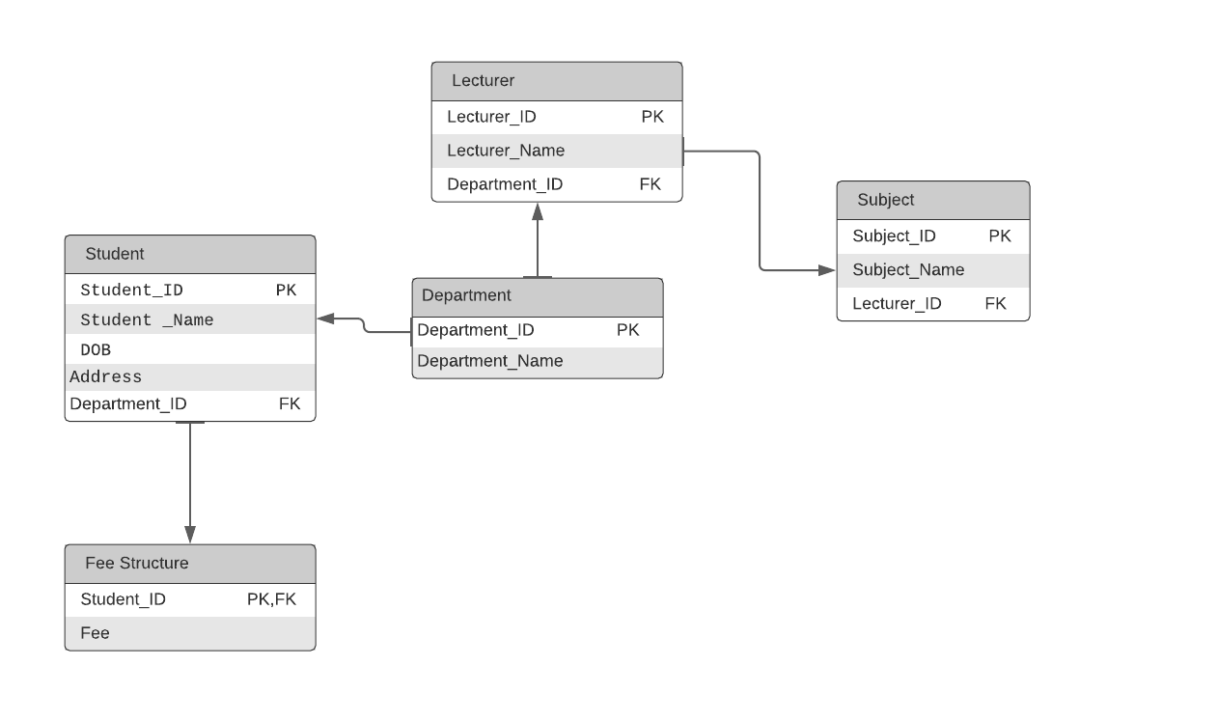

**Need to plan on the Primary key and the Foreign keys.**

Student Table : Student_ID(Primary Key) Department_ID(Foreign Key)

Subjects Table : Subject_ID(Primary Key) Department_ID(Foreign Key)

Lecturers Table : Lecturer_ID(Primary Key) Department_ID(Foreign Key)

Departments Table : Department_ID(Primary Key)

Fee Structure Table : Student_ID(Primary Key, Foreign Key)

**The association between them to be decided!**

**ALL OPERATIONS DONE IN SQL FILE ‘Student’**