ST. VINCENT PALLOTTI COLLEGE OF ENGINEERING AND TECHNOLOGY, NAGPUR
Department of Computer Science and Engineering (Data Science)
ACTIVITY REPORT 2025-2026
Topic: WEB-BASED MATHEMATICAL EXPRESSION EVALUATOR
Submitted By: 1. Harshal Kature (UID: 24006034)
2. Sanjana Reddy (UID: 24006040)
Semester: 4th Sem

1. Introduction

The Interactive Expression Evaluator is a specialized pedagogical platform designed to demystify the computational logic behind mathematical parsing. While humans intuitively process expressions like 5 + (3 * 2) through visual pattern recognition, computers require a structured, step-by-step approach to manage operator precedence and nesting. This tool bridges that gap by providing a transparent, visual window into the stack-based data structures that power modern compilers and calculators.
At its core, the application serves as a functional demonstration of the Shunting-Yard algorithm and Postfix evaluation. By transforming abstract code into a dynamic, interactive experience, it allows users to witness exactly how data is buffered, prioritized, and reduced. This introduction of visual feedback into a traditionally "invisible" process makes it an essential resource for students of computer science, software engineering, and discrete mathematics.

- Objectives of the Project
- To understand and implement the Stack data structure in a real-world application by using it for infix - to - postfix conversion and postfix expression evaluation through the Shunting-Yard algorithm.
- To develop a fully functional web-based calculator interface where users can input mathematical expressions, evaluate results, and view the step-by-step working of the Stack during conversion and evaluation.
- To ensure the system is robust, maintainable, and educational by handling errors such as invalid syntax, mismatched parentheses, and division by zero gracefully, while keeping the JavaScript code clean and well-documented.

- Stack Data Structure: Concepts & Theory

  - Definition

A Stack is a linear data structure that follows the Last-In First-Out (LIFO) principle — the element inserted last is the first to be removed. It is analogous to a pile of plates: you add and remove plates only from the top of the pile. Stacks are one of the most fundamental and widely-used data structures in computer science

.

Operation | Description | Time Complexity | Return Value
push(x) | Insert element x at the top of stack | O(1) | void
pop( ) | Remove and return the top element | O(1) | top element
peek( ) | View top element without removing it | O(1) | top element
isEmpty( ) | Check if the stack is empty | O(1) | boolean
size ( ) | Return number of elements in stack | O(1) | integer

- Stack Data Structure: Concepts & Theory

3.1 Stack in JavaScript
JavaScript arrays natively support stack operations. The push() method adds an element to the top of the stack, and the pop() method removes and returns the last element, making arrays a natural and efficient choice for implementing stacks:
const stack = [];
stack.push(5); // Stack: [5]
stack.push(10); // Stack: [5, 10]
let top = stack.pop(); // top = 10, Stack: [5]
let peek = stack[stack.length - 1]; // peek = 5

3.2 Operator Precedence and Associativity
Expression evaluation depends on operator precedence (which operator binds tighter) and associativity (left-to-right or right-to-left for same-precedence operators). The table below defines the rules used in our evaluator:
Operator | Symbol | Precedence | Associativity
Exponentiation | ^ | 4 (Highest) | Right to Left
Multiplication | * | 3 | Left to Right
Division | / | 3 | Left to Right
Addition | + | 2 | Left to Right
Subtraction | - | 2 (Lowest) | Left to Right

- Algorithm: Postfix Expression Evaluation

4.1 Overview of the Shunting-Yard Algorithm
The Shunting-Yard algorithm, invented by computer scientist Edsger Dijkstra, converts a mathematical expression written in standard infix notation to postfix (Reverse Polish Notation) using a stack. It correctly handles operator precedence, associativity, and parentheses. The algorithm processes each token in the input from left to right and uses an operator stack and an output queue.

4.2 Algorithm Steps
- Initialize an empty operator stack and an empty output list.
- Tokenize the input expression into numbers, operators, and parentheses.
- For each token: If it is a number (operand), add it directly to the output list.
- If it is an operator (op): While the stack is not empty, and the top of the stack is an operator with greater precedence (or equal precedence and left-associative), pop it to the output. Then push the current operator onto the stack.
- If it is a '(' (left parenthesis), push it onto the stack.
- If it is a ')' (right parenthesis), pop operators from the stack to the output until a '(' is found. Discard the '('.
- After all tokens are processed, pop any remaining operators from the stack to the output.
- The output list is the postfix expression.

4.3 Worked Example: (3 + 5) * 2 - 4 / 2
Below is a step-by-step trace of the Shunting-Yard algorithm for the expression (3 + 5) * 2 - 4 / 2:

Step | Token | Operator Stack | Output Queue
1 | ( | [ ( ] | [ ]
2 | 3 | [ ( ] | [ 3 ]
3 | + | [ (, + ] | [ 3 ]
4 | 5 | [ (, + ] | [ 3, 5 ]
5 | ) | [ ] | [ 3, 5, + ]
6 | * | [ * ] | [ 3, 5, + ]
7 | 2 | [ * ] | [ 3, 5, +, 2 ]
8 | - | [ - ] | [ 3, 5, +, 2, * ]
9 | 4 | [ - ] | [ 3, 5, +, 2, *, 4 ]
10 | / | [ -, / ] | [ 3, 5, +, 2, *, 4 ]
11 | 2 | [ -, / ] | [ 3, 5, +, 2, *, 4, 2 ]
12 | END | [ ] | [ 3, 5, +, 2, *, 4, 2, /, - ]

The resulting postfix expression is: 3 5 + 2 * 4 2 / - which evaluates to: (3+5)*2 - 4/2 = 16 - 2 = 14.
- Algorithm: Postfix Expression Evaluation
5.1 Overview
Once the infix expression has been converted to postfix notation, evaluating it is straightforward using a single numeric stack. The algorithm scans the postfix expression from left to right, pushing operands onto the stack and applying operators to the top two operands as they are encountered. The final result is the single remaining value on the stack.

5.2 Algorithm Steps
- Initialize an empty numeric operand stack.
- For each token in the postfix expression:
- If the token is a number (operand), push it onto the stack.
- If the token is an operator (+, -, *, /, ^), pop the top two values from the stack. Let them be b (popped first) and a (popped second). Apply the operator: result = a op b. Push the result back onto the stack.
- After processing all tokens, the stack contains exactly one value: the final result.
- If the stack contains more than one value at the end, the expression was invalid.
5.3 Worked Example: Postfix 3 5 + 2 * 4 2 / -
Step | Token | Action | Operand Stack
1 | 3 | Push 3 | [ 3 ]
2 | 5 | Push 5 | [ 3, 5 ]
3 | + | Pop 5, 3 -> 3 + 5 = 8, Push 8 | [ 8 ]
4 | 2 | Push 2 | [ 8, 2 ]
5 | * | Pop 2, 8 -> 8 * 2 = 16, Push 16 | [ 16 ]
6 | 4 | Push 4 | [ 16, 4 ]
7 | 2 | Push 2 | [ 16, 4, 2 ]
8 | / | Pop 2, 4 -> 4 / 2 = 2, Push 2 | [ 16, 2 ]
9 | - | Pop 2, 16 -> 16 - 2 = 14, Push 14 | [ 14 ]
10 | END | Stack has one value: 14 = Final Result | [ 14 ]

5.4 Core JavaScript Implementation
The following code snippets illustrate the key functions in the implementation:

function getPrecedence(op) {
if (op === '^') return 4;
if (op === '*' || op === '/') return 3;
if (op === '+' || op === '-') return 2;
return 0;
}

function infixToPostfix(expression) {
const output = [], stack = [];
const tokens = tokenize(expression);
for (let token of tokens) {
if (!isNaN(token)) { output.push(token); }
else if (isOperator(token)) {
while (stack.length && getPrecedence(stack[stack.length-1])
>= getPrecedence(token) && token !== '^')
output.push(stack.pop());
stack.push(token);
} else if (token === '(') { stack.push(token); }
else if (token === ')') {
while (stack[stack.length-1] !== '(')
output.push(stack.pop());
stack.pop(); // discard '('
}
}
while (stack.length) output.push(stack.pop());
return output;
}

- OUTPUT
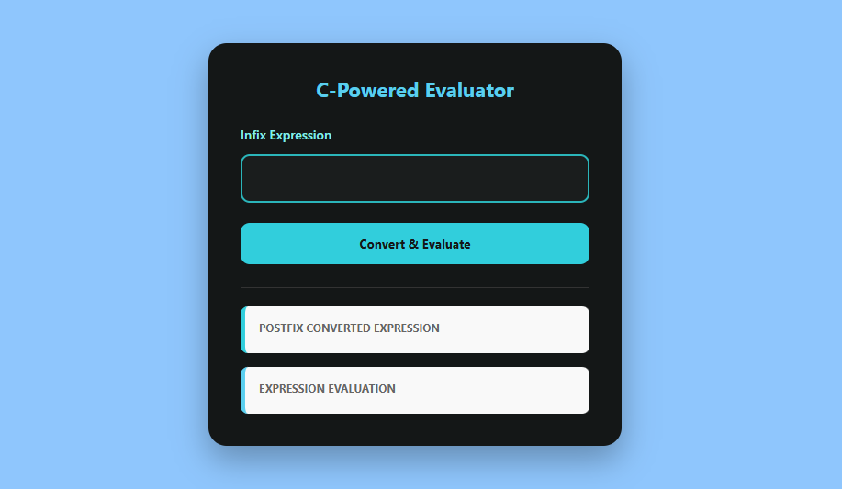
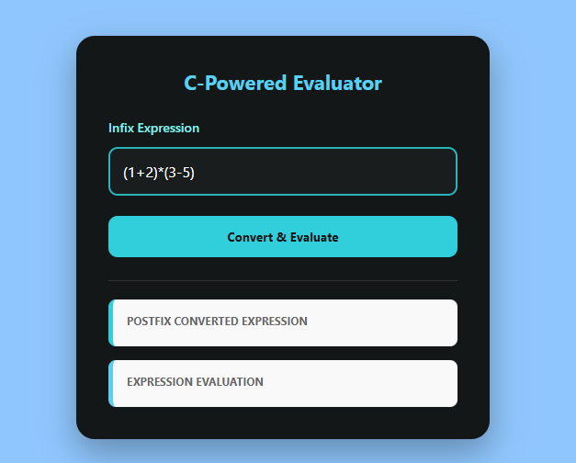
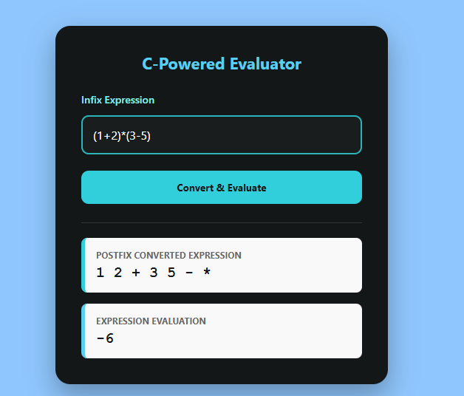
7. Results

An interactive web-based expression evaluator built on stack-based architecture serves as a functional bridge between high-level mathematical notation and low-level computational logic. By implementing a visual interface for the Shunting-Yard and Postfix Evaluation algorithms, the tool transforms abstract data structure concepts into a tangible, observable process.

FACULTY COORDINATOR:

Prof. Kalyani Satone Dr. Nischal Puri

