**Program 1**

Aim of the program:

Create a topology and simulate sending a simple PDU from source to destination using hub and switch as connecting devices and demonstrate ping messages.

 Procedure along with the topology:

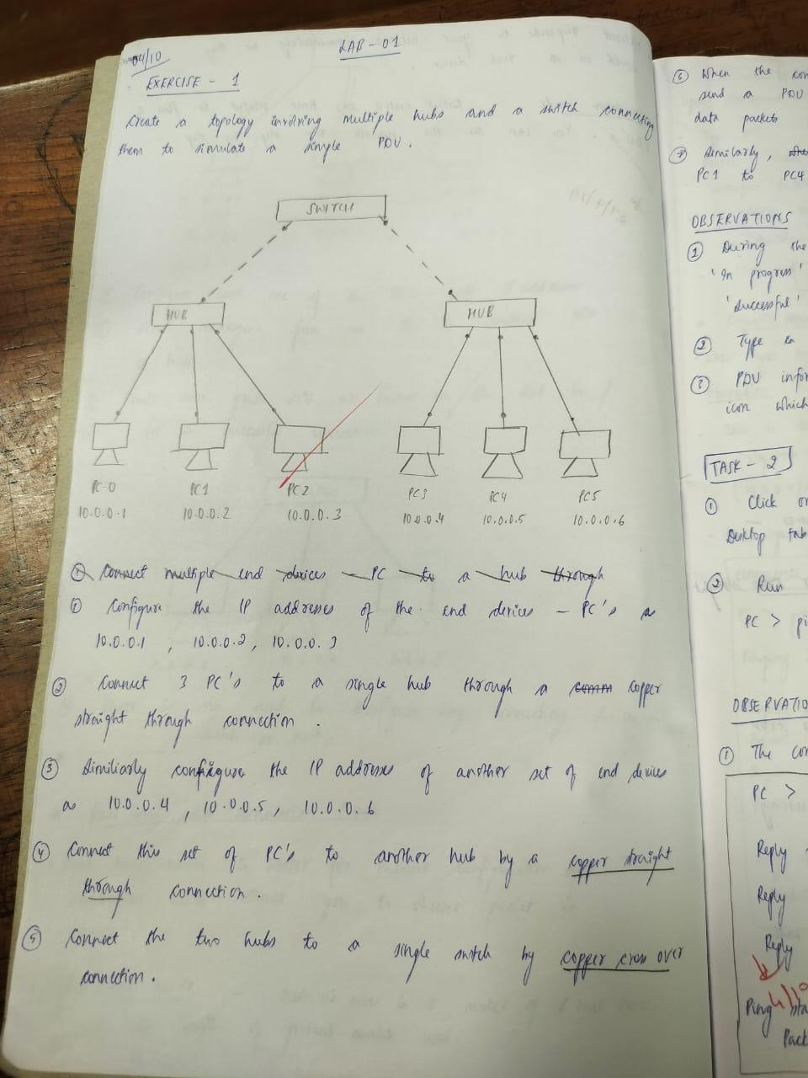

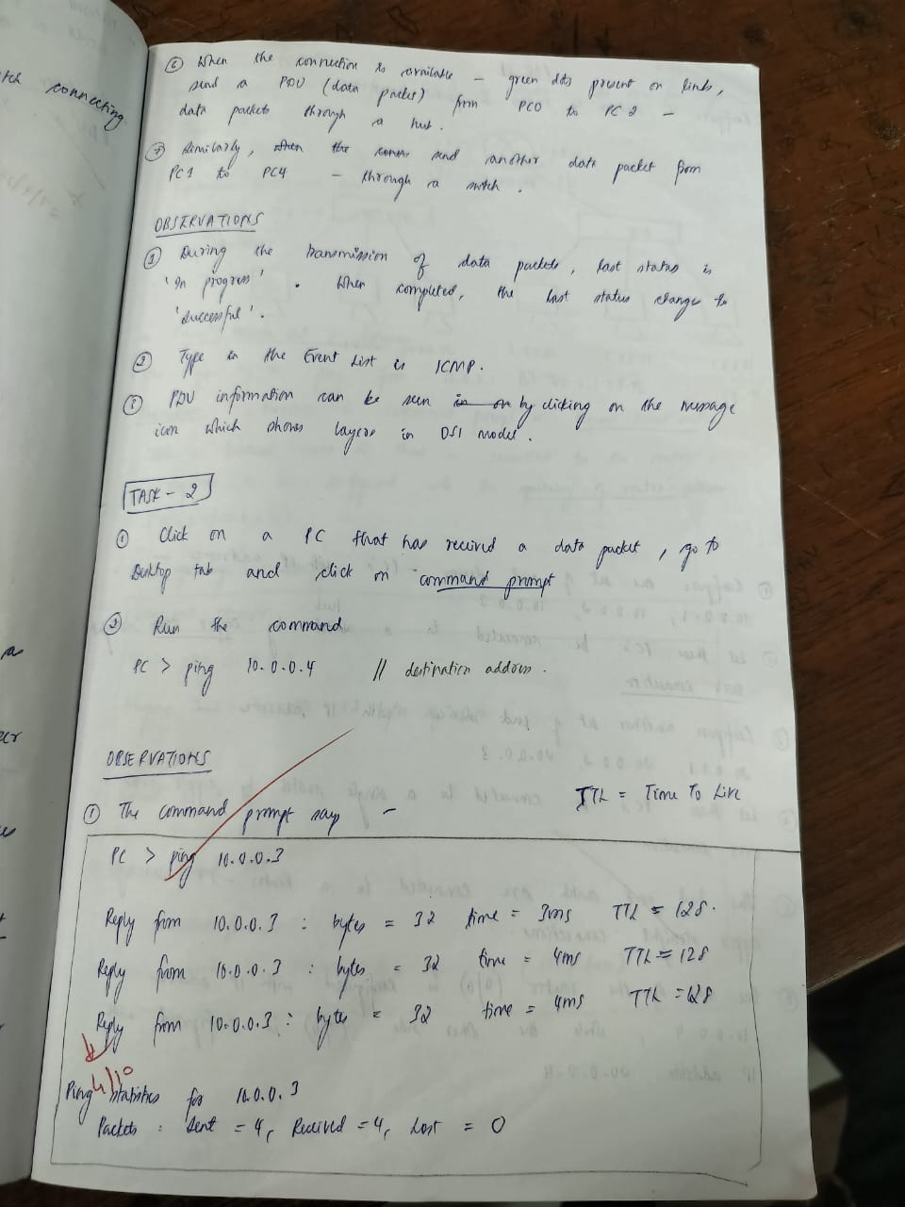

 Screen shots/ output :

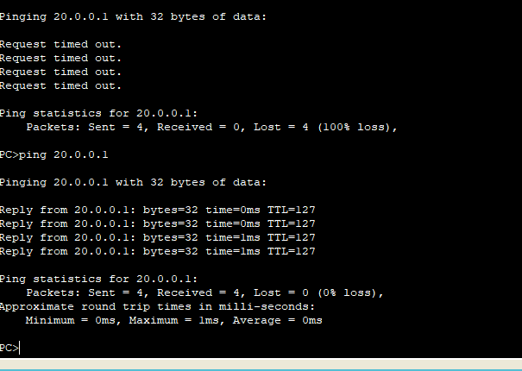

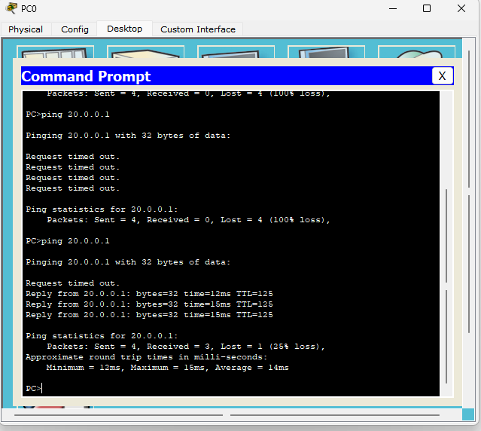

 Observation:

