**Program 10-TELNET**

Aim of the program:

To understand the operation of TELNET by accessing the router in server room from a PC in IT office.

Procedure along with the topology:

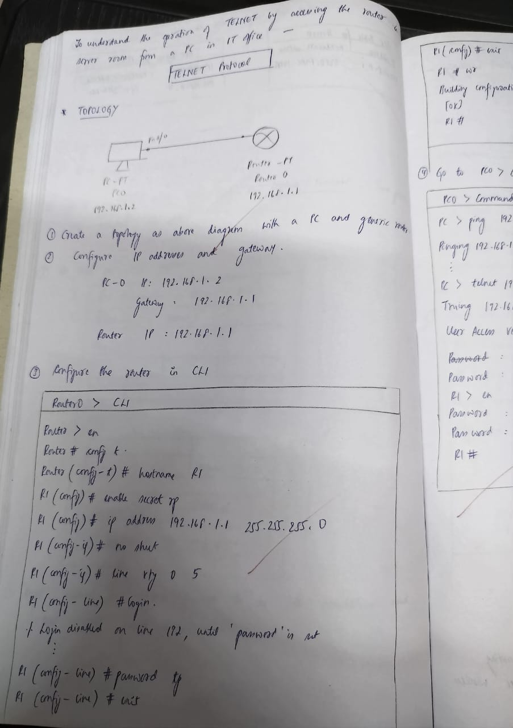

 Screen shots/ output :

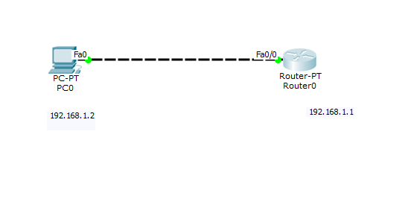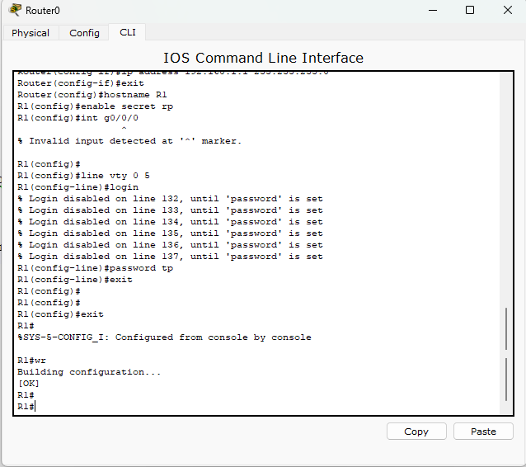

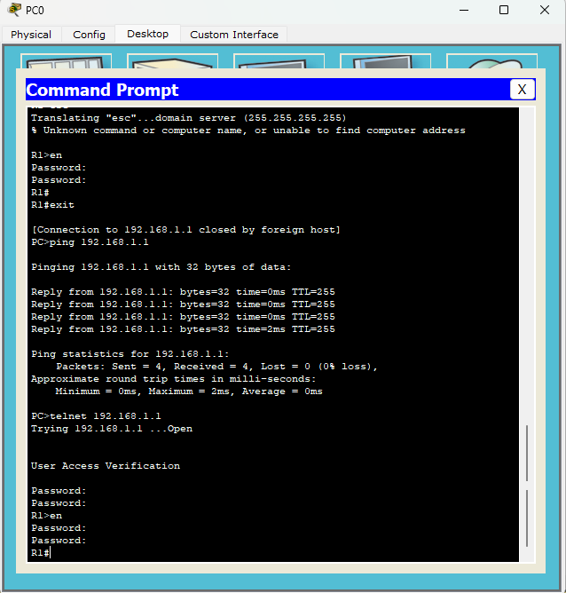

Observation:

