INTERNET PROGRAMMING LAB

Experiment 16: ComplainEase – Online Complaint Registration and Management
Aim: An online platform where users register complaints with category, description, location and supporting files; officers update status and proof of work; the admin generates officer credentials and manages accounts.

Output screenshots
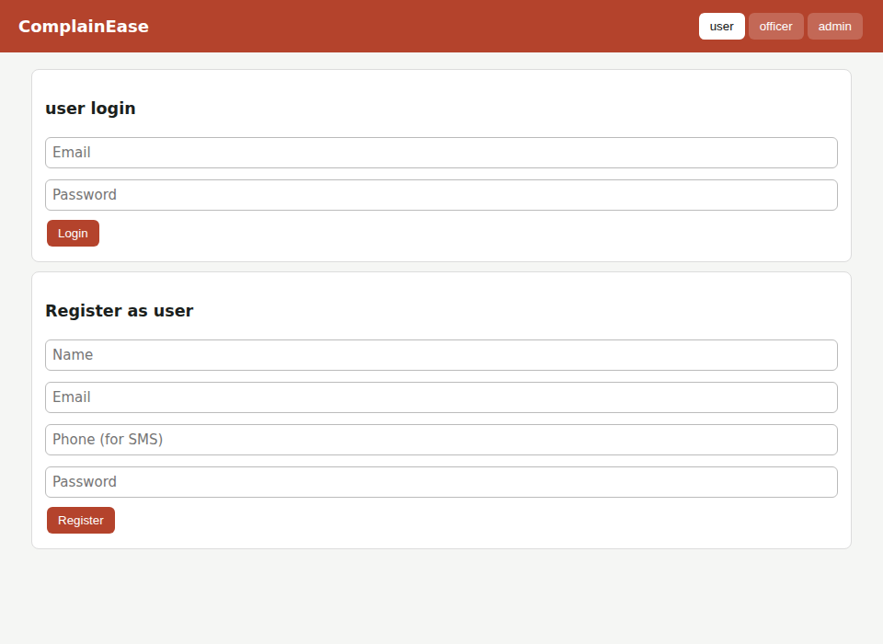
Figure 1: User login and registration page
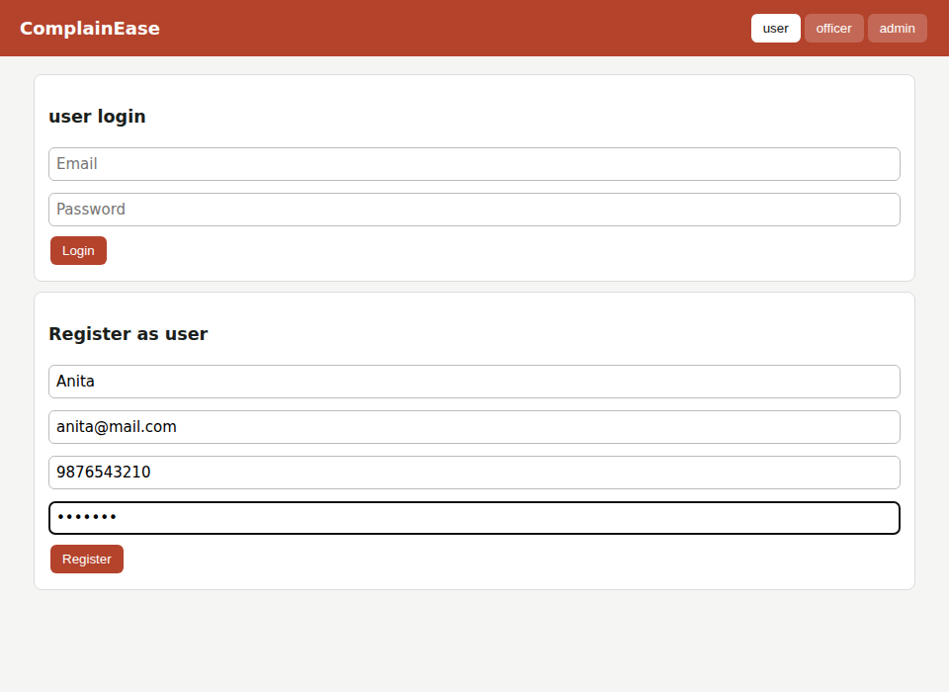
Figure 2: User registration form filled
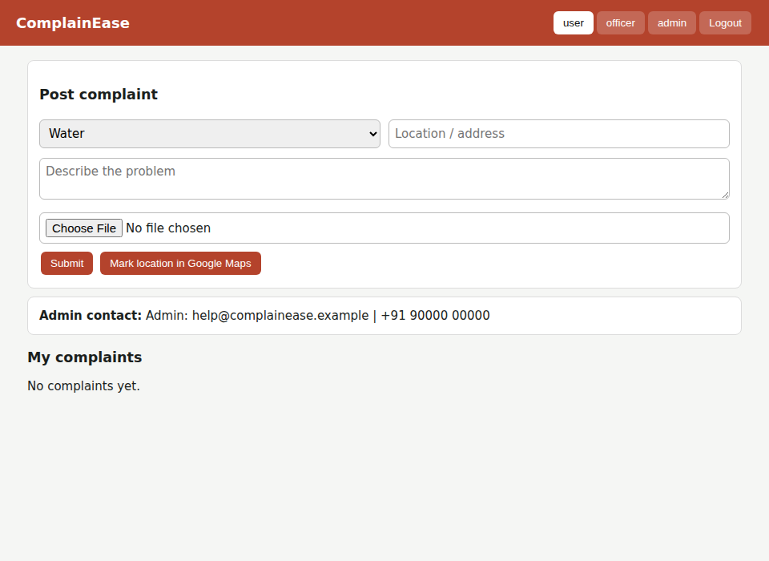
Figure 3: User dashboard – post complaint form
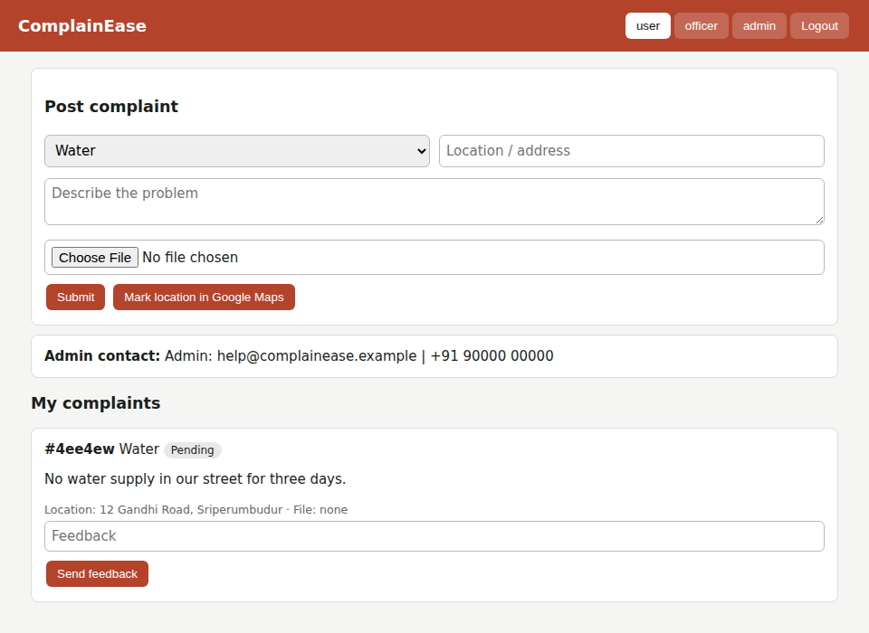
Figure 4: Complaint submitted – listed under My complaints with status Pending
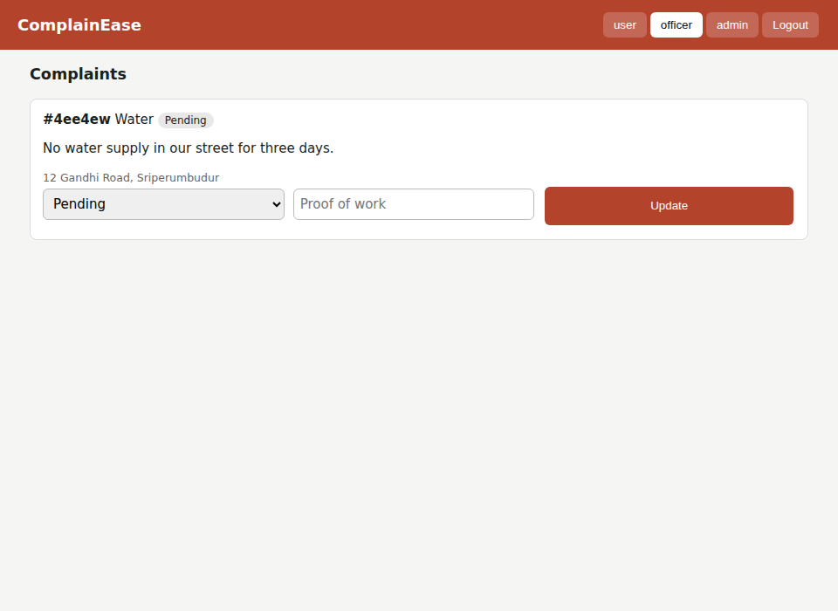
Figure 5: Officer – view complaints
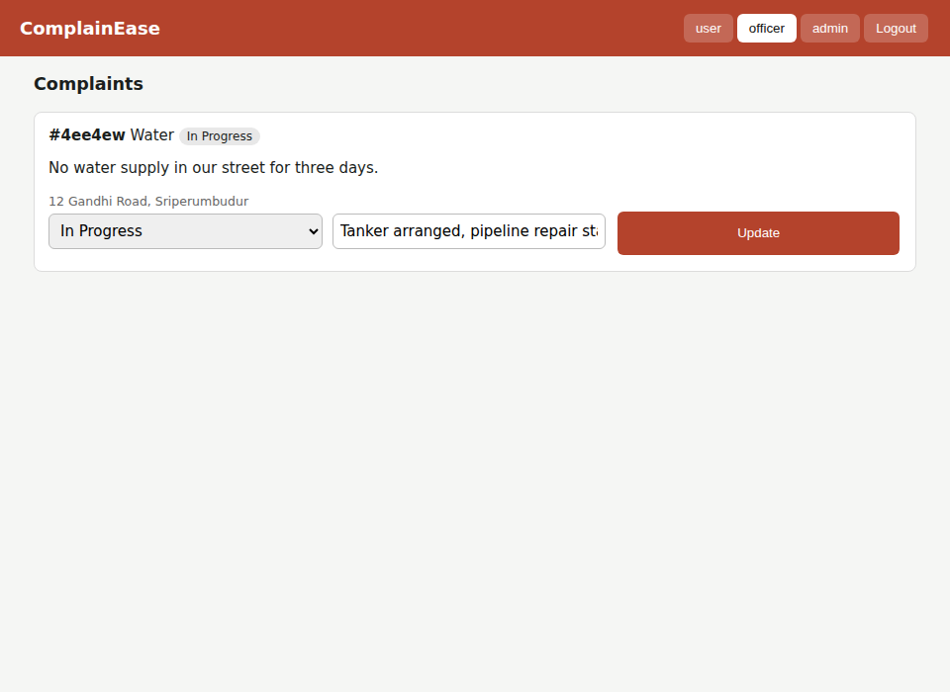
Figure 6: Officer – status and proof of work updated
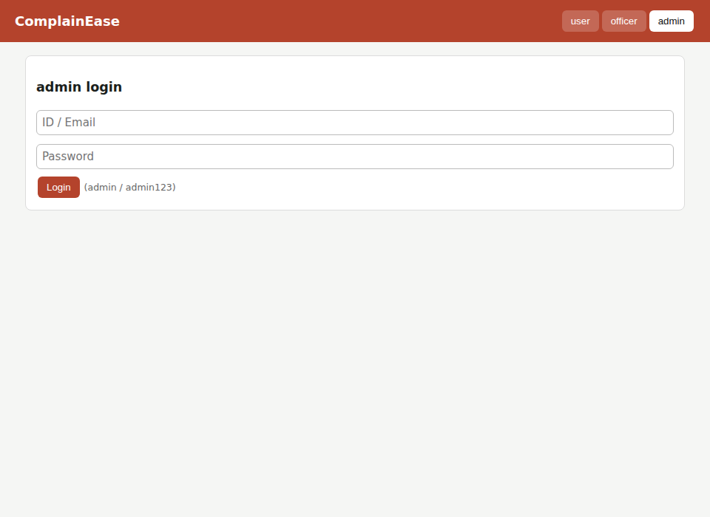
Figure 7: Admin login page
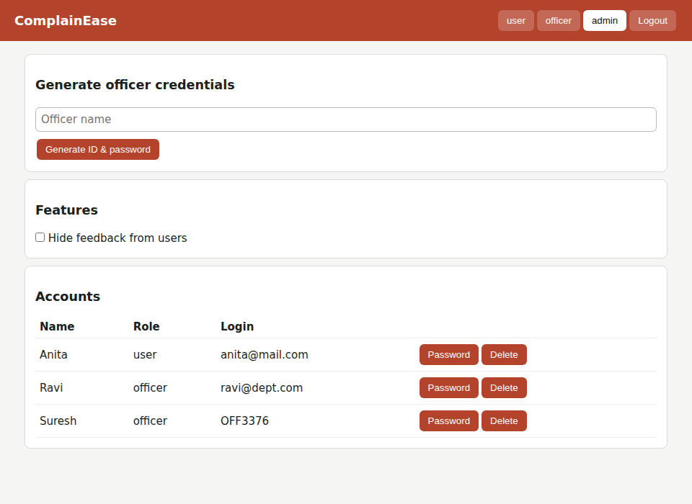
Figure 8: Admin – officer ID and password generated, account management
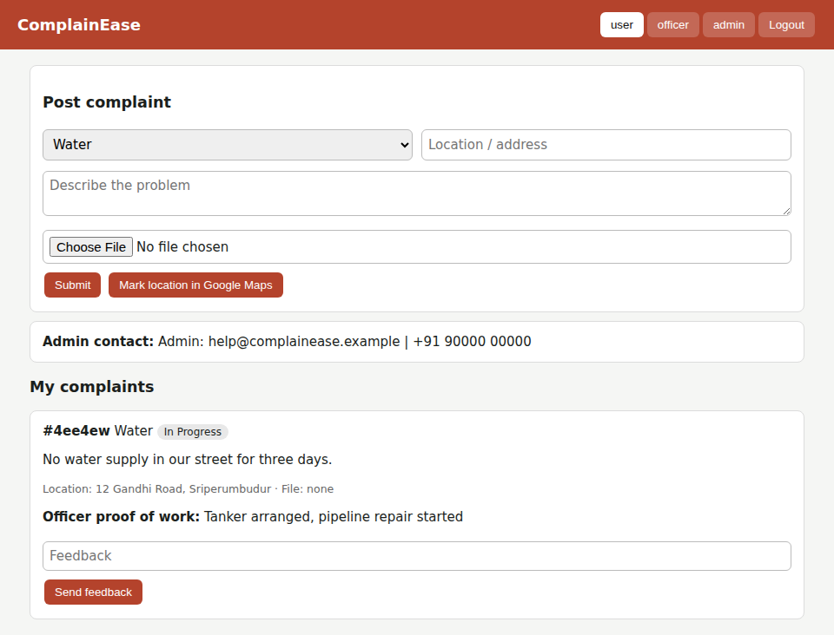
Figure 9: User – sees updated status, officer proof of work and feedback option
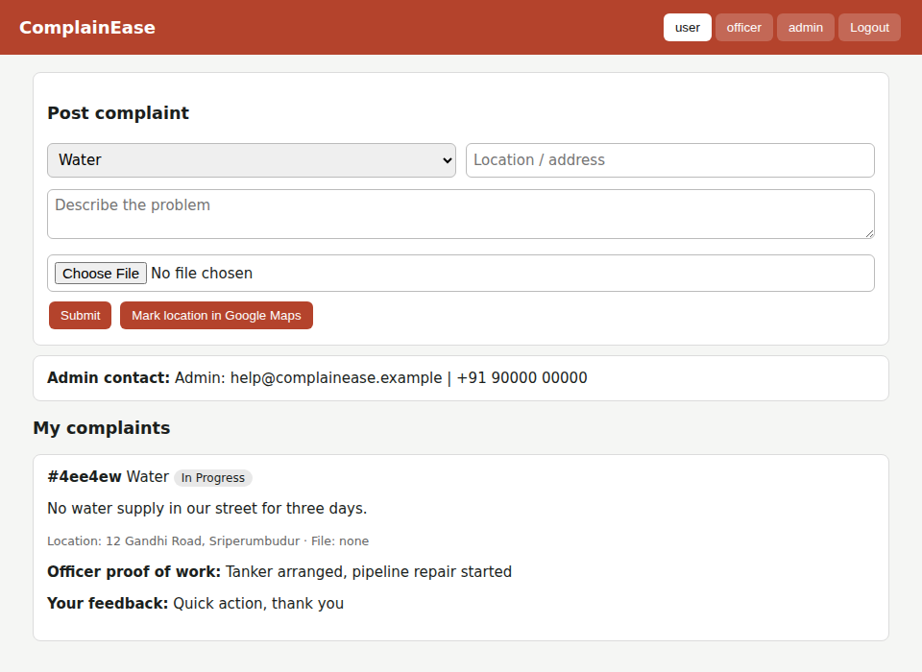
Figure 10: User – feedback submitted

