INTERNET PROGRAMMING LAB

Experiment 17: VoteOnline – Secure E-Voting Platform
Aim: An e-voting platform where the admin creates candidates, allocates them to wards and manages the voter list, and voters log in with Voter ID and OTP verification to cast one vote.

Output screenshots
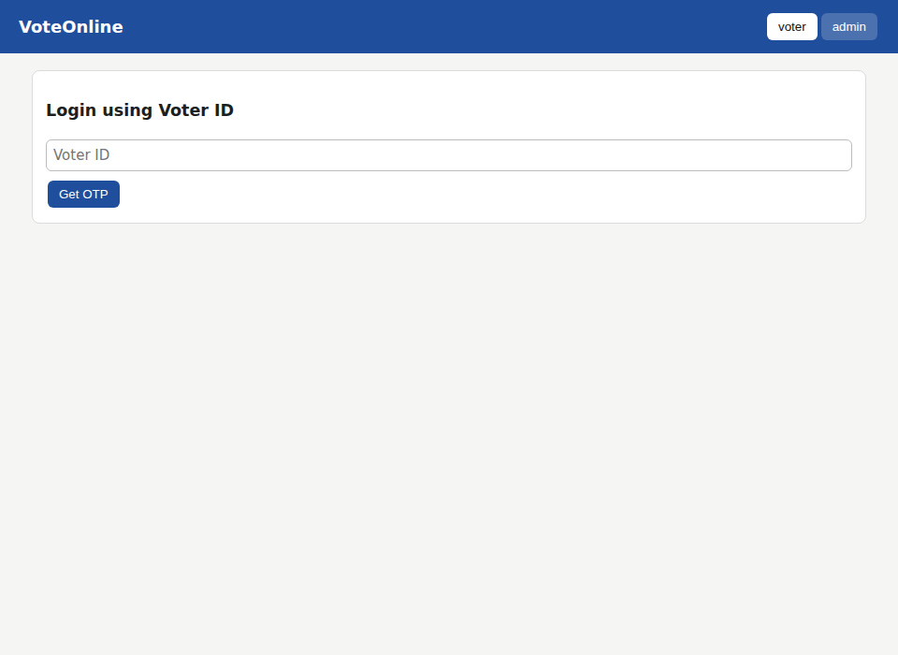
Figure 1: Voter login using Voter ID
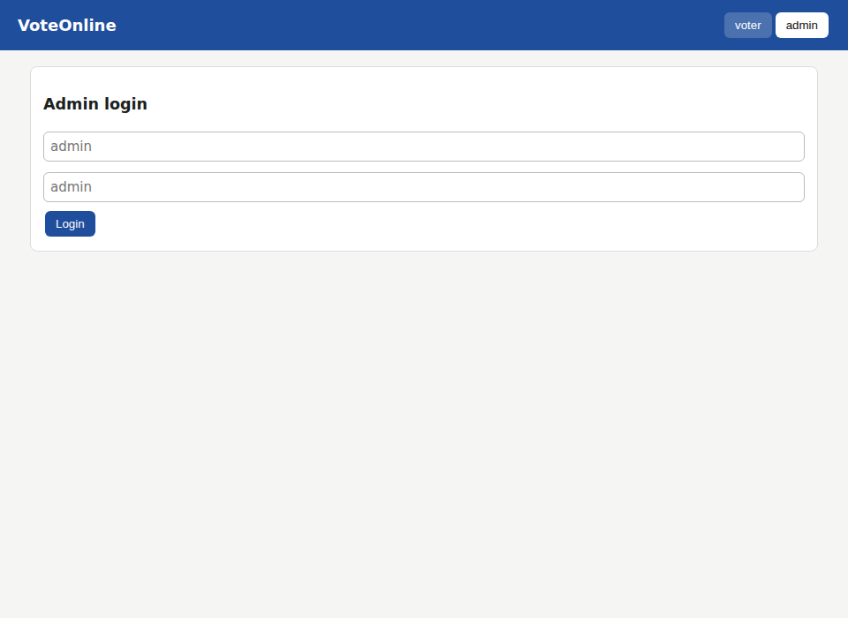
Figure 2: Admin login
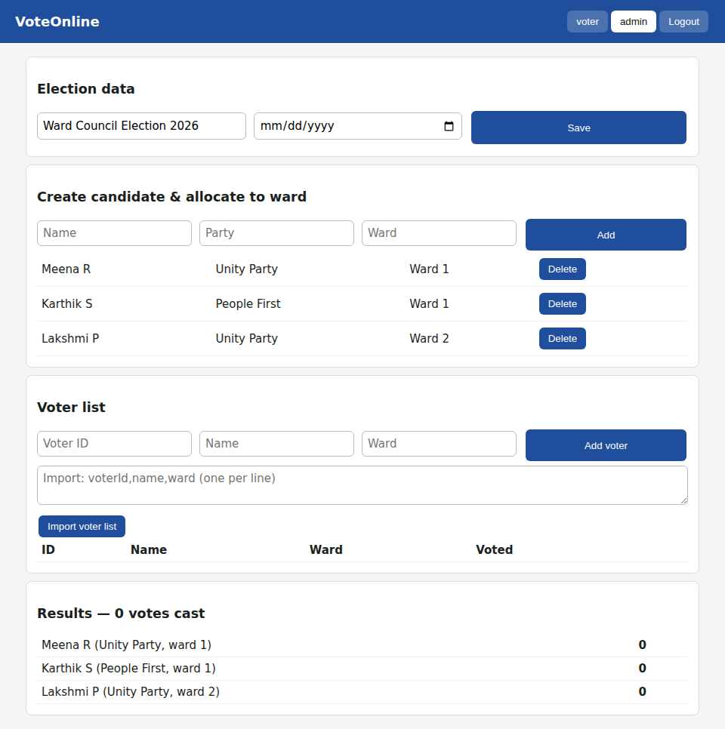
Figure 3: Admin – create candidates and allocate to wards
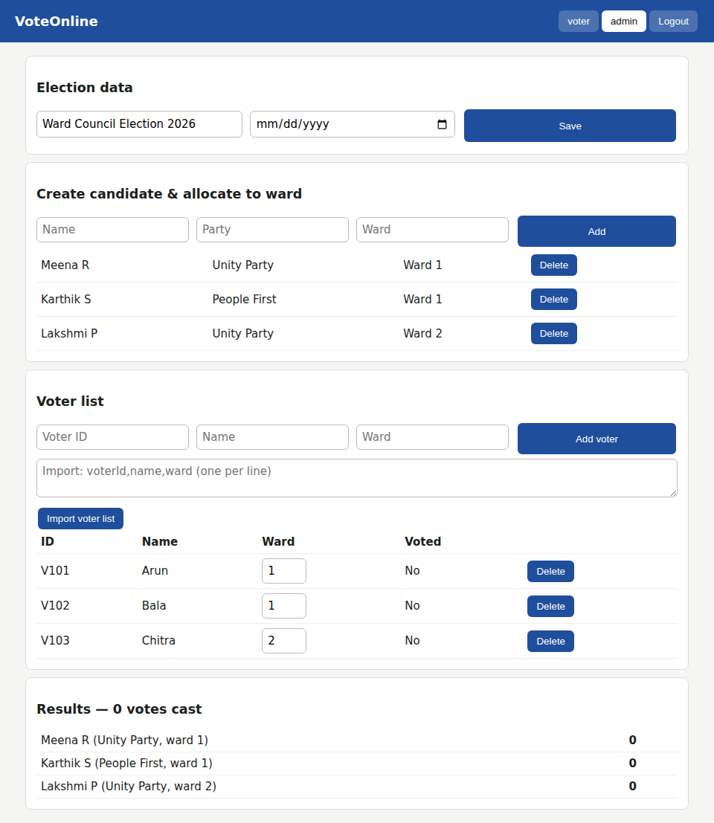
Figure 4: Admin – voter list imported
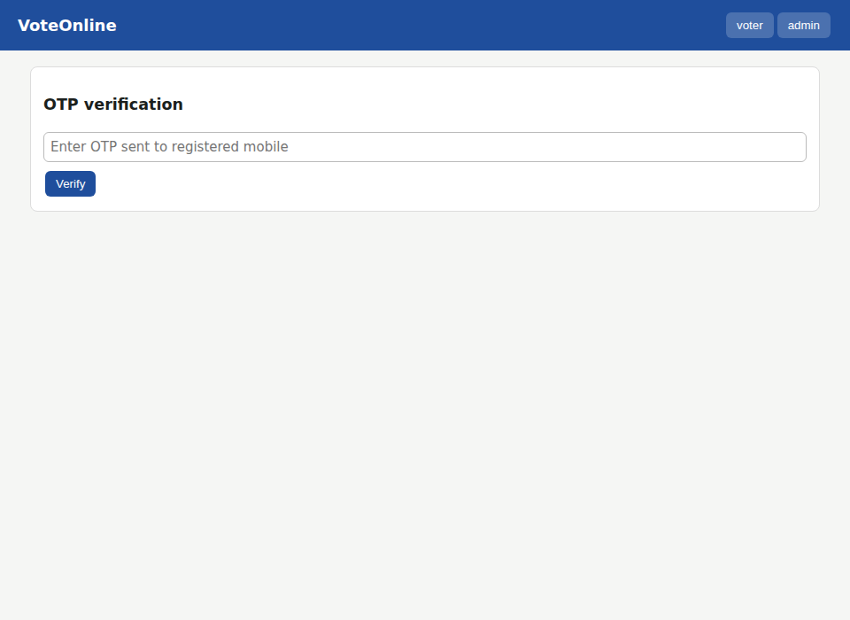
Figure 5: OTP verification page (OTP: 8572)
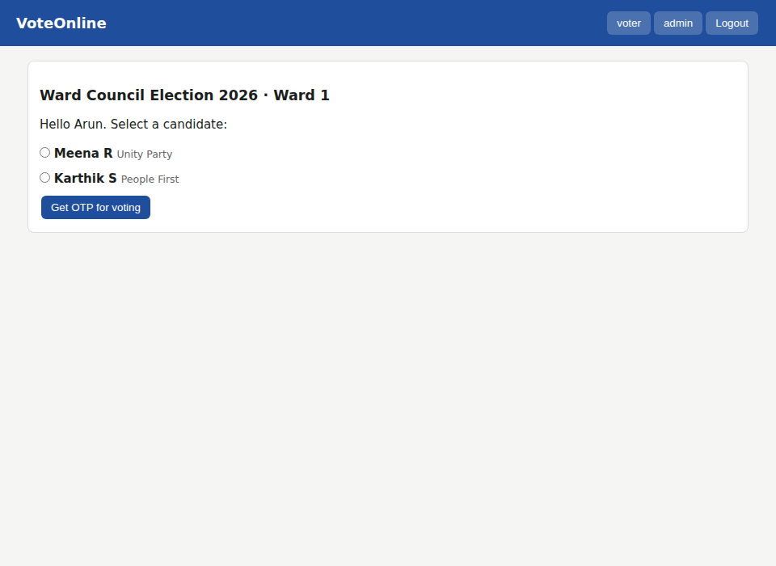
Figure 6: Voter – candidate list for own ward
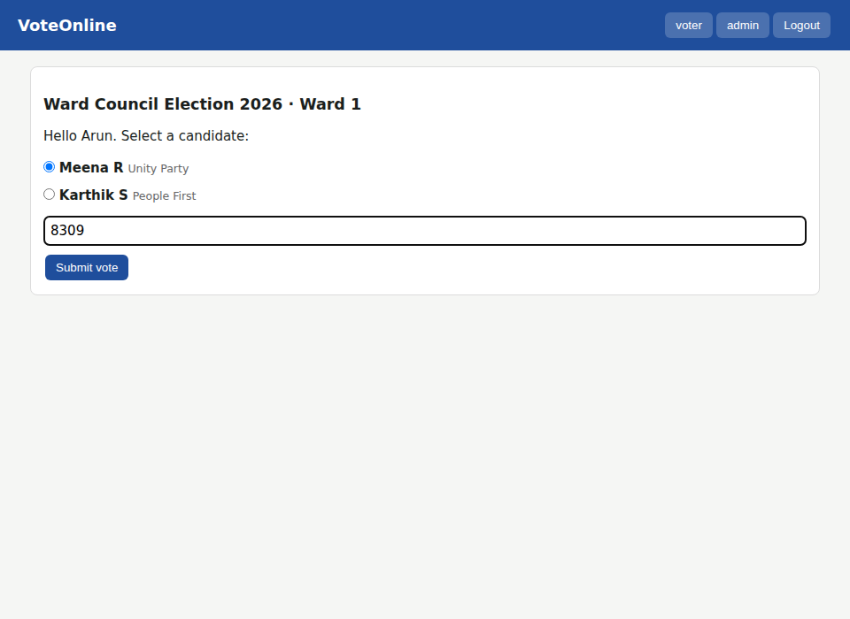
Figure 7: Voter – candidate selected, voting OTP entered
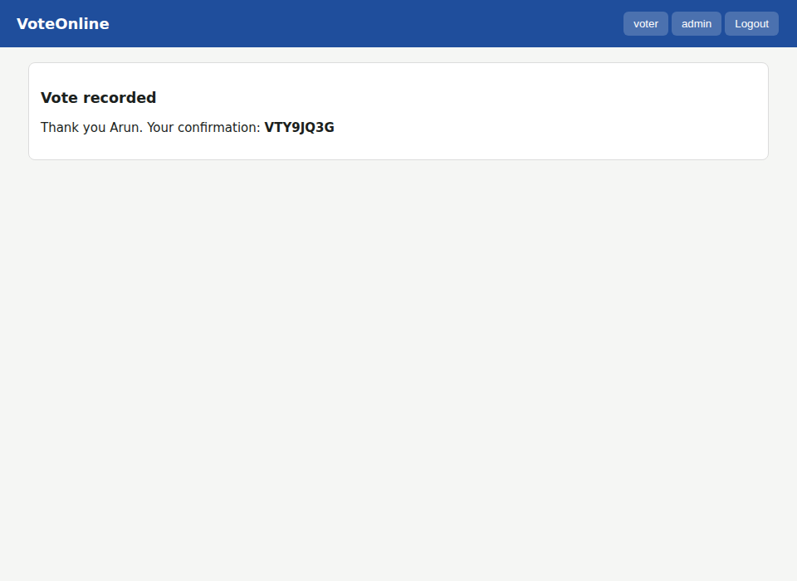
Figure 8: Vote submitted – confirmation reference
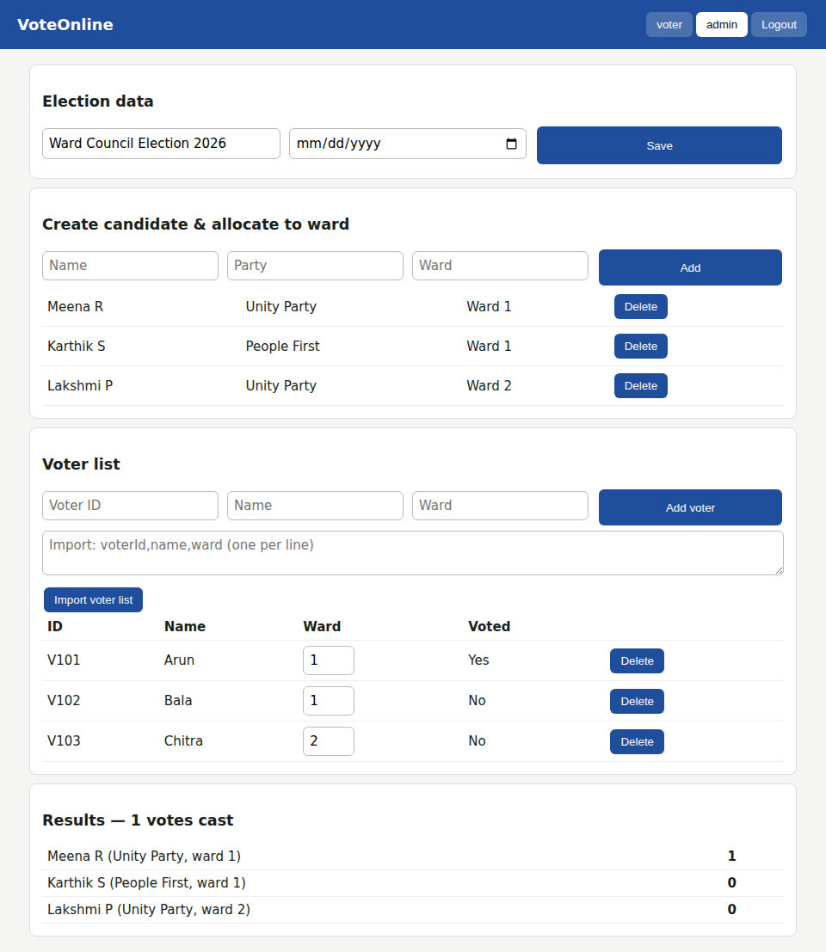
Figure 9: Admin – voter list status and election results

