INTERNET PROGRAMMING LAB

Experiment 18: AgriMart – Online Agricultural Marketplace
Aim: An online store for seeds, fertilizers, pesticides, equipment and tools. Farmers manage products, orders and shipping; customers search, add to cart, pay from a wallet and track orders.

Output screenshots
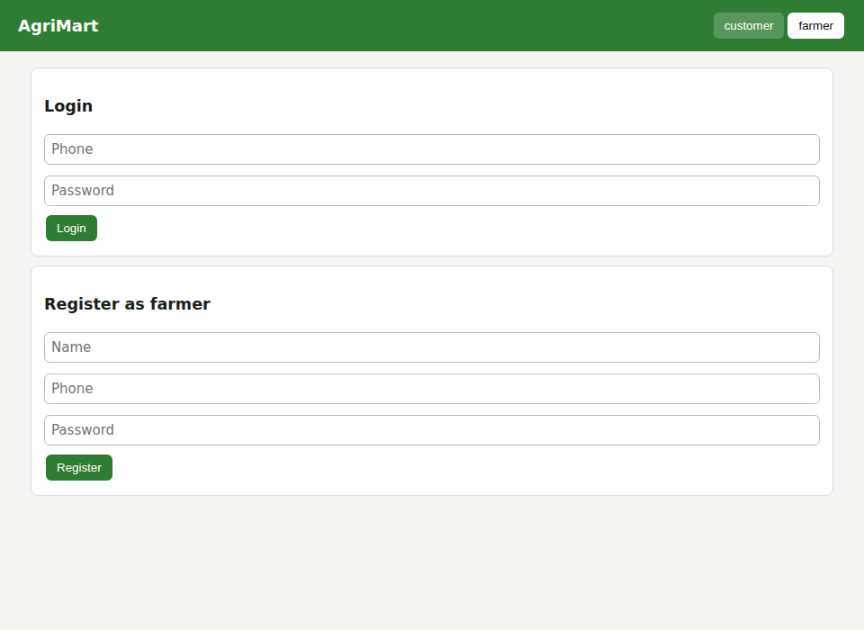
Figure 1: Farmer login and registration
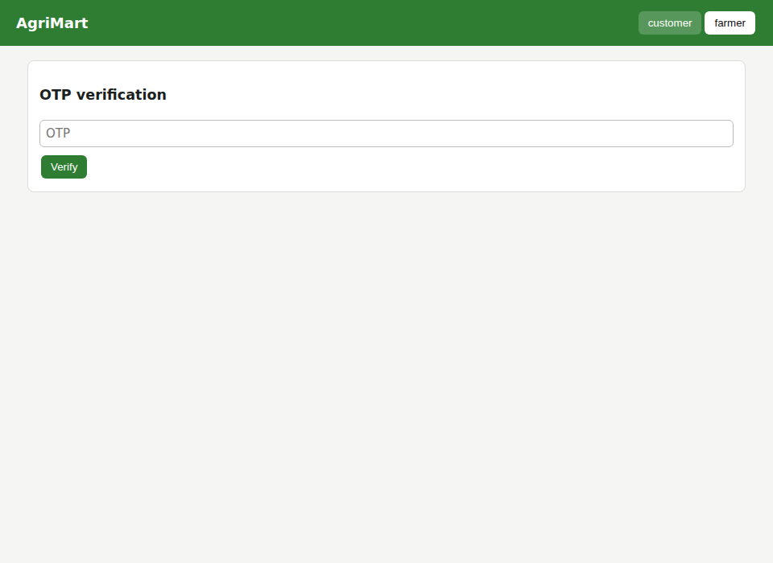
Figure 2: OTP verification (OTP: 4146)
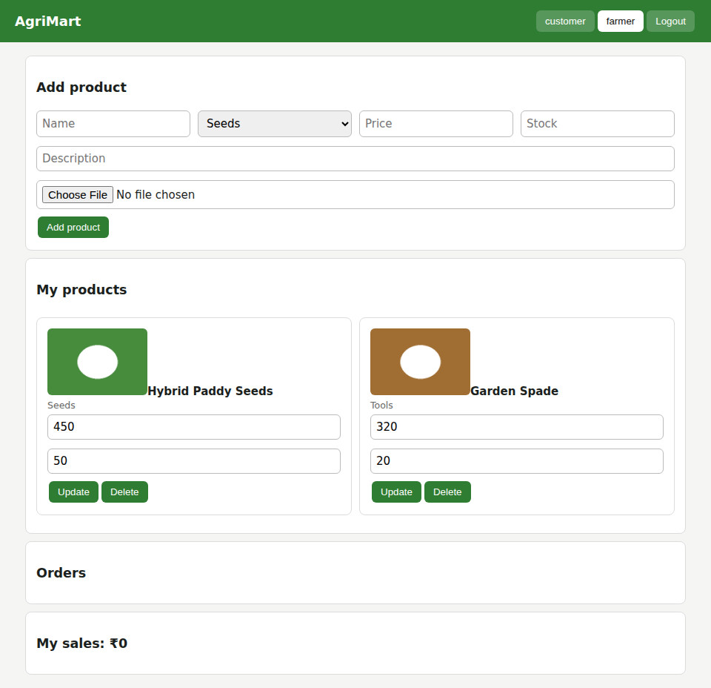
Figure 3: Farmer – add product with image upload, product list with update/delete
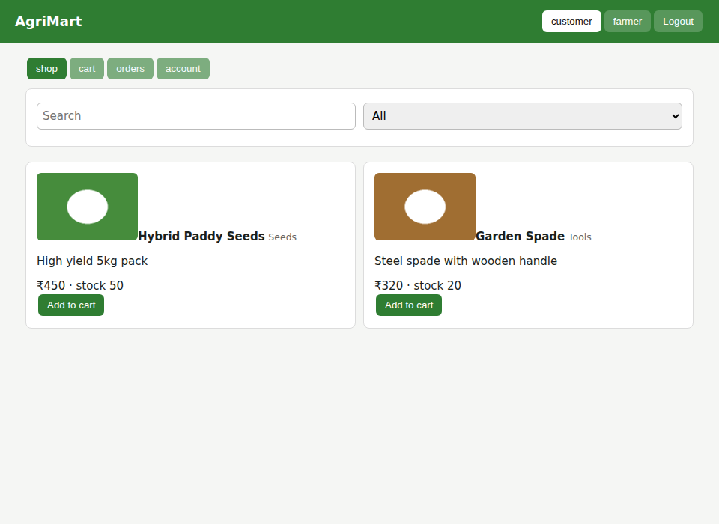
Figure 4: Customer – shop with search and category filter
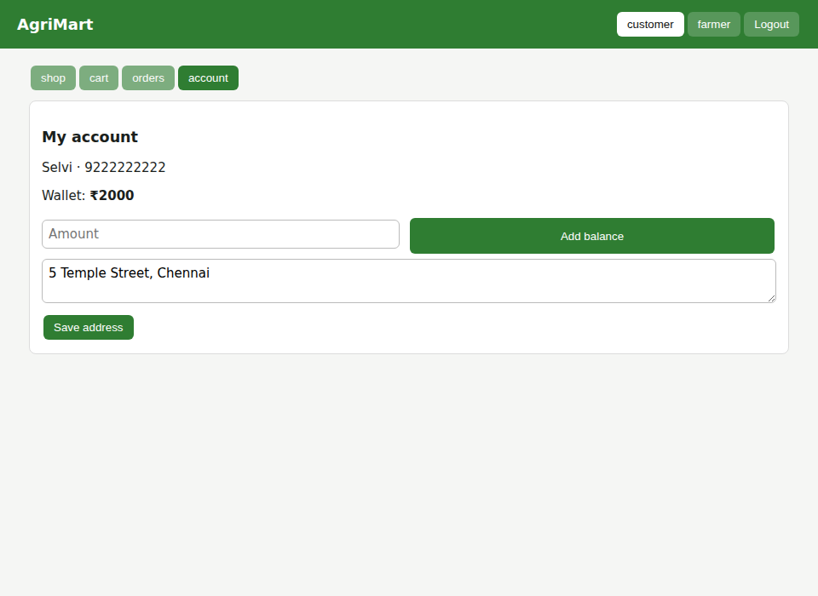
Figure 5: Customer – wallet balance and shipping address
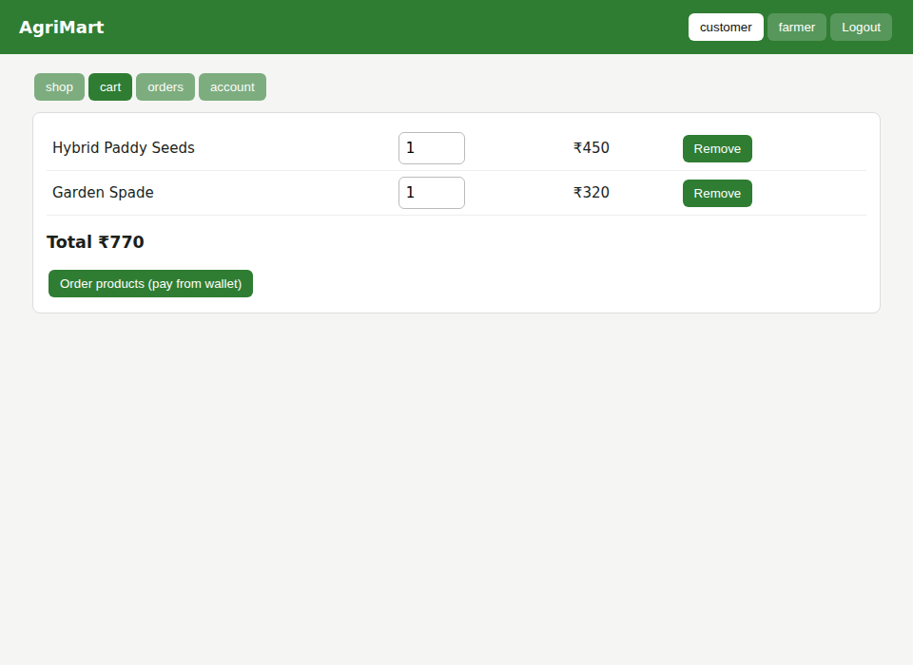
Figure 6: Customer – cart with edit quantity and remove
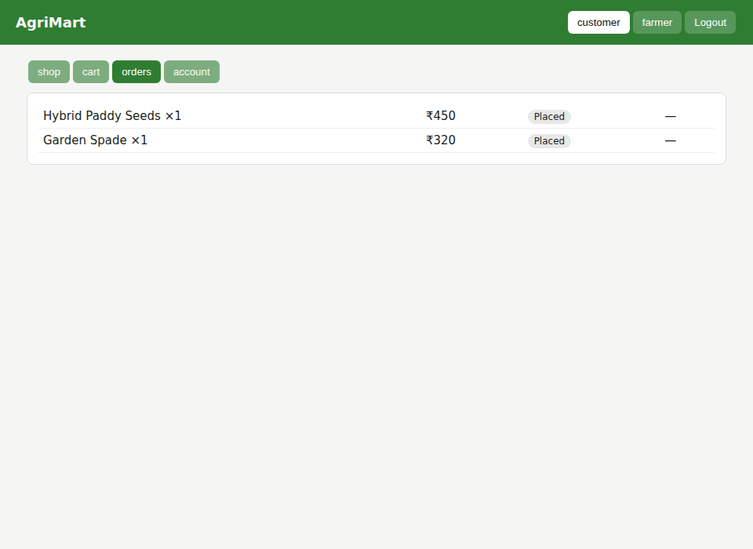
Figure 7: Customer – order placed, status shown
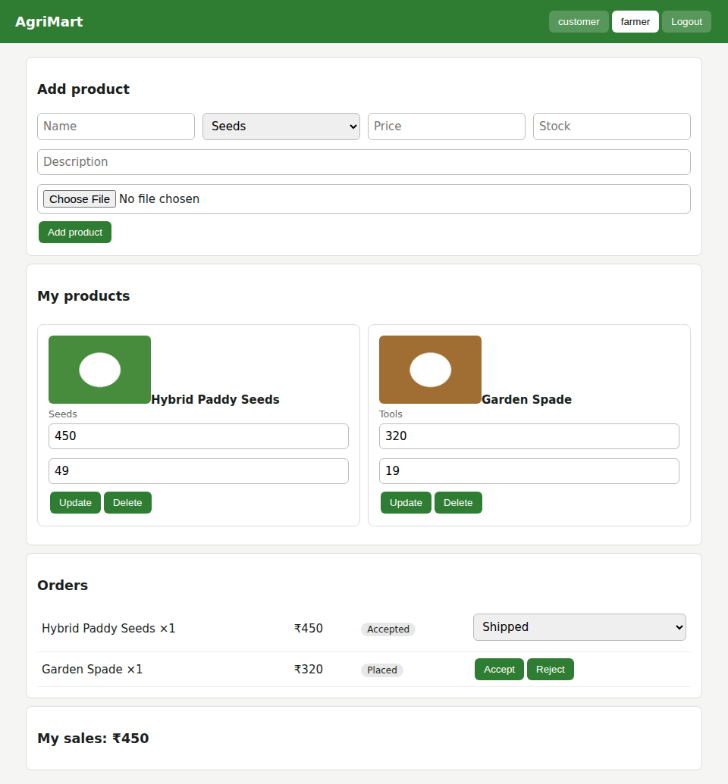
Figure 8: Farmer – manage orders, update shipping status, my sales

