INTERNET PROGRAMMING LAB

Experiment 19: VetCure – Livestock Disease Consultation
Aim: Farmers send animal symptoms (text, image, video or audio) to subscribed doctors, pay private clinic fees by bank transfer or Easypaisa, and receive solutions, cures, news and area-wise disease reports.

Output screenshots
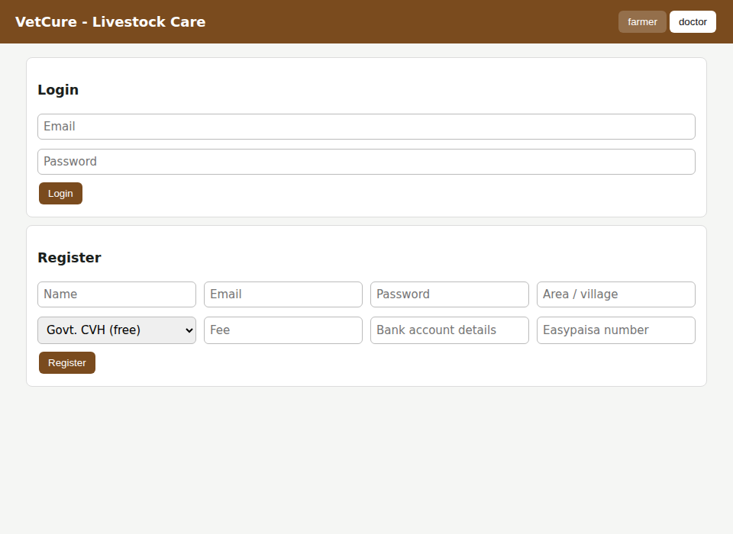
Figure 1: Registration and login page
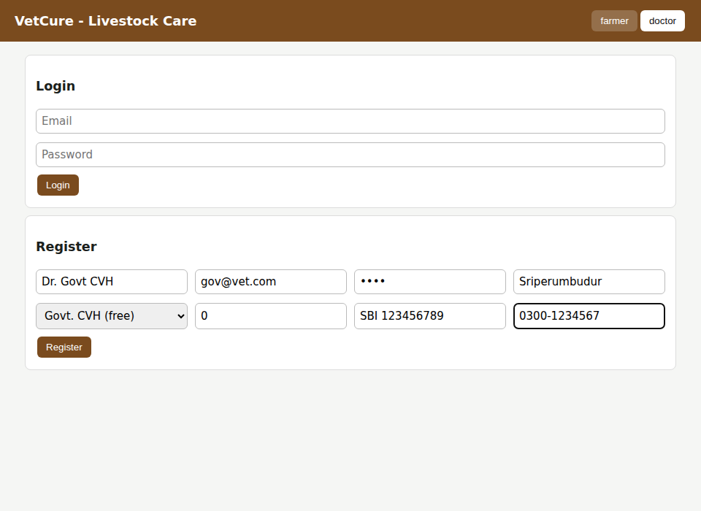
Figure 2: Doctor registration with bank and Easypaisa details
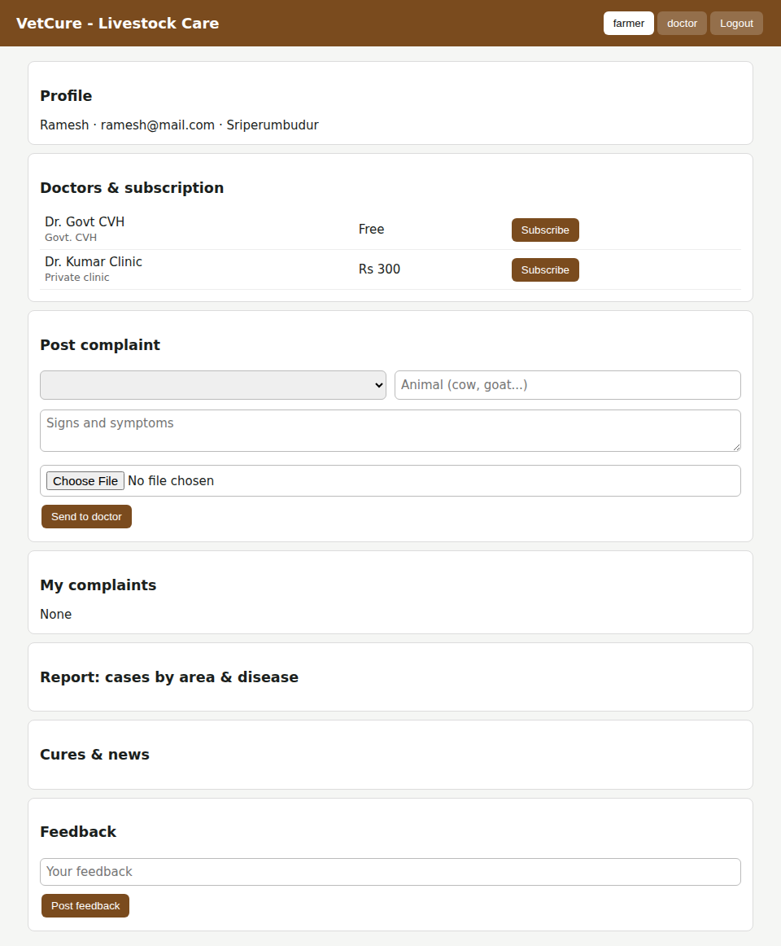
Figure 3: Farmer dashboard – profile and doctor list
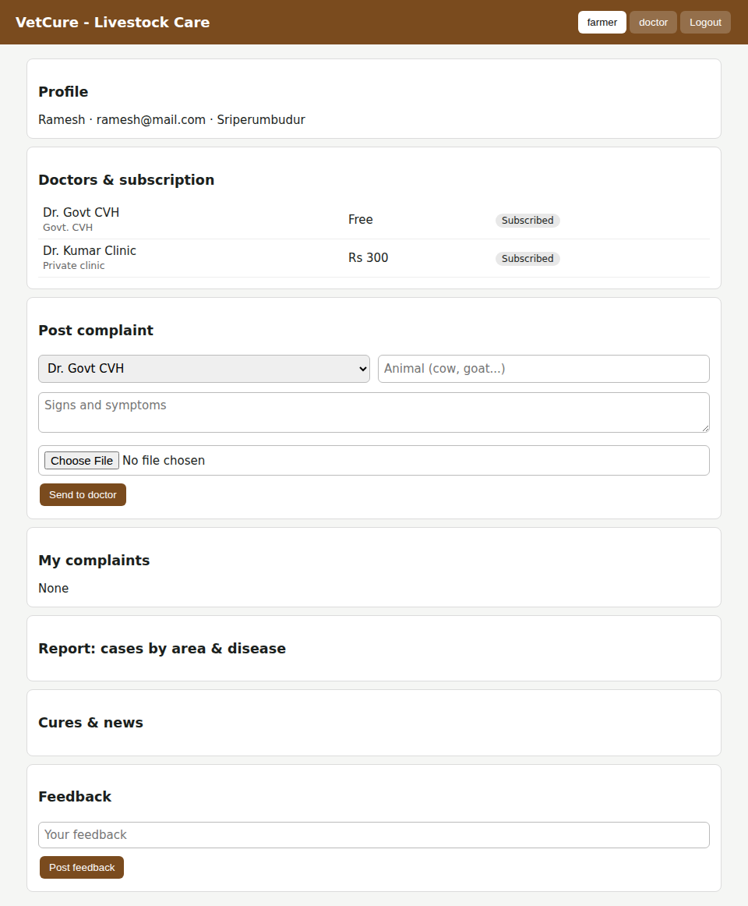
Figure 4: Subscribed to Govt CVH (free) and private doctor (Easypaisa payment)
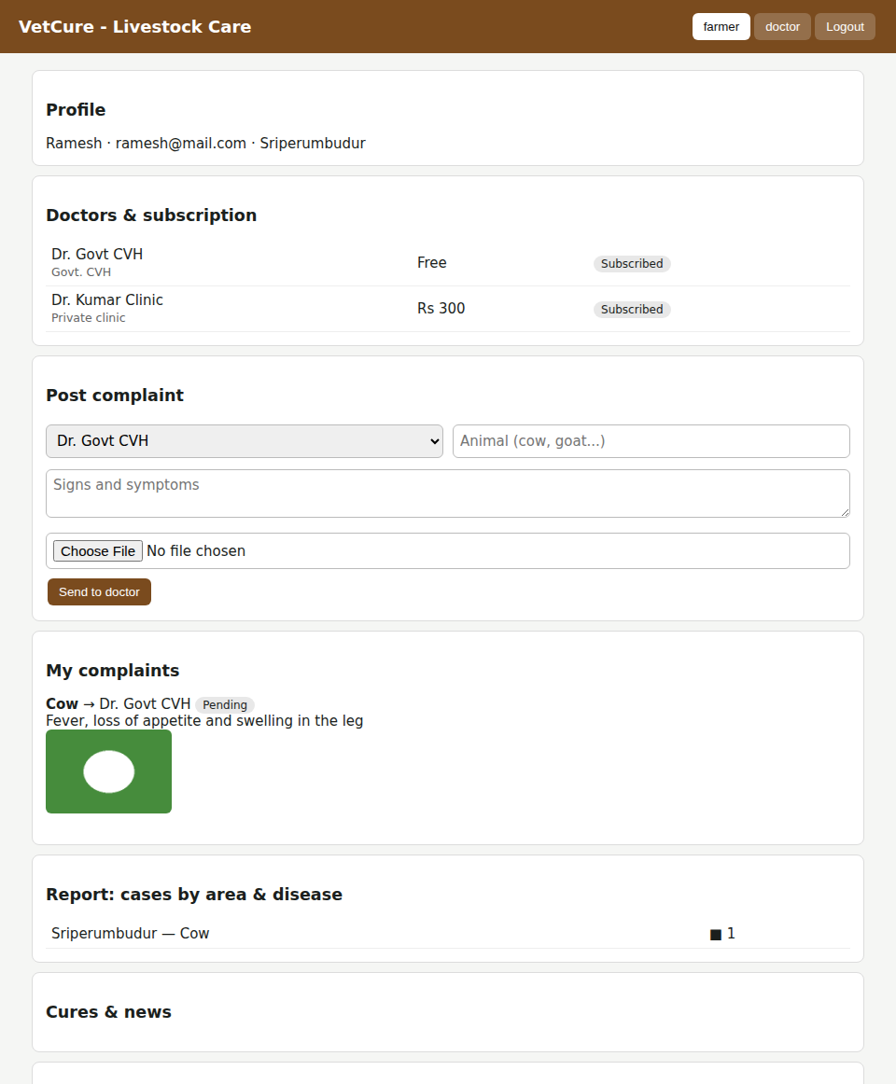
Figure 5: Farmer – complaint posted with image
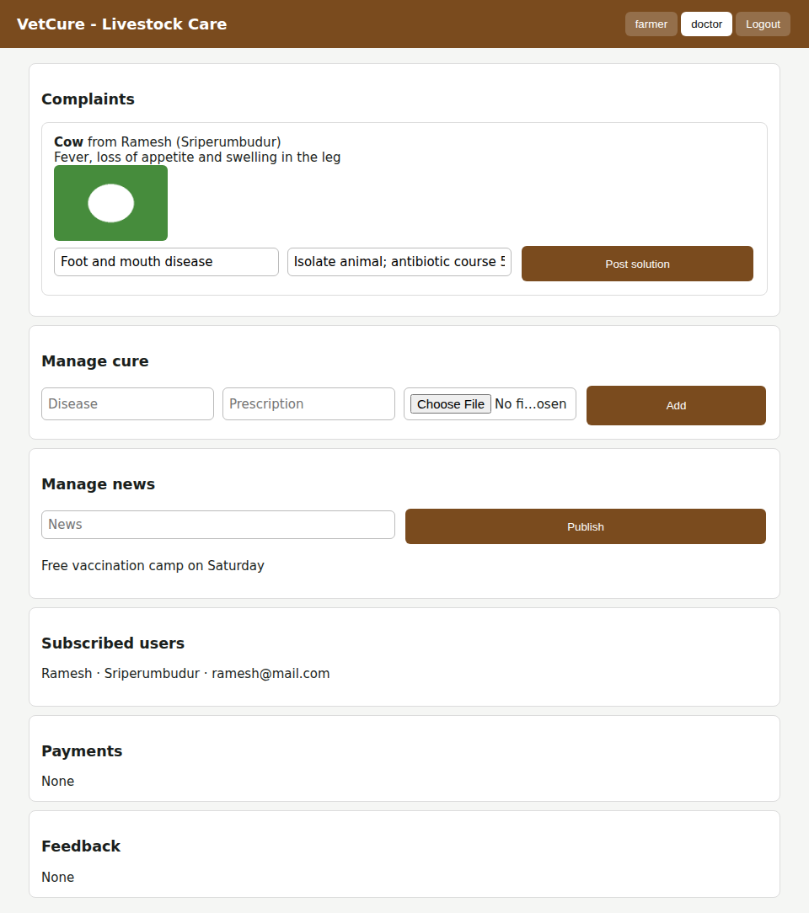
Figure 6: Doctor – view complaint, post solution, manage cure and news
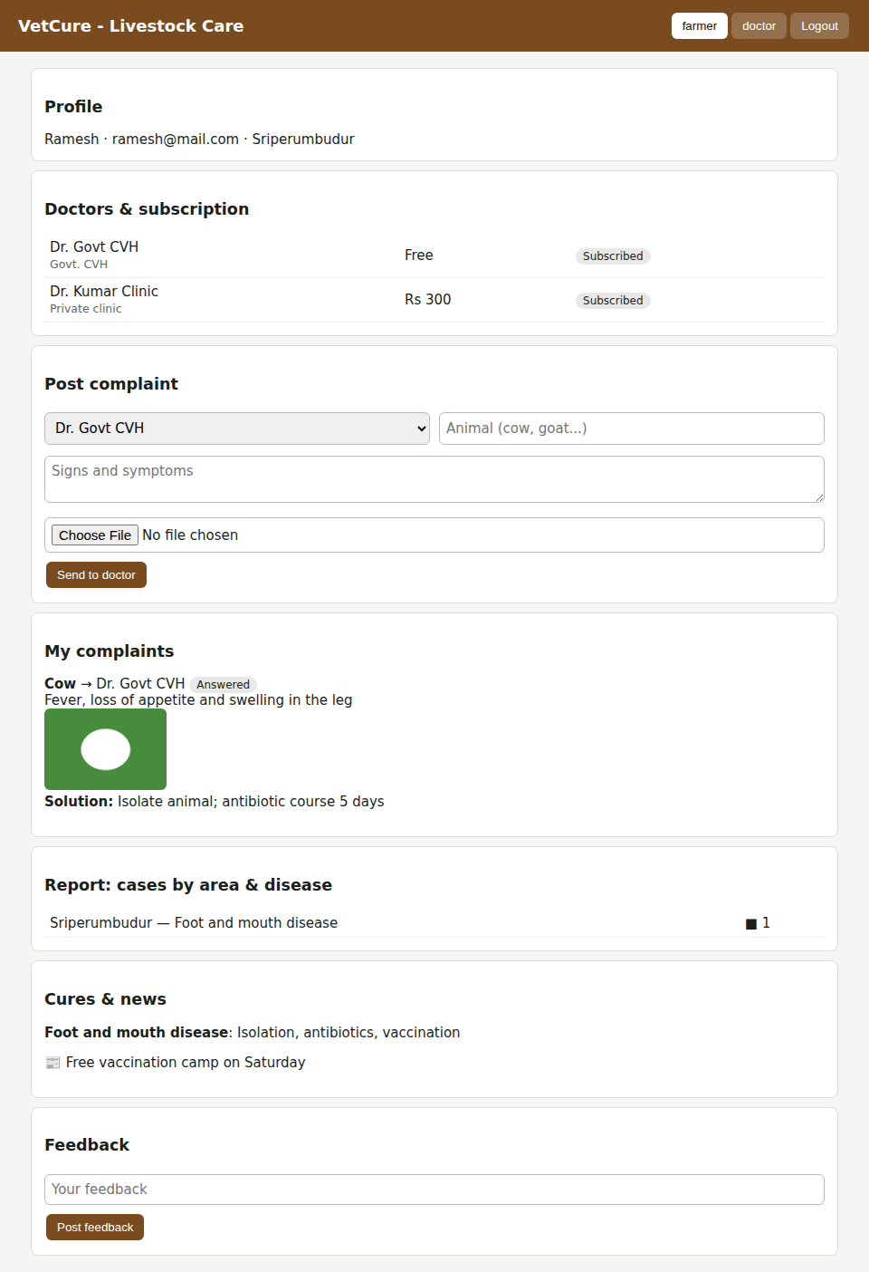
Figure 7: Farmer – solution received, area-wise disease report, cures and news

