INTERNET PROGRAMMING LAB

Experiment 20: RentRide – Online Vehicle Rental
Aim: A vehicle rental platform where users search by type, location and price, book vehicles and review rentals, and the admin manages vehicles and approves bookings.

Output screenshots
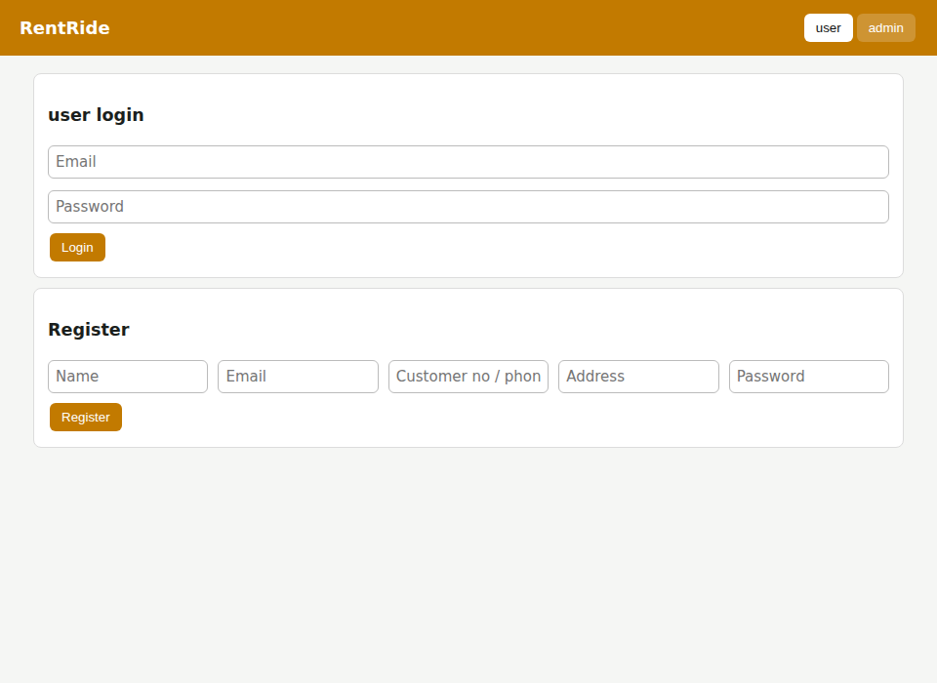
Figure 1: User login and registration
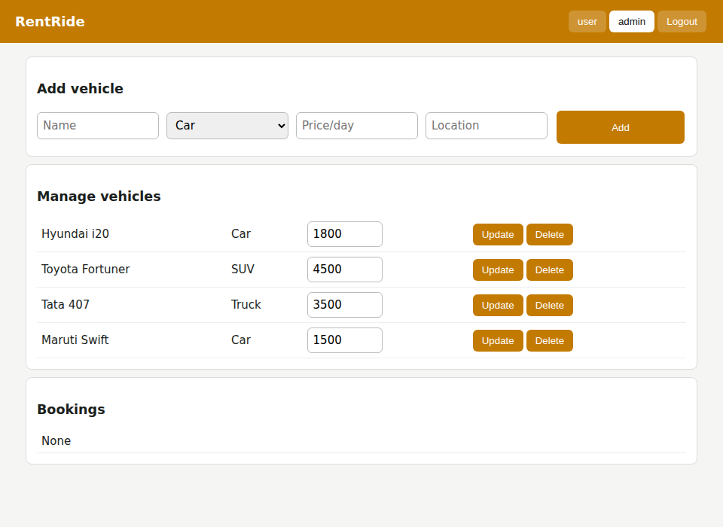
Figure 2: Admin – add vehicle and manage vehicle details
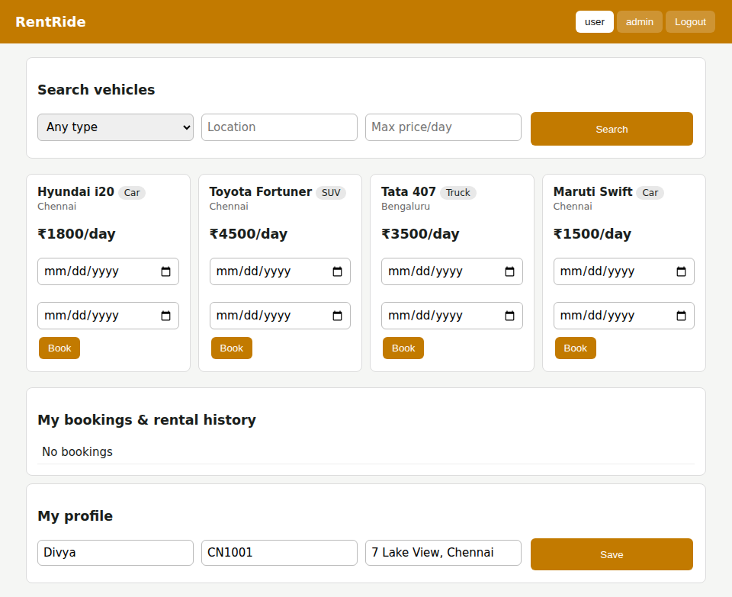
Figure 3: User dashboard – vehicle list
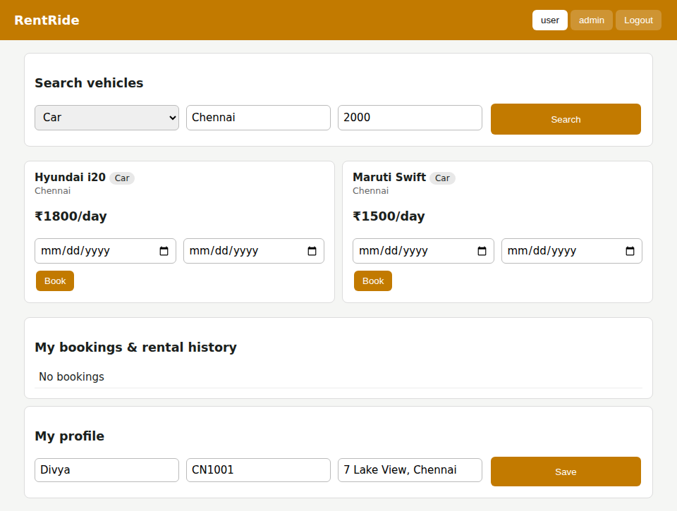
Figure 4: Search with filters: type Car, location Chennai, price up to 2000
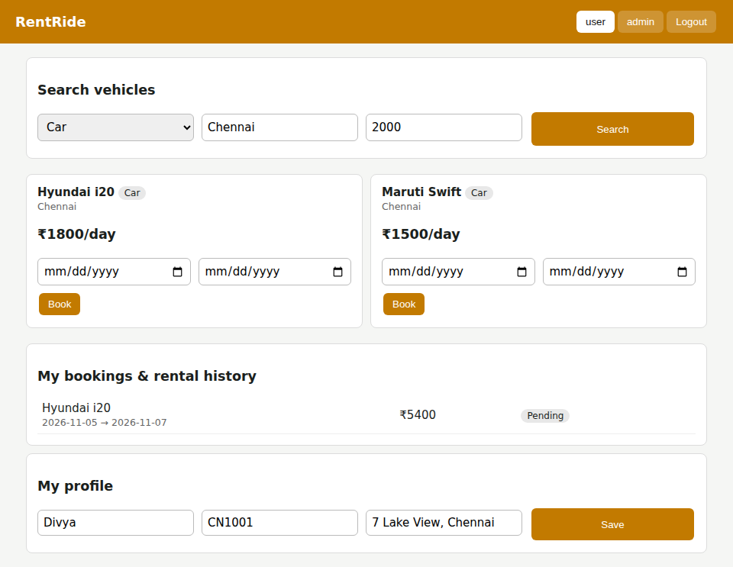
Figure 5: Booking made – status Pending
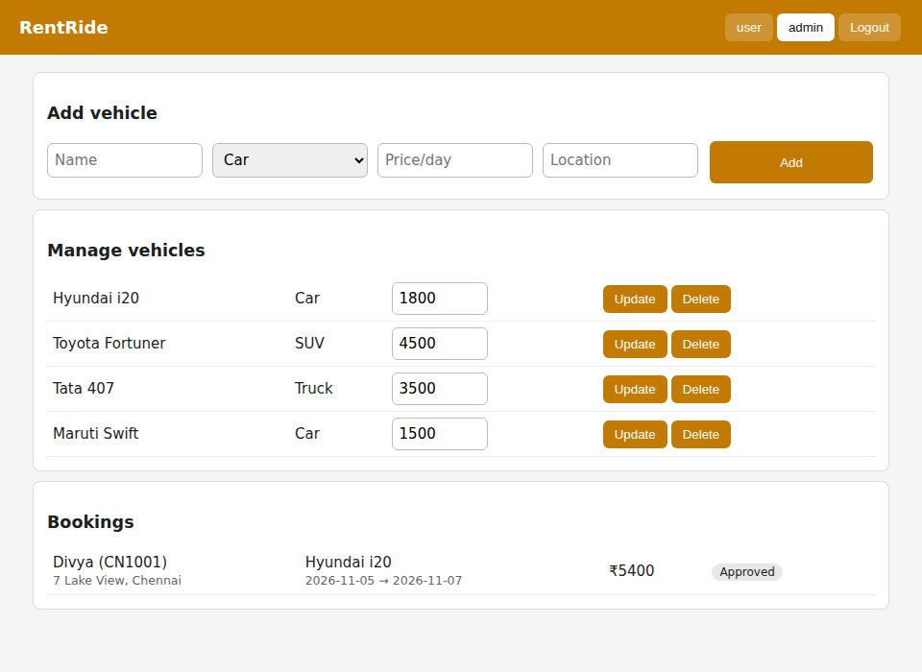
Figure 6: Admin – approve user booking
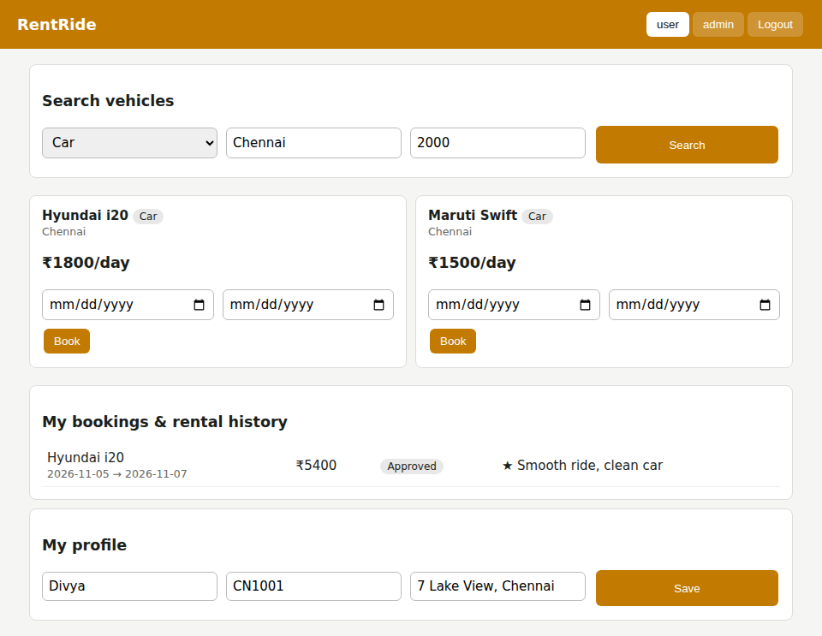
Figure 7: User – booking status Approved, review posted, profile

