“VISVESVARAYA TECHNOLOGICAL UNIVERSITY, BELAGAVI”


B.L.D.E.A's V.P. DR. P.G. HALAKATTI COLLEGE OF
ENGINEERINGAND TECHNOLOGY, VIJAYAPUR --
586103

DEPARTMENT OF COMPUTER SCIENCE
& ENGINEERING

Artificial Intelligence Assignment Project
Course Code : BCS515B

Name : Pavan Sabani Name : Sanjana Baragi
USN : 2BL22CS149 USN : 2BL22CS158

UNDER THE GUIDANCE HOD
Mrs.D.M.Ijeri Dr . LEENA RAGHA

ACKNOWLEDGEMENT

An activity work of immense Sheer Size and it cannot be proficient by an individual all by them ultimately, I am gratifying to a number of individuals whose qualified guidance and assistance and encouragement have made it a pleasant venture to undertake this activity work. I am grateful to my Institution V.P.DR. P.G. HALAKATTI COLLEGE OF ENGINEERING AND TECHNOLOGY with its ideals and inspiration for having provided us with the facilities, which has made this activity work a success.
It is my pleasure to tender my heartfelt thanks to our College Trustees for their vision behind, towards the successful completion of our activity. I would like to express my gratitude to Dr.V.G.Sangam, Principal BLDEACET, who is the source of inspiration as well providing an amiable atmosphere to work in.
Further, I would like to express my kind gratitude towards Leena Ragha, HOD, Dept. Of CSE and the whole department for providing us kindly environment for the successful completion of the activity work. I also extend my sincere thanks to my activity work coordinator Mrs.D.M.Ijeri for the timely suggestions and cooperation throughout my dissertation.
It's my duty to thank one and all faculties of CSE Department, who have directly or indirectly supported to accomplish the activity work successfully. I would also like to thank my friends, who really helped us to complete this activity work successfully.
INDEX

Sl.no | Title | Page No
1 | Introduction | 04
2 | Dataset | 05
3 | Objectives | 06
4 | Logistic Regression | 06
5 | AI Model Selection | 07
6 | Standard Libraries | 07
7 | Architecture of Model | 08
8 | Statistical Overview | 09
9 | Implementation & Accuracy | 10
10 | Output of the Model | 11
11 | Conclusion | 12

INTRODUCTION

Diabetes is a chronic metabolic disorder characterized by elevated blood sugar levels due to insufficient insulin production, improper insulin utilization, or both. According to the World Health Organization (WHO), diabetes affects millions globally, posing a significant public health challenge. If left undiagnosed or poorly managed, it can lead to severe complications, including cardiovascular diseases, kidney failure, nerve damage, and vision loss.
Current situation of diabetes detection :
- The current state of diabetes detection has significantly advanced, yet challenges remain.

- Traditional methods of diabetes diagnosis include measuring fasting blood glucose levels, oral glucose tolerance tests (OGTT), and HbA1c tests, which provide reliable metrics for assessing blood sugar control over time.

- While these methods are accurate, they often require clinical visits, are invasive, and may not be easily accessible in low-resource settings.

- As a result, many cases, especially in developing regions, remain undiagnosed until complications arise.

- Despite these advancements, global disparities in healthcare access and affordability persist.

- Rural and underserved populations face barriers to regular screening and care.

- Efforts are underway to bridge these gaps through mobile health applications, telemedicine, and point-of-care diagnostics, making diabetes detection more accessible.

- However, raising awareness about diabetes and promoting routine screenings remain critical to reducing the global burden of undiagnosed cases

DATASET : PIMA INDIA
This dataset is originally from the National Institute of Diabetes and Digestive and Kidney Diseases. The objective of the dataset is to diagnostically predict whether or not a patient has diabetes, based on certain diagnostic measurements included in the dataset. Several constraints were placed on the selection of these instances from a larger database. In particular, all patients here are females at least 21 years old of Pima Indian heritage. The size of the dataset is relatively small by modern standards, which could lead to overfitting in complex models.

Features :
- Pregnancies: Number of pregnancies.
- Glucose: Plasma glucose concentration over 2 hours.
- BloodPressure: Diastolic blood pressure (mm Hg).
- SkinThickness: Triceps skinfold thickness (mm).
- Insulin: 2-hour serum insulin (mu U/ml).
- BMI: Body Mass Index (weight in kg/(height in m)^2).
- DiabetesPedigreeFunction: A function that scores the likelihood of diabetes based on family history.
- Age: Age in years.
- Outcome: Target variable (1 if the patient has diabetes, 0 otherwise).
- The target variable is binary:
- 1: Indicates the presence of diabetes.
- 0: Indicates the absence of diabetes.

Characteristics:
- Contains 768 entries.
- Some features have missing values represented as zeroes, which are handled by replacing them with the column mean in this project.

Applications :
The Pima Indian Diabetes Dataset serves as a benchmark in:
- Machine Learning: Used to test classification algorithms such as logistic regression, decision trees, support vector machines, and neural networks.
- Feature Engineering: Provides a platform to explore data preprocessing, handling missing values, and feature scaling.
- AI in Healthcare: Helps researchers develop predictive models for diabetes risk assessment.
OBJECTIVES
Statement :
The primary aim of this project is to predict the likelihood of diabetes in individuals by analyzing various health metrics and characteristics. These metrics include glucose levels, blood pressure, body mass index (BMI), insulin levels, and, for females, the number of pregnancies. By developing a predictive machine learning model, the project seeks to facilitate the early detection of diabetes risk, empowering individuals and healthcare providers to take timely preventive or management measures.
Clarity of Problem Statement
- The project defines a clear goal: to predict diabetes risk using a machine learning model.
- The focus is on health data-driven predictions, where input features like glucose levels, BMI, and blood pressure are used to evaluate the likelihood of diabetes.

ALGORITHM : Logistic Regression
Logistic regression is a widely used supervised learning algorithm in machine learning, especially for binary classification problems like diabetes detection. It predicts the probability of an outcome (e.g., presence or absence of diabetes) based on input features and is highly interpretable, making it a popular choice in healthcare applications.
Steps in Using Logistic Regression for Diabetes Detection:
- Data Preprocessing:
  - Handle missing or anomalous values in the dataset.
  - Normalize features to ensure faster convergence.
- Model Training:
  - Fit the logistic regression model to the training data.
- Evaluation:
  - Use metrics like accuracy, precision, recall, F1-score, and AUC-ROC to evaluate the model.
- Prediction:
  - Input unseen data into the trained model to predict diabetes risk.

AI MODEL SELECTION

- Appropriate Choice of Model :
The project employs Logistic Regression, a suitable and well-understood method for binary classification tasks like diabetes prediction. Logistic regression is a popular model choice because of its interpretability and efficiency, especially with well-preprocessed datasets.

- Justification of Model Selection :
Logistic Regression is appropriate for this problem due to the binary nature of the outcome (diabetes: yes/no) and the relatively straightforward relationship between the predictors and the target variable. It provides a baseline model, making it easier to interpret and analyze before moving to more complex models if needed.

- Comparison with Alternatives :
While logistic regression is chosen for its simplicity, alternative models like Decision Trees, Random Forest, or Support Vector Machines could have been considered for potentially better performance. However, these models might require more computational resources and fine-tuning. The project could expand on these comparisons for a comprehensive analysis.

STANDARD LIBRARIES
- NumPy (import numpy as np):
  - Used for numerical computations and handling arrays, including replacing zeros with NaN values.

- Pandas (import pandas as pd):
  - Used for data manipulation and analysis, particularly for loading, summarizing, and cleaning the dataset.

- Scikit-learn:
  - train_test_split: Splits the dataset into training and testing subsets.
  - StandardScaler: Standardizes features by removing the mean and scaling to unit variance.
  - LogisticRegression: Implements logistic regression for classification.
  - accuracy_score: Computes the classification accuracy.
  - confusion_matrix: Evaluates the performance using a confusion matrix.
  - classification_report: Provides a detailed classification report with precision, recall, and F1 score.
ARCHITECTURE OF MODEL

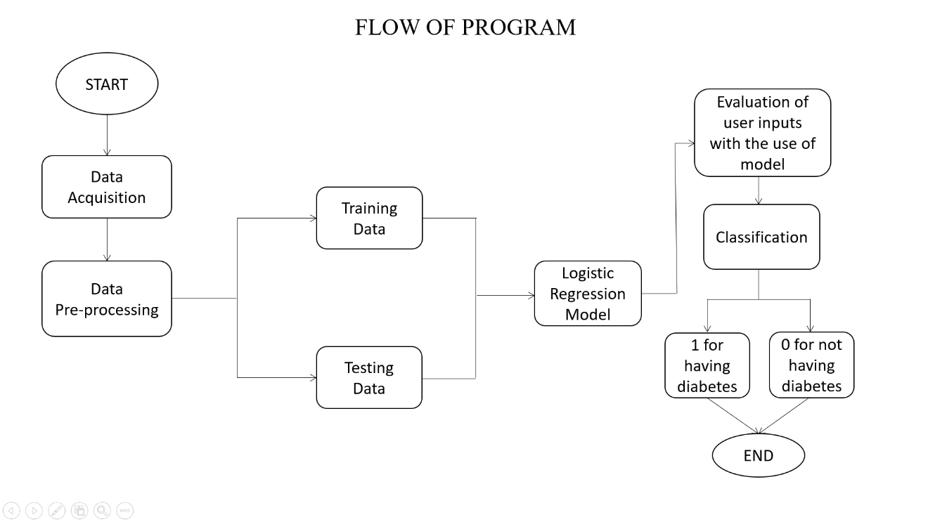
Fig 7.1 Flow chart of the Model

The provided figure 7.1 flowchart outlines the process of a machine learning program designed for diabetes prediction. It begins with the Start node, leading to the Data Acquisition step, where the dataset is collected. This is followed by Data Pre-processing, where the dataset undergoes cleaning and preparation, such as handling missing values or scaling the features. The data is then split into two subsets: Training Data and Testing Data. The Training Data is used to train the Logistic Regression Model, which forms the foundation of the prediction process. After training, the model is evaluated using Testing Data to ensure accuracy and reliability.

The model is then used to process User Inputs, which are evaluated using the trained logistic regression model. This produces an Output that predicts whether the user has a risk of diabetes. The result is binary: 1 for having diabetes or 0 for not having diabetes, ultimately concluding with the End node. This flowchart clearly visualizes the logical steps of data handling, model training, and prediction output in the machine learning pipeline.

STATISTICAL OVERVIEW

When the program is executed , it provides the following information on the model.
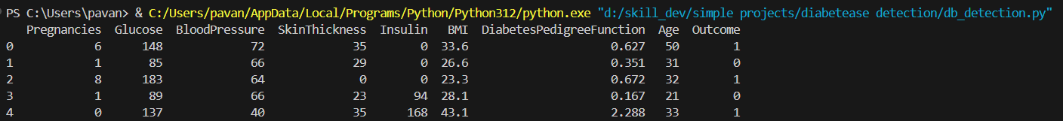
Fig 8.1 : Health data
Fig 8.1 showcases the initial rows of the dataset used for training and evaluating a diabetes prediction model. Each row represents a data instance containing multiple features that are critical for diagnosing diabetes. The last column, Outcome, represents the target variable, where 1 indicates diabetes presence and 0 indicates its absence.

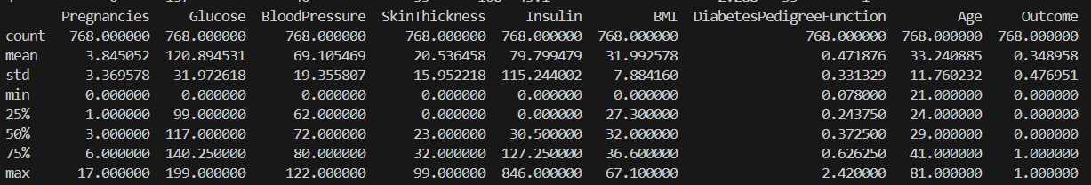
Fig 8.2 : Statistical Summary of the Diabetes Dataset

Fig 8.2 presents the statistical summary of the dataset used for training and evaluating a diabetes prediction model. Each column represents a feature, and the rows show various statistical measures for these features. The total number of records are 768. The average(mean) value for each feature of Glucose, BMI etc. The range of values for each feature i.e minimum and maximum values. Quartiles (25%, 50%, 75%) these indicate the data distribution(for example : 25% of values fall below the first quartile (e.g., Glucose = 99)).
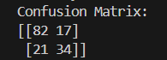
Fig 8.3 displays the performance evaluation. The confusion matrix provides the counts of correctly and incorrectly classified instances for the two classes. 82: True Negatives, 17: False Positives, 21: False Negatives, 34: True Positives
Fig 8.3 : Model Evaluation
IMPLEMENTATION & ACCURACY
Implementation:
1. Data Preparation:
- Handling Missing Values: Replaced zeros in certain columns (Glucose, BloodPressure, SkinThickness, Insulin, and BMI) with NaN and then filled these missing values with the column mean using df.fillna(df.mean(), inplace=True).
- Feature-Target Split: Features (X) were separated from the target variable (Outcome).
- Train-Test Split: The dataset was divided into training (80%) and testing (20%) subsets using train_test_split.
2. Feature Standardization:
- Used StandardScaler to standardize the features, ensuring that each feature had a mean of 0 and a standard deviation of 1. This step is crucial for models like Logistic Regression, which perform better with standardized data.
3. Model Training:
- Implemented a Logistic Regression model from sklearn.linear_model.
- The model was trained on the standardized training dataset using the fit method.
4. Model Prediction:
- Predictions were made on the testing dataset using the predict method.
- Additionally, user input data was scaled and predicted using the same model.
5. Performance Metrics:
- Confusion Matrix: Used to analyze the number of true positives, true negatives, false positives, and false negatives.

Accuracy:
- Score : 75.32%

- Computed using accuracy_score, which calculates the percentage of correctly classified instances.

OUTPUTS OF THE MODEL
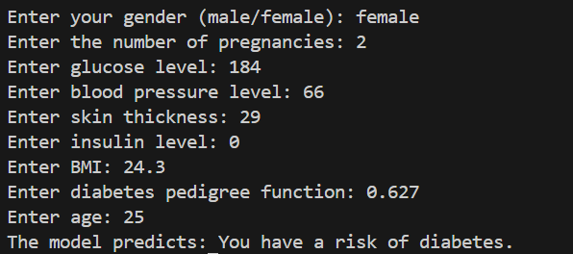
Fig 11.1 shows the output for a diabetes detection of female patient. It takes some health-data as input required to test diabetes of patient and based on the provided input values, the model predicts that the patient do have risk of diabetes.
Fig 11.1: Sample output of female patient
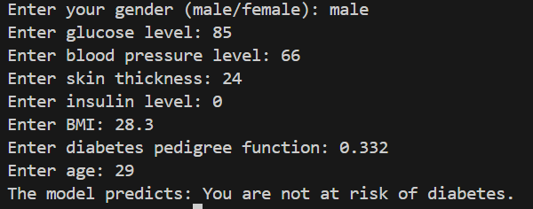
Fig 11.2 shows the output of male patient. Based on the input values, he is not at immediate risk of diabetes. This likely means the glucose level, insulin level, and other indicators are within a range that does not strongly suggest the presence of diabetes.
Fig 11.2: Sample output of male patient
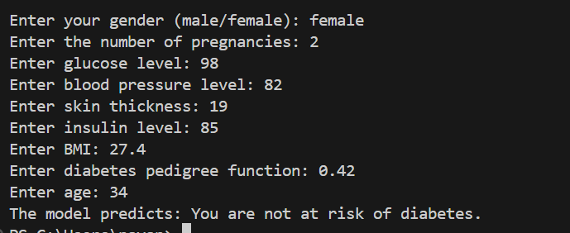
Fig 11.3 shows the output of female patient. This figure demonstrates that model evaluates multiple health metrics to assess the risk of diabetes and predicts that she is not having the risk of diabetes.

Fig 11.3: Sample output of female patient
CONCLUSION

This project serves as a meaningful step toward integrating AI intohealthcare diagnostics. It demonstrates the potential of machine learning to empower both patients and healthcare providers with tools for early disease detection, ultimately contributing to better health outcomes and reduced healthcare costs.

Moreover, this project emphasizes the critical role AI can play in transforming traditional healthcare practices. By providing data-driven insights, machine learning models like the one implemented here bridge the gap between raw clinical data and actionable predictions. This empowers healthcare providers to make informed decisions with greater accuracy and efficiency.

For patients, such tools mean quicker access to assessments and potentially earlier interventions. In regions with limited healthcare resources, AI-driven diagnostics can help democratize access to quality healthcare, addressing disparities and improving equity. Automated systems reduce the dependency on specialized personnel, making diagnostic services more scalable and cost-effective.

