AuthentiText
A Data Analytics Approach to Detecting AI-Generated Essays
Project Report

Domain: Data Analytics (Text Analytics, NLP & Predictive Modeling)
Dataset: Training_Essay_Data.csv (29,145 labeled essays)
from Kaggle (kaggle.com/datasets/sunilthite/llm-detect-ai-generated-text-dataset)
September 2026

Prepared By: Sanjana Paul
Internship ID: IBMUEDA5282
Bachelor of Computer Applications
NSHM College of Management & Technology
September 2026

Contents
1. Introduction 3
2. Problem Statement & Objectives 3
2.1 Problem Statement 3
2.2 Objectives 3
3. Dataset Description 3
4. Methodology 4
5. Exploratory Data Analysis 4
5.1 Class Distribution 4
5.2 Text Length Analysis 5
5.3 Stylometric Features 5
5.4 Word Cloud Analysis 6
6. Feature Engineering 6
6.1 Configuration 6
7. Model Building 7
8. Results & Evaluation 7
8.1 Model Comparison 7
8.2 Best Model: Linear SVM 7
8.3 Cross-Validation 8
8.4 Feature Interpretability 8
9. Streamlit Application 8
9.1 Single Essay Check 9
9.2 Batch Check (CSV) 9
9.3 About the Project 9
10. Conclusion & Future Work 9
10.1 Conclusion 9
10.2 Limitations 9
10.3 Future Work 9
11. References & Tech Stack 9
11.1 Tech Stack 10
11.2 Dataset Source 10

1. Introduction
The rapid advancement and widespread accessibility of Large Language Models (LLMs) such as ChatGPT, Claude, and Gemini have made it increasingly easy to generate fluent, human-like text on virtually any topic. While this has created enormous productivity benefits, it has also introduced significant challenges around academic integrity, misinformation, content authenticity, and trust in written communication.
This project, AuthentiText, approaches the problem of distinguishing human-written essays from AI-generated essays as a data analytics case study built on unstructured text data. The workflow follows a standard analytics lifecycle — data collection and cleaning, exploratory data analysis (EDA) to uncover measurable differences between the two groups, feature engineering to convert text into quantitative variables, and predictive modeling to test whether those variables can reliably classify new essays. The resulting model is then delivered through an interactive Streamlit dashboard so the analysis and its conclusions can be explored by a non-technical user.
In short, this is a text/NLP analytics project: descriptive analytics (EDA) is used to understand the data, and predictive analytics (machine learning classification) is used to act on it — both core techniques within the broader field of data analytics.

2. Problem Statement & Objectives

2.1 Problem Statement
Given a piece of essay text, analyze its measurable characteristics (length, vocabulary, structure) to determine whether it was written by a human or generated by an AI language model. This is addressed using a combination of exploratory data analysis and supervised predictive modeling — a binary text classification problem.

2.2 Objectives
- Perform exploratory data analysis (EDA) to uncover measurable structural and stylistic differences between human and AI-generated essays (word count, sentence length, vocabulary patterns).
- Clean and preprocess raw essay text to prepare it for quantitative analysis.
- Engineer numerical text features (TF-IDF) that summarize each essay's content for analysis and modeling.
- Apply predictive analytics techniques — training and comparing multiple classification models — to test whether these features can distinguish the two classes.
- Evaluate model performance using standard analytics metrics (accuracy, precision, recall, F1-score, ROC-AUC) and select the best-performing approach.
- Present the findings through an interactive Streamlit dashboard for real-time and batch analysis, making the results accessible without needing to read code.

3. Dataset Description
The dataset used for this project is Training_Essay_Data.csv, containing 29,145 essays with a binary label indicating authorship.

Attribute | Details
File name | Training_Essay_Data.csv
Total rows | 29,145 essays
Columns | text (essay content), generated (label)
Label meaning | 0 = Human-written, 1 = AI-generated
Class distribution | Human: 17,508 (60.1%) | AI-generated: 11,637 (39.9%)
Missing values | None
Duplicate rows | 1,805 (retained; duplicates are legitimate repeated essay submissions)
Avg. word count (Human) | ~430 words
Avg. word count (AI-generated) | ~312 words

The dataset is moderately imbalanced (60% human vs. 40% AI-generated), which was addressed using stratified train-test splitting to preserve class proportions in both training and test sets.

4. Methodology
The project follows a standard data analytics workflow — moving from raw data to descriptive insights (EDA) and then to predictive insights (classification modeling) — applied to unstructured text data:
- Data Loading & Inspection — load the CSV, check shape, types, missing values, and duplicates.
- Exploratory Data Analysis (EDA) — descriptive analytics on class balance, text length distributions, and vocabulary patterns.
- Text Preprocessing — lowercase conversion, URL/number/punctuation removal, whitespace normalization.
- Feature Engineering — converting text into numerical variables using TF-IDF vectorization (unigrams + bigrams, 15,000 features).
- Train-Test Split — 80/20 stratified split for unbiased performance analysis.
- Predictive Modeling — Logistic Regression, Multinomial Naive Bayes, Linear SVM, Random Forest.
- Evaluation — accuracy, precision, recall, F1-score, ROC-AUC, confusion matrix, 5-fold cross-validation.
- Model Selection & Persistence — best model (by F1-score) saved with joblib.
- Reporting & Deployment — Streamlit dashboard for interactive, real-time and batch analysis of results.

5. Exploratory Data Analysis

5.1 Class Distribution
The dataset contains 17,508 human-written essays (60.1%) and 11,637 AI-generated essays (39.9%).
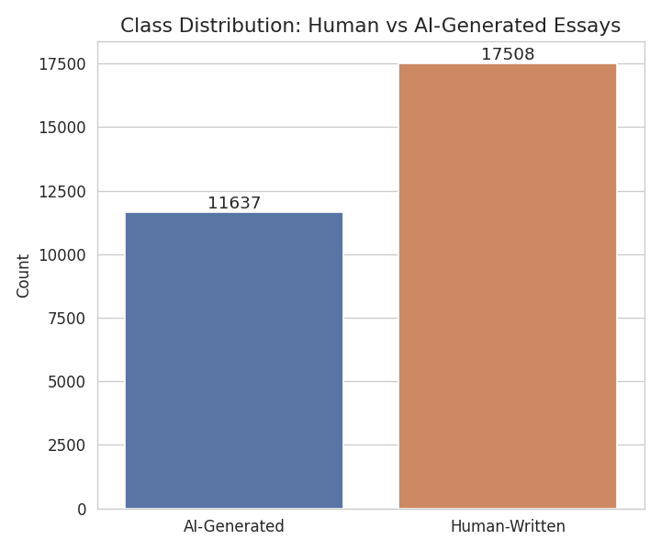
Figure 1: Class distribution of human vs. AI-generated essays.

5.2 Text Length Analysis
Human-written essays tend to be noticeably longer on average (~430 words) than AI-generated essays (~312 words) in this dataset, and show greater variance in length. This is a meaningful distinguishing signal captured implicitly through TF-IDF features and document length.
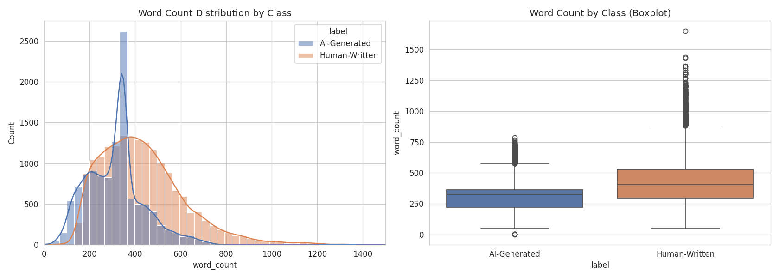
Figure 2: Word count distribution and boxplot comparison by class.

5.3 Stylometric Features
Average word length and sentence count were also examined. AI-generated essays show more consistent (less variable) sentence structuring, consistent with the more uniform generation patterns of language models compared to the natural variability of human writing.
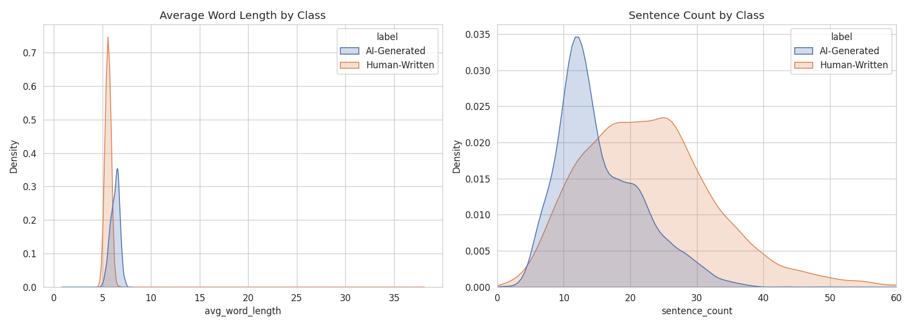
Figure 3: Average word length and sentence count distributions by class.

5.4 Word Cloud Analysis
Word clouds were generated separately for each class (with English stopwords removed) to visually inspect the most frequent vocabulary used by human writers versus AI-generated text.
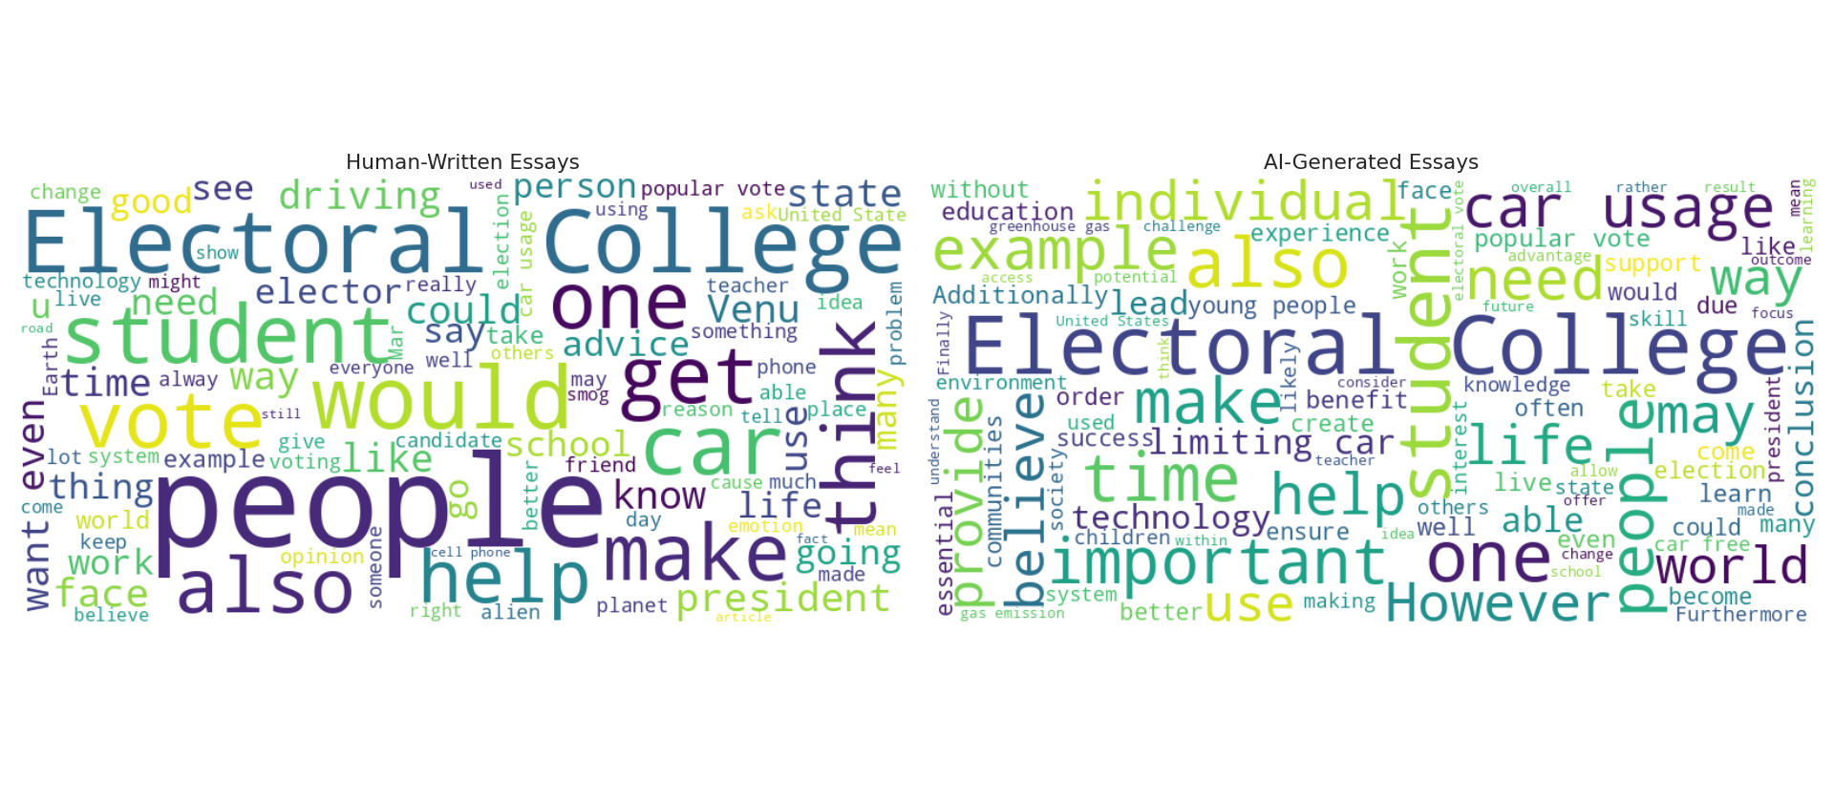
Figure 4: Word clouds for human-written (left) vs AI-generated (right) essays.

6. Feature Engineering
TF-IDF (Term Frequency–Inverse Document Frequency) was chosen as the primary feature representation. TF-IDF assigns higher weight to terms that are frequent within a specific document but rare across the overall corpus, making it effective at capturing distinctive vocabulary and phrasing patterns.

6.1 Configuration
- N-gram range: unigrams and bigrams (1,2) — captures both individual words and short phrases.
- Max features: 15,000 — keeps the most informative terms while controlling dimensionality.
- min_df = 3, max_df = 0.9 — removes extremely rare and overly common terms.
- Stop words: English stop words removed.
- Sublinear TF scaling applied to dampen the effect of very high term frequencies.
After vectorization, the training set produced a sparse feature matrix of shape (23,316 × 15,000), and the test set (5,829 × 15,000).

7. Model Building
Four classical machine learning classifiers, well-suited to high-dimensional sparse text data, were trained and compared:
Model | Rationale
Logistic Regression | Strong, interpretable linear baseline for high-dimensional sparse text data.
Multinomial Naive Bayes | Classic, fast probabilistic baseline widely used for text classification.
Linear SVM (calibrated) | Max-margin classifier, typically very effective on sparse TF-IDF features.
Random Forest | Non-linear ensemble baseline for comparison against linear models.

All models were trained on the same TF-IDF feature matrix for a fair comparison. The Linear SVM was wrapped with CalibratedClassifierCV to produce well-calibrated probability estimates (needed for the confidence scores shown in the Streamlit app).

8. Results & Evaluation

8.1 Model Comparison
All four models were evaluated on a held-out test set of 5,829 essays (20% of the data, stratified by class). Results are summarized below:
Model | Accuracy | Precision | Recall | F1-Score | ROC-AUC
Logistic Regression | 0.9913 | 0.99 | 0.99 | 0.9890 | 0.9996
Multinomial Naive Bayes | 0.9770 | 0.97 | 0.97 | 0.9711 | 0.9959
Linear SVM (Best) | 0.9978 | 1.00 | 1.00 | 0.9972 | 1.0000
Random Forest | 0.9864 | 0.98 | 0.98 | 0.9829 | 0.9990

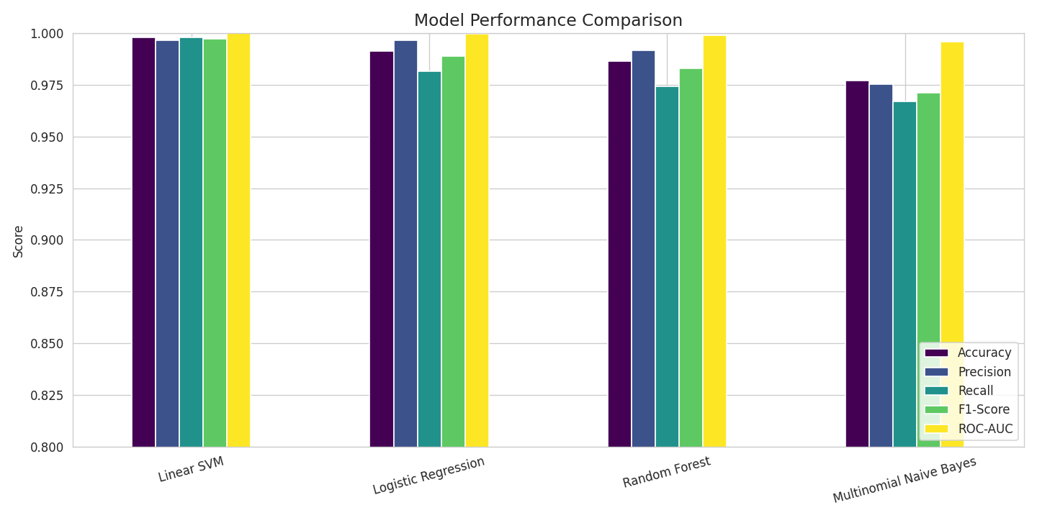
Figure 5: Bar chart comparison of Accuracy, Precision, Recall, F1-Score, and ROC-AUC across all four models.

8.2 Best Model: Linear SVM
The Linear SVM (calibrated) achieved the best overall performance with an F1-score of 0.9972 and a near-perfect ROC-AUC of 1.0000. The confusion matrix and ROC curves below confirm the model's strong discriminative ability, with very few misclassifications on the test set.
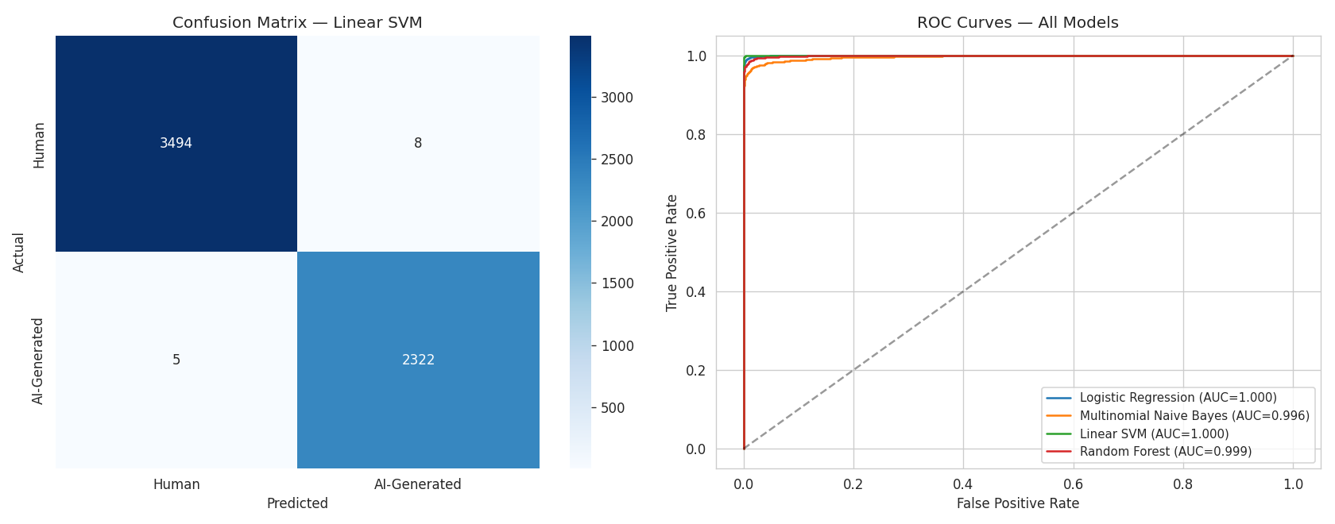
Figure 6: Confusion matrix for the best model (left) and ROC curves for all models (right).

8.3 Cross-Validation
To verify robustness, 5-fold cross-validation was performed on the training set using the best model. The mean F1-score across folds was 0.9946 (± 0.0009), confirming that the model's strong performance is stable and not an artifact of a lucky train-test split.

8.4 Feature Interpretability
Using the Logistic Regression model's coefficients, the terms most strongly associated with each class were identified. This provides interpretability into what lexical patterns the model relies on to distinguish AI-generated from human-written text — e.g., certain transitional/formal phrases were more indicative of AI-generated text, while more personal, narrative vocabulary was more indicative of human writing.
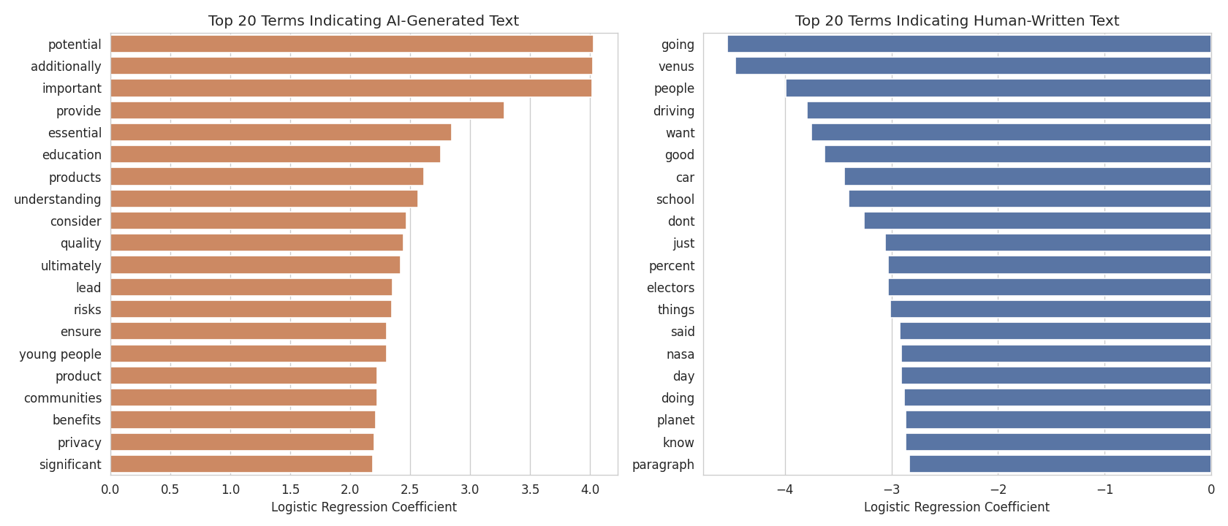
Figure 7: Top 20 terms most indicative of AI-generated text (left) vs. human-written text (right).

9. Streamlit Application
To make the model usable beyond the notebook environment, an interactive web application (app.py) was built using Streamlit. The application loads the saved TF-IDF vectorizer and trained model, and offers three main features:

9.1 Single Essay Check
Users can paste or type an essay (or select a built-in sample) and receive an instant prediction (Human-Written or AI-Generated) along with a confidence bar chart and basic text statistics (word count, sentence count, average word length, etc.).

9.2 Batch Check (CSV)
Users can upload a CSV file containing a text column with multiple essays. The app runs predictions on every row, displays a preview and summary counts, and allows downloading the full results as a CSV.

9.3 About the Project
A dedicated tab summarizes the dataset, pipeline, tech stack, and limitations for transparency.
The app can be launched locally with:
streamlit run app.py

10. Conclusion & Future Work

10.1 Conclusion
This project successfully demonstrates a complete data analytics pipeline applied to unstructured text data — moving from exploratory analysis to predictive modeling to detect AI-generated essays. The EDA stage uncovered clear, measurable differences between human and AI-generated writing (essay length, sentence structure, vocabulary usage), and the predictive modeling stage confirmed that these differences are strong enough to classify new essays reliably. Using TF-IDF features combined with classical machine learning classifiers, a Linear SVM model achieved excellent performance (99.78% accuracy, 0.9972 F1-score, and a near-perfect ROC-AUC of 1.0000) on a held-out test set, validated with 5-fold cross-validation. The analysis and trained model were then made accessible to non-technical users through an interactive Streamlit dashboard supporting both single-essay and batch predictions.

10.2 Limitations
- The dataset reflects essays from specific LLM generations available at the time of collection; performance may degrade on text from newer or different LLMs.
- Purely lexical (TF-IDF) features do not capture deeper semantic, discourse-level, or stylistic signals that transformer-based models could exploit.
- Very short text inputs (a sentence or two) may not provide enough signal for a reliable prediction.

10.3 Future Work
- Fine-tune a transformer-based model (e.g., DistilBERT, RoBERTa) for potentially higher accuracy and better generalization.
- Incorporate perplexity and burstiness-based statistical detectors, similar to tools like GPTZero.
- Expand training data with outputs from newer LLMs (GPT-4o, Claude, Gemini, etc.) to improve robustness.
- Deploy as a public API or browser extension for real-time academic integrity checking.

11. References & Tech Stack

11.1 Tech Stack
- Python 3 — core programming language
- pandas, numpy — data manipulation
- scikit-learn — TF-IDF vectorization, ML models, evaluation metrics
- nltk — stopword lists
- matplotlib, seaborn, wordcloud — data visualization
- joblib — model persistence
- Streamlit — web application frontend

11.2 Dataset Source
Training_Essay_Data.csv — a labeled collection of human-written and AI-generated essays, from Kaggle (kaggle.com/datasets/sunilthite/llm-detect-ai-generated-text-dataset).

