AI Assisted Coding – Assignment 6.5

Course Code - 24CS002PC215

Course Title - AI Assisted Coding

Year / Sem - II / I (2 – 1)

Regulation - R24

Date: 24-08-2025

Student Name: G.Sanjansah

Hall Ticket Number: 2503a52l20

Student Mail-ID : [2503a52l20@sru.edu.in](mailto:2503a52l20@sru.edu.in)

# Task 1: Setup AI Coding Tool

- Installed and configured GitHub Copilot in VS Code.  
- Enabled real-time code suggestions.

Screenshot:

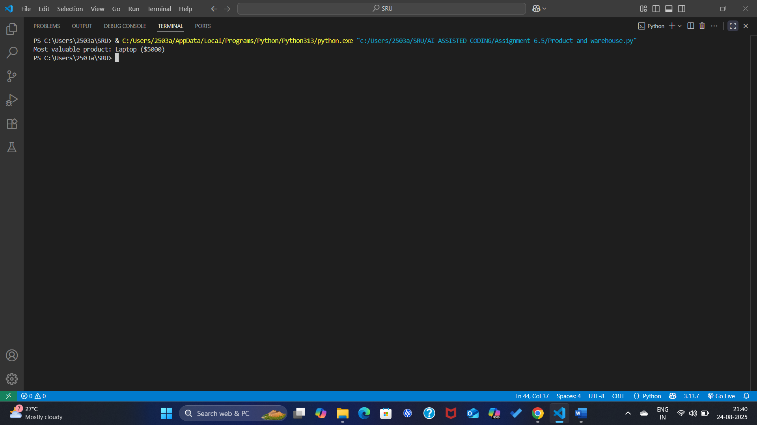

# Task 2: Class Design Using AI Assistance

- Designed Product class with attributes (name, price, quantity).  
- __init__() method auto-suggested by Copilot.  
- calculate_value() method auto-suggested by Copilot.

Screenshot of Task Question:

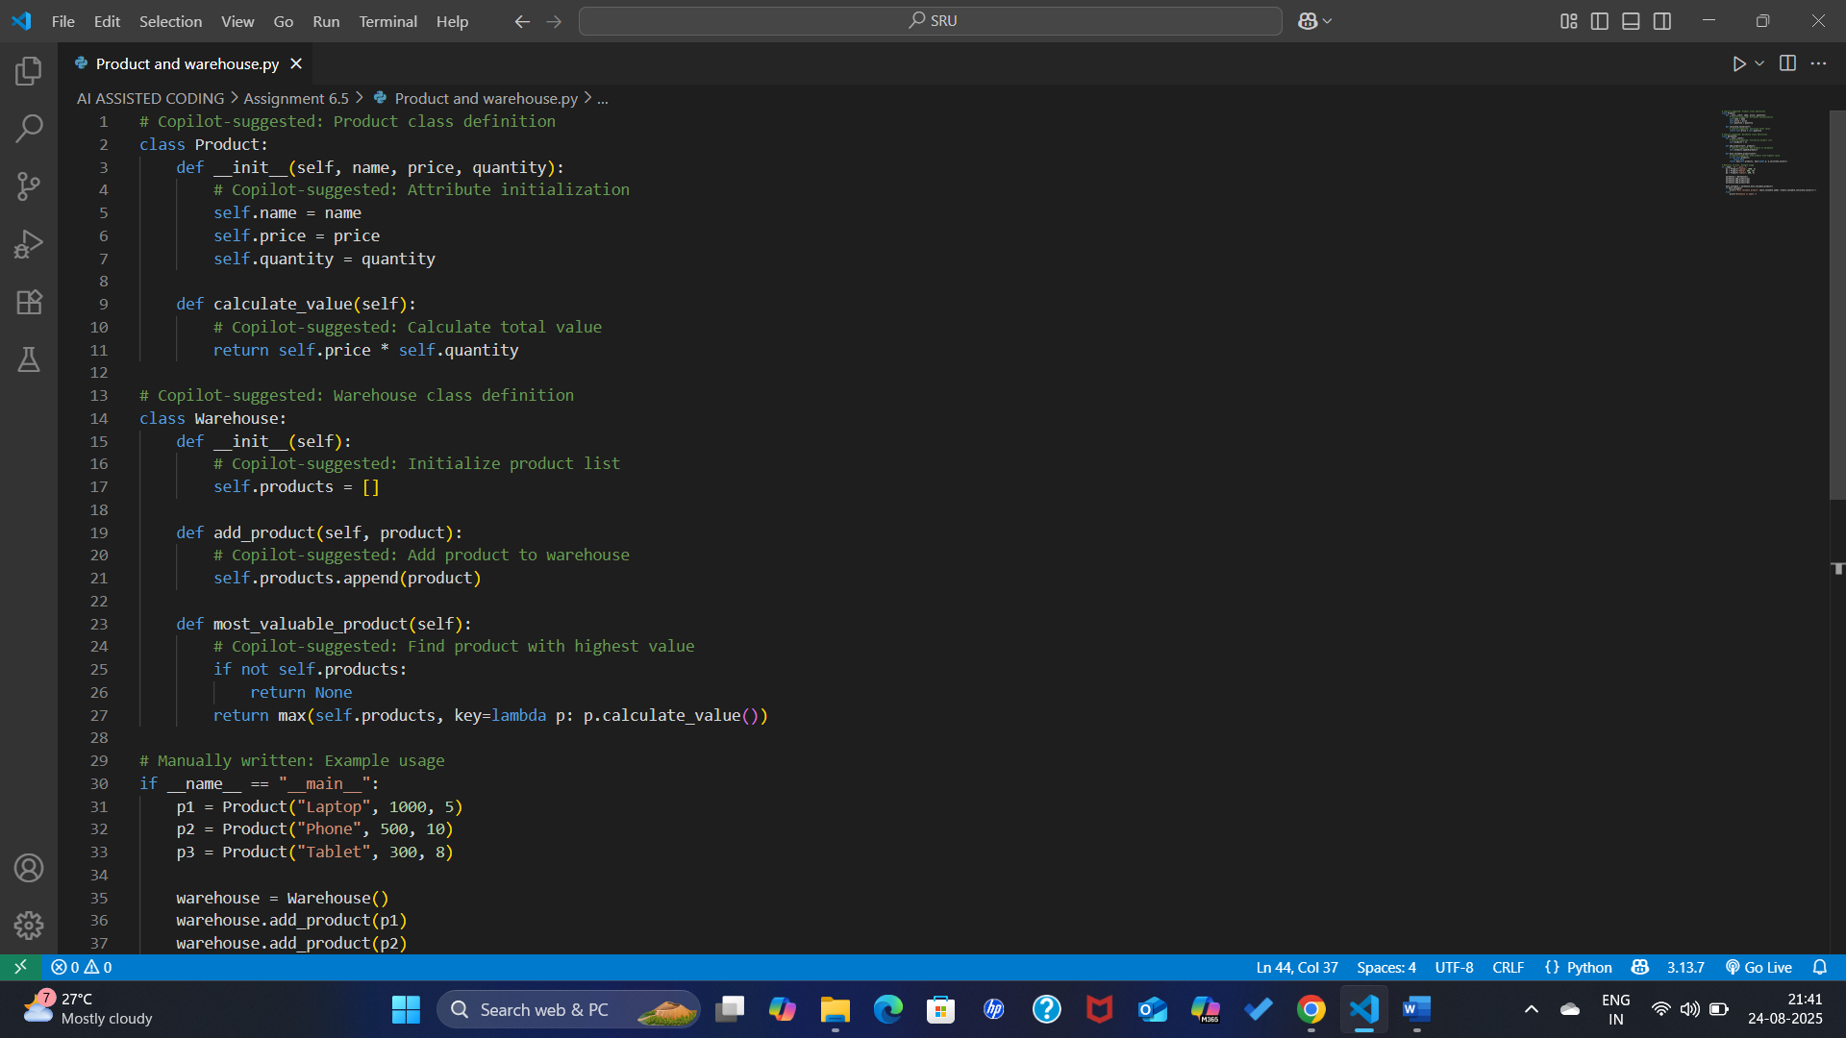

Screenshot of VS Code (Product class):

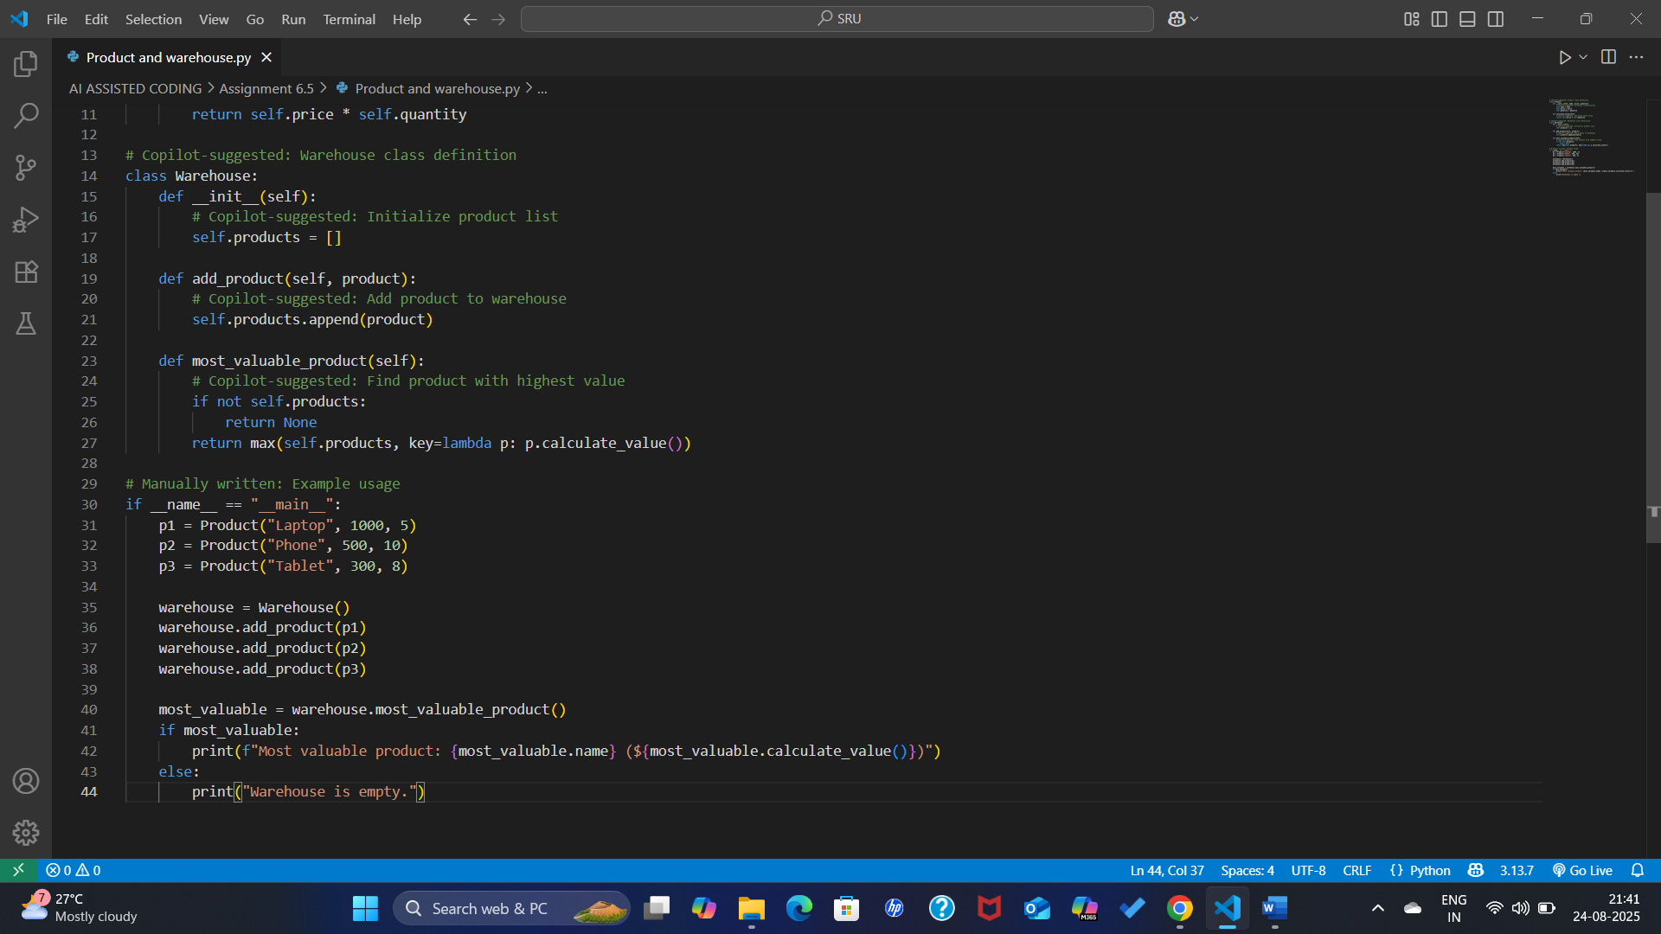

# Task 3: Create Another Class – Warehouse

- Created Warehouse class with:  
 - Method add_product() (AI-suggested)  
 - Method most_valuable_product() (AI-suggested)

Screenshot of Task Question:

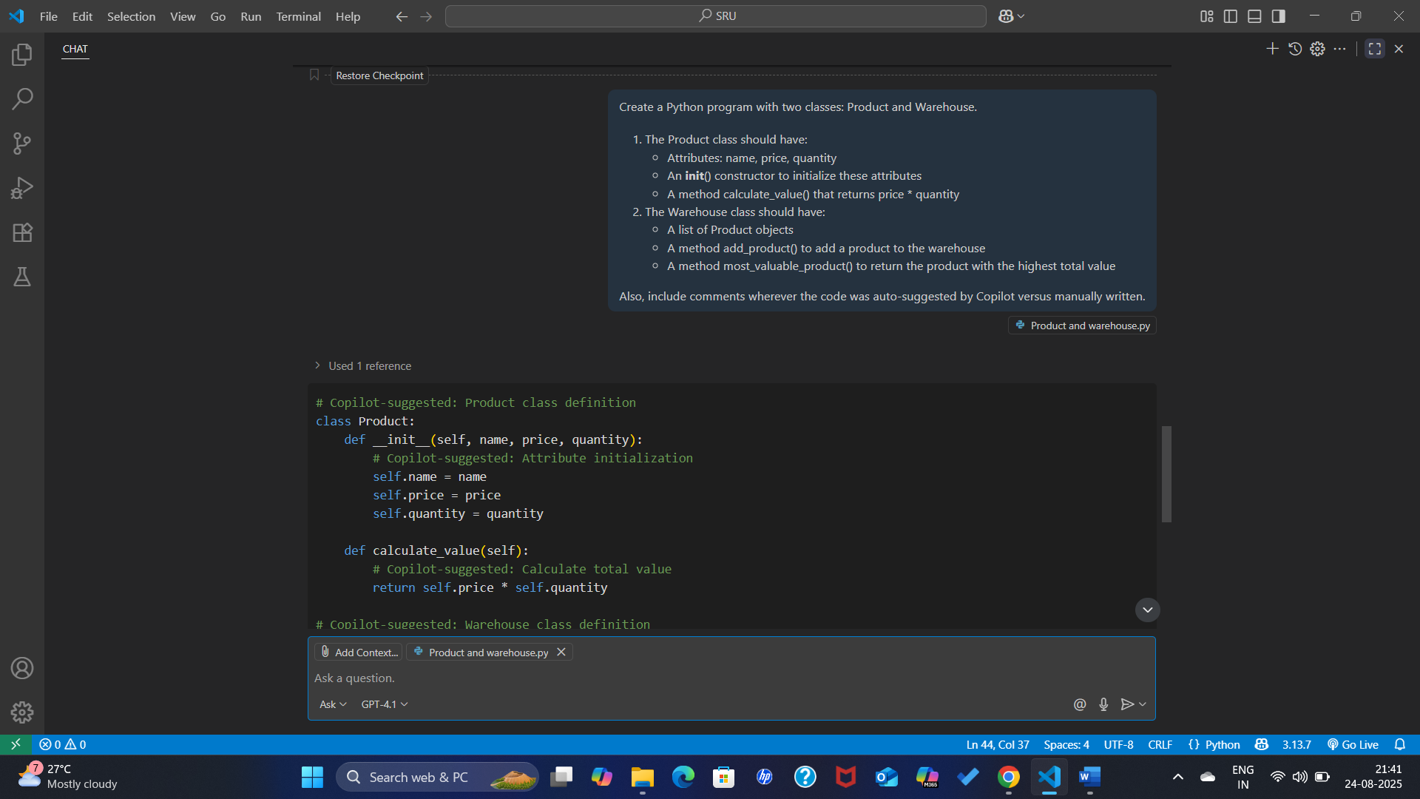

# Task 4: Reflection

- AI Suggestions:  
 - Copilot completed most of the class definitions, constructors, and methods.  
 - Especially useful in writing boilerplate code quickly without syntax errors.  
  
- Manual Work:  
 - Example usage (if __name__ == '__main__':) written manually.  
 - Printing logic (print(f'...')) adjusted by me.  
  
- Accuracy:  
 - Copilot suggestions were correct and relevant.  
 - Only minor edits were needed.

# Output Screenshot

Shows the most valuable product identified correctly by the program.

