PROJECT COMPASS: A SECURE HYBRID FILE RETRIEVAL AND QUESTION ANSWERING SYSTEM FOR ORGANIZATIONS
A MINI PROJECT REPORT
Submitted by
SANJAY RAJ B (910623104307)
ARUN KUMARAN N R (910623104009)
DHANUS KUMAR M (910623104302)
in partial fulfillment for the award of the degree
of
BACHELOR OF ENGINEERING
in
COMPUTER SCIENCE AND ENGINEERING

K.L.N. COLLEGE OF ENGINEERING
(An Autonomous Institution, Affiliated to Anna University, Chennai)
OCTOBER 2026

K.L.N. COLLEGE OF ENGINEERING
(An Autonomous Institution, Affiliated to Anna University, Chennai)
BONAFIDE CERTIFICATE
Certified that this mini project report “PROJECT COMPASS: A SECURE HYBRID FILE RETRIEVAL AND QUESTION ANSWERING SYSTEM FOR ORGANIZATIONS” is the bonafide work of “SANJAY RAJ B (910623104307)”, “ARUN KUMARAN N R (910623104009)”, “DHANUS KUMAR M (910623104302)” who carried out the mini project under my supervision.
Submitted for the mini project viva-voce conducted on ____________________.

SIGNATURE  Dr. A. ASKARUNISA  PROFESSOR AND HEAD  Computer Science and Engineering | SIGNATURE  Mrs. M. NITHYA  SUPERVISOR  ASSISTANT PROFESSOR  Computer Science and Engineering

INTERNAL EXAMINER | EXTERNAL EXAMINER

ACKNOWLEDGEMENT
The satisfaction and euphoria that accompany the successful completion of any task would be incomplete without mention of the people who made it possible, whose constant guidance and encouragement crowned our efforts with success.
We extend our gratitude to the Founder, Late. Thiru. K.L.N. KRISHNAN, and the Management Members of K.L.N. College of Engineering for making us march towards the glory of success. We express our sincere thanks to our respected Principal, Dr. A.V. RAM PRASAD, M.E., Ph.D., for all the facilities offered.
We would like to express our deep gratitude and heartfelt thanks to Dr. A. ASKARUNISA, Professor and Head of the Department of Computer Science and Engineering, K.L.N. College of Engineering, who motivated and encouraged us to undertake this mini project during this academic year.
Our profound and sincere thanks to our Mini Project Guide and respected Mini Project Coordinator, Mrs. M. NITHYA, Assistant Professor, Department of Computer Science and Engineering, K.L.N. College of Engineering, whose support was invaluable throughout the period of our work.
We thank our teaching staff for sharing their knowledge and views to enhance our mini project. We also thank our non-teaching staff for extending their technical support to us. We thank our parents for giving us such a wonderful life and our friends for their encouragement throughout the mini project. Finally, we thank the Almighty for giving us the health to finish the mini project successfully.

ABSTRACT
Project Compass is a secure, self-hosted file retrieval and question answering system for organizations. Traditional file search relies on exact keywords and cannot answer questions, semantic search alone can miss exact identifiers, and cloud-based AI assistants require confidential documents to be sent to external services. Project Compass addresses these limitations in a single system.
Uploaded documents are converted to passages and indexed both in a BM25 keyword index and in a FAISS vector index. For each question the two indexes are searched in parallel and their rankings are fused using Reciprocal Rank Fusion with k = 60. A cross-encoder reranker then re-scores the shortlist, and a refusal safety gate blocks answer generation when the evidence is not sufficient, preventing unsupported responses.
When the evidence is adequate, the top passages are passed to the Qwen 2.5 3B language model running locally through Ollama, and the answer is streamed to the user with source citations. Every upload, query, answer and refusal is written to an audit log. The system is built with Django and provides a dark, two-panel web interface with a document sidebar showing indexing status, chat with citation chips, and a switch between hybrid, keyword and semantic search.
By combining hybrid retrieval, reranking, refusal gating, local inference and audit logging on an entirely open-source stack, Project Compass delivers accurate, verifiable and privacy-preserving answers from organizational documents.

TABLE OF CONTENTS
CHAPTER NO. | TITLE | PAGE NO.
 | ABSTRACT | iv
 | LIST OF FIGURES | viii
 | LIST OF ABBREVIATIONS | ix
 | LIST OF SYMBOLS | x
1 | INTRODUCTION | 1
 | 1.1 INFORMATION RETRIEVAL IN ORGANIZATIONS | 1
 | 1.2 PROJECT COMPASS SYSTEM | 1
 | 1.3 FEATURES OF PROJECT COMPASS | 2
 | 1.3.1 Hybrid Retrieval | 2
 | 1.3.2 Cross-Encoder Reranking | 2
 | 1.3.3 Refusal Safety Gate | 2
 | 1.3.4 Local Language Model | 2
 | 1.3.5 Audit Logging | 3
 | 1.3.6 User Interface | 3
2 | LITERATURE REVIEW | 4
3 | SYSTEM ANALYSIS | 6
 | 3.1 EXISTING SYSTEM | 6
 | 3.1.1 Keyword and File-Name Search | 6
 | 3.1.2 Pure Semantic Search Systems | 6
 | 3.1.3 Cloud-Hosted AI Assistants | 6
 | 3.1.4 Scalability and Trust Challenges | 7
 | 3.2 PROPOSED SYSTEM | 7
4 | SYSTEM REQUIREMENTS | 9
 | 4.1 HARDWARE REQUIREMENTS | 9
 | 4.2 SOFTWARE REQUIREMENTS | 9
 | 4.3 HARDWARE DESCRIPTION | 10
 | 4.3.1 Processor (CPU) | 10
 | 4.3.2 Memory (RAM) | 10
 | 4.3.3 Graphics Processor (GPU) | 10
 | 4.3.4 Storage | 10
 | 4.4 SOFTWARE DESCRIPTION | 10
 | 4.4.1 Django | 10
 | 4.4.2 FAISS | 10
 | 4.4.3 BM25 | 11
 | 4.4.4 Cross-Encoder Reranker | 11
 | 4.4.5 Ollama and Qwen 2.5 3B | 11
 | 4.4.6 Frontend | 11
 | 4.4.7 Operating System | 11
5 | SYSTEM DESIGN | 12
 | 5.1 SYSTEM ARCHITECTURE | 12
 | 5.2 DATA FLOW DIAGRAM | 12
6 | SYSTEM IMPLEMENTATION | 14
 | 6.1 LIST OF MODULES | 14
 | 6.2 MODULE DESCRIPTION | 14
 | 6.2.1 Document Ingestion and Indexing | 14
 | 6.2.2 Hybrid Retrieval | 14
 | 6.2.3 Cross-Encoder Reranking | 15
 | 6.2.4 Refusal Safety Gate | 15
 | 6.2.5 Answer Generation and Citations | 16
 | 6.2.6 Audit Logging | 16
 | 6.2.7 User Interface | 17
7 | RESULTS AND DISCUSSION | 18
8 | SAMPLE CODE | 21
9 | SYSTEM TESTING | 22
 | 9.1 UNIT TESTING | 22
 | 9.2 FUNCTIONAL TESTING | 22
 | 9.3 INTEGRATION TESTING | 22
 | 9.4 PERFORMANCE TESTING | 22
 | 9.5 SECURITY TESTING | 22
 | 9.6 USABILITY TESTING | 23
10 | CONCLUSION | 24
11 | FUTURE ENHANCEMENT | 25
12 | REFERENCES | 26

LIST OF FIGURES
FIGURE NO. FIGURE NAME PAGE NO.
5.1 Architecture Diagram 12
5.2 Data Flow Diagram 13
6.1 Document Upload and Indexing Status 14
6.2 Search Mode Selection 15
6.3 Refusal Safety Gate Response 16
6.4 Chat Answer with Source Citation Chips 16
6.5 Audit Log View 16
6.6 Project Compass Main Interface 17
7.1 Answer Generated with Source Citations 18
7.2 Hybrid, Keyword and Semantic Search Comparison 18
7.3 Refusal of an Out-of-Scope Question 19
7.4 Latency Benchmark 20

LIST OF ABBREVIATIONS
ABBREVIATION | EXPANSION
AI | Artificial Intelligence
API | Application Programming Interface
BM25 | Best Matching 25 (ranking function)
CPU | Central Processing Unit
DFD | Data Flow Diagram
FAISS | Facebook AI Similarity Search
GPU | Graphics Processing Unit
LLM | Large Language Model
MRR | Mean Reciprocal Rank
NLP | Natural Language Processing
OCR | Optical Character Recognition
RAG | Retrieval-Augmented Generation
RAM | Random Access Memory
REST | Representational State Transfer
RRF | Reciprocal Rank Fusion
UI | User Interface

LIST OF SYMBOLS
SYMBOL | SYMBOL NAME
 | Process
 | External Entity
 | Data Store
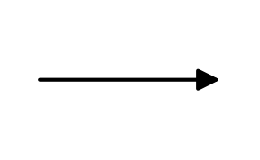 | Data Flow
 | Decision
 | Boundary / Group

CHAPTER 1

INTRODUCTION

1.1 INFORMATION RETRIEVAL IN ORGANIZATIONS
Every organization accumulates a large and continuously growing collection of documents such as policies, reports, manuals, contracts, meeting notes and technical specifications. Finding the right piece of information inside this collection is a daily need for employees, yet it is still handled mostly by folder browsing, file-name search or simple keyword matching. Keyword search is precise when the exact words are known, but it fails when the same idea is expressed in different words. Semantic search based on text embeddings solves that vocabulary problem, but it can miss exact identifiers, codes, names and numbers that matter a great deal in official documents.
Retrieval-Augmented Generation (RAG) combines a retrieval step with a language model so that answers are written from the retrieved passages instead of from the model's memory alone. This reduces invented answers and lets every statement be traced back to a source file. However, many RAG assistants depend on external cloud services, which is unacceptable for confidential organizational data, and most of them do not record who asked what or refuse questions that the documents cannot answer.
Project Compass is designed to close these gaps. It is a secure, self-hosted file retrieval and question answering system that combines keyword and semantic retrieval, reranks the candidates, refuses to answer when the evidence is insufficient, runs the language model locally, and keeps an audit trail of every interaction.

1.2 PROJECT COMPASS SYSTEM
Project Compass allows an authorized user to upload organizational files, have them indexed automatically, and then ask questions in natural language. For every question the system searches the indexed files using two complementary methods at the same time: BM25 for exact keyword matching and FAISS for semantic vector similarity. The two ranked lists are merged using Reciprocal Rank Fusion (RRF) with the constant k = 60, and the merged candidates are re-scored by a cross-encoder reranker that reads the question and each passage together.
Before an answer is generated, a refusal safety gate checks whether the retrieved evidence is strong enough to support a reliable answer. If it is not, the system says so instead of guessing. When the evidence is sufficient, the top passages are passed to a locally hosted Qwen 2.5 3B language model running on Ollama, which streams its answer to the user together with clickable source citations. No document text leaves the organization's own machines.
The backend is built with Django and exposes the upload, search, chat and audit functions to a web interface. The interface follows a clean dark, two-panel design in which the left panel lists documents with their indexing status and the right panel hosts the chat, the source citation chips and a switch between hybrid, keyword-only and semantic-only search.

1.3 FEATURES OF PROJECT COMPASS
Project Compass integrates the following features, which together make retrieval accurate, secure and accountable.

1.3.1 Hybrid Retrieval
The system runs BM25 keyword search and FAISS semantic search in parallel and fuses their rankings with RRF (k = 60). Keyword search guarantees that exact terms such as clause numbers, product codes and names are found, while semantic search finds passages that express the same meaning in different words. Running the two searches in parallel keeps the response time low.

1.3.2 Cross-Encoder Reranking
The fused shortlist is passed through a cross-encoder model that scores each passage against the question jointly. Because a cross-encoder examines the question and passage together, it judges relevance more accurately than either first-stage method. It is applied only to the shortlist so that the additional cost stays small.

1.3.3 Refusal Safety Gate
A safety gate sits between reranking and generation. If the best evidence does not meet the required relevance level, the system refuses to answer and tells the user that the indexed documents do not contain a reliable answer. This prevents confident but unsupported responses, which are the main risk of language-model-based assistants.

1.3.4 Local Language Model
Answers are produced by the Qwen 2.5 3B model served through Ollama on the organization's own hardware. The model is small enough to run locally, responses are streamed token by token so the user sees the answer start immediately, and confidential documents are never sent to a third-party service.

1.3.5 Audit Logging
Every upload, query, answer and refusal is recorded with the user and the time. The audit trail supports accountability and lets administrators review how the system is being used, which is an essential requirement for enterprise deployment.

1.3.6 User Interface
The web interface provides a Gemini-style dark theme with a two-panel layout, chat-based question answering, source citation chips that open the cited document, a document sidebar that shows indexing status, and a search-mode switch (hybrid, keyword or semantic). A compass-needle motion language replaces generic loading spinners during retrieval, reranking and streaming, giving the product a consistent identity.
CHAPTER 2

LITERATURE REVIEW
[1] Lewis, P. et al. Retrieval-Augmented Generation for Knowledge-Intensive NLP Tasks. Advances in Neural Information Processing Systems (NeurIPS), 2020.
This work introduces RAG, in which a pre-trained sequence-to-sequence generator is combined with a dense retriever over an external document index, and shows strong results on open-domain question answering. The merit is that answers are grounded in retrieved text and the knowledge base can be updated by changing the index instead of retraining the model. The demerit, from an enterprise viewpoint, is that retrieval is dense-only, the work targets public corpora, and it provides no access control, audit trail or explicit refusal behaviour. Project Compass keeps the retrieve-then-generate principle but adds hybrid retrieval, a refusal safety gate and audit logging, and runs the generator locally.
[2] Karpukhin, V. et al. Dense Passage Retrieval for Open-Domain Question Answering. Proc. EMNLP, 2020.
This study shows that dense dual-encoder retrieval can outperform a strong BM25 baseline for open-domain question answering. The merit is that meaning-based matching finds relevant passages even when they share few words with the question. The demerit is that purely dense retrieval can be weaker on rare terms, identifiers and exact phrases, and that it needs a trained encoder. Project Compass uses embeddings for semantic matching through FAISS but does not rely on them alone; BM25 runs beside them so that exact terms are never lost.
[3] Robertson, S. and Zaragoza, H. The Probabilistic Relevance Framework: BM25 and Beyond. Foundations and Trends in Information Retrieval, 2009.
This survey describes the BM25 ranking function, which scores documents by term frequency, inverse document frequency and length normalisation. The merit is that BM25 is fast, needs no training and is very reliable for exact keyword matching. The demerit is vocabulary mismatch: a passage that uses different words from the question is not retrieved. Project Compass keeps BM25 as the lexical half of its hybrid retriever and compensates for its weakness with semantic search.
[4] Cormack, G. V., Clarke, C. L. A. and Buettcher, S. Reciprocal Rank Fusion Outperforms Condorcet and Individual Rank Learning Methods. Proc. ACM SIGIR, 2009.
This paper proposes Reciprocal Rank Fusion, which combines several ranked lists by summing 1/(k + rank) for each document, with k = 60 used in the original work. The merit is that fusion needs no training and no score normalisation, so it can merge BM25 and vector rankings whose scores are on different scales. The demerit is that it uses ranks only and does not itself judge relevance. Project Compass therefore uses RRF with k = 60 to build the shortlist and then applies a cross-encoder reranker to judge the candidates.
[5] Nogueira, R. and Cho, K. Passage Re-ranking with BERT. arXiv:1901.04085, 2019.
This work applies a BERT cross-encoder to rerank candidate passages and reports a large improvement on the MS MARCO passage ranking task. The merit is much higher ranking quality because the question and passage are read together. The demerit is that a cross-encoder must run once per question-passage pair, which is expensive if applied to a whole collection. Project Compass applies its cross-encoder only to the fused shortlist, gaining the accuracy while keeping latency low.
CHAPTER 3

SYSTEM ANALYSIS

3.1 EXISTING SYSTEM
Existing solutions for finding information inside organizational files are generally limited to keyword-based tools or to general-purpose AI assistants. Each has drawbacks in accuracy, privacy or accountability.

3.1.1 Keyword and File-Name Search
Operating-system search and shared-drive search look for exact words or file names. They do not understand meaning, so a query phrased differently from the document returns nothing. They also cannot answer a question; the user must open every result and read it.

3.1.2 Pure Semantic Search Systems
Systems built only on embeddings understand meaning but may miss exact identifiers, codes and numbers, and they rank results without a second check of relevance. They typically return a list of files instead of a direct, cited answer.

3.1.3 Cloud-Hosted AI Assistants
Cloud assistants can answer questions in natural language, but uploading confidential documents to an external service creates privacy, compliance and cost concerns. They may also produce confident answers that are not supported by the organization's own files, and they seldom provide an organization-controlled audit trail.
Disadvantages
- Keyword tools cannot match meaning and cannot answer questions directly.
- Semantic-only tools can miss exact terms and identifiers.
- Cloud assistants expose confidential data to third parties.
- Most tools give no refusal when evidence is missing, so unsupported answers can appear reliable.
- Little or no audit logging of who searched for what.

3.1.4 Scalability and Trust Challenges
As the number of documents grows, single-method retrieval degrades and users lose trust in the results. Without source citations and audit records it is difficult to verify answers or to demonstrate compliance.

3.2 PROPOSED SYSTEM
Project Compass is a self-hosted system that lets users upload files and ask questions in natural language. Uploaded files are converted to text, split into passages, and indexed twice: once in a BM25 keyword index and once in a FAISS vector index built from text embeddings.
For each question, BM25 and FAISS are queried in parallel and their rankings are merged with Reciprocal Rank Fusion (k = 60). A cross-encoder reranker then re-scores the merged candidates. A refusal safety gate examines the reranked evidence and blocks generation when the evidence is not sufficient.
When evidence is sufficient, the top passages are given to the Qwen 2.5 3B model running locally on Ollama. The answer is streamed to the user with source citations that link back to the original documents. All actions are written to an audit log.
The system is delivered as a web application with a dark two-panel interface, a document sidebar showing indexing status, and a switch between hybrid, keyword and semantic search.
Advantages
- Hybrid retrieval finds both exact terms and semantically related passages.
- Cross-encoder reranking improves the order of the final evidence.
- The refusal safety gate prevents unsupported answers.
- The language model runs locally, so documents stay inside the organization.
- Every answer carries source citations and every action is audit logged.
- Parallel retrieval, a quantized local model and streaming keep the system responsive.
- Built on open-source components, so there are no per-query licensing costs.
Overcoming Existing Limitations
- Combines keyword and semantic search to remove the weaknesses of each single method.
- Replaces confidential-data upload to cloud services with fully local inference.
- Answers only when the documents support it, improving trust.
- Provides citations and audit records for verification and compliance.
CHAPTER 4

SYSTEM REQUIREMENTS
Project Compass requires a machine that can index documents, run BM25 and FAISS searches, execute a cross-encoder reranker and host a small language model locally, together with a web browser for the user interface. The specific values used during development and testing are listed below.

4.1 HARDWARE REQUIREMENTS
Table 4.1 Hardware Requirements
Component | Specification
Processor (CPU) | [ENTER VALUE]
Memory (RAM) | [ENTER VALUE]
Graphics Processor (GPU) | [ENTER VALUE or None]
Storage | [ENTER VALUE]
Display / Peripherals | [ENTER VALUE]
Network | [ENTER VALUE]

4.2 SOFTWARE REQUIREMENTS
Table 4.2 Software Requirements
Component | Specification
Operating System | [ENTER VALUE]
Programming Languages | Python [ENTER VERSION], JavaScript
Backend Framework | Django [ENTER VERSION]
Keyword Retrieval | BM25 [ENTER LIBRARY]
Vector Retrieval | FAISS [ENTER VERSION]
Embedding Model | [ENTER MODEL NAME]
Reranker | Cross-encoder [ENTER MODEL NAME]
Language Model | Qwen 2.5 3B via Ollama [ENTER VERSION]
Frontend | React with Tailwind CSS [CONFIRM]
Database | [ENTER VALUE]
Development Environment | [ENTER VALUE]
Web Browser | [ENTER VALUE]

4.3 HARDWARE DESCRIPTION

4.3.1 Processor (CPU)
The processor runs the Django backend, document parsing, BM25 search and, when no GPU is used, the language model itself. [Describe the processor used and why it is sufficient.]

4.3.2 Memory (RAM)
Memory holds the FAISS index, the BM25 index, the embedding and reranker models, and the quantized language model during operation. [Describe the RAM used.]

4.3.3 Graphics Processor (GPU)
A GPU is optional. It can speed up embedding, reranking and text generation, but the system is designed so that a quantized 3B-parameter model can run on ordinary hardware. [State whether a GPU was used.]

4.3.4 Storage
Storage holds the uploaded files, extracted text, indexes, model files and the audit database. [Describe the storage used.]

4.4 SOFTWARE DESCRIPTION

4.4.1 Django
Django is a Python web framework that provides the project's models, user authentication, administration and request handling. It stores document metadata, indexing status and audit records and exposes the upload, search and chat endpoints used by the interface.

4.4.2 FAISS
FAISS (Facebook AI Similarity Search) is a library for fast similarity search over dense vectors. Passage embeddings are stored in a FAISS index, and each question embedding is compared against it to retrieve the semantically closest passages.

4.4.3 BM25
BM25 is a ranking function based on term frequency, inverse document frequency and document length. It scores passages by how well they match the words of the question and complements semantic search by guaranteeing exact-term matches.

4.4.4 Cross-Encoder Reranker
The cross-encoder takes a question and a passage as one input and outputs a relevance score. It is used to reorder the fused shortlist so that the most relevant passages reach the language model first.

4.4.5 Ollama and Qwen 2.5 3B
Ollama is a runtime for hosting language models locally. Project Compass uses it to serve the Qwen 2.5 3B model, which generates answers from the retrieved passages and streams them to the interface without contacting any external service.

4.4.6 Frontend
The interface is a single-page web application with a dark, two-panel layout, styled with Tailwind CSS. It provides chat, citation chips, the document sidebar, the search-mode switch and the compass-needle motion elements. [Confirm frontend framework and version.]

4.4.7 Operating System
[Enter the operating system used for development and deployment, and any driver or runtime notes.]
CHAPTER 5

SYSTEM DESIGN

5.1 SYSTEM ARCHITECTURE
An architecture diagram is a visual representation of the structure and components of a system and of how they interact. The architecture of Project Compass is divided into two pipelines. The indexing pipeline extracts text from uploaded files, splits it into passages, creates embeddings and builds the BM25 and FAISS indexes. The query pipeline retrieves candidates in parallel, fuses them with RRF, reranks them, applies the refusal safety gate, and passes the approved context to the local language model. The audit log records activity from both pipelines.
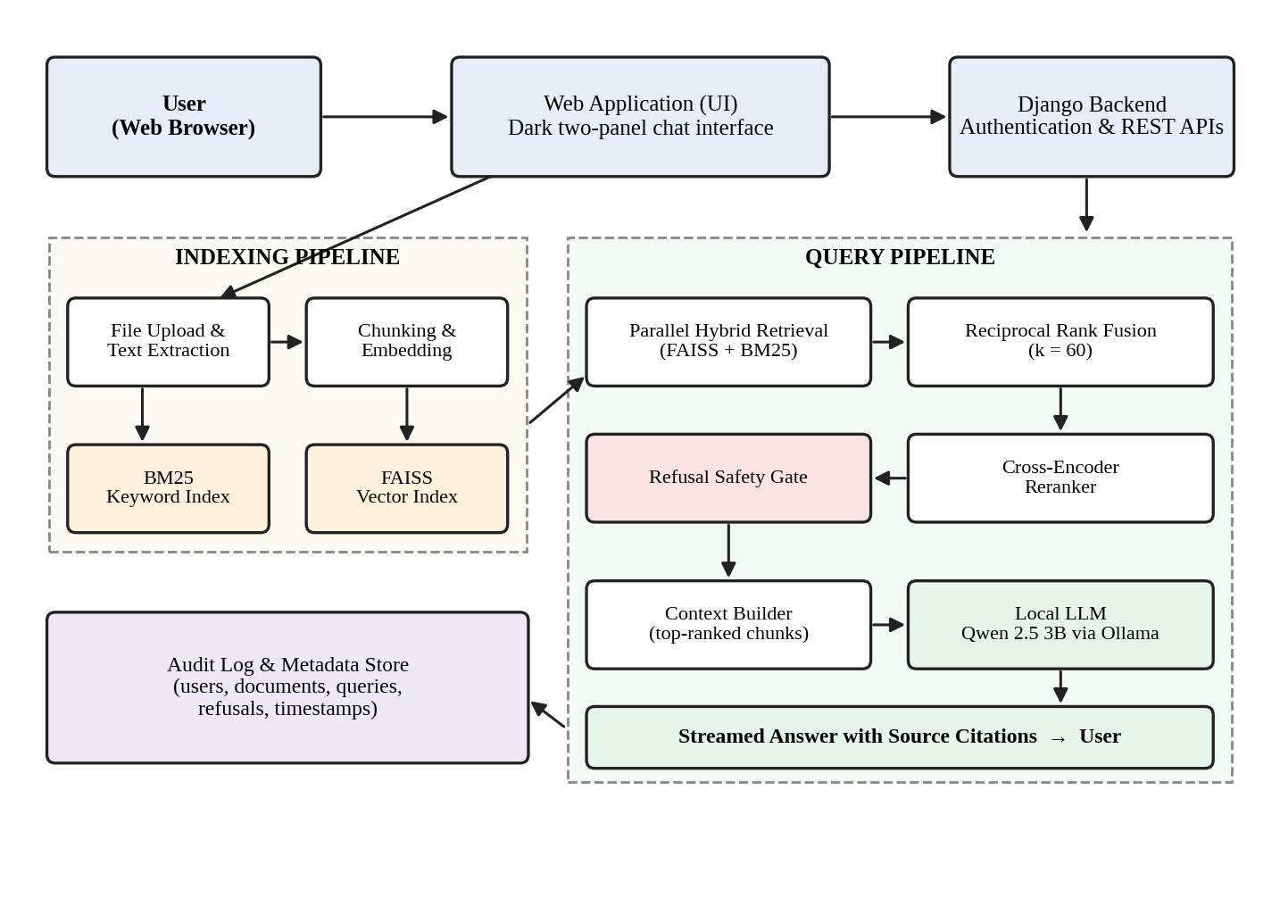
Figure 5.1 Architecture Diagram

5.2 DATA FLOW DIAGRAM
A data flow diagram shows how data moves between external entities, processes and data stores. In Project Compass the user supplies files and queries; the upload process writes the file store and both indexes; the retrieval, reranking and generation processes read the indexes and produce the final answer; and the audit process writes every event to the audit log.
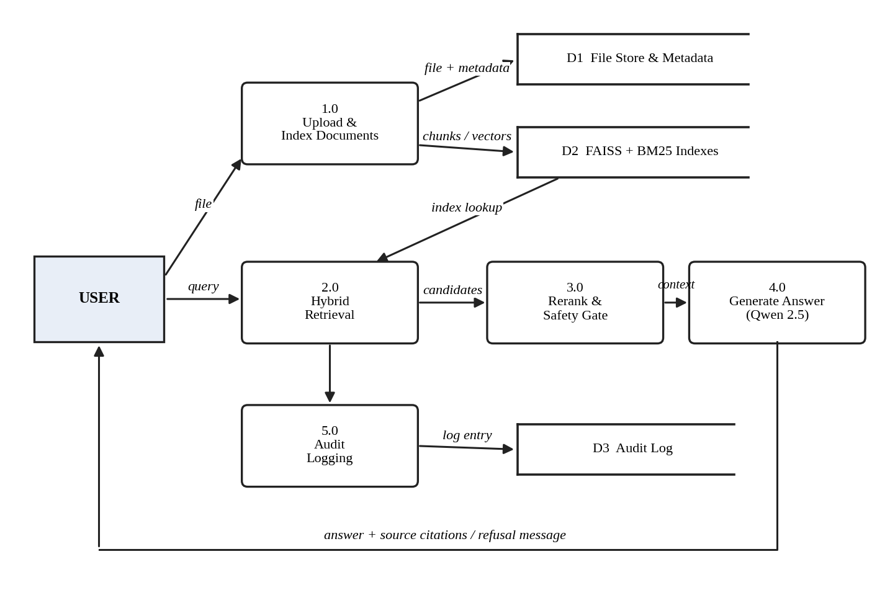
Figure 5.2 Data Flow Diagram
CHAPTER 6

SYSTEM IMPLEMENTATION

6.1 LIST OF MODULES
- Document Ingestion and Indexing
- Hybrid Retrieval
- Cross-Encoder Reranking
- Refusal Safety Gate
- Answer Generation and Citations
- Audit Logging
- User Interface

6.2 MODULE DESCRIPTION

6.2.1 Document Ingestion and Indexing
Users upload files through the web interface. The system extracts the text, splits it into passages, creates an embedding for each passage and adds it to the FAISS vector index, while the same passages are added to the BM25 keyword index. Document metadata and indexing status (queued, indexing, ready or failed) are stored through Django models and shown live in the document sidebar. [Add supported file types and passage size used.]
[INSERT SCREENSHOT: Document sidebar showing files and their indexing status]
Figure 6.1 Document Upload and Indexing Status

6.2.2 Hybrid Retrieval
When a question is submitted, BM25 and FAISS are queried in parallel. Each returns a ranked list of passages. The two lists are combined using Reciprocal Rank Fusion, in which each passage receives a score of 1/(k + rank) from every list it appears in, with k = 60, and the passages are ordered by total score. Because RRF uses ranks instead of raw scores, the incompatible score scales of BM25 and vector similarity do not need to be normalised. The user can switch between hybrid, keyword-only and semantic-only modes from the interface.
[INSERT SCREENSHOT: Search-mode toggle (hybrid / keyword / semantic)]
Figure 6.2 Search Mode Selection

6.2.3 Cross-Encoder Reranking
The fused shortlist is re-scored by a cross-encoder that reads the question and each candidate passage together and outputs a relevance score. The passages are reordered by this score and only the top-ranked passages are kept as context. Reranking only the shortlist gives the accuracy benefit of a cross-encoder without the cost of applying it to the whole collection.

6.2.4 Refusal Safety Gate
Before generation, the safety gate checks whether the top reranked evidence is strong enough to support an answer. If it is not, generation is skipped and the user receives a clear message that the indexed documents do not contain a reliable answer. The refusal is also written to the audit log. [Add the threshold or rule used by the gate.]
[INSERT SCREENSHOT: A refused out-of-scope question]
Figure 6.3 Refusal Safety Gate Response

6.2.5 Answer Generation and Citations
The approved passages are inserted into a prompt that instructs the Qwen 2.5 3B model to answer only from the supplied context. The model is served locally through Ollama and its output is streamed to the interface token by token. Each answer is shown with source citation chips that identify the document and passage used, so that the user can verify the answer.
[INSERT SCREENSHOT: A chat answer with citation chips]
Figure 6.4 Chat Answer with Source Citation Chips

6.2.6 Audit Logging
Every upload, query, answer and refusal is recorded with the user and the time. The audit log gives administrators a complete history of system use and supports security reviews and compliance checks.
[INSERT SCREENSHOT: Audit log page or admin view]
Figure 6.5 Audit Log View

6.2.7 User Interface
The interface uses a Gemini-style dark theme with two panels: a document sidebar and a chat area. A compass-needle motion language replaces generic spinners: the needle swings during retrieval, settles during reranking, locks on when the answer starts streaming, and jitters briefly when the refusal gate blocks a question. The same motion vocabulary is used for indexing progress, panel transitions and latency indicators.
[INSERT SCREENSHOT: Full two-panel interface]
Figure 6.6 Project Compass Main Interface
CHAPTER 7

RESULTS AND DISCUSSION
Project Compass answers natural-language questions over the uploaded organizational documents and returns each answer with source citations. The system was evaluated on the aspects listed below. [Add the number and type of documents indexed and the number of test queries used.]
[INSERT SCREENSHOT: Chat answer with citation chips]
Figure 7.1 Answer Generated with Source Citations
The answer is streamed while it is being generated, and each statement can be traced to the cited passage, which lets the user verify the result without opening every file.
[INSERT SCREENSHOT: Same query in the three search modes]
Figure 7.2 Hybrid, Keyword and Semantic Search Comparison
Hybrid retrieval combines the strengths of the two first-stage methods: keyword search finds passages containing the exact terms of the question, semantic search finds passages that express the same meaning in different words, and RRF merges both lists into a single shortlist that the reranker orders.
[INSERT SCREENSHOT: Refusal message for a question not covered by the documents]
Figure 7.3 Refusal of an Out-of-Scope Question
When a question is not covered by the indexed documents, the refusal safety gate blocks generation and informs the user, instead of producing an unsupported answer.
Table 7.1 Retrieval Performance Comparison
Metric | Keyword only | Semantic only | Hybrid (RRF) | Hybrid + Rerank
Top-k hit rate | [VALUE] | [VALUE] | [VALUE] | [VALUE]
MRR | [VALUE] | [VALUE] | [VALUE] | [VALUE]
Average latency (s) | [VALUE] | [VALUE] | [VALUE] | [VALUE]

Table 7.2 System-Level Results
Measure | Result
Average time to first streamed token | [VALUE]
Average end-to-end answer time | [VALUE]
Out-of-scope questions correctly refused | [VALUE]
Documents indexed / passages indexed | [VALUE]

[INSERT SCREENSHOT: Latency benchmark chart or table]
Figure 7.4 Latency Benchmark
The results show how each stage contributes to the final quality: fusion widens the coverage of relevant passages, reranking improves their order, and the safety gate protects the user from unsupported answers. [Add 2 or 3 sentences interpreting your measured values from Tables 7.1 and 7.2.]
CHAPTER 8

SAMPLE CODE
This chapter presents representative code from Project Compass. The Reciprocal Rank Fusion routine below implements the fusion step described in Chapter 6 with k = 60.
8.1 Reciprocal Rank Fusion
def reciprocal_rank_fusion(ranked_lists, k=60):
"""Fuse several ranked lists of passage IDs using RRF."""
scores = {}
for ranking in ranked_lists:
for rank, passage_id in enumerate(ranking, start=1):
score = 1.0 / (k + rank)
scores[passage_id] = scores.get(passage_id, 0.0) + score
return sorted(scores, key=scores.get, reverse=True)

# usage: fused = reciprocal_rank_fusion([bm25_ids, faiss_ids], k=60)

8.2 Django Models (documents, passages, audit log)
[PASTE YOUR CODE FROM THE PROJECT HERE]
8.3 Indexing Pipeline (extraction, chunking, embedding, FAISS and BM25)
[PASTE YOUR CODE FROM THE PROJECT HERE]
8.4 Cross-Encoder Reranking
[PASTE YOUR CODE FROM THE PROJECT HERE]
8.5 Refusal Safety Gate
[PASTE YOUR CODE FROM THE PROJECT HERE]
8.6 Ollama Streaming Call and Prompt
[PASTE YOUR CODE FROM THE PROJECT HERE]
CHAPTER 9

SYSTEM TESTING
System testing of Project Compass verifies that every component works correctly on its own and together with the others, that retrieval is accurate and fast, and that the system behaves safely when the evidence is missing. The testing covers document indexing, hybrid retrieval, reranking, the refusal safety gate, answer generation with citations, audit logging and the user interface.

9.1 UNIT TESTING
Each module is tested independently. Text extraction is checked on each supported file type, chunking is checked for correct passage boundaries, the BM25 and FAISS indexes are checked to return the expected passages for known queries, the RRF routine is checked against hand-computed scores, and the reranker is checked to order a known relevant passage above irrelevant ones.

9.2 FUNCTIONAL TESTING
Functional testing checks the system against its requirements using complete scenarios: uploading a file and waiting for it to become ready, asking a question whose answer is in the documents, asking a question that is not covered, switching search modes, and opening a source citation.

9.3 INTEGRATION TESTING
Integration testing confirms that the modules work together: the upload process produces both indexes, parallel retrieval feeds fusion, fusion feeds the reranker, the gate controls whether the local model is called, and every step writes to the audit log.

9.4 PERFORMANCE TESTING
Performance testing measures retrieval latency, reranking time, time to the first streamed token and end-to-end answer time for a set of test queries, and checks how the results change as the number of indexed documents grows.

9.5 SECURITY TESTING
Security testing checks that only authenticated users can upload or query, that questions outside the documents are refused, that no document text is sent outside the local machine, and that audit records are created for every action.

9.6 USABILITY TESTING
Usability testing evaluates whether users can upload documents, understand indexing status, read answers with citations, and use the search-mode switch without instruction, and whether the motion elements communicate progress clearly.
Table 9.1 Sample Test Cases
ID | Test Case | Expected Result | Status
TC1 | Upload a supported document | File is indexed and status changes to ready | [PASS/FAIL]
TC2 | Ask a question answered in the documents | Answer streams with correct source citation | [PASS/FAIL]
TC3 | Query containing an exact code or identifier | Passage containing it is retrieved (keyword match) | [PASS/FAIL]
TC4 | Query using different wording from the document | Relevant passage is retrieved (semantic match) | [PASS/FAIL]
TC5 | Question not covered by any document | Refusal message; no answer generated | [PASS/FAIL]
TC6 | Switch search mode to keyword-only | Only BM25 results are used | [PASS/FAIL]
TC7 | Perform upload, query and refusal | Each action appears in the audit log | [PASS/FAIL]
TC8 | Click a citation chip | Cited document and passage open | [PASS/FAIL]
CHAPTER 10

CONCLUSION
Project Compass addresses the practical problem of finding reliable answers inside large collections of organizational files without exposing them to outside services. By combining BM25 keyword search with FAISS semantic search, merging their results with Reciprocal Rank Fusion, reranking with a cross-encoder and gating generation with a refusal safety check, the system retrieves accurate evidence and answers only when that evidence supports an answer.
Running the Qwen 2.5 3B model locally through Ollama keeps confidential documents inside the organization, and source citations together with audit logging make every answer verifiable and every action accountable. The clean dark web interface with its document sidebar, search-mode switch and compass-needle motion language makes the system easy to use.
The project demonstrates that a fully open-source, self-hosted retrieval and question answering system is a practical and trustworthy alternative to cloud assistants, and it provides a foundation for further enhancement.
CHAPTER 11

FUTURE ENHANCEMENT
Project Compass can be extended in several directions. Optical character recognition can be added so that scanned documents and images become searchable. Fine-grained, per-document access control based on user roles can ensure that each user retrieves only the files they are permitted to see. Support for more languages can be introduced with multilingual embedding and reranking models.
For organization-scale deployments, the retrieval layer can be moved to a distributed vector database and the language model served through a high-throughput inference engine, with scheduled and incremental indexing of changing document sets. A feedback mechanism can allow users to mark answers as helpful or incorrect so that retrieval quality can be measured and improved over time. Larger language models and domain-specific fine-tuning of the embedding and reranking models can further improve answer quality.
CHAPTER 12

REFERENCES
1. Lewis, P., Perez, E., Piktus, A., et al., "Retrieval-Augmented Generation for Knowledge-Intensive NLP Tasks," Advances in Neural Information Processing Systems (NeurIPS), vol. 33, 2020.
2. Karpukhin, V., Oguz, B., Min, S., et al., "Dense Passage Retrieval for Open-Domain Question Answering," in Proc. Conference on Empirical Methods in Natural Language Processing (EMNLP), 2020, pp. 6769-6781.
3. Robertson, S. and Zaragoza, H., "The Probabilistic Relevance Framework: BM25 and Beyond," Foundations and Trends in Information Retrieval, vol. 3, no. 4, pp. 333-389, 2009.
4. Cormack, G. V., Clarke, C. L. A. and Buettcher, S., "Reciprocal Rank Fusion Outperforms Condorcet and Individual Rank Learning Methods," in Proc. ACM SIGIR Conference on Research and Development in Information Retrieval, 2009, pp. 758-759.
5. Nogueira, R. and Cho, K., "Passage Re-ranking with BERT," arXiv preprint arXiv:1901.04085, 2019.
6. Johnson, J., Douze, M. and Jegou, H., "Billion-Scale Similarity Search with GPUs," IEEE Transactions on Big Data, vol. 7, no. 3, pp. 535-547, 2021.
7. Reimers, N. and Gurevych, I., "Sentence-BERT: Sentence Embeddings using Siamese BERT-Networks," in Proc. EMNLP-IJCNLP, 2019, pp. 3982-3992.
8. Qwen Team, "Qwen2.5 Technical Report," arXiv preprint arXiv:2412.15115, 2024.

