

**ARDUINO LASER SECURITY ALARM**

**A MINI PROJECT REPORT**

***Submitted By:***

**Shreysh Babu-1NH18EE056**

**Sanjay G-1NH18EE052**

**Rutik Belekar-1NH18EE048**

***In partial fulfillment of the award of the degree of***

***B.E***

**BRANCH OF STUDY**

**Electrical and Electronics Engineering**



DEPARTMENT OF ELECTRICAL AND ELECTRONICS ENGINEERING

CERTIFICATE

Certified that the Mini Project work entitled “ARDUINO LASER SECURITY ALARM” carried out by **Shreysh Babu – 1NH18EE056, Sanjay G – 1NH18EE052, Rutik Belekar-**

**1NH18EE048,** are Bonafede students of New Horizon College of Engineering submitted the report in completion of project at department of Electrical and Electronics Engineering, New Horizon college of Engineering during the academic year 2019-20. It is certified that all the corrections/suggestions indicated for internal assessment have been incorporated in the report deposited in the department library. The project report has been approved as it satisfies the academic requirements in respect to project work prescribed for said Degree.

**Project guide HOD**

**EEE**

**Name of the Guide**

**Mr Satish kumar**

# TABLE OF CONTENTS

|  |  |  |  |
| --- | --- | --- | --- |
| **SI.NO** | **CONTENTS** |  | **PAGE No.** |
| **1.** | **ABSTRACT** | **4** |  |
| **2.** | **INTRODUCTION** | **6** |  |
| **3.** | **BLOCK DIAGRAM** | **7** |  |
| **4.** | **CIRCUIT DIAGRAM** | **8** |  |
| **5.** | **COMPONENTS REQUIRED**   * **Arduino nano** * **GSM module** * **Piezo buzzer** * **LDR** * **Laser module** * **Bread board** * **Resistor** * **Jumper wire** | **9** |  |
| **6.** | **CONNECTION AND WORKING** | **24** |  |
| **7.** | **CODE** | **25** |  |
| **8.** | **ADVANTAGES** | **27** |  |
| **9.** | **CONCLUSION** | **28** |  |

# ABSTRACT

The aim of the project is to design a cost efficient security system using Arduino, laser

And gsm module. Customary security systems are expensive and not affordable as a home security system.

This project is also an implementation of modern technology. We have planned and built up an Arduino based laser security framework utilizing SMS based security. The laser security is the initial security & main security and the GSM is the secondary security we have implemented. In this project, the laser will cover a particular area or place, if the laser beam is interrupted for any reason then the buzzer will start buzzing and the GSM module will send an SMS to the registered mobile number/numbers to alert the owner about intrusion.

Here we use a GSM sim900A to send SMS alert and a LDR to detect the laser light intensity. A program has been developed and burnt into the Arduino module. The system is found to be working satisfactorily after construction and testing. The developed system can be used for any security purposes. Example: offices, bank vaults, museum etc.

.

# ACKNOWLEDGEMENT

We have put a lot of effort into this project. However, it would not have been possible without the support and help of many individuals and organizations. We would like to extend a sincere thanks to all of them.

We are highly indebted to or HOD, project guide and faculty members for their guidance and constant supervision as well as for providing the necessary information regarding the project.

This enabled us to successfully complete the project on time.

We would also like to express our gratitude towards our parents and other members for their kind co-operation and encouragement.

Finally we would like to covey a special thanks to our colleagues who have willingly helped us within the best of their abilities.

# INTRODUCTION

Security gives insurance to our life and variable resources. Guaranteeing of wellbeing and security of individuals and their significant things in home are significant for dodging the illicit assurance from the gatecrashers by robbery which isn't wellbeing . At present security has become a basic issue for the vast majority of the individuals in rustic and metropolitan territories. The things will attempt to cheat or take the property which may imperil the security of their possessions, for example, ornaments, significant records and cash in the houses, workplaces and homes.

Creating Home security has been a worry for all individuals living in urban communities around the world. Home security frameworks are for computerizing, improving security, wellbeing, correspondence, solace and energy saving. A brilliant home framework is worked with various sorts of sensors to give hint and exact observing. In nowadays, home security has become a significant issue because of high pace of wrongdoings. Before all else, the security framework was very fundamental and offered less difficult offices. However, in the current days numerous different offices are remembered for the framework to make the city-homes more agreeable, savvy and secure .

To conquer this security danger, the vast majority of the individuals will introduce bundle of locks or shutting frameworks. Yet, at present the burglary will be handily occurred due to the mechanical locks which are effectively brake over by utilizing progressed apparatuses. Subsequently, we made an endeavor to build up a high level Home security framework with unique mark and delicate secret word validation. And furthermore actualizing the GSM Technology for sending alert message about the home storage which will be more secure than others as an ease framework to supplant the present method as introduced in dynamic for the activity of home storage spaces utilized by the individuals.

# BLOCK DIAGRAM

# https://lh5.googleusercontent.com/Dw8McvASZY6puyYbSrpGbHHqP48jFkzG8Pf7Fr-uEUpwWYZqoouKzmtboRSlQcLWxUFgJmztvViloMWoBtewcyO-BPrYwtkeG9NtOua1rlX1fEcTiyRQbAgEJpcECFWBF1jkI1o

**Fig:1 –BLOCK DIAGRAM OF ARDUINO LASER SECURITY ALARM**

**CIRCUIT DIAGRAM**

# 

**Fig:2 –CIRCUIT DIAGRAM OF ARDUINO LASER SECURITY ALARM**

# COMPONENTS REQUIRED

* **ARDUINO NANO**
* **GSM SIM 900A**
* **PIEZO BUZZER**
* **LDR**
* **LASER MODULE**
* **BREADBOARD**
* **RESISTOR (10K OHM)**
* **JUMPER WIRES**

**1. ARDUINO NANO:**

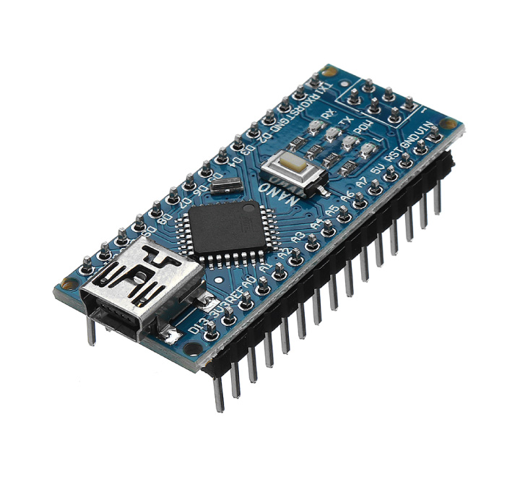

## Fig:3 – ARDUINO NANO

The Arduino Nano is a compact and breadboard-friendly board which is based on the ATmega328P.

It offers similar network and specs of the Arduino Uno board in a more modest structure factor.

The Arduino Nano is furnished with 30 male Input/Output headers in a dip-30 like configuration, which can be programmed using the Arduino Software integrated development environment (IDE), which is common to all arduino boards and running in online and offline mode. The board can be powered through a through a 9V battery, or by connecting a type-b micro-USB cable.

The Arduino Nano has various ways for communicating with a PC, another Arduino, or other microcontrollers. The ATmega328 give UART TTL (5V) serial communication, which is accessible on computerized pins 0 (RX) and 1 (TX). A FTDI FT232RL on the board channels this serial communication over USB and the FTDI drivers (included with the Arduino programming) give a virtual com port to programming on the PC. The Arduino programming incorporates a chronic screen which permits straightforward literary information to be shipped off and from the Arduino board.

The RX and TX LEDs on the board will blink when information is being sent by means of the FTDI chip and USB association with the PC (however not for sequential correspondence on pins 0 and 1). A SoftwareSerial library considers sequential correspondence on any of the Nano's advanced pins. The ATmega328 additionally uphold I2C (TWI) and SPI correspondence. The Arduino programming incorporates a Wire library to streamline utilization of the I2C transport.

Instead of requiring an actual press of the reset button before a transfer, the Arduino Nano is planned in a way that permits it to be reset by programming running on an associated PC. One of the equipment stream control lines (DTR) of the FT232RL is associated with the reset line of the ATmega328 through a 100 nanofarad capacitor. At the point when this line is stated (taken low), the reset line drops adequately long to reset the chip.

This arrangement has different ramifications. At the point when the Uno is associated with a PC running Mac OS X or Linux, it resets each time an association is made to it from programming (by means of USB). For the accompanying half-second or something like that, the bootloader is running on the Uno. While it is customized to overlook twisted information (for example anything other than a transfer of new code), it will block the initial not many bytes of information shipped off the board after an association is opened.

The pinout diagram of Arduino nano is as follows:

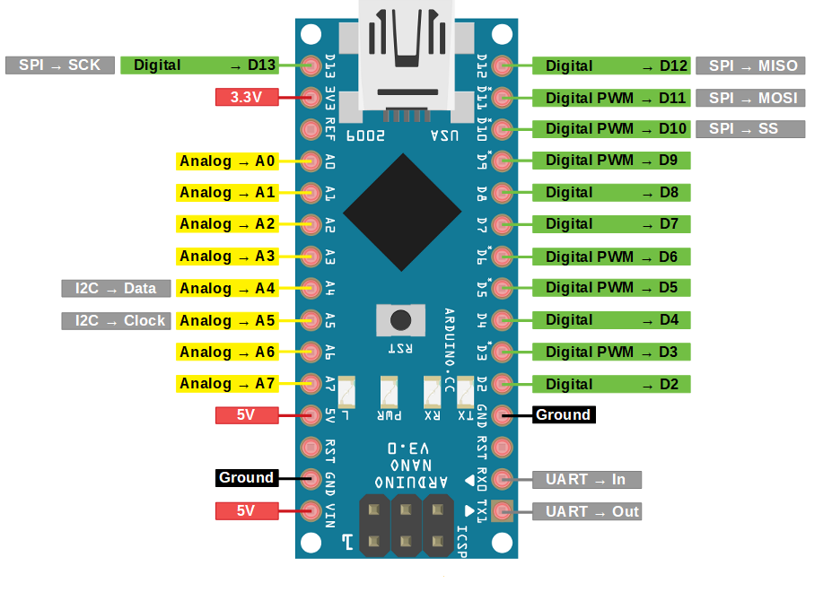

## Fig:4 –ARDUINO NANO PINOUT DIAGRAM

**2. GSM SIM900A MODULE:**

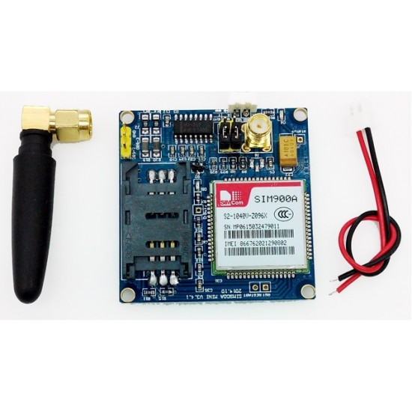

## Fig:5 – GSM SIM900A

SIM900A GSM Module is the littlest and least expensive module for GPRS/GSM correspondence. It is normal with Arduino and microcontroller in a large portion of implanted application. The module offers GPRS/GSM innovation for correspondence with the employments of a portable sim. It utilizes a 900 and 1800MHz recurrence band and permits clients to get/send versatile calls and SMS. The keypad and show interface permits the engineers to make the modify application with it. Besides, it likewise has modes, command mode and data mode. In each nation the GPRS/GSM and various conventions/frequencies to work. Order mode causes the designers to change the default setting as per their necessities.

This module is connected with +4.0V standard force supply. It can work upto +4.5V controlled force and any higher voltage may harm the module. Furthermore, the source should have the option to convey a peak current of 2A. The UART interface is set up as appeared in figure. You can simply interface RXD of module to TXD of Arduino and TXD is associated with RXD of ARDUINO. The ground of regulator and module should be associated for voltage reference. Here AUDIO IN is associated with MIC and AUDIO OUT is associated with a speaker or headset. Also, finally we need to associate a working GSM SIM card to the module. On driving the module the NETLIGHT LED will squint intermittently to state fruitful association. In this project, the TX pin of sim900A is connected to D7 and RX is connected to D8.

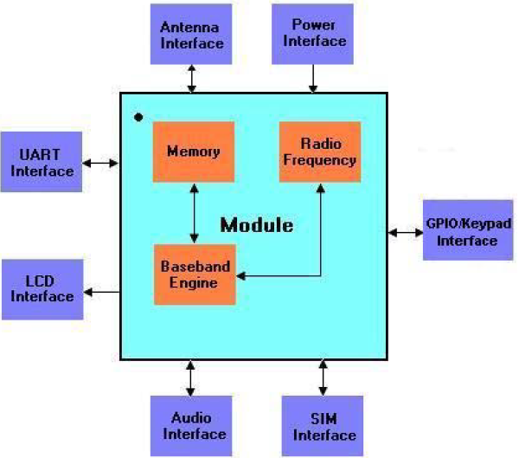**Fig:6 –GSM MODULE BLOCK DIAGRAM**

**3. PIEZO BUZZER:**

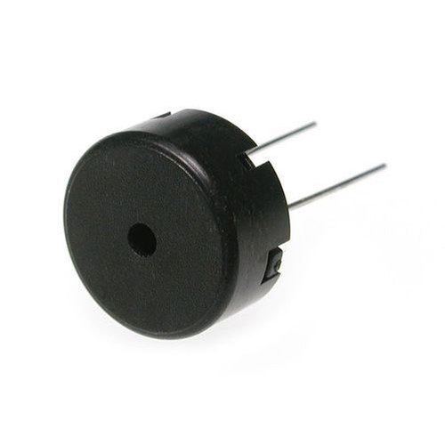

## Fig:7 – PIEZO BUZZER

a piezo buzzer is a kind of electronic gadget that is utilized to create a tone, alert or sound. It's lightweight with a basic development, and it's ordinarily an ease item. However simultaneously, contingent upon the piezo fired buzzer details, it's additionally solid and can be developed in a wide scope of sizes that work across shifting frequencies to create distinctive sound yields.

The utilization of the piezo buzzer was found gratitude to a reversal of the piezoelectricity rule that was found by Jacques and Pierre Curie in 1880. They found that power could be created when a mechanical weight was applied to specific materials — and the reverse was valid also.

So when certain piezoelectric materials are exposed to a substituting field of power, the piezo buzzer component — frequently a synthetic piezoceramic material — stretches and packs in succession with the recurrence of the flow. Thus, it delivers a discernible sound.

Not at all like attractive buzzers that have a limited working voltage of somewhere close to one and 16 volts, piezo buzzers can ordinarily work anyplace somewhere in the range of three and 250 volts. Moreover, attractive buzzers have a more powerful utilization of 30 to 100 milliamperes, while piezo buzzers typically burn-through under 30 milliamperes — even at higher rate frequencies. Also, in spite of the fact that piezo buzzers require a bigger impression than attractive buzzers, they produce a higher sound weight level.

**4. LDR ( LIGHT DEPENDENT RESISTOR) :**

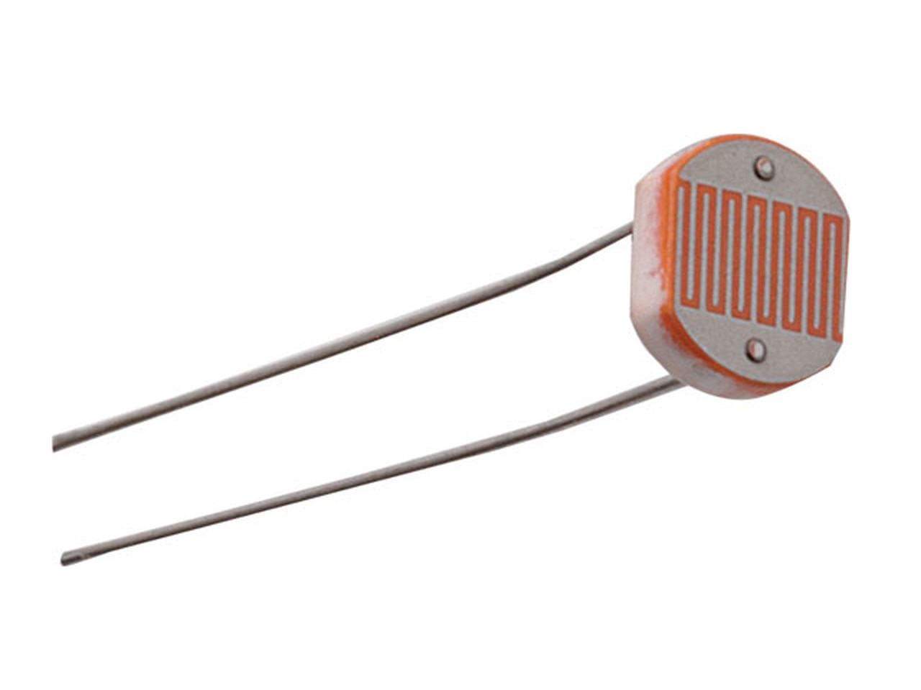

## Fig:8- LIGHT DEPENDENT RESISTOR

A photoresistor or light dependent resistor is an electronic segment whose value is sensitive to light. At the point when light falls upon it, at that point the opposition changes. Estimations of the opposition of the LDR may change over numerous significant degrees the estimation of the obstruction falling as the degree of light increments.

It isn't remarkable for the estimations of opposition of a LDR or photoresistor to be a few megohms in dimness and afterward to tumble to two or three hundred ohms in bright light. With quite a wide variety in opposition, LDRs are anything but difficult to utilize and there are numerous LDR circuits accessible. The affectability of light dependent resistors or photoresistors additionally changes with the frequency of the incident light.

LDRs are produced using semiconductor materials to empower them to have their light delicate properties. Numerous materials can be utilized, however one famous material for these photoresistors is cadmium sulfide, CdS, despite the fact that the utilization of these cells is presently confined in Europe on account of natural issues with the utilization of cadmium.

Likewise cadmium CdSe is additionally confined. Different materials that can be utilized incorporate lead sulfide, PbS and indium antimonide, InSb.

Albeit a semiconductor material is utilized for these photoresistors, they are simply latent gadgets since they don't have a PN intersection, and this isolates them from other photodetectors like photodiodes and phototransistors..

Ldr circuit symbol:

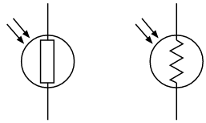

## Fig:9 – LDR symbol

**5. LASER MODULE KY-008:**

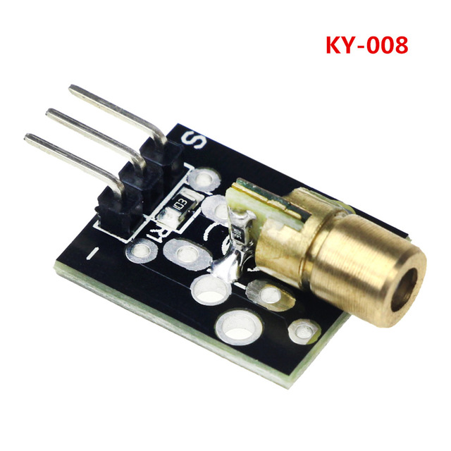

## Fig:10-KY-008 laser module

A laser module would incorporate at least one laser diodes just as some optical and electronic parts that are utilized for running the diodes and shaft molding. This is typically encased in a powerful walled in area.

The quantity of diodes utilized inside the module and its interior structure is about by module power yield, laser shaft boundaries such us size (distance across) and uniqueness, and by different properties that are set by the application the laser module is proposed for. The laser beam is produced from at least 1 semiconductor laser diodes, at that point optically formed, combined and adjusted to make a solitary and centered laser beam emerging from the gap. The nature of the yielded laser shaft is controlled by: quality and appropriateness of the producer (laser diode) nature of optical parts nature of module plan, skeleton and arrangement instruments, module temperature dependability and nature of driving gadgets the capacity of module maker to manage their responsibility competently enough, particularly with regards to arrangement Accuracy and mastery in planning, machining and gathering of laser modules are both basic for the nature of outcome

The KY-008 Laser transmitter module consists of a 650nm red laser diode head and a resistor.

Its features are:

* The Operating Voltage is 5V
* Dimensions of the KY-008 laser module are 18.5mm x 15mm
* The Output Power is5mW
* Wavelength of the laser is 650nm
* Operating Current less than 40mA
* Working Temperature -14°F to 104°F

**6. RESISTOR:**

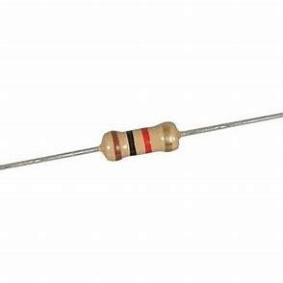

## Fig:11 - RESISTOR

Resistor is a passive element that is used to used to add resistance in an electrical circuit.

An ideal resistor follows OHM’s law i.e, V=I*R

They are used in electrical networks and electronic circuits.

Uses of resistor:

* Used to divide voltage
* Used to reduce current flow
* Adjust signal levels
* Terminate transmission line

In this experiment, we use 4 x 470Ω Resistors (1/4 Watt),8 x 100Ω Resistors (1/4 Watt)

**7. Jumper wires:**

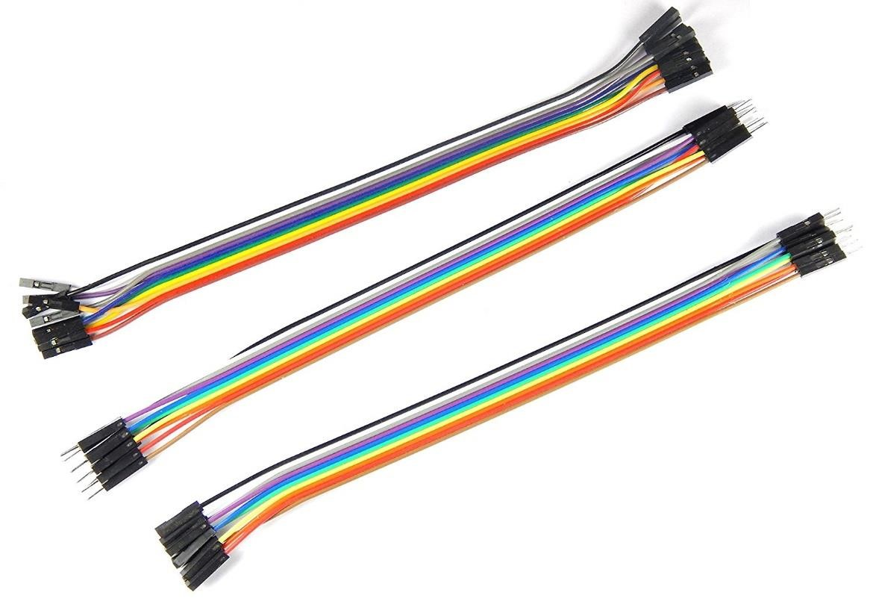

## Fig:12 – JUMPER WIRES

jumper wires are wires that have connectors or connecting pins at two ends. They allow connection between two points without the need 0f soldering.

There are three types 0f jumper wires:

Male-Male jumper wires- they have connector pins at each end

Male-Female/Female-Male jumper wires - they have 0ne connector at 0ne end and 0ne connector pin at the 0ther end.

Female-Female jumper wires- they have connectors at each end

# CONNECTION AND WORKING

In this model, the main components used are (a)Arduino nano (b)GSM SIM900A (c) LDR (d) laser module (e) piezo buzzer. The LDR is connected in series with a 10k ohm resistor which makes a voltage divider circuit and the input is given to A1 pin of the Arduino nano. A piezo buzzer is connected to analog pin A0 and to GND. A laser diode is connected to 5v and GND. The TX pin of GSM module is given to digital pin 7 and the RX pin is connected to digital pin 8 of the Arduino for communication. The 5v and GND of GSM module is connected to 5v and GND of the Arduino.

The LDR is connected in series with a 10k ohm resistor which makes a voltage divider circuit. Since, the LDR is a light dependent resistor as the name suggests and its resistance value changes with a change in the amount of light falling on it. Hence, a change in resistance of the LDR will result in change in the voltage. This change of voltage is monitored using the analog pin A1 of Arduino nano. So, when the laser is pointed toward the ldr the value observed in the analog pin greater than 1000 and when an obstruction is made then the value of ldr goes below 400. When this change is observed the Arduino is programmed to turn on the piezo buzzer and send an alert SMS to the registered mobile number. This continues as long as the obstruction is observed.

**SOFTWARE REQUIREMENTS:**

* Language**:** C or C++

**CODE:**

#include <SoftwareSerial.h>

SoftwareSerial SIM900(7, 8);

String textForSMS;

int data = 0;

const int buzzer = A0;

const int ldrpin = A1;

void setup() {

randomSeed(analogRead(0));

Serial.begin(9600);

SIM900.begin(9600);

Serial.println(" logging time completed!");

pinMode(buzzer, OUTPUT);

pinMode(ldrpin, INPUT);

}

void loop() {

data = analogRead(ldrpin);

Serial.println(data);

if ( data < 400)

{

textForSMS = "\nIntruder detected";

sendSMS(textForSMS);

Serial.println(textForSMS);

Serial.println("message sent.");

analogWrite(buzzer, data);

delay(5000);

noTone(buzzer);

}

}

void sendSMS(String message)

{

SIM900.print("AT+CMGF=1\r");

delay(1000);

SIM900.println("AT + CMGS = \"+917022134900\"");

delay(1000);

SIM900.println(message);

delay(1000);

SIM900.println((char)26);

delay(1000);

SIM900.println();

delay(100);

}

# ADVANTAGES

1. Not as bulky as other security sytems
2. Cheaper and more affordable compared to other systems
3. Provides high security
4. Consumes less power
5. Easy to maintain

**CONCLUSION**

Home security system plays a vital role in daily life of city dwellers. It makes life easy, comfortable and free from worry. The system was made using two layers of security. Our objective was to develop a security system which will provide both high security and be cheaper in cost. The proposed project is developed and works satisfactorily. Our model is less bulky and consumes less power and any damaged part can be easily removed and replaced.

# REFERENCES

**IJERT PAPER ON Development of GSM Based Advanced Alert Home Locker Safety Security System Using Arduino UNO by B.Rama Murthy, O.Jagadish, K.Tanveer Alam , V. Mahammad Dada , K. Priyanka Gandhi**

**Research gate paper on Design and Development of a Versatile and Intelligent Home Security System by Md. Khalid Hossain Jewel , Md. Niaz Mostakim , M. K. Rahman , Md. Shahjahan Ali ,**

**Sheikh Dobir Hossain , Md. Khalid Hossain , Himangshu Kumar Ghosh**

**Electronicsclinic.com**