**Intermediate output of map function**

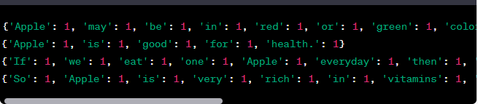

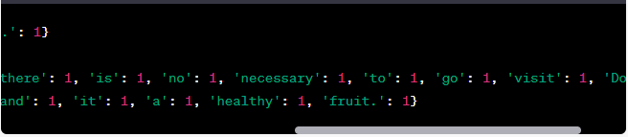

**Final output of map reduce function**

