**ROAD ACCIDENT ANALYSIS**

**OBJECTIVE:**

To gather insights from Road accident data for Stake holders to take Actions and Implement the Findings to avoid furthermore accidents and casualties. In this analysis we deep dive in to data and find Casualties by Road type, Area, Traffic controls and many more attributes.

**DATABASE & TOOLS:**

MS SQL Server

**Q1) Find Casualties happened on different road conditions.**

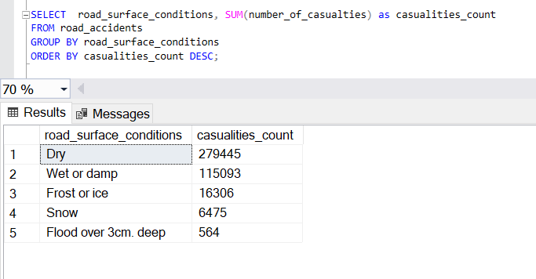

**Q2) Which day of the week has more number of Accidents. Arrange the data as highest first.**

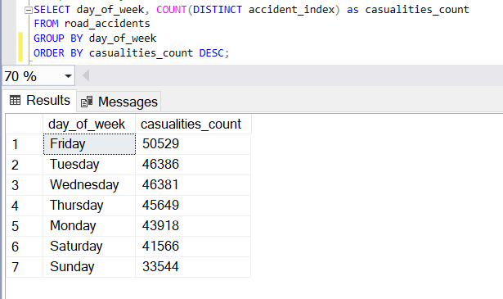

**Q3) Query to find Accidents happened in different road types.**

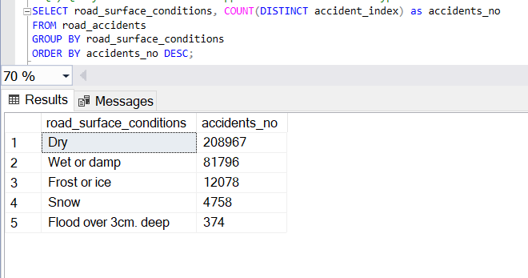

**Q4) Write a Query to Find No of accidents and casualties under different Traffic Controls.**

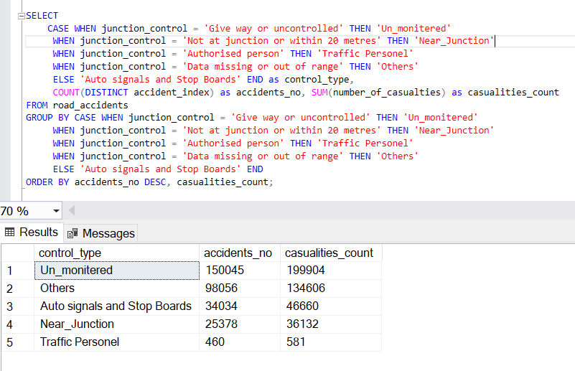

**Q5) Query to Find different casualties happened in the year 2022 with different severity and percentage.**

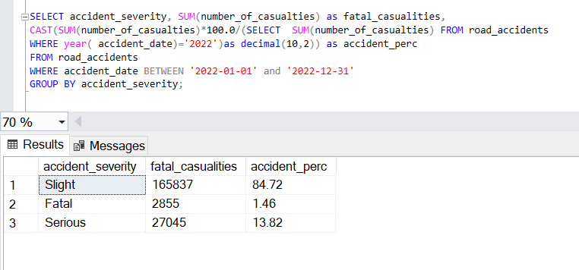

**Q6) Query to find Casualties by Vehicle Types in the Year 2022 and order them with higher count first.**

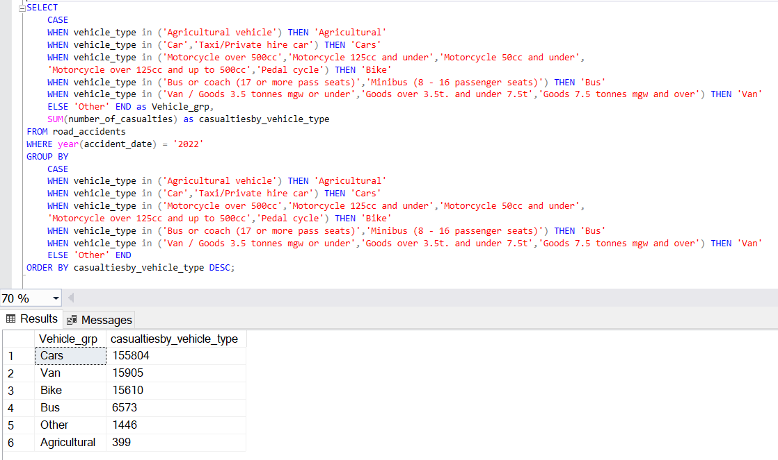

**Q7) Query to find Casualties by Road Types and Their Percentage.**

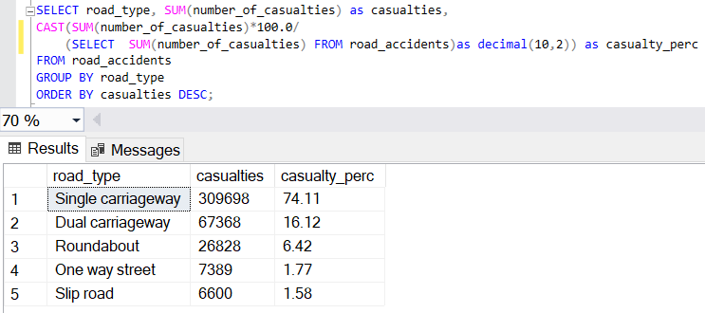

**Q8) Query to find MoM changes for 2021 to 2022.**

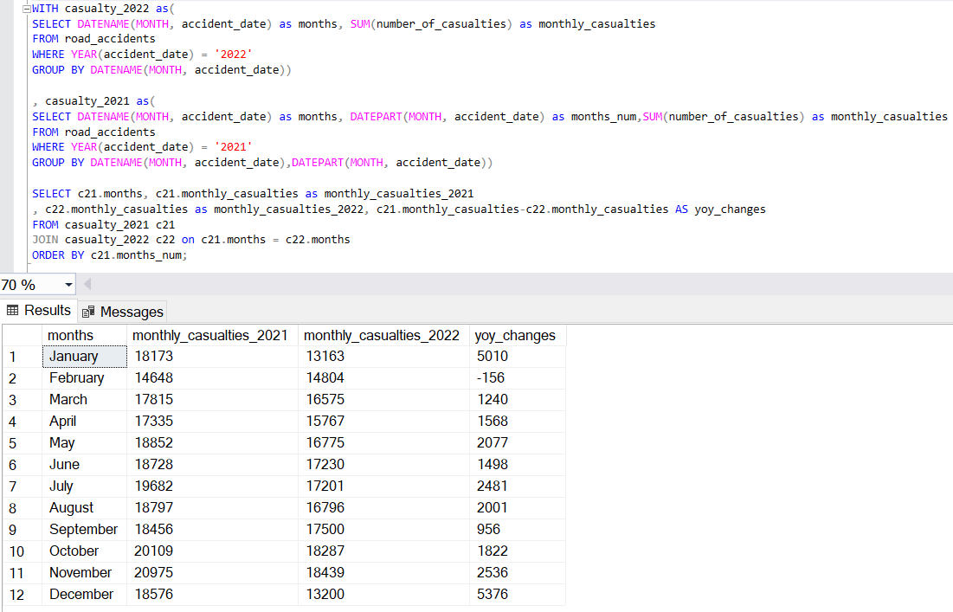

**Q9) Query to find Casualties by Areas.**

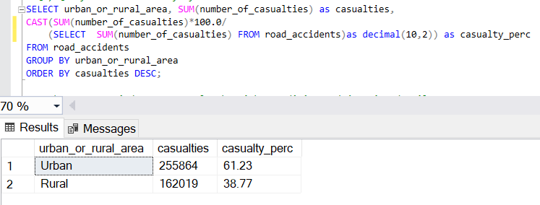

**Q10) Query to Find Top 5 Casualties by Light condition and Junction Details.**

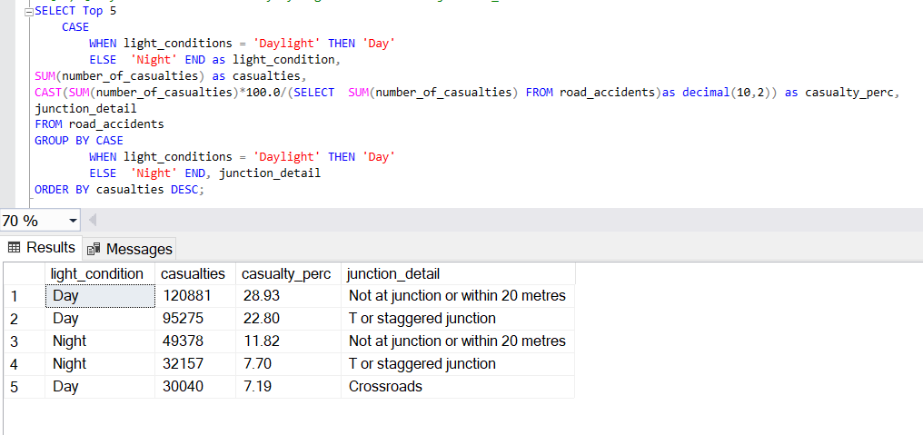

**Q11) Query to Find Top 10 Location by No of Casualties.**

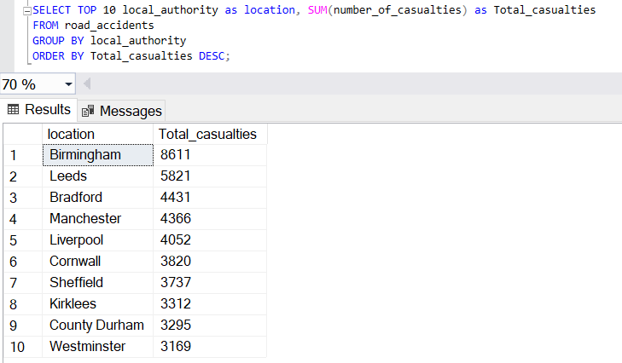

**Q12) Accidents happened under different Speed Limit and Traffic signal.**

