Netflix Content Analysis Dashboard
An Exploratory Data Analysis using Power BI

Prepared by:
Sanjay Kandimalla

Dataset:
Netflix Movies and TV Shows Dataset

1. Project Overview
This project presents an end-to-end exploratory and visual analysis of Netflix’s content catalog using Power BI.
The objective is to understand how Netflix’s content has evolved over time, how it is distributed across movies and TV shows, how content characteristics vary (ratings, duration, seasons), and how Netflix’s presence differs globally.
The analysis is delivered through three interactive dashboards, each focusing on a distinct analytical theme.

2. Dataset Description
- Source: Netflix Movies and TV Shows dataset
- Granularity: One record per title
- Key Fields Used:
  - show_id
  - type (Movie / TV Show)
  - release_year
  - rating
  - movie_duration
  - tv_seasons
  - genre
  - country
Data Modeling Approach
- Fact table: titles_fact
- Dimension tables:
  - genre_dim
  - country_dim
- Relationships were defined using show_id
- Measures created using DAX, including:
  - Total Titles
  - Total Movies
  - Total TV Shows
  - Latest Content Year

3. Dashboard 1: Content Overview
Purpose
Provide a high-level summary of Netflix’s catalog and its growth over time.
Key Visuals
- KPI Cards:
  - Total Titles
  - Total Movies
  - Total TV Shows
  - Latest Content Year
- Line Chart: Netflix Content Growth Over Time
- Donut Chart: Movies vs TV Shows
- Bar Chart: Top Movie Genres on Netflix
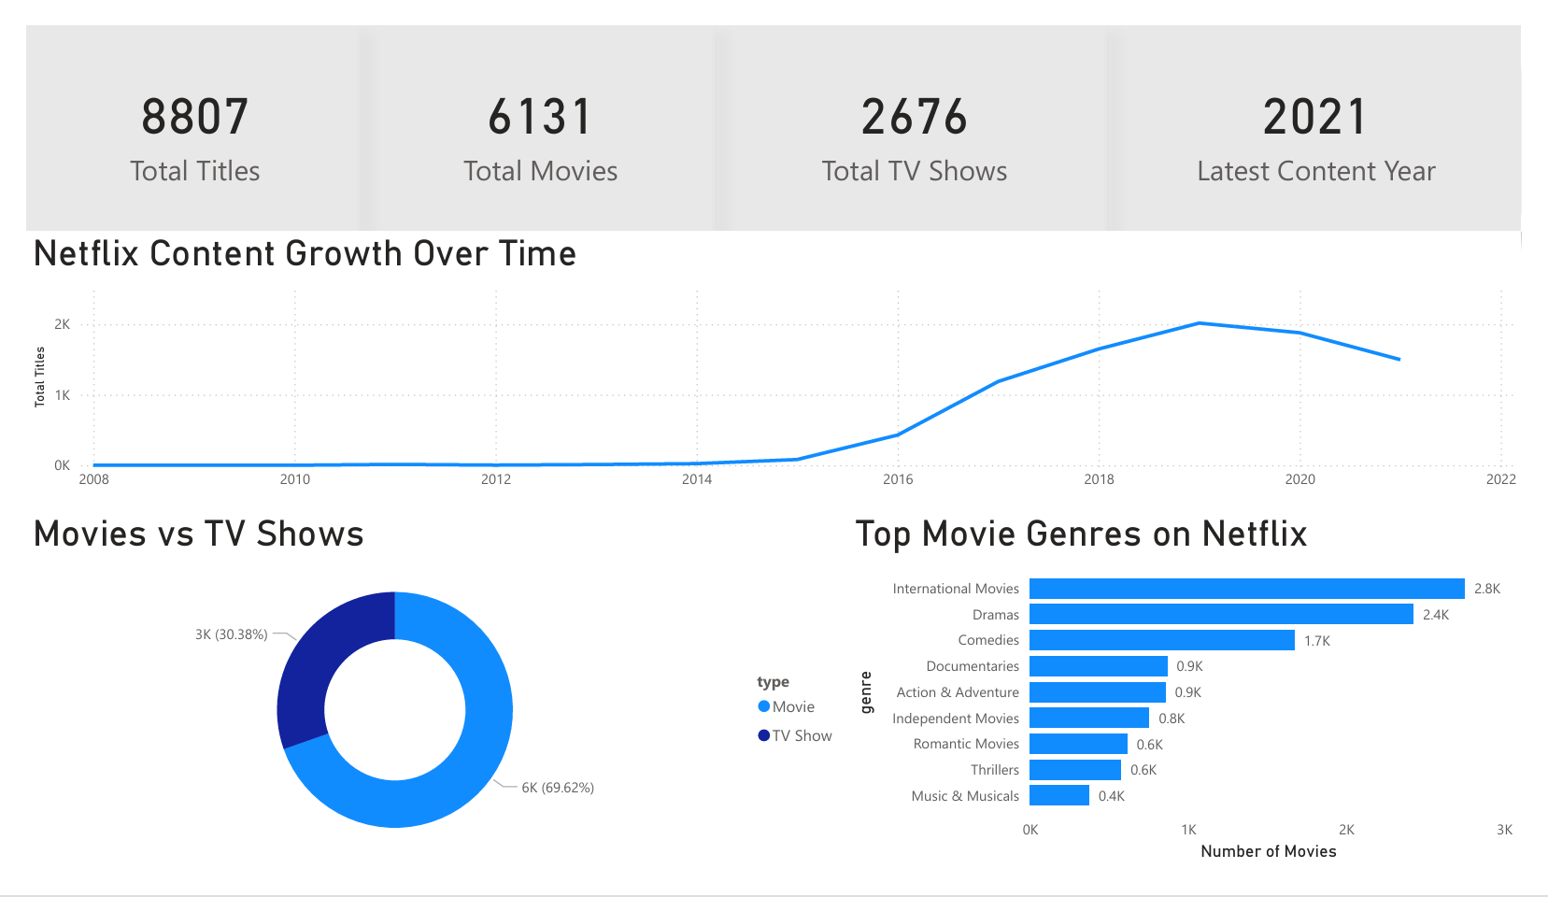

Key Insights
- Netflix hosts 8,807 total titles, with movies accounting for ~70% of the catalog.
- Content growth was relatively slow until 2014, followed by rapid expansion after 2015.
- The number of new titles peaked around 2019, with a slight decline afterward.
- International Movies and Dramas dominate Netflix’s movie catalog, reflecting a strong focus on global audiences.

4. Dashboard 2: Content Characteristics
Purpose
Analyze qualitative and structural properties of Netflix content.
Key Visuals
- Line Chart: Total Titles by Release Year and Type
- Histogram / Column Chart: TV Shows by Number of Seasons
- Stacked Bar Chart: Movies vs TV Shows by Rating
- Bar Chart: Movie Duration Buckets
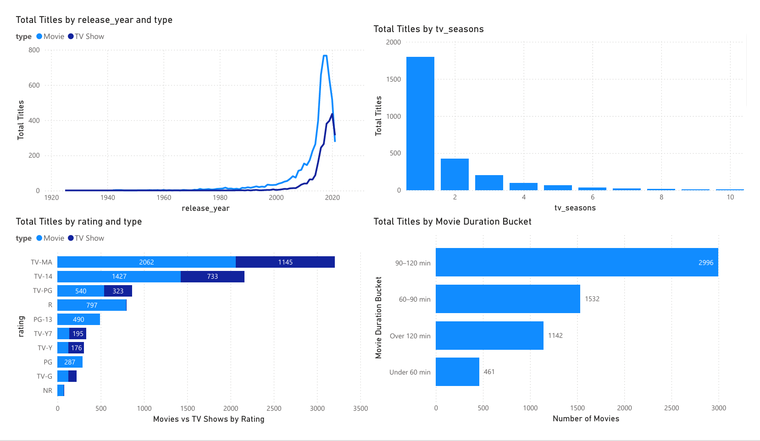

Key Insights
- Both movies and TV shows increased sharply in recent decades, with movies consistently outpacing TV shows.
- The majority of TV shows have 1–2 seasons, indicating Netflix’s preference for limited or short-run series.
- TV-MA and TV-14 are the most common ratings, showing a strong focus on mature audiences.
- Most movies fall within the 90–120 minute duration range, aligning with standard feature-length formats.

5. Dashboard 3: Global Distribution
Purpose
Examine Netflix’s geographic reach and country-level content distribution.
Key Visuals
- World Map: Netflix Global Content Distribution
- Horizontal Bar Chart: Top 10 Countries by Number of Titles
- Slicers:
  - Content Type (Movie / TV Show)
  - Release Year Range
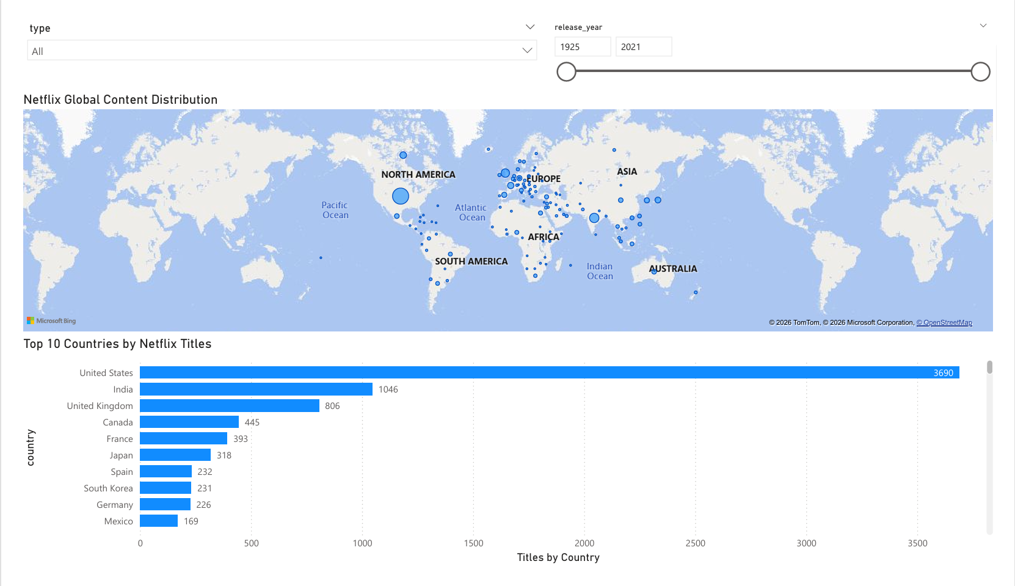
Key Insights
- The United States dominates Netflix’s catalog, followed by India and the United Kingdom.
- Strong content presence is observed across Europe and Asia, highlighting Netflix’s global expansion strategy.
- Interactive slicers allow users to explore how content distribution changes by content type and time period.
6. Design & Visualization Decisions
- Misleading visuals (e.g., genre share percentages across multi-genre titles) were intentionally removed.
- Genre analysis was restricted to movies only to avoid incorrect attribution.
- Slicers were added only where they add analytical value, avoiding unnecessary clutter.
- Dashboards were aligned for consistency in spacing, fonts, and layout.

7. Business Takeaways
- Netflix prioritizes movies over long-running TV series, likely to support binge-watching behaviour.
- Strong emphasis on international content reflects a global growth strategy.
- Mature audience ratings dominate the platform, suggesting targeted content production.
- Limited-season TV shows reduce production risk while maintaining audience engagement.

8. Conclusion
This Power BI project demonstrates how interactive dashboards can be used to derive meaningful insights from large entertainment datasets.
Through careful data modeling, thoughtful visualization choices, and structured storytelling, the analysis highlights Netflix’s strategic focus on growth, global expansion, and content optimization.
The project is designed to be portfolio-ready, interactive, and aligned with real-world business analysis standards.
9. Tools & Technologies Used
- Power BI
- DAX
- Data Modeling (Star Schema)
- Data Visualization Best Practices

