1)

import java.util.*;

import java.lang.*;

public class prgm1{

public static void main(String ar[]){

Scanner sc=new Scanner(System.in);

String mstr="";

int min=Integer.MAX_VALUE;

char c;

int n=sc.nextInt();

String[] sar=new String[n];

for(int i=0;i<n;i++){

sar[i]=sc.next();

if(min>sar[i].length()){

mstr=sar[i];

min=sar[i].length();

}

}

String suff="";

int u=0;byte f=0;

for(int j=mstr.length()-1;j>=0;j--){

c=mstr.charAt(j);

for(int i=0;i<sar.length;i++){

if(sar[i].charAt(sar[i].length()-u-1)==c){

f=1;

}

else{

f=0;

break;

}

}

if(f==1){

suff=c+suff;

}

u++;

}

System.out.println(suff);

}

}

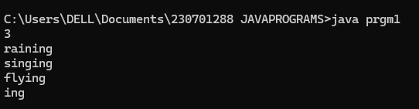

2)

import java.util.*;

import java.lang.*;

public class prgm1{

public static void main(String ar[]){

Scanner sc=new Scanner(System.in);

String s = sc.nextLine();

String[] sar=s.split(" ");

for(String w:sar){

if(w.length()%2==0){

System.out.println(w);

}

}

}

}

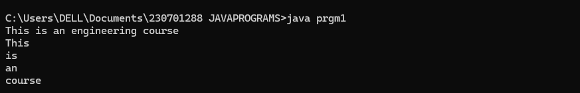

3)

import java.util.*;

public class prgm{

    public static void main(String ar[]){

        StringBuffer sb = new StringBuffer("Rajalakshmi");

sb.append(" College, Kanchipuram");

sb.insert(1, "Engineering ");

int start = sb.indexOf("Kanchipuram");

int end = start + "Kanchipuram".length();

sb.replace(start, end, "Chennai");

sb.delete(sb.indexOf("Chennai"),

sb.indexOf("Chennai") + "Chennai".length());

System.out.println(sb.reverse());

    }

}

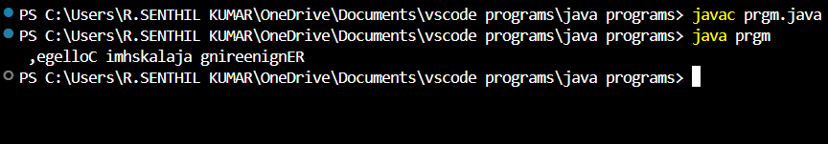

4)

import java.util.*;

public class prgm{

    public static void main(String ar[]){

        Scanner sc = new Scanner(System.in);

        String str = sc.nextLine();

sc.close();

String[] wds = str.split(" ");

StringBuilder sb = new StringBuilder();

for (String w : wds) {

if (w.length() <= 2) {

sb.append(w.toLowerCase());

} else {

sb.append(Character.toUpperCase(w.charAt(0)));

sb.append(w.substring(1).toLowerCase());

}

sb.append(" ");

}

System.out.println(sb.toString().trim());

    }

}

