**CE1:**

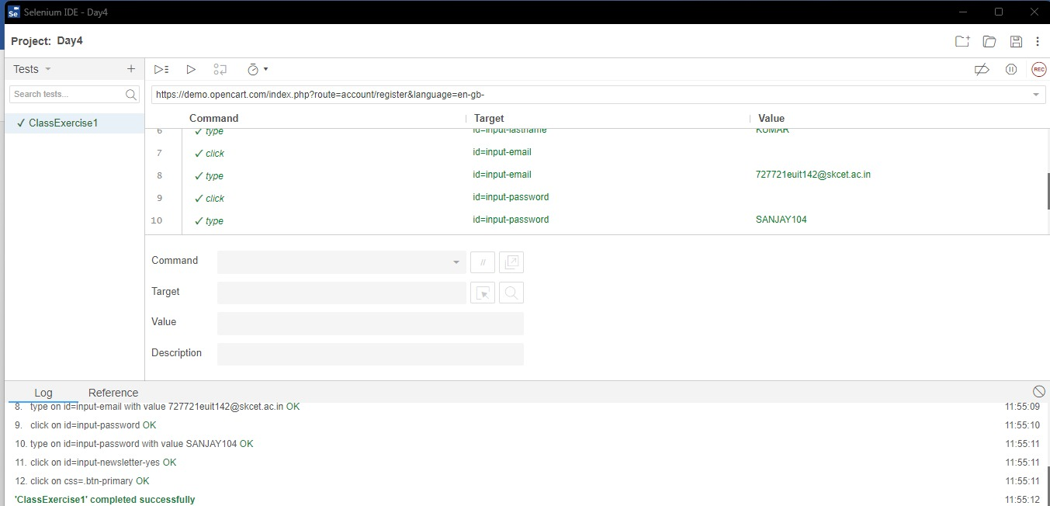

**CE2:**

**package** com.test.ClassExercise;

**import** org.openqa.selenium.By;

**import** org.openqa.selenium.JavascriptExecutor;

**import** org.openqa.selenium.WebDriver;

**import** org.openqa.selenium.WebElement;

**import** org.openqa.selenium.chrome.ChromeDriver;

**import** org.openqa.selenium.chrome.ChromeOptions;

**import** io.github.bonigarcia.wdm.WebDriverManager;

**public** **class** CE2

{

**public** **static** **void** main( String[] args ) **throws** InterruptedException

{

ChromeOptions co=**new** ChromeOptions();

co.addArguments ("--remote-allow-origins=*");

WebDriverManager.*chromedriver*().setup ();

WebDriver driver=**new** ChromeDriver(co);

driver.get("https://demo.opencart.com/index.php?route=account/register&language=en-gb");

driver.manage().window().maximize();

WebElement fname=driver.findElement(By.*id*("input-firstname"));

fname.sendKeys("SANJAY KUMAAR");

WebElement lname=driver.findElement(By.*id*("input-lastname"));

lname.sendKeys("P");

WebElement email=driver.findElement(By.*cssSelector*("input#input-email"));

email.sendKeys("727721euit139@skcet.ac.in");

JavascriptExecutor js= (JavascriptExecutor) driver;

js.executeScript("window.scrollBy (0,1000)", "");

Thread.*sleep*(2000);

driver.findElement(By.*id*("input-password")).sendKeys("Sanjay123");

Thread.*sleep*(2000);

driver.findElement(By.*id*("input-newsletter-yes")).click();

Thread.*sleep*(2000);

driver.findElement(By.*name*("agree")).click();

Thread.*sleep*(2000);

driver.findElement(By.*xpath*("//*[@id=\"form-register\"]/div/div/button")).click();

}

}

**CE3:**

**package** com.test.ClassExercise;

**import** org.openqa.selenium.By;

**import** org.openqa.selenium.JavascriptExecutor;

**import** org.openqa.selenium.WebDriver;

**import** org.openqa.selenium.chrome.ChromeDriver;

**import** org.openqa.selenium.chrome.ChromeOptions;

**import** io.github.bonigarcia.wdm.WebDriverManager;

**public** **class** CE3 {

**public** **static** **void** main(String[] args) **throws** InterruptedException {

ChromeOptions co=**new** ChromeOptions();

co.addArguments("--remote-allow-origins=*");

WebDriverManager.*chromedriver*().setup();

WebDriver driver=**new** ChromeDriver(co);

driver.get("https://demo.opencart.com/index.php?route=checkout/voucher&language=en-gb");

driver.manage() .window().maximize() ;

driver.findElement(By.*xpath*("//input[@id=\"input-to-name\"]")).sendKeys ("Sanjay");

JavascriptExecutor js= (JavascriptExecutor) driver;

js.executeScript("window.scrollBy (0,500)", "");

Thread.*sleep*(5000);

driver.findElement(By.*xpath*("//input[@id=\"input-theme-6\"]")).click();

}

}

**CE4:**

**package** com.test.ClassExercise;

**import** org.openqa.selenium.JavascriptExecutor;

**import** org.openqa.selenium.WebDriver;

**import** org.openqa.selenium.chrome.ChromeDriver;

**import** org.openqa.selenium.chrome.ChromeOptions;

**import** io.github.bonigarcia.wdm.WebDriverManager;

**public** **class** CE4

{

**public** **static** **void** main(String[] args) **throws** InterruptedException

{

ChromeOptions co=**new** ChromeOptions();

co.addArguments ("--remote-allow-origins=*");

WebDriverManager.*chromedriver*().setup ();

WebDriver driver=**new** ChromeDriver(co);

driver.get ("https://j2store.net/free/");

driver.manage().window().maximize();

JavascriptExecutor js= (JavascriptExecutor) driver;

js.executeScript("window.scrollBy (0,1000)", "");

Thread.*sleep*(3000);

driver.navigate().to("https://j2store.net/free/index.php/shop?filter_catid=11");

Thread.*sleep*(3000);

driver.navigate().back();

Thread.*sleep*(3000);

driver.navigate().forward();

Thread.*sleep*(3000);

driver.navigate().refresh();

Thread.*sleep*(3000);

driver.close();

}

}

**CE5.1:**

package com.test.ClassExercise;

import org.openqa.selenium.By;

import org.openqa.selenium.WebDriver;

import org.openqa.selenium.chrome.ChromeDriver;

import org.openqa.selenium.chrome.ChromeOptions;

import io.github.bonigarcia.wdm.WebDriverManager;

public class CE5_1 {

public static void main(String[] args)throws InterruptedException {

ChromeOptions co=new ChromeOptions();

co.addArguments("--remote-allow-origins=*");

WebDriverManager.chromedriver().setup();

WebDriver d=new ChromeDriver(co);

d.get("https://j2store.net/free/");

d.manage().window().maximize();

String CurrentUrl=d.getCurrentUrl();

String ExpectedUrl="https://j2store.net/free/";

if(CurrentUrl.equals(ExpectedUrl))

{

System.out.println("URL MATCHED.");

}

else

{

System.out.println("URL NOT MATCHED.");

}

d.findElement(By.xpath("//*[@id=\"Mod112\"]/div/div/ul/li[1]/a")).click();

String CUrl=d.getCurrentUrl();

String EUrl="https://j2store.net/free/index.php/shop?filter_catid=11";

if(CUrl.equals(EUrl))

{

System.out.println("URL MATCHED.");

}

else

{

System.out.println("URL NOT MATCHED.");

}

d.close();

}

}

**Output:**

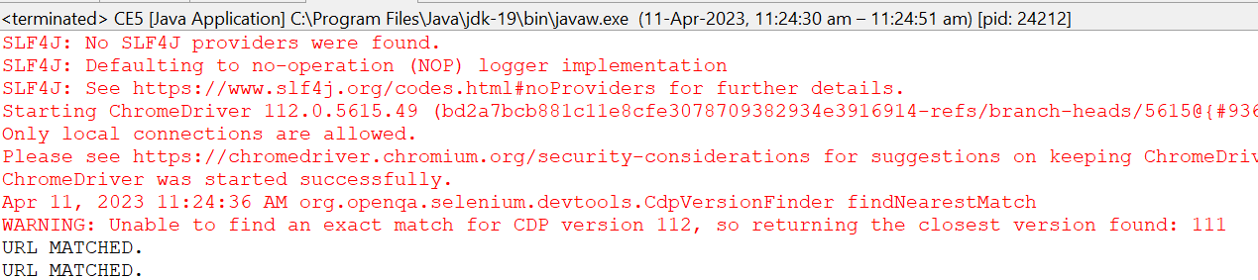

**CE5.2:**

**package** com.test.ClassExercise;

**import** org.openqa.selenium.By;

**import** org.openqa.selenium.WebDriver;

**import** org.openqa.selenium.WebElement;

**import** org.openqa.selenium.chrome.ChromeDriver;

**import** org.openqa.selenium.chrome.ChromeOptions;

**import** java.util.*;

**import** io.github.bonigarcia.wdm.WebDriverManager;

**public** **class** CE5_2 {

**public** **static** **void** main(String []Args) {

ChromeOptions co=**new** ChromeOptions();

co.addArguments("--remote-allow-origins=*");

WebDriverManager.*chromedriver*().setup();

WebDriver driver =**new** ChromeDriver(co);

driver.get("https://j2store.net/free/");

WebElement el6= driver.findElement(By.*linkText*("Clothing (5)"));

el6.click();

List<WebElement> li=driver.findElements(By.*xpath*("//h2[@itemprop=\"name\"]"));

**for**(WebElement e:li) {

System.***out***.println(e.getText());

}

}

}

**Output:**

