**CE1:**

package com.test.ClassExercise;

import org.openqa.selenium.By;

import org.openqa.selenium.WebDriver;

import org.openqa.selenium.WebElement;

import org.openqa.selenium.chrome.ChromeDriver;

import org.openqa.selenium.chrome.ChromeOptions;

import org.openqa.selenium.interactions.Actions;

import io.github.bonigarcia.wdm.WebDriverManager;

public class D5_CE1 {

public static void main(String[] args) throws InterruptedException{

WebDriverManager.chromedriver().setup();

ChromeOptions co=new ChromeOptions();

co.addArguments("--remote-allow-origins=*");

WebDriver driver=new ChromeDriver(co);

driver.get("https://demoqa.com/droppable/");

driver.manage().window().maximize();

WebElement drag=driver.findElement(By.id("draggable"));

WebElement drop=driver.findElement(By.id("droppable"));

Actions a=new Actions(driver);

a.dragAndDrop(drag, drop).build().perform();

}

}

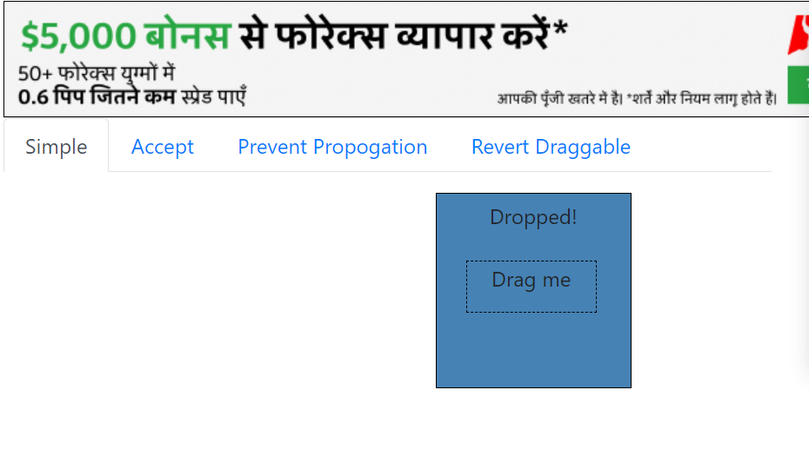

**CE2:**

**package** com.test.ClassExercise;

**import** org.openqa.selenium.By;

**import** org.openqa.selenium.WebDriver;

**import** org.openqa.selenium.WebElement;

**import** org.openqa.selenium.chrome.ChromeDriver;

**import** org.openqa.selenium.chrome.ChromeOptions;

**import** org.openqa.selenium.interactions.Actions;

**import** io.github.bonigarcia.wdm.WebDriverManager;

**public** **class** D5_CE2 {

**public** **static** **void** main(String[] args) **throws** InterruptedException{

WebDriverManager.*chromedriver*().setup();

ChromeOptions co=**new** ChromeOptions();

co.addArguments("--remote-allow-origins=*");

WebDriver driver=**new** ChromeDriver(co);

driver.get("https://jqueryui.com/droppable/");

driver.manage().window().maximize();

driver.switchTo().frame(0);

WebElement drag=driver.findElement(By.*id*("draggable"));

WebElement drop=driver.findElement(By.*id*("droppable"));

Actions a=**new** Actions(driver);

a.dragAndDrop(drag, drop).build().perform();

}

}

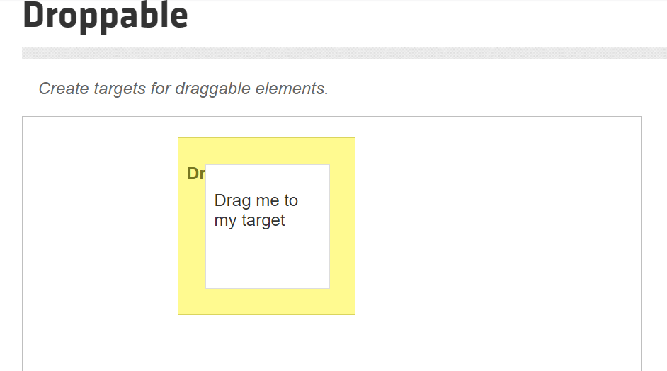

**CE3:**

**package** com.test.ClassExercise;

**import** org.openqa.selenium.Alert;

**import** org.openqa.selenium.By;

**import** org.openqa.selenium.WebDriver;

**import** org.openqa.selenium.WebElement;

**import** org.openqa.selenium.chrome.ChromeDriver;

**import** org.openqa.selenium.chrome.ChromeOptions;

**import** io.github.bonigarcia.wdm.WebDriverManager;

**public** **class** D5_CE3 {

**public** **static** **void** main(String[] args) **throws** InterruptedException{

WebDriverManager.*chromedriver*().setup();

ChromeOptions co=**new** ChromeOptions();

co.addArguments("--remote-allow-origins=*");

WebDriver driver=**new** ChromeDriver(co);

driver.get("https://demo.guru99.com/test/delete_customer.php");

driver.manage().window().maximize();

WebElement txtBox1=driver.findElement(By.*name*("cusid"));

txtBox1.sendKeys("401");

WebElement submitBtn=driver.findElement(By.*name*("submit"));

submitBtn.click();

Alert alert1=driver.switchTo().alert();

Thread.*sleep*(3000);

alert1.dismiss();

txtBox1.sendKeys("402");

submitBtn.click();

Alert alert2=driver.switchTo().alert();

alert2.accept();

Alert alert3=driver.switchTo().alert();

String txt=alert3.getText();

alert3.accept();

System.***out***.println(txt);

}

}

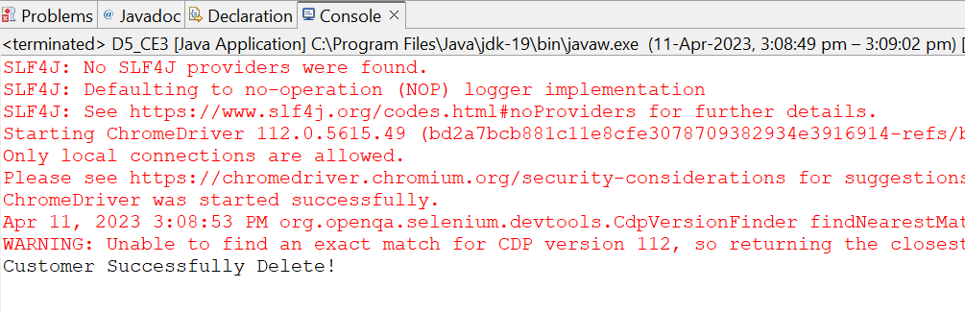

**CE4:**

**package** com.test.ClassExercise;

**import** org.openqa.selenium.By;

**import** org.openqa.selenium.WebDriver;

**import** org.openqa.selenium.WebElement;

**import** org.openqa.selenium.chrome.ChromeDriver;

**import** org.openqa.selenium.chrome.ChromeOptions;

**import** io.github.bonigarcia.wdm.WebDriverManager;

**public** **class** D5_CE4 {

**public** **static** **void** main(String[] args) **throws** InterruptedException {

WebDriverManager.*chromedriver*().setup();

ChromeOptions co=**new** ChromeOptions();

co.addArguments("--remote-allow-origins=*");

WebDriver driver=**new** ChromeDriver(co);

driver.get("https://www.abhibus.com/bus-ticket-booking");

driver.manage().window().maximize();

WebElement submitBtn=driver.findElement(By.*xpath*("//*[@id=\"datepicker1\"]"));

submitBtn.click();

WebElement submitBt=driver.findElement(By.*xpath*("//*[@id=\"ui-datepicker-div\"]/div[1]/table/tbody/tr[3]/td[5]/a"));

submitBt.click();

WebElement from=driver.findElement(By.*xpath*("//*[@id=\"source\"]"));

from.sendKeys("Coimabatore");

WebElement to=driver.findElement(By.*xpath*("//*[@id=\"destination\"]"));

to.sendKeys("Dharmapuri");

}

}

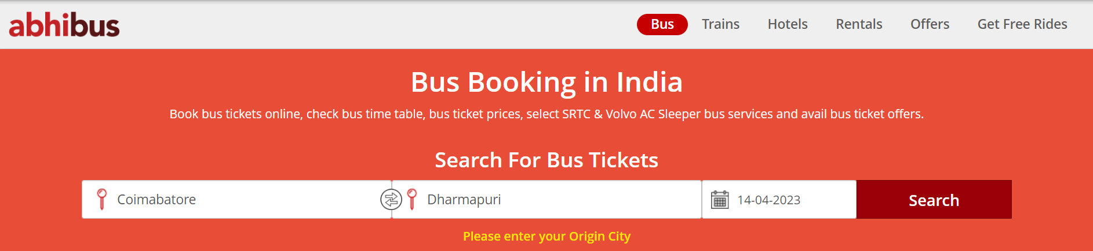

**CE5:**

**package** com.test.ClassExercise;

**import** org.openqa.selenium.By;

**import** org.openqa.selenium.Keys;

**import** org.openqa.selenium.WebDriver;

**import** org.openqa.selenium.WindowType;

**import** org.openqa.selenium.chrome.ChromeDriver;

**import** org.openqa.selenium.chrome.ChromeOptions;

**import** io.github.bonigarcia.wdm.WebDriverManager;

**public** **class** D5_CE5 {

**public** **static** **void** main(String[] args) **throws** InterruptedException {

WebDriverManager.*chromedriver*().setup();

ChromeOptions co=**new** ChromeOptions();

co.addArguments("--remote-allow-origins=*");

WebDriver driver=**new** ChromeDriver(co);

driver.get("https://www.google.com/");

driver.manage().window().maximize();

driver.findElement(By.*name*("q")).sendKeys("Apple");

driver.findElement(By.*name*("q")).sendKeys(Keys.***ENTER***);

System.***out***.println(driver.getWindowHandle());

System.***out***.println(driver.getTitle());

driver.switchTo().newWindow(WindowType.***TAB***);

driver.get("https://www.google.com/");

driver.manage().window().maximize();

driver.findElement(By.*name*("q")).sendKeys("Selenium");

driver.findElement(By.*name*("q")).sendKeys(Keys.***ENTER***);

System.***out***.println("/n"+driver.getWindowHandle());

System.***out***.println("\n"+driver.getTitle());

driver.switchTo().newWindow(WindowType.***TAB***);

driver.get("https://www.google.com/");

driver.manage().window().maximize();

driver.findElement(By.*name*("q")).sendKeys("Cucumber");

driver.findElement(By.*name*("q")).sendKeys(Keys.***ENTER***);

System.***out***.println("/n"+driver.getWindowHandle());

System.***out***.println("\n"+driver.getTitle());

}

}

