**CE1:**

**package** com.test.ClassExercise;

**import** org.testng.annotations.Test;

**import** org.testng.Assert;

**import** org.testng.annotations.DataProvider;

**public** **class** Day9_CE1 {

@Test(dataProvider = "dp")

**public** **void** add(Integer n1, Integer n2) {

**int** n3=n1+n2;

**int** n4=30;

Assert.*assertEquals*(n3, n4);

System.***out***.println("add: "+n3);

}

@Test(dataProvider = "dp")

**public** **void** sub(Integer n1, Integer n2) {

**int** n3=n1-n2;

**int** n4=-10;

Assert.*assertEquals*(n3, n4);

System.***out***.println("sub: "+n3);

}

@Test(dataProvider = "dp")

**public** **void** mul(Integer n1, Integer n2) {

**int** n3=n1*n2;

**int** n4=200;

Assert.*assertEquals*(n3, n4);

System.***out***.println("mul: "+n3);

}

@Test(dataProvider = "dp")

**public** **void** div(Integer n1, Integer n2) {

**int** n3=n1/n2;

**int** n4=0;

Assert.*assertEquals*(n3, n4);

System.***out***.println("div: "+n3);

}

@DataProvider

**public** Object[][] dp() {

**return** **new** Object[][] {

**new** Object[] { 10, 20 },

};

}

}

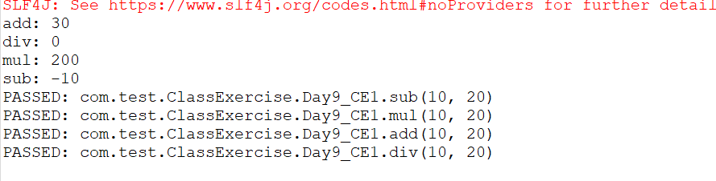

**CE2:**

**package** com.test.ClassExercise;

**import** java.util.concurrent.TimeUnit;

**import** org.openqa.selenium.By;

**import** org.openqa.selenium.WebDriver;

**import** org.openqa.selenium.chrome.ChromeDriver;

**import** org.openqa.selenium.chrome.ChromeOptions;

**import** org.testng.Assert;

**import** org.testng.annotations.Test;

**import** io.github.bonigarcia.wdm.WebDriverManager;

**public** **class** Day9_CE2 {

WebDriver driver;

@Test

**public** **void** testCase1() {

WebDriverManager.*chromedriver*().setup();

WebDriver driver;

ChromeOptions co = **new** ChromeOptions();

co.addArguments("--remote-allow-origins=*");

driver=**new** ChromeDriver(co);

driver.get("https://www.godaddy.com/en-in");

driver.manage().window().maximize();

String actualTitle="Domain Names, Websites, Hosting & Online Marketing Tools - GoDaddy IN";

String extractedTitle=driver.getTitle();

Assert.*assertEquals*(actualTitle, extractedTitle);

String actualURL="https://www.godaddy.com/en-in";

String extractedURL=driver.getCurrentUrl();

Assert.*assertEquals*(actualURL, extractedURL);

System.***out***.println("Hello");

driver.quit();

}

@Test

**public** **void** testCase2() **throws** InterruptedException{

WebDriverManager.*chromedriver*().setup();

WebDriver driver;

ChromeOptions co = **new** ChromeOptions();

co.addArguments("--remote-allow-origins=*");

driver=**new** ChromeDriver(co);

driver.get("https://www.godaddy.com/en-in");

driver.manage().window().maximize();

driver.manage().timeouts().~~implicitlyWait~~(30, TimeUnit.***SECONDS***);

driver.findElement(By.*xpath*("//*[@id=\"id-631b049a-e9c0-4d24-8710-c504745206dd\"]/div[2]/div[1]/ul/li[1]/button")).click();

driver.findElement(By.*linkText*("Domain Name Search")).click();

}

@Test

**public** **void** testCase3() **throws** InterruptedException{

WebDriverManager.*chromedriver*().setup();

WebDriver driver;

ChromeOptions co = **new** ChromeOptions();

co.addArguments("--remote-allow-origins=*");

driver=**new** ChromeDriver(co);

driver.get("https://www.godaddy.com/en-in");

driver.manage().window().maximize();

driver.manage().timeouts().~~implicitlyWait~~(30, TimeUnit.***SECONDS***);

driver.findElement(By.*xpath*("//*[@id=\"id-631b049a-e9c0-4d24-8710-c504745206dd\"]/div[2]/div[1]/ul/li[1]/button")).click();

driver.findElement(By.*linkText*("Domain Name Search")).click();

String actualTitle="Domain Names, Websites, Hosting & Online Marketing Tools - GoDaddy IN";

String extractedTitle=driver.getTitle();

Assert.*assertEquals*(actualTitle, extractedTitle);

String actualURL="https://www.godaddy.com/en-in";

String extractedURL=driver.getCurrentUrl();

Assert.*assertEquals*(actualURL, extractedURL);

}

}

