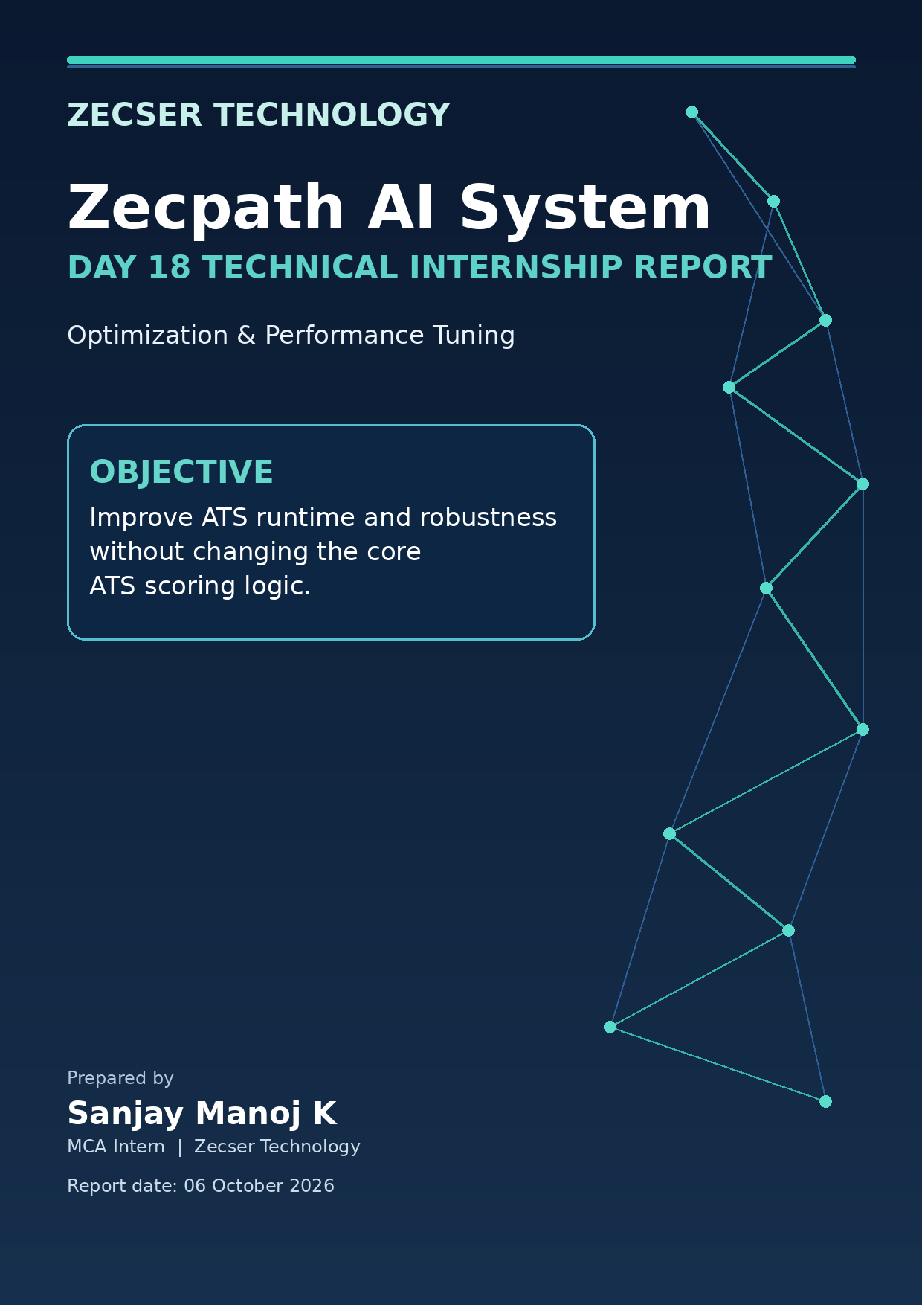

TABLE OF CONTENTS

1. Executive Summary ..................................................3
2. Day 18 Scope and Requirements ..........................4
3. Work Completed and Implementation ..................5
4. Optimized Architecture ........................................7
5. Processing Workflow ..............................................8
6. Key Code Implementations ....................................9
7. Performance Benchmark and Methodology ..........10
8. Performance Results ..............................................11
9. Noisy Resume Stability Regression ..................12
10. End-to-End ATS Regression ................................13
11. Challenges and Solutions ..................................14
12. Deliverables and Artifacts ..............................15
13. Verification and Reproducibility ..................16
14. Next Steps ..............................................................17
15. Conclusion ..............................................................18
Report basis
This Day 18 report documents the official optimization task, the implemented code changes, the three-run performance benchmark, the noisy-resume regression test, and the verified ATS outputs. The ATS scoring formulas and ranking thresholds were intentionally preserved.

1. Executive Summary
Day 18 - Optimization & Performance Tuning

Day 18 focused on making the Zecpath AI System ATS pipeline more production-ready by reducing avoidable processing overhead and improving resilience to noisy resume text. The implementation concentrated on component reuse, batch-level Job Description parsing, resume-text normalization, and conservative candidate-entity detection. The core ATS scoring logic was not redesigned or replaced.
29.7% faster  Full ATS pipeline improvement | 67.5% faster  Semantic matching improvement | 95.71 MB stable  Peak traced allocation | 0.0000  Noisy-resume score drift

Area | Original baseline | Day 18 average | Observed result
Model initialization | 8.4438 s | 6.8044 s | 19.4% faster
Text extraction | 0.0171 s | 0.0201 s | 17.5% slower; small absolute overhead
Semantic matching | 0.3297 s | 0.1072 s | 67.5% faster
Full ATS pipeline | 28.2071 s | 19.8234 s | 29.7% faster
Peak traced allocation | 95.71 MB | 95.71 MB | Stable

Key finding
The largest measurable gain came from eliminating repeated heavy-engine initialization. The end-to-end benchmark moved from 28.2071 s to a three-run Day 18 average of 19.8234 s, a reduction of approximately 8.38 seconds.

2. Day 18 Scope and Requirements

The official Day 18 task defined the objective as making the ATS production-ready, with five focus areas: extraction speed, model response time, memory handling, entity detection, and noisy-resume handling. The required deliverables were an optimized ATS engine, a performance report, and stability improvements.
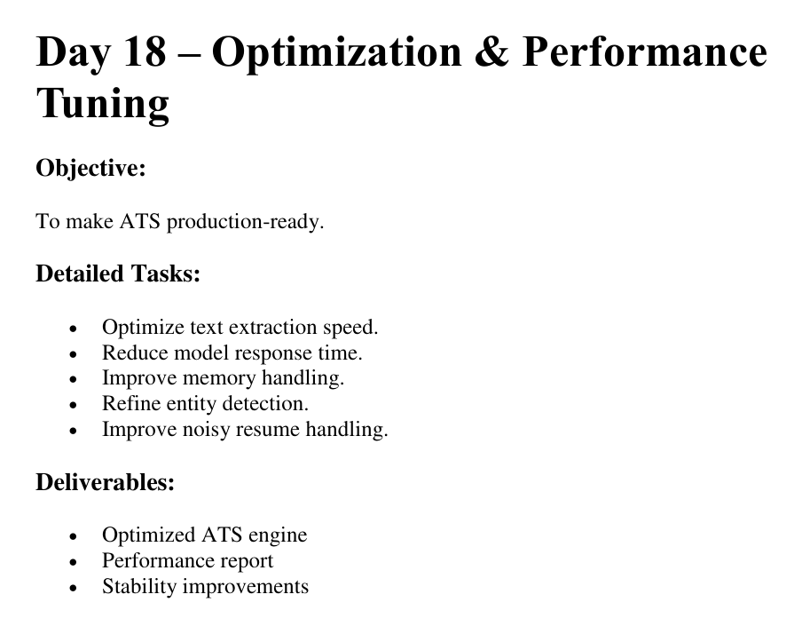
Figure 1. Official Day 18 task brief (project task sheet).
Requirement | Implementation completed | Evidence
Optimize text extraction speed | Added lightweight normalization/entity pass while avoiding repeated heavy work | 3-run benchmark
Reduce model response time | Reused SemanticMatchingEngine and other reusable processing components | Semantic time 0.1072 s average
Improve memory handling | Monitored allocations with tracemalloc and avoided repeated object creation | Peak 95.71 MB stable
Refine entity detection | Added conservative name, email, phone and URL detection | Entity regression PASS
Improve noisy resumes | Added Unicode, whitespace, separator and duplicate-line cleanup | Clean/noisy score diff 0.0000

Scope boundary: no ATS scoring formula, signal weights, decision thresholds, or ranking strategy were intentionally changed as part of the Day 18 optimization work.

3. Work Completed and Implementation

File / component | Day 18 work | Purpose
scoring/day18_resume_quality.py | New helper module | Normalize noisy text and detect basic candidate entities
scoring/day14_end_to_end.py | Integrated preprocessing; reused engines; parsed JD once | Reduce repeated work inside candidate loop
day18/day18_baseline_benchmark.py | Three-run benchmark harness | Measure extraction, semantic, full-pipeline and memory behavior
day18/day18_noisy_resume_test.py | Dedicated stability regression test | Validate robustness against injected formatting noise
outputs/day14_real_ranked_candidates.json | Generated end-to-end output | Preserve recruiter-facing JSON result

The optimized batch structure now creates heavy and reusable components once and passes them into each candidate scoring call. The same batch also constructs the validated JobRequirement once instead of rereading and reparsing the Job Description for every resume.
Representative batch-level optimization
batch_job_requirement = day13.JobRequirement(**job)
batch_skill_engine = day13.SkillExtractionEngine()
batch_semantic_engine = day13.SemanticMatchingEngine()
batch_experience_parser = day13.ExperienceParser()
batch_education_parser = day13.EducationCertificationParser()
batch_ats_engine = day13.ATSScoringEngine()
result = score_candidate(
resume_path,
jd_path,
job_requirement=batch_job_requirement,
skill_engine=batch_skill_engine,
semantic_engine=batch_semantic_engine,
experience_parser=batch_experience_parser,
education_parser=batch_education_parser,
ats_engine=batch_ats_engine,
)

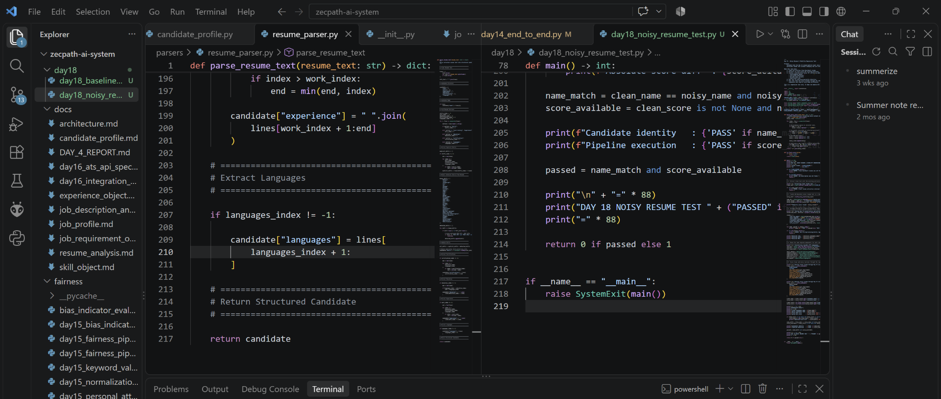
Figure 2. VS Code project view showing resume parsing and Day 18 test implementation (user-provided development screenshot).

4. Optimized Architecture

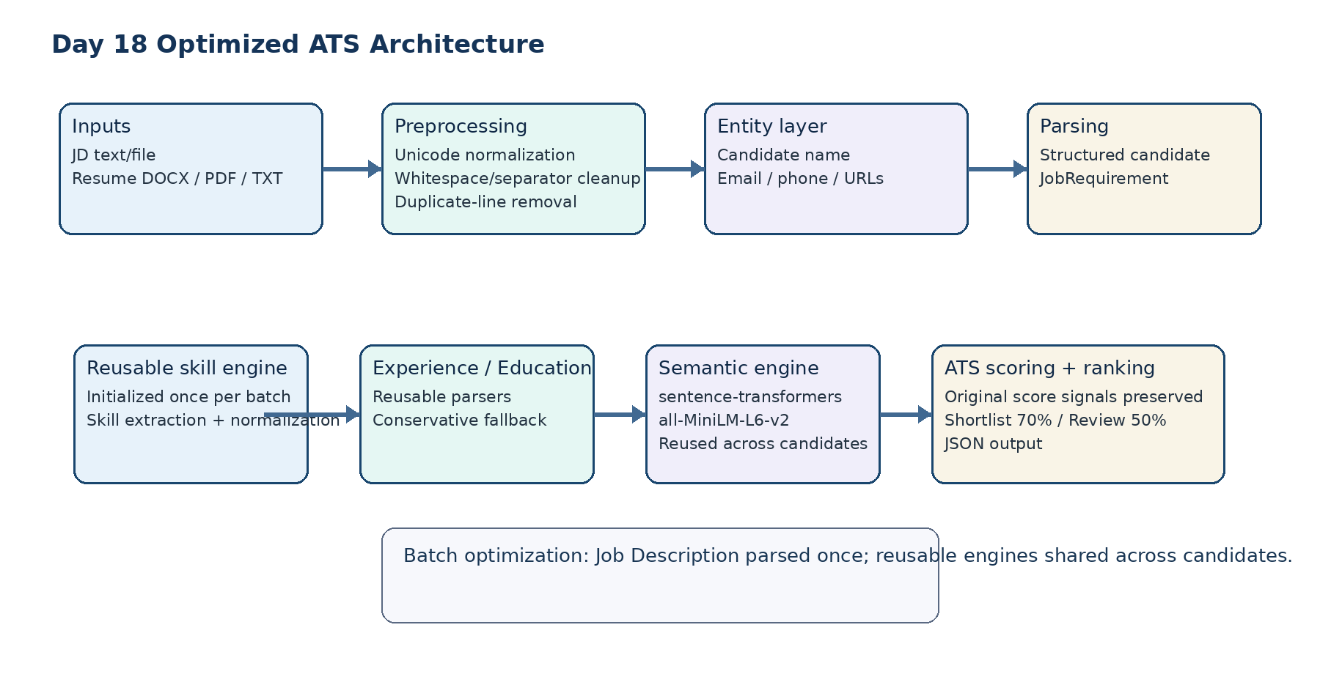
Figure 3. Day 18 optimized ATS architecture and component-reuse strategy.
The architecture preserves the existing Day 9-Day 14 scoring pipeline while adding a Day 18 preprocessing layer before resume parsing and moving reusable components to the batch scope. The semantic model remains the same model used by the existing semantic matching stage; the optimization changes its lifecycle, not its matching objective.
Optimization point | Before | After
Semantic engine lifecycle | Constructed repeatedly inside candidate processing | Constructed once and reused across the batch
Skill engine lifecycle | Constructed inside candidate processing | Constructed once and shared
JD parsing | Repeated for each candidate | Parsed and validated once per batch
Resume input | Raw extracted text sent directly to parser | Normalized and entity-processed first
Scoring logic | Day 13 signal calculation | Preserved

5. Processing Workflow

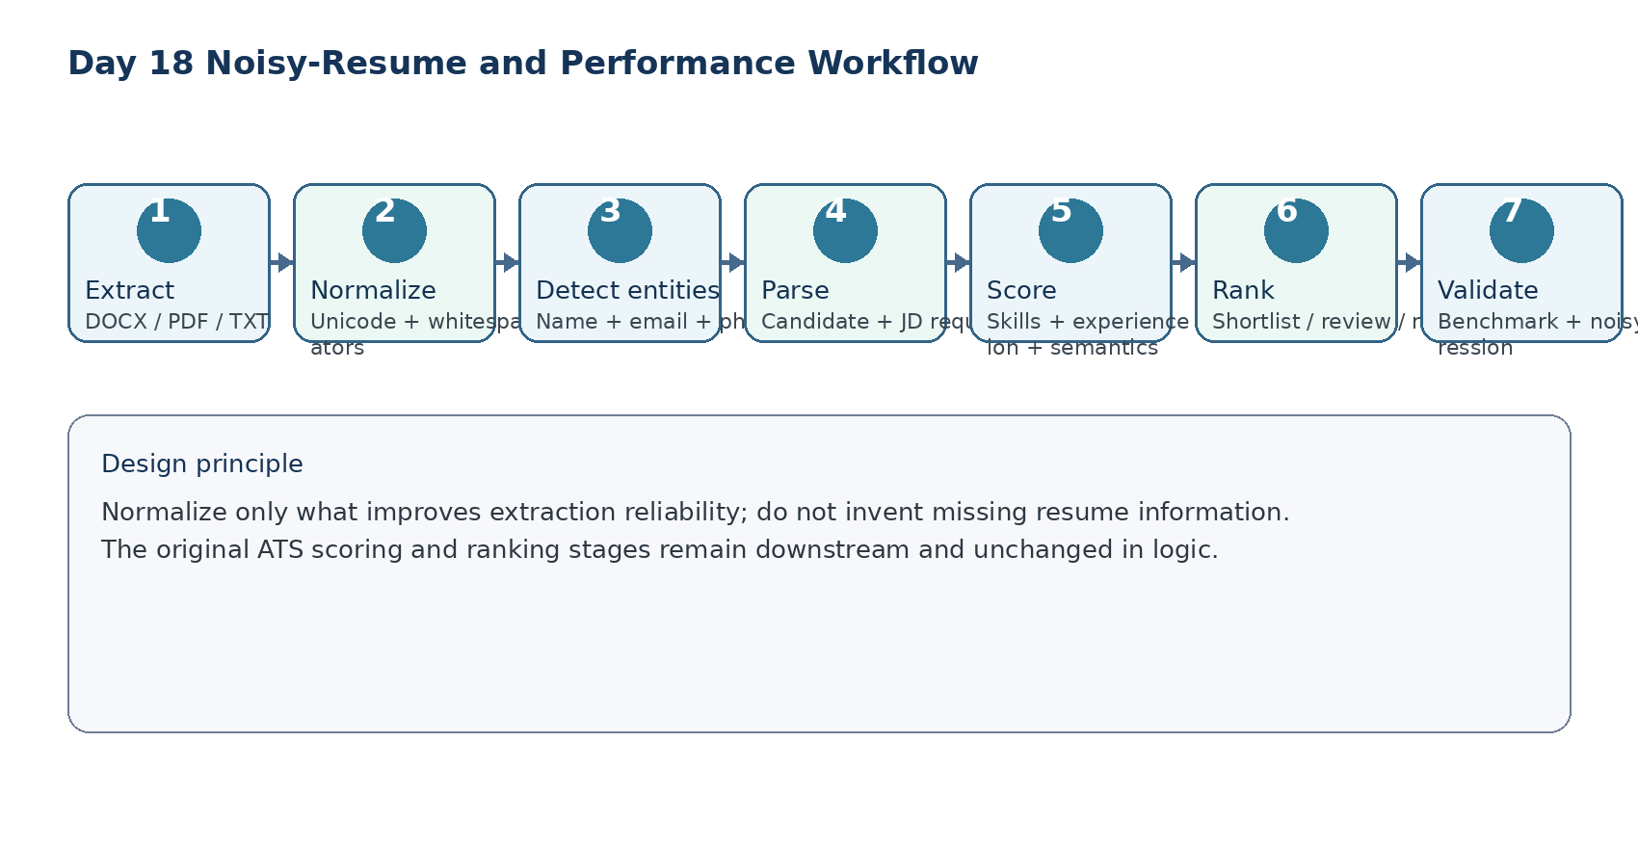
Figure 4. Day 18 processing workflow from document extraction to validation.
The quality layer is deliberately conservative: it normalizes formatting noise but does not invent missing resume information. Candidate-name detection is restricted to plausible leading lines, while email, phone and URL detection use explicit patterns.
Data-flow principle
The optimized flow separates input hygiene from scoring. This keeps reliability improvements isolated from the ATS decision model and makes the changes easier to test independently.

6. Key Code Implementations

6.1 Resume normalization
text = unicodedata.normalize("NFKC", text)
text = text.replace("\u00A0", " ")
text = text.replace("\u200B", "")
text = text.replace("–", "-").replace("—", "-")
text = re.sub(r"[ \t]+", " ", line).strip()

This step addresses common extraction artifacts such as non-breaking spaces, zero-width characters, inconsistent line endings, Unicode dash variants, and repeated whitespace. After cleanup, repeated lines are removed using a normalized comparison key.
6.2 Conservative entity detection
def detect_entities(text: str) -> ResumeEntities:
normalized_text = normalize_resume_text(text)
return ResumeEntities(
candidate_name=detect_candidate_name(normalized_text),
email=detect_email(normalized_text),
phone=detect_phone(normalized_text),
urls=detect_urls(normalized_text),
)

The entity layer supports candidate identification and basic contact metadata discovery. It is intentionally conservative, especially for candidate names, to avoid turning arbitrary first-line text into a false identity.
6.3 Day 14 integration boundary
raw_resume_text = day13.extract_resume_text(str(resume_path))
resume_text, resume_entities = prepare_resume(raw_resume_text)
detected_name = resume_entities.candidate_name
candidate = day13.parse_resume_text(resume_text)
candidate_name = detected_name or candidate.get("name") or resume_path.stem

The original parser remains in use; Day 18 adds a normalized text input and a safe identity fallback rather than replacing the parser.

7. Performance Benchmark and Methodology

The benchmark measured four timing dimensions and one memory indicator: text extraction, semantic model initialization, semantic matching, full ATS pipeline execution, and peak Python allocation using tracemalloc. Three post-optimization runs were recorded on Python 3.14.2.
Measurement note
The benchmark script is named day18_baseline_benchmark.py and prints a "BASELINE SUMMARY" label, but the three recorded runs in this report were executed after the Day 18 optimizations were integrated. The original pre-optimization reference values are retained separately for comparison.

Metric | Run 1 | Run 2 | Run 3 | Day 18 average
Model initialization | 6.2227 s | 7.2501 s | 6.9405 s | 6.8044 s
Text extraction | 0.0206 s | 0.0203 s | 0.0194 s | 0.0201 s
Semantic matching | 0.1078 s | 0.1031 s | 0.1106 s | 0.1072 s
Full ATS pipeline | 19.2633 s | 20.4150 s | 19.7918 s | 19.8234 s
Peak traced allocation | 95.71 MB | 95.71 MB | 95.71 MB | 95.71 MB

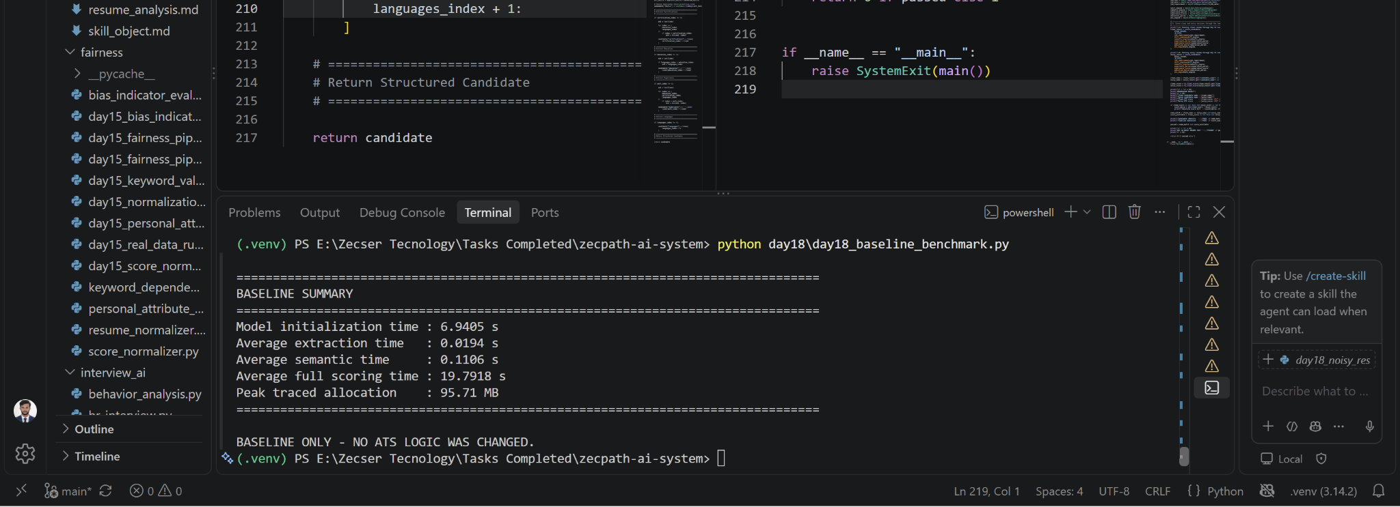
Figure 5. Benchmark console output visible in the development environment (user-provided screenshot).

8. Performance Results

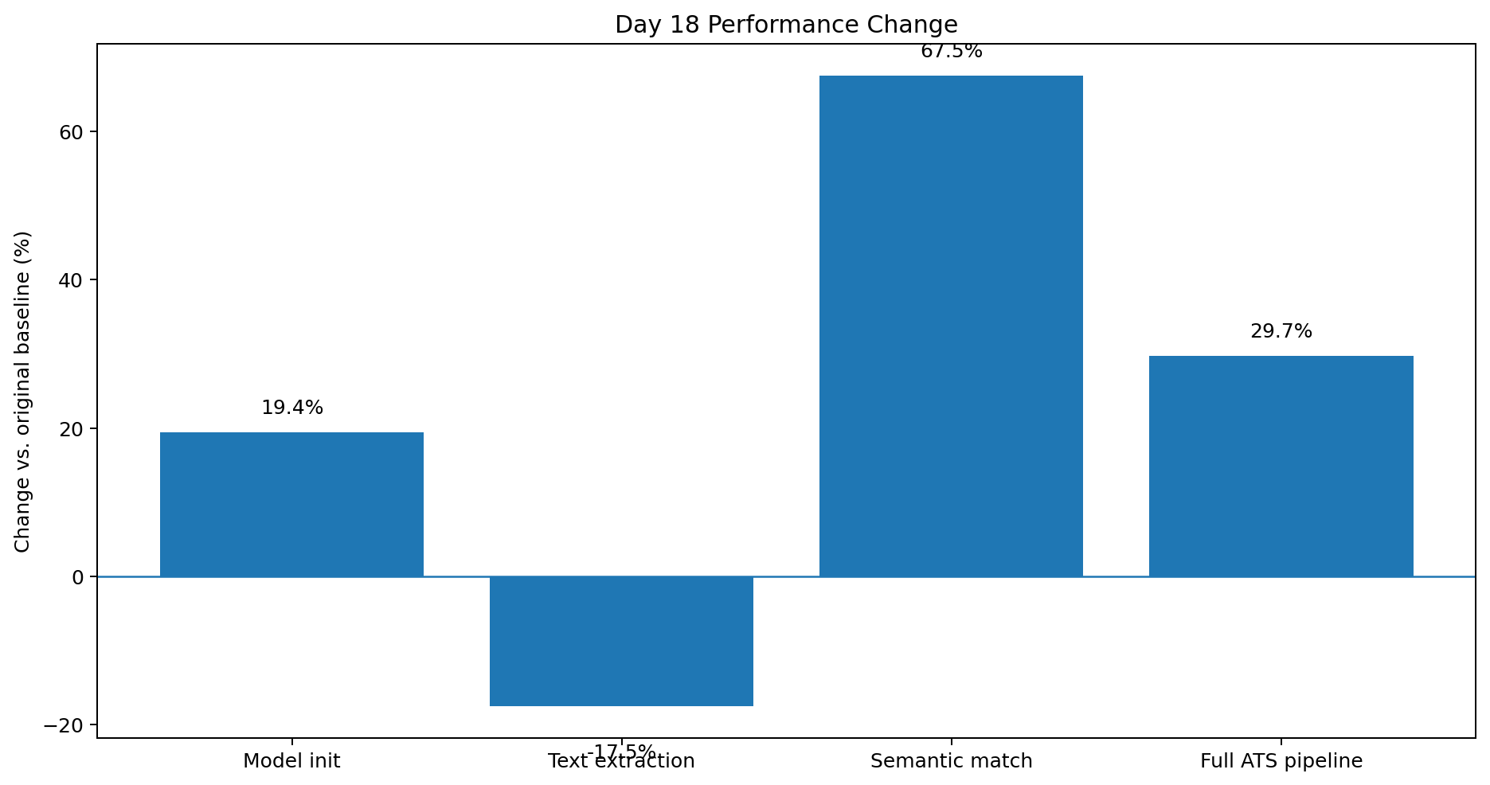
Figure 6. Percentage change in Day 18 performance metrics versus the original recorded baseline.
Metric | Original baseline | Day 18 average | Change | Interpretation
Model initialization | 8.4438 s | 6.8044 s | -19.4% | Lower initialization overhead
Text extraction | 0.0171 s | 0.0201 s | +17.5% | Small absolute overhead from quality layer
Semantic matching | 0.3297 s | 0.1072 s | -67.5% | Largest component-level gain
Full ATS pipeline | 28.2071 s | 19.8234 s | -29.7% | Main production-readiness result
Peak traced allocation | 95.71 MB | 95.71 MB | 0.0% | Stable under tracemalloc

Performance conclusion
The three-run Day 18 average reduces full ATS processing by approximately 8.38 seconds relative to the original recorded baseline. The measured result is strong enough to document a meaningful optimization, while memory remains stable rather than reduced.

9. Noisy Resume Stability Regression

A dedicated regression script generated a temporary noisy TXT version of the clean AI-developer resume and injected common text-extraction disturbances. The same Job Description and scoring path were then applied to the clean and noisy inputs.
Test | Expected behavior | Observed result | Status
Text not empty | Normalized text remains usable | PASS | PASS
NBSP removal | Non-breaking spaces removed | PASS | PASS
Zero-width removal | Hidden zero-width characters removed | PASS | PASS
Candidate-name detection | Sophia Martinez recovered | PASS | PASS
Email detection | Sophia.Martinez@example.com recovered | PASS | PASS
URL output type | Entity collection remains a list | PASS | PASS
Candidate identity | Clean and noisy names match | PASS | PASS
ATS score availability | Both runs produce valid score | PASS | PASS

Sophia Martinez  Clean candidate | Sophia Martinez  Noisy candidate | 0.5797  Clean ATS score | 0.5797  Noisy ATS score

Regression result
Absolute ATS score difference = 0.0000. Candidate identity = PASS. Pipeline execution = PASS. The final console status reported: DAY 18 NOISY RESUME TEST PASSED.

The test reported an empty detected URL list; this is not a failure because the test resume did not contain a URL. The important regression conditions were identity preservation, score preservation, and successful pipeline execution.

10. End-to-End ATS Regression

The optimized Day 14 end-to-end pipeline was executed against the same three representative resumes used by the benchmark. All three candidates completed successfully and the recruiter-facing output remained valid.
Rank | Candidate | ATS score | Status | Role
1 | Sophia Martinez | 57.97% | REVIEW | AI/ML Engineer
2 | Entry-Level Data Scientist | 29.02% | REJECT | AI/ML Engineer
3 | Sanskar Sankar | 13.69% | REJECT | AI/ML Engineer

Regression check | Result
Three candidates processed | PASS
Ranking output generated | PASS
JSON output generated | PASS
Shortlist decision executed | No candidates shortlisted
Review queue | Sophia Martinez only
Auto-rejection queue | Entry-Level Data Scientist; Sanskar Sankar

Stability statement
The benchmark and end-to-end run completed without pipeline failure. The ordering of the three representative candidates remained stable after the Day 18 integration.

11. Challenges and Solutions

Challenge | Observed issue | Day 18 solution | Outcome
Repeated model initialization | Heavy semantic engine lifecycle repeated in candidate processing | Create once at batch scope and reuse | Semantic matching substantially faster
Repeated Job Description parsing | Same JD processed for every resume | Parse and validate once per batch | Removes repeated work
Noisy extraction artifacts | Unicode/whitespace/hidden characters can disturb downstream parsing | Normalize text before resume parsing | Noisy regression passed
Candidate identity under noise | First line can be malformed or mixed with metadata | Conservative candidate-name detector | Identity preserved
Memory interpretation | tracemalloc does not equal OS RSS | Report traced allocations explicitly and avoid claiming RSS reduction | Memory result documented accurately
Library/API warnings | fitz deprecation and unauthenticated HF Hub warnings remained | Record as maintenance items rather than changing scope mid-task | Pipeline still passed

Engineering lesson
The most reliable optimization was lifecycle-level: expensive objects were reused rather than repeatedly recreated. Reliability work was kept at the text-input boundary so the existing scoring behavior remained easy to compare.

12. Deliverables and Artifacts

OFFICIAL DAY 18 DELIVERABLES
1. Optimized ATS engine
2. Performance report
3. Stability improvements

Deliverable / artifact | Ready state | Description
Optimized ATS engine | READY | Reusable ATS components, batch-level JD parsing, resume-quality preprocessing integrated into Day 14 flow
Performance report | READY | Three benchmark runs, average metrics, baseline comparison, interpretation and limitations
Stability improvements | READY | Entity detection, noisy-text normalization, noisy-resume regression and end-to-end regression
day18_resume_quality.py | READY | Normalization + candidate entity helper
day18_baseline_benchmark.py | READY | Benchmark harness used for recorded measurements
day18_noisy_resume_test.py | READY | Noisy resume regression harness
day14_real_ranked_candidates.json | GENERATED | Recruiter-facing JSON output from successful end-to-end execution

3 / 3 ready  Official deliverables | PASS  Syntax checks | 3  Benchmark runs | PASS  Noise regression

13. Verification and Reproducibility

The work was verified through syntax compilation, real end-to-end execution, a three-run performance benchmark, and a dedicated noisy-resume regression test. The commands below reproduce the core checks from the project root.
Syntax verification
python -m py_compile scoring\day18_resume_quality.py
python -m py_compile scoring\day14_end_to_end.py

Performance benchmark
python day18\day18_baseline_benchmark.py

Noisy-resume stability regression
python day18\day18_noisy_resume_test.py

End-to-end ATS regression
python -m scoring.day14_end_to_end ^
data\day12_benchmarks\ai_ml_engineer.txt ^
data\resumes\ai-developer-resume.docx ^
data\resumes\data-scientist-resume.pdf ^
data\resumes\finance-resume.docx

Verification dimension | Recorded evidence | Status
Compilation | Both modified Python modules compile without output/error | PASS
Real batch scoring | Three representative resumes completed | PASS
Performance | Three benchmark runs recorded | PASS
Memory measurement | Peak traced allocation 95.71 MB | PASS
Noise robustness | Clean/noisy candidate and score identical | PASS
Output artifact | outputs/day14_real_ranked_candidates.json generated | PASS

14. Next Steps

Next step | Reason | Priority
Replace deprecated fitz usage with current PyMuPDF import path | Remove future API compatibility warning | High
Add operating-system RSS measurement to benchmark | Complement tracemalloc with process-level memory visibility | High
Expand benchmark dataset beyond three resumes | Improve statistical confidence and reduce sensitivity to individual runs | High
Harden semantic-score boundary handling | Prevent future contract issues when similarity outputs are outside scorer expectations | High
Add more noisy-resume fixtures | Cover OCR-like spacing, column flattening, malformed headers and repeated blocks | Medium
Add performance trend tracking | Make future Day 19+ changes comparable against the Day 18 baseline | Medium

Forward plan
Day 18 establishes a measured performance and reliability reference point. Future optimization should build on these measurements while keeping scoring behavior explicitly versioned and regression-tested.

15. Conclusion

Day 18 completed the requested Optimization & Performance Tuning phase for the Zecpath AI System. The implementation improved the lifecycle of reusable ATS components, introduced a dedicated resume-quality/entity layer, reduced repeated Job Description parsing, and added dedicated performance and noisy-input validation.
The final three-run benchmark recorded an average full ATS pipeline time of 19.8234 seconds versus the original recorded baseline of 28.2071 seconds, representing approximately 29.7% faster processing. Semantic matching improved by approximately 67.5%, while peak traced Python allocation remained stable at 95.71 MB.
The most important robustness result came from the noisy-resume regression: the clean and intentionally noisy versions produced the same candidate identity and the exact same ATS score of 0.5797, with a score difference of 0.0000 and a final PASS status.
Day 18 completion status
COMPLETE - Optimized ATS engine, performance evidence, stability improvements, noisy-resume regression, end-to-end regression, and supporting artifacts are ready for internship documentation.

Source note: Day 18 task specification, recorded benchmark outputs, project implementation notes, and user-provided development screenshot.

