# Creating a docker image using Installing Docker
- Enter the following commands to inatall and verify installation of Docker
```bash
sudo apt update
sudo apt install -y docker.io
sudo systemctl enable docker --now

Download Docker plugins in Jenkins
- Go to Jenkins `Dashboard` -> `Manage Jenkins` -> `Available Plugins` -> Search `Docker`
- Select these plugins and Install
- Docker
- Docker Commons
- Docker Pipeline
- docker-build-step
- CoudBees Docker Build and Publish

## Add Jenkins to Docker group
- Go to terminal and run these commands to add Jenkins to docker group
```bash
sudo usermod - aG docker jenkins
sudo systemctl restart jenkins
sudo reboot
```
- This will do its thing and reboot the system

## Setting up docker credentials
- Go to Jenkins > `Manage Jenkins` > `Credentials` > `System` > `Global Credentials (Unrestricted)` > `Add Credentials`
- Fill your Docker hub `username` , `password`, and in the `id` field enter `docker-seccred`##

Creating and building a pipeline
- Go to Jenkins `Dashboard` > `Create a Job`
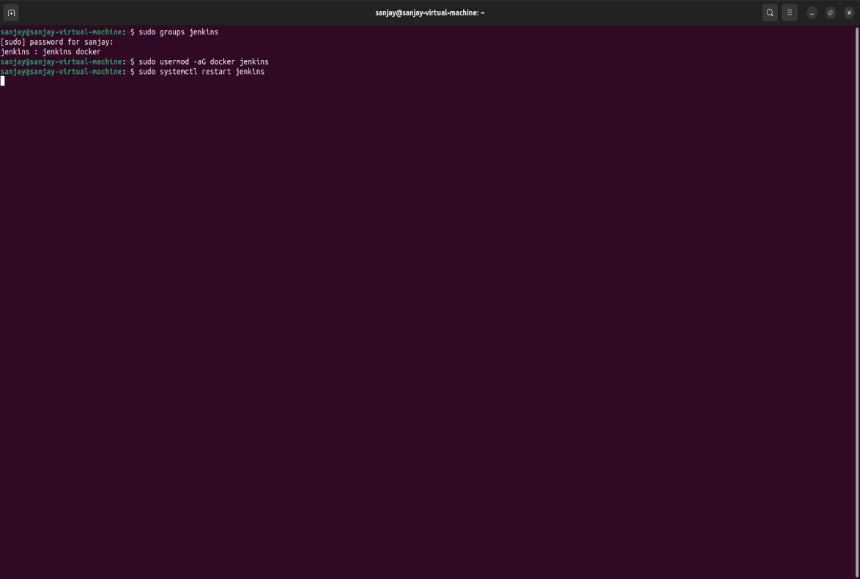
- Enter a project name
- Select `pipeline`
- Click `Ok`

- Go to `pipeline`
- Paste this script below and change the credential wherever mentioned:
```groovy
pipeline {
agent any

environment {
IMAGE_NAME = "22ITR090/project1" // Replace with your Docker Hub username and image name
TAG = "latest"
CONTAINER_NAME = "my-container"
PORT = "3001"
}

stages {

stage('Clone Repository') {
steps {
echo "Cloning GitHub repository..."
git 'https://github.com/sanjay/docker.git' // Replace with your repo URL
}
}

stage('Build Docker Image') {
steps {
echo "Building Docker image..."
sh 'chmod +x build.sh'
sh './build.sh'
}
}

stage('Login to Docker Hub') {
steps {
echo "Logging into Docker Hub..." // Change the cedentialsID if you have docker credentials already added with another id other than docker-seccred
withCredentials([usernamePassword(credentialsId: 'docker-seccred', usernameVariable: 'DOCKER_USER', passwordVariable: 'DOCKER_PASS')]) {
sh 'docker login -u $DOCKER_USER -p $DOCKER_PASS'
}
}
}

stage('Push Docker Image') {
steps {
echo "Pushing Docker image to Docker Hub..."
sh "docker tag $IMAGE_NAME:$TAG $IMAGE_NAME:$TAG"
sh "docker push $IMAGE_NAME:$TAG"
}
}

stage('Deploy Docker Container') {
steps {
echo "Deploying Docker container..."
sh 'chmod +x deploy.sh'
sh './deploy.sh'
}
}
}

post {
success {
echo "Deployment Successful!"
}
failure {
echo "Deployment Failed!"
}
}
}

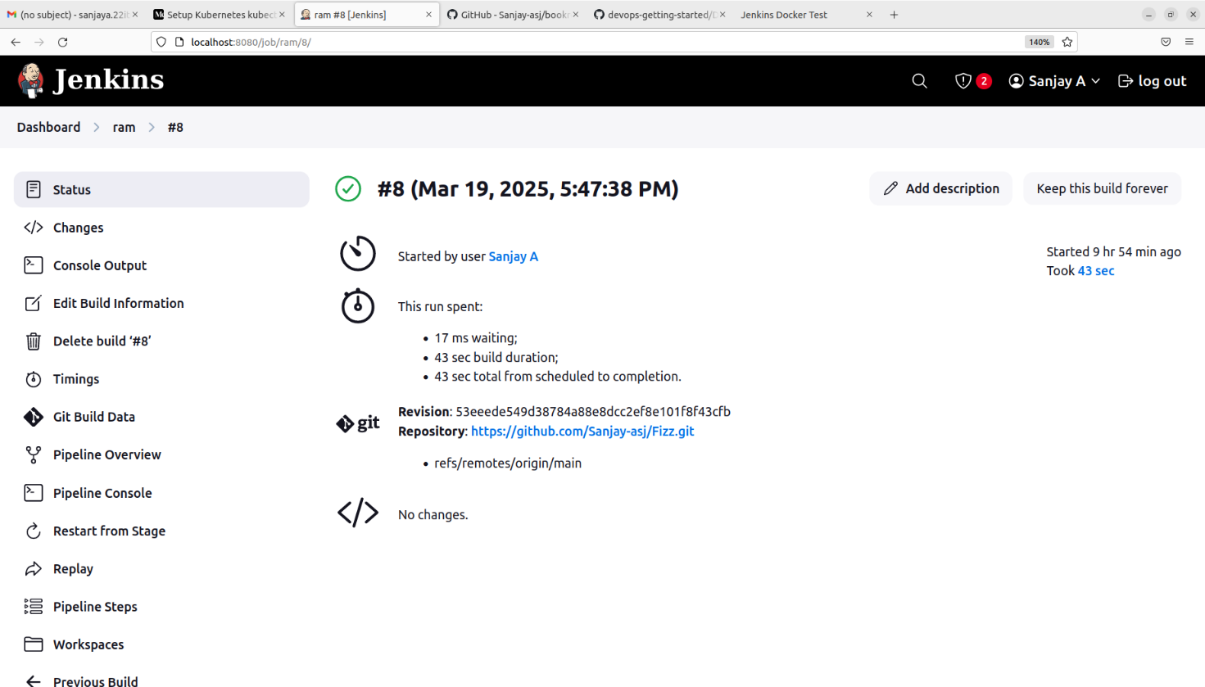
```
- click `save`
- click `build`

- Go to `localhosy:3001`

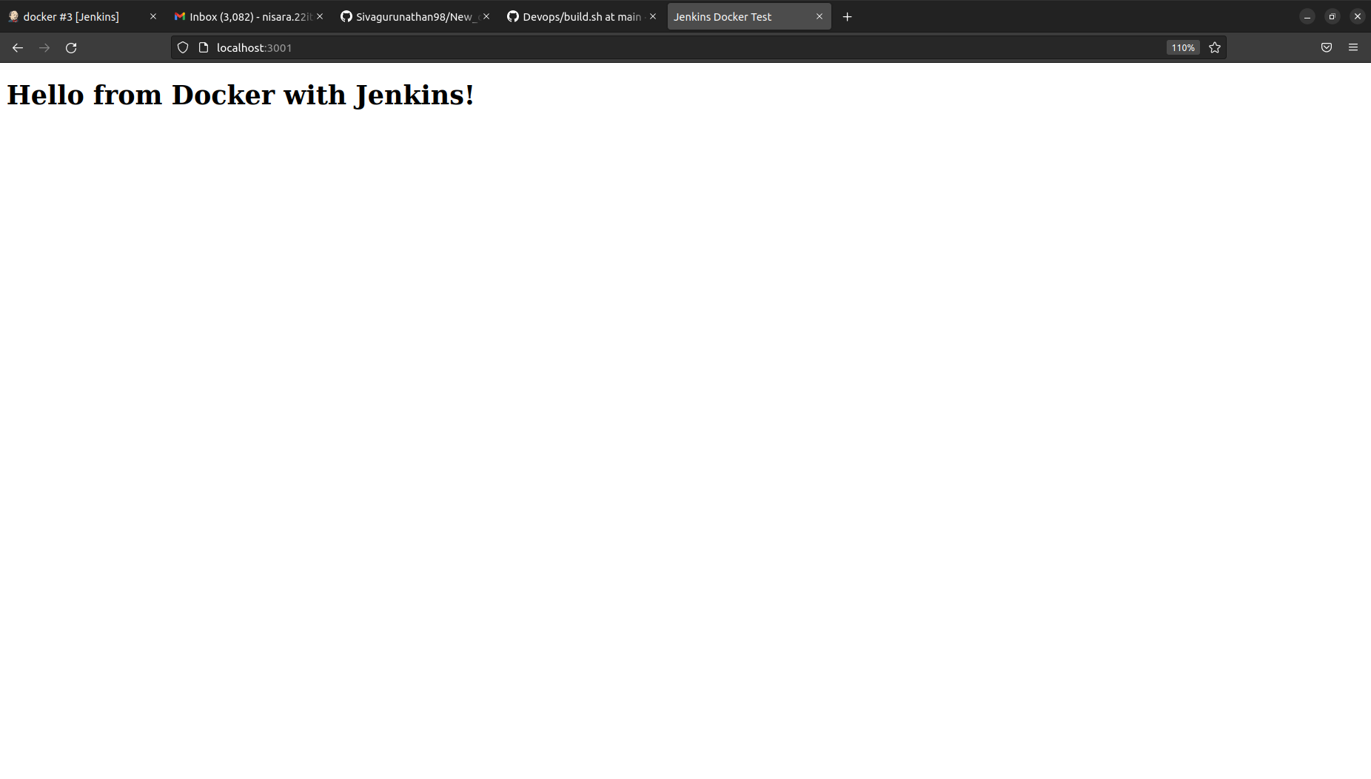
Final Output:

