- WirelessChargingSystemforElectric
Two-Wheelers

Abstract

Thisprojectdevelopsawirelesschargingsystemfor electrictwo-wheelersusinginductivepowertransfer technology.Thesystemeliminatestheneedforphysical connectors by transferring energy between a primary coil on the charging station and a secondary coil mounted on thevehicle.Powerelectronicscircuitsregulatethe chargingprocesstoensureefficiencyandsafety,whileIoT integration can enable monitoring of battery status in real time.Theproposedsystemoffersaconvenient,user- friendly, and reliable solution to promote the adoption of electric mobility.
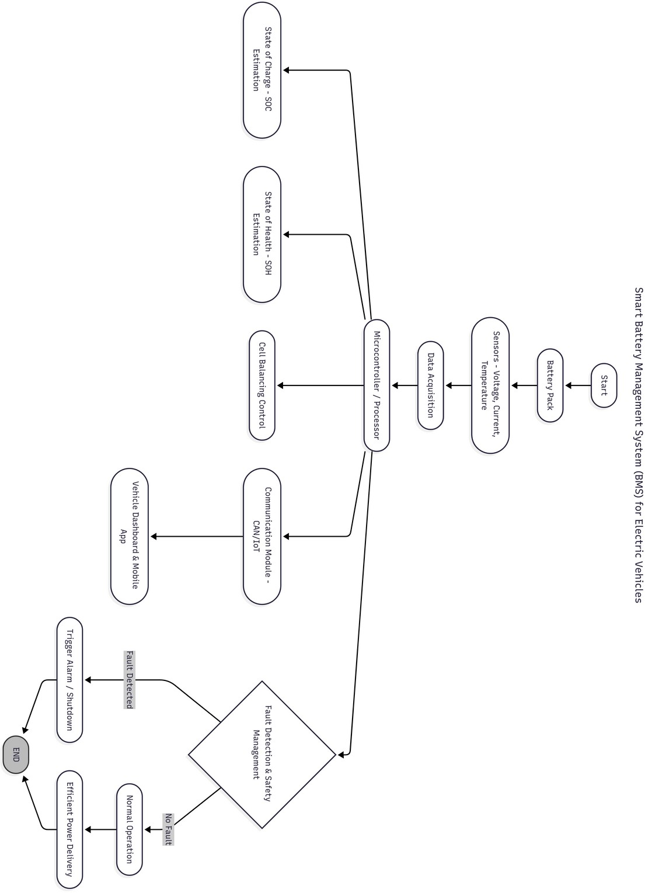
DifferenceBetweenExistingSystemandProposed
System
Aspect

Charging Method

Convenience

Wearand Tear

Safety

Efficiency
ExistingSystem(Wired
Charging)

Requires physical plug-in connectorsbetweencharger and vehicle.

User must manually connect/disconnectthe charging cable.

Connectorsandcableswear out over time due to repeated plugging/unplugging.

Risk of electric shock, sparks, or short circuit in caseof improperhandling or rain.

High efficiency due to direct connection, but performance can reducedue to poor cable quality or damage.
ProposedSystem(Wireless ChargingwithIoT)

Usesinductivepowertransfer(IPT)– no physical connector required.

Fully automatic – vehicle just needs to be parked on the charging pad.

Nomechanicalwearsinceit’s contactless.

Contactlesspowertransferensures improved safety, especially in wet conditions.

Slightlylowerefficiencycomparedto wired (due to coil alignment losses), butregulatedusingpowerelectronics.

- AutomaticPackagingandSortingSystem
usingMICROCONTROLLER

Abstract

This project presents an automatic packaging and sorting systemcontrolledbya advanced microscontroller (MICROCONTROLLER) for industrial automation. The system uses sensors to detect product type, size, or weight, and actuators such asconveyorsandpneumaticarmstosortandpackage itemsaccordingly.TheMICROCONTROLLERensuresprecisecontrol, reliability,andflexibilityinhandlingdifferentproducts while reducing human effort and errors. This automation improvesproductionefficiency,accuracy,andcost- effectiveness,makingithighlysuitableformodern manufacturing and logistics industries.
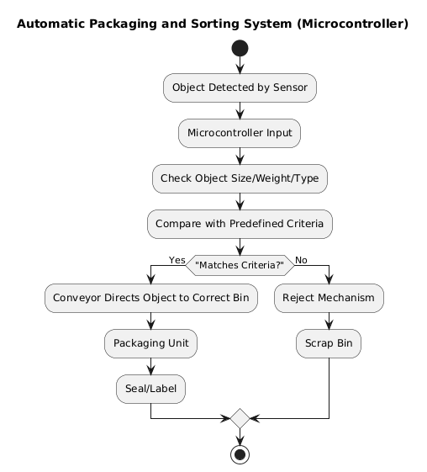
DifferenceBetweenExistingSystemandProposed
System
Aspect

Operation

Accuracy

Speed

Flexibility

Safety

Consistency
ExistingSystem(Manual/Semi-
automaticSorting)

Relies heavily on manual labor or partially automated machines.

Prone to human errors in counting, sorting, and packaging.

Limitedbyoperator’sefficiency and fatigue.

Difficulttoreconfigurefor different products.

Workersexposedtorepetitive tasks and possible hazards.

Productpackagingmayvarydue to manual handling.
ProposedSystem(Automatic
MICROCONTROLLER-basedSorting& Packaging)

Fully automated using MICROCONTROLLER with sensor-based decision making.

HighaccuracyduetoMICROCONTROLLERlogic and sensor integration.

High-speed continuous operation without human intervention.

Easily reprogrammed in MICROCONTROLLER fornew product specifications.

Saferasmachineshandlemost processes.

Uniform and consistent packaging quality.

- 3DPrintingofLightweightAutomotive
Components

Abstract

This project explores the use of 3D printing technology to designandmanufacturelightweightautomotive componentswithimprovedperformanceandreduced materialusage.Byemployingadditivemanufacturing, complexgeometriesthataredifficulttoachievewith traditionalmethodscanbeproduced,enablingweight reductionwithoutcompromisingstrength.Lightweight materials such as composites and high-strength polymers areusedtooptimizeefficiencyandfueleconomyin vehicles.Theproposedapproachdemonstrateshow3D printingcansupportsustainable,cost-effective,and innovative solutions in the automotive industry.
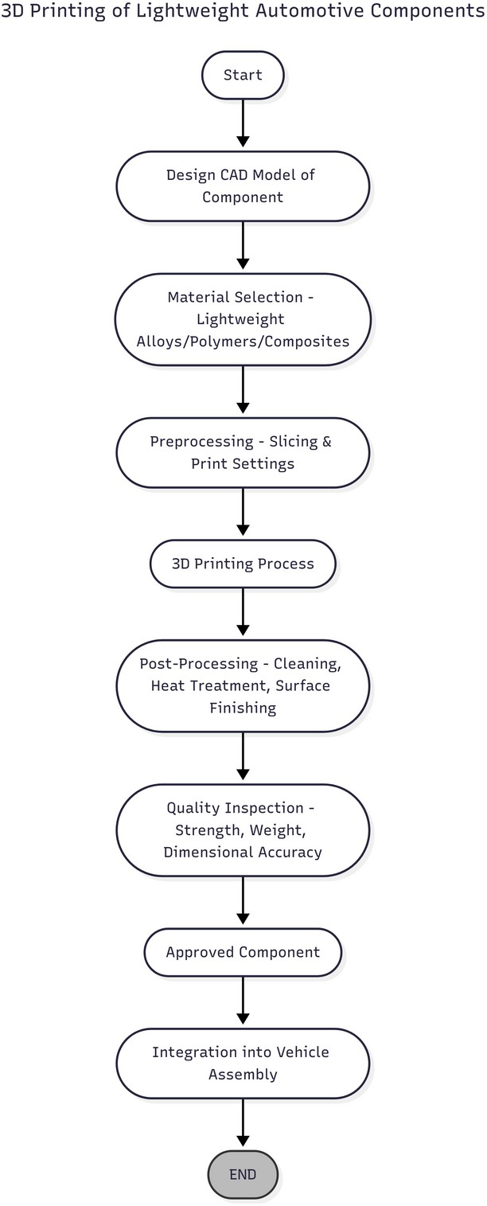
DifferenceBetweenExistingSystemandProposed
System
Aspect

ManufacturingMethod

DesignFlexibility

MaterialUsage

WeightReduction

CostEfficiency
ExistingSystem(Conventional
ManufacturingofAutomotive Components)

Traditionalsubtractivemethods (casting, forging, machining, molding).

Limited to simple or moderately complex geometries due to tooling constraints.

Higher material wastage (cutting,machining,excess molds).

Weightreductionislimitedby machining and material constraints.

Highsetupcost(molds,dies, tooling)forsmallproduction runs.
ProposedSystem(3DPrinting
of LightweightComponents)

Additivemanufacturing(layer- by-layer 3D printing).

Enablescomplexandoptimized geometries (e.g., lattice structures, hollow parts) without tooling limitations.

Minimal wastage – only requiredmaterialisdeposited.

Significantlightweighting possibleusingcomposites, polymers, and optimized designs.

Cost-effectiveforprototyping and low-volume production, eliminates tooling costs.

- FabricationofSolarAssistedCharging
StationforElectricVehicles

Abstract

Thisprojectfocusesonthedesignandfabricationofa solar-assisted charging station for electric vehicles (EVs). The system uses photovoltaic (PV) panels to harness solar energy, which is stored in a battery bank and supplied to EVsthrougharegulatedpowerconverter.Ahybrid provisionisincludedtoutilizegridpowerduringlow- sunlight conditions, ensuring uninterrupted charging. The solar-assistedchargingstationreducesdependencyon conventionalelectricity,promotesrenewableenergy utilization,andsupportssustainabletransportationby providinganeco-friendlyandcost-effectivecharging solution.
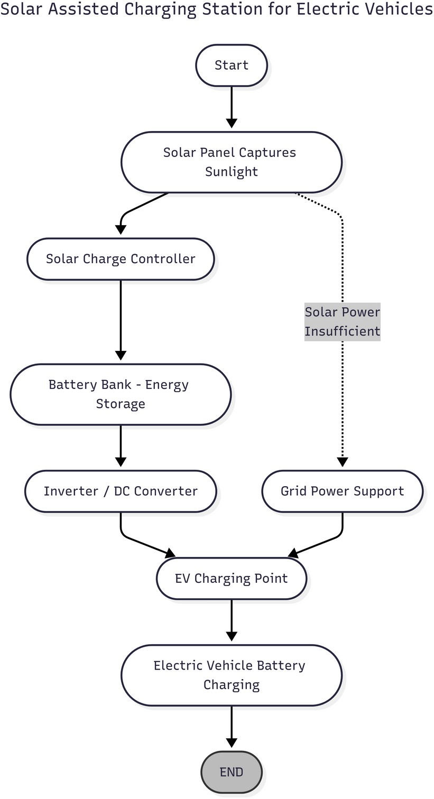
DifferenceBetweenExistingSystemandProposed
System
Aspect

PowerSource

EnergyCost

Sustainability

Availability

Reliability

Environmental Impact
ExistingSystem(Conventional
EVChargingStations)

Fullydependentontheelectric grid.

High electricity cost due to relianceonconventionalpower.

Dependent on fossil-fuel-based gridpower→noteco-friendly.

Limitedtoareaswithgrid access; outages can affect charging.

Grid fluctuations may impact charging quality.

Increases greenhouse gas emissionsindirectlyviagrid dependency.
ProposedSystem(SolarAssisted
EVChargingStation)

Uses solar PV panels as the primarysource,withgridas backup.

Reducedchargingcostby utilizingfreesolarenergy.

Promotesrenewableenergy utilization,reducingcarbon footprint.

Workseveninremote/off-grid areas with sufficient sunlight.

Batterybank+hybridprovision ensures uninterrupted power supply.

Eco-friendly and supports sustainable transportation.

- FabricationofanIoTEnabledAnti-Theft
VehicleLockSystem

Abstract

This project presents the design and fabrication of an IoT- enabledanti-theftlocksystemforvehicles,aimedat enhancingsecurityandusercontrol.Thesystemusesa microcontroller interfaced with sensors and a relay-based locking mechanism to prevent unauthorized engine start. Through IoT integration, the vehicle owner can monitor thestatusofthevehicleandcontrolthelock/unlock functions remotely using a mobile application. Alerts are generatedincaseoftamperingorunauthorizedaccess attempts.Theproposedsystemprovidesalow-cost, reliable, and smart solution for vehicle theft prevention.
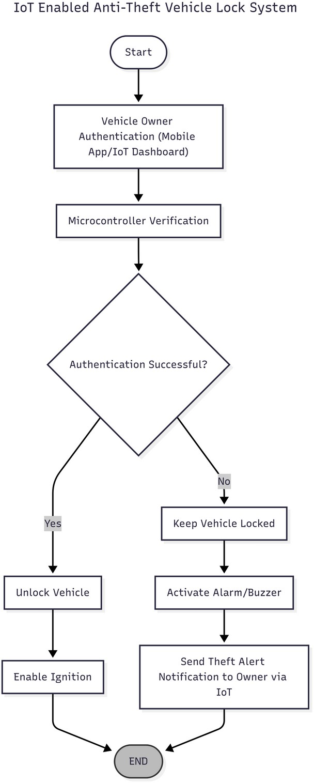
DifferenceBetweenExistingSystemandProposed
System
Aspect

ControlMethod

Monitoring

Alerts

Accessibility

Reliability
ExistingSystem
(ConventionalVehicle Locking / Anti-Theft Methods)

PhysicalkeysorRFID- based systems.

No real-time monitoring; theft can only be noticed after occurrence.

Limited or no alert system;onlycaralarms whichcanbebypassed.

Owner must be physically near the vehicletolock/unlock.

Mechanicallockscanbe broken; alarms can be disabled.
ProposedSystem(IoT-
Enabled Anti-Theft Vehicle Lock System)

ControlledviaIoTmobile app, allowing remote lock/unlock.

Real-timemonitoringof vehicle status via IoT platform.

Instant tamper/theft alerts sent to owner’s smartphone.

Remoteaccessfromanywhere via the internet.

Uses relay-based engine lock with IoT control, harder to bypass.

- DesignofaVehicle-to-Vehicle
CommunicationSystem

Abstract

This project focuses on the design of a Vehicle-to-Vehicle (V2V) communication system to enhance road safety and trafficmanagement.Thesystemenablesvehiclesto exchangereal-timeinformationsuchasspeed,position, andbrakingstatususingwirelesscommunication protocols.Amicrocontrollerprocessesthedataand generatesalertsforcollisionavoidance,lanechanging,andtrafficcongestionupdates.Byallowingvehiclesto communicatewitheachother,theproposedsystem improvesdrivingawareness,reducesaccidents,and supportsthedevelopmentofintelligenttransportation systems.
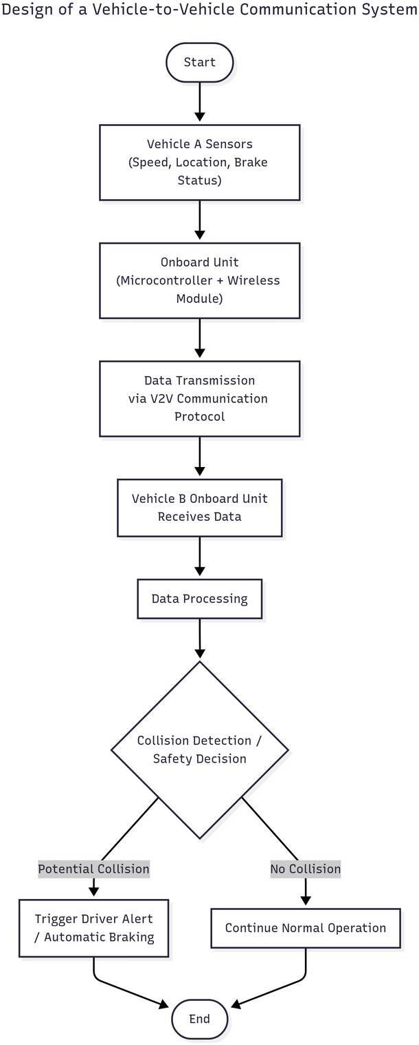
DifferenceBetweenExistingSystemandProposed
System
Aspect

Communication

Awareness

Collision Avoidance

Traffic Management

TechnologyScope

Safety
ExistingSystem(Conventional
VehicleSafety&Communication)

Vehicles operate independently withnodirectvehicle-to-vehicle communication.

Drivers rely mainly on visual observation,mirrors,andsensors like ABS/parking sensors.

Dependent on driver’s reaction timeandonboardvehiclesensors only.

Congestionidentifiedonlythrough traffic signals, cameras, or navigation apps.

Limited to in-vehicle systems (cruisecontrol,ABS,airbags,etc.).

Safetyfeaturesactonlyduringor after hazardous situations.
ProposedSystem(V2V
CommunicationSystem)

Vehicles exchange data wirelessly (speed,position,braking,etc.)in real time.

Drivers receive real-time alerts fromnearbyvehicles,improving situational awareness.

Proactive alerts shared between vehiclesenablequickerpreventive action.

Vehiclessharetrafficupdates directly,supportingsmoother traffic flow.

Supports intelligent transportationsystems(ITS) with connected vehicles.

Providesearlywarningsystem, reducing accident risks.

- DevelopmentofaRoadCondition
SensingVehicleModel

Abstract

Thisprojectaimstodevelopavehiclemodelcapableof sensing and monitoring road conditions in real time. The systemusessensorssuchasaccelerometers,vibration sensors,andcamerastodetectpotholes,bumps,and unevensurfaceswhilethevehicleisinmotion.The collecteddataisprocessedbyamicrocontrollerand transmitted to an IoT platform for analysis and mappingofroadquality.Alertsaregeneratedfordangerous conditions,enablingauthoritiesanddriverstotake preventivemeasures.Theproposedmodelprovidesacost-effectivesolutiontoimproveroadsafety, maintenance planning, and driving comfort.
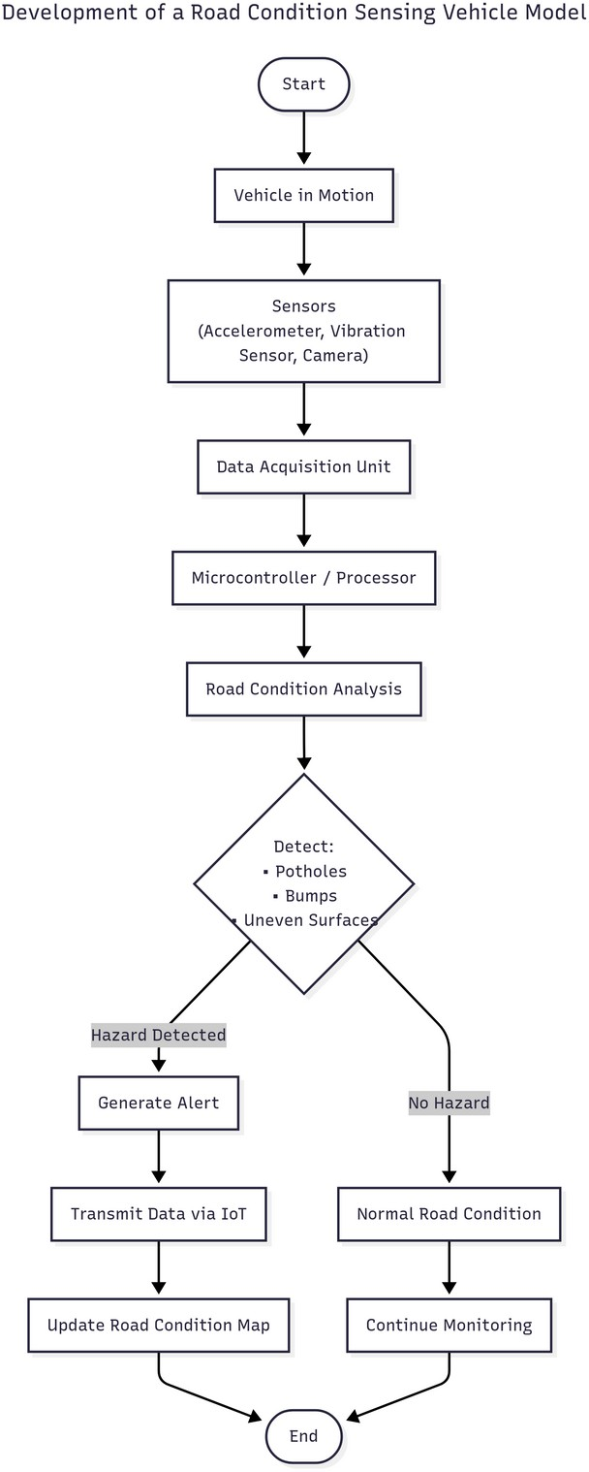
DifferenceBetweenExistingSystemandProposed
System
Aspect

DataCollection

ResponseTime

Accuracy

Coverage

Information Sharing

Safety
ExistingSystem(Conventional
RoadMonitoring&Maintenance)

Manual inspection by authorities or citizen complaints.

Slow,asissuesarereportedafter accidents or severe damage.

Limited by human observation and periodic surveys.

Onlyspecificareascheckedduring scheduled inspections.

Maintenance data often delayed and not shared with drivers.

Driversareunawareof potholesor hazards until encountering them.
ProposedSystem(Road
ConditionSensingVehicleModel)

Automatic sensing using accelerometers, vibration sensors,andcameraswhile vehicle is in motion.

Real-timedetectionandalertsfor potholes, bumps, and dangerous road conditions.

Highaccuracywithsensor-based detection and IoT mapping.

Continuous monitoring as vehiclestravelondifferentroads.

Data transmitted to IoT platformformappingand immediate driver/authority alerts.

Driversreceiveadvancealerts, improvingsafetyandcomfort.

- FabricationofaBluetooth-BasedSmart
IgnitionSystem

Abstract

This project presents the fabrication of a Bluetooth-based smartignitionsystemforvehicles,aimedatenhancing securityandconvenience.Thesystemusesa microcontrollerintegratedwithaBluetoothmoduleto establish a secure connection with the user’s smartphone. Onceauthenticated,theignitionsystemisactivated wirelessly,eliminatingtheneedforatraditionalkey. Unauthorized access is prevented as the vehicle can only bestartedthroughthepairedmobiledevice.The proposedsystemoffersalow-cost,reliable,anduser- friendlysolutiontomodernizevehicleignitionand improve anti-theft protection.
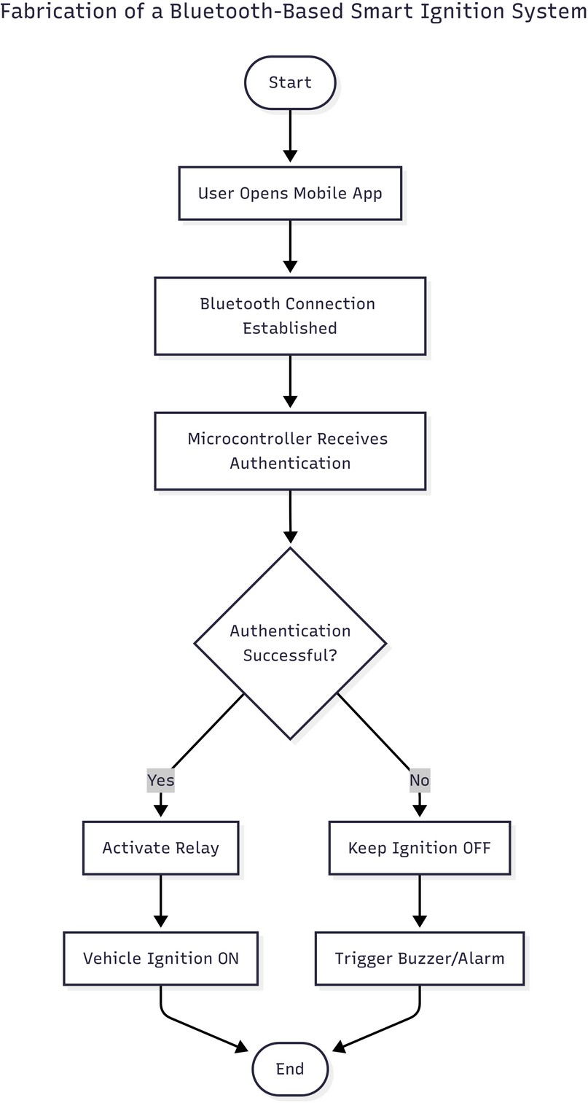
DifferenceBetweenExistingSystemandProposed System
Aspect

IgnitionMethod

Security

Convenience

UserAuthentication

Anti-Theft Protection
ExistingSystem(Conventional
Key-BasedIgnition)

Requiresaphysicalkeytostart the engine.

Keyscanbelost,duplicated,or stolen, increasing theft risk.

Manual operation; driver must always carry the key.

No authentication beyond the physical key.

Mechanicallocksareeasierto tamper with.
ProposedSystem(Bluetooth-
BasedSmartIgnition)

Uses a Bluetooth connection via smartphone to activate ignition.

Only the paired smartphonecanstartthevehicle,preventing unauthorized access.

Keylessandwirelessoperation, controlled directly from mobile.

Smartphone pairing provides two-level authentication (Bluetooth + user control).

Wireless system with relay controlmakeshot-wiringand tampering difficult.

- FabricationofanAirQuality
MonitoringSystemInsideCar

Abstract

Thisprojectfocusesonthefabricationofanairquality monitoringsystemdesignedforin-vehicleenvironments. ThesystemusesgassensorssuchasMQ-seriesand particulate matter (PM) sensors to measure pollutants like CO,CO₂,anddustlevelsinsidethecarcabin.A microcontroller processes the sensor data and displays air quality status on an LCD/IoT dashboard, while alerts are generated if pollutant levels exceed safety thresholds. The systemcanalsointerfacewiththecar’sventilationto improvecabinairquality.Theproposedsolutionenhancespassengersafety,comfort,andhealthby ensuring clean air during travel.
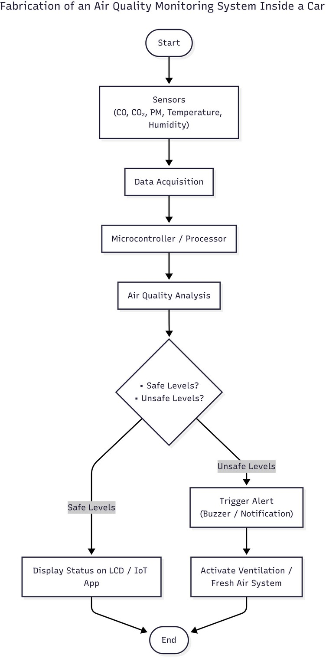
DifferenceBetweenExistingSystemandProposed
System
Aspect

Monitoring

Awareness

Response

Safety

Comfort
ExistingSystem(ConventionalIn-Car
Ventilation/Filters)

Noreal-timemonitoringofcabinair; only air filters are used.

Driversandpassengersareunaware of pollutant levels until they feel discomfort.

Ventilationsystemworksmanuallyor automatically with limited control.

Riskof exposuretoharmfulgases like CO if filters are insufficient.

No data-driven control, only user perception of air quality.
ProposedSystem(AirQuality
MonitoringSystemInsideCar)

Continuous monitoring of CO, CO₂, PM, and other pollutants with sensors.

Air quality status is displayed in real time on LCD/IoT dashboard.

System can generate alerts and controlventilationwhenunsafe levels are detected.

Improvedpassengersafetywith proactive detection and warning.

Data-based comfort management,ensuringcleaner air inside cabin.

- FabricationofaLoadSensing
HydraulicBrakeSystem

Abstract

This project presents the design and fabrication of a load sensing hydraulic brake system to improve vehicle safety and braking efficiency. The system automatically adjusts the braking force applied to the wheels based on the load actingonthevehicle.Aload-sensingvalveisintegrated intothehydraulicbrakecircuittodistributebraking pressureproportionally,preventingwheellockand ensuringstablebrakingundervaryingloadconditions.Theproposedsystemenhancesvehiclecontrol,reduces stopping distance, and increases overall safety, making it suitable for modern automotive applications.
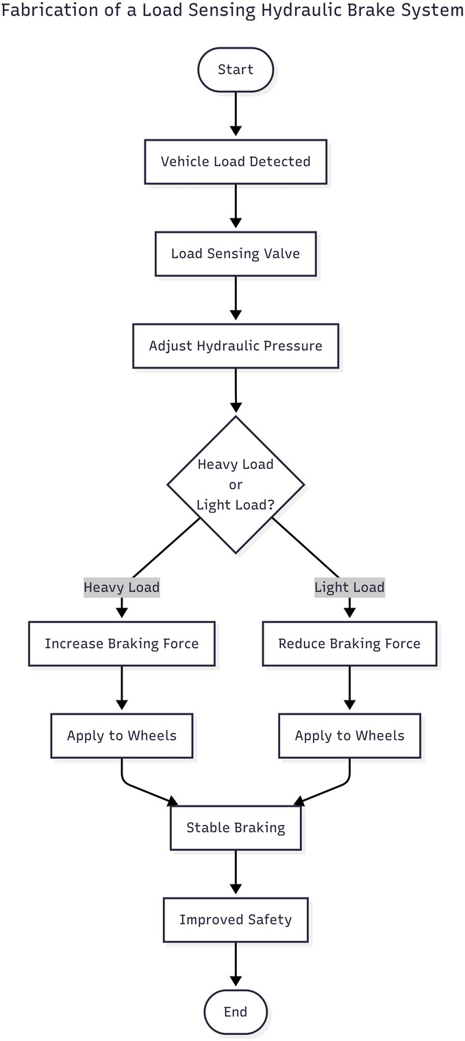
DifferenceBetweenExistingSystemandProposed
System
Aspect

BrakingForce Distribution

Safety

Stopping Distance

Stability& Control

Driver Effort

Efficiency

Applications
ExistingSystem(Conventional
HydraulicBrakeSystem)

Appliesuniformbrakingforce irrespective of vehicle load.

Higherchanceof wheellockor skidding under heavy load.

Longer stopping distance under full load.

Vehiclestabilitydecreasesunder uneven or heavy loads.

Driver has to rely more on judgment and manual braking.

Lessefficientunderdifferentloading conditions.

Suitablemainlyforlight-load vehicles.
ProposedSystem(LoadSensing
HydraulicBrakeSystem)

Brakingforceisautomatically adjusted according to vehicle load.

Preventswheellockbybalancing brake pressure with load.

Reducedstoppingdistancedue to optimized braking force.

Improvedvehiclecontroland stability, even with varying loads.

Automaticadjustmentreduces driver effort and dependence.

Consistentbrakingefficiency across all load conditions.

Idealformodernvehicles, trucks, and heavy-duty applications.

