Palm Jaggery (Borassus flabellifer): A Comprehensive Review of Its Botany, Production, Nutritional Profile, Therapeutic Benefits, and Global Significance [None]

Abstract [None]
Palm jaggery from the inflorescence sap of palmyra palm (Borassus flabellifer L.) is an ancient non-centrifugal sugar (NCS) with technological sweetness and functional nutraceutical traits pan together .It contains millions of bacterial and yeast cells, a greater variety of organic acids and lipids and a complex array of minerals, vitamins, amino acids, polyphenols and Maillard reaction products; which together give the honey its characteristic flavour profile shared with cane sugar (complex/long-lasting), the ability to maintain sweetness even at very high dilutions in water1, lower glycemic response as well as multiple putative health benefits. This review synthesizes current knowledge on the botany and ecology of B. flabellifer, sap and jaggery production technologies, physicochemical and nutritional characteristics, pharmacological activities, comparative advantages over other sweeteners, and socio‑ecological relevance, with a focus on recent advances in process optimization and functional food applications. A flow diagram of the palm jaggery production chain from sap extraction to final product is conceptually summarized in the text below. A quantitative nutritional overview is depicted in the accompanying multi-panel chart. [1], [2], [3]

Keywords: Palm jaggery; Borassus flabellifer; palmyra palm; non-centrifugal sugar (NCS); sap tapping; neera extraction; jaggery production technology; physicochemical properties; mineral composition; vitamin content; polyphenols; Maillard reaction products; antioxidant activity; antimicrobial effects; anti-inflammatory properties; low glycemic index sweetener; functional food applications; traditional medicine; rural livelihoods; sustainable agroforestry; environmental resilience [None]
1. Introduction
Palm jaggery, also known as palm sugar or palmyrah jaggery, is obtained by boiling the unfermented sap (neera) collected from palm inflorescence till it becomes a supersaturated syrup and allowed to crystallize into dark brown viscous solid or granulated forms of sugar. Non-centrifugal sugars (i.e., palm jaggery) are fundamentally different from refined sucrose in the sense subject only to natural anhedral microcrystals wrapped with residual molasses and bioactive compounds with no whirling or bleaching process involved. [None]
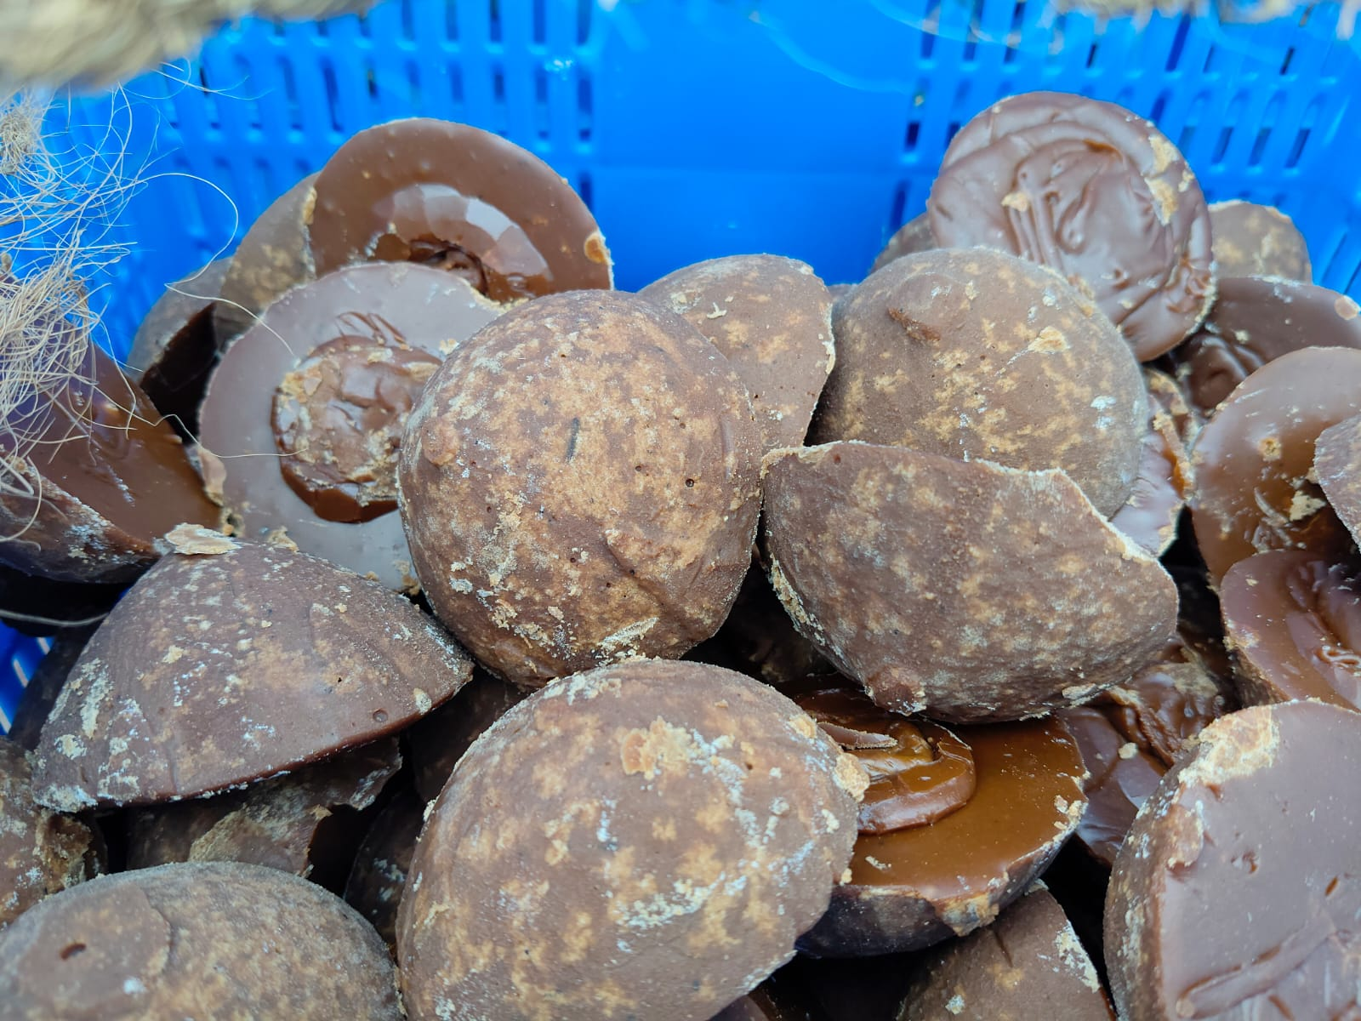
1.1 Overview of traditional sweeteners [None]
Traditional sweeteners include honeys, syrups made with minimal processing of plant juices, and unrefined sugars (cane jaggery/gur, palm jaggery, panela, kokuto, namtan tanode). Jaggery from sugarcane and palms has historically provided energy, micronutrients, and flavor in daily diets throughout South and Southeast Asia. It is frequently incorporated into ceremonial, medicinal, and celebratory contexts. These products, in contrast to refined sugar, display complex matrices rich in minerals (such as K, Ca, and Fe), vitamins (such as B complex and vitamin C), amino acids, and phenolics that may influence gut ecology, oxidative stress, and glycemic response [5], [7], [10] [4], [8], [9].
1.2 Historical significance of palm jaggery [None]
Due to its nearly 800 documented uses in food, fiber, lumber, and medicine, especially in India, Sri Lanka, and Southeast Asia, the palmyra palm is commonly referred to as the "tree of life” . The tapping of palmyra inflorescences for sap, its quick fermentation into toddy, and its concentration into jaggery as a significant rural livelihood and trade commodity are documented in historical accounts from South India, Sri Lanka, and Cambodia. Palm jaggery is a highly prized sweetener with ritual significance in Hindu ceremonies and traditional systems like Ayurveda and Siddha in Tamil Nadu, which is home to half of India's estimated 102 million palmyrah palms. [None]
1.3 Rationale for the review
Palmyra palm jaggery is still understudied and undervalued in comparison to sugarcane products and other palm sugars, despite a resurgence of interest in natural and low-glycemic sweeteners. The current body of knowledge is dispersed throughout the fields of agronomy, technology, nutrition, and pharmacology. Furthermore, artisanal open-pan processing with inconsistent quality and little market penetration continues to be a major component of smallholder-dominated production. The objectives of this review are to: (i) compile botanical and ecological data on B. flabellifer; (ii) evaluate traditional and contemporary jaggery production methods critically; (iii) compile the nutritional, phytochemical, and bio functional evidence; (iv) contrast palm jaggery with other sweeteners; and (v) address socioeconomic, environmental, and research viewpoints . [None]
2. Botany of the Palmyra Palm (Borassus flabellifer) [None]
2.1 Taxonomy and botanical characteristics
Borassus flabellifer L. (Arecaceae) is a dioecious, tall, unbranched palm with a robust columnar trunk (up to 25–30 m), crowned by a terminal cluster of large fan-shaped leaves. Within the genus Borassus, three economically important species—B. flabellifer (Asia), B. aethiopum (Africa) and B. sundaicus (Indonesia)—are distinguished by leaf-scale morphology, endocarp excrescences, and inflorescence architecture. The palmyra inflorescences are large, branched spadices borne in the leaf axils; both male and female inflorescences can be tapped for sap. [None]
The plant contains diverse phytochemicals including steroidal saponins (borassosides, flabelliferins), polysaccharides, phenolics, and spirostane-type steroids distributed across roots, leaves, fruits and seeds. These constituents underpin many of the reported antimicrobial, anti‑inflammatory, antioxidant and wound healing activities of palmyra-derived preparation. [None]
2.2 Growth requirements and climatic conditions
Palmyra thrives in semi‑arid to sub‑humid tropical climates, typically on sandy or lateritic soils with low fertility and good drainage. It is tolerant to drought, salinity and high temperatures, making it well adapted to coastal belts and dry inland tracts. The palm is slow‑growing, requiring about 15–30 years to attain tappable maturity, but individual trees can remain productive for several decades once established. [None]
Sap yield and composition are influenced by sex of the tree, season, tapping technique, and local agroecology [14], [21], [29]. Individual trees may produce 6–10 L of sap per day, with soluble solids typically 7–15 °Brix and total sugars 103–169 g/L, largely as sucrose with minor glucose and fructose[14], [29]. Cooler nights generally favour higher sap yields and better quality [14], [21].
2.3 Global distribution and cultivation practices
Though most likely of African origin, B. flabellifer is now extensively naturalized and grown in South and Southeast Asia and some regions of East and West Africa. The main Asian range includes India (Tamil Nadu, Andhra Pradesh, Odisha, West Bengal, Bihar, Gujarat, Karnataka, Maharashtra, Kerala), Sri Lanka, Bangladesh, Myanmar, Thailand, Cambodia, Vietnam, Laos, Indonesia, Malaysia, Philippines, and southern China. In India, palmyrah is the state tree of Tamil Nadu and is estimated to have about 102 million palms, of which about half are found in the southern districts.

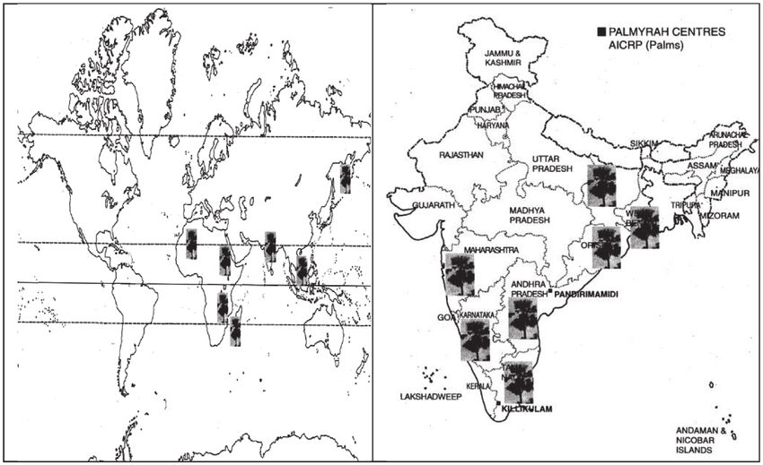
The main cultivation pattern is semi-wild, with palms scattered around field boundaries, sand dunes, and wastelands, rather than in plantations. Farmers harvest inflorescences seasonally (January to June), practice mixed farming or agroforestry with palmyrah, and use leaves, fibers, and wood for local construction and handicrafts, developing varied low-input, multiple-output systems [13], [14], [22], [26].

3. Production of Palm Jaggery
3.1 Sap (Neera) extraction process
Neera is the clear, sweet, non-fermented sap dripping from the cut tip of the inflated palmyra inflorescence stem. Tapping requires beating the spadix to induce sap flow, cutting the tip, and connecting a collection receptacle. Traditional practices involve the use of open earthenware or bamboo vessels suspended below the cut end, sometimes lined internally with lime to partially retard fermentation. Improved, modern tapping systems utilize closed stainless steel or plastic sap chillers with ice packs and food-grade tubing to minimize microbial contamination and fermentation in the field.
Sap extraction is normally done twice a day (morning and evening). As the sugar-rich sap readily ferments because of the presence of indigenous yeasts and lactic acid bacteria, the pH drops from 7.0-7.4 to acidic values in a few hours, requiring immediate preservation or jaggery production [14], [21], [30], [31].
3.2 Traditional vs. modern jaggery production techniques [None]
In the traditional open pan process, filtered sap is treated with lime (approx. 2.1-2.5 g/L) and sometimes plant clarificants, boiled in wood-fired furnaces using iron or mild steel pans. Scum with coagulated proteins, polyphenols, and insoluble impurities is removed by skimming, and boiling continues until the syrup reaches 110-120 °C and 65-70 °Brix, at which point it thickens and darkens due to the Maillard reaction and caramelization. After cooling with vigorous agitation, supersaturated syrup crystallizes to a semi-solid form, which can be shaped into blocks or pulverized into granulated jaggery.
Contemporary modifications are intended to enhance energy efficiency, product quality, and sanitation. These modifications include:
• Steam jacketed pans heated by boilers, preventing smoke contamination and enhancing heat transfer and fuel economy. [None]
• Two-, three-, and four-pan furnaces, in which pre-heating of fresh sap is done in gutter pans using flue gas waste heat recovery, raising thermal efficiency and lowering bagasse consumption.
• Vacuum evaporators concentrating sap at lower temperatures (e.g., 70-90 °C), minimizing non-enzymatic browning and retaining vitamins and phenolics.
• Spray drying and membrane filtration for producing light-colored palm sugar powders with reduced stickiness and longer shelf life.
These technological advances minimize fuel consumption, ensure product quality [13], [14], [21], [22], [29], [32].
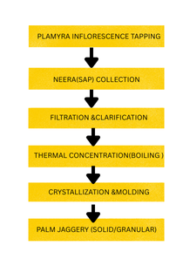
3.3 Quality parameters and grading standards
Key physico‑chemical parameters of palm jaggery include moisture (typically 3–10% in blocks; ~8.3% reported in one classic analysis), total and reducing sugars, ash, pH, colour (Lab*), total soluble solids, mineral profile, and microbial load. Excessive moisture, high reducing sugars, and low glass transition temperature promote hygroscopicity, caking, microbial spoilage and quality deterioration. [None]
Critical process‑linked quality indicators are:
- Moisture content: lower moisture (~8–10%) improves shelf life and reduces stickiness. [None]
- Reducing sugars: influence Maillard browning, flavour generation and crystallization behaviour.
- Colour: palmyrah jaggery is intrinsically darker than cane jaggery due to higher fructose content and more intense Maillard and caramelization reactions.
- Glass transition and sticky point temperatures: determine storage stability; palmyrah granules show relatively high Tg (~74.5 °C dry basis), but Tg declines with increasing moisture. [None]
Although no internationally harmonized standards exist, national or regional specifications (e.g., Thai industrial standards) typically prescribe minimum °Brix, limits for moisture and ash, and microbiological safety criteria [13], [15], [16], [32], [33], [34].
4. Nutritional Composition of Palm Jaggery
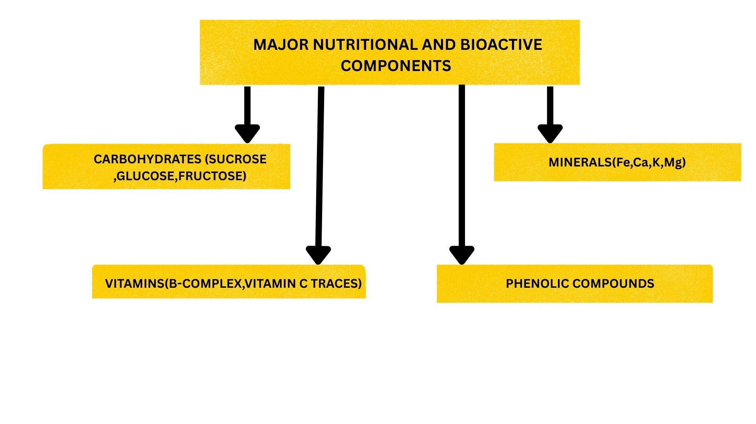
4.1 Macronutrient profile
Palmyra palm jaggery is mainly a carbohydrate-rich food, with conventional analysis showing the presence of 87-91 g of carbohydrates per 100 g, of which 82-84 g is sugars. Sucrose is the principal sugar (about 65-80%), along with substantial quantities of glucose and fructose, and trace amounts of oligosaccharides and dietary fiber (inulin-type fructans). Protein is present in low but not insignificant amounts (about 1.0-2.2 g/100 g), and fat is present in minute quantities (0-0.2 g/100 g). The energy value is similar to cane jaggery and refined sugar, at about 364-380 kcal/100 g.
The table below combines proximate composition information for palmyrah jaggery made using open pan boiling techniques.[13], [15], [34], [35]
4.2 Micronutrients: iron, calcium, potassium, magnesium and others
One of the characteristic aspects of palm jaggery is the presence of a high mineral content compared to refined sugar and even sugarcane jaggery. Traditional and modern values indicate the following: [None]
- Iron: ~6–10 mg/100 g (some sources 120–130 mg/kg), supporting hemoglobin synthesis.
- Calcium: ~140–233 mg/100 g (up to 900–1000 mg/100 g in some modern comparative tables), substantially higher than cane jaggery (80–100 mg/100 g). [None]
- Potassium: ~100–140 mg/100 g in early work; more recent technological reviews often cite 800–900 mg/100 g and very high K:Na ratio, favourable for blood pressure regulation.
- Phosphorus: ~16–27 mg/100 g.[1] [None]
- Magnesium: ~5–42 mg/100 g, though values up to 30–50 mg/100 g are also reported.
- Trace elements: copper, cobalt, nickel and manganese occur in tens of mg/kg range
Vitamin composition, although meager compared to the sap, includes thiamine (B1), riboflavin (B2), nicotinic acid (B3), and vitamin C, with B-group vitamins being derived from sap and partially preserved during heating. Neera itself is rich in vitamin C and B-complex vitamins, but a large portion of it is destroyed during heating and storage. [16], [29], [33], [34], [36]
Nutritional Composition of Palmyra Palm Jaggery

Category | Component | Values (per 100 g) | Notes
Macronutrients | Carbohydrates | 87–91 g | Predominantly sugars
 | Sugars (total) | 82–84 g | Mainly sucrose
 | Sucrose | 65–80% | Major sugar fraction
 | Glucose & Fructose | Significant amounts | Simple sugars
 | Oligosaccharides & Fibre | Small fractions | Includes inulin-type fructans
 | Protein | 1.0–2.2 g | Low but non-negligible
 | Fat | 0–0.2 g | Minimal
 | Energy | 364–380 kcal | Comparable to cane jaggery/refined sugar
Micronutrients | Iron | 6–10 mg (120–130 mg/kg) | Supports hemoglobin synthesis
 | Calcium | 140–233 mg (up to 900–1000 mg in some reports) | Higher than cane jaggery
 | Potassium | 100–140 mg (up to 800–900 mg in recent reviews) | High K:Na ratio, beneficial for BP regulation
 | Phosphorus | 16–27 mg | Moderate
 | Magnesium | 5–42 mg (sometimes 30–50 mg) | Variable
 | Trace elements | Copper, cobalt, nickel, manganese (tens of mg/kg) | Present in small amounts
Vitamins | Thiamine (B1), Riboflavin (B2), Nicotinic acid (B3), Vitamin C | Modest levels | Derived from sap, partly degraded during heating
Phytochemicals & Antioxidants | Phenolic acids | Gallic, tannic, pcoumaric, ferulic | Antioxidant activity
 | Aromatic acetophenones | 2,3,4trihydroxy5methyl acetophenone | Strong DPPH scavenging, antimicrobial
 | Maillard intermediates | 5hydroxymethylfurfural, DDMP | Antioxidant & anticarcinogenic potential
 | Flavonoids & tannins (from leaves) | Not directly ingested via jaggery | Strong antibacterial & antifungal activity
Medicinal/Therapeutic Benefits | Antioxidant properties | DDMP & phenolics show free radical scavenging | Potential role in reducing ROS linked to chronic diseases
 | In vitro assays | Significant DPPH & H₂O₂ scavenging | Activity modulated by processing temperature/time
 | Comparative activity | Leaf extracts IC₅₀ values ≈ ascorbic acid | Dose-dependent antioxidant effects

4.3 Phytochemicals and antioxidants
Palmyra sap and jaggery contain a range of polyphenols and Maillard reaction products with documented antioxidant activity. Identified compounds in palmyrah syrup and sugar include
Pic to be added

Figure 2: Comprehensive nutritional profile of palmyra palm jaggery showing proximate composition, vitamin content, and mineral composition per 100g [None]
- Phenolic acids (gallic, tannic, p‑coumaric, ferulic).
- Aromatic acetophenones such as 2,3,4‑trihydroxy‑5‑methyl acetophenone, showing strong DPPH radical scavenging and antimicrobial activity. [None]
- Maillard intermediates such as 5‑hydroxymethylfurfural and 2,3‑dihydro‑3,5‑dihydroxy‑6‑methyl‑4H‑pyran‑4‑one (DDMP) with antioxidant and anti‑carcinogenic potential.
In vitro assays on palmyrah syrup and sugar demonstrate significant DPPH and hydrogen peroxide scavenging, with phenolic content modulated by processing temperature and time—higher temperatures accelerate Maillard reactions but may also degrade thermolabile phenolics. Additionally, leaves and other plant parts of B. flabellifer possess flavonoids, tannins and other phytochemicals that contribute to strong antibacterial, antifungal and antioxidant activities, although these are not directly ingested via jaggery [8], [19], [23], [29], [31], [37].

5. Medicinal and Therapeutic Benefits
5.1 Antioxidant properties [None]
The antioxidant properties of palmyrah products are due to the combination of indigenous phenolic compounds and Maillard reaction products formed during heat concentration of sap. Research on palmyrah syrup and sugar has revealed the presence of DDMP and its derivatives with strong free radical activity in DPPH assays. The leaf extracts of palmyrah have shown dose-dependent DPPH and hydrogen peroxide scavenging with IC₅₀ values similar to ascorbic acid, due to the high content of flavonoids and tannins. Although there are no direct clinical studies on the effect of jaggery intake on oxidative stress markers, the availability of these antioxidants indicates their potential use in ROS modulation in chronic diseases. . [None]

5.2 Anti‑inflammatory effects
Different components of B. flabellifer have been shown to possess anti-inflammatory properties in experimental models. The ethanolic extracts of the male inflorescence have been shown to decrease edema and inflammatory mediators in animal models, attributed to triterpenes and steroidal saponins. The antioxidant properties of flavonoids and phenolics in palm jaggery and its products could potentially modulate the inflammatory process by reducing ROS-mediated activation of NF-κB, although this needs to be confirmed in clinical studies. [8], [13], [24], [26].
5.3 Antimicrobial activity
The methanolic and acetone extracts of B. flabellifer leaves and seed coats have been found to possess broad-spectrum antibacterial and antifungal properties against Gram-positive and Gram-negative bacteria (Staphylococcus aureus, Bacillus subtilis, Escherichia coli, Pseudomonas aeruginosa) and fungi (Aspergillus spp., Candida spp.) with MIC values ranging from 50-70 µg/mL. This is attributed to the presence of phenolic, tannin, and saponin compounds that can interact with microbial membranes and enzymes. Although jaggery itself is not considered a major antimicrobial agent, the use of palm-based traditional medicines like jaggery and herbs takes advantage of its antimicrobial properties in treating minor infections and wounds. [19], [24], [25], [30]
5.4 Digestive health benefits
Palm jaggery is also employed as an aid to digestion in Indian cuisine, taken in small amounts after meals to promote the secretion of saliva and digestive juices. Palm jaggery has been ascribed mild laxative properties based on its dietary fiber, magnesium, and osmotic properties of sugars, which can help alleviate constipation. In addition, the inulin-type fructans and other fermentable carbohydrates in palm jaggery may have prebiotic properties, which can help promote beneficial gut flora, although human evidence is limited. [19], [24], [25], [30]
5.5 Hemoglobin and anemia management [None]
The fact that palmyrah jaggery has a relatively high iron content has been an established reason for its use in treating anemia, particularly in women and children. Plant iron is less bioavailable than heme iron, but the coexistence of ascorbic acid and low gastric pH can increase iron absorption through ascorbate-ferric complexes. School-feeding programs using neera supplementation in India showed improved hemoglobin and nutritional status, indicating that products derived from palmyrah sap can make a significant contribution to iron supplementation. However, human studies are required to determine the bioavailability of iron from palm jaggery. [19], [24], [25], [30]
5.6 Respiratory health (cold, cough, asthma support)
Palm jaggery is recommended in traditional medical literature of India and Sri Lanka as an additive in decoctions for the treatment of dry cough, common cold, and mild asthma. The role of palm jaggery as an expectorant has been ascribed to its ability to mobilize mucus, offer warmth and energy, and enhance phytomedicinal properties. Although not evidence-based, these practices are consistent with the general evidence that warm carbohydrate-rich fluids can temporarily alleviate mucociliary clearance and symptoms of upper respiratory infections. [19], [24], [25], [30]
5.7 Energy metabolism and glycemic impact [None]
Although palmyrah palm sugar is energy-dense, it has a lower glycemic index (GI) than refined cane sugar, primarily because of its complex sugar composition (sucrose, glucose, and fructose) and fiber and phytochemical content. In vitro digestion and human GI trials have indicated that the GI of palm sugars and palm-sweetened foods is in the low to moderate range (~35-65) compared to cane sugar (~70-80). Wheat-based foods and bread sweetened with palm sugar have shown slower digestion of starch, reduced postprandial glucose peaks, and decreased insulin secretion, which can be ascribed to the interactions of sucrose, starch, and water, as well as competition for water during starch gelatinization.
From a metabolic perspective, fructose moieties are initially processed in the liver before being added to the glucose pool in the blood, causing a delayed and reduced glycemic response compared to glucose ingestion. However, high fructose intake can cause deleterious metabolic effects; hence, palm jaggery should be considered a relatively better but still caloric sweetener, not to be used freely by diabetics. [19], [24], [25], [30]
5.8 Liver detoxification potential
The traditional remedy ascribes “blood and liver purification” actions to neera and palm jaggery, possibly due to its vitamin C, phenolic, and mineral components that could have a role in the enhancement of hepatic antioxidant mechanisms and conjugation reactions. Animal studies using palmyrah sap extracts have shown some hepatoprotective activity (such as a reduction in blood glucose and improvement in enzyme levels), but concrete evidence is not available for jaggery. [19], [24], [25], [30]
5.9 Effects on reproductive health (traditionally cited)
There are occasional mentions of palmyrah-based formulations in ethnomedicinal literature for improving fertility or menstrual cycles, probably due to the increased energy levels and iron status as a result of regular jaggery intake. But there are no scientific studies to support any direct action on reproductive hormones or fertility parameters. The proposed benefits are more likely to be due to the correction of anemia, malnutrition, and general health rather than any endocrine action. [19], [24], [25], [30]
6. Comparison with Other Natural Sweeteners
6.1 Cane jaggery vs. palm jaggery
Cane jaggery and palm jaggery share similar production logic but differ in composition and functional attributes.
Attribute | Cane jaggery | Palmyra palm jaggery
Major sugar | Sucrose (70–85%) | Sucrose (65–80%), higher fructose & glucose
Minerals | Moderate; Ca ~80–100 mg/100 g, K ~1000–1100 mg/100 g | Generally higher Fe, Ca (often 2–10× cane), K high but somewhat lower than cane in some datasets
Vitamins | Low, some B‑group | B‑group plus more vitamin C residues
Colour & flavour | Light to dark brown, caramel | Darker, earthy, nutty, coffee‑like, complex aroma
GI | High (~70–80) | Lower (~60–65 or less in formulations)
Process | Cane juice boiling | Neera boiling; more pronounced Maillard & caramelization

Overall, palm jaggery offers superior micronutrient density and a lower glycemic impact, with a more complex flavour profile that is advantageous in chocolates, desserts and beverages.[13], [15], [38]
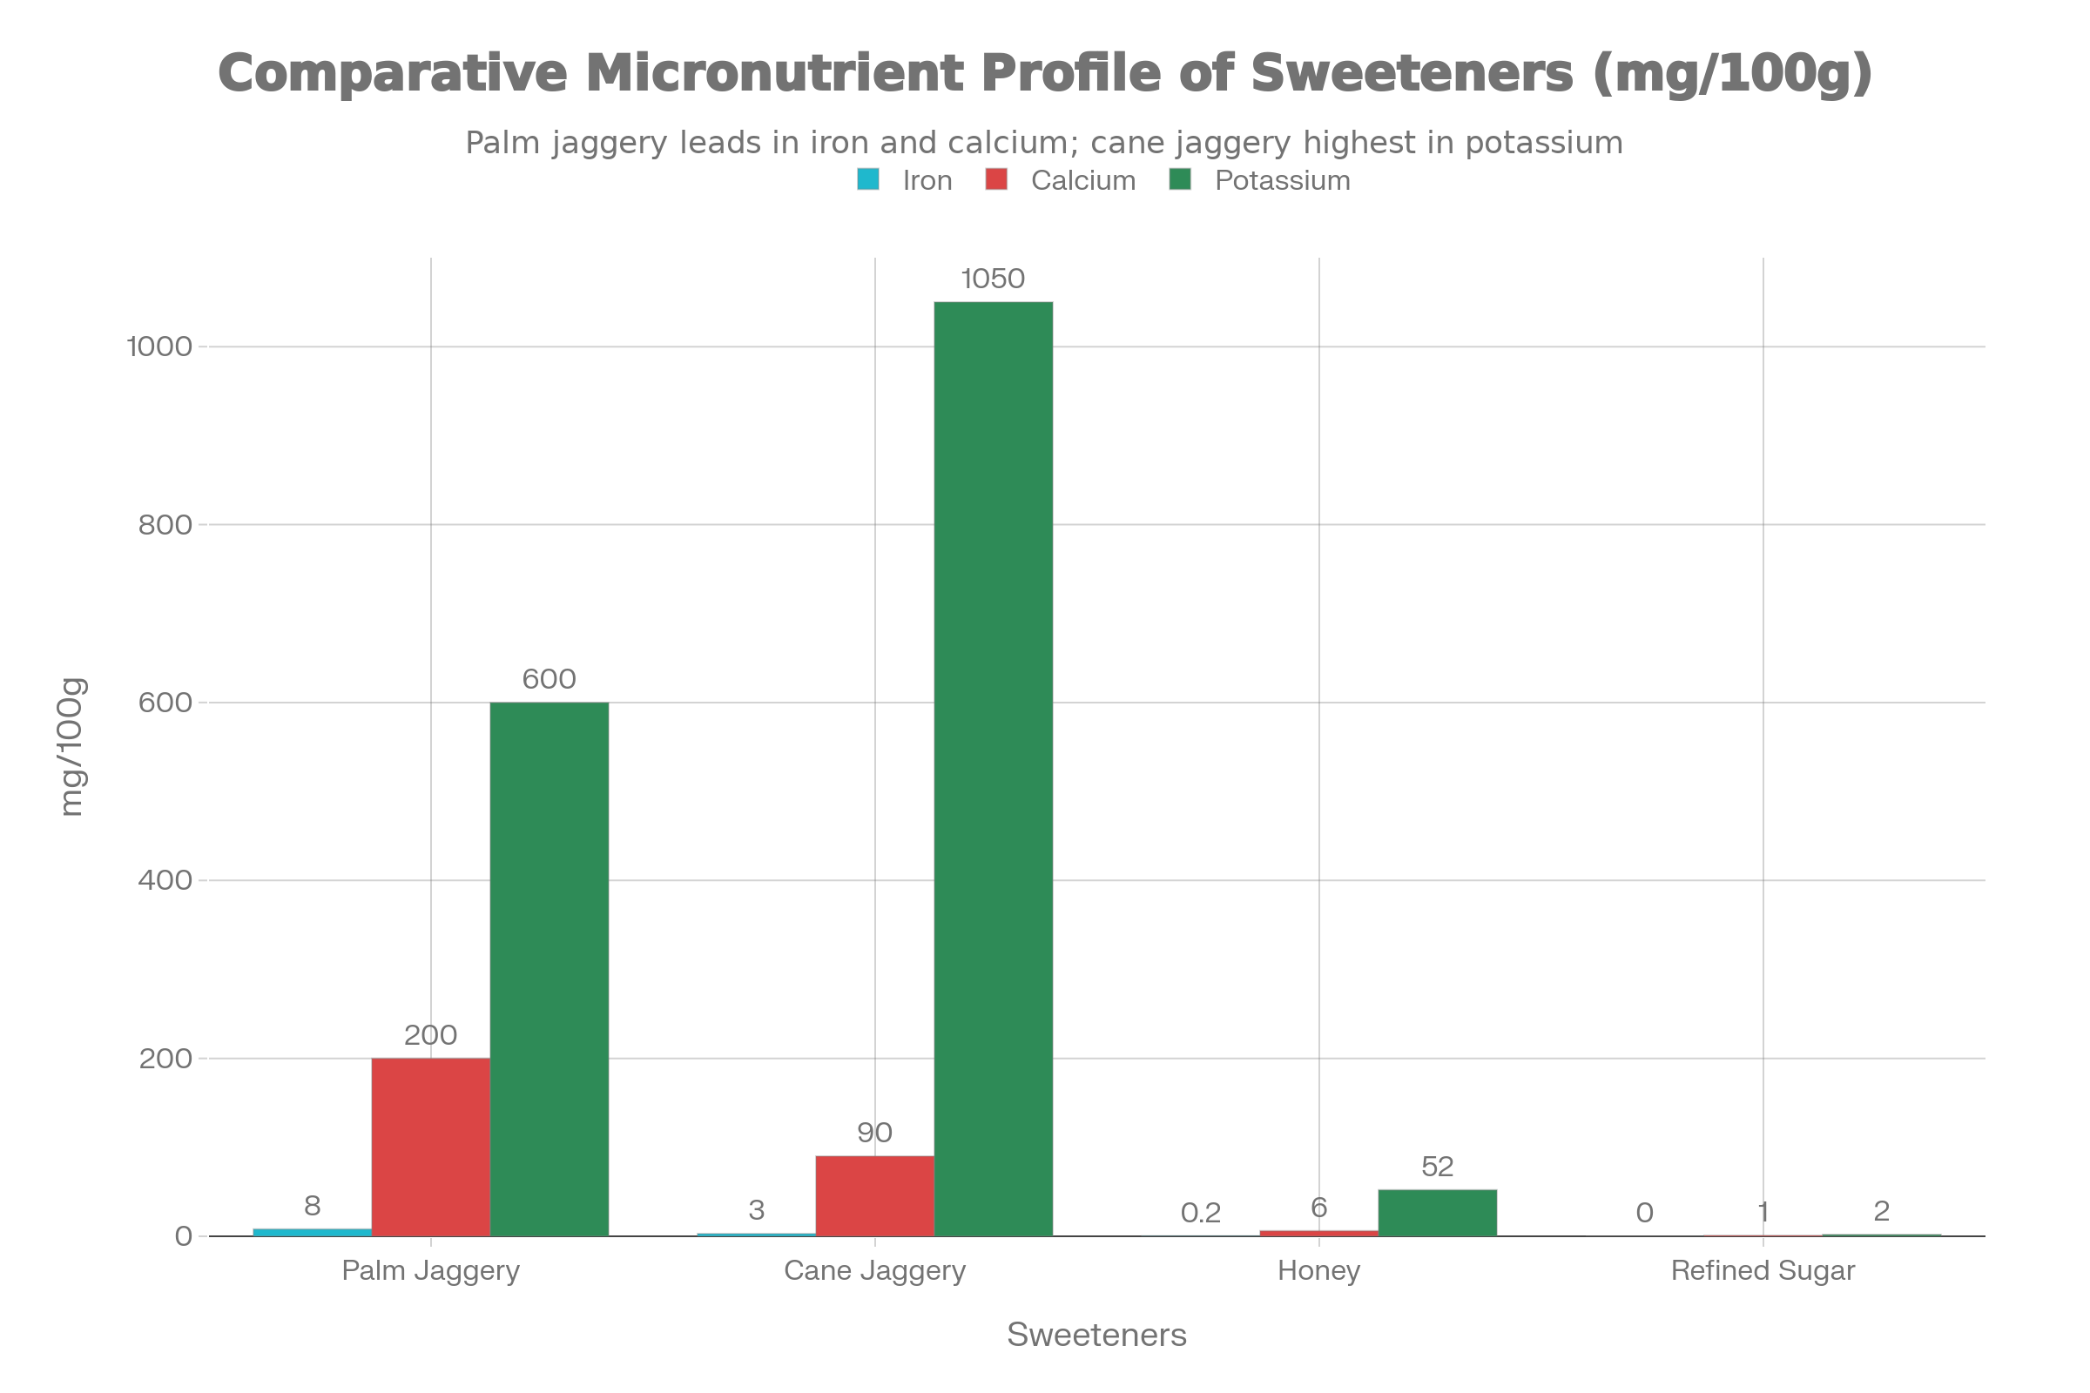
6.2 Honey vs. palm jaggery
Both honey and palm jaggery are less processed sweet foods with bioactive properties, but they are quite different from each other. [None]
•Honey is a combination of fructose and glucose with trace amounts of enzymes, polyphenols, and antibacterial properties (such as hydrogen peroxide). Its GI can be high but may also be moderate.
•Palm jaggery is a solid form of sucrose with high mineral and some fiber and Maillard compound content. It has higher iron and potentially higher potassium and calcium content per weight than honey, but it does not contain the enzyme fingerprint of honey.
In terms of nutritional benefits, both honey and palm jaggery can be considered better than sugar if used in moderation, but palm jaggery is more beneficial if iron and calcium deficiencies are common. [14], [23], [34]
6.3 Refined sugar vs. palm sugar (health perspective)
Refined white sugar is nearly pure sucrose (>99.5%) with low mineral, vitamin, and phytochemical content and a high GI value (~58-68). Palmyrah palm NCS, on the other hand, is:
•Unrefined and less processed, with retained molasses and accompanying micronutrients.
•High in minerals and phytochemicals, with potential functional properties in addition to sweetness.
•Lower glycemic effect in some in vitro and in vivo studies.
But both have similar caloric values, and thus the superiority of palm jaggery over sugar is in its nutritional and metabolic differences rather than in being non-caloric.
7. Socio‑Economic Importance
7.1 Role in rural livelihoods
Palmyrah-based enterprises are the backbone of economic activity in many palm-dense areas, as they generate seasonal employment through tapping, jaggery making, toddy extraction, fruit and kernel use, leaf craft, and fiber products. Tapping is a highly specialized and labor-intensive process that is often done from a young age and involves tapping tall palms twice a day. Home-scale jaggery production involves boiling, molding, packaging, and marketing.[14], [28], [39]
7.2 Employment generation in palm‑rich regions
In states such as Tamil Nadu and Odisha, thousands of families are involved in palmyrah-related activities, ranging from toddy shops and neera units to jaggery and candy manufacturing. Palmyrah value addition (such as palm candy, liquid jaggery, and flavored jaggery confectioneries) has been identified as a means of providing rural employment and self-help group activities for women. Sap collection mechanization and improved furnaces can also improve productivity and employment levels by moving employment into higher-value-added processing and marketing activities. [13], [14], [28]
7.3 Market demand and trade trends
Worldwide, the palm sugar market (over various palm species) is expected to expand greatly as demand for organic, vegan, and low GI sweeteners increases, with market valuations forecasted in the multi-billion-dollar range by mid-decade. However, palmyrah palm jaggery is currently represented inadequately compared to coconut and sugar palm jaggery, partly because of the lack of organized cultivation and logistical issues (the sap is perishable). The key to unlocking a premium market niche for palmyrah jaggery could be to establish it as a geographical indication product, and to standardize its quality as “natural, unrefined, low GI”.[14], [17], [29], [37]
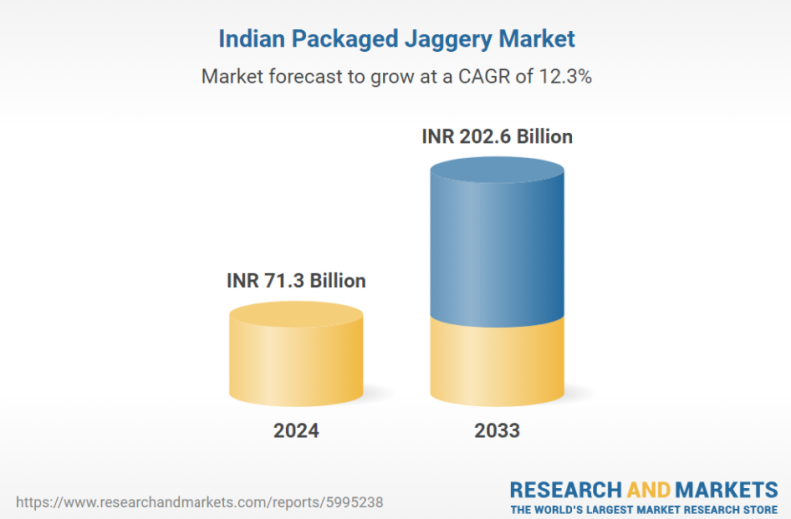
8. Environmental Impact & Sustainability [None]
8.1 Ecological importance of palmyra palms
Palmyrah palms are very useful in maintaining landscape stability, biodiversity, and microclimate in coastal and semi-arid environments. The extensive root system of the palmyrah palm helps to stabilize the dunes and marginal soils, while the canopy and leaf litter provide habitat for birds, insects, and understory vegetation. They are long-lived perennials that sequester carbon for long periods of time and can be used in agroforestry.
8.2 Zero‑waste uses (leaves, fruits, timber)
Virtually all parts of the palmyra palm are utilized:[7][8] [None]
- Leaves: thatching, mats, baskets, handcrafts, writing material (traditional palm‑leaf manuscripts).
- Fruit and seeds: edible jelly endosperm, pulp for sweets and beverages, starchy seed shoots; several value‑added products documented. [None]
- Fibre: brushes, ropes, brooms, packing materials. [None]
- Timber: durable wood for beams, rafters, and rural construction.
- By‑products: leaf midribs and waste fiber used as fuel in jaggery furnaces or as mulch.
This zero‑waste ethos underpins the palm’s “tree of life” designation and enhances its sustainability
profile relative to annual sugar crops. [None]
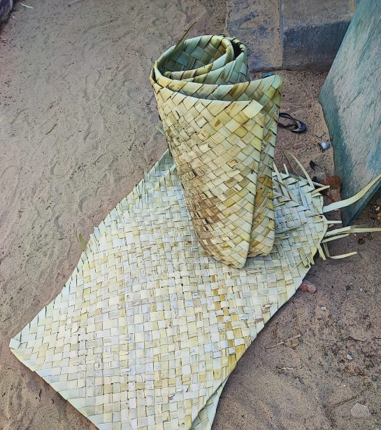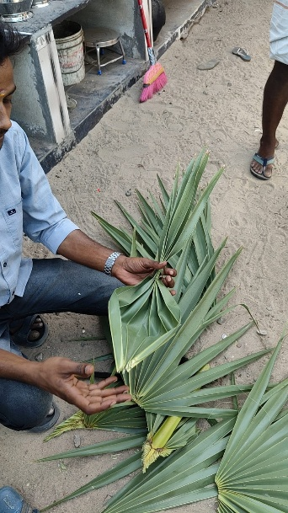
8.3 Climate resilience and carbon benefits
Palmyrah palms are relatively drought-resistant and can be grown on marginal soils without irrigation, agrochemicals, and soil disturbance, unlike water- and input-intensive sugarcane. The tapping of inflorescences for sap is non-destructive and enables repeated harvests for several years without cutting down the tree, which is consistent with climate-smart agriculture and zero hunger goals by providing a new source of carbohydrates in the region. Although LCA-type studies remain few, the integration of perennial biomass, low-input, and multiple-product use patterns appears to have a positive carbon and environmental impact profile for sweeteners from palmyrah palms. [26], [38]
9. Traditional and Culinary Uses
9.1 Culture‑specific uses across India, Sri Lanka, Southeast Asia
Palm jaggery features in a wide range of regional cuisines: [None]
- South India (Tamil Nadu, Andhra Pradesh, Karnataka, Kerala): traditional sweets (kheers, payasams, kozhukattai), breakfast dumplings, and festival foods use palmyrah jaggery for its robust flavour and perceived healthfulness. [None]
- Sri Lanka: palm jaggery (hukuru) sweetens milk‑based desserts, herbal decoctions and confectionery.
- Southeast Asia: palmyrah and other palm sugars are integral to savoury‑sweet curries, sauces and snacks, often balancing chilli and sourness. [None]
9.2 Use in Ayurvedic and Siddha formulations
Jaggery has been classified as a deepana (appetite-stimulating), pachana (digestive), and rakta vardhaka (blood-enriching) drug in Ayurvedic and Siddha systems of medicine, and is used as an anupana (vehicle) for powder and decoction preparations. Palm jaggery is specifically used in respiratory, digestive, and female reproductive disorders where its warming, mucolytic, and hematinic actions are desired. While these actions are largely empirical, they do not contradict the nutritional and mild pharmacological properties discussed above. [None]
9.3 Modern food industry applications
The palmyrah palm sugar has been introduced into the following products by modern scientific research and artisan production: [None]
• Chocolate: as a natural sweetener with nut, roasted, caramel, and cotton candy flavors; palm-sweetened dark chocolates have been found to have different volatile compound profiles and acceptable rheology and texture when optimized.
• Dairy products and desserts: flavored yogurts, puddings, ice creams, and kombucha drinks using palm jaggery as a sweetener and source of polyphenols and minerals.
• Functional bakery products: breads and biscuits with lower GI and improved micronutrient composition by partial or complete substitution of cane sugar.
Optimization studies have shown that palm sugar can be used to alter the gelatinization, melting, glass transition, and texture properties, which require careful optimization but also provide opportunities for the development of differentiated health-positioned products.
10. Challenges in Palm Jaggery Production [None]
10.1 Seasonal dependence [None]
The sap flow rate is highly seasonal, with the peak tapping months differing from place to place but generally occurring during the drier months. This makes it difficult to have a continuous supply of jaggery. The off-season activities in the value chain (candy, syrups, dried fruits) may help mitigate the seasonality issue but do not fully address it.
10.2 Labour‑intensive tapping process
Palm tapping is physically strenuous and hazardous, with frequent ascents of tall palms and delicate manipulations in spadix processing and pot handling. Demographic changes and a lack of interest among the younger generation pose a threat to the sustainability of tapping skills, resulting in the underutilization or abandonment of palmyrah stands in certain areas. The development of safe climbing aids, training packages, and economic incentives is essential for maintaining the tapping labor force.
10.3 Issues in adulteration and quality control [None]
The high price in the market and the unavailability of the product can lead to the addition of cane sugar, artificial sweeteners, or colorants to palm jaggery. The other reason could be the misrepresentation of jaggery obtained from other palm trees as palmyrah. Poor hygiene practices during the collection of sap and boiling can lead to contamination of the product by microbes, which can affect the shelf life of the product.
10.4 Decline in palmyra cultivation
Despite the palmyrah’s strong ecological niche, there are a number of factors that contribute to the decline or plateau in the number of palms: slow growth rate during the juvenile phase, competition from more lucrative cash crops (such as sugarcane and oil palm), unclear land rights, and a lack of government support for palmyrah agroforestry. Land use change in palmyrah-dominant regions results in the loss of jaggery production, biodiversity, and cultural significance. A more integrated strategy for sap income, fruit, and ecotourism could re-popularize palmyrah cultivation [None]
11. Global Distribution of Palmyra Palm
11.1 Major palm jaggery–producing countries
The chief producers of palmyrah jaggery are India (Tamil Nadu, Andhra Pradesh, Odisha, West Bengal, and the western coastal states), Sri Lanka, Bangladesh, Myanmar, Thailand, Cambodia, and some countries in Indonesia and Vietnam. In Africa, B. aethiopum is tapped for sap and sweeteners in West and East African countries, but jaggery type non-centrifugal sugar is less advanced.
11.2 Regional variations in production & consumption
In South Asia, the palmyrah sap is used for the preparation of both non-alcoholic drinks (neera, vinegar) and alcoholic toddy, while jaggery production becomes more frequent in areas where the sales of toddy are restricted by alcohol regulations or in areas where there is a preference for solid sweeteners. In Southeast Asia, the systems are more oriented towards fresh fermented drinks and sugar production from other palm species like Arenga, Cocos, and Nypa, with the palmyrah being of secondary importance.
11.3 FAO statistics and data gaps [None]
Non-Centrifugal Sugars, or NCS, are known to be a separate commodity by FAO, but the data on palmyrah sugar versus other palm sugars has not been well developed, and a large part of the palmyrah products remain unorganized or unreported. This has led to the need for estimates of production and trade data from national surveys or case studies at the local level, thus underlining the need for better global data on palmyrah resources, production, and value chains. [None]
12. Recent Research Trends
12.1 Biochemical studies
Recent studies have been directed at understanding the composition, Maillard reactions, and physical properties of the palmyrah palm NCS: [None]
• Comprehensive analysis of the volatile compounds (pyrazines, ketones, phenols, and sulfur compounds) contributing to the characteristic aroma of palm sugar.
• Study of sucrose-glucose-fructose co-melting properties, glass transition, hygroscopicity, and crystallization to enhance drying and storage properties.
• Examination of phenolic compounds and Maillard reaction products, such as antioxidants and toxic compounds (e.g., HMF and acrylamide), as a function of temperature-time treatment conditions.
12.2 Pharmacological studies
Apart from in vitro antioxidant and antimicrobial assays, other research areas in palmyrah products are: [None]
• Assessment of the anti-inflammatory and hypoglycemic properties of palmyrah sap in animal models.
• Antioxidant, antimicrobial, and cytoprotective activities of leaf, fruit, and syrup extracts.
• Analysis of palm wine microbiota and their functional capabilities for the development of probiotics.
But human health outcome studies of jaggery are very limited.
12.3 Innovations in preservation and processing
Technological innovations aim to stabilize sap, reduce energy use and standardize jaggery quality:[25][8] [None]
- Pasteurization combined with nisin or chitosan to extend sap shelf life while limiting sucrose inversion and browning.
- Membrane filtration, ultrafiltration and ozonation to clarify sap and reduce enzymatic browning prior to concentration. [None]
- Spray‑drying and vacuum evaporation to produce fine palm sugar powders with lower HMF and improved colour, flavour and shelf stability. [None]
These advances support the integration of palmyrah sugar into industrial food systems as a standardized functional ingredient. [None]
13. Future Prospects
13.1 Opportunities for commercialization
Rising demand for natural, minimally processed, plant‑based sweeteners with functional claims creates substantial opportunities for palmyrah jaggery. Strategic commercialization pathways include:
- Geographical indication and regional branding (e.g., “Thoothukudi palmyrah jaggery”) to capture terroir and cultural value.
- Organic and fair‑trade certification to access premium export markets.^{[1][12]}
- Integration into health‑positioned products (granola, energy bars, sports drinks, nutraceuticals) as a “mineral‑rich natural sugar”.
13.2 Use in functional foods
Palmyrah jaggery’s combination of minerals, polyphenols and lower GI supports its use as a functional ingredient in:
- Low‑GI bakery items and cereals.
- Fortified desserts and dairy products targeting iron and calcium deficiency.
- Probiotic beverages (kombucha, fermented teas) where palmyrah sugars support microbial growth and provide additional antioxidants.
Standardization of composition, sensory properties and health claims will be crucial for regulatory acceptance and consumer trust.
13.3 Market potential in health‑conscious diets
As the dangers of refined sugars have become better understood, health-conscious consumers are open to sweeteners that provide “more than empty calories.” Palmyrah jaggery fills this demand as a dense, traditional, plant-based sweetener with a strong story of sustainability. However, public communication must temper enthusiasm with reality, focusing on moderation in consumption and resisting the temptation to make “sugar-free” or “diabetic-safe” claims.
14. Conclusion
Palmyrah palm jaggery at Borassus flabellifer has been a special meeting point of botanical stamina, technological variety, dietary abundancy and cultural richness. Being a non-centrifugal sugar, it contains minerals (especially iron, calcium and potassium), vitamins, polyphenols and Maillard products which make it special compared to refined sucrose, even against cane jaggery. Its antioxidant, antimicrobial and lower-glycemic activity has been shown experimentally, and its traditional knowledge has focused on its digestive, hematinic and respiratory effects, although it has not been shown to a considerable degree in clinical studies.
Simultaneously, the palmyrah jaggery industry is highly limited: the sap seasonality, tapping risky and labour-intensive, inefficient process, risk of adulteration of the end product, and the failure of policy and research agenda to focus on palmyrah agroecosystems. The current developments in sap preservation, energy efficient processing and functional product development prove that these issues can be overcome and that palmyrah sugar could be repackaged as a new modern functional sweetener with its roots in sustainable and smallholder friendly value-chains.
Future research issues involve the in-depth profiling of bioactive compounds of various palmyrah jaggery types, in vitro and in vivo testing of mineral and phenolic bioavailability and long-term clinical trials to assess metabolic and hematologic effects and life-cycle analysis of palmyrah sugar against cane and beet sugars. A parallel socio-technical intervention on the mechanization of the tapping process, improvement of the occupational safety, promotion of the palmyrah planting, and enhancement of producer organizations will make the palm jaggery achieve its full potential of becoming a globally known, health-compatible natural sweetener to the extent that it will boost the livelihood of rural people and the sustainability of the ecological conditions.
15. Reference
[1] S. Behera, “Phytochemical Constituents and Nutritional Potential of Palmyra Palm: A Review,” The Review of Contemporary Scientific and Academic Studies, vol. 2, no. 12, Dec. 2022, doi: 10.55454/rcsas.2.12.2022.003.
[2] V. PC, M. GN, S. M, and M. HP, “Vale Added Food Products from Palmyrah Palm (Borassus Flabellifer L),” Journal of Nutrition and Health Sciences, vol. 4, no. 1, May 2017, doi: 10.15744/2393-9060.4.105.
[3] A. R. Basava Prasad, A. Arunkumar, S. Vignesh, D. V. Chidanand, and N. Baskaran, “Exploring the nutritional profiling and health benefits of Palmyra palm haustorium,” South African Journal of Botany, vol. 151, pp. 228–237, Dec. 2022, doi: 10.1016/j.sajb.2022.01.027.
[4] A. Upadhyaya and S. K. Sonawane, “Palmyrah palm and its products (Neera, Jaggery and Candy)—A Review on chemistry and technology,” Applied Food Research, vol. 3, no. 1, Jun. 2023, doi: 10.1016/j.afres.2022.100256.
[5] M. K. Rayappa, “Palmyrah palm (Borassus flabellifer) non-centrifugal sugar - Current production practices as a natural sugar and a promising functional food/additive,” Dec. 01, 2023, Elsevier B.V. doi: 10.1016/j.jafr.2023.100829.
[6] V. P. Vijaya kumara B and M. G. Prasad KR, “Physico-Chemical Properties of Palmyrah fruit Pulp (Borassus flabellifer L),” J. Nutr. Food Sci., vol. 05, no. 05, 2015, doi: 10.4172/2155-9600.1000391.
[7] J. Sharifi-Rad et al., “Revisiting the nutraceutical profile, chemical composition, and health benefits of jaggery: Updates from recent decade,” Apr. 01, 2023, John Wiley and Sons Inc. doi: 10.1002/efd2.75.
[8] R. Mariselvam and P. M. Selvakumar, “Review on the Nutraceutical Values of Borassus flabelifer Linn,” Journal of Pharmaceutics and Drug Research JPDR, vol. 3, no. 1, pp. 268–271, [Online]. Available: www.scitcentral.com
[9] G. Kennedy, Z. Wang, P. Maundu, and D. Hunter, “The role of traditional knowledge and food biodiversity to transform modern food systems,” Dec. 01, 2022, Elsevier Ltd. doi: 10.1016/j.tifs.2022.09.011.
[10] A. D. Saputro, D. Van de Walle, and K. Dewettinck, “Physicochemical properties of coarse palm sap sugars as natural alternative sweetener,” Food Biosci., vol. 38, Dec. 2020, doi: 10.1016/j.fbio.2020.100780.
[11] K. Vanitha et al., “Health benefits and neutracuticle properties of palmyra palm - A forgotten treasure,” Plant Science Today, Jul. 2025, doi: 10.14719/pst.7398.
[12] J. Sharifi-Rad et al., “Revisiting the nutraceutical profile, chemical composition, and health benefits of jaggery: Updates from recent decade,” Apr. 01, 2023, John Wiley and Sons Inc. doi: 10.1002/efd2.75.
[13] M. K. Rayappa, “Palmyrah palm (Borassus flabellifer) non-centrifugal sugar - Current production practices as a natural sugar and a promising functional food/additive,” Dec. 01, 2023, Elsevier B.V. doi: 10.1016/j.jafr.2023.100829.
[14] A. Upadhyaya and S. K. Sonawane, “Palmyrah palm and its products (Neera, Jaggery and Candy)—A Review on chemistry and technology,” Applied Food Research, vol. 3, no. 1, Jun. 2023, doi: 10.1016/j.afres.2022.100256.
[15] A. D. Saputro, D. Van de Walle, and K. Dewettinck, “Physicochemical properties of coarse palm sap sugars as natural alternative sweetener,” Food Biosci., vol. 38, Dec. 2020, doi: 10.1016/j.fbio.2020.100780.
[16] V. P. Vijaya kumara B and M. G. Prasad KR, “Physico-Chemical Properties of Palmyrah fruit Pulp (Borassus flabellifer L),” J. Nutr. Food Sci., vol. 05, no. 05, 2015, doi: 10.4172/2155-9600.1000391.
[17] R. Mariselvam and P. M. Selvakumar, “Review on the Nutraceutical Values of Borassus flabelifer Linn,” Journal of Pharmaceutics and Drug Research JPDR, vol. 3, no. 1, pp. 268–271, [Online]. Available: www.scitcentral.com
[18] G. Kennedy, Z. Wang, P. Maundu, and D. Hunter, “The role of traditional knowledge and food biodiversity to transform modern food systems,” Dec. 01, 2022, Elsevier Ltd. doi: 10.1016/j.tifs.2022.09.011.
[19] D. H. T. Le et al., “Bioactive and physicochemical characteristics of natural food: Palmyra palm (borassus flabellifer linn.) syrup,” Biology (Basel)., vol. 10, no. 10, Oct. 2021, doi: 10.3390/biology10101028.
[20] T. S. Mary and J. V. Jasmin, “Phytochemical and nutrient analysis of borassus flabellifer fruit and formulation of products,” Int. J. Health Sci. (Qassim)., May 2022, doi: 10.53730/ijhs.v6ns1.7768.
[21] Md. S. Ahmad, R. Kumar, M. W. Siddiqui, F. Homa, M. P. Devi, and Md. A. Anwer, “Hygienic collection and preservation of neera from palmyrah palm,” Agriculture Association of Textile Chemical and Critical Reviews, vol. 13, no. 1, pp. 303–310, Mar. 2025, doi: 10.21276/aatccreview.2025.13.01.302.
[22] V. PC, M. GN, S. M, and M. HP, “Vale Added Food Products from Palmyrah Palm (Borassus Flabellifer L),” Journal of Nutrition and Health Sciences, vol. 4, no. 1, May 2017, doi: 10.15744/2393-9060.4.105.
[23] S. Behera, “Phytochemical Constituents and Nutritional Potential of Palmyra Palm: A Review,” The Review of Contemporary Scientific and Academic Studies, vol. 2, no. 12, Dec. 2022, doi: 10.55454/rcsas.2.12.2022.003.
[24] J. Manisha, T. Roja, S. Saipriya, R. Jayaprakash, G. Rajender, and R. Swamy, “The Pharma Innovation Journal 2022; 11(2): 812-816 Development of palm jaggery and comparison with sugarcane jaggery,” 2022, [Online]. Available: http://www.thepharmajournal.com
[25] P. G. Jamkhande, V. A. Suryawanshi, T. M. Kaylankar, and S. L. Patwekar, “Biological activities of leaves of ethnomedicinal plant, Borassus flabellifer Linn. (Palmyra palm): An antibacterial, antifungal and antioxidant evaluation,” Bulletin of Faculty of Pharmacy, Cairo University, vol. 54, no. 1, pp. 59–66, Jun. 2016, doi: 10.1016/j.bfopcu.2016.01.002.
[26] K. Vanitha et al., “Health benefits and neutracuticle properties of palmyra palm - A forgotten treasure,” Plant Science Today, vol. 12, pp. 1–11, Jan. 2025, doi: 10.14719/pst.7398.
[27] V. Shanmugalingam, S. V. Sathasivampillai, and S. Srithayalan, “International Journal of Innovative Research and Reviews Pharmacological Activities of Borassus flabellifer L. Extracts and Isolated Compounds,” International Journal of Innovative Research and Reviews (INJIRR), vol. 5, no. 2, pp. 23–31, 2021, [Online]. Available: http://www.injirr.com/article/view/78
[28] T. Panda, N. Mishra, B. K. Pradhan, S. Rahimuddin, and R. B. Mohanty, “ Palmyra Palm ( Borassus flabellifer L., Arecaceae) as a Valuable Resource for Livelihood Security in Odisha, India ,” Advanced Research in Life Sciences, vol. 5, no. 1, pp. 64–70, Jan. 2021, doi: 10.2478/arls-2021-0031.
[29] T. Sarkar, M. Mukherjee, S. Roy, and R. Chakraborty, “Palm sap sugar an unconventional source of sugar exploration for bioactive compounds and its role on functional food development,” Apr. 01, 2023, Elsevier Ltd. doi: 10.1016/j.heliyon.2023.e14788.
[30] J. Jayashri, M. Anand, I. P. Vethamoni, G. Amuthaselvi, and A. Ramalakshmi, “The therapeutic and preservation potentials of palmyrah (Borassus flabellifer L.) in its edible and non-edible forms,” 2025, Horizon e-Publishing Group. doi: 10.14719/pst.7837.
[31] T. Anggraini et al., “Characteristics of Sugar Palm Sap Powder (Arenga pinnata Merr.) Produced using the Foam-mat Drying Method with Various Encapsulant Agents,” Asian Journal of Dairy and Food Research, no. Of, Jul. 2025, doi: 10.18805/ajdfr.drf-490.
[32] S. K. Tyagi, S. Kamboj, Himanshu, N. Tyagi, R. Narayanan, and V. V. Tyagi, “Technological advancements in jaggery-making processes and emission reduction potential via clean combustion for sustainable jaggery production: An overview,” Jan. 01, 2022, Academic Press. doi: 10.1016/j.jenvman.2021.113792.
[33] S. S. Patil, K. P. Pol, A. S. Khaire, P. P. Sitre, P. N. Gurav, and P. D. Rajigare, “DESIGN AND DEVELOPMENT OF STEAM OPERATED JAGGERY MAKING SYSTEM,” 2017.
[34] P. Verma, N. G. Shah, and S. M. Mahajani, “Why jaggery powder is more stable than solid jaggery blocks,” LWT, vol. 110, pp. 299–306, Aug. 2019, doi: 10.1016/j.lwt.2019.04.093.
[35] S. S. Patil, K. P. Pol, A. S. Khaire, P. P. Sitre, P. N. Gurav, and P. D. Rajigare, “DESIGN AND DEVELOPMENT OF STEAM OPERATED JAGGERY MAKING SYSTEM,” 2017.
[36] T. Medha et al., “Investigation of morphological, structural, and thermal changes in palmyra starch (Borassus flabellifer) induced by ultrasonication and alcohol-alkali treatment,” Ind. Crops Prod., vol. 225, Mar. 2025, doi: 10.1016/j.indcrop.2025.120515.
[37] V. Shanmugalingam, S. V. Sathasivampillai, and S. Srithayalan, “International Journal of Innovative Research and Reviews Pharmacological Activities of Borassus flabellifer L. Extracts and Isolated Compounds,” International Journal of Innovative Research and Reviews (INJIRR), vol. 5, no. 2, pp. 23–31, 2021, [Online]. Available: http://www.injirr.com/article/view/78
[38] S. Dharini, S. Mithul, D. Gokul, S. Mathew, M. Mithun, and S. Chakkaravarthi, “Nutritional characteristics and phytochemical screening of traditional panai (Borassus flabellifer) olai kozhukattai,” Journal of Food and Dietetics Research, vol. 1, no. 1, Apr. 2021, doi: 10.48165/jfdr.2021.1101.
[39] S. S. Patil, K. P. Pol, A. S. Khaire, P. P. Sitre, P. N. Gurav, and P. D. Rajigare, “DESIGN AND DEVELOPMENT OF STEAM OPERATED JAGGERY MAKING SYSTEM,” 2017.

References
References
[1] Unknown Author, "Palmyrah palm and its products (Neera, Jaggery and Candy)—A Review on," User Provided PDF, n.d..
[2] Unknown Author, "Palmyrah palm (Borassus flabellifer) non-centrifugal sugar - Current," User Provided PDF, n.d..
[3] Unknown Author, "eFood - 2023 - Sharifi‐Rad - Revisiting the nutraceutical profile chemical composition and health benefits of jaggery ," User Provided PDF, n.d..
[4] Unknown Author, "Vale_Added_Food_Products_from_Palmyrah_Palm_Borass varoius things that can be done for everything," User Provided PDF, n.d..
[5] Unknown Author, "PST-ePrint-7398-article," User Provided PDF, n.d..
[6] Unknown Author, "Palm sap sugar an unconventional source of sugar exploration," User Provided PDF, n.d..
[7] Unknown Author, "Development of palm jaggery and comparison with sugar cane jaggery," User Provided PDF, n.d..
[8] Unknown Author, "THing to be seen," User Provided PDF, n.d..
[9] Unknown Author, "Physico-Chemical Properties of Palmyrah fruit Pulp (Borassus flabellifer L)," User Provided PDF, n.d..
[10] Unknown Author, "Technological-advancements-in-jaggery-making-processes-and_2022_Journal-of-E," User Provided PDF, n.d..
[11] Unknown Author, "3th," User Provided PDF, n.d..
[12] Unknown Author, "Fermentation-microbiome-and-metabolic-profiles-of-Indian-pal_2022_Gene-Repor," User Provided PDF, n.d..

