Digital Receipt Vault using Blockchain & IPFS

A PROJECT REPORT

Submitted by

SANJAY S M 71762205104
SANJEEV SINGH KATAL 71762205106
SWETHA G 71762205118

TAMILSELVAN D 71762205119

in partial fulfillment for the award of the degree
of

BACHELOR OF ENGINEERING
in

COMPUTER SCIENCE AND ENGINEERING



COIMBATORE INSTITUTE OF TECHNOLOGY
(Government Aided Autonomous Institution Affiliated to Anna University)
COIMBATORE-641014

ANNA UNIVERSITY: CHENNAI 600 025
February 2026

COIMBATORE INSTITUTE OF TECHNOLOGY
(A Govt. Aided Autonomous Institution Affiliated to Anna University)
COIMBATORE - 641014

BONAFIDE CERTIFICATE

Certified that this project “Digital Receipt Vault using Blockchain and IPFS” the bonafide work of SANJAY S M (717623052104),
SANJEEV SINGH KATAL (71762205106), SWETHA G (71762205118) and TAMILSELVAN D (71762205119) under my supervision during the academic year 2025-2026.

Ms . REVATHI MANOHARAN | Dr A KUNTHAVAI B.E., M.S., Ph.D.,
SUPERVISOR, | HEAD OF THE DEPARTMENT,
Department of CSE, | Department of CSE,
Coimbatore Institute of Technology, | Coimbatore Institute of Technology
Coimbatore - 641014. | Coimbatore - 641014.

Certified that the candidates were examined by us in the project work viva-voce examination held on ........................

Internal Examiner External Examiner

Place: Coimbatore
Date:

ACKNOWLEDGEMENT

We express our sincere thanks to our Principal Dr. A Rajeswari for providing us a great opportunity to carry out our work. The following words are a small part of expressing our gratitude. This work is the outcome of her inspiration and the product of her vast knowledge and rich experience.
We record a deep sense of gratitude to Dr. Kunthavai A, B.E., M.S., Ph.D., Professor & Head of the Department of Computer Science and Engineering, for her encouragement during this tenure.
We equally tender our sincere thankfulness to our project guide Ms. Revathi Manoharan, Assistant Professor, Department of Computer Science and Engineering, for her valuable suggestions and guidance during this project.
During the entire period of the project, all faculty members of the Department of Computer Science and Engineering have offered ungrudging help. It is also a great pleasure to acknowledge the unfailing help we have received from our friends.
It is a matter of great pleasure to thank our parents and family members for their constant support and cooperation in the pursuit of this endeavor.

ABSTRACT

The growing use of digital receipts and documents has highlighted major challenges such as forgery, centralized control, and unreliable verification. Conventional systems rely on centralized databases, making documents vulnerable to tampering, data breaches, and single points of failure. To overcome these limitations, this project presents a decentralized and cryptographically secure digital receipt issuance and verification system using IPFS, blockchain technology, and public-key cryptography.

In the proposed system, receipt files are uploaded by the issuer and stored in IPFS, which generates a unique Content Identifier (CID) based on the file’s cryptographic hash, ensuring data integrity and immutability. The issuer digitally signs the CID along with receipt metadata and generates a claimable link for the user. The user claims ownership by signing the receipt using their private key, and the signed transaction is permanently recorded on the Ethereum blockchain via a Solidity smart contract. The smart contract stores only essential metadata such as the CID, issuer and owner addresses, signatures, and timestamps, ensuring scalability and low on-chain storage cost.

TABLE OF CONTENTS

CHAPTER  NO. | TITLE | PAGE NO.
 | ACKNOWLEDGEMENT | II
 | ABSTRACT | III
 | LIST OF TABLES | VI
 | LIST OF FIGURES | VI
 | LIST OF ABBREVIATIONS | VII
1 | INTRODUCTION | 1
1.1 | BACKGROUND AND MOTIVATION | 1
1.2 | PROBLEM STATEMENT | 2
1.3 | OBJECTIVES | 2
1.4 | OVERVIEW OF THE PROPOSED SOLUTION | 2
1.5 | SCOPE OF THE PROJECT | 3
2 | LITERATURE SURVEY | 4
2.1 | FINDINGS FROM LITERATURE SURVEY | 4
2.2 | LITERATURE SURVEY SUMMARY IN  TABULAR FORM | 5
3 | SYSTEM ARCHITECTURE | 7
3.1 | SYSTEM OVERVIEW | 7
4 | SYSTEM REQUIREMENTS | 11
4.1 | SOFTWARE REQUIREMENTS | 11
CHAPTER  NO. | TITLE | PAGE NO.
5 | SYSTEM DESIGN AND IMPLEMENTATION | 12

5.2 | MODULES PLANNED TO BE COMPLETED | 12
6 | RESULTS AND DISCUSSION | 14
7 | CONCLUSION | 17
8 | REFERENCES | 18

LIST OF TABLES

Table No. | Title | Page no.
1 | Literature survey table | 7, 8

LIST OF FIGURES

Figure No. | Title | Page no.

3.1 | SYSTEM ARCHITECTURE | 11
3.2 | CRYPTOGRAPHIC & BLOCKCHAIN | 12
6.1 | COMPANY PAGE | 16
6.2 | USER PAGE | 16
6.3 | USER RECEIPTS | 17
6.4 | CLAIM LINK | 17
6.5 | IPFS PAGE | 18
6.6 | RECEIPT VERIFICATION | 18

LIST OF ABBREVIATIONS

IPFS | _ | InterPlanetary File System
CID | _ | Content Identifier
SHA | _ | Secure Hash Algorithm
PKI | _ | Public Key Infrastructure
ECDSA | _ | Elliptic Curve Digital Signature Algorithm
ETH | _ | Ethereum
IDE | _ | Integrated Development Environment
SMTP | _ | Simple Mail Transfer Protocol
P2P | _ | Peer-to-Peer
EVM | _ | Ethereum Virtual machine

CHAPTER 1
INTRODUCTION

1.1 BACKGROUND AND MOTIVATION

The rapid digitization of financial and official transactions has led to widespread use of digital receipts and documents. While digital formats improve accessibility and efficiency, they also introduce challenges related to security, authenticity, and trust. Traditional systems rely heavily on centralized databases and authorities for document issuance and verification, which makes them vulnerable to tampering, data breaches, and unauthorized access.

Blockchain technology, combined with decentralized storage and cryptographic techniques, offers a promising solution to address these issues by enabling immutable, transparent, and trustless document verification systems. To overcome these limitations, this project presents a decentralized and cryptographically secure digital receipt issuance and verification system using IPFS, blockchain technology, and public-key cryptography.

In the proposed system, receipt files are uploaded by the issuer and stored in IPFS, which generates a unique Content Identifier (CID) based on the file’s cryptographic hash, ensuring data integrity and immutability. The issuer digitally signs the CID along with receipt metadata and generates a claimable link for the user. The user claims ownership by signing the receipt using their private key, and the signed transaction is permanently recorded on the Ethereum blockchain via a Solidity smart contract.

1.2 PROBLEM STATEMENT

- Existing digital document management systems lack a reliable mechanism to guarantee document authenticity, immutability, and ownership.
- Centralized storage makes documents susceptible to tampering and unauthorized access. Verification depends on the issuing organization, resulting in delayed and unreliable third-party validation.
- There is no standardized, tamper-proof method to prove that a document was issued by a legitimate authority and has not been altered over time.
- There is a need for a decentralized and cryptographically secure system for document issuance and verification.

1.3 OBJECTIVES

- To design and implement a decentralized digital receipt and document verification system.
- To ensure immutability and integrity of documents using blockchain and contentaddressed storage.
- To enable cryptographic proof of ownership through digital signatures.
- To support trustless third-party verification without dependence on centralized authorities.
- To provide a scalable and cost-efficient solution by storing only essential metadata on-chain.

1.4 OVERVIEW OF THE PROPOSED SOLUTION

The proposed solution follows a layered architecture consisting of application, backend, storage, and blockchain layers. Receipt files are uploaded by the issuer and stored in IPFS, which generates a unique Content Identifier (CID) based on the file’s cryptographic hash. The issuer digitally signs the CID and receipt metadata, and a claimable link is generated for the user. The user claims ownership by signing the receipt, and the transaction is recorded on the Ethereum blockchain using a Solidity smart contract. The smart contract stores metadata such as the CID, issuer address, owner address, cryptographic signatures, and timestamps. Verification is performed by deriving public keys from stored signatures, enabling secure and trustless validation.

1.5 SCOPE OF THE PROJECT

- Applicable to digital receipts, invoices, certificates, and official documents.
- Supports public verification without revealing sensitive document content.
- Eliminates document forgery and unauthorized modification through immutability.
- Can be extended to support NFT-based ownership, multi-signature verification, or privacy-enhancing techniques.
- Suitable for use in finance, education, healthcare, legal systems, and egovernance platforms.

CHAPTER 2
LITERATURE SURVEY

Key Findings from Literature Survey
- Adoption of Hybrid Blockchain–IPFS Architectures
The literature consistently shows that hybrid architectures combining blockchain and IPFS are preferred over fully on-chain storage systems. Large data such as documents, receipts, and records are stored off-chain in IPFS, while blockchain is used to store hashes and metadata for integrity verification. This approach significantly reduces storage cost, improves scalability, and maintains immutability, making it suitable for real-world applications involving large volumes of data.

- Extensive Use of Smart Contracts for Trust Automation
Smart contracts are widely utilized to automate processes such as receipt issuance, verification, access control, and fair exchange. By embedding business logic directly into smart contracts, these systems eliminate dependency on centralized authorities and trusted third parties. The reviewed studies demonstrate that smart contracts ensure transparency, enforce predefined rules, and provide non-repudiation in digital transactions.

- Strong Emphasis on Cryptographic Security Mechanisms
Security is a key focus in all reviewed papers, with extensive use of cryptographic techniques including digital signatures, hashing, encryption algorithms, and key management schemes. These mechanisms ensure data authenticity, confidentiality, and integrity throughout the system. The integration of cryptography with blockchain immutability effectively prevents data tampering, forgery, and unauthorized access.

- Emerging Focus on Scalability and Practical Deployment
Recent research increasingly addresses performance limitations of blockchain through off-chain computation, middleware layers, and cross-chain mechanisms. These optimizations improve transaction throughput and reduce latency, enabling deployment in complex scenarios such as supply chains and multi-party contracts. However, the literature also highlights the need for simpler architectures and better user experience to support wider adoption.

Title | Authors | Year and Mode of Publication | Methodology used
An integrated blockchain and IPFS-based solution for secure and efficient source code repository hosting using middleman approach | Md. Rafid Haque, Sakibul Islam Munna, Sabbir Ahmed | 2025 – Arxiv | Hybrid architecture using IPFS for off-chain storage, Ethereum smart contracts for hash verification, and a middleware layer for encryption and CID management.
A Security-Oriented Data-Sharing Scheme Based on Blockchain | Wei Ma | 2024 – MDPI | Blockchain-based data sharing using smart contracts, ECC encryption, and digital signatures to enforce access control and data integrity.
A cross-chain model for warehouse receipts in port supply chain based on notary mechanism and ShangMi cryptographic algorithms | Yangbo Chen, Wei Ou | 2025 - ResearchGate | Cross-chain blockchain model with notary mechanism and ShangMi cryptographic algorithms for secure receipt verification and transfer.

Title | Authors | Year and Mode of Publication | Methodology used
A Blockchain-Enabled Framework for Storage and Retrieval of Social Data | Aishwarya Parab , Prakhar Pradha, Yogesh Simmhan | 2025 - Arxiv | Hybrid IPFS–blockchain framework with smart contracts for data provenance, access control, and trust management.
A Blockchain-Based Protocol for Fair Delivery for Receipts | M. Francisca Hinarejos, Josep-Lluis Ferrer-Gomila | 2024 - MDPI | Smart contract–based fair exchange protocol using cryptographic commitments and digital signatures to ensure non-repudiation.
A Fair Multi-Party Contract Signing Scheme Based on Off-Chain Protocols and On-Chain Smart Contracts | Rong Jiang Yulin Li Xuetao Pu Xueke Wang | 2025 - Springer | Off-chain signature exchange combined with on-chain smart contract verification and penalty enforcement.

CHAPTER 3
SYSTEMARCHITECTURE
3.1 System Overview :

Storage Layer (IPFS) IPFS (InterPlanetary File System)
- Stores receipt files in a decentralized and distributed manner.
- Generates a Content Identifier (CID) based on the cryptographic hash of the file.
- Ensures immutability, as any change in the file results in a new CID.
- Prevents unauthorized modification of stored documents.
Only the CID is used for blockchain reference, reducing storage overhead.

Blockchain Layer Ethereum Blockchain
- Provides an immutable ledger to store receipt verification data.
- Ensures transparency, security, and tamper resistance.

Solidity Smart Contract
Stores only essential metadata:
- Content Identifier (CID)
- Receipt Hash
- Issuer’s Digital Signature
- Issuer’s Blockchain Address
- Owner’s Blockchain Address
- Issuance Timestamp

Smart Contract Responsibilities
- Records receipt issuance and ownership claims.
- Verifies cryptographic signatures.
- Enables public, trustless verification using CID.
- Prevents duplicate claims or unauthorized ownership changes

Third-Party Verification Component
- Any external entity (employer, auditor, institution) can verify a receipt.
- Verification is done by submitting the CID to the smart contract.
- Public keys are derived from stored signatures to validate:
o Authenticity of the issuer o Ownership of the user
- No interaction with the issuing company is required.
- Integrated PostgreSQL for structured data management, including user profiles, products, and order histories.

Upload Request Module
- Receives receipt files from the company page , Uploads files to IPFS.
- Retrieves the generated CID and sends it back to the application layer.

Claim Link Generation
- Creates a secure, unique claimable link associated with the CID.
- Ensures only the intended recipient can claim ownership.

Notification / Email Service
- Sends the claimable link to the user via email.
- Ensures secure delivery of receipt ownership requests.
The backend does not store documents permanently, maintaining decentralization.

User Interaction Interfaces
- Provides separate interfaces for issuers, recipients, and verifiers to interact with the system securely.
- Enables issuing organizations to upload digital receipts, obtain the IPFS-generated Content Identifier (CID), digitally sign the receipt metadata, and generate a secure claimable link for recipients.
- Allows recipients to access the claimable link, cryptographically sign the receipt using their private key, and claim ownership by submitting the signed transaction to the blockchain.
- Supports public, read-only verification where third parties can validate receipt authenticity using the CID without accessing or revealing sensitive document content

3.6 ARCHITECTURE DIAGRAM
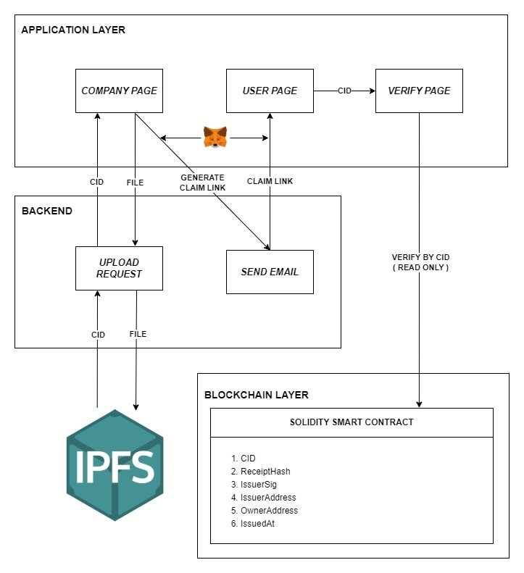

Fig 3.1 System Architecture

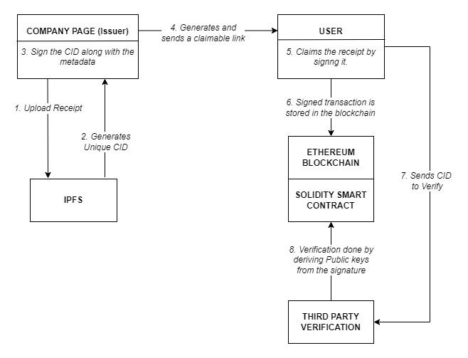
Cryptographic + Blockchain flow

:

Fig 3.2 Cryptographic + Blockchain Flow

CHAPTER 4
SYSTEM REQUIREMENTS

4.1 SOFTWARE REQUIREMENTS

• Frontend Technologies
HTML, CSS, JavaScript with React.js for building issuer, recipient, and verification interfaces.

• Backend Technologies
Node.js with Express.js for handling API requests, IPFS interaction, claim-link generation, and email services.
• Blockchain Platform
Ethereum blockchain (Testnet - Sepolia).

• Smart Contract Language
Solidity for implementing receipt issuance, ownership claiming, and verification logic.
- Blockchain Development Tools
Hardhat for smart contract development, testing, and deployment.
- Wallet & Web3 Integration
MetaMask for user authentication and transaction signing.

• Decentralized Storage
IPFS (via Lighthouse SDK).

CHAPTER

5

SYSTEM

DESIGN

AND

IMPLEMENTATION

MODULES COMPLETED
5.1

. Issuer Module
1

•

Provides an interface for organizations to upload digital receipts or documents.

•

Handles receipt issuance and initiates the IPFS upload process.

•

Displays the generated Content Identifier (CID) returned from IPFS.

•

Digitally signs the CID along with receipt metadata to ensure authenticity.

•

Generates a secure claimable link for the intended recipient.

. IPFS Storage Module
2

•

Stores uploaded receipt files in a decentralized and distributed manner.

•

Generates a unique CID based on the cryptographic hash of the document.

•

Ensures immutability, as any modification to the file results in a new CID.

•

Reduces on
-
chain storage by keeping documents off the blockchain.

3
. Recipient (User) Module

•

Allows users to access the receipt using the claimable link.

•

Enables users to cryptographically sign the receipt using their private key.

•

Confirms receipt ownership by submitting the signed claim to the blockchain.

•

Prevents unauthorized ownership claims.

4
. Smart Contract Module

•

Implements receipt issuance, ownership claiming, and verification logic using Solidity.

•

Stores essential metadata such as CID, receipt hash, issuer signature, issuer address, owner
address, and issuance timestamp.

•

Ensures immutability and transparency of receipt records.

•

Prevents duplicate or fraudulent receipt claims.

5. Verification Module
- Allows third parties to verify receipts using the CID.
- Retrieves and validates blockchain data in read-only mode.
- Verifies issuer and owner authenticity using cryptographic signatures.
- Does not expose sensitive document content during verification.

6. Backend Services Module
- Acts as an intermediary between frontend, IPFS, and blockchain layers.
- Handles file upload requests and IPFS interactions.
- Generates claimable links and manages email notifications.
- Ensures secure API communication.

CHAPTER 6
RESULTS AND DISCUSSION

6.1 Company Page

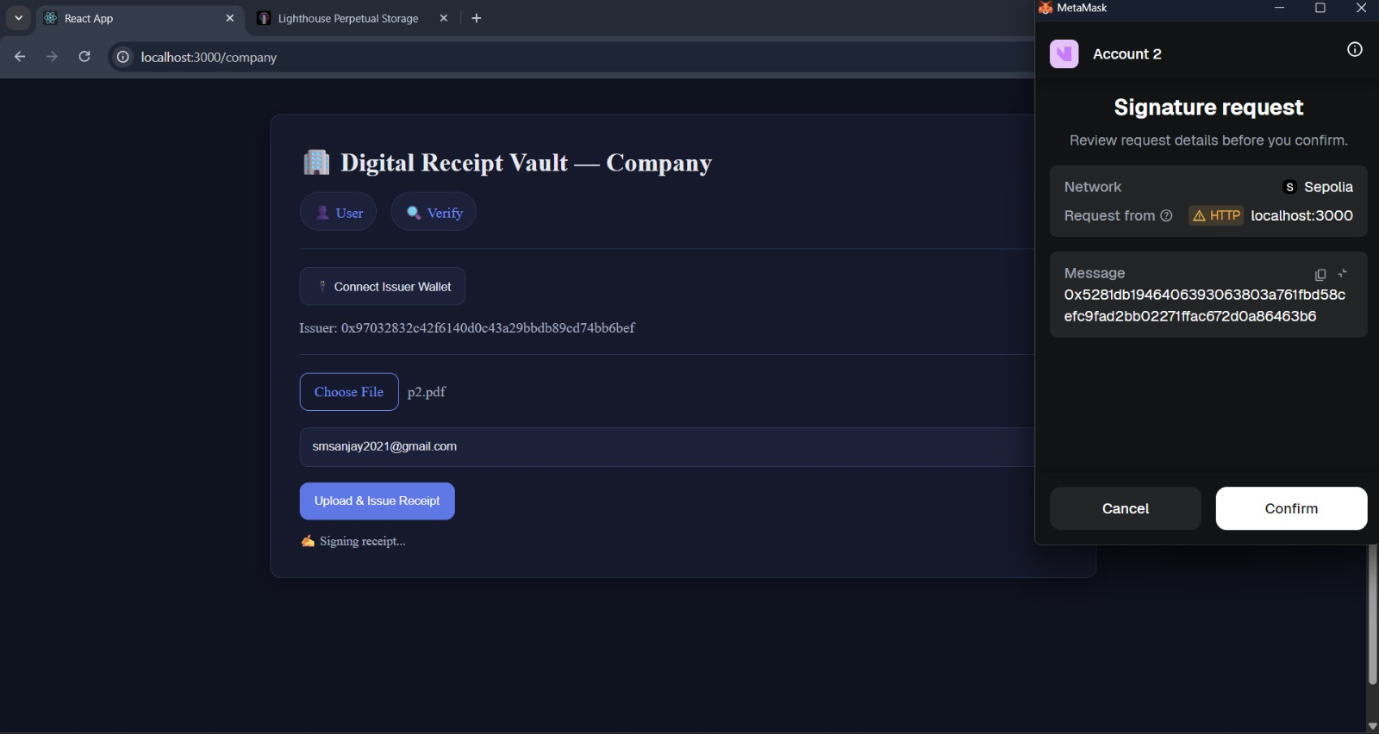

6.2 User Page

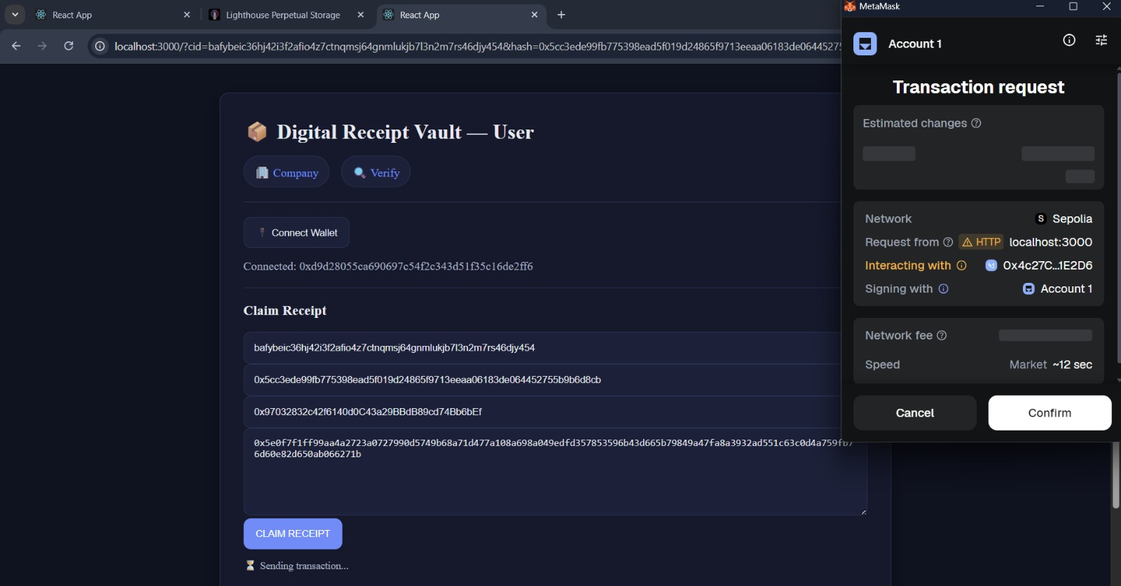

6.3 User Receipts

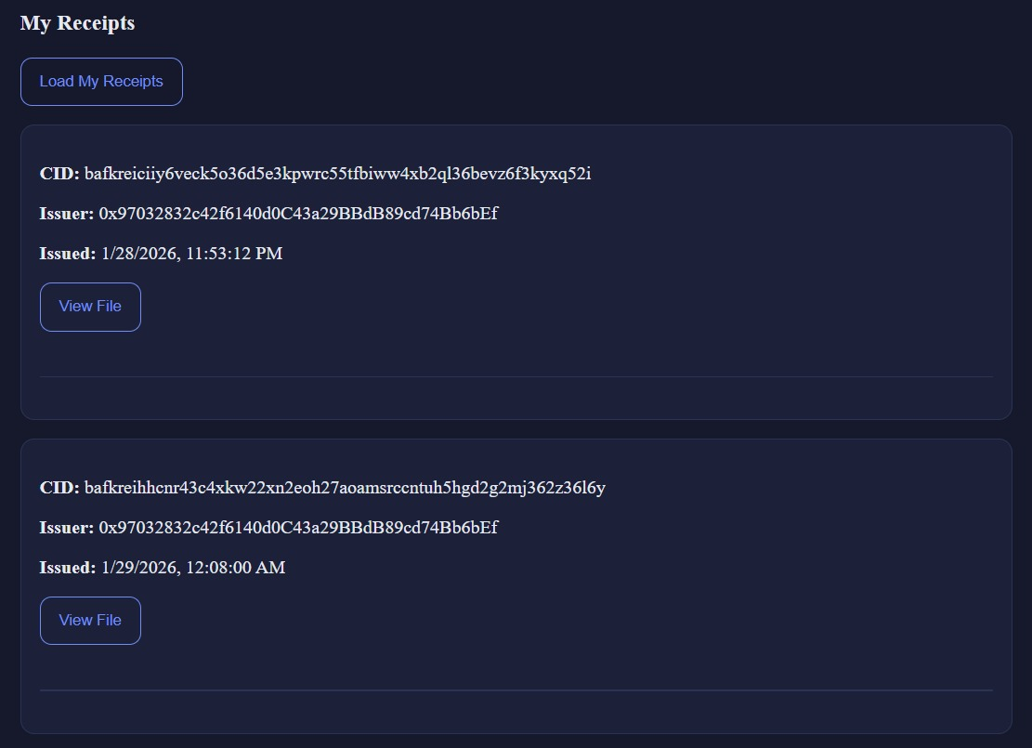

6.4 Claim Link

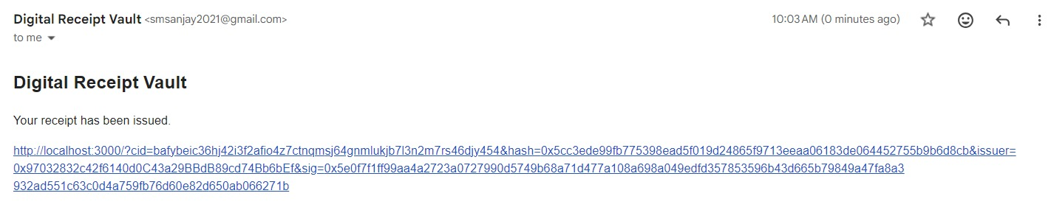

6.5 IPFS Page

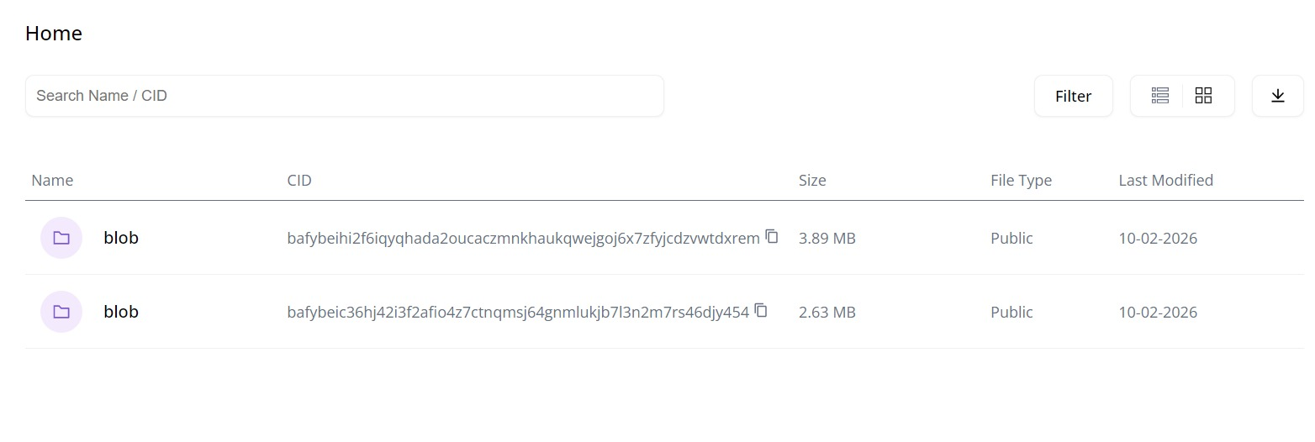

6.6 Receipt Verification

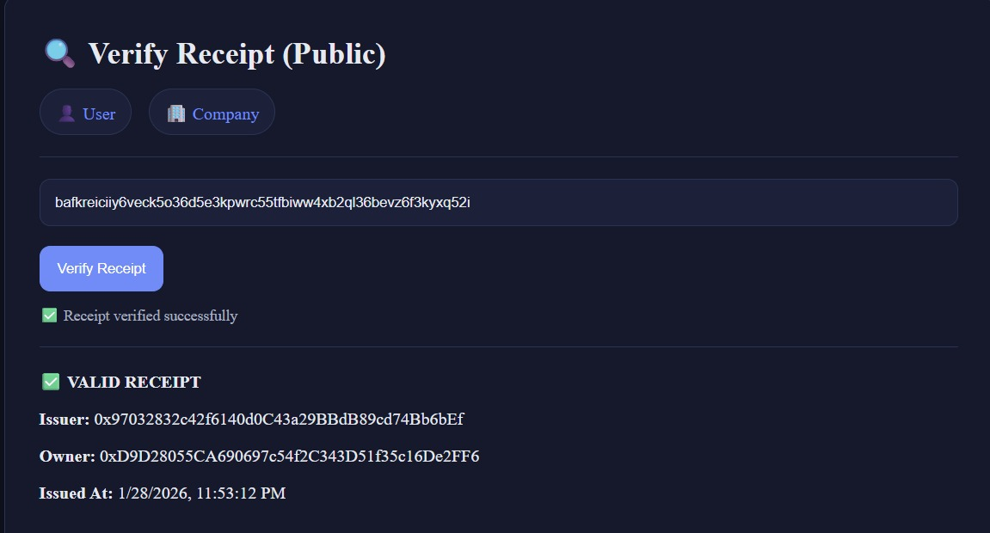

CHAPTER 7

CONCLUSION :

This project successfully demonstrates a decentralized, secure, and tamperproof digital receipt verification system by integrating IPFS, blockchain technology, and cryptographic signatures. By eliminating reliance on centralized authorities, the system ensures document authenticity, integrity, and transparent ownership through immutable blockchain records and contentaddressed storage.
The use of IPFS enables efficient and decentralized storage of receipt files, while the Ethereum blockchain and Solidity smart contracts provide a permanent and verifiable ledger for receipt metadata and ownership claims. The claim-based ownership mechanism and trustless third-party verification ensure that receipts can be securely issued, claimed, and validated without manual intervention.
Overall, the proposed solution offers a scalable and reliable framework for digital document management, with strong potential for adoption in financial, educational, legal, and e-governance applications.

CHAPTER 8

REFERENCES

- Haque MR, Islam Munna S, Ahmed S, Islam MT, Hassan Onik MM, Rahman AA (2025) An integrated blockchain and IPFS-based solution for secure and efficient source code repository hosting using middleman approach. PLoS One 20(9): e0331131.
- Manzoor, A.; Braeken, A.; Kanhere, S.S.; Ylianttila, M.; Liyanage, M. Proxy Re-Encryption Enabled Secure and Anonymous IoT Data Sharing Platform Based on Blockchain. J. Netw. Comput. Appl. 2021, 176, 102917.
- Riazi, M. et al. Design, simulation and feasibility of the innovative agricultural warehouse receipt system through dynamic programming and agent-based models. Sci. Rep. 14, 23182
- Jamil, A., Iqbal, N., Khan, A. & Kim, T. H. A systematic review of blockchain technology for government information sharing. Comput. Mater. Contin.74, 1799–1818. 10.32604/cmc.2023.049856 (2023)
- Mut-Puigserver, M.; Payeras-Capellà, M.M.; Cabot-Nadal, M.A. Blockchain-based fair certified notifications. In Proceedings of the Data Privacy Management, Cryptocurrencies and Blockchain Technology: ESORICS 2018 International Workshops, DPM 2018 and CBT2018

