**Subqueries**

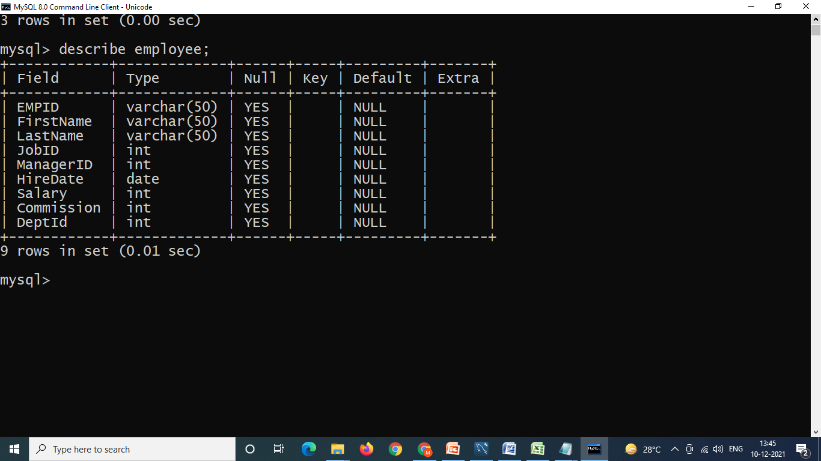

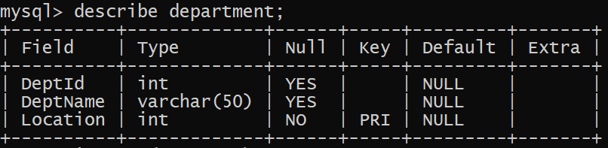

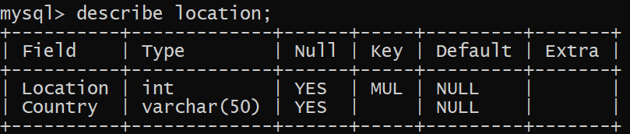

1. **Write a query to fetch the employee who are working under TESTING department**
2. **Write a query to**